**COL334 Assignment 3**

**Packet Trace Analysis**

Vidit Jain 2017CS10389

Rahul Yadav 2017CS50602

< Different FTP commands>

1. All TCP data was considered. All rows having [SYN] in their Info column

|  |  |  |
| --- | --- | --- |
| **Day** | **Unique server IPs** | **Unique Client IPs** |
| 1 | 45 | 522 |
| 2 | 50 | 939 |
| 3 | 89 | 510 |

|  |  |
| --- | --- |
| **Day** | **Unique Flows** |
| 1 | 3256 |
| 2 | 5422 |
| 3 | 3280 |

1. All unique 4-tuples of the form <source IP, destination IP, source port, destination port> were considered for calculations, ie, for each exchange between a client and server, there are 2 different TCP flows.
2. Traffic flows for each day

Day 1

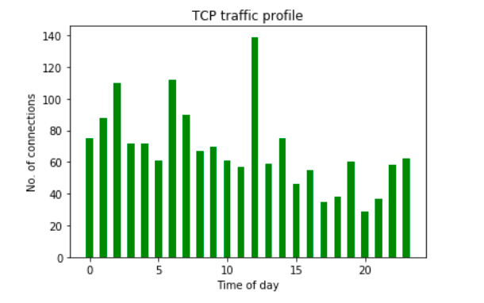

Day 2

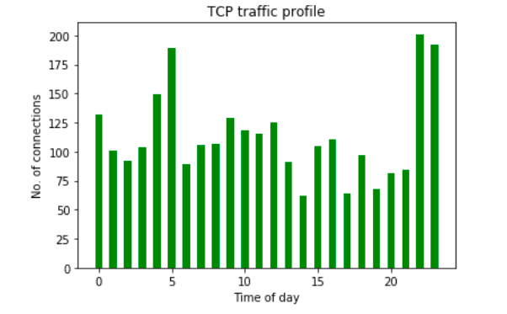

Day 3

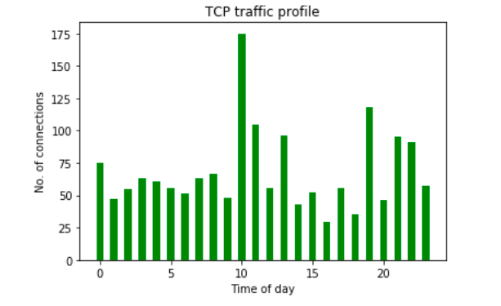

To check whether a server is under a DOS attack, we can maintain a **weighted history of the traffic** expected at any given point of time, in form the TCP connections opened. If the difference in the TCP connections opened to the server at to the TCP connections expected **is more than a certain threshold,** we can claim that a DOS attack is ongoing.

1. 3 tables were created, Table 1 with all TCP SYN packet transmissions, Table 2 with FIN and Table 3 with RST packet transmissions. For each transmission in Table 1, the earliest transmission after this one was found in Table 2 and Table 3, such that the IP addresses communicating matched with that of the transmission from Table 1. This gave us the time when this particular TCP connection ended. This was done for all packet transmissions in Table 1, thus excluding those whose start/end time wasn’t captured in the packet trace. This also took care of the different connections between same ports.

10.

**DAY1**

* **Inter-Arrival Distribution between 2 consecutive connections**

With outliers

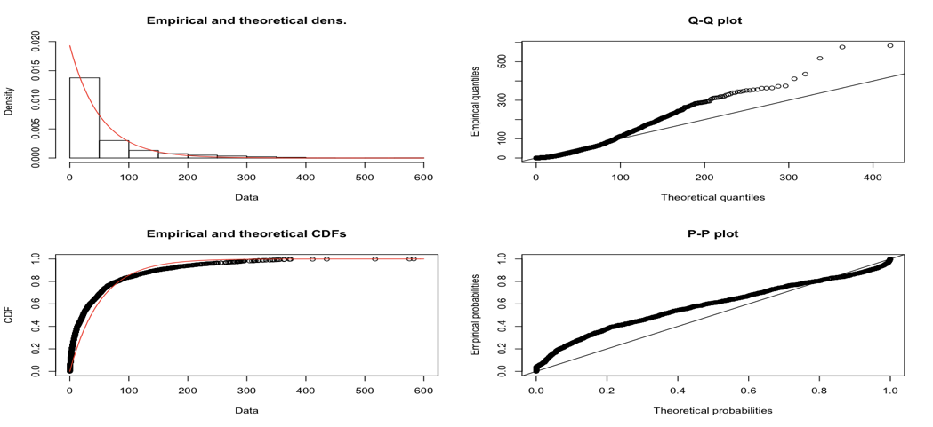

Exponential distribution Parameters:

Rate : 0.0192

After removing outliers :

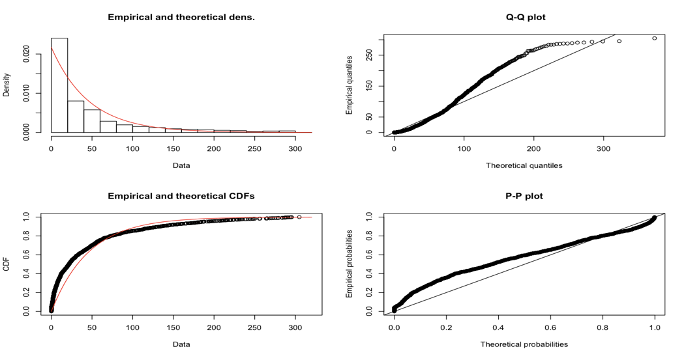

Other Distributions on given dataset :

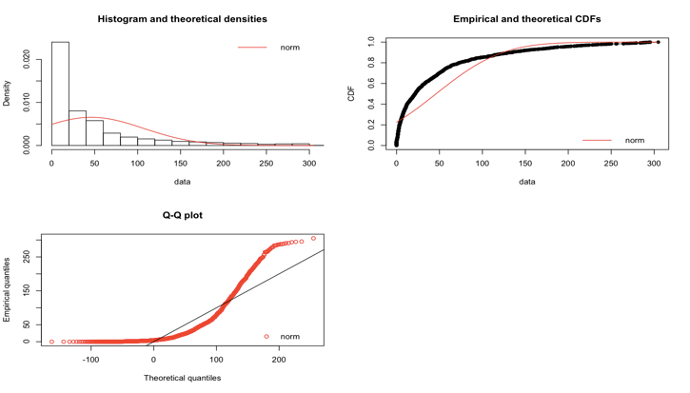 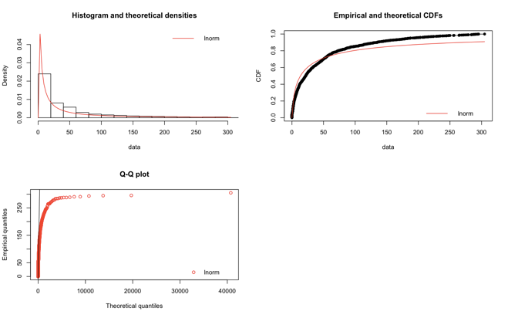

Normal distribution Parameters: Log - Normal distribution Parameters:

mean : 46.07 meanlog : 2.60

sd : 60.91 sdlog 2.33

* **Inter-Arrival Distribution between 2 consecutive incoming packets to server**

With outliers

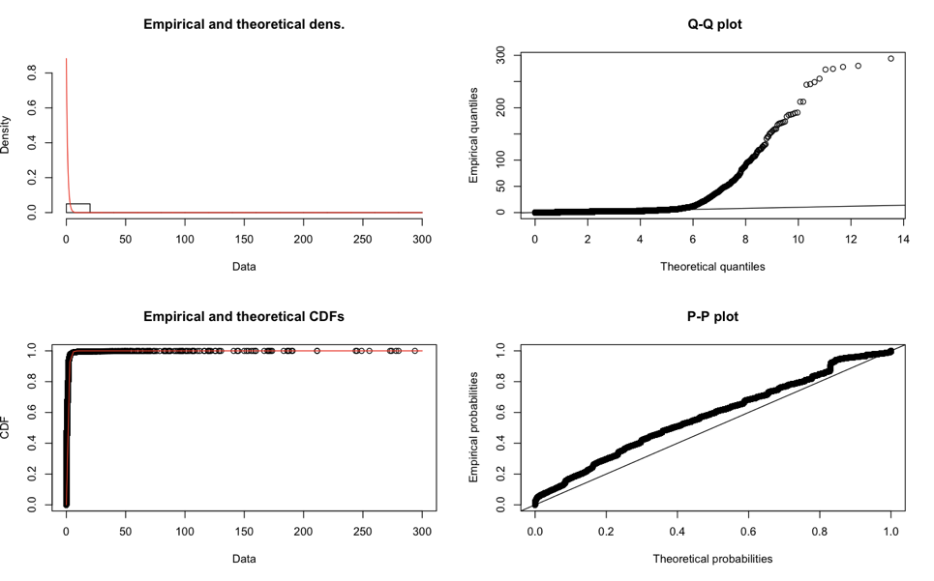

Exponential distribution Parameters:

Rate : 0.88

After removing outliers :

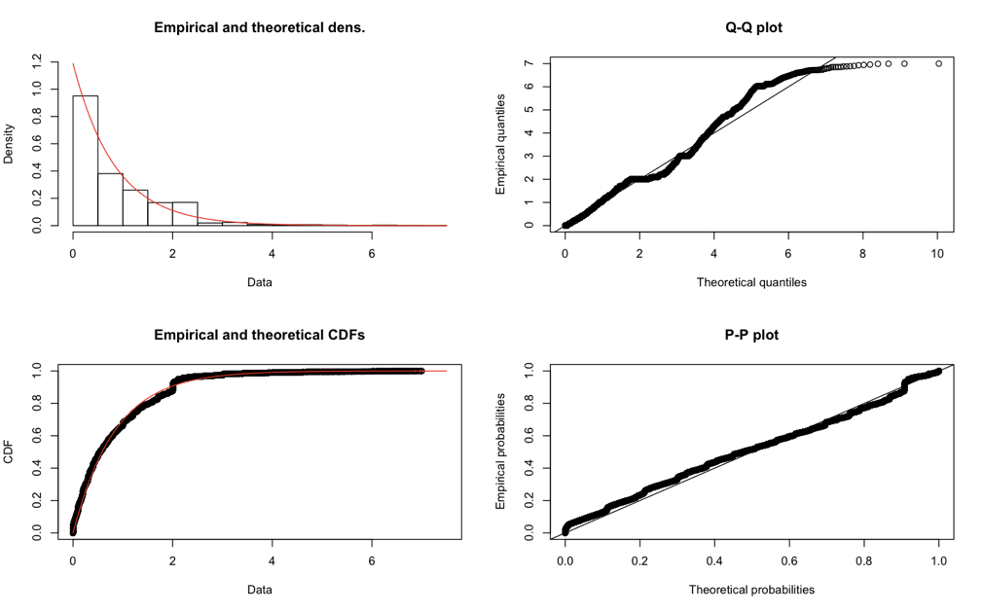

Other Distributions on given dataset :

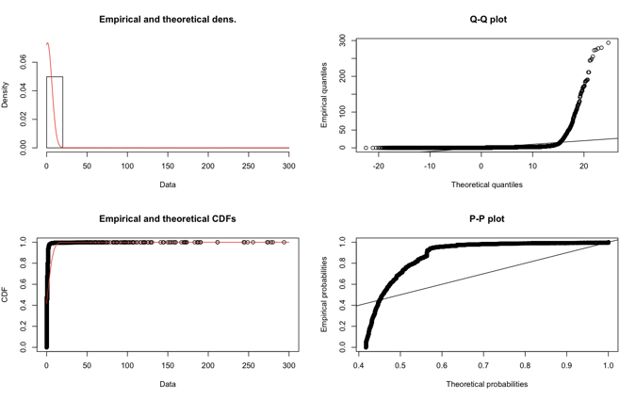 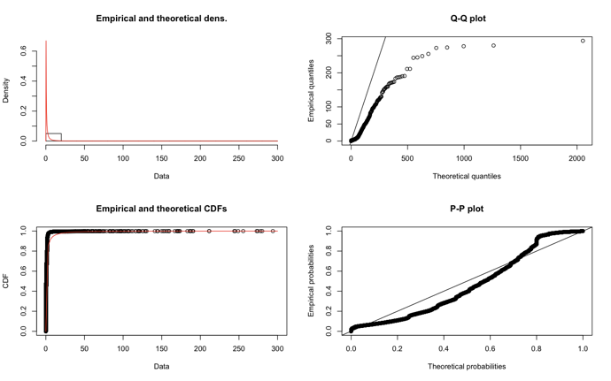

Normal distribution Parameters: Log - Normal distribution Parameters:

mean : 1.13 meanlog : -0.96

sd : 5.41 sdlog : 1.97

**DAY2**

* **Inter-Arrival Distribution between 2 consecutive connections**

With outliers

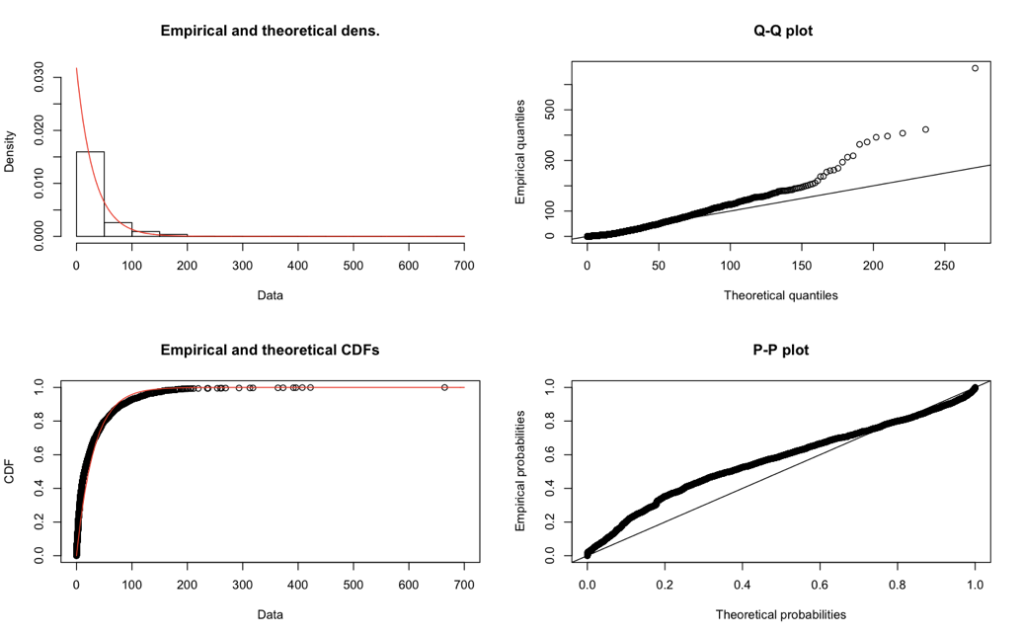

Exponential distribution Parameters:

Rate : 0.031

After removing outliers :

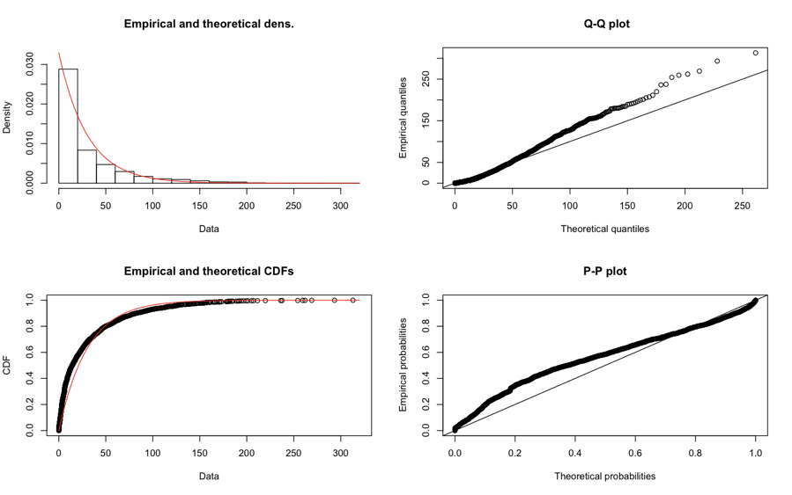

Other Distributions on given dataset :

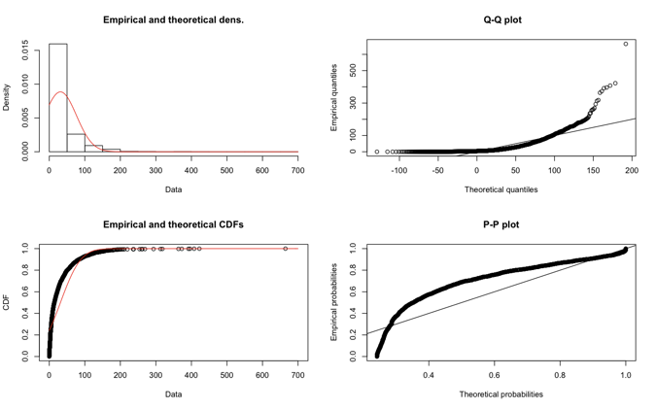 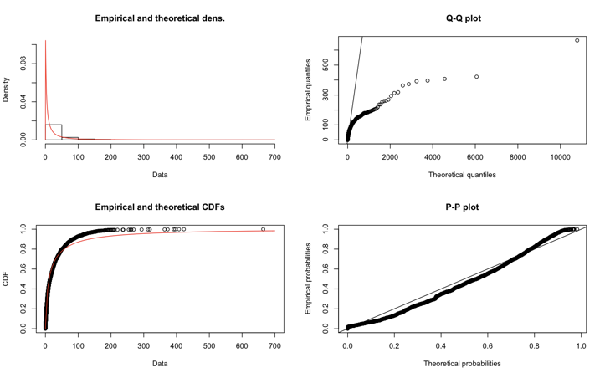

Normal distribution Parameters: Log - Normal distribution Parameters:

mean : 31.50 meanlog : 2.42

sd : 45.02 sdlog 1.92

* **Inter-Arrival Distribution between 2 consecutive incoming packets to server**

With outliers

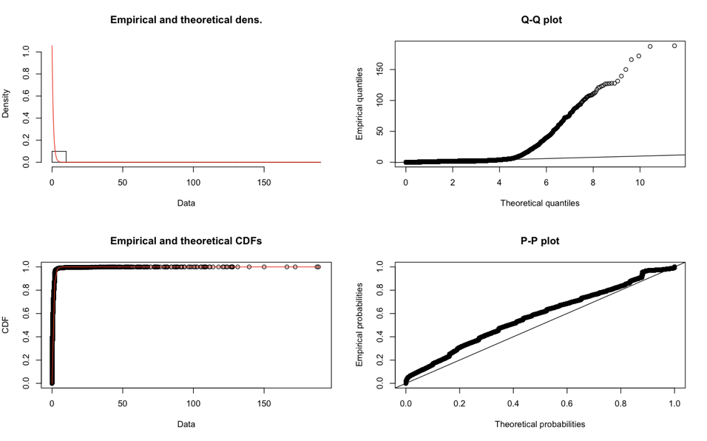

Exponential distribution Parameters:

Rate : 1.05

After removing outliers :

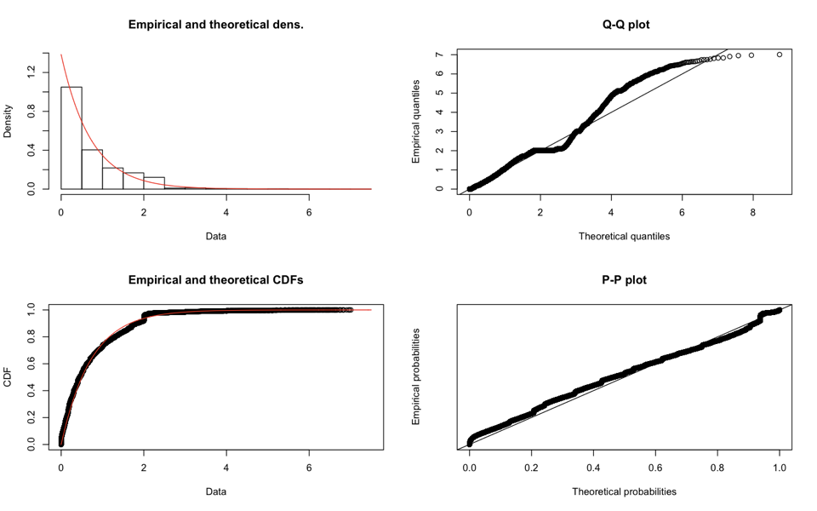

Other Distributions on given dataset :

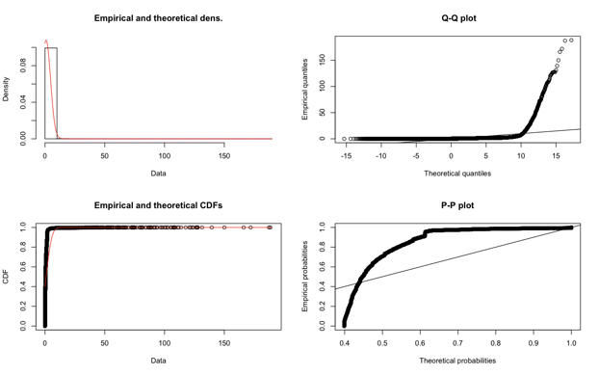 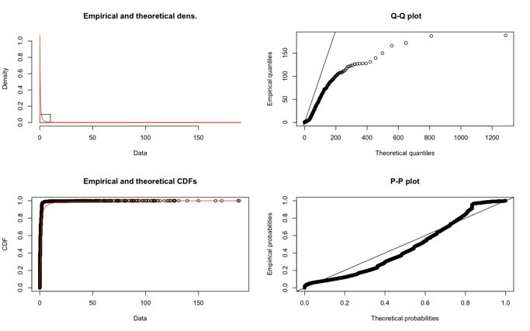

Normal distribution Parameters: Log - Normal distribution Parameters:

mean : 0.94 meanlog : -1.12

sd : 3.69 sdlog : 1.88

**DAY3**

* **Inter-Arrival Distribution between 2 consecutive connections**

With outliers

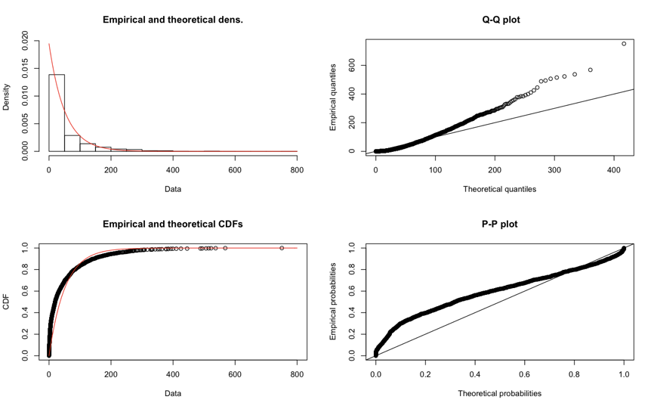

Exponential distribution Parameters:

Rate : 0.019

After removing outliers :

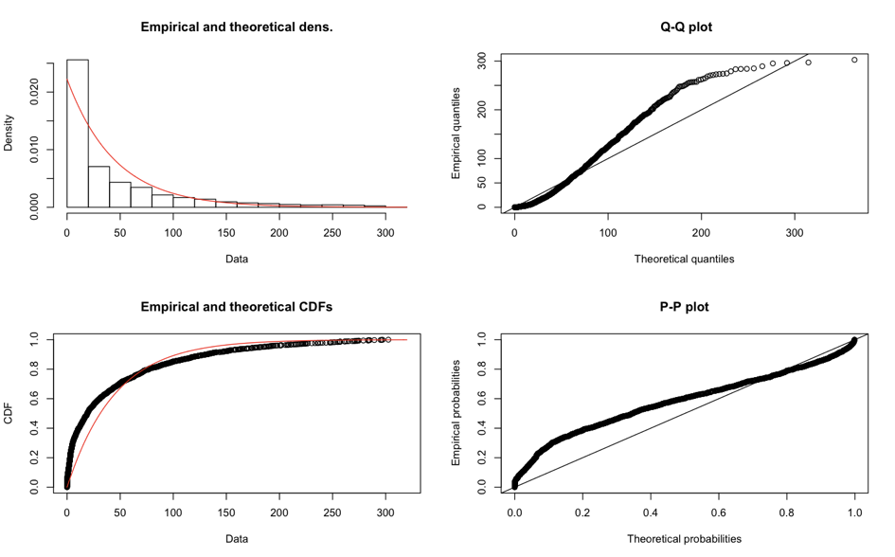

Other Distributions on given dataset :

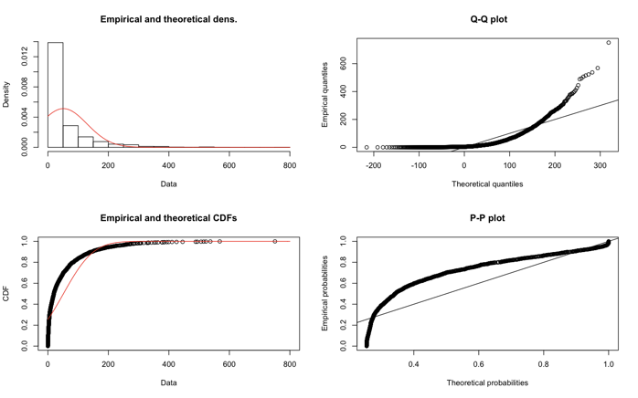 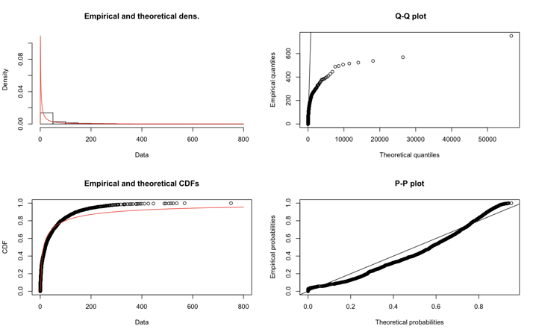

Normal distribution Parameters: Log - Normal distribution Parameters:

mean : 51.37 meanlog : 2.51

sd : 77.83 sdlog : 2.45

* **Inter-Arrival Distribution between 2 consecutive incoming packets to server**

With outliers

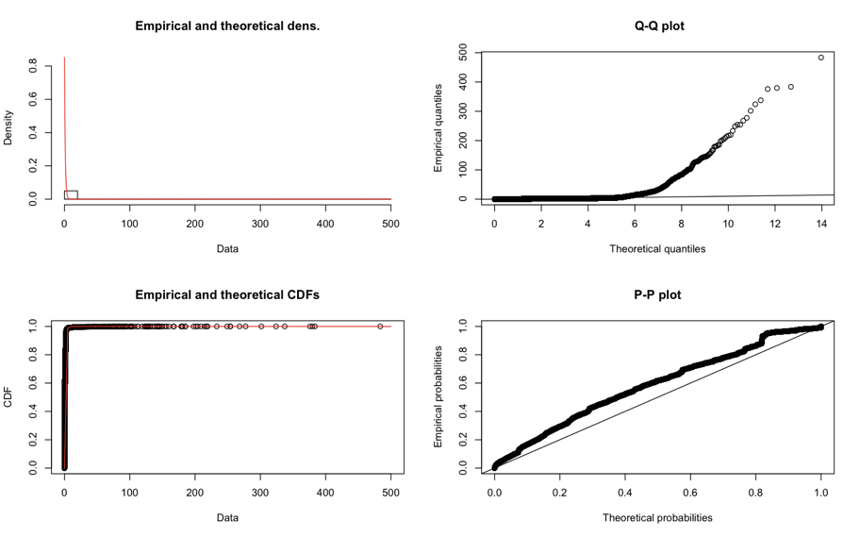

Exponential distribution Parameters:

Rate : 0.85

After removing outliers :

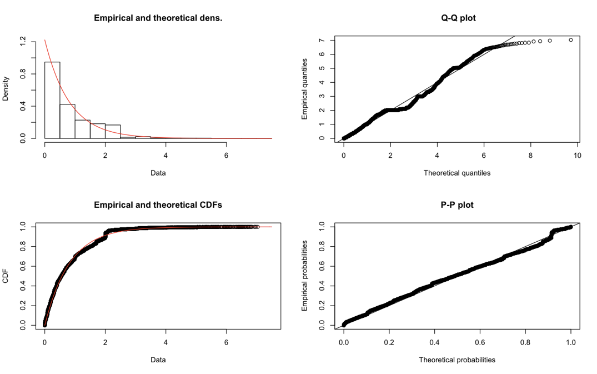

Other Distributions on given dataset :

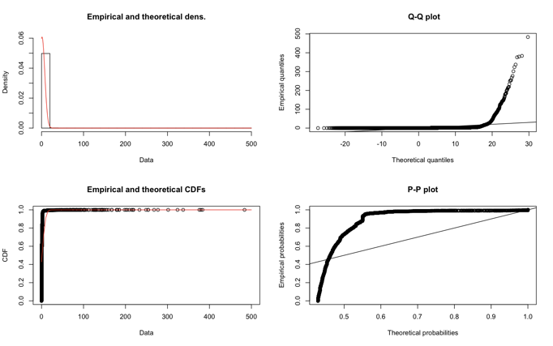 

Normal distribution Parameters: Log - Normal distribution Parameters:

mean : 1.17 meanlog : -0.85

sd : 6.56 sdlog : 1.61

From the above graphs, it may be seen that the Exponential distribution fits the data best, specially when compared to Normal and Log-Normal distributions. Also, removal of outliers leads to a better fitting of the exponential distribution, as evident from the various plots.