**Template Designer UAT Issues**

1. Not all data sources are set up. Please set up all data sources following the spreadsheet we shared earlier.

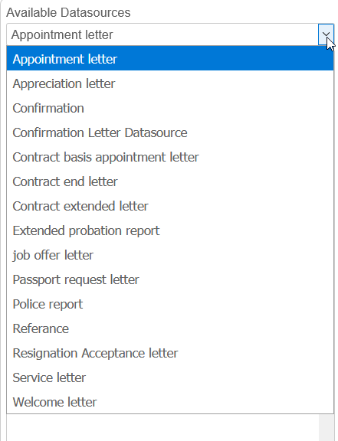

1. We were unable to test the workflow for export approval. Where is it defined?

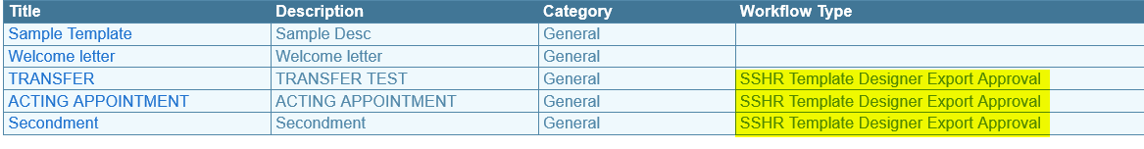

1. We cannot filter using unique numbers e.g. U1703031. We can only use system generated numbers like 000001.

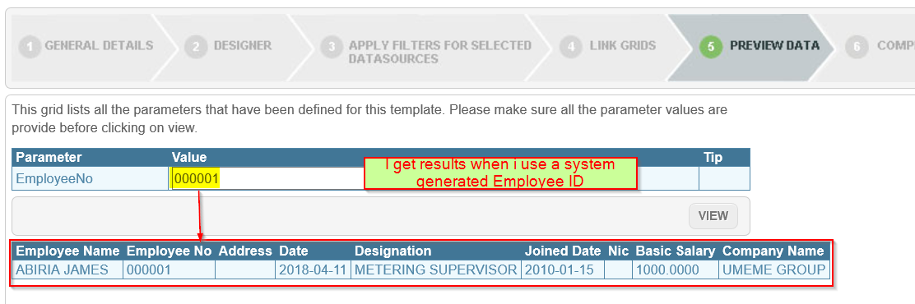

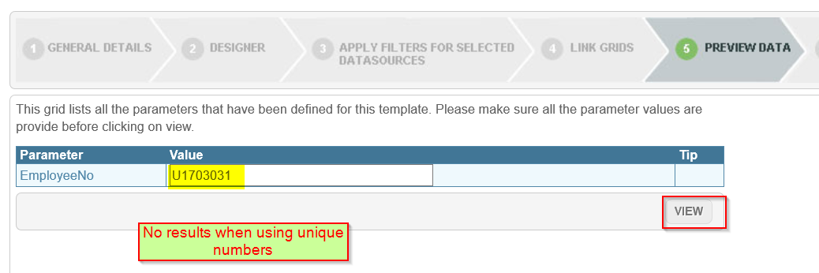

Unique No should be used instead of Employee No

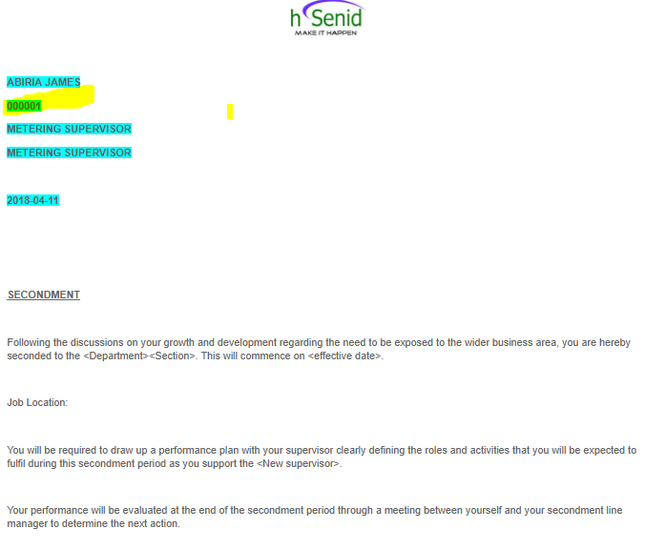

1. Error when previewing a template. E.g. Acting Appointment

*This only happens on the template I created. I can preview some of the others.*

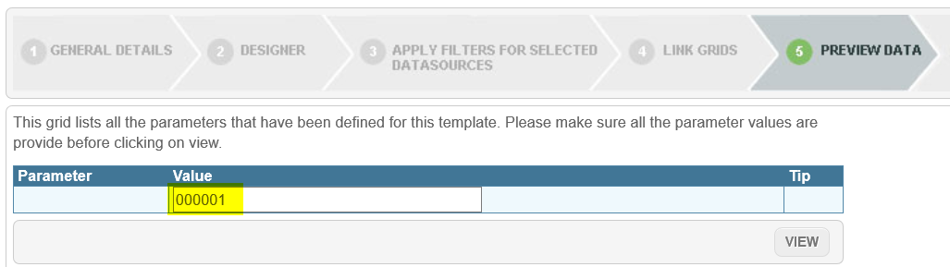

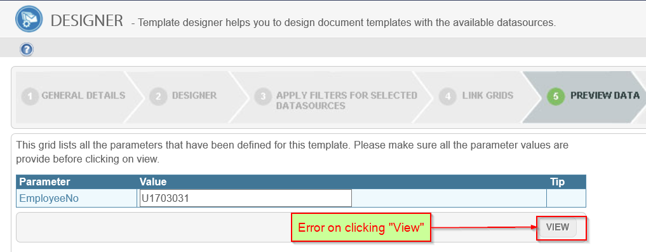

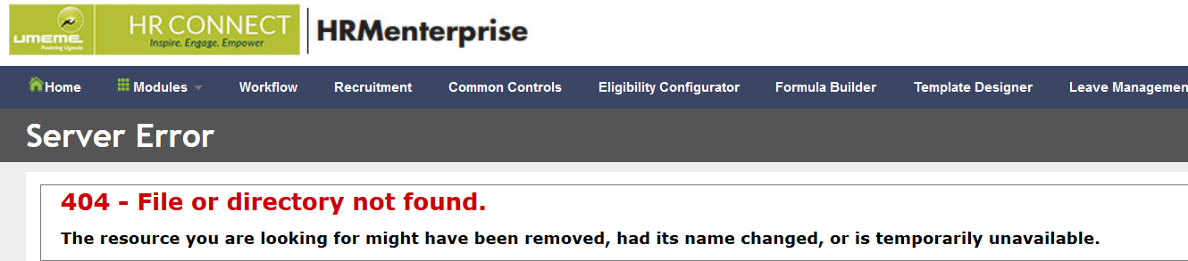

1. I am not able to view the template I created with capability "**All**" under "*List Templates*" until I explicitly assign it to "**IT Security Group**". My expectation is that once it is assigned to all, everyone should be able to view it.

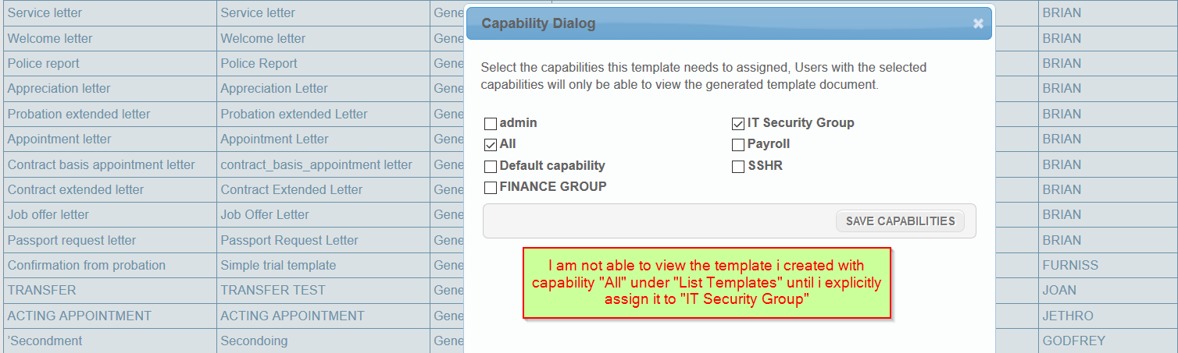

1. Why is there a date selector next to all customer fields? Some custom fields don’t require date inputs.

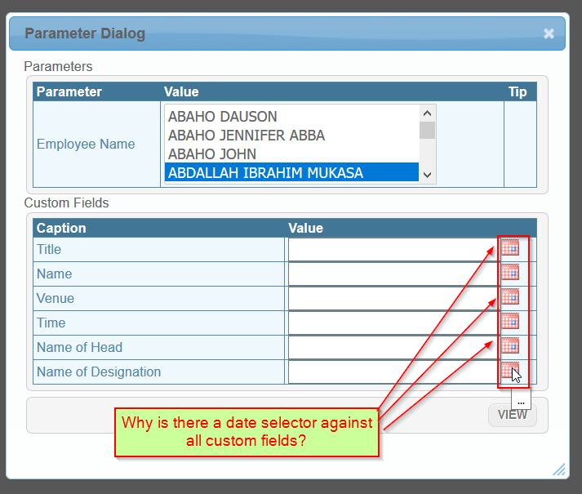

1. Still showing the hsenid logo instead of the Umeme logo. Please change it.

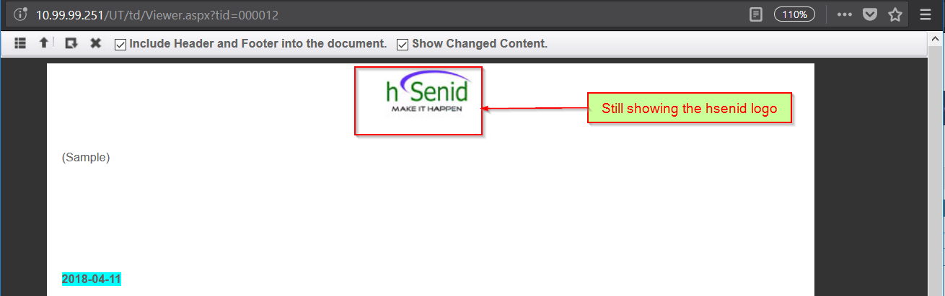

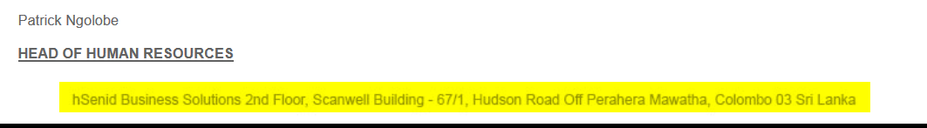

1. Should the exported letter have the letterhead? The current one doesn’t.

