Juan Antonio Villagomez

860969573

ME 120

**PID Simulink Project**

Provided an .mdl named “CruiseControlWebsite”, we were able to simulate the speed of a vehicle within a range a range of time spanning 100 seconds. In order to explore blocks in Simulink, we were asked to adjust the model to fit three different situations: the vehicle increasing velocity by a desired 10MPH, the vehicle converging, or settling, at its final speed within half the default time, and the vehicle encountering an incline after 60 seconds of beginning its acceleration toward the desired velocity.

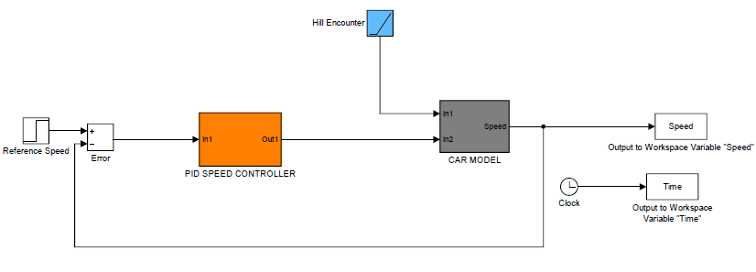

Figure 1: Block Diagram of model representing a vehicle with initial velocity of 40 MPH

1. Provided a reference block containing default values of a step time of zero (seconds) and an initial reference speed of zero (MPH), the reference block was set to have a final reference speed of 50 (MPH). As instructed, the gains remained at their default values (integralGain==0.01, proportionalGain==0.1). I measured the time (Setting Time, Ts) it took for the response to converge, or settle, within 1% of 50 (MPH). The settling time was calculated using the MATLAB code below:

C:\Users\jvill\AppData\Local\Microsoft\Windows\INetCache\Content.Word\within001.png

Figure 2: Snippet where I calculate Settling time within 1%. Full code is provided in Figure 7 for reference.

**Note**: “Speed” variable referenced in the first line is the Speed array generated by simulating the model in Simulink. The array named “error” is generated using the error formula:

error = [absoluteValue(desired-actual)/desired]. “Time” variable referenced in third line, is also generated through Simulink simulation. Complete code can be found on at end of report.

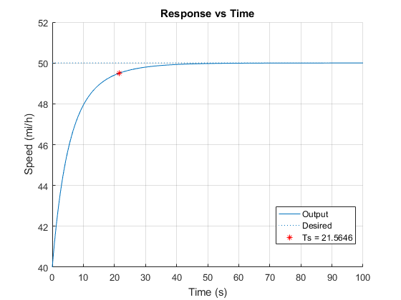

Figure 3: Plot for Part 1. Using Default Gains, from 40MPH to 50MPH

1. Using default gains in part one, we calculated a settling time (Ts) of 21.5646 seconds. We were asked to change the default gains of the PID controller to achieve a settling time that is at least 50% lower than our previous value. Given the aforementioned criteria, the new settling time must be equal to/lower than 10.7323 seconds. Tuning the integral gain from 0.01 to 0.18, the system reached an acceptable settling time of 10.2646 seconds (exceeding minimum criteria). The proportional gain did not need to be changed and thus remained at default value (0.1). The resulting speed profile has an improved rise time and settling time, but as the undesirable feature of an overshoot that was not present using default gains. The overshoot is undesirable considering that it places an unfavorable amount of excess stress on the mechanical components of the vehicle. The overshoot features a maximum of 50.3126 MPH (depicted in graph below).

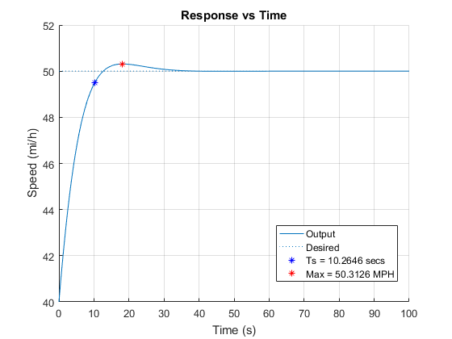

Figure 4: Plot for Part 2. Using Integral Gain=0.018 and Proportional Gain=0.1, from 40MPH to 50MPH

1. A hill was added at Time=60 seconds to monitor how the tuned controller would perform with this disturbance. Upon hitting a local minimum in speed (from hill encounter), it is apparent that the rise, settle times from this disturbance are greater than the rise, settle times from the initial acceleration from 40MPH -50MPH. The slope of the velocity is smaller upon climbing hill, than it is when accelerating from zero seconds to the settle time of 10.2686 seconds. Further tuning should take place to improve the settle time (within 1%) after encountering the incline. From the visual, the system takes longer than 10 seconds to settle back within 1% of desired speed.

**Note:** Red dotted lines represent the approximate time interval where the speed of the vehicle deviates from our desired value (50MPH) by more than or equal to 1%. Red dotted lines should not be misinterpreted for exact interval.

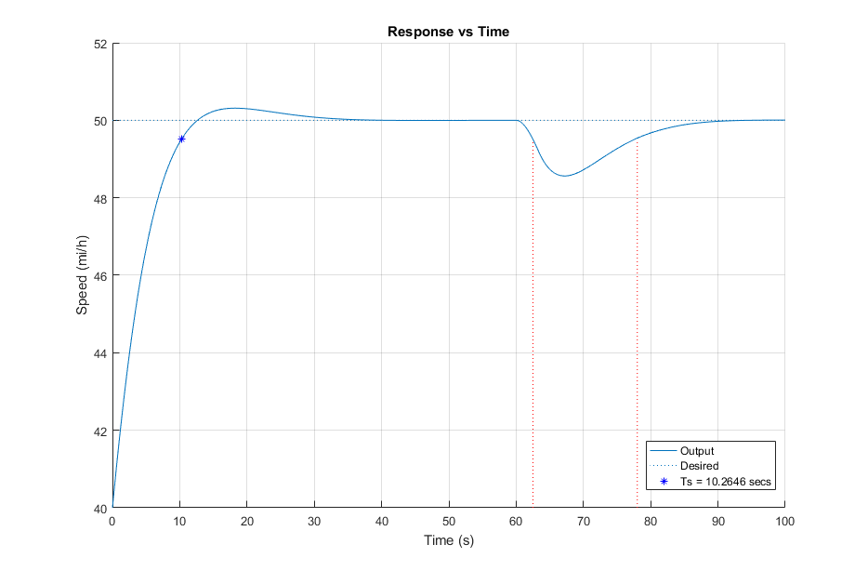

Figure 5: Plot for Part 3. Using Integral Gain=0.018 and Proportional Gain=0.1, With inclined hill at

Time=60 seconds. Redlines approximate the interval where system deviates from desired speed by >= 1%

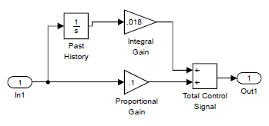

Figure 6: Tuned PID for Part 2-3. Using Integral Gain=0.018 and Proportional Gain=0.1

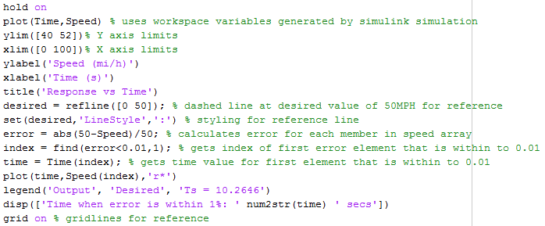

Figure 7: MATLAB code for reference of Figure 3, where I calculate the settling time.