# CSC 486B Assignment 4

Dr. Kwang Moo Yi

Julius Villamayor

V00795790

Mar 23 2018

In this assignment, we use TensorFlow to create a Convolutional Neural Network and train it on CIFAR-10. By default, we use 3 convolutional layers (with a max pooling layer between each) before the outputs are fed into fully connected layers for final output. With default parameters, the best accuracy achieved was 0.5831. The progress of this is shown below.

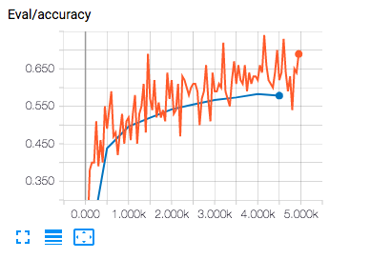

Figure 1. Eval/accuracy for default parameters.

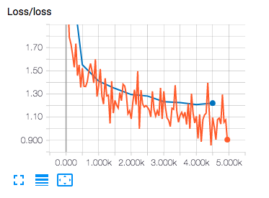

Figure 2. Loss for default parameters.

As well as trying default parameters, 3 additional models were built with modified base filters. By default, the base filter value was 8. This value is how many filters the first convolutional layer has. Each subsequent filter doubles the number of filters of the layer preceding it. Results of experimenting with this value are shown below.

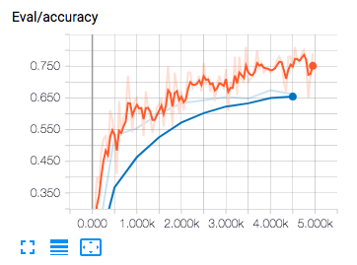

Figure 3. Eval/accuracy for num_conv_base=16.

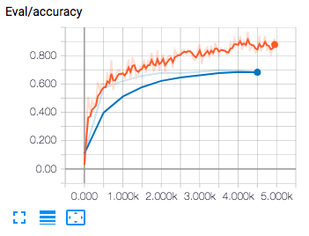

Figure 4. Eval/accuracy for num_conv_base=32.

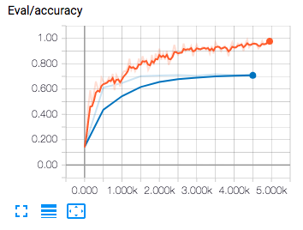

Figure 5. Eval/accuracy for num_conv_base=64.

The table below shows the best validation accuracies achieved for each number of neurons.

|  |  |
| --- | --- |
| **num_conv_base** | **Accuracy** |
| 8 | 0.5831 |
| 16 | 0.6617 |
| 32 | 0.6696 |
| 64 | 0.7159 |

Table 1. num_conv_base vs. accuracy for 4 values of num_conv_base.