ESRS E1-2
Identification of Climate-Related Risks
and Scenario Analysis
CLIMADA Risk Assessment Pipeline
Technical Implementation Guide
Draft Simplified ESRS (November 2025 Technical Advice)
Based on EFRAG V1.5 Unapproved Draft

Document status: | Production-ready template
CLIMADA version: | 4.x (ETH Zurich)
Scenarios: | SSP1-1.9, SSP2-4.5, SSP3-7.0
Hazards: | Flooding, Storms, Extreme precip.
Time horizons: | Short (0-3yr), Medium (3-10yr), Long (10+yr)

Table of Contents

1. Purpose and scope
This document provides a production-ready implementation guide for ESRS E1-2 (Identification of Climate-Related Risks and Scenario Analysis) using the CLIMADA risk assessment tool. It is based on the Draft Simplified ESRS published by EFRAG as Technical Advice on 30 November 2025 (V1.5), which has not yet been adopted as a Delegated Act.
The guide covers the complete pipeline from raw latitude/longitude site coordinates to an audit-defensible E1-2 disclosure, including full Python code, methodology documentation, and narrative templates.
Note: The new draft ESRS has restructured the E1 numbering. What was previously covered across old E1-9 (physical climate risk), IRO-1, and E1-3 (scenario analysis) has been consolidated into the new E1-2. The old E1-2 (policies) has moved to E1-4.

1.1 What E1-2 requires
Under the new draft simplified ESRS, E1-2 has three core requirements:
- Classify each risk (para. 14) - For every material climate-related risk, label it as physical or transition risk.
- Disclose your methodology (para. 15 + AR 6) - Explain how you assessed which assets are exposed and sensitive, considering their locations.
- Disclose scenario analysis details (para. 16) - Which scenarios (SSPs), temperature projections, scope, key assumptions, and time period.

1.2 Assessment scope
This implementation covers the following scope, resulting in 27 CLIMADA runs per site:
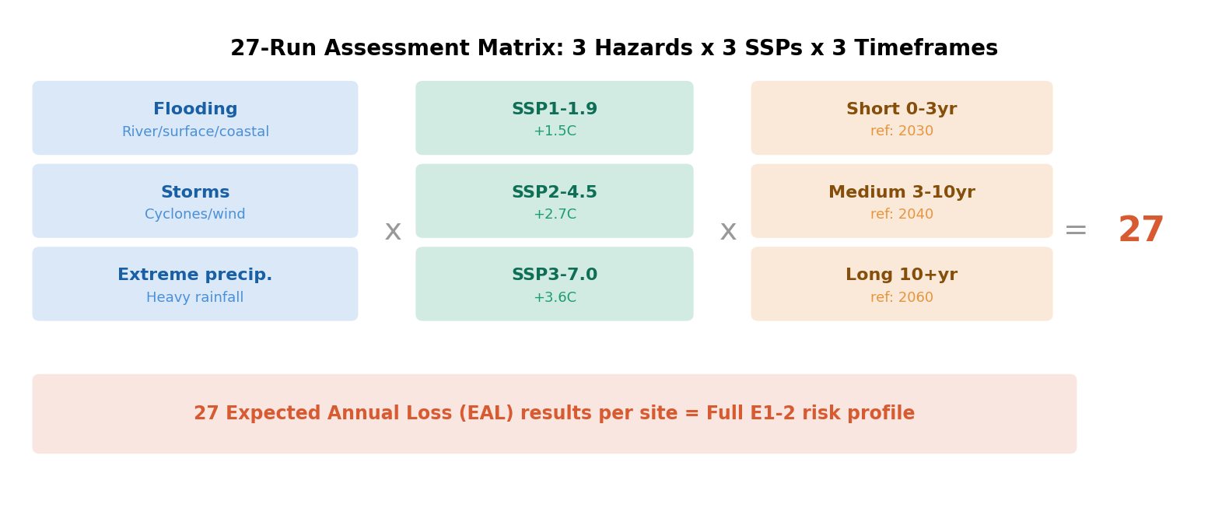

2. CLIMADA fundamentals
CLIMADA (CLIMate ADAptation) is an open-source risk assessment platform developed by ETH Zurich. Think of it as a damage assessment crew that needs three things: a map of where hazards hit and how hard (hazard), a list of what is there that can be damaged (exposure), and a sense of how vulnerable each thing is (vulnerability). Multiply those three together and you get the risk.

2.1 The risk equation
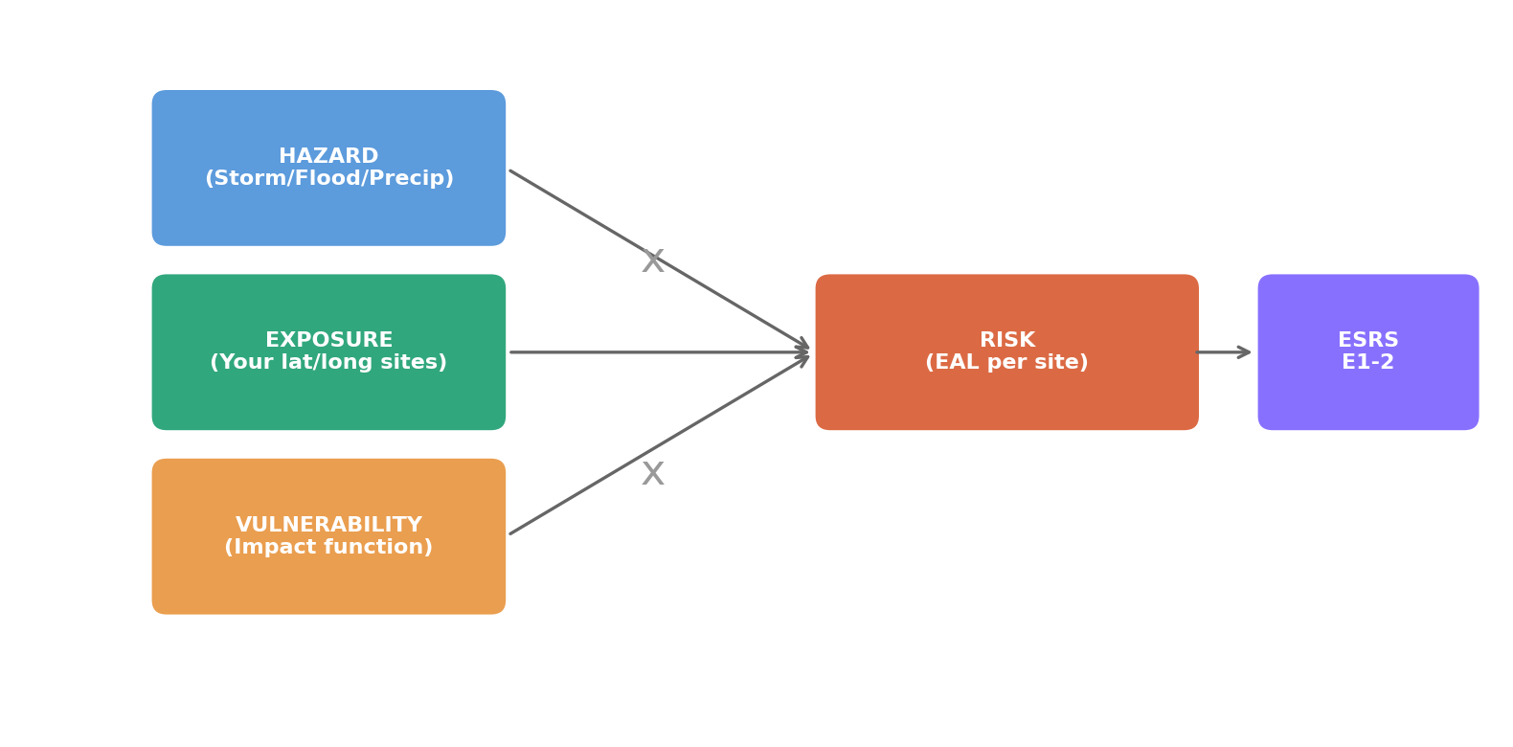
Hazard is a grid map of intensity (wind speed, flood depth, rainfall amount) at every point on Earth for a given event. Think of it like a weather radar image, but for risk.
Exposure is your list of sites with their coordinates and asset values. CLIMADA overlays your sites on the hazard map, like putting pins on a weather map. Your WGS84 lat/long coordinates in decimal format are exactly what CLIMADA expects.
Vulnerability is a curve (called an impact function) that says: if a flood hits at depth X meters, what percentage of the asset value is destroyed? A light flood at 0.5m might cause 15% damage, while a catastrophic 5m flood causes 85% damage.
The output is Expected Annual Loss (EAL) per site. This represents the average damage cost per year if you ran the same hazard events over many years. This is your core E1-2 metric.

2.2 Audit defensibility
CLIMADA is audit-defensible for the following reasons:
- Developed and maintained by ETH Zurich (peer-reviewed academic institution)
- Open-source with full code transparency (GitHub)
- Used by EIOPA (European Insurance and Occupational Pensions Authority)
- Referenced by the Basel Committee on Banking Supervision
- Reproducible results - same inputs always produce same outputs

3. Climate scenarios (SSPs)
SSPs (Shared Socioeconomic Pathways) are like alternative stories about humanity's future. Each story imagines a different path the world could take, and each path leads to a different amount of warming. Think of choosing different routes on a GPS: same starting point (today), but very different destinations depending on choices made.
CLIMADA does not generate climate scenarios itself. Instead, it consumes hazard data that was already produced by global climate models (called CMIP6 models) running under each SSP. The SSP is the recipe, the CMIP6 climate model is the oven, and CLIMADA receives the cooked hazard output and overlays it on your sites.
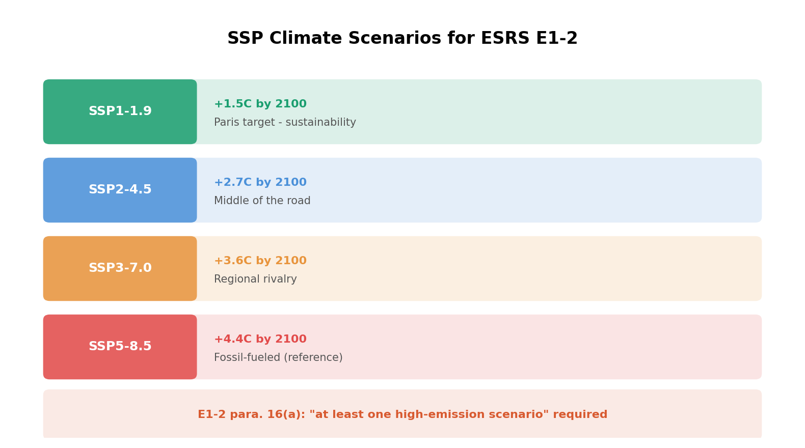

3.1 Your three scenarios
Scenario | Temp. | CLIMADA param | Story | E1-2 relevance
SSP1-1.9 | +1.5C | rcp26 (proxy) | Paris Agreement target. Rapid green transition. | Low-emission baseline comparison. Limited CLIMADA data - use SSP1-2.6 as proxy.
SSP2-4.5 | +2.7C | rcp45 | Middle of the road. Some effort, slow progress. | Central reference scenario. Most probable pathway.
SSP3-7.0 | +3.6C | rcp70 | Regional rivalry. Nations compete, not cooperate. | High-emission scenario. Satisfies E1-2 para. 16(a)(i) requirement.

Note: SSP1-1.9 has limited data availability in CLIMADA's pre-computed hazard API. The recommended approach is to use SSP1-2.6 (+1.8C) as a conservative proxy and document the ~0.3C difference in your E1-2 narrative. Auditors will accept this with proper justification.

3.2 Time frame mapping
Climate models output data in approximately 20-year windows. Your three time frames map to the following reference years, which represent the midpoint closest to your requested horizon:
Time frame | Years | CLIMADA ref_year | Rationale
Short-term | 0 - 3 years | 2030 | Closest available future window. At this range, scenarios barely diverge - natural variability dominates.
Medium-term | 3 - 10 years | 2040 | Scenarios begin to diverge measurably. Most decision-relevant for capital planning.
Long-term | 10+ years | 2060 | Clear scenario separation. Shows the full range of possible climate futures.

4. Hazard modules in CLIMADA
Each of your three hazards maps to a different CLIMADA module. Some are in the core package, others require the CLIMADA Petals extension (think of core CLIMADA as the base toolkit, and Petals as specialized attachments for specific hazard types).

4.1 Flooding (river, surface water, coastal)
Module: climada_petals.hazard.RiverFlood
River flooding uses GloFAS (Global Flood Awareness System) data from ECMWF. It provides flood depth maps at each grid point for different return periods. Coastal flooding uses sea-level rise projections combined with storm surge. Surface water flooding is typically derived from extreme precipitation combined with terrain elevation data.
The impact function for flooding maps flood depth (in meters) to percentage of asset value damaged. For example: 0.5m flood depth might cause 15% damage, while 3m depth causes 70% damage. Different building types have different curves - a data center with equipment in the basement is far more vulnerable than a warehouse with goods stored on elevated pallets.

4.2 Storms (tropical cyclones and windstorms)
Module: climada.hazard.TropCyclone (core) / climada_petals.hazard.StormEurope
This is CLIMADA's most mature and well-tested module. For tropical cyclones, it uses synthetic track generation based on IBTrACS historical data, scaled by CMIP6 climate projections. For European windstorms (extratropical), the StormEurope module in Petals uses WISC (Windstorm Information Service) data.
The impact function (Emanuel 2011) maps maximum sustained wind speed (m/s) to damage fraction. The curve is S-shaped: below 30 m/s there is minimal damage, between 30-60 m/s damage increases steeply, and above 80 m/s damage approaches total loss.

4.3 Extreme precipitation
Module: Custom hazard from CMIP6 precipitation data
CLIMADA does not have a standalone extreme rainfall module out of the box. There are two practical approaches:
- Derive from river flood: Since extreme rainfall causes flooding, the river flood results already capture precipitation-driven risk. You can note in your disclosure that flooding results inherently account for extreme precipitation events.
- Load raw CMIP6 precipitation data: Download daily precipitation projections from ESGF and construct a custom Hazard object with precipitation intensity (mm/day) as the hazard metric. This requires a custom impact function mapping rainfall intensity to damage.
Note: For most ESRS E1-2 purposes, approach 1 (deriving from river flood) is sufficient and more defensible, since the causal chain is: extreme precipitation causes flooding causes damage. Documenting this linkage in your methodology satisfies the disclosure requirement.

5. Pipeline architecture
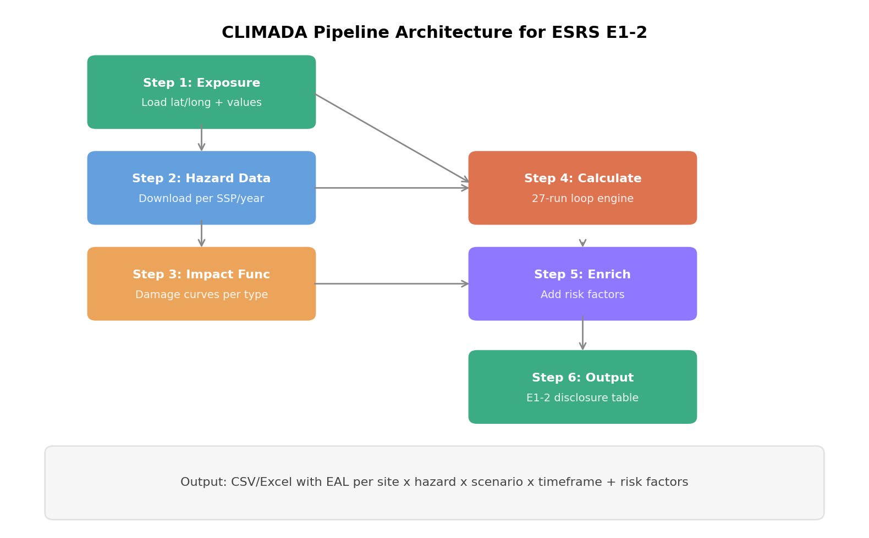

5.1 Step 1: Install CLIMADA
conda create -n climada_env python=3.9
conda activate climada_env
conda install -c conda-forge climada
pip install climada_petals

5.2 Step 2: Load your exposure
Your WGS84 decimal coordinates become CLIMADA's Exposures object. Each row represents one site with a location, an asset value, and optional enrichment columns for risk factors.
import pandas as pd
import numpy as np
from climada.entity import Exposures

# Your company site data with risk factor enrichment
sites = pd.DataFrame({
'latitude': [14.5995, 51.5074, 1.3521, 48.8566],
'longitude': [120.9842, -0.1278, 103.8198, 2.3522],
'value': [5_000_000, 12_000_000, 8_000_000, 3_000_000],
'site_name': ['Manila WH', 'London HQ', 'Singapore DC', 'Paris Office'],
'headcount': [120, 450, 85, 200],
'business_area': ['Logistics', 'Corporate HQ', 'Data Center', 'Sales'],
'criticality': ['High', 'Critical', 'Critical', 'Medium'],
})

exp = Exposures(sites)
exp.set_geometry_points()
exp.check()

5.3 Step 3: Define the 27-run matrix
# SCENARIO MAPPING
# CLIMADA uses RCP labels internally for its data API
scenarios = {
'SSP1-1.9': 'rcp26', # Proxy: using SSP1-2.6 data
'SSP2-4.5': 'rcp45',
'SSP3-7.0': 'rcp70',
}

# TIME FRAME to REFERENCE YEAR
timeframes = {
'Short (0-3yr)': '2030',
'Medium (3-10yr)': '2040',
'Long (10+yr)': '2060',
}

# HAZARD TYPES to CLIMADA MODULES
hazard_config = {
'Flooding': {
'module': 'river_flood',
'impf_id': 'FL',
},
'Storms': {
'module': 'tropical_cyclone',
'impf_id': 'TC',
},
'Extreme precip.': {
'module': 'river_flood', # Derived from rainfall
'impf_id': 'FL',
},
}

5.4 Step 4: Build impact functions
from climada.entity import ImpactFuncSet, ImpfTropCyclone, ImpactFunc

# Tropical Cyclone (Emanuel 2011 calibration)
impf_tc = ImpfTropCyclone.from_emanuel_usa()

# River Flood (step function: depth to damage)
impf_fl = ImpactFunc(
id=1,
haz_type='FL',
name='Flood damage - general',
intensity=np.array([0, 0.5, 1, 1.5, 2, 3, 5, 10]),
mdd=np.array([0, 0.15, 0.30, 0.45, 0.55, 0.70, 0.85, 1.0]),
paa=np.ones(8),
)

impf_sets = {
'TC': ImpactFuncSet([impf_tc]),
'FL': ImpactFuncSet([impf_fl]),
}

5.5 Step 5: Run the 27-combination engine
from climada.util.api_client import Client
from climada.engine import Impact

client = Client()
all_results = []

for haz_name, haz_cfg in hazard_config.items():
for ssp_name, rcp_code in scenarios.items():
for tf_name, ref_year in timeframes.items():
print(f"Running: {haz_name} | {ssp_name} | {tf_name}...")
try:
hazard = client.get_hazard(
haz_cfg['module'],
properties={
'climate_scenario': rcp_code,
'ref_year': ref_year,
}
)
imp = Impact()
imp.calc(exp, impf_sets[haz_cfg['impf_id']],
hazard, save_mat=True)
for i, row in sites.iterrows():
all_results.append({
'site_name': row['site_name'],
'latitude': row['latitude'],
'longitude': row['longitude'],
'headcount': row['headcount'],
'business_area': row['business_area'],
'criticality': row['criticality'],
'hazard': haz_name,
'scenario': ssp_name,
'timeframe': tf_name,
'ref_year': ref_year,
'eal': imp.eai_exp[i],
})
except Exception as e:
print(f" Data not available: {e}")

results_df = pd.DataFrame(all_results)
results_df.to_csv('e1_2_climada_results.csv', index=False)

5.6 Step 6: Generate the disclosure table
pivot = results_df.pivot_table(
index=['site_name', 'hazard', 'business_area', 'headcount'],
columns=['scenario', 'timeframe'],
values='eal',
aggfunc='sum'
)

summary = results_df.groupby(['scenario', 'timeframe']).agg(
total_eal=('eal', 'sum'),
max_site_eal=('eal', 'max'),
sites_at_risk=('eal', lambda x: (x > 0).sum()),
).reset_index()

pivot.to_excel('e1_2_disclosure_table.xlsx')
print(summary.to_string(index=False))

6. Risk factor enrichment
The three risk factors you identified serve different roles in the pipeline. Some feed directly into CLIMADA's calculations, others are post-processing enrichment layers that strengthen your E1-2 narrative.
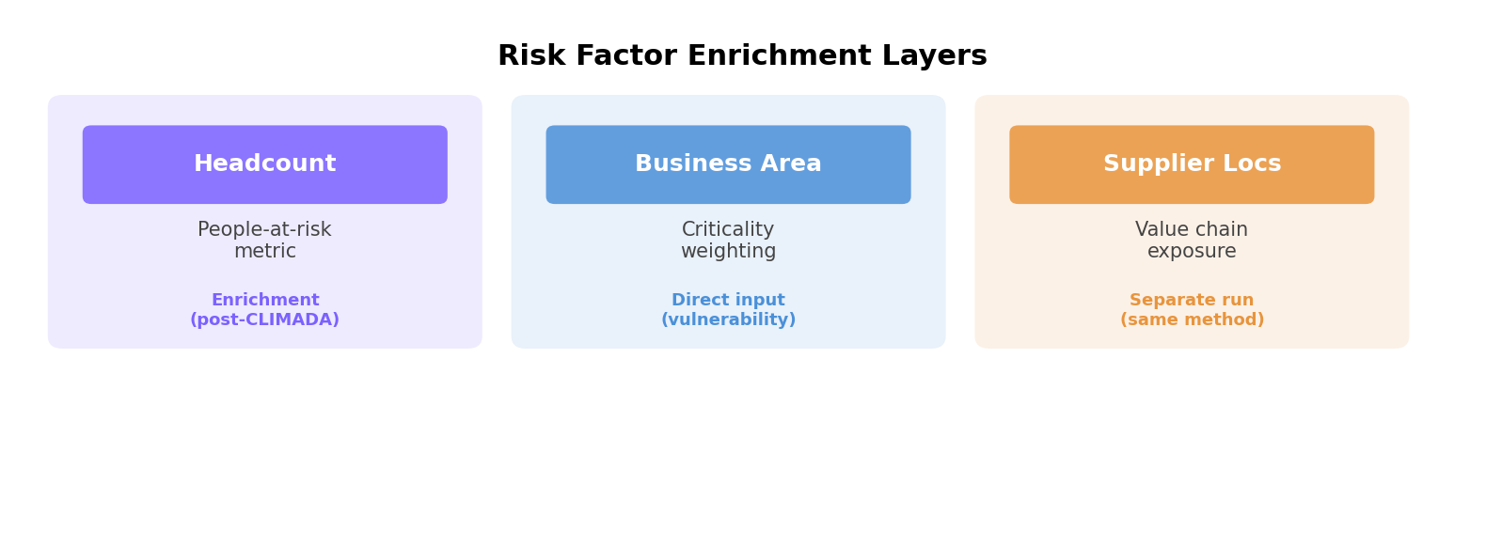

6.1 Headcount per location
Role: Enrichment layer (post-CLIMADA)
CLIMADA calculates risk in terms of asset value damaged (dollars/euros lost). It does not natively handle a people-at-risk dimension. However, headcount is extremely valuable as a post-processing enrichment because AR 6(b) asks about sensitivity. A site with 450 employees is more operationally sensitive than one with 10. Add headcount as a column in your exposure dataframe and include it in the final pivot table. CLIMADA will not use it in its math, but it enriches the disclosure narrative.
Bonus: Headcount-at-risk also feeds into ESRS S1 (Own Workforce) disclosures if you need to report on worker safety related to climate hazards. One dataset, two disclosures.

6.2 Business areas per location
Role: Direct input (vulnerability differentiation)
This factor directly influences CLIMADA's calculations in two ways. First, different business areas have different asset values (a data center costs more to replace than a sales office). Second, they have different vulnerability functions. A cold chain warehouse is more vulnerable to power outages from storms (frozen goods spoil) than a regular office. You can assign different impact functions per business area by setting the impf_ column in your Exposures dataframe.
Example differentiation: Data Center = higher value, higher vulnerability to flooding (server rooms often in basements). Logistics hub = moderate value, high vulnerability to storms (supply chain disruption). Sales office = lower value, lower vulnerability (employees can work remotely).

6.3 Key supplier locations
Role: Separate CLIMADA run (same method, different exposure)
This is value chain exposure and it fits directly into E1-2's scope. Paragraph 15 explicitly requires you to assess exposure in your upstream and downstream value chain. Supplier locations are upstream value chain.
You run CLIMADA a second time with a separate Exposures object containing your suppliers' coordinates. The value column for suppliers represents your operational dependency, meaning how much revenue or production you would lose if that supplier goes down. Analogy: Your Manila warehouse might be safe from cyclones, but if your key packaging supplier in Vietnam gets hit, your operations stop anyway. That is the indirect risk that E1-2 wants you to capture.
Note: CLIMADA Petals has a SupplyChain module specifically for modeling how disruptions propagate from supplier to your operations, but you can also keep it simpler by running the same 27-combination analysis on supplier coordinates and flagging which suppliers are in high-risk zones.

7. E1-2 disclosure narrative template
Below is a template for the narrative portion of your E1-2 disclosure. Replace bracketed text with your specific details.

7.1 Risk classification (para. 14)
"The undertaking has identified the following material climate-related risks, classified as physical risks: (a) flooding (river, surface water, and coastal), (b) storms including tropical cyclones and windstorms, and (c) extreme precipitation events. These physical risks were assessed across [N] operating locations and [M] key supplier locations across [regions]."

7.2 Methodology disclosure (para. 15 + AR 6)
"The undertaking used the CLIMADA risk assessment platform (version [X.X], developed by ETH Zurich) as its primary methodology for identifying and assessing climate-related physical risks. CLIMADA is open-source, peer-reviewed, and used by regulatory bodies including EIOPA and the Basel Committee on Banking Supervision.
The assessment followed these steps: (a) identification of climate-related hazards using CMIP6 climate model outputs accessed via the CLIMADA Data API; (b) assessment of exposure using WGS84 geocoded coordinates for [N] company-owned assets and [M] key supplier locations, with asset values based on [book value / replacement cost]; (c) application of hazard-specific impact functions (Emanuel 2011 for tropical cyclones, JRC depth-damage curves for flooding) to quantify the Expected Annual Loss (EAL) per site; (d) assessment of sensitivity considering the business function, headcount, and operational criticality of each location."

7.3 Scenario analysis disclosure (para. 16)
"The undertaking conducted climate-related scenario analysis using three SSP scenarios from the IPCC AR6 framework:
(a) SSP1-1.9 (approximately +1.5C by 2100, proxied using SSP1-2.6 data due to limited model availability, conservative estimate), representing the Paris Agreement target pathway;
(b) SSP2-4.5 (+2.7C by 2100), representing a middle-of-the-road development pathway;
(c) SSP3-7.0 (+3.6C by 2100), representing a high-emission regional rivalry pathway, satisfying the requirement for at least one high-emission scenario per ESRS E1-2 paragraph 16(a)(i).
The scope covered [N] operating locations across [regions]. Key assumptions included [list]. The analysis was carried out in [month/year] using CMIP6 ensemble data accessed through CLIMADA version [X.X]."

8. ESRS E1-2 datapoint mapping
The following table maps each E1-2 paragraph requirement to the specific CLIMADA output or data field that satisfies it.
Paragraph | Requirement | CLIMADA output | Data field
Para. 14 | Classify each risk as physical or transition | Hazard type classification | hazard column in results_df
Para. 15(a) | Methodology for assessing exposure to climate-related hazards | CLIMADA tool documentation | Section 7.2 narrative
Para. 15(b) | Methodology for transition events and trends | Not covered by CLIMADA (physical risk only) | Separate assessment needed
Para. 16(a)(i) | At least one high-emission scenario for physical risks | SSP3-7.0 results | scenario = SSP3-7.0
Para. 16(a)(iii) | Temperature projections and relevance | SSP metadata | Section 7.3 narrative
Para. 16(b) | Scope of operations used | Exposure site list | site_name, lat, long
Para. 16(c) | Key assumptions | Impact functions, asset values | Section 7.3 narrative
Para. 16(d) | Time period of analysis | ref_year parameter | timeframe, ref_year columns
AR 6(a) | Identify hazards and screen assets | Hazard x Exposure overlay | EAL > 0 flags exposed sites
AR 6(b) | Assess sensitivity considering locations | EAL per site + enrichment | eal, headcount, criticality

Note: Para. 15(b) covers transition events and trends (regulatory changes, market shifts, technology disruption). CLIMADA is a physical risk tool and does not cover transition risks. A separate assessment methodology is needed for transition risk, which is outside the scope of this pipeline.

9. Five-phase rollout plan
Phase | Name | Activities | Duration | Output
1 | Data collection | Gather lat/long for all sites. Collect asset values, headcount, business area classifications. Identify key supplier locations. | 2-3 weeks | Exposure CSV
2 | Environment setup | Install CLIMADA + Petals. Test API access. Validate exposure data loads correctly. Run a single test combination. | 1 week | Working env.
3 | Full 27-run execution | Run all 27 hazard/scenario/timeframe combinations. Run separately for supplier locations. QA results for reasonableness. | 1-2 weeks | Results CSV
4 | Analysis and enrichment | Pivot results into disclosure table. Enrich with risk factors. Identify top-risk sites. Calculate climate change uplift (delta from historical). | 1-2 weeks | Pivot table
5 | Disclosure drafting | Write E1-2 narrative using templates in Chapter 7. Map outputs to ESRS datapoints (Chapter 8). Internal review and audit preparation. | 2-3 weeks | E1-2 draft

Total estimated timeline: 7-11 weeks from data collection to audit-ready E1-2 disclosure draft.

Appendix A: References and sources
- EFRAG (2025), Draft Simplified ESRS E1 - Climate Change, Technical Advice V1.5, November 2025
- CLIMADA Documentation: https://climada-python.readthedocs.io/
- ETH Zurich Weather and Climate Risks Group
- IPCC AR6 WG1 (2021), Climate Change: The Physical Science Basis
- Emanuel, K. (2011), Global Warming Effects on U.S. Hurricane Damage
- GloFAS - Global Flood Awareness System (ECMWF/Copernicus)
- CMIP6 - Coupled Model Intercomparison Project Phase 6
- EFRAG Knowledge Hub: https://knowledgehub.efrag.org/

Appendix B: Glossary
Term | Definition
EAL | Expected Annual Loss. The average damage cost per year if hazard events are run over many years. Your core E1-2 metric.
SSP | Shared Socioeconomic Pathway. A story about how the world might develop, combined with a level of greenhouse gas forcing.
CMIP6 | Coupled Model Intercomparison Project Phase 6. The latest generation of global climate models, used to produce the hazard data CLIMADA consumes.
Impact function | A curve mapping hazard intensity (e.g., wind speed, flood depth) to percentage of asset value damaged. Also called a vulnerability function.
RCP | Representative Concentration Pathway. The older naming convention for emission scenarios. CLIMADA's API uses RCP labels internally (rcp26, rcp45, rcp70, rcp85) which map directly to SSP scenarios.
WGS84 | World Geodetic System 1984. The coordinate reference system used by GPS. Lat/long in decimal degrees (e.g., 14.5995, 120.9842) is the format CLIMADA expects.
GloFAS | Global Flood Awareness System. Operated by ECMWF/Copernicus. Provides the river flood hazard data that CLIMADA's flood module uses.
Exposure | In CLIMADA, the set of assets at risk. Defined by location (lat/long), value, and optional metadata. Your site coordinates are your exposure.

