**Specifications:**

* ~~Your project should consist of an HTML document and 3 directories for each of the following:~~ **~~1)~~** ~~an external JavaScript file which contains all your JavaScript code,~~ **~~2)~~** ~~an external CSS file, and~~ **~~3)~~** ~~at least 1 image file.~~ There should be **NO** JavaScript code (like event attributes) in your HTML file *otherwise points will be deducted*.
* ~~Your program will consist of 2 game screens. The first will be a~~ **~~start screen~~** ~~which should contain an image, a description of the game, and a button. Below is a sample screenshot of what this might look like:~~  
  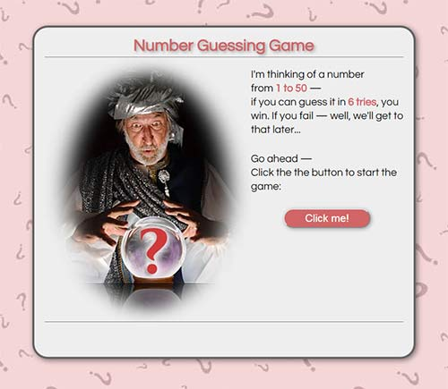
* ~~When the button is clicked, the start screen will be replaced by the~~ **~~game screen~~**~~, which is where all the user interaction will take place. Here is a sample screenshot of what the game screen (already in progress) might look like:~~  
  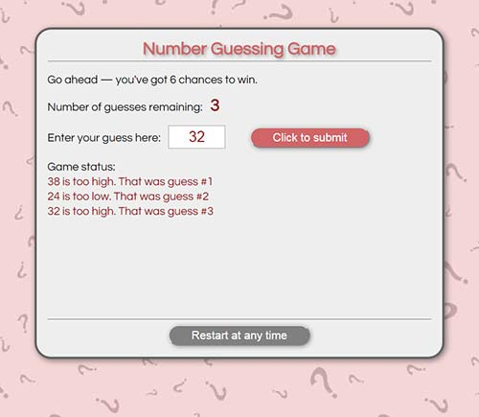  
  ***NOTE:*** *We haven't discussed how to show/hide HTML content yet, but I will reveal all in class. If you plan on starting the project right away, try working on the game screen in the meantime. That is the most important part.*
* The game screen will contain at a minimum:   
  **1)** a counter of some sort that shows how many guesses have been made (or how many are left, your choice)  
  **~~2)~~**~~a textbox for entering the player's guess~~   
  **~~3)~~**~~a button that will evaluate the player's guess when it is clicked~~   
  **~~4)~~**~~some kind of message that tells the user their status after each guess~~ -- the more information the better  
  **~~5)~~** ~~a restart button that will refresh the browser when clicked, effectively restarting the game. This feature is~~ **~~optional~~**~~, but the code to do this is quite simple:~~

~~location.reload(true); // reload browser window to restart the game~~

* ~~The game will evaluate the player's guess and determine if it is less than, equal to, or greater than the computer's number.  If it is equal to the computer's number than the player wins and the game ends. After each guess, the computer should generate an appropriate message, like "Your guess was too high" or "Your guess was too low".~~
* ~~The player will be allowed six guesses. If they exceed six guesses then the computer wins and the game ends. The computer is permitted to gloat.~~
* The game screen should let the player know whether they have won or lost and what the random number was they were trying to guess (to prove the computer wasn't cheating, of course). ***NOTE:*** *Reasonable (understandable and helpful) messages to the user will be part of your project grade.*
* Comment the JavaScript code to describe how it is working. ***NOTE:*** *Adding informative or helpful comments will be part of your project's grade. This lets me know that you understand the code you are creating.* Don't just throw together 2 or 3 comments to meet the requirements; as a rule, I would expect 1 informative comment every 5-8 lines of code.
* ~~You should use CSS so that the game is well formatted. You must also indent your HTML, CSS and JavaScript to make everything readable. Child elements should be indented inside parent elements, CSS declarations should be aligned vertically, the code inside JavaScript blocks should be indented, and so on. Indentation and script organization should also be consistent.~~***~~NOTE:~~*** *~~Reasonable and consistent indentation will be part of your project's grade.~~*
* ~~The program should check to make sure that the user entered a number, rather than text or a blank field. If the user did not enter a number then the computer should reply with something like: "Please Enter a Number". You can decide whether this will cost the player a guess or not.  You should also test if the user entered a value within the proper range, and display an appropriate message if they did not.~~
* ~~Utilize input text fields for all user input and utilize the~~ **~~innerHTML~~** ~~property to write all output to the browser window. Your program should NOT contain any popup window methods (~~*~~alert~~*~~,~~ *~~prompt~~*~~,~~ *~~confirm~~*~~) or document.write methods. You may leave in~~ *~~console.log~~* ~~statements for debugging purposes.~~
* The HTML and the CSS should pass W3C validation. If you are unable to have it pass validation then include the W3C errors with your submission. You do not have to pass JSLint or JSHint, but these sites are ***very***useful for spotting errors in your code.