Decomposition potential and population structure among active microbial communities in deep salt marsh sediments

Joseph H. Vineis^{1,2}, Ashley N. Bulseco^{1,3}, Sa’ad A. A. Rafie¹, Zoe G. Cardon², and Jennifer L. Bowen¹

¹Marine Science Center, Northeastern University, Nahant, Massachusetts, USA
²The Ecosystems Center, Marine Biological Laboratory, Woods Hole, Massachusetts, USA
³Department of Biological Sciences, University of New Hampshire, Durham, New Hampshire, USA

Supplemental Figures

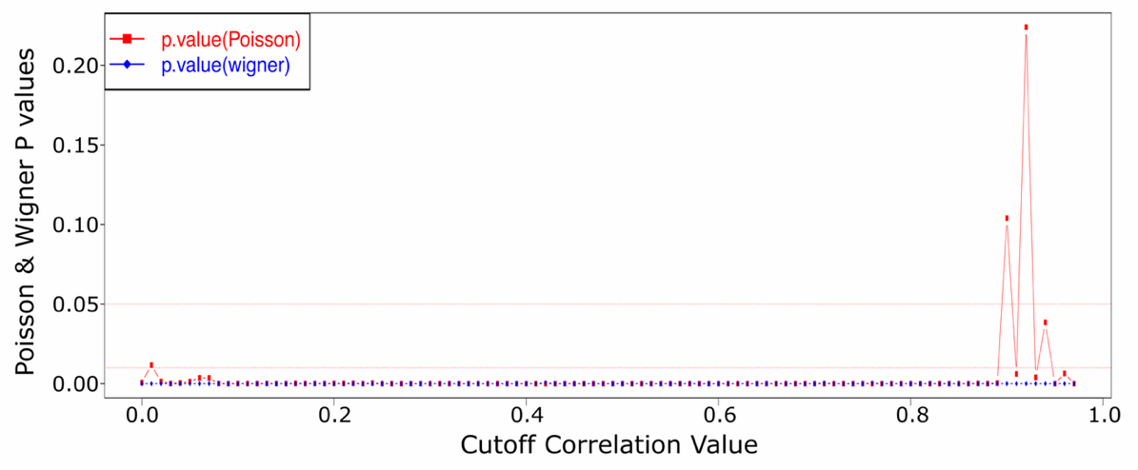
Figure S1. Cutoff plot used to identify a threshold for significant correlations in the RMT network.
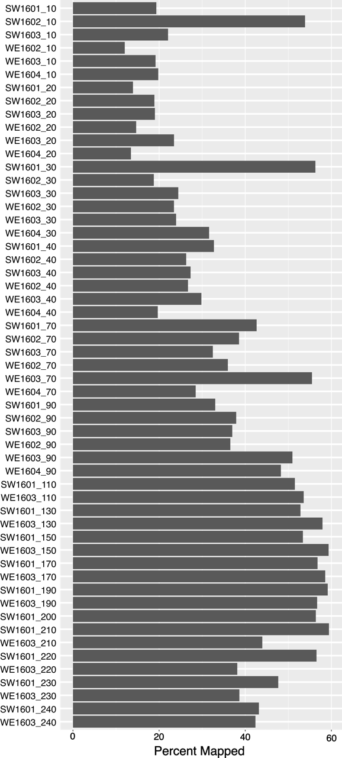
Figure S2. Percent read recruitment to the collection of non-redundant MAGs to the total number of available reads for each of the 55 samples. The sample name on the x-axis contains the sample core name and the depth of the sample separated by an underscore.

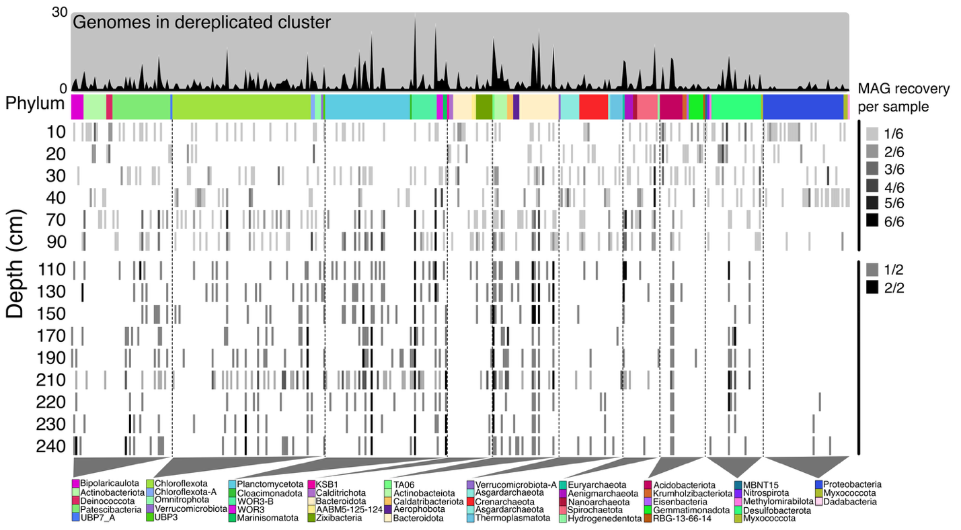
Figure S3.Summary of redundant genome recovery per sample. This line plot at the top of the figure(dark gray and black) shows how many genomes were grouped into the dereplicated genome cluster. The second layer from the top represents the phylum level classification for the representative MAG in the cluster. The heat map layers show the proportion of samples where a MAG in the dereplicated genome cluster was recovered. The key indicating how many of the same MAGs (identified by dRep) were collected per depth is show on the right. The MAGs are organized according to the phylogenetic reconstruction outlined in the methods section. The phylum color key is shown at the bottom of the figure and the gray triangles above the phylum color align with the heatmap.

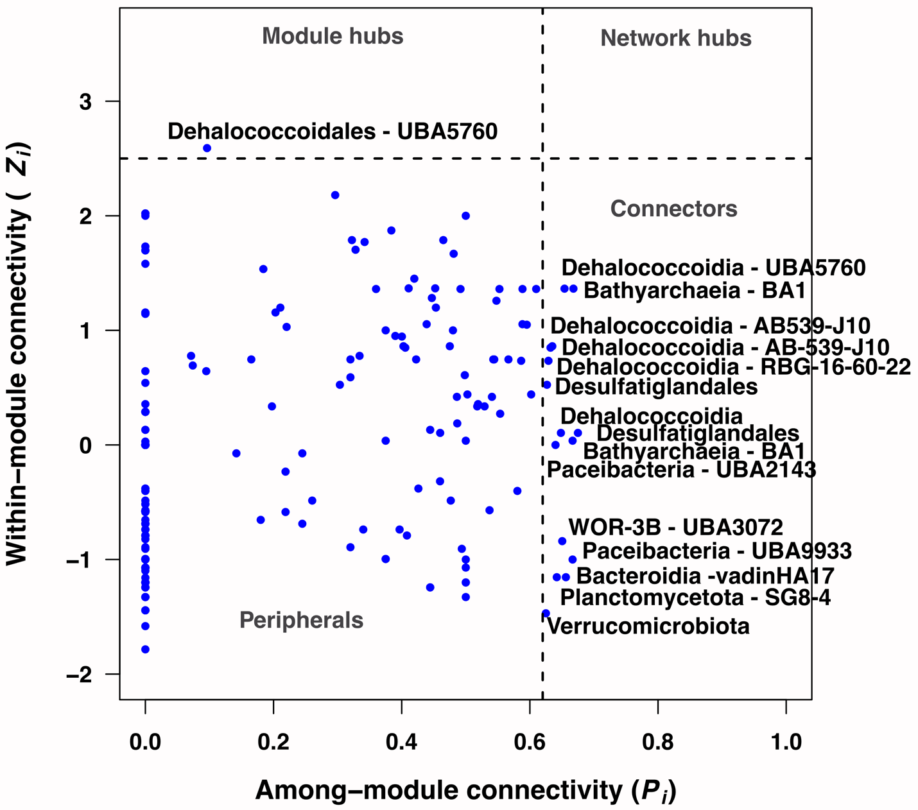
Figure S4. Module ZP plot for the RMT network. The axes are within-module connectivity (Z) and among-module connectivity (P). A network hub (Z > 2.5 and P > 0.62), module hub (Z > 2.5 and P < 0.62), connector (Z < and P > 0.62), or peripheral (Z < 2.5 and P < 0.62) are outlined by dashed lines.

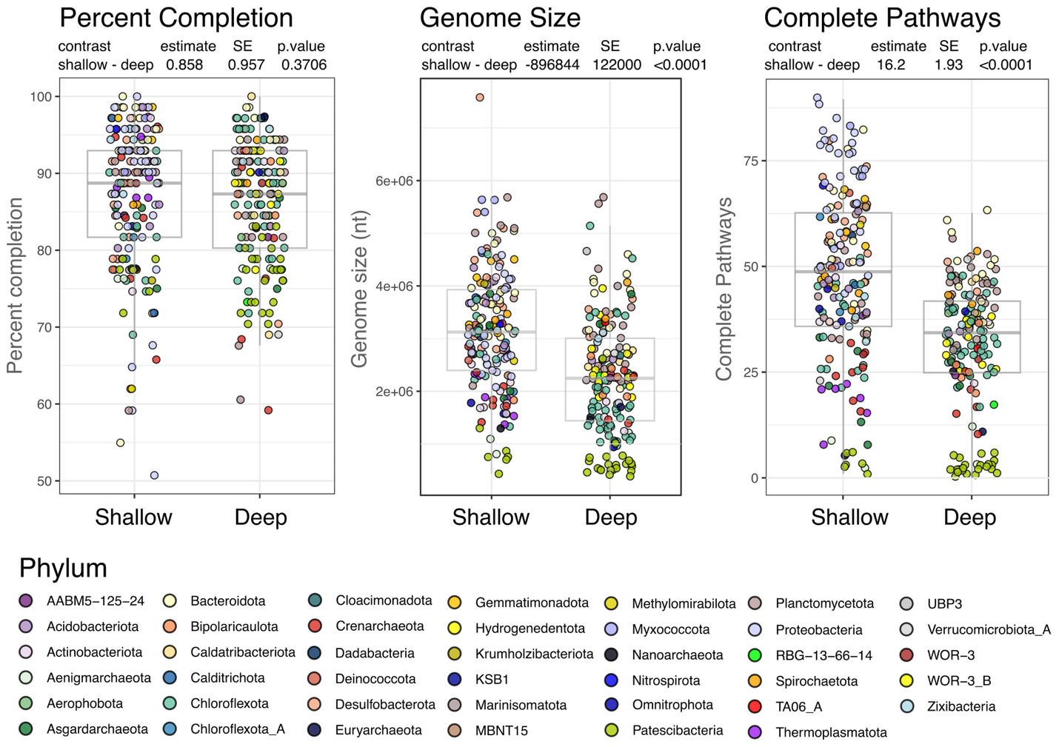
Figure S5. Points and box whisker plots for the percent completion, genome size, and number of complete metabolic pathways. The color of the point in each of the plots shows the phylum level classification and the box whisker plots show the median, 25th, and 75th percentile. Statistics at the top of each plot show the comparison between the MAGs with a generally shallow distribution (unconnected, modules 3 and 6) vs deep (modules 1,2,4,5 and 7). The statistics of the ANOVA and least mean squares analysis are shown at the top of each figure. The results include the estimated difference between groups, the standard error of the estimate and the p-value.
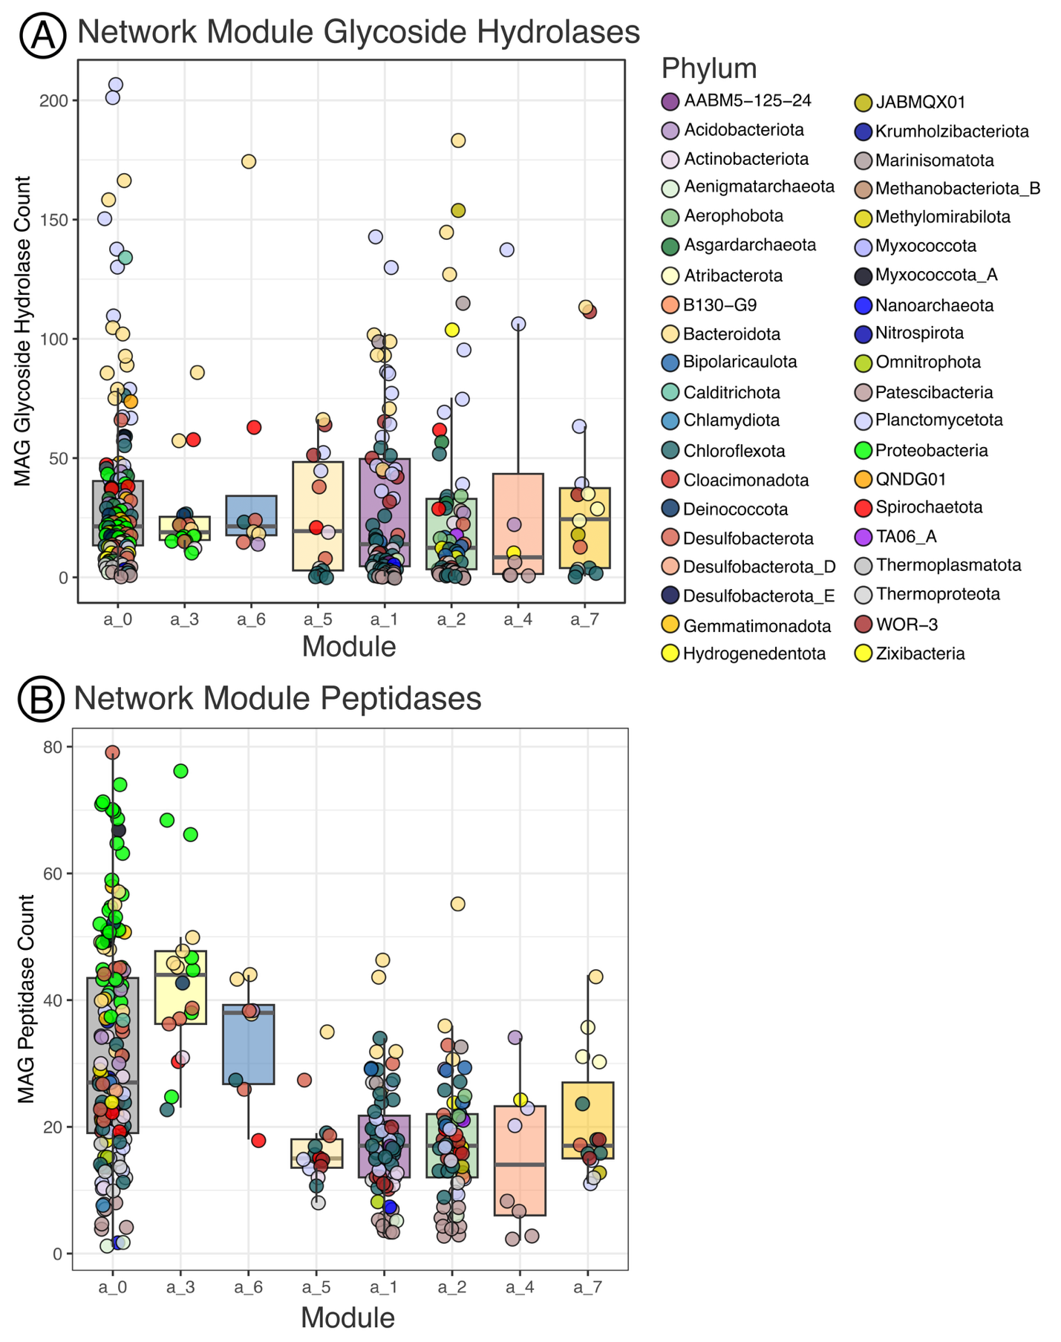
Figure S6. A.) Glycoside hydrolase (GH) (CAZymes) and B.) peptidase (MEROPS) homolog totals in each MAG, grouped according to their network module. The points show the counts for each MAG and are colored according to phylum level classification. The box-whisker plots are shown to provide the median, 25th, and 75th percentiles. The color of the box aligns with the network modules shown on the x-axis for the unconnected MAGs (“a_0”) and other studied modules, ordered from shallow to deep distribution (see Fig. 4 in the main text). The significance of the ANOVA and Least-Square means test for the MEROPS are shown in Table S3.

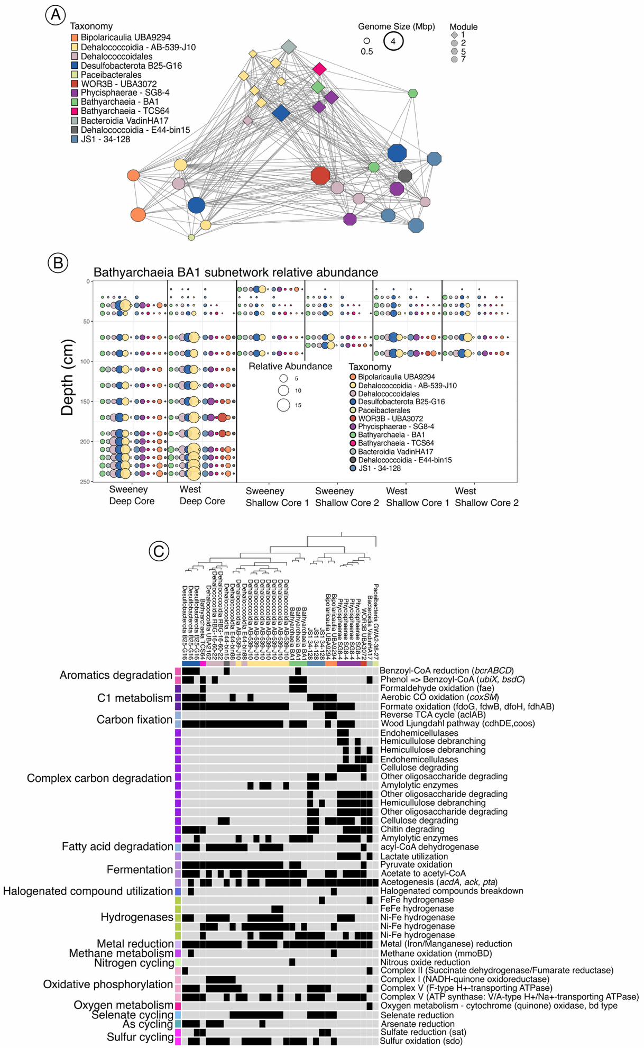
Figure S7. Bathyarchaeia BA1 subnetwork. A.) The connections among MAGs in the subnetwork. All connections in the network are positive. The shape of the node indicates the module from the network including all MAGs (Fig. 4A), different colors are used for order level taxonomy, and the size of the shape is indicative of the MAG size in Mbp. Taxonomic names include family or genus name when possible. B.) A bubble plot for each of the six cores showing the relative abundance of MAGs in the subnetwork with the same colors applied to the taxonomic groups in A. C.) METABOLIC functional annotation for each of the MAGs in the subnetwork. At the top of the panel, is the phylogenetic structure of the subcommunity The presence of a function is marked by a black bar in the panel and grey if the function was absent. A color bar is show for the taxonomy and is consistent with panel A and B.

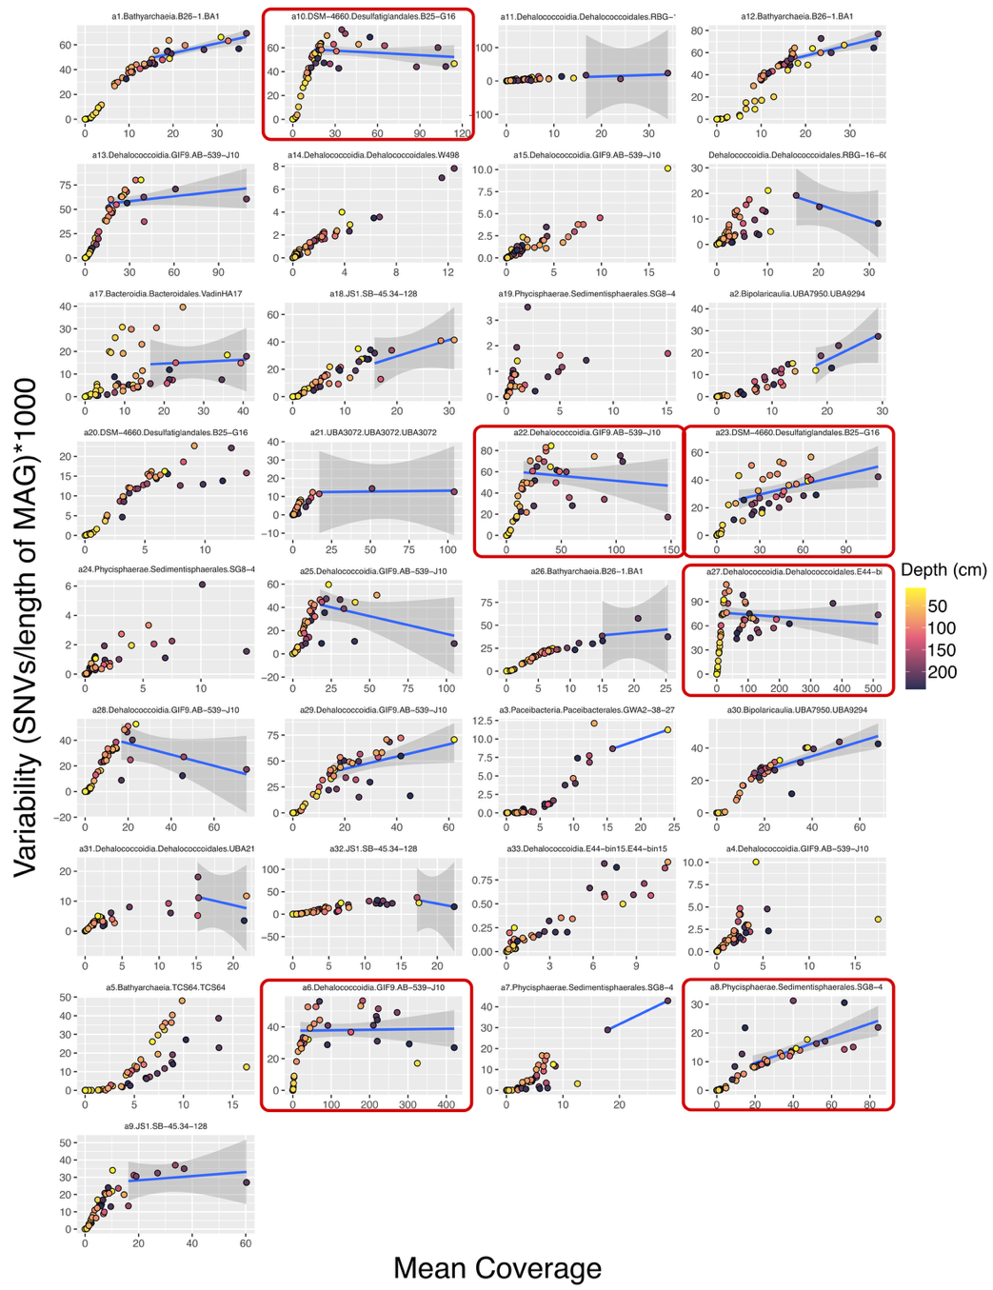
Figure S8. Plots of mean coverage (x-axis) and SNV variability (y-axis) for MAGs in the BA1 Bathyarchaeia subnetwork. The points are colored according to the sample depth. A linear model line is plotted for points that are greater than a mean coverage of 15. A red box is drawn around plots that were evaluated for patterns in the SNV profile and density.

Supplemental Tables are found in the git for this manuscript.

https://github.com/jvineis/DEEP-CORE-MANUSCRIPT/

