GOVERNMENT OF INDIA
MINISTRY OF CONSUMER AFFAIRS, FOOD & PUBLIC DISTRIBUTION
DEPARTMENT OF CONSUMER AFFAIRS — LEGAL METROLOGY DIVISION
OIML R 76-2 PATTERN EVALUATION TEST REPORT
Non-Automatic Weighing Instruments (NAWI) Model Approval Compliance

1. Instrument Specifications & Testing Officer Credentials
Report Ref. No: | TR-2026-2400C2 | Evaluation Date: | 26-09-2026 02:38:06 UTC
Inspecting Officer: | Insp. Vikram Malhotra (GATC-MH-2026-112) | Testing Lab: | Regional Reference Standards Laboratory (RRSL)
Manufacturer: | Eagle Scales Pvt Ltd | Environment: | 22.5°C | 50% RH
Instrument Model: | DS-215 | Serial Number: | SN-2026-98124
Accuracy Class: | Class III | Interval (e): | 5.0 g (n = 6000)
Max Capacity (Max): | 30.0 kg | Min Capacity (Min): | 100.0 g

2. Photographic Ground-Truth Binding (Exhibits A & B)
[STRICT-LIABILITY OVERRIDE LOGGED]: Officer manually modified field(s): Critical Max Indication (Discrepancy with Photo: Display shows 30.018kg, officer entered 30.005kg). Raw unedited photographic evidence is permanently bound into this electronic record under Section 63 BSA 2023.
Exhibit A (Machine Nameplate):

Exhibit B (Digital Scale Display at Max Load 30.0 kg):
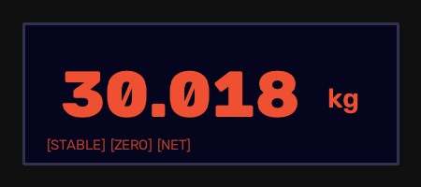

3. Weighing Performance Test Observations (Clause A.4.4)
Load m (kg) | Indication I (kg) | Load in e | Error E (g) | MPE (±g) | Verdict
0.100 | 0.100 | 20 e | +0.00 | ±2.50 | PASS
30.000 | 30.005 | 6000 e | +5.00 | ±7.50 | PASS

4. Pattern Evaluation Decision
OVERALL METROLOGICAL RESULT: PASS

5. Certificate under Section 63 Bharatiya Sakshya Adhiniyam (BSA), 2023
I, Insp. Vikram Malhotra (Badge: GATC-MH-2026-112), Inspecting Officer, solemnly certify under Section 63 BSA 2023 that the electronic observations and cryptographic digest in this document were generated automatically without human falsification. The physical photographic evidence serves as an unalterable ground-truth witness.
Cryptographic SHA-256 Digest: fd51dc98a19450124fb73b7b6d438afe9ae360b8edb3e0589ae4da4dca1921ea

