**2. Configuration of OpenCV and minGW on windows**

Opencv no longer supports MinGW compiler. So we have to configure it through CMake.

Step 1: Download and install minGW compiler from <https://sourceforge.net/projects/mingw/files/>

Step 2: Add a path variable to “MinGW bin folder” (System properties>>advanced>>Environment Variables>>System variable>>path)

Step 3: Download and install OpenCV from <https://opencv.org/releases.html>

Step 4: Download and install CMake from <https://cmake.org/download/>

Step 5: Open cmake and browse and select “Opencv/sources” for sources and the destination folder.

Select mingw compiler and press configure. After configuration, select generate button

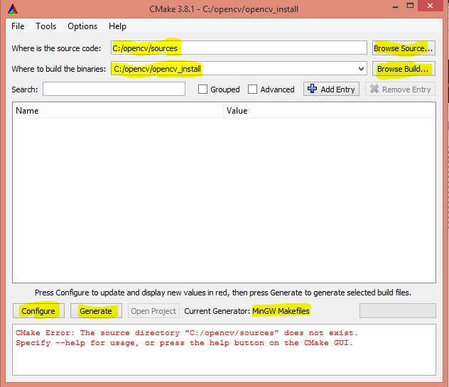

Step 6: Open command prompt and open “opencv_install” folder

Step 7: Type command ‘mingw32-make’. It will configure mingw32 required files.

Header files will be stored in ‘opencv/build/include’ folder

Library files will be stored in ‘opencv_install/lib’

Application extension (dll) files will be stored in ‘opencv_install/bin’

**3. Compilation using command prompt**

Go to project folder using cd (cd c:\project)

Type command:

g++ test.cpp -I"C:\j\opencv\build\include" -L"C:\j\j\lib" -lopencv_core2412 -lopencv_imgproc2412 -lopencv_highgui2412 -o test

test.cpp : project code c++ file

test :output file name

-I”….” : “…” stands for opencv include directory for header path

-L”….” : “…” stands for opencv library folder path

-l :required linking for library files

2412 : opencv version 2.4.12