DEPLOY

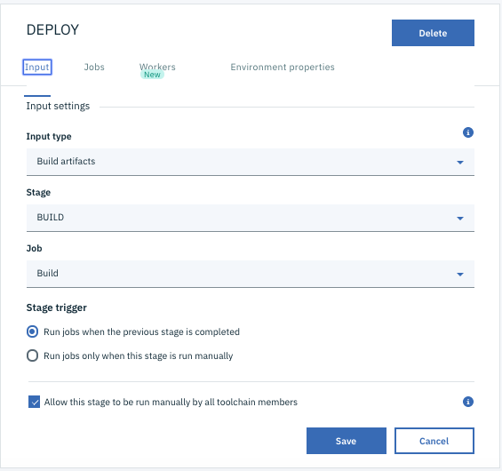

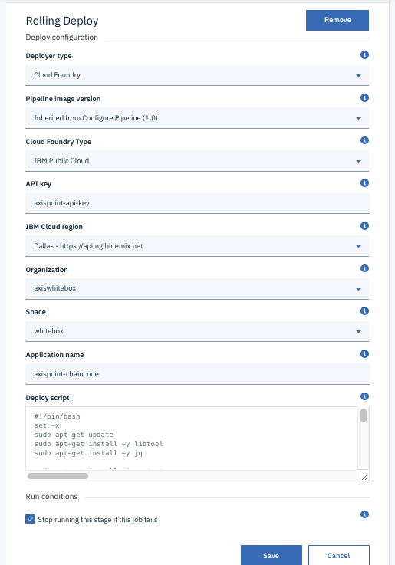

Environment Variables:

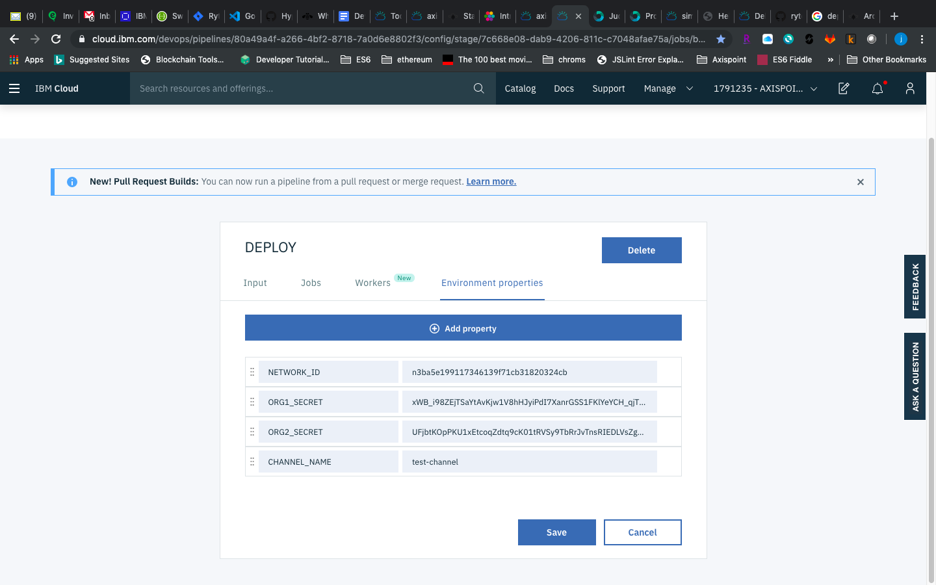

#!/bin/bash

set -x

sudo apt-get update

sudo apt-get install -y libtool

sudo apt-get install -y jq

sudo apt-get install zip gzip tar

CC_VERSION=$(date +%Y%m%d)-${BUILD_NUMBER}

echo $CC_VERSION

PROJECT="axispoint-cc"

URL="https://blockchain-starter.ng.bluemix.net"

CHAINCODE_ARGS=$CC_VERSION

pwd

ls -la

ls -la src/

cd src

ls -la $PROJECT/

rm -rf $PROJECT/$PROJECT

ls -la $PROJECT/

MYZIP="zip -r $PROJECT.zip $PROJECT"

$MYZIP

ls -la

curl -w '%{http_code}' -X POST -H 'accept: application/json' -u "org1:$ORG1_SECRET" -H 'Content-Type: multipart/form-data' -F "files=@$PROJECT.zip;type=application/zip" -F "chaincode_id=$PROJECT" -F "chaincode_version=$CC_VERSION" -F 'chaincode_type=golang' "$URL/api/v1/networks/$NETWORK_ID/chaincode/install"

echo ""

echo "Install succeeded, look at the result above"

echo ""

curl -w '%{http_code}' -X POST -H 'accept: application/json' -u "org2:$ORG2_SECRET" -H 'Content-Type: multipart/form-data' -F "files=@$PROJECT.zip;type=application/zip" -F "chaincode_id=$PROJECT" -F "chaincode_version=$CC_VERSION" -F 'chaincode_type=golang' "$URL/api/v1/networks/$NETWORK_ID/chaincode/install"

echo ""

echo "Install succeeded, look at the result above"

echo ""

BODY="{ \"chaincode_id\": \"$PROJECT\", \"chaincode_version\": \"$CC_VERSION\", \"chaincode_type\": \"golang\", \"chaincode_arguments\": [ \"$CC_VERSION\" ], \"endorsement_policy\": { \"identities\": [ { \"role\": { \"name\": \"member\", \"mspId\": \"org1\" } }, { \"role\": { \"name\": \"member\", \"mspId\": \"org2\" } } ], \"policy\": { \"1-of\": [ { \"signed-by\": 0 }, { \"signed-by\": 1 } ] } }}"

BODY_FILE=body.json

echo "$BODY" >"$BODY_FILE"

cat $BODY_FILE

curl -w '%{http_code}' -X POST -H 'accept: application/json' -u "org1:$ORG1_SECRET" -H 'Content-Type: application/json' -d '@body.json' "$URL/api/v1/networks/$NETWORK_ID/channels/$CHANNEL_NAME/chaincode/instantiate"

echo ""

echo "Instatiate succeeded, look at the result above"

echo ""

<https://cloud.ibm.com/devops/pipelines/4567764b-5603-4241-941e-663acf70cfed?env_id=ibm:yp:us-south>