TEST

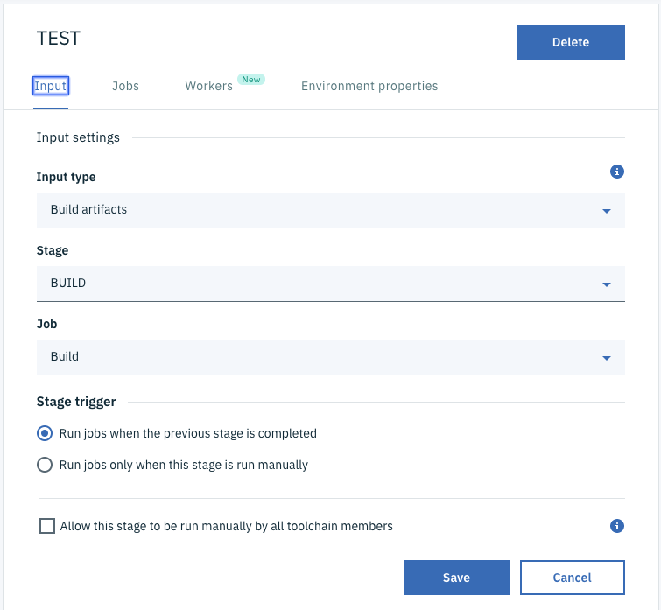

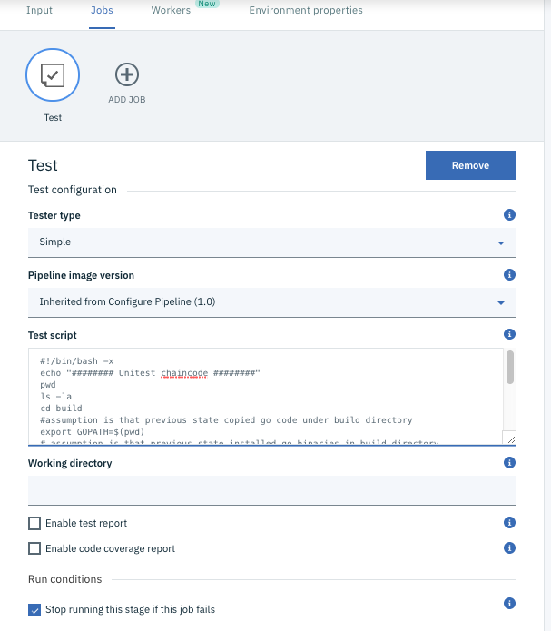

#!/bin/bash -x

echo "######## Unitest chaincode ########"

pwd

ls -la

cd build

#assumption is that previous state copied go code under build directory

export GOPATH=$(pwd)

# assumption is that previous state installed go binaries in build directory

export GOROOT=$(pwd)/go

export PATH=${GOROOT}/bin:$PATH

# assumption is that previous state placed fabric src in the build directory

echo "######## Testing chaincode ########"

go test -v axispoint-cc

pwd