**Skeleton Program-Live Data Feed**

The skeleton of the program will essentially record and store live data. We can later use this to identify patterns and constantly update strategies.

So first we pull technical data from trading view for each of the major currency pairs and constantly update a google docs/excel sheet with this data. This basic data consists of bid/ask prices next to the currencies with time stamps. This will be our live data feed so that we can test future strategies. We will do this for day intervals at first to make it simple. This means that everything on trading view is based on the previous 24 hours of data.

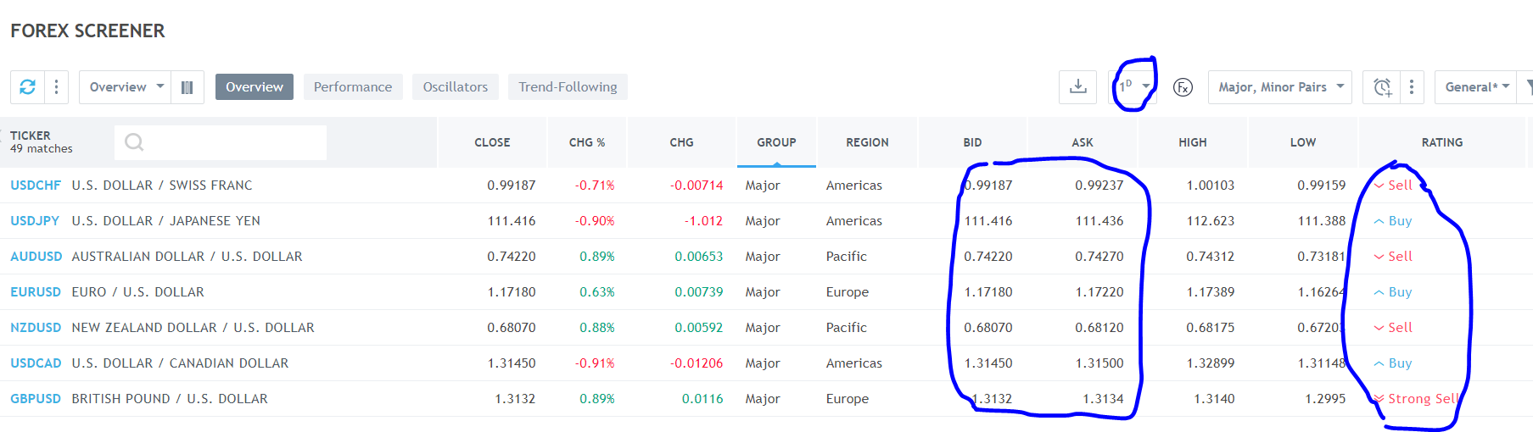

Example of formatting we could use to record data pulled.

