**Appendix X - DATABASE STORAGE**

After completing our ER and schema designs for the important information we needed to store. From there, we created our database and began filling it with sample data for our site. Our goal was to fill out enough information to make the site feel like it was already up and running with real users. Below lists all the data stored in each table of our database, in alphabetical order. Note that some fields will be missing, do to difficulty of fitting all of the information on the page.

**Table 1: Address Table**

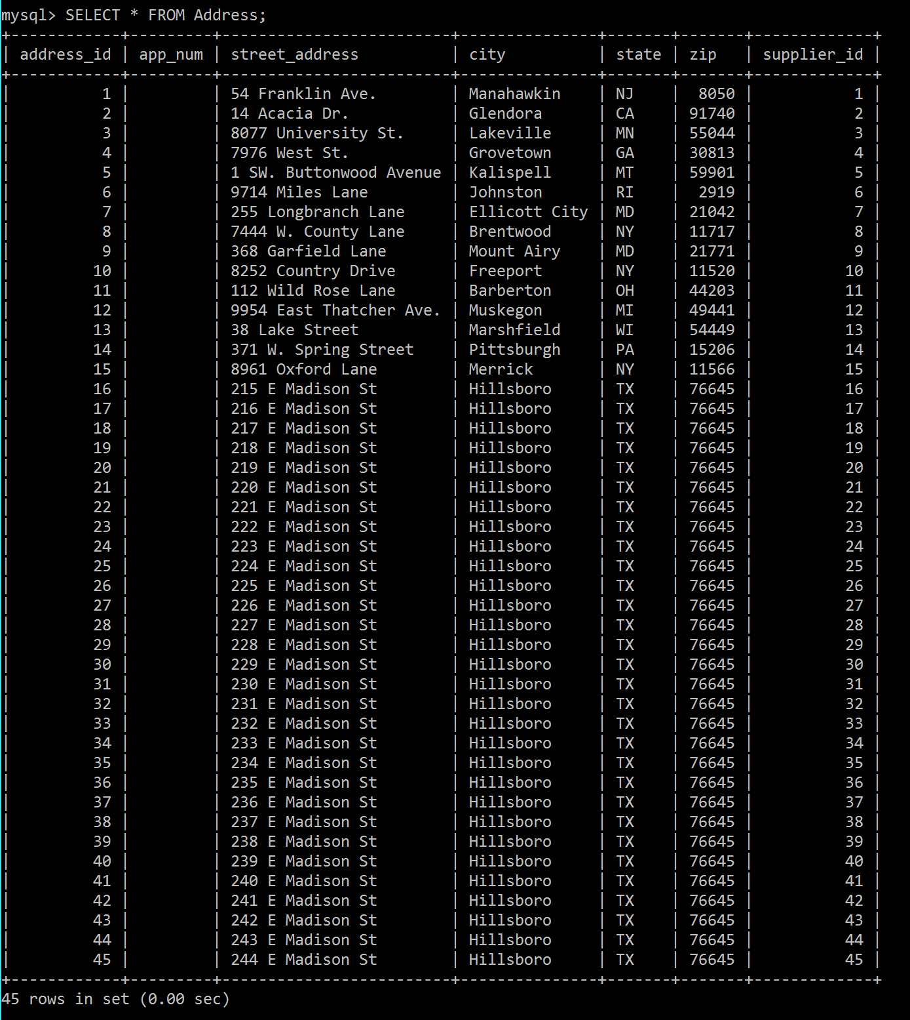

**Table 2: Auction Table**

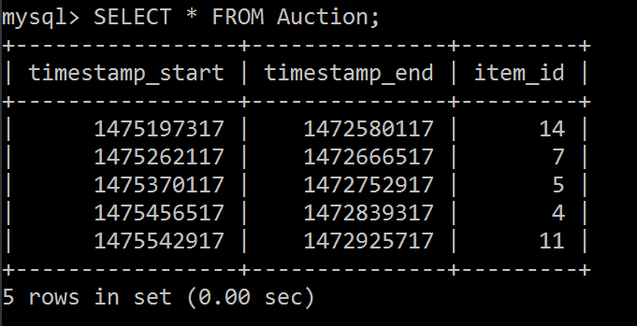

**Table 3: Bid Table**

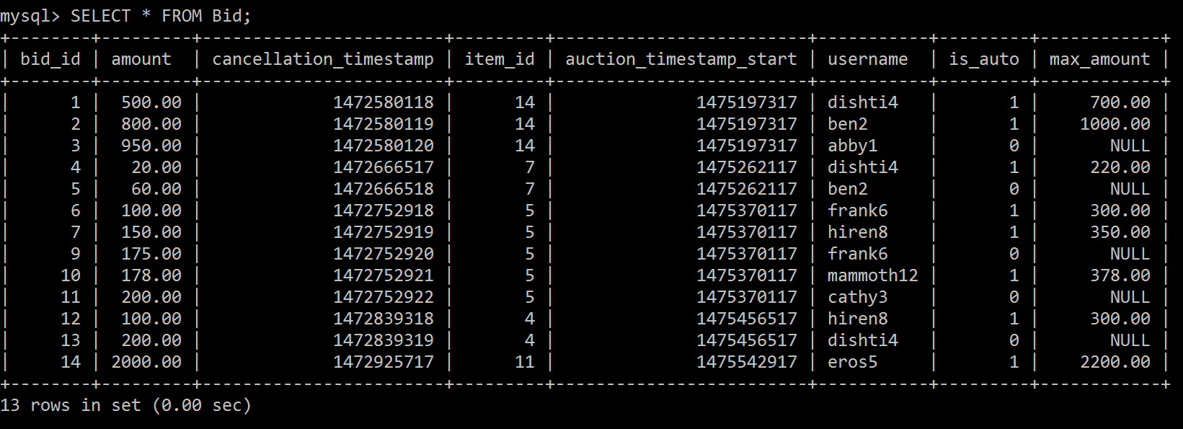

**Table 4: Category Table**

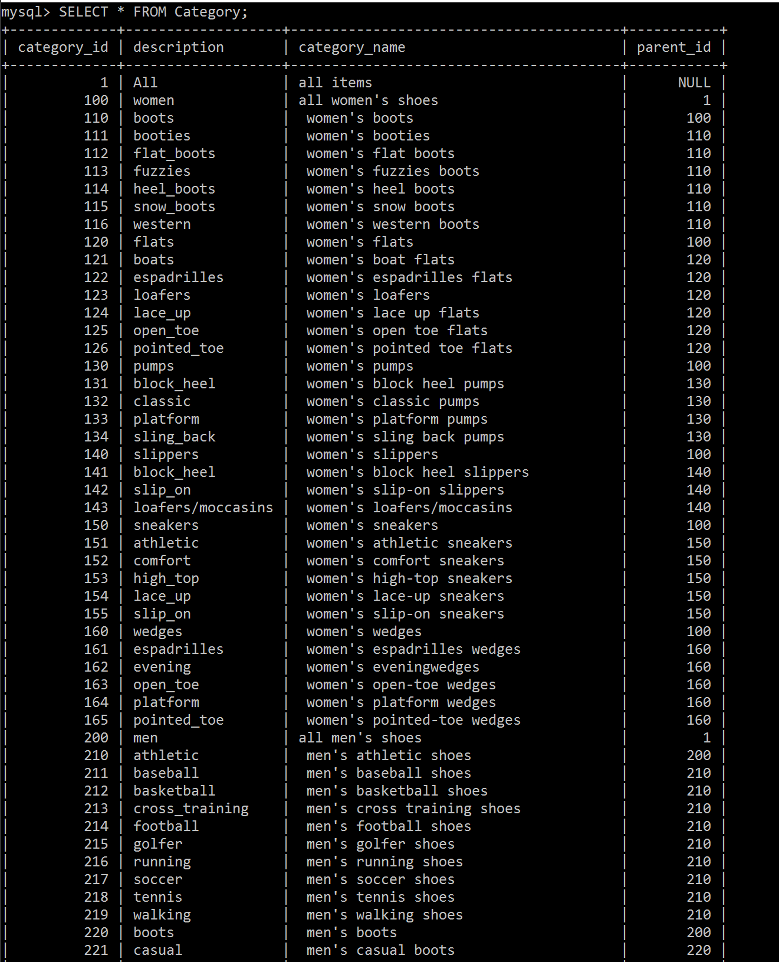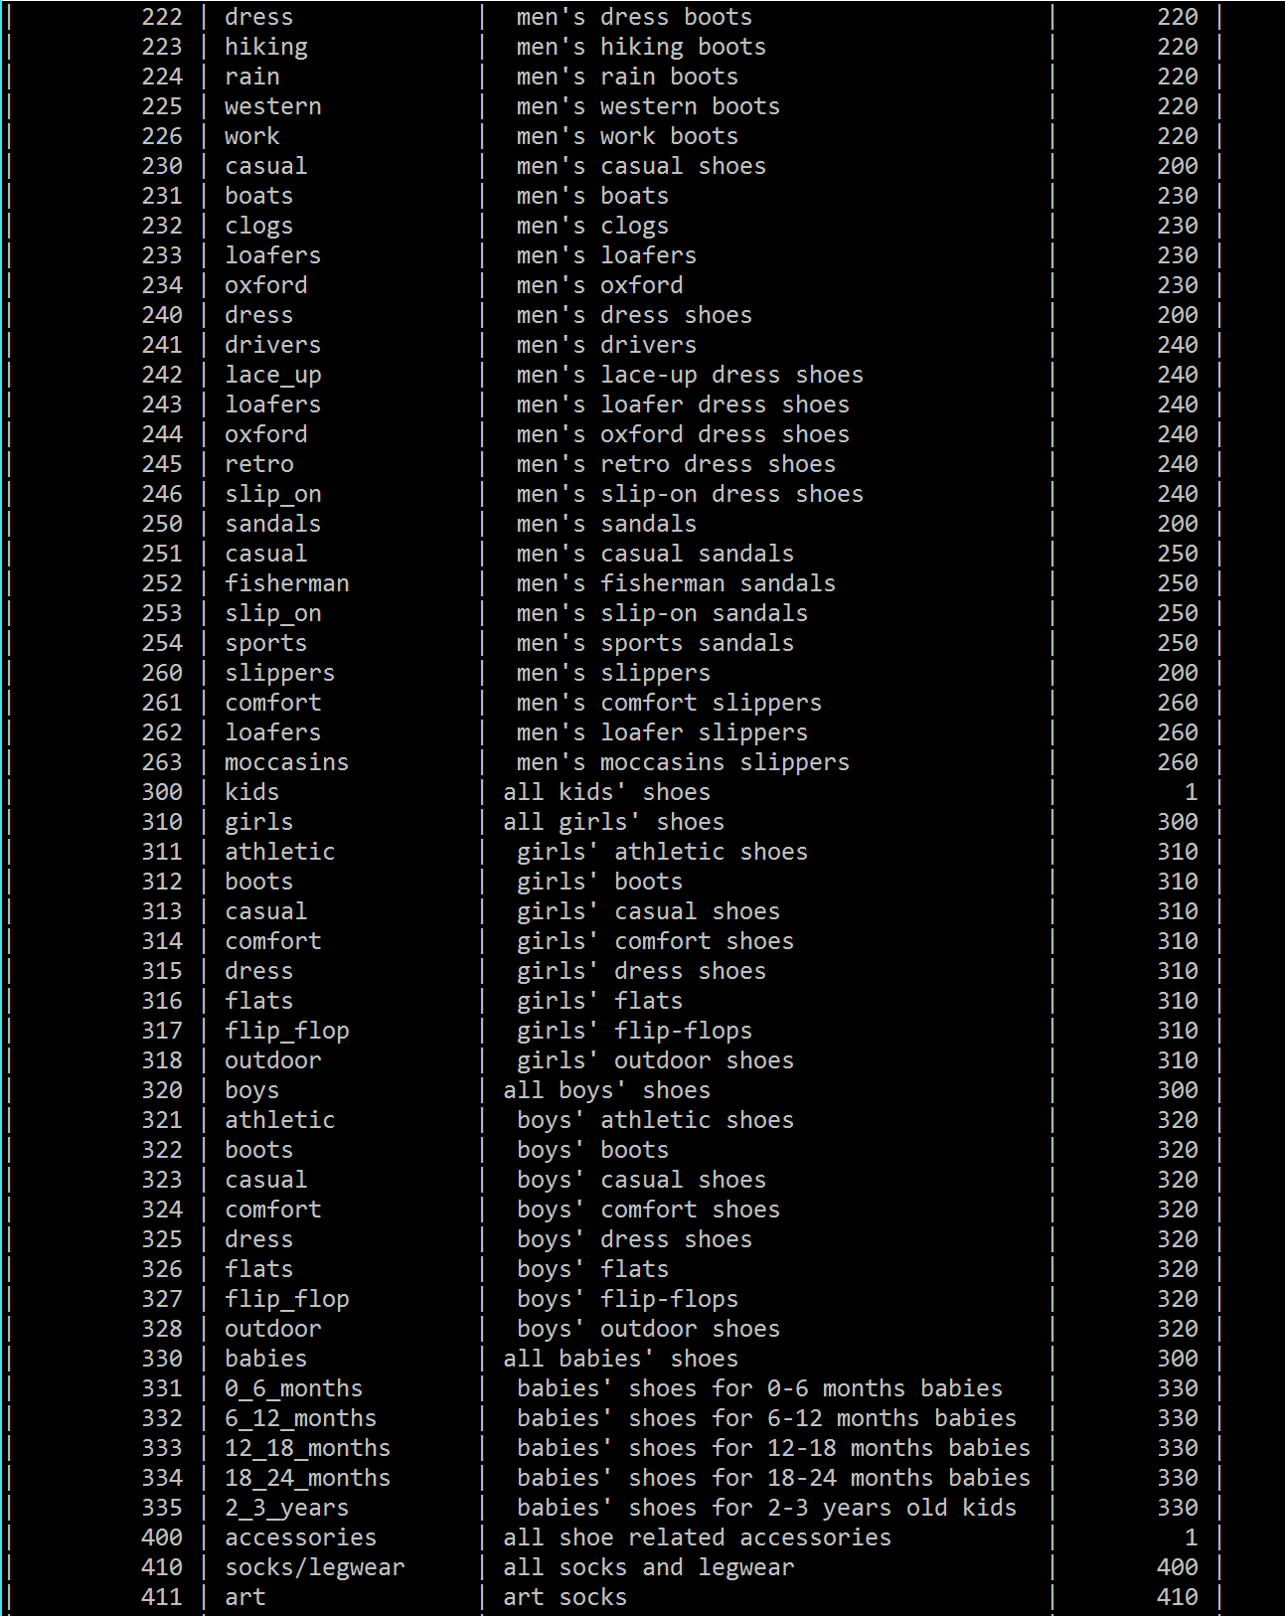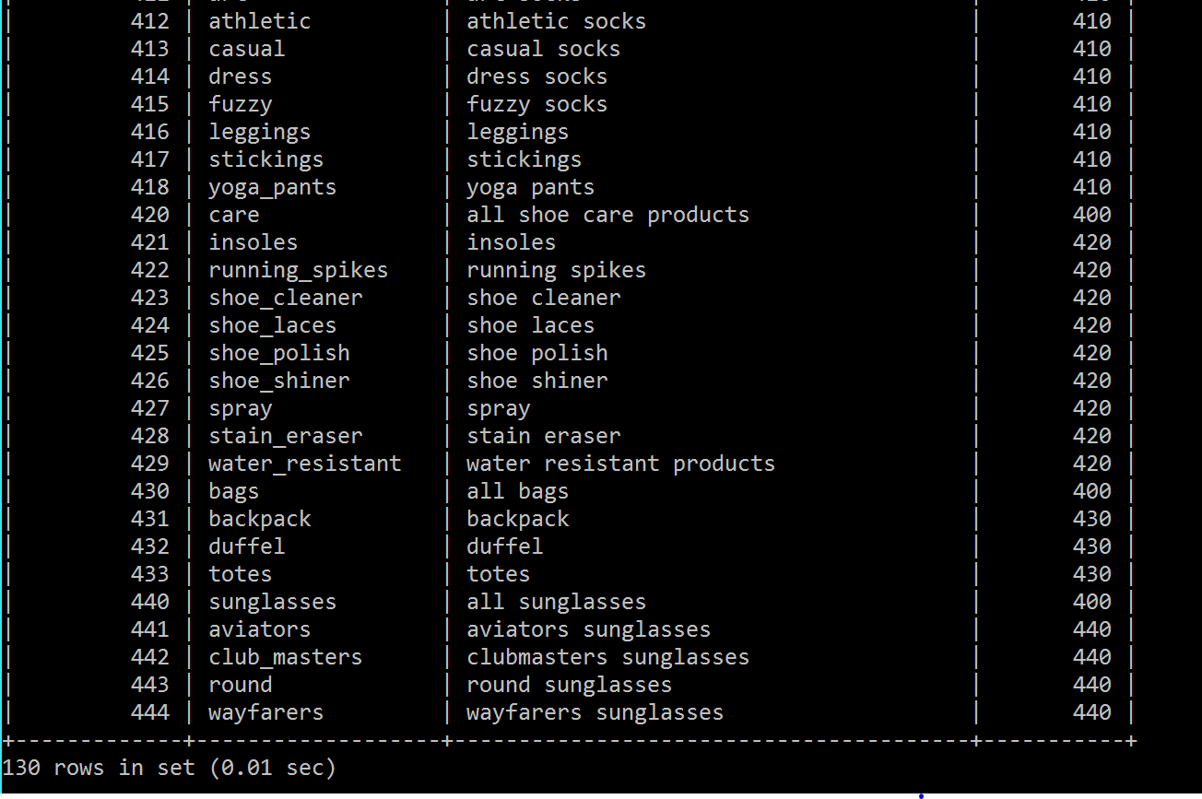

**Table 5: Company_Data Table**

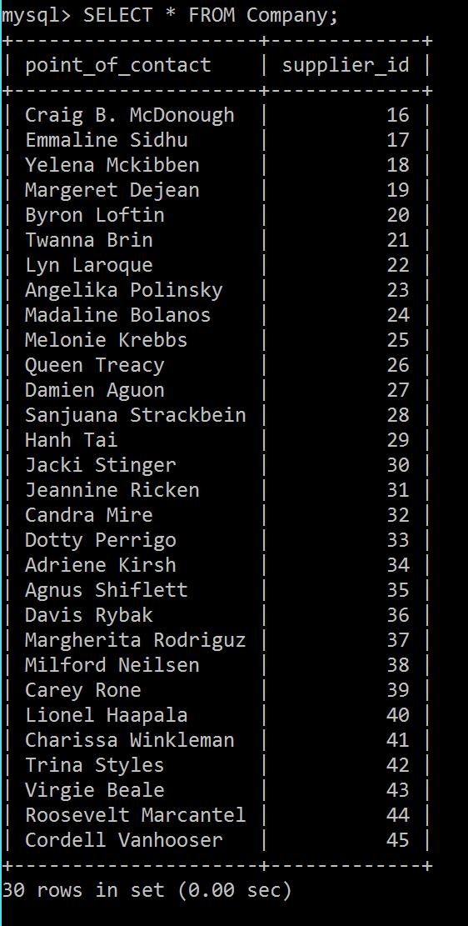

**Table 6: Contact_By Table**

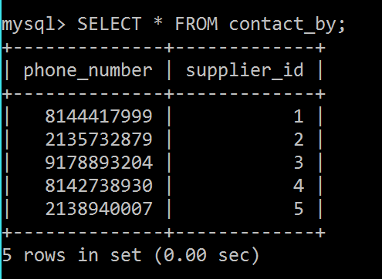

**Table 7: Credit_Card Table**

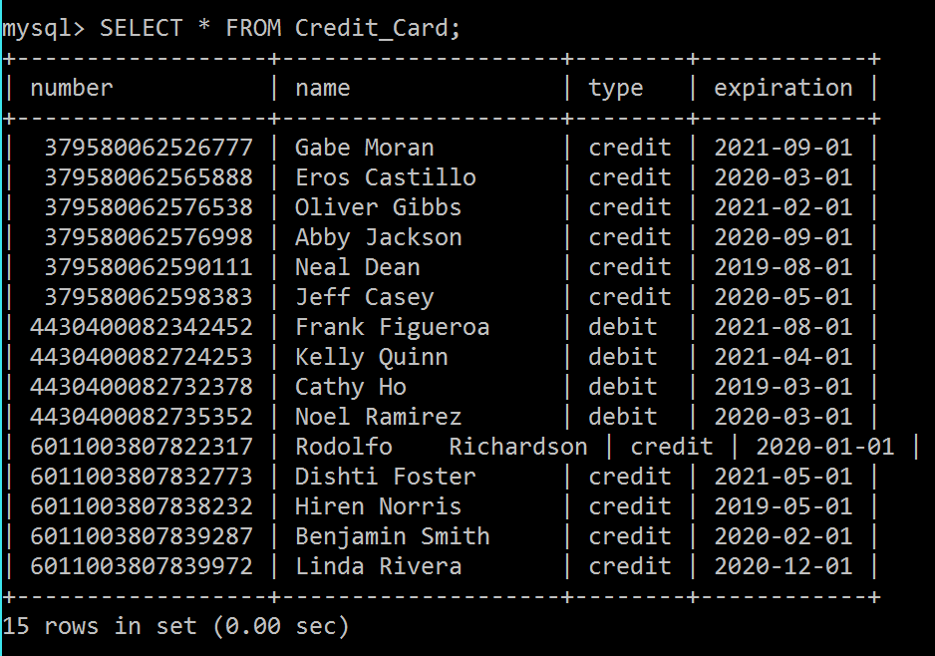

**Table 8: Custom_Shoe Table**

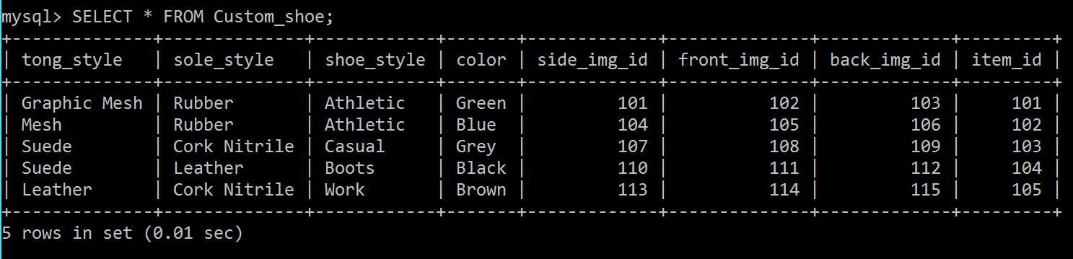

**Table 9: Customer_Service Table**

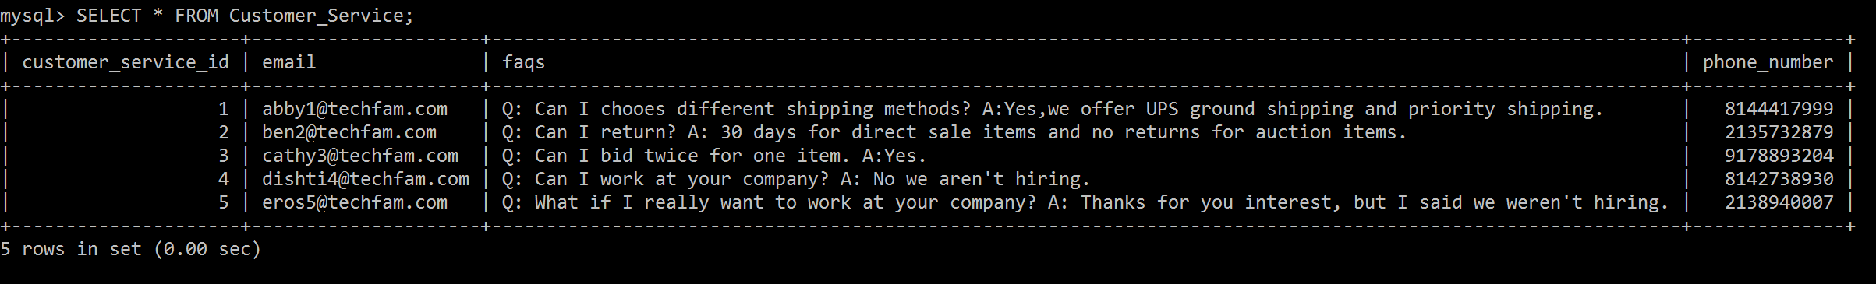

**Table 10: Footwear Table**

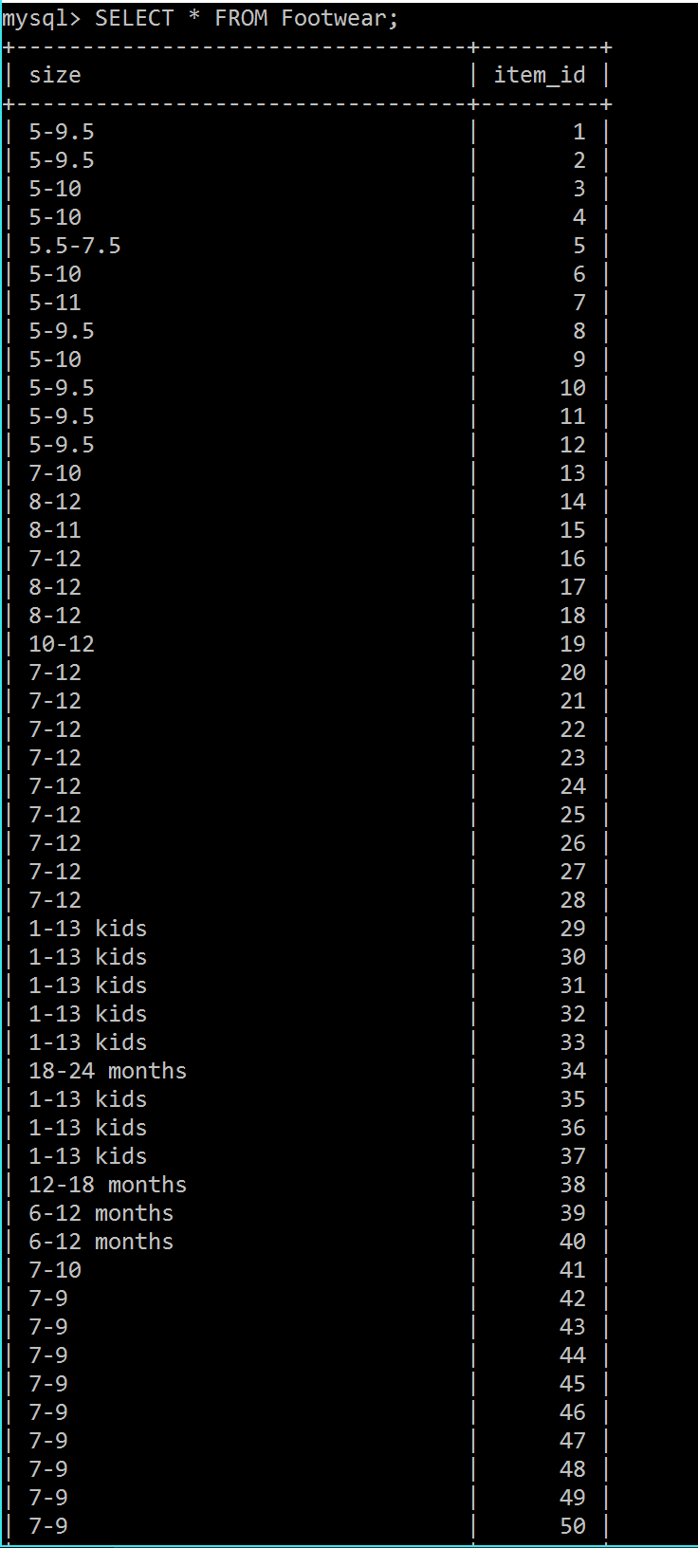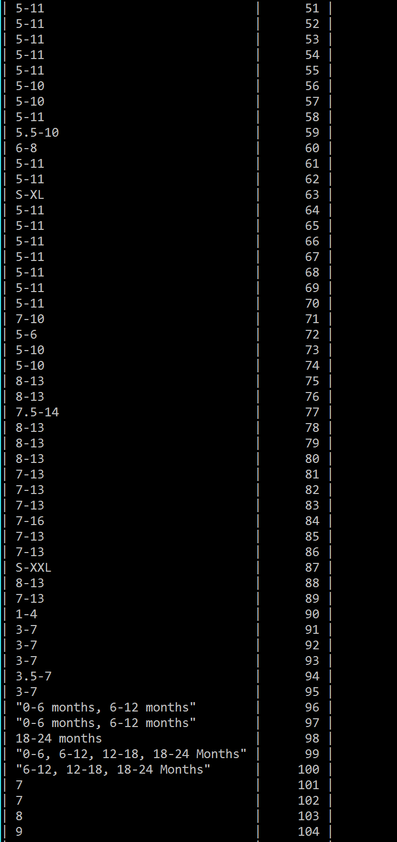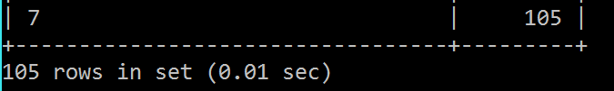

**Table 11: Has_Visual Table**

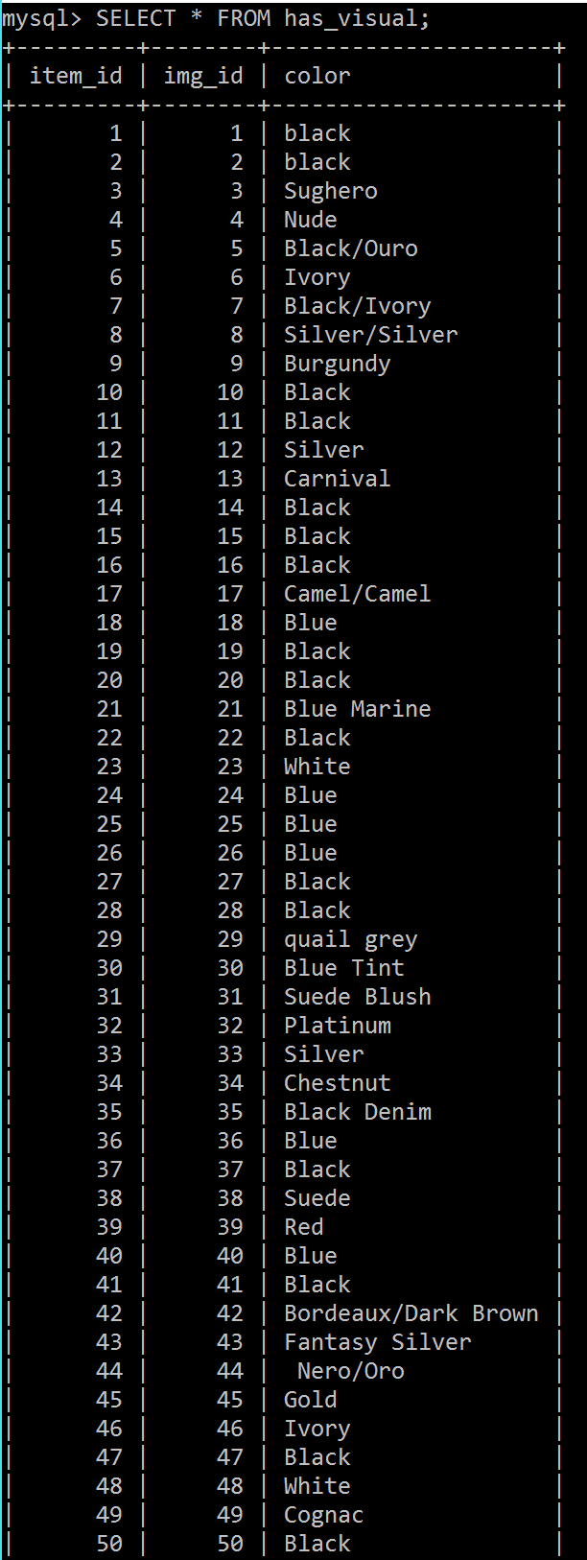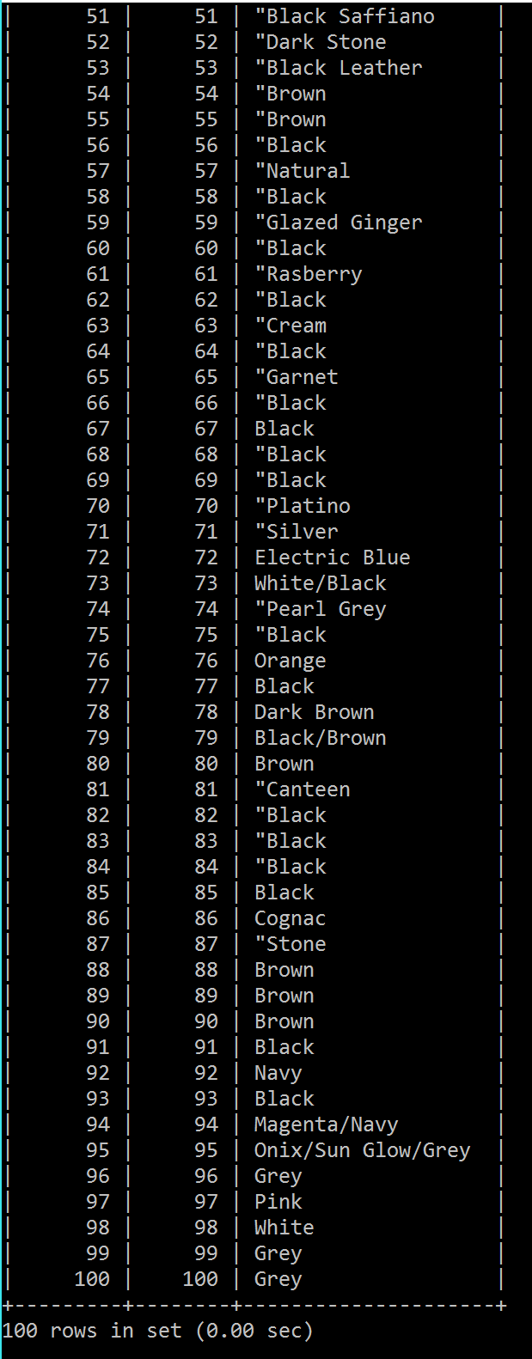

**Table 12: Image Table**

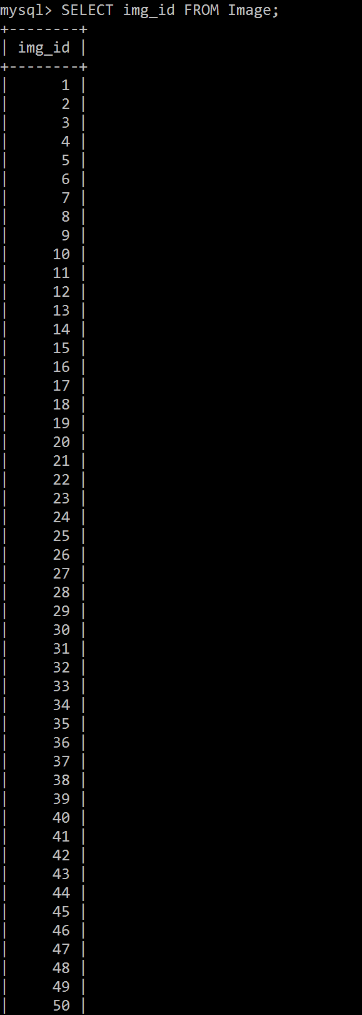

**Note that this table also has a column of images, but this could not be printed out due to the size of the data. Also note that the real table goes all the way up to Image_ID 115.**

**Table 13: Pays_With Table**

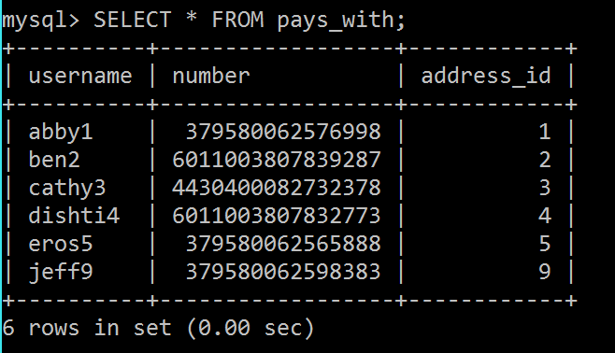

**Table 14: Phone Table**

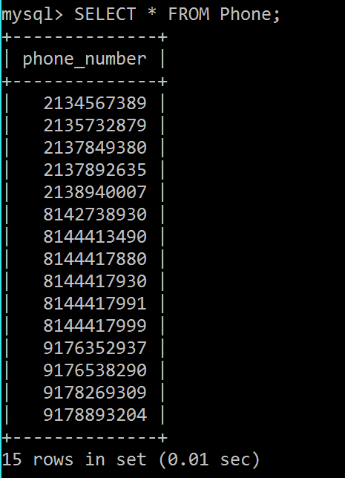

**Table 15: Rating Table**

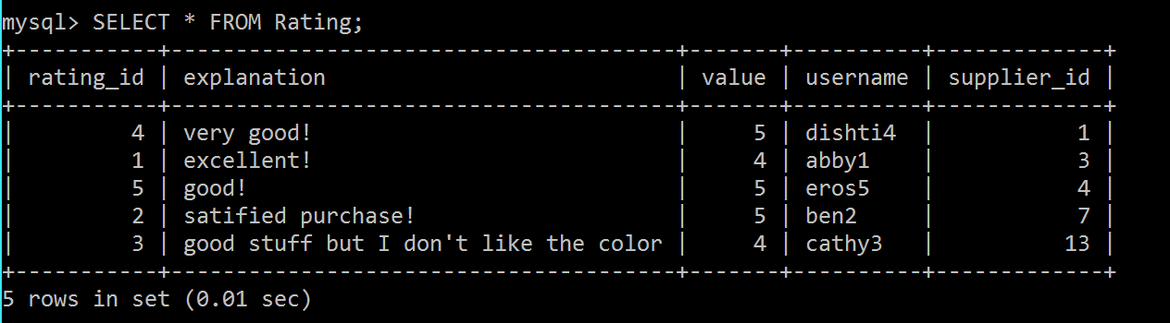

**Table 16: Register_Users Table**

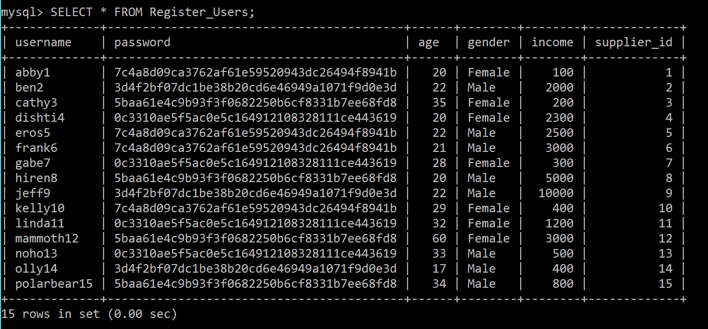

**Table 17: Sale Table**

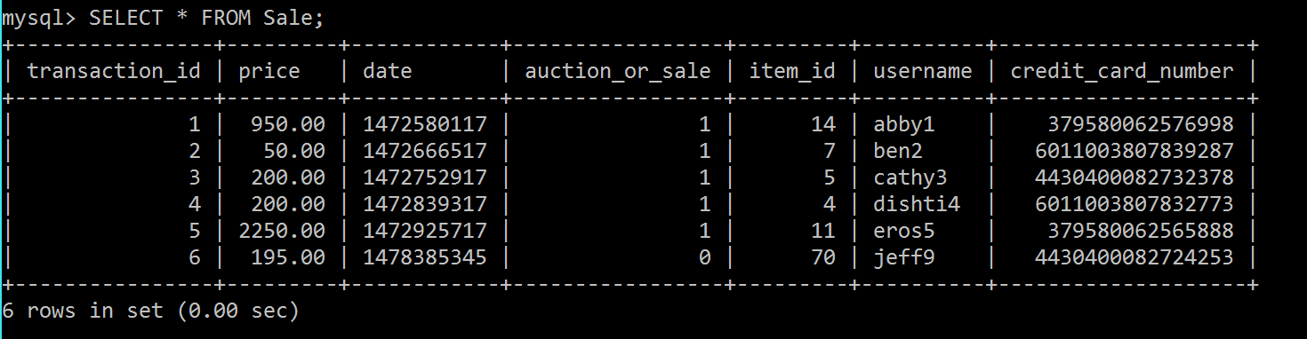

**Table 18: Sales_Item Table**

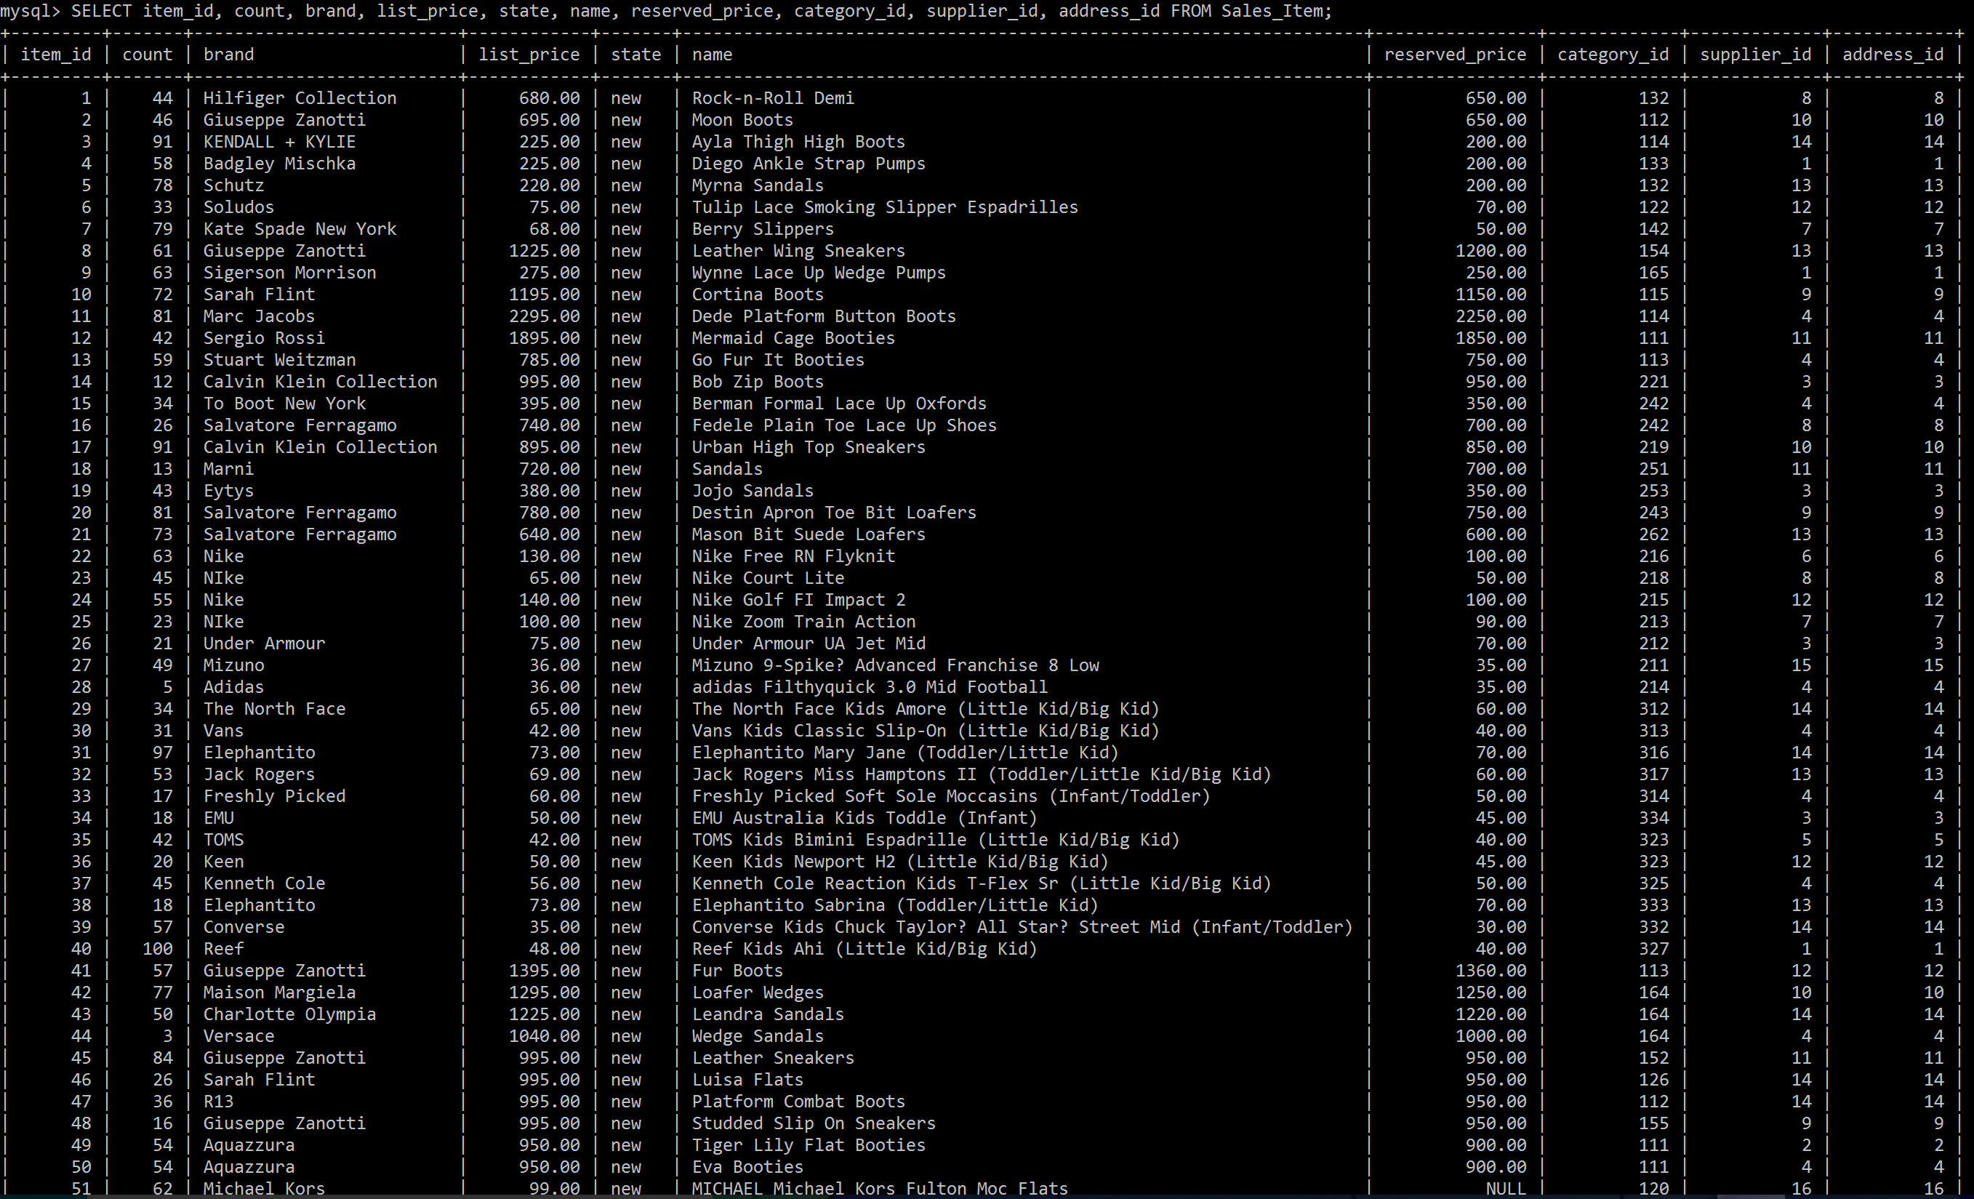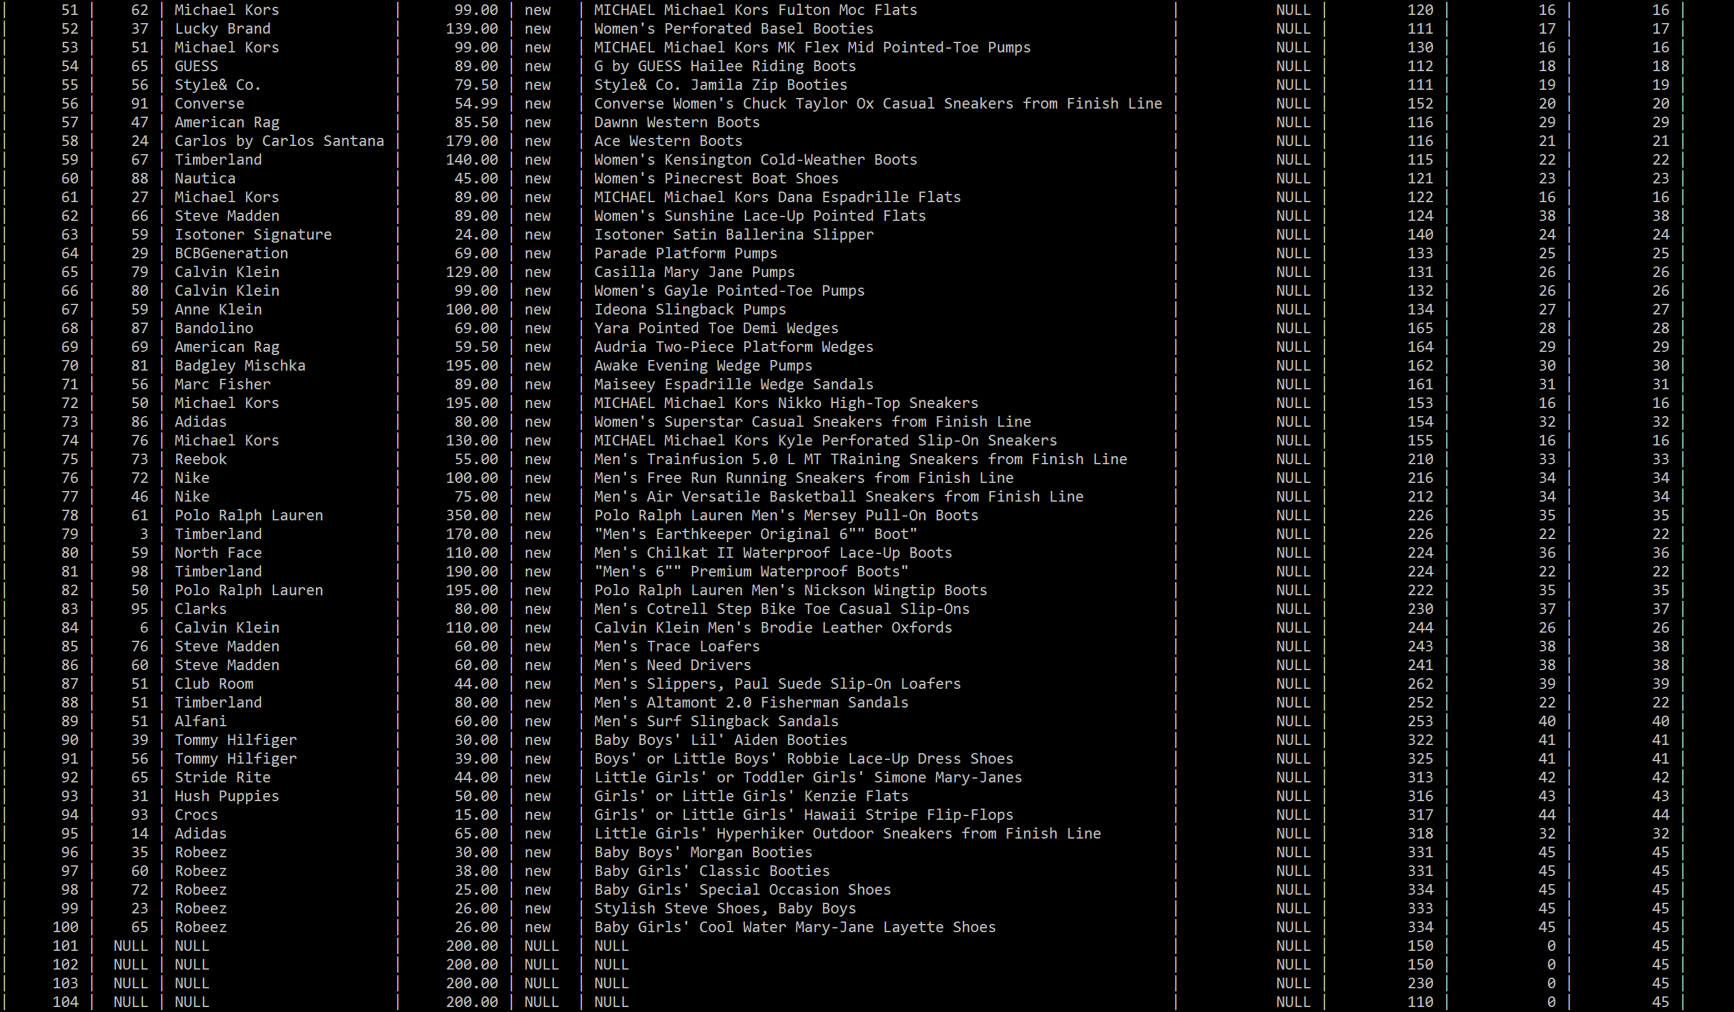

**Note that this table also has a description column, but due to the size of the data, it could not be fit**

**Table 19: Suppliers Table**

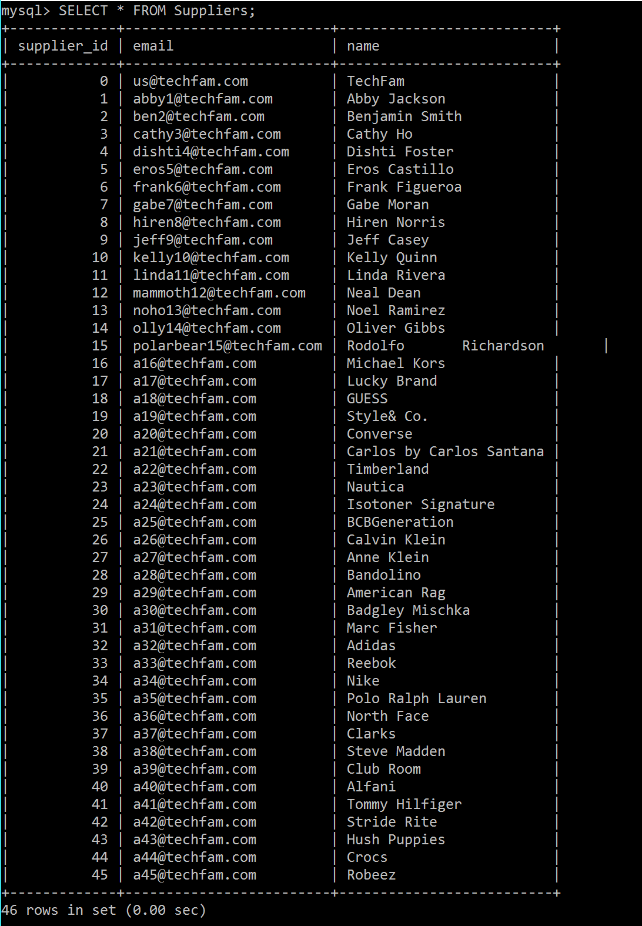

**Table 20: UPS Table**

