TECHFAM
CMPSC 431W

Phase Two: Shoe Retailers’ Database

Ben Myers
Chao Guo
Hiren Patel
Guojing Wang
Jeff Li
Dishti Gurnani
Table of Contents
Table of Contents 2
1. INTRODUCTION 5
2.ANALYSIS AND CONCEPTUAL DESIGN 6
2.1.Sales Item 6
2.2.Categories 9
2.3.Suppliers 11
2.4.Company 12
2.5.Registered Users 13
2.6.Rating 16
2.7.Browsing 17
2.8.Searching 18
2.9.Sale 19
2.10.Bidding 21
2.11.Order and Sale Reports 23
2.12.Delivery 25
2.13.Custom Shoes 26
2.14.Customer Service 28
3.TECHNOLOGY SURVEY 29
3.1.MySQL 29
3.2.Frontend 30
3.3.Backend 30
3.4.Other Technologies 31
4.CONCLUSION 32
5.APPENDIX A – GITHUB GRAPHS 33
6.APPENDIX B – ASANA SUMMARY 34
7.APPENDIX C – CATEGORY TREE 35
35
8.APPENDIX D – SCHEMAS IN THIRD NORMAL FORM 36
9.APPENDIX E: MASTER ER DIAGRAM 39
10.APPENDIX F – DATABASE STORAGE 41
11.WORKS CITED 55
Table of Figures
Figure 1 – Sales_Item, Footwear, Address, and Image ER Diagram 6
Figure 2 – Sales_Item SQL Table 7
Figure 3 – Footwear SQL Table 8
Figure 4 – Address SQL Table 9
Figure 5 – Image SQL Table 9
Figure 6 – has_visual SQL Table 9
Figure 7 – Category ER Diagram 10
Figure 8 – Category SQL Table 11
Figure 9 – Suppliers, Company, Phone ER Diagram 12
Figure 10 – Suppliers SQL Table 12
Figure 11 – Phone SQL Table 12
Figure 12 – contact_by SQL Table 12
Figure 13 – Company SQL Table 13
Figure 14 – Registered_Users, Suppliers, Company, Credit_Card ER Diagram 14
Figure 15 – Registered_Users SQL Table 15
Figure 16 – Credit_Card SQL Table 16
Figure 17 – pays_with SQL Table 16
Figure 18 – Rating ER Diagram 16
Figure 19 – Rating SQL Table 17
Figure 20 – Searching Process Diagram 19
Figure 21 – Sale ER Diagram 20
Figure 22 – Sale SQL Table 20
Figure 23 – Auction and Bid ER Diagram 22
Figure 24 – Auction SQL Table 21
Figure 25 – Bid SQL Table 23
Figure 26 – Order Sale Report Process Diagram 24
Figure 27- UPS ER Diagram 25
Figure 28 – UPS SQL Table 26
Figure 29 – Custom_Shoe ER Diagram 27
Figure 30 – Custom_Shoe SQL Table 27
Figure 31 – Customer_Service ER Diagram 28
Figure 32 – Customer_Service SQL Table 28
Figure 33 – Pros and Cons of MySQL 29
Figure 34 – Frontend Programming Languages 30
Figure 35 – Most Used Programming Languages 31

- INTRODUCTION
When forming our startup, we considered several different items to sell. We wanted to distribute a popular product that was easy to categorize for simple website navigation. We brainstormed and decided to join the $52-billion-dollar shoe industry. ^{[5]}
After choosing to create an online shoe store, we looked at competing companies to see how they displayed their products. We noticed Amazon provides a name, description, price, image, company name, delivery information, and availability (sometimes including number in stock). ^{[1]} While looking at eBay, we found additional important details, like current bid amounts and condition of the product. ^{[3]} This gave us a general idea of what information we needed to store for each sales item.
Next we looked directly at the competition, and began browsing shoe sites. We noticed that stores like Designer Shoe Warehouse allowed you to search for shoes based on category, brand, size, and color. ^{[8]} We also discovered that shoe stores often sell other products like socks, backpacks, and shoe care items. ^{[2]}
Using our knowledge on Database Management Systems we will develop an envisioned model that helps customers shop for shoes in the most intriguing way possible. We will meet the following requirements described further in this analysis.
- ANALYSIS AND CONCEPTUAL DESIGN
  - Sales Item
With our initial research complete, we designed the Sales_Item entity to represent each product (See Figure 1). It is identified by its unique key, item_id. Every sales item has a name and description so sellers can properly market their product. We added a brand attribute so users can search for their favorite brands (See Section 2.7). Each sales item has two prices recorded, the list_price and the reserved_price, which are explained in more detail in Section 2.8 and 2.9. The state attribute describes the quality of used products. Finally, the count attribute tracks how many items are in stock.

Figure 1 – Sales_Item, Footwear, Address, and Image ER Diagram
The ER diagram displayed in Figure 1 was later converted into a table in our database (See Figure 2), with Sales_Item set as the name of the table. Item_id was set as the primary key and is stored as an integer value. The rest of the attributes were added as regular columns, where count was set as an integer, brand, state, description was set as string values. Also, the list_price and reserved_price was added as decimal values, only allowing 2 digits after the decimal, thus using the notation for currency.
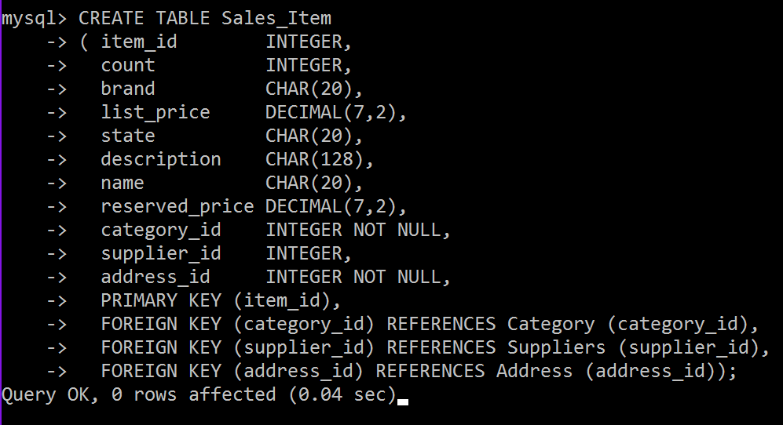
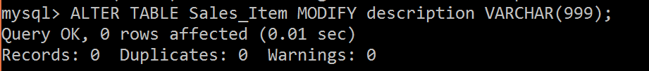
Figure 2 – Sales_Item SQL Table
Like other shoe websites, we wanted to sell non-shoe items. We provide bags, sunglasses, shoe care items, and socks. Bags, sunglasses, and care items can be fully described by the Sales_Item entity, but socks and shoes require additional information. As a result, we created the Footwear entity (See Figure 1) to account for these missing fields, which includes the size attribute (for socks and shoe size).
In order to show this ISA relationship in the database, we made a new table called Footwear (See Figure 3), where a foreign key (item_id) from the Sales_Item table is used as the primary key. That way, every Footwear field is required to have a corresponding Sales_Item field, which holds the rest of the data for the Footwear field. We also added ON DELETE CASCADE line to the foreign key, so that if the Sales_Item field is deleted, the Footwear item field that corresponds to the given Sales_Item will also be deleted. Lastly, the Footwear table has a column called size which holds the size of the shoe (recorded as a string).
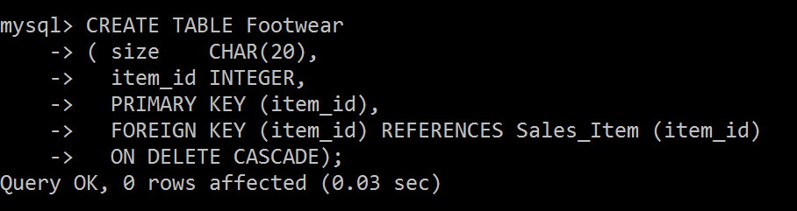
Figure 3 – Footwear SQL Table
Next, Sales_Items require information that is too complex to represent as attributes. The Address was created as a separate entity because attributes may be reused by other entities, such as users and shipping. Note that every Sales_Item is required to have exactly one address. Attributes of the Address entity include the street_address, app_num (apartment number), city, state, and zip_code. Each Sales_Item has its own visual, where color is an attribute of the relationship between the Sales_Item and the visual. This attribute allows the user to filter out products when searching or browsing, based on the color of bag, shoe, or sock that they desire (See sections 2.7 and 2.8). Visual is represented by the Image entity (See Figure 1). Every Sales_Item can have one or more image, which will be displayed on each product's webpage. Each image has a unique img_id, as well as an image attribute, which holds the actual photo data.
As shown in the Figure 1, the Address entity is too complex to be record as a single attribute, so it was turned into its own table called Address (See Figure 1). Again, the primary key is the address_id (set as an integer) and the rest of the attributes are recorded as strings (or as an integer for zip) in the table. Since a Sales_Item is required to have exactly one Address, we added an address_id foreign key to the Sales_Item table, and force all entries in that column to be not null. That way, every field in Sales_item will have an address. Note that an address does not necessarily have to have a relationship with a Sales_Item.
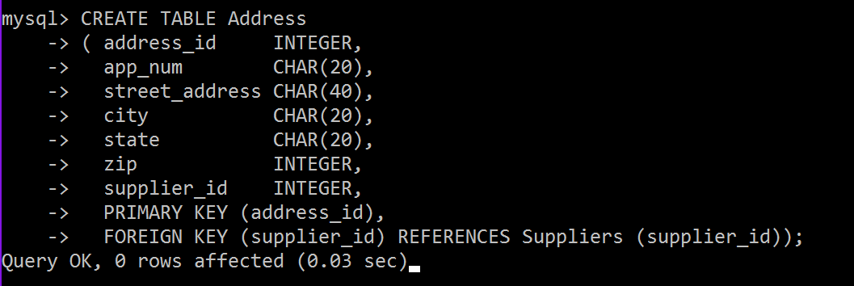
Figure 4 – Address SQL Table
The Image table (Figure 5) on the other hand, only needs a primary key image_id (integer) and a column of image blobs. As shown in the ER diagram, there is a many-to-many relationship between Sales_Item and Image, so the has_visual table was created to record this relationship. In the has_visual table (Figure 6), the primary keys of a Sales_item and Image are stored, and the combination of these two foreign keys act as the primary key of the table. In addition, the relationship in the ER diagram contains the attribute color. This was added to the table and is represented as a column of strings.
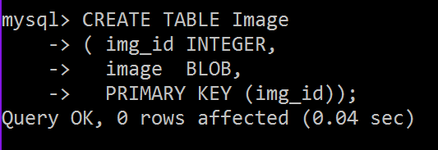
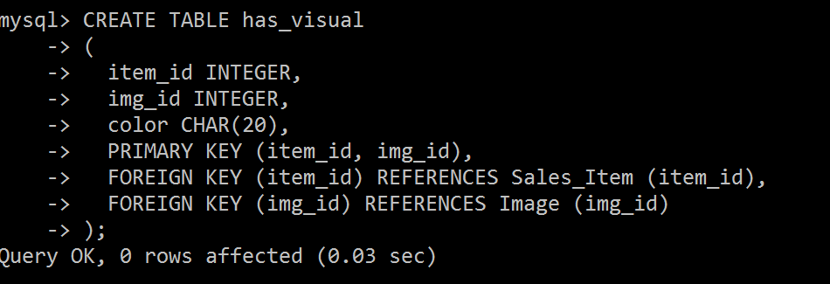

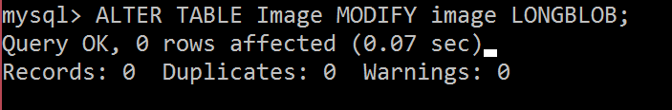
Figure 5 – Image SQL Table Figure 6 – has_visual SQL Table
  - Categories
There is a variety of footwear to categorize. This categorization will dictate the databases needed for this online business. TechFam must distribute enough styles of footwear to become a central hub for all individuals looking to purchase shoes. However, it is critical to be efficient when creating the databases, avoiding any data redundancies.
TechFam’s shoe selection targets people of all genders and ages. As a result, the root node, “All,” must have three children, “Men”, “Women”, and “Kids”. The children nodes of these three nodes are categories of the different types of shoe, such as “Boots,” “Sneakers,” etc. Next, the different types of shoes are broken down even further by subtypes. In addition to the first three children nodes, there is a fourth node, “Accessories,” contains items that are not shoes. See Appendix C for an in-depth visualization of the categories.
We researched a few different shoe websites to obtain the categories. Zappos^{[7]} is a general shoe distributor that contains the vastest selection, contributing to the majority of our category ideas. JustFab ^{[11]} delved deep into the various types of women’s shoes.
The ER diagram in Figure 10 explains the basic outline for how each category will be stored in the database. Categories have primary key, categoryID, to uniquely identify each other. The description attribute briefly details the kind of product that is contained within the category itself. Note that there are relationships between the category and its parent node and children node(s) which follow the classification tree in Appendix C. Each child node points to its parent, and can have a max of one parent. The parent, on the other hand, can have multiple children. This is shown by the Parent_of relationship.

Figure 7 – Category ER Diagram
When this ER Diagram was converted into a table, the Category entity and the Parent_of relationship were combined into one table called Category. This table uses the category_id (integer) as the primary key, and contains description and category_name columns. These components make up the Category entity section of the table. Next, the parent_id was added so that each child could identify its parent Category field. Since parent_id is an attribute, we guarantee that each child can only have a max of one parent (or no parent at all if it’s the root node), while parents can still have multiple children.
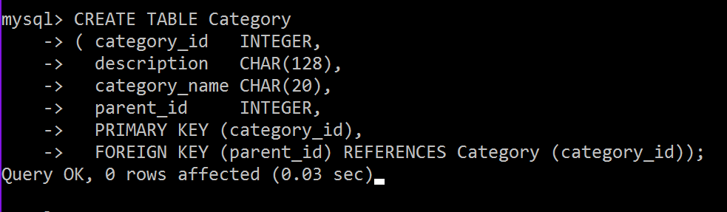
Figure 8 – Category SQL Table
There is one more important relationship in the ER diagram called member_of. This shows that every Sales_Item is required to have an identifying category. This relationship was merged with the Sales_Item table (Figure 2) with the category_id column. This is a foreign key that points to the Category the Sales_Item is a member of. Note also that category_id is set to NOT NULL, so that every Sales_Item is required to have a Category.
  - Suppliers
Suppliers is a parent entity of both companies and registered users. A Suppliers job is to sell shoes that they manufacture on our website. The attributes for the Suppliers entity include the supplier_id, email and name. The supplier is assigned a name and is used to identify the supplier.
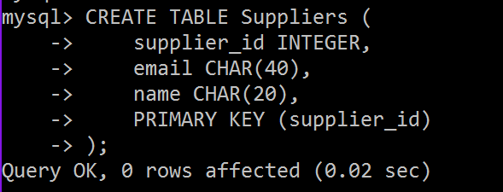
Figure 9 – Suppliers, Company, Phone ER Diagram Figure 10 – Suppliers SQL Table
Multiple phone numbers of the suppliers is also recorded, as represented by the contact_by relationship. The point of contact helps the customer contact the seller in case there are any questions or concerns. This relationship requires two additional tables (besides the Supplier table). The first table is the Phone table, which simply has a primary key of phone number. The second table is the contact_by table. This table takes two foreign keys, the primary key of Suppliers, and the primary key of Phone. Then it will match a given phone number with a supplier. The primary keys of this table is the combination of both foreign keys.
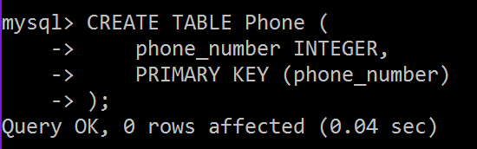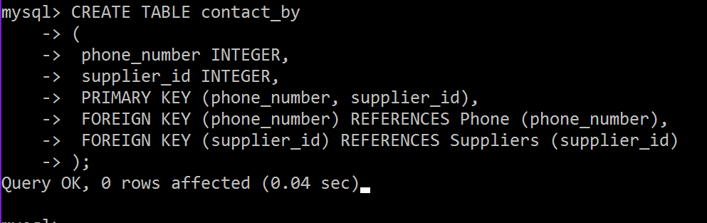
Figure 11 – Phone SQL Table Figure 12 – contact_by SQL Table
The supplier also has an Address, shown by the location_adddress relationship. A Supplier can have many addresses, but an Address can only point to a single Supplier. Therefore, there is a one-to-many relationship between Suppliers and Address. The database records this information by adding the supplier_id attribute to the Address table (Figure 4), which points to the primary key of a Supplier.
  - Company
Company is a child entity of Supplier. It contains all the information of supplier, with the addition of the point_of_contact attribute, which is the name of the person to contact for the given company. Company can use the name attribute of Suppliers to record the company name, and also use the email attribute as well as the phone and address relationships to record where the company is located, and how to contact them. An important thing to note is that companies cannot buy products; they can only sell.
The Company table is fairly simplistic. It uses the Supplier’s supplier_id as its primary key. If the Supplier’s field is deleted, the corresponding Company’s field will also be deleted. The Company table also has the point_of_contact column, which stores strings.
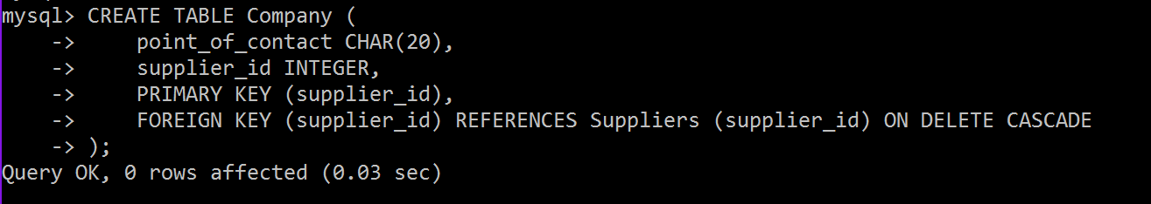
Figure 13 – Company SQL Table
  - Registered Users
Registered_Users is the second child entity of Suppliers. Along with selling products, Registered_Users can bid or directly buy shoes. This feature asks the user to fill out the following information while they register:
- A user ID or username, which helps users stay anonymous and allows us to identify them.
- A password to secure their account.
- Gender.
- An email and multiple phone numbers as a mode of contact to the registered user. Although these information are located in the in the Supplier entity.
- Multiple credit cards and addresses of the registered user, which helps process payments, billing information, and return information.
- Age and income is used to calculate a statistics for each user. The income here stands for the income the user has made on our website.

Figure 14 – Registered_Users, Suppliers, Company, Credit_Card ER Diagram

Similar to the Company table, the Register_Users table has a foreign key that links to a unique supplier_id. The supplier_id cannot be null, that way every Register_Users has a corresponding Supplier entity. Like the Company table, the Register_Users field will be deleted if the Supplier field is deleted. Unlike the Company table, the Register_Users use their own username attribute as the primary key. Since every username must be unique and is the main way other users will identify one another, we thought username would suite as a better primary key.
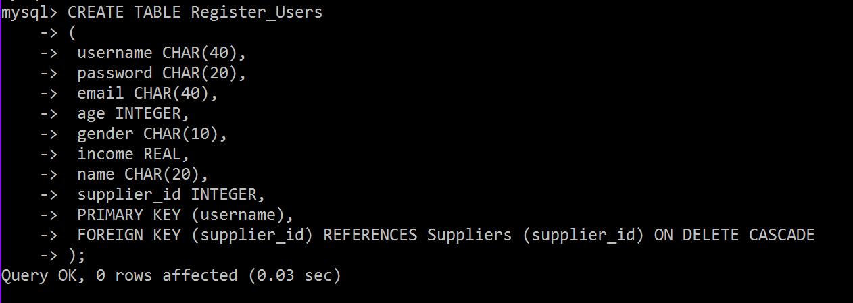

Figure 15 – Registered_Users SQL Table
One important relationship to note with Register_Users is the pays_with relationship. This links the Credit_Card entity, Register_User entity, and Address entity together. This allows each Register_User to have multiple credit cards and multiple billing addresses. This information is stored in the table pays_with. It records the username, credit card number, and address_id of each member of the relationship. It also uses these three foreign keys as the table’s primary key.
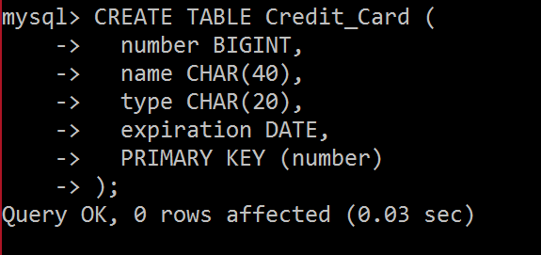
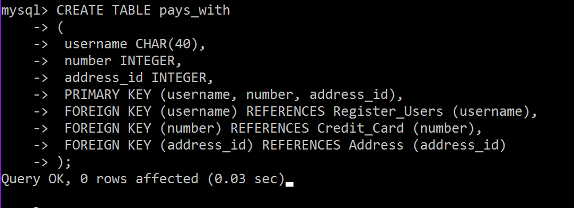
Figure 16 – Credit_Card SQL Table Figure 17 – pays_with SQL Table
  - Rating
Rating is an important measure for a seller’s reputation. A user might want to know what rating a seller might have. Many websites now have rating system for sellers. For example, sellers on eBay can earn stars based on the number of ratings they get ^{[4]}. The rating system on this website can be modeled by a Rating entity, which has a relationship with a single Register_User, who create the rating, and a single Supplier, who the register user rates. The application quality entity Rating is created with primary key rating_id, a scale based non-key attribute value, and a textual non-key attribute explanation.
Figure 18 – Rating ER Diagram
The value is a scale attribute that can be selected from 1 star to 5 stars. The explanation is a textual attribute that allows a user to explain why one gives such scaled-rating or any additional comments. A seller will also have an average rating showing on his/her profile. The average rating calculates the mean of each rating value then rounds to the nearest star scale.
For the table for Rating, there is a partial key rating_id, in addition to the explanation and value attributes. There is also a foreign key pointing to the username of the reviewer and the supplier_id of the company or user being reviewed. These two foreign keys help combine Rating with the by and has relationships. Also, in the ER diagram, Rating is a weak entity to Supplier. So if the Supplier deletes their account, then all the ratings for them will also be deleted. This is done with the ON DELETE CASCADE line where the supplier_id is declared a foreign key. Rating is given a primary key which combines the supplier_id with the partial key rating_id.

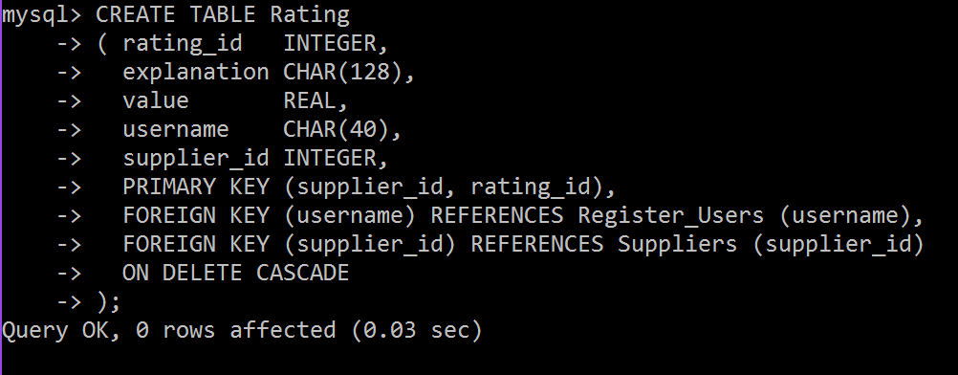
Figure 19 – Rating SQL Table
  - Browsing
Users are able to browse the items by traversing the category tree (Appendix C). When a user chooses a category, the user will want to know all of the categories that are directly linked to that current category. The tree traversal algorithm to be implemented will follow a derivative of the breadth-first search algorithm. At each point, they are given a summary of all the items that appear in that category. For example, if the user is in the “Women’s” category, the provided categories are “Boots”, “Flats”, “Pump”, “Sandals”, “Sneakers”, and “Wedges”. However, in traditional breadth-first search algorithms, the other nodes in the same level as the previously mentioned categories, will be shown. So our form of the algorithm will limit the traversing within the current node and its children.
Another important browsing feature is to allow the user the ability to traverse both ways through the tree, including moving downwards and upwards through the tree. The user will be able to return to the parent node of their current category. In addition, there will be a home button to traverse the user back to the root node.
In the browser bar, user can access their account information. This includes their profile, feedback, and settings. Profile contains their personal information, items they are selling, current bids, and history. Feedback has ratings and reviews. Settings include login information, credit card information, and shipping/billing address.
There will be a homepage which consists of the current deals and other features usually found in homepages. This homepage is not located anywhere in the classification tree, yet contains various items from different categories.
During our research of other shoe/clothing sites, we were attracted to a certain type of user interface that made browsing very easy and fast. Particularity, Macy’s online store featured a row of tabs near the top of the page. These tabs were the major categories of clothing, “Men”, “Women”, etc. When the user selects one of the tabs, a drop down menu appears, listing all of the categories within that major category. Furthermore, under those categories were subcategories that were indented to easily show its lower levelness. We found this interface in other sources as well and we find this way of browsing to be the most user-friendly because it gives the user a broad overview of the classification tree. TechFam will follow this structure of browsing.
  - Searching
On shopping websites, like Amazon, a user might want to search for a series of specific items. This can be modeled by two kinds querying, “User search Items”, and “User choose Categories then search Items”, as shown in Figure 20.

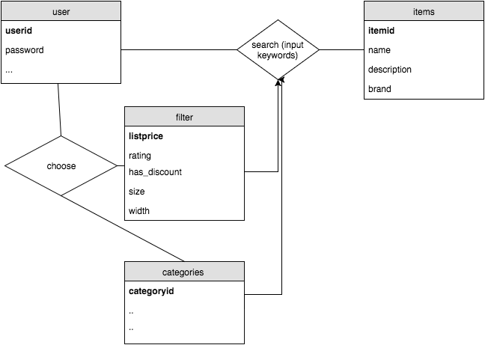
Figure 20 – Searching Process Diagram

If a user chooses to input keywords, the database will look for items that contains these keywords. A user can also choose certain categories or other filters first then input keywords to narrow down the results. Attributes in Sales_Item like name, description, brand, etc. shall be searchable.
  - Sale
Items on sale will be the ones not auctioned off. We will create an option for buying the item now. When the user enters a specific item description, that item information will be pulled from our database. The user interface will display all the items matching that description. The user will be allowed to add items to the cart, use their credit card information and check out. After the transaction has completed the item count will decrement. The transaction information will remain in the system for six months and will be stored using the ER diagram in Figure 21.

Figure 21 – Sale ER Diagram
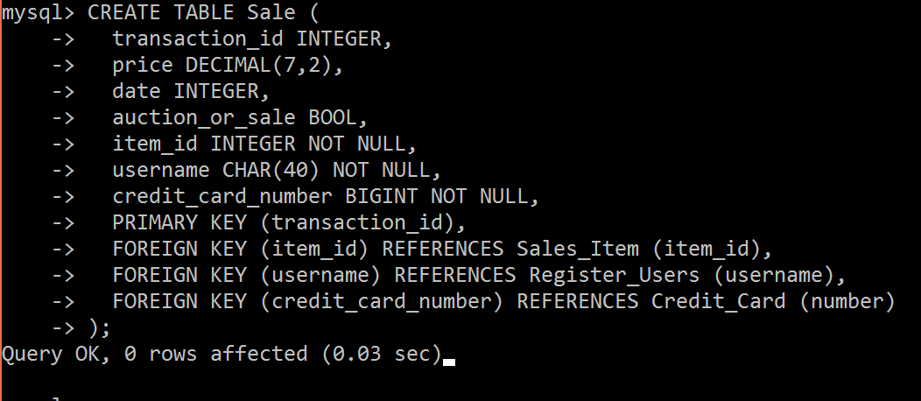
Figure 22 – Sale SQL Table
We created a table call Sale, where we had tansaction_id as the primary key. The table checks if it is an auction or a regular sale, using a Boolean. The foreign key that was referenced from Sales_Item was item_id, where it was linked on the ER diagram by relationship item_sold. It also includes username that is a foreign key, which is referenced from Register_Users, while credit_card_number was referenced from the Credit_Card entity.
  - Bidding
Unlike many shoe websites, our database will have the option of auctioning items. A user can access these items by searching through the pull-down menu and clicking on an item through the categories included, as well as entering a specific item name through the search bar. The database will retrieve information and after clicking the auctioned items option the user will be able to view the item. The user has the option to sort items based on price from highest to lowest or vice versa.
Bidding Rules:
• Users must remember each bid is a contract.
• Each item will have a specific time stamp listed under description.
• Bids can only be canceled 24 hours prior to time stamp deadline.
• Bids will be in 2 dollar increments.
Selling an item:
• Under options, select selling button and Users can only sell one item at a time.
• Select the item for sale and give a brief description.
• List the timestamp value for the starting and ending.
• Select the reserve price for the item.
• Review everything and select the confirm button.
• You will be notified when the auction has ended and who had the winning bid.
We will feature manual bidding and automatic bidding. First let’s talk about the manual way, where the user enters a bid value that is at least $2 more than the current highest bid. The user will be notified when someone overtakes them as the lead bidder. On the other hand, we have automatic bidding, where the user will be prompted to enter the maximum value they are willing to pay for the item being auctioned off. The system will bid $2 more than the current highest bid until your bid reaches the maximum value you are willing to play or the auction ends. The user with the highest bid wins, and pays the amount they bid. For both bidding options at the end of the auction, the user with the winning bid will be notified, that he or she has won. The system will charge the user’s credit card with winning bid amount and after receiving the payment, the seller will be required to ship the item. The transaction will stay in the system for 6 months. The user can view their current bids under the account options.
The Auction will have a time_stamp_start for the start of the auction and a time_stamp_end for the end of the auction. The auction will record all the bids that users place and these will have a relationship (item_auctioned) to the sale items.

Figure 23 – Auction and Bid ER Diagram
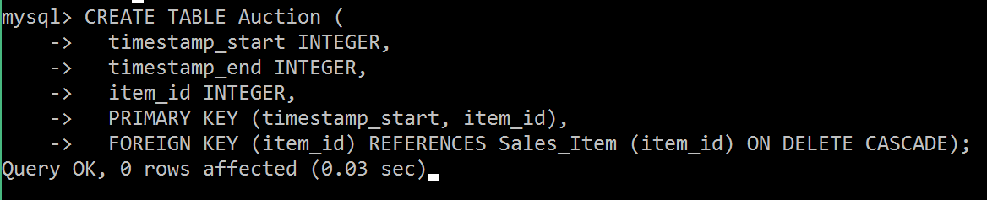
Figure 24 – Auction SQL Table
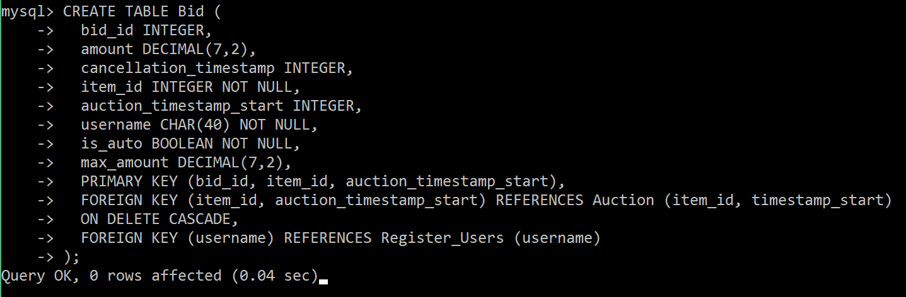
Figure 25 – Bid SQL Table
The table on the left was created for Auctions taking place, where it included timestamps for start and end. We referenced the item_id from the Sales_Items entity through the relationship of item_auctioned. Our partial key is timestamp_start, which is sourced from item_id. This could only be done using on delete cascade. timestamp_end refers to the time when the auction ends. Timestamps are recorded as integers based on the Unix machine time. This method is simpler than using traditional timestamps and yields the same performance.
For the Bid entity, we created a table called Bid, where we had bid_id as the primary key, amount as a decimal because it can not exceed more than 7-digit value max. cancellation_timestamp holds the time when the auction is over. username lets us know who is the bidder. is_auto is a Boolean value that determines if automatic bidding feature is turned on. max_amount determines the highest bid before automatic bidding ceases. Our foreign key was item_id and auction_timestamp_start, which are referenced through Auction. Again we had to use an on delete cascade if the they are removed.
  - Order and Sale Reports
With everything set up, it is important to consider how our system keeps track of all the orders that go through the system. We want to be able to generate a weekly report for each category that we are selling. This will not only inform us on how we are doing in terms of revenue but also help us monitor consumer behavior. By recording and analyzing reports of user activity, companies can improve their sites functionality.^{[9]} Having this functionality in our application and design, we believe our marketing team will be able to take a full advantage of this report function and produce the most effective marketing strategy that will help to maximize company’s profit.
Moving into the implementation of our report, each report will carry a specific report id that is relevant to the seller account detail and the time period for which the report is on. Our goal is to make our report as informative and dynamic as possible. We want to create an interface that allows our users to easily assess their data with a few clicks of a button.
Our design will include a bunch of useful keywords that relate to type of data that will be displayed such as total revenue, total cost, number of purchases, etc. In the backend of this functionality, we will use these keywords and put together a query that will access our database and pull up the request data and present them in a neat view.
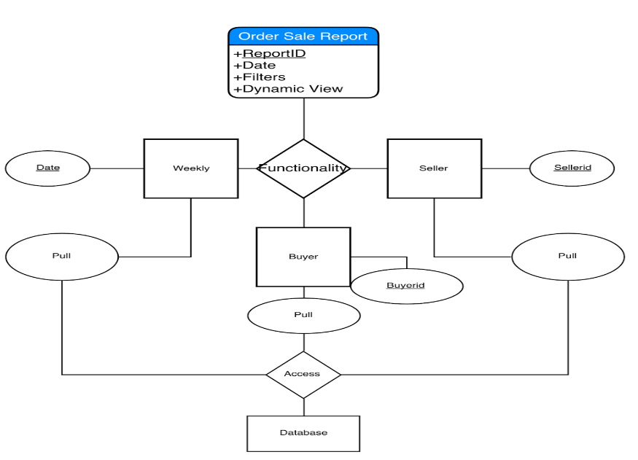
Figure 26 – Order Sale Report Process Diagram
  - Delivery
The other important thing that we are focusing on is our delivery system. We understand that it is our duty to fulfill our customers’ orders with the best service possible. This is why we are taking extra steps to secure every single transaction amongst our users.
With our delivery system, we will generate a unique id (shipping_id) for every delivery that is only available for the buyer, seller, and our engineers. Nevertheless, this id will only be created after a confirmation of payment has been posted. This means there will be lower chance of error for shipping confirmation. Why compete in the shipping market when companies like UPS, FedEx, and DHL have proven themselves to be among the best in the industry. While companies like UPS help to provide their customers with useful developer API, we aim to utilize their API to create the best interface for our users without traversing to another website. ^{[10]} We want to provide the tracking number for the shipment to allow users to see the status of their shipment from our website. We hope that our efforts in providing a friendly user interface will keep our customers satisfied with our products and services.

Figure 27- UPS ER Diagram
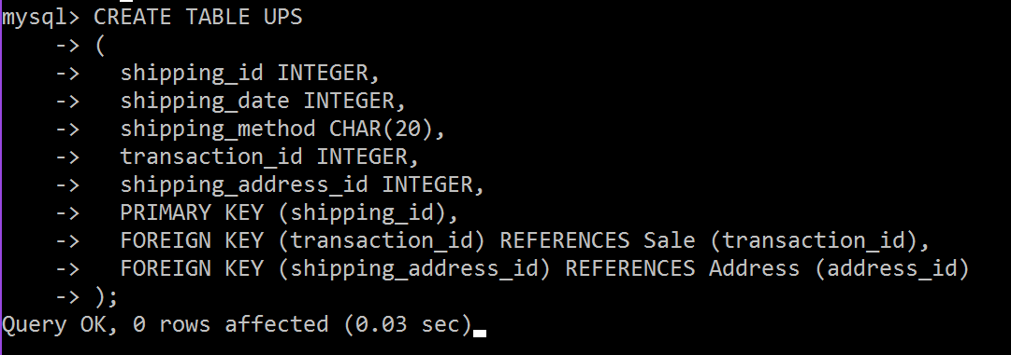
Figure 28 – UPS SQL Table
For the entity in the ER diagram of UPS, created a table called UPS, created tuples of its attributes. Used shipping_id as the primary key. We have an attribute that stores the method of shipping (shipping_method). Another attribute is used to record the date of shipping (shipping_date). For the foreign key, we used transaction_id because once a sale has been made sale_info relationship is accessed, where it gives the transaction id to the UPS service. address_id keeps track on where the package is being shipped to.
  - Custom Shoes
Unlike most sites, our team decided to create a custom shoe feature. We researched Nike’s custom shoe system for guidance. ^{[6]} First, the user will click on the custom shoe feature in the browser bar. Then, they can pick between a men’s, women’s, boys’, or girls’ shoe. After that, they can pick a particular category of shoe, such as athletic, casual, etc. and then pick a subcategory, such as running shoe or cleat. From there, the user has several features they can choose from a multiple choice list. These features include the size of the shoe, the width of the shoe, the side, back, and front image, tong style, the shoe sole style, and the coloring of the shoe.
The way the custom shoe information is stored is in the Custom_Shoe entity. This entity is a sub-entity of the sales items but it contains additional information for the customization process such as a side, back, and front image labels. In our database, we will store every possible combination of custom shoes in the Custom_Shoe entity. Then, during the creation process, as the user selects new attributes, different images will be displayed on screen, based on the default and user selections.

Figure 29 – Custom_Shoe ER Diagram

Figure 30 – Custom_Shoe SQL Table
We created a table based on the entity Custom_Shoe, each custom shoe you design will allow you to view the front, side, and back image. It will allow you to customize the tong, sole, shoe and color style, as shown in the ER diagram. Again the primary key is item_id because selecting a specific item allows you to customize it, where on delete cascade is used. The foreign keys include the relationships of side_img_id, front_img_id, and back_img_id, which reference the Image entity. We also have a foreign key of item_id which references Footwear.
  - Customer Service
We are providing users a way to contact us. This bonus feature allows us to connect us with the users. Users can email or call us. We also provide a FAQ page that helps users navigate better. This page also helps users get answers to common questions. Customer service options will be located at the bottom of every page. This feature also helps us get feedback about our services, which provides a scope for improvement.

Figure 31 – Customer_Service ER Diagram

Figure 32 – Customer_Service SQL Table
We created the table Customer_Service as an extra feature. The primary key for it is customer_service_id. We created a tuple of faqs for customers to access frequent questions, we also included an email, and a phone_number. The foreign key for it is phone_number, where it is referenced from the entity Phone.
- TECHNOLOGY SURVEY
  - MySQL
We selected MySQL as our database because it is a relational database, meaning that it is suited for storage and retrieval. The relational part of the database allows for an easier and wider range of access to data that will allow us to manipulate the data in our system to its full potential.
MySQL is easier for us to use, given our limited experiences in database language. Moreover, MySQL is also an open source software that is owned by Oracle, which means that our group will not have to spend any money to use it. Needless to say, MySQL is also very popular amongst programmers. There is a great online community that we can fall back on when we are in trouble.
We did take several limitations of MySQL into account including poor performance scaling, limited functionality, and lesser overall quality compared to other database languages.^{[11]} We decided that poor performance scaling would not be a big issue due to the fact that we are not operating with a ton of data. Next, we are also not anticipating a great number of functionality to implement inside our database, as we will have backend codes that will do the job. Our intended use of the database should be straightforward – push and pull requests. Lastly, quality and stability is not something we are currently targeting for in our prototype phase. Our goal to set up the environment first and make everything work before we optimize to our environment.
Pro | Cons
Easy to use | Poor performance scaling
Open source | Limited functionality
Great online community | Inferior quality to top-tier databases
Suitable performance | Stability issues
Figure 33 – Pros and Cons of MySQL

  - Frontend
Since our team has the most experiences in JavaScript, we decided to design our front end in JavaScript, HTML 5, and CSS. We chose JavaScript because it remains one of today’s most used languages in websites. It is easier to code than server-side languages, and it offers a great range of variety when it comes to dynamic views and displays for our users. Moreover, JavaScript is entirely a client side programming, meaning the computation is done on our users’ computer rather than having data sent back to the server and back out to the user. We rely on this mechanism to make it easier for our servers, so we can reach up to more users.
HTML 5 and CSS will be used to make our website more visibly attractive to our users. We hope that our front-end code will be able to take a full advantage of our design to create the best user experiences possible. Nevertheless, these two languages are easy to learn and implement since they are ubiquitous in today’s websites.

Figure 34 – Frontend Programming Languages
  - Backend
We want to link our frontend code to our database through a backend written in Java. Mainly because Java is still one of the most popular languages in the industry and many of us have experience with it. Java offers a wide range of functionality and online communities to help us achieve what we want.
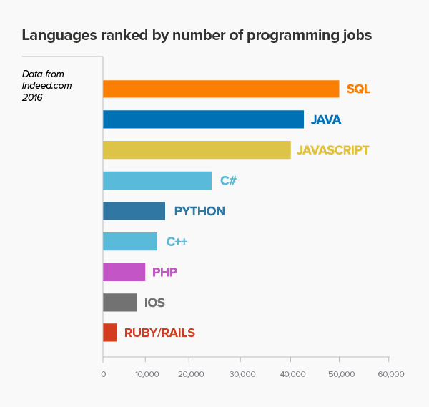
Figure 35 – Most Used Programming Languages
  - Other Technologies
Draw.io – We used Draw.io to do most of our Entity-Relationship diagrams. It is an easy to use online program that allows us to organize our diagrams neatly.
Asana – We use Asana to plan most of our daily activities and group goals. It offers a clear view of what our goals are and how to get there, if we put in the work to create it.
GitHub – GitHub is where our repository is located. We have access to our peers’ work and to the progression of our big project. Moreover, it is very convenient for each of us to edit and make commentary about others work.
GroupMe – We use GroupMe to communicate with one another.
- CONCLUSION
There were many options to choose from when selecting a database. After our first meeting we gathered ideas from everyone and ended with a shoe retailers’ database. The shoe industry is enormous and there were many features that we wanted to talk about besides the given ones. Everyone did their research on ideas and how we would incorporate the given features. The bonus features we selected were custom shoes and customer service. We assigned each person separate features, where each would do research on their specific topic and write a rough draft for analysis, we discussed how each person should implement certain ideas pertaining to their feature.
Next, we broke up into 2 teams, we had 3 on editing, while the rest on presentation. The biggest challenge we faced was making sure the information lined up perfectly between each topic because some features are closely connected to each other. Our main goal was making sure we developed a database that was user-friendly, yet offered complex features. Overall, phase one was a success where we implemented the design specifications according to the criteria.
As we move forward with our design we will implement a website that represents our database in a consumer friendly manner. Our website will allow the user to quickly locate desired items and purchase safely within our database on a protected web server. To do this we will apply browsing and searching techniques using the Breadth-First Search algorithm. Another addition will be Order and Sales Report, where we will store the transaction information in our database for business purposes. Most importantly, the database will be ready for real-world use.
- APPENDIX A – GITHUB GRAPHS
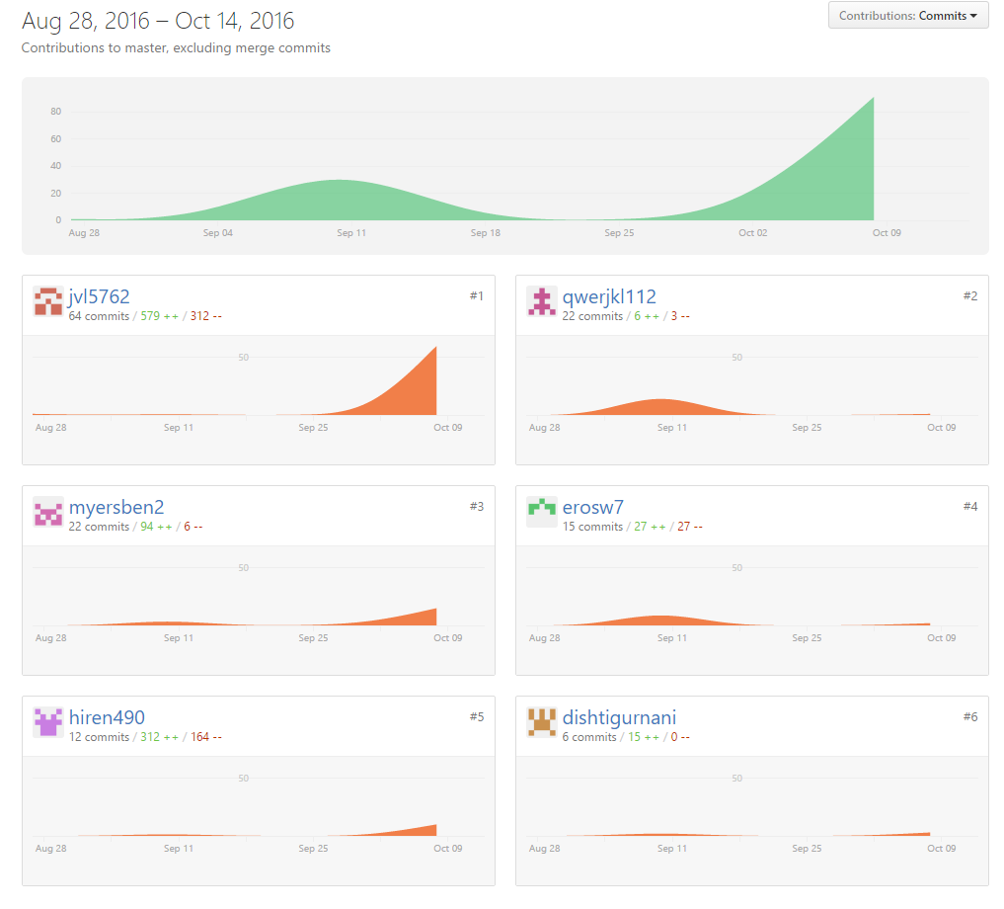
- APPENDIX B – ASANA SUMMARY
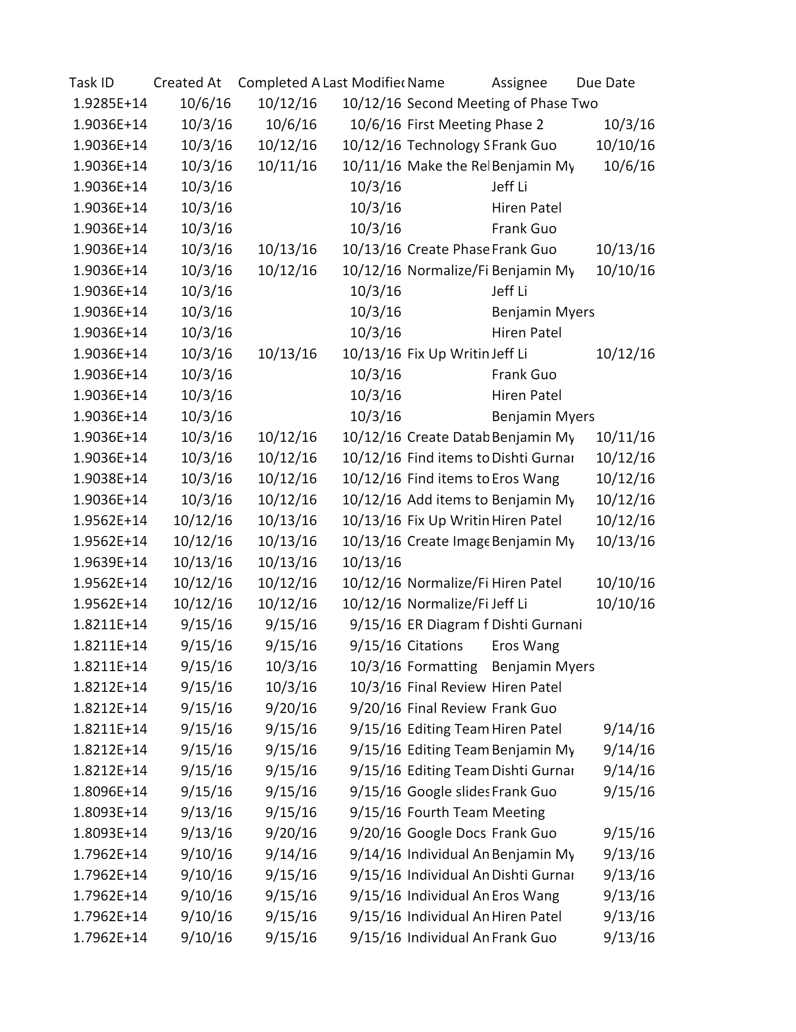

- APPENDIX C – CATEGORY TREE

- APPENDIX D – SCHEMAS IN THIRD NORMAL FORM
address
address_id:  integer | app_num:  string | street_address:  string | city:  string | state:  string | zip:  integer | supplier_id:  integer

auction
timestamp_start:  timestamp | timestamp_end:  timestamp | item_id:  integer

bid
bid_id:  integer | amount:  integer | cancellation_timestamp:  timestamp | item_id:  integer | auction_timestamp_start: timestamp | username:  String | is_auto:  Boolean | Max_amount:  real

category
category_id:  integer | description:  string | category_name:  string | parent_id:  integer

company
point_of_contact:  string | supplier_id:  integer

contact_by
phone_number:  integer | supplier_id:  integer

credit_card
number:  integer | name:  string | type:  string | expiration:  timestamp

custom_shoe
tong_style:  string | sole_style:  string | shoe_style:  string | color:  string | side_img_id:  integer | front_img_id:  integer | back_img_id:  integer | item_id:  integer

customer_service
customer_service_id:  integer | email:  string | faqs:  string | phone_number:  integer

footwear
size: string | item_id: integer

has_visual
item_id: integer | img_id: integer | color: string

image
img_id: integer | image: blob

pays_with
username: string | number: integer | address_id: integer

phone
phone_number: integer

rating
rating_id:  integer | explanation:  string | value:  real | username:  string | supplier_id:  integer

register_user
username:  string | password:  string | age: integer | gender:  string | income:  real | name: string | supplier_id:  integer

sale
transaction_id: integer | price: real | date: timestamp | auction_or_sale:  boolean | item_id: integer | username:  string | credit_card_number:  integer

sales_item
item_id:  integer | count:  integer | brand:  string | list_price:  real | state:  string | description:  string | name:  string | reserved_price:  real | category_id:  integer | supplier_id:  integer | address_id:  integer

supplier
supplier_id: integer | email: string | name: string

ups
shipping_id: integer | shipping_date: timestamp | shipping_method:  string | transaction_id: integer | shipping_address_id:  integer

- APPENDIX E: MASTER ER DIAGRAM
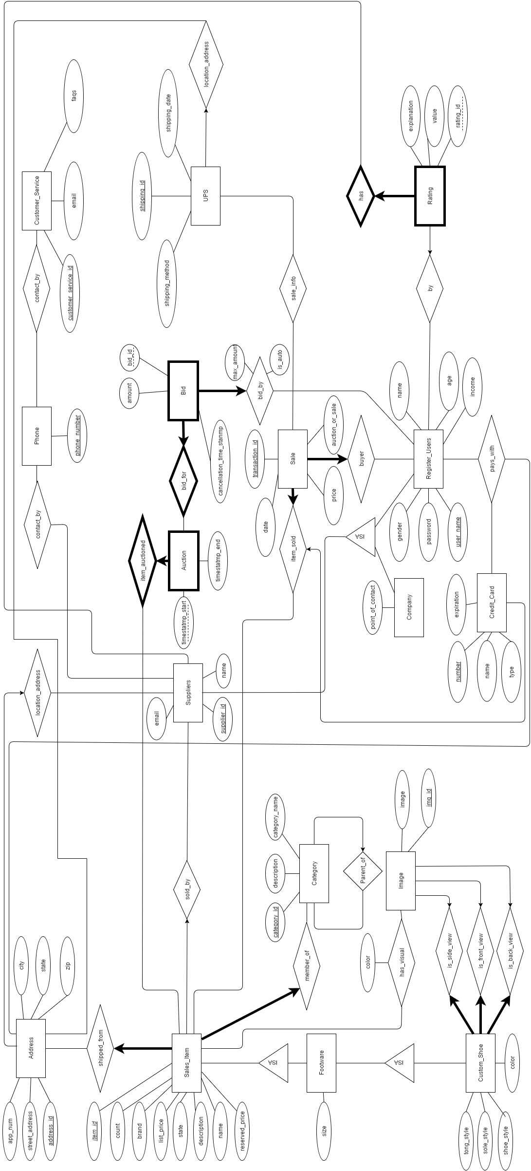
- APPENDIX F – DATABASE STORAGE
After completing our ER and schema designs for the important information we needed to store, we created our database and began filling it with sample data. Our goal was to fill out enough information to make the site feel like it was already up and running with real users. Below lists all the data stored in each table of our database, in alphabetical order. Note that some fields will be missing, due to difficulty of fitting all of the information on the page.
Table 1: Address Table
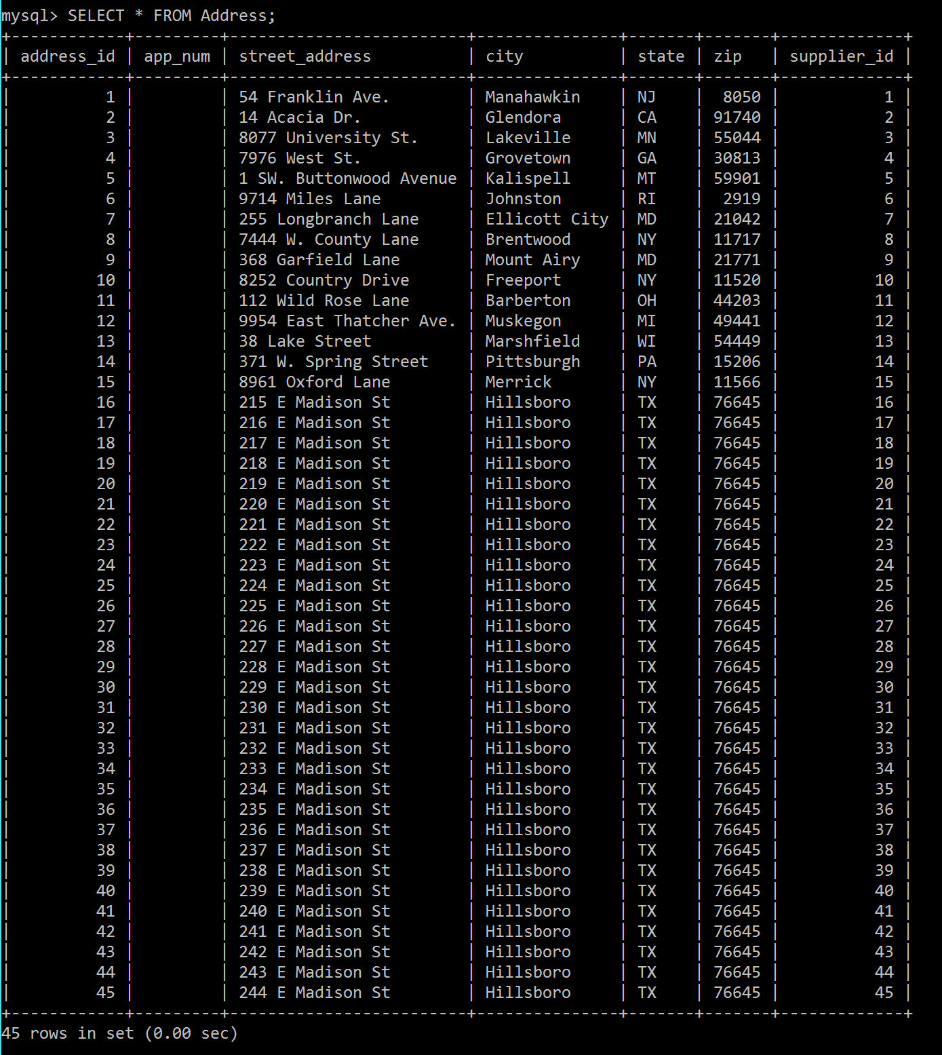

Table 2: Auction Table
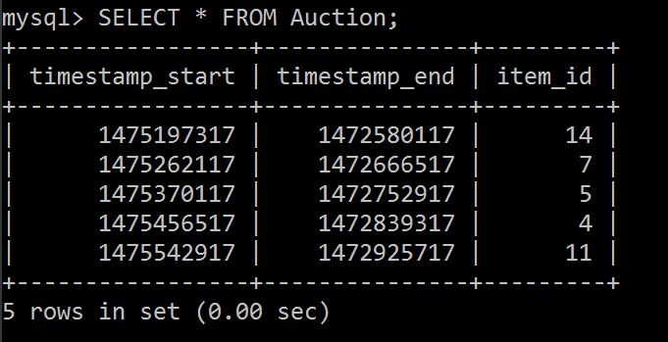

Table 3: Bid Table
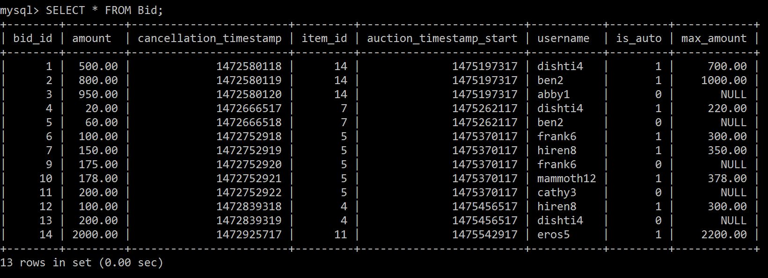

Table 4: Category Table
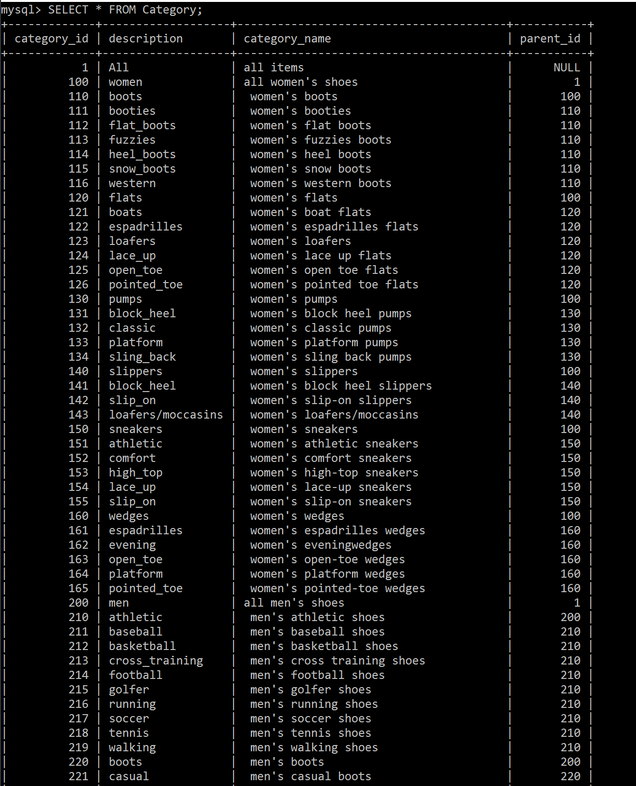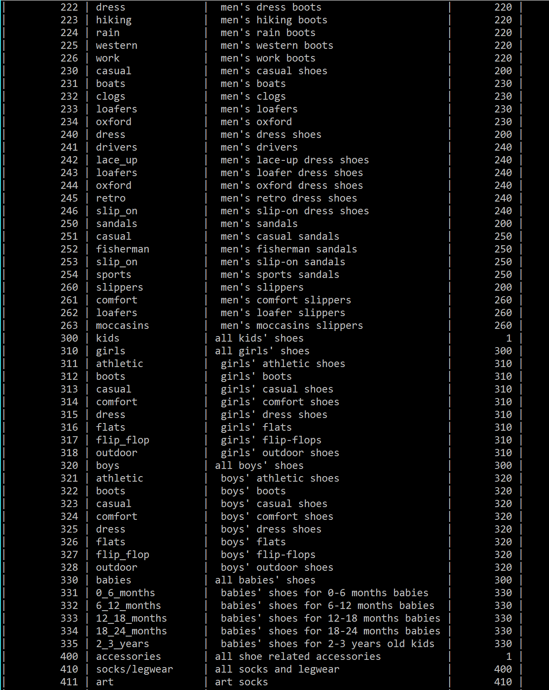
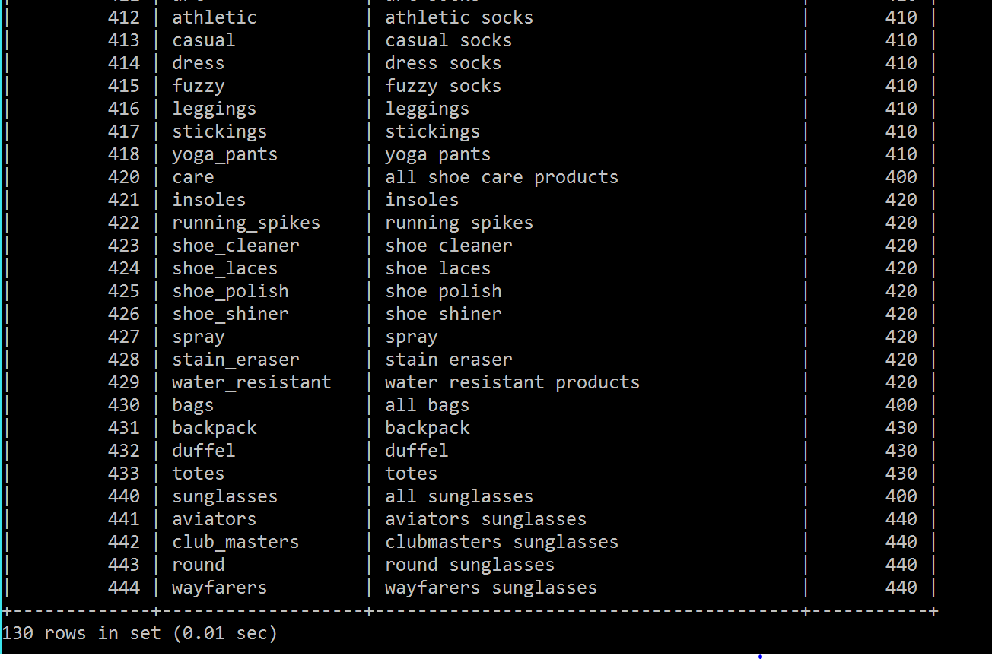
Table 5: Company_Data Table
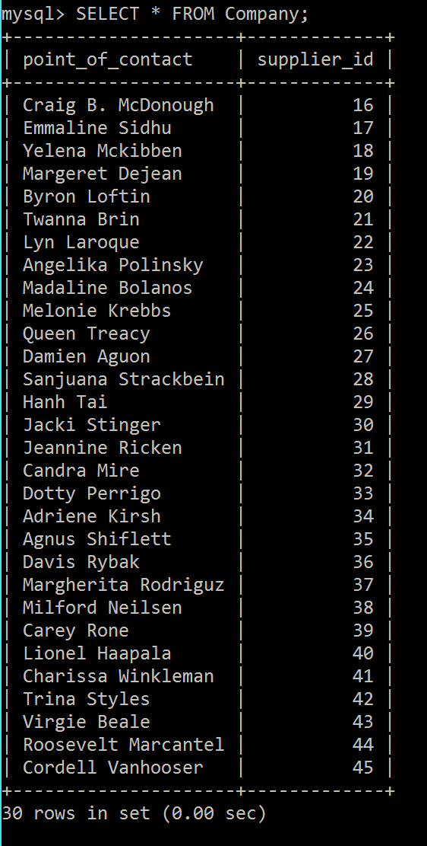

Table 6: Contact_By Table
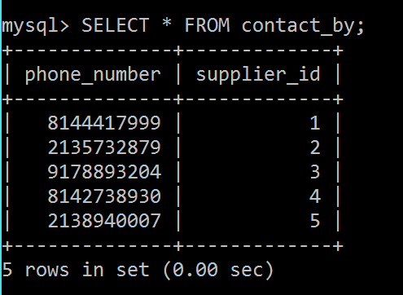

Table 7: Credit_Card Table
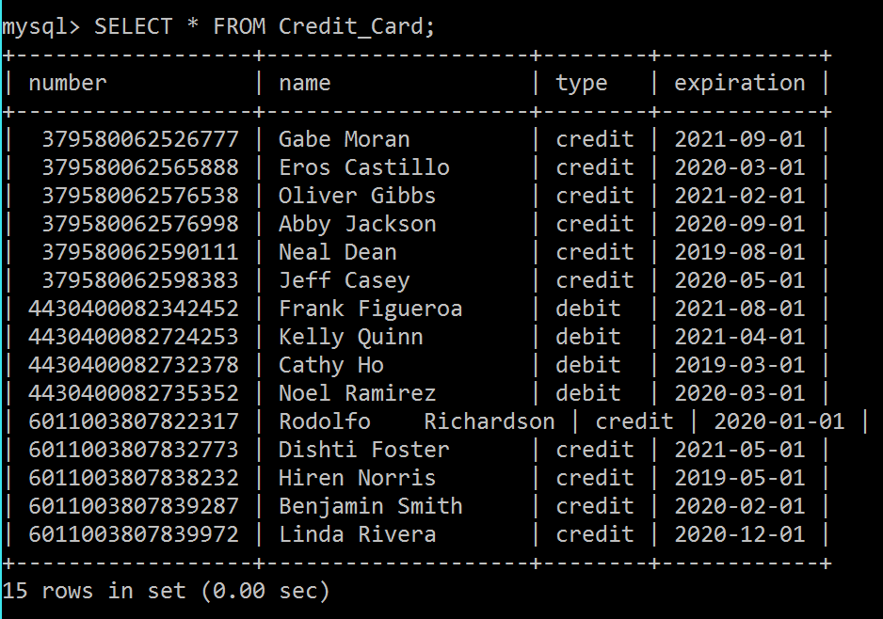

Table 8: Custom_Shoe Table
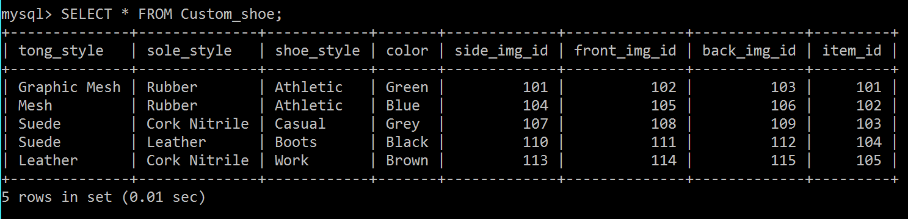

Table 9: Customer_Service Table
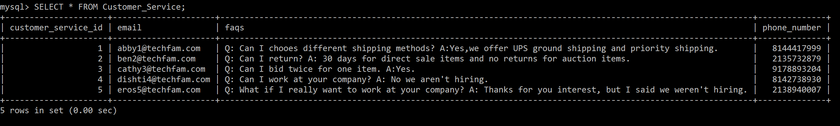

Table 10: Footwear Table
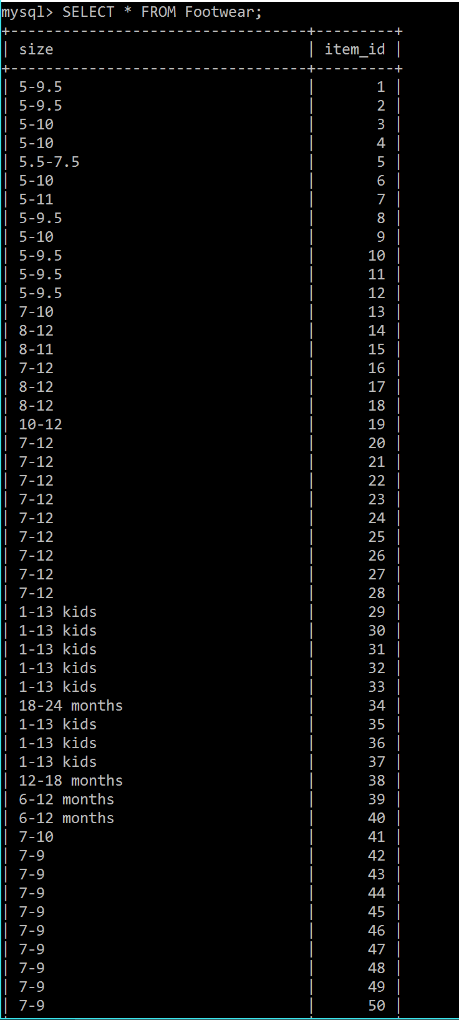

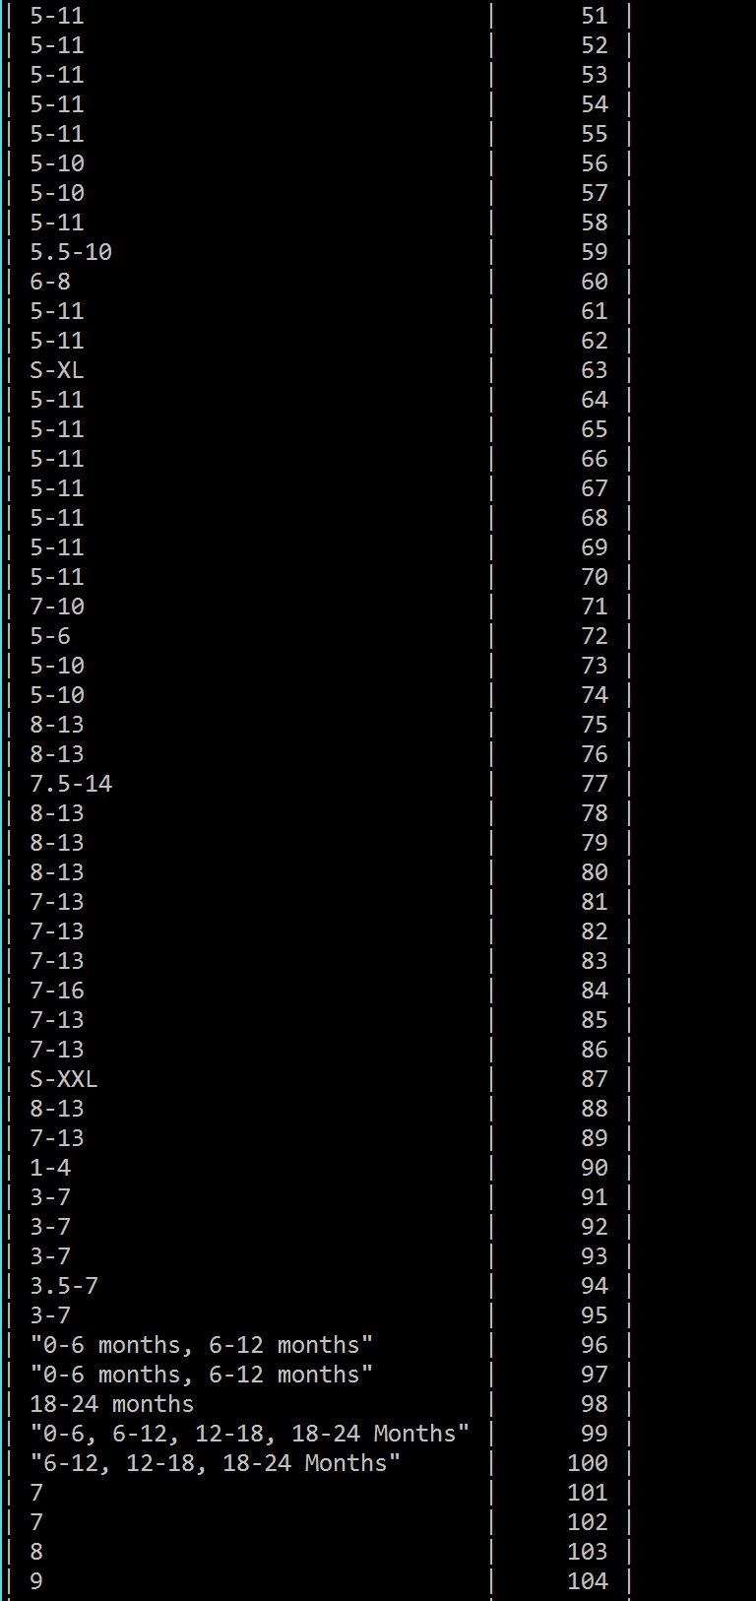

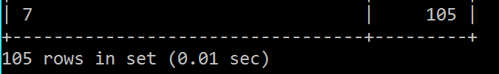

Table 11: Has_Visual Table
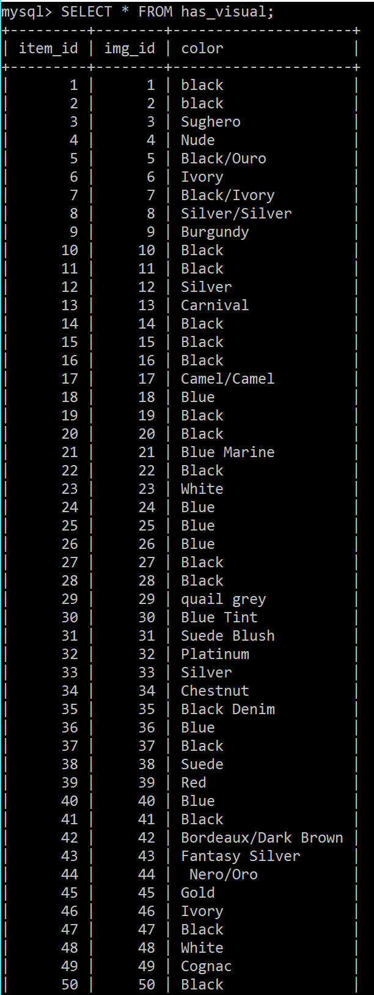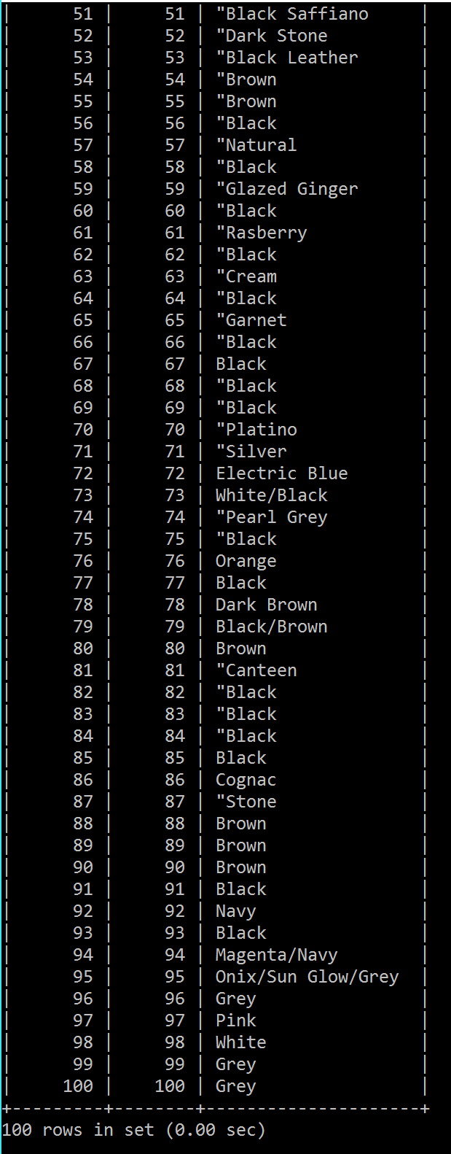

Table 12: Image Table
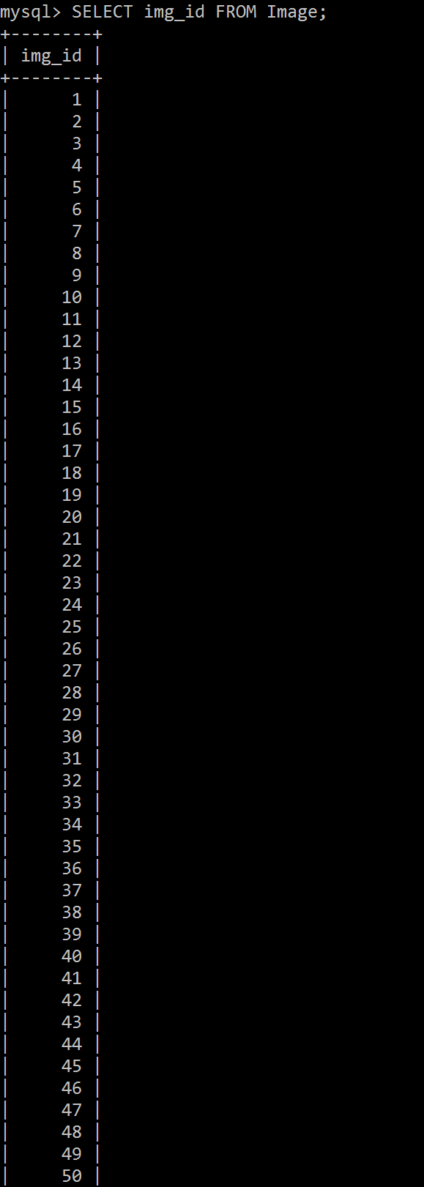

Note that this table also has a column of images, but this could not be printed out due to the size of the data. Also note that the real table goes all the way up to Image_ID 115.

Table 13: Pays_With Table
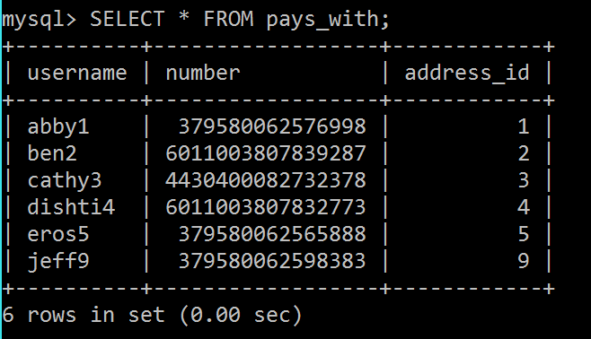

Table 14: Phone Table
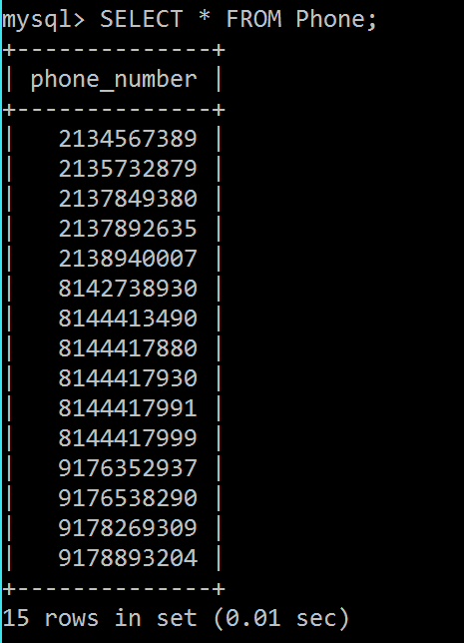

Table 15: Rating Table
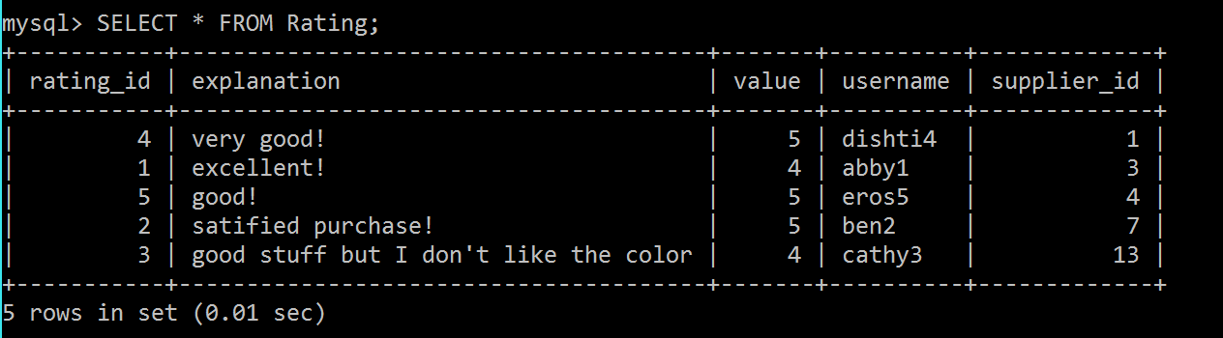

Table 16: Register_Users Table

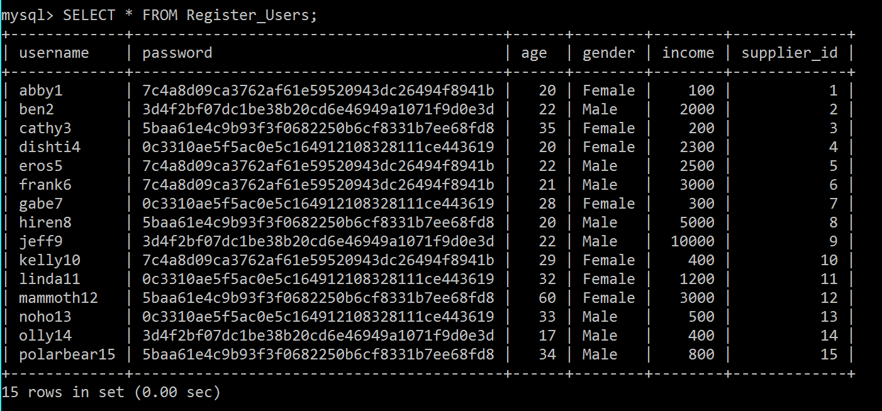

Table 17: Sale Table
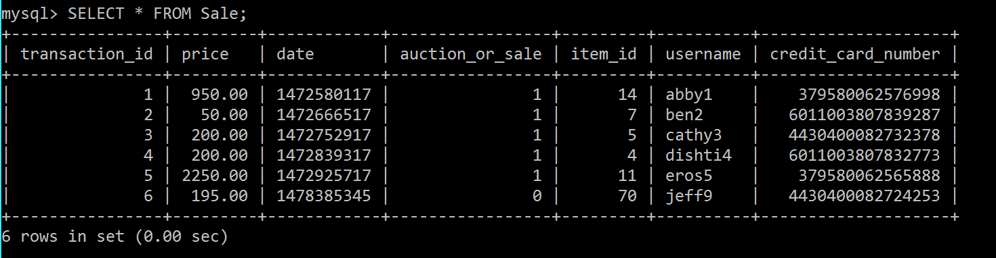

Table 18: Sales_Item Table

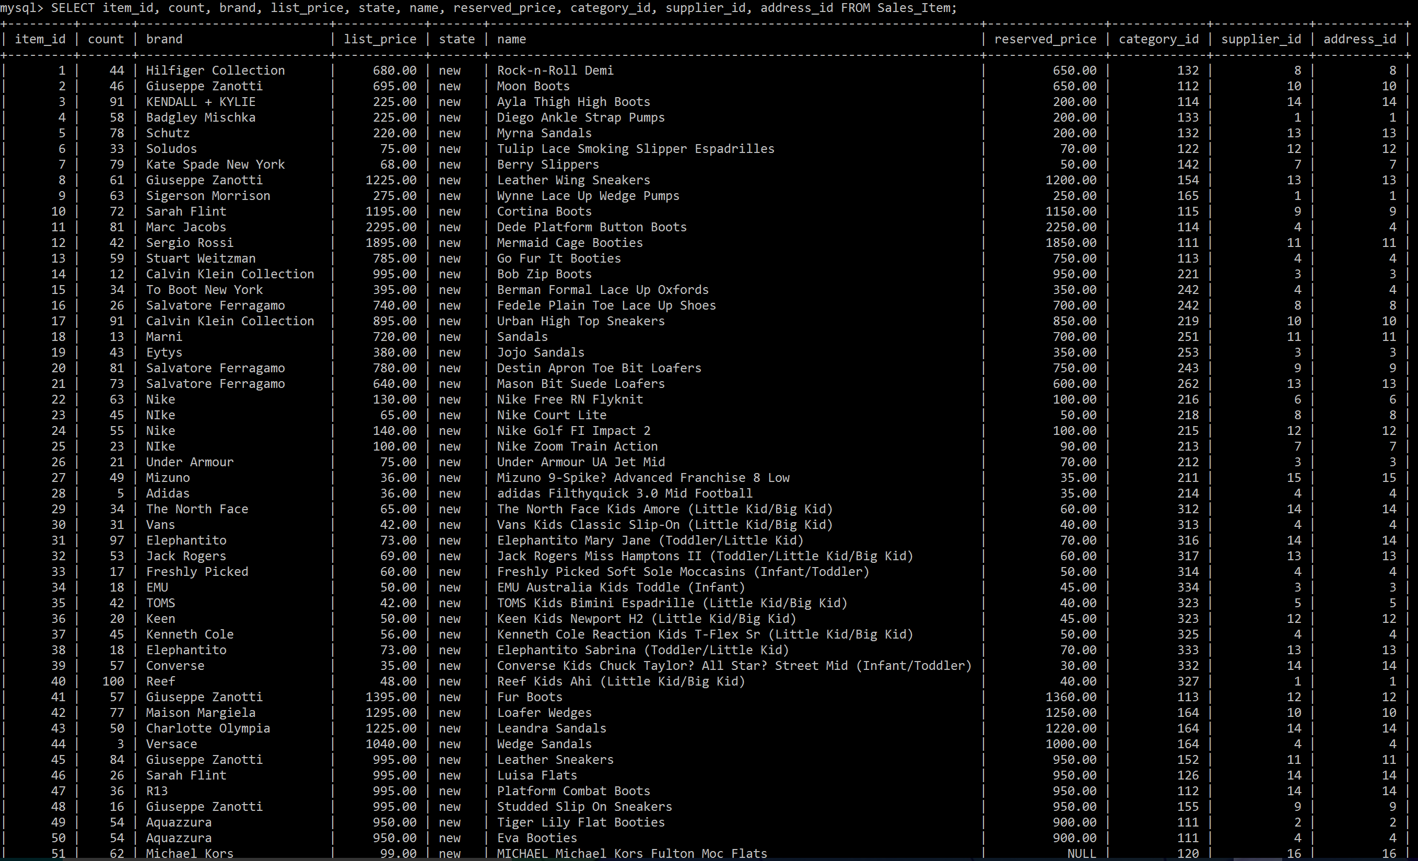

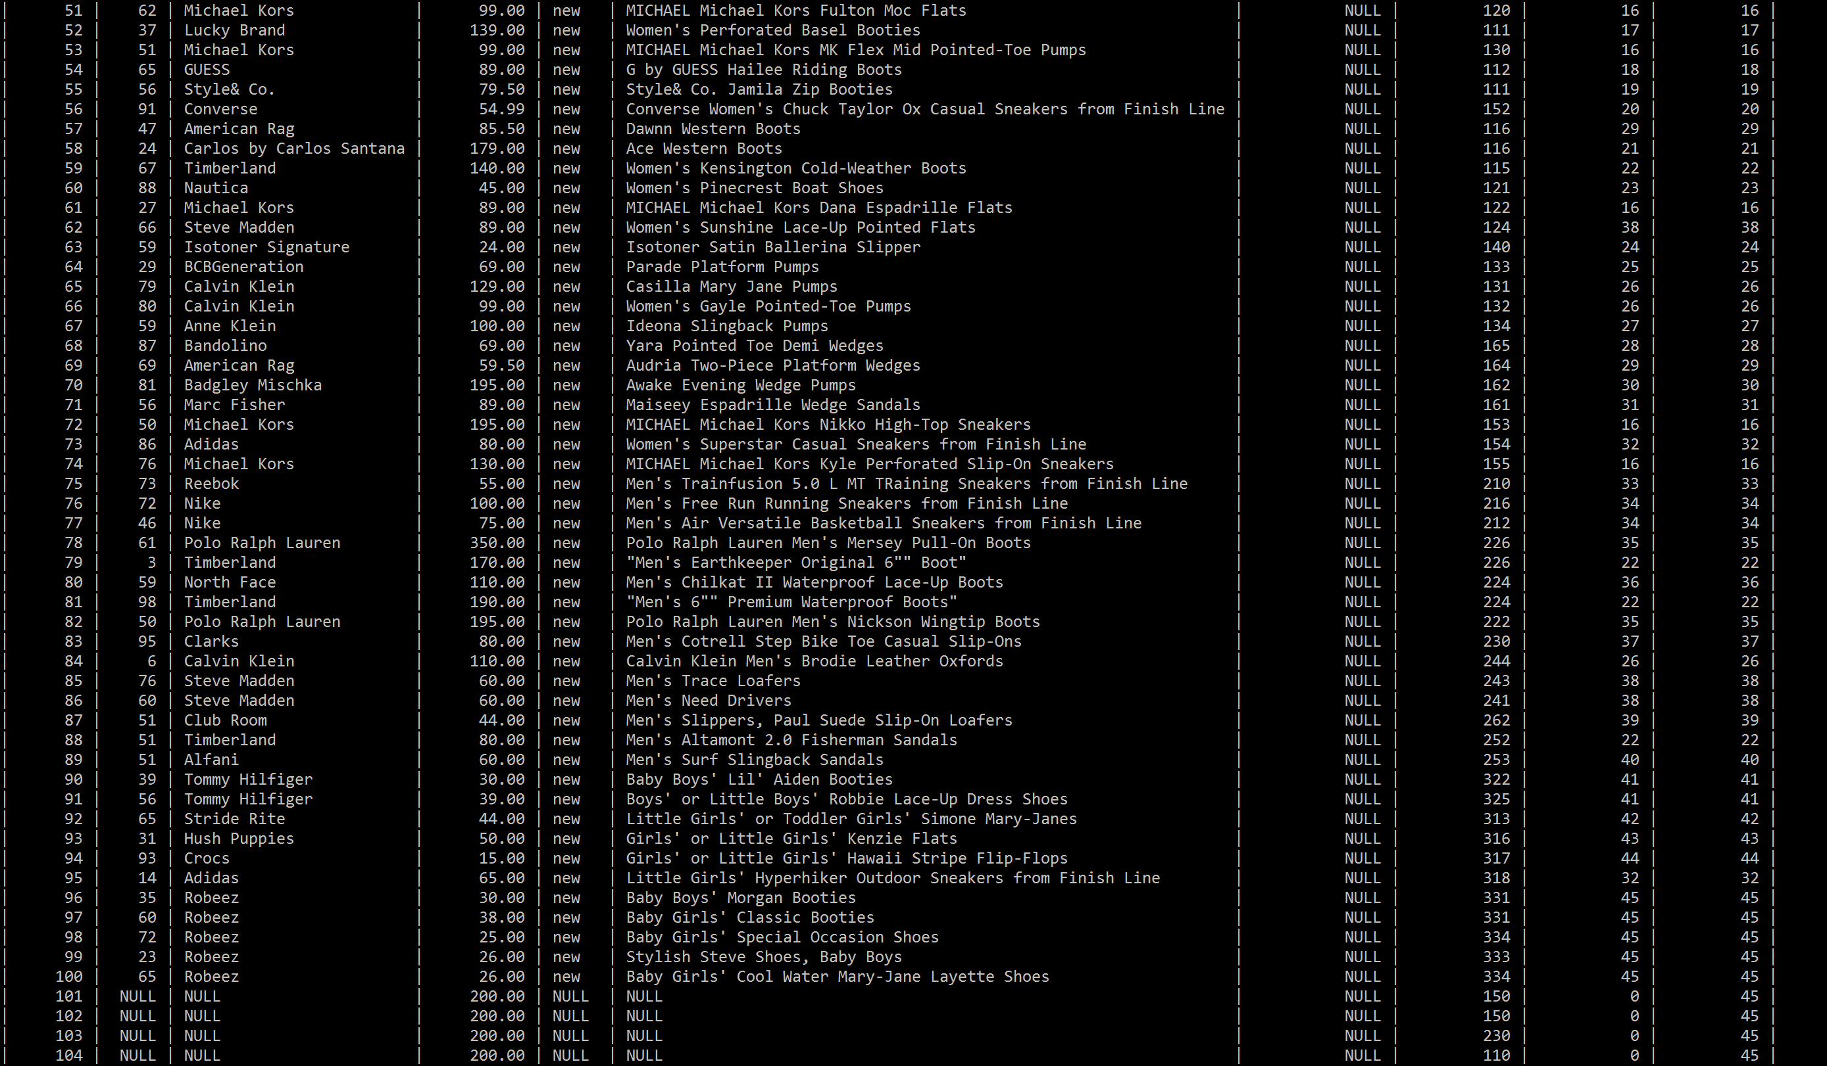

Note that this table also has a description column, but due to the size of the data, it could not be fit

Table 19: Suppliers Table

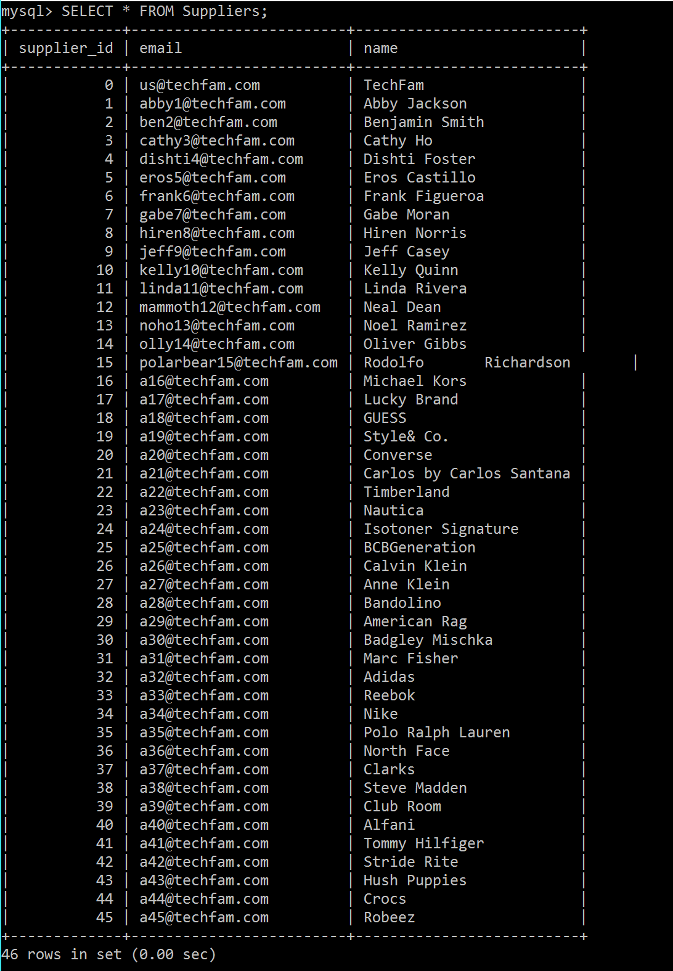

Table 20: UPS Table

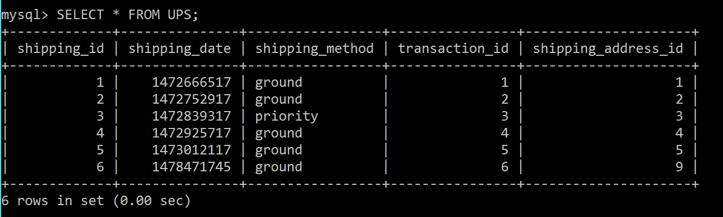

- WORKS CITED
1. "Amazon." Amazon. N.p., n.d. Web. 13 Sept. 2016.
2. Caleres. Shoes, boots, sandals - famous footwear online. 2016. Web. 15 Sept. 2016.
3. "EBay." Electronics, Cars, Fashion, Collectibles, Coupons and More. N.p., n.d. Web. 15 Sept. 2016.
4. "Feedback Scores, Stars, and Your Reputation." Feedback Scores, Stars, and Your Reputation. N.p., n.d. Web. 13 Sept. 2016.
5. Harden, Seth. "Footwear Industry Statistics." Statistic Brain. N.p., 03 Sept. 2016. Web. 15 Sept. 2016.
6. "Official Store. Nike.com." N.p., n.d. Web. 15 Sept. 2016.
7. "Online Shoes, Clothing, Free Shipping and Returns| Zappos.com." Online Shoes, Clothing, Free Shipping and Returns| Zappos.com. N.p., n.d. Web. 15 Sept. 2016.
8. "Shoes, Boots, Sandals, Handbags, Free Shipping! | DSW.com." Shoes, Boots, Sandals, Handbags, Free Shipping! | DSW.com. N.p., n.d. Web. 15 Sept. 2016.
9. "The Purpose of Weekly Status Reports." Reportingadvice. N.p., 2013. Web. 14 Sept. 2016.
10. "United States." UPS Developer Kit. N.p., n.d. Web. 14 Sept. 2016.
11. Women’s shoes, boots, Handbags & clothing online. 2010. Web. 15 Sept. 2016.
12. "Five Advantages & Disadvantages Of MySQL." Datarealm. N.p., 2016. Web. 14 Oct. 2016.

