The two approaches to predicting coordinates from a quadratic form

There are two – ultimately equivalent – ways of going from a quadratic form as measured in threshold experiments to a predicted perceptual space. See psg_qformpred.m for implementation. See Math Structures in Neuroscience course notes, MVAR.

Given a set of binary texture coordinates, i.e., row vectors of length 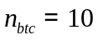, we have a quadratic form  (of size 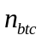)that predicts discrimination thresholds, namely, the textures with coordinates and 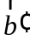 are discriminable if, regarding the coordinates as a row vector,
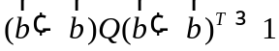.
This corresponds to a distance given by
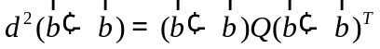.

So, to find points whose Euclidean distance corresponds to , we can take
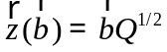,
so
.
Finding 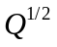 is accomplished by diagonalizing it, and reconstituting using the square root of the eigenvalues: if 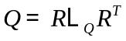, then 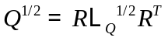.

Method 1 of psg_qformpred.m (“d_qform”) is to use for the full model and subtract the centroid. (Equivalently, since is linear, we could first subtract the centroid from the ’s. Then make lower-dimensional models by taking the first principal components. So then, say that 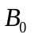 is a matrix in which each row is a , after centering, i.e.,.

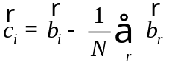.
Then a matrix whose rows are the centered ’s is given by
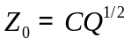.
Then make lower-dimensional models by taking the first principal components of 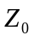. This is equivalent to diagonalizing
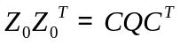.

So if 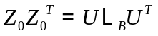, then the th model is first columns of 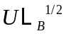.

Note that, except for 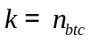, this is NOT equivalent to diagonalizing as , and using its first principal components of in , i.e, taking the coordinates as the first colums of 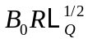, because the eigendirections of and 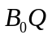 are different.
.
Method 2 uses the coordinates 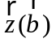 to compute a matrix of pairwise distances, and then does classical multidimensional scaling on these distances via the Kruskal method: Compute a matrix of squared distances, whose elements are

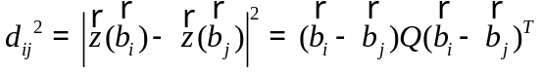.

The Kruskal recipe calls for computing
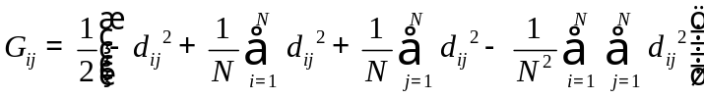,
diagonalizing , and using the first eigenvectors, normalized by the square root of their eigenvalues) as the coordinates.

In computing , we can use centered versions, since the centering subtracts out. So
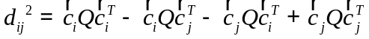,
where 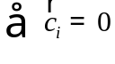.
So
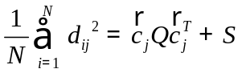, 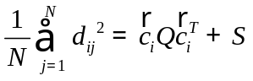, 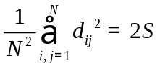, where 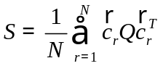

Putting into yields

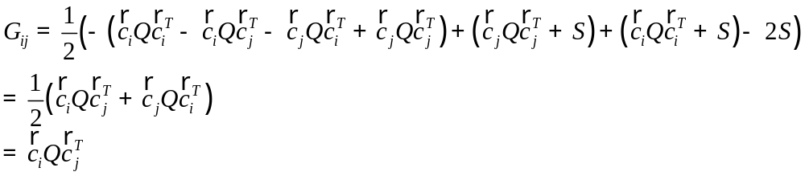,

i.e., the matrix to be diagonalized for MDS is given by
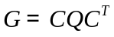,

which is the same matrix as in the method 1, eq. .

