1Q)Scope and task:

ANS)

### Scope of our Gan’s image generation model and similar project in real world applications is in healthcare, animation industry,cybersecurity , Editing photographs,translating images etc this the scope

Task: generating fake image From the given data

2Q)

Ans)

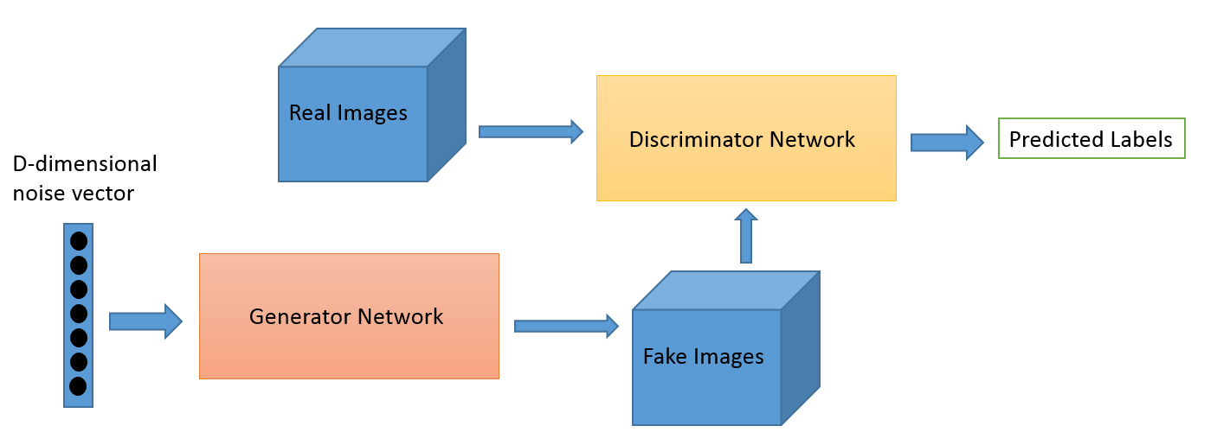

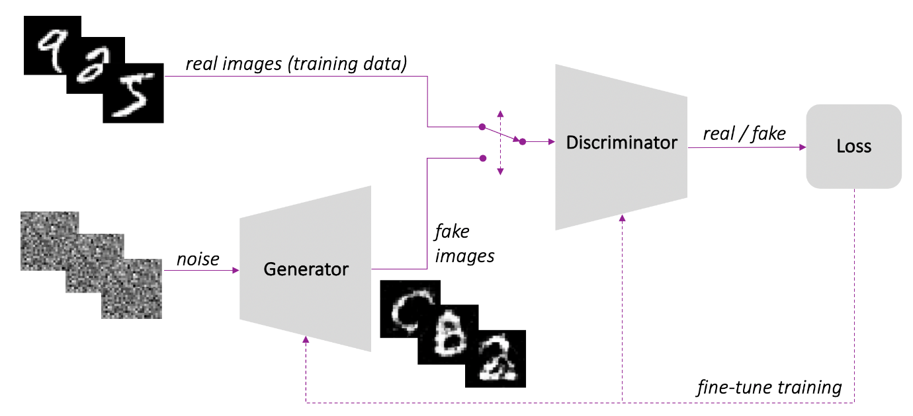

3Q)Features to be used:

Ans) Only image data set of faces of celebrity people

4Q)

Ans)

In GANs, there is a generator and a discriminator. The Generator generates fake samples of data(be it an image, audio, etc.) and tries to fool the Discriminator. The Discriminator, on the other hand, tries to distinguish between the real and fake samples. The Generator and the Discriminator are both Neural Networks and they both run in competition with each other in the training phase. The steps are repeated several times and in this, the Generator and Discriminator get better and better in their respective jobs after each repetition. Like on going multi feed back loop

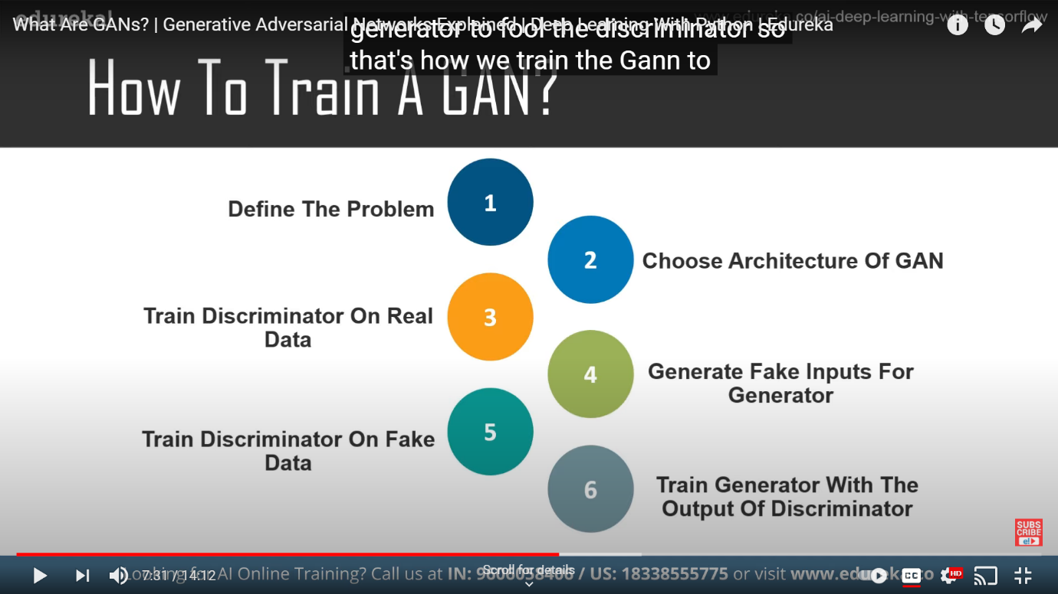

5Q)

Libraries thinking on use:-

### pytorch

### Keras-GAN

### TensorFlow-GAN

### And I think writing or implementing my own neural network algorithm for classification and discriminator by using middle some libraries like pandas,numpy etc

### And to get the final out come as generating fake images

Sources:-

<https://www.youtube.com/watch?v=5g1eXmQtl0E>

<https://www.allerin.com/blog/5-applications-of-generative-adversarial-networks>

<https://wiki.pathmind.com/generative-adversarial-network-gan>

<https://www.geeksforgeeks.org/generative-adversarial-network-gan/>