Iris

JB

This is a R code to visualization iris dataset. It splits the data into three subplot by Species.

## **Step by Step Process**

## 1. Load library

library(ggplot2)

* ggplot2 is a package for drawing charts in R
* library() is a function to read a package

## 2. Draw scatter plot

iris_plot <- ggplot(iris, aes(x=Sepal.Length, y = Sepal.Width))+  
 geom_point() +  
 facet_grid(. ~ Species)

## 3. Prepare Labels

g_labels <- data.frame(Species = c("setosa", "versicolor", "virginica"),   
 label=c("Setosa", "Versicolor", "Virginica"))

## 4. Add labels to the plot

iris_plot +  
 geom_text(x = 7, y = 4, aes(label = label), data = g_labels) +  
 labs(title = "Iris",  
 x = "Sepal length",  
 y = "Sepal width",  
 caption = "By JB, Data Visualization course, Tunghai University, 2024")+  
 theme(plot.title = element_text(hjust = 0.5, size = 20))

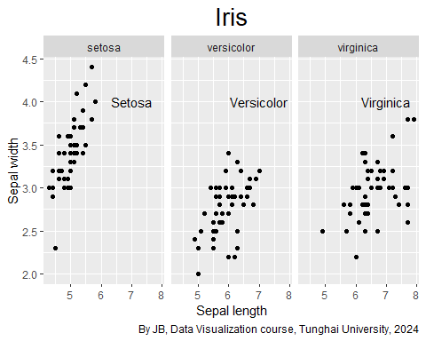

library(ggplot2)  
 iris_plot <- ggplot(iris, aes(x=Sepal.Length, y = Sepal.Width))+  
 geom_point() +  
 facet_grid(. ~ Species)  
  
g_labels <- data.frame(Species = c("setosa", "versicolor", "virginica"),   
 label=c("Setosa", "Versicolor", "Virginica"))  
  
iris_plot +  
 geom_text(x = 7, y = 4, aes(label = label), data = g_labels) +  
 labs(title = "Iris",  
 x = "Sepal length",  
 y = "Sepal width",  
 caption = "By JB, Data Visualization course, Tunghai University, 2024")+  
 theme(plot.title = element_text(hjust = 0.5, size = 20))

