Fall 2025 6372 Midterm

Directions: Please provide all of your answers in this document and submit it to 2DS. Note: By turning in a midterm, you promise to not have consulted with anyone about the content of this test during the administration of it through any media (chat, phone, email, etc.). Not adhering to the SMU honor code has serious consequences. After completion, do not talk about the exam with any other student until I give the ok.
ATTENTION: Please highlight your responses in a different color font. Also, you may include commentary to your multiple choice answers if you feel it necessary. I’m not expecting you too, but it could help if you are not certain. All questions are 3 points each unless noted otherwise.

- A researcher is working with a multiple linear regression model (19 predictors available). They decided to perform a feature selection algorithm in which multiple models are compared. The MSE points are plot in the graph below (MSE on y-axis, # of predictors in the model on the x-axis). They used a train/validation set to assess the best fit. An Explain how you know which curve corresponds to the training MSE and test MSE.

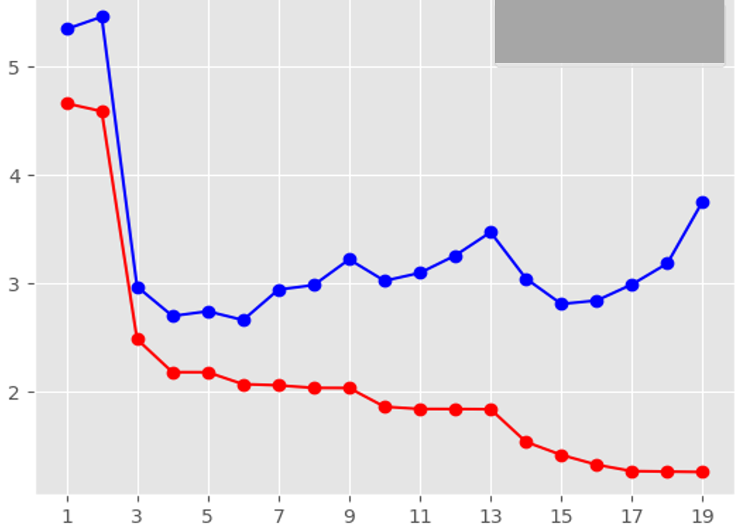
TLDR: Red is the Training Set and Blue is the Test Set.
The red curve would likely be the training set. As the number of predictors increase in the model, the MSE lowers, likely indicating that the model is training to the dataset and introducing more variance to the model. The blue curve shows a trend that would likely fit towards a validation set. The models that have a higher number of predictors are trained specifically to the training data set, testing it against new data usually ends up with a higher MSE.

- Continuing from #1, use the graph to explain the idea of a model that is suffering from “bias” in your own words. Important: You MUST use the graph in #1 to explain the idea. No generic statements from online sources.

As you can see from the graph, when the model only had 3 or less predictors in the model, the MSE were much larger than the models that had more predictors. Those models are likely introducing bias by not capturing an accurate depiction of what is truly driving the pattern for the response variables, thus coming up with a high MSE.

- Which model appears to be suffering from overfitting the most? (Model # corresponds to the x-axis in the graph in problem #1.)
  - Model 1
  - Model 2
  - Mode 13
  - Model 19
  - Not enough info to tell

Model 19 has the largest discrepancy between the training and test set. Showing us that this particular does very well with the dataset that it was trained on but not on new data.

For the next set of questions (#4-#7), consider the following scenario. A modeler is considering four models that involve two numeric predictors X1, X2 and one categorical variable X3. The models are listed below using R syntax.

Model 1: lm(Y~X1+X2+X3)
Model 2: lm(Y~X1+X2+X3+X1:X3)
Model 3: lm(Y~poly(X1,4)+poly(X2,4)+X3))
Model 4: lm(Y~log(X1)+log(X2))

- The following are additive models.
  - Model 1
  - Model 1 and 2
  - Model 1 and 3
  - Model 1 and 4
  - Model 1, 3, and 4
  - None of the models are additive
Model 2 has an interaction term at the end of the model (almost missed that)
The rest of the models (1,2, and 3) add each predictor to each other.

- When examining the validation MSE for the four models, Model 1 has a much lower MSE than Model 3, Model 3’s poor performance (compared to Model 1 only) is most likely due to the following:
  - Model 3 is suffering from bias
  - Model 3 is suffering from high variance
  - Model 3 is suffering from both high bias and high variance
  - Assumptions are not met for Model 3

When comparing model 1 and model 3, its likely that Model 3 has a higher variance. This is because its a much more complex model and likely could be from overfitting to the model.

- Suppose that the validation MSE for model 2 is much lower (by a large amount) than all the others. What would you expect to find during your EDA on this data set? That is, what characteristics of the data would you expect to see in order for the validation MSEs to play out this way?

We would likely see an interesting interaction between predictors x1 and x3. As you inspect the relation ship between the response and the two predictors, we would probably see that the slopes would change depending on either x1 or x3.

- Model 1,2, and 4 are all interpretable models:

- True
- False

- The major difference(s) between parametric and nonparameteric models is(are)

  - Parametric models typically have strict assumption on the errors of the model
  - Nonparametric models do not suffer from the bias-variance trade off
  - Nonparametric models do not require a predetermined mathematical form for the relationship between the response and the predictors
  - Both a and b
  - Both a and c
  - Both b and c

- If there are 800 observations in a data set being used to perfom 5-fold cross validation, how many observations are in each training data set and how many training data sets are there?
  - 800 observations each, 5 training set
  - 800 observations each, 1 training sets
  - 160 observations each, 5 training sets
  - 160 observations each, 800 training sets
  - 640 observations each, 5 training sets
  - 640 observations each, 160 training sets
  - 800 observations each, 120 training sets
  - 800 observations each, 80 trainings set

800/5 = 160
800 – 160 = 640

- Using a feature selection tool within an MLR project, combined with a CV or validation RMSE metric, produces a model with the following properties:
  - The model is selected to have a good balance between bias and variance
  - The model will have the best prediction performance of any MLR model that was built using the same data set
  - The model will produce residual diagnostics that are consistent with the MLR assumptions
  - All of the above
  - Only A and B

- A key major advantage of a multiple linear regression model over other regression tools is that
- They cannot suffer from high variance or high bias
- It can model complexity in an automated way
- They do not require EDA
- Effect of a predictor can be assessed in the presence of a confounding variable
- The assumptions have to be met in order for conclusions to be drawn

Usually from how we interpret it. “By holding other variables constant, the response is affected postively/negatively” by this ONE predictor.”

- Which model fit metric for MLR does not have any sort of control for overfitting?
  - Train MSE
  - Validation MSE
  - K-fold CV MSE
  - AIC
  - BIC/SBC
  - Adjusted R-squared
  - All of the above

Similar to the first few questions. Only using the metric for Train MSE for a model fit won’t help us avoid overfitting. In fact, the larger or more complex that the model gets the MSE could get lower and the Train MSE usefulness drops.

- When applied on the same data set with the same set of predictors, a LASSO multiple linear regression fit with a very large penalty value will yield

- A model with more coefficients than an OLS MLR model applied to the same set of predictors
- A model with less coefficients than an OLS MLR model applied to the same set of predictors
- A model that is exactly the same as the OLS MLR model applied to the same set of predictors
Note: OLS MLR here is just referring to using the lm() function in R.

- What are the assumptions of an MLR model (select all that apply)
  - The errors are Normally distributed
  - The predictors are linearly related to the response
  - The response variable (with no other knowledge) is normally distributed
  - The errors have constant variance
  - The errors are independent
  - The errors are not independent

- The graphs below are residual diagnostics from a simple linear model fit. Comment on what assumptions appear to be violated if any and support your answer using the graph. If you feel there are violations, provide at least two possible approaches to deal with the issue.

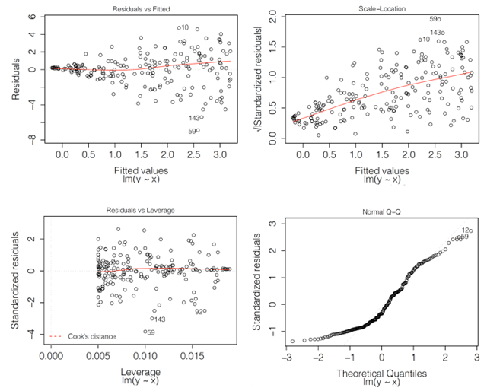

From the residual and scale plots, you are able to observe a fanning effect indicating the spread of the residuals do not have constant variance.
From the QQ plot, there are pointst that start to deviate heavily on the left tail, indicating that the errors are not distributed normally.
Seeing that residual graphs are from lm(y ~ x), we should try to log the response variable. We should also look into using bootstrapping, if logging the response doesn’t help us achieve normality on the residuals.

- (A regression model is used to compare two methods of teaching sight singing to third graders. The first teaching strategy (Approach) is the control group and is the current adopted strategy. The second teaching strategy, “Treat”, is a new strategy. The students were NOT randomly assigned to either of the two groups due to logistics of the schools schedules and logistics. The study gave each student an initial test before any training was provided. The students test score were then recorded as (InitialTS). After the initial test, students received training over a reasonable of amount of time during the school year and a final test was conducted and the score recorded (FinalTS).

Examine the regression model below. Write a formal conclusion using the regression model to determine if the new approach is associated with higher test scores. You may assume all assumptions are met.

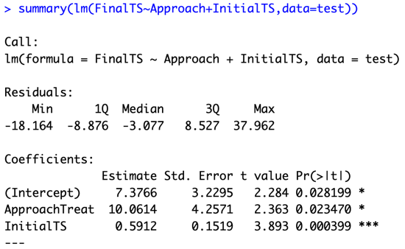

Assuming all the assumptions are met, the model shows that the new strategy “Treat”, has a statistically significant effect on third-grader’s sight-singing test scores. Students in the “Treat” group had scored 10.66 points (adjusting for the student’s initial test scores to the intercept) higher than the “approach” group. Assuming that the significance level is set the 0.05, at a p-value of 0.023 the new teaching strategy yields statically significant improvements.

- Interpret the 10.0614 quantity in the table in the previous problem.

10.0614 is the estimate for students in the Treat approach. Since the “approach” approach is the control reference, the estimate 10.0614 is the average adjustment to the test scores for students that were taught with the “Treat” approach.

- Consider your answer in 17. Why would a researcher prefer the interpretation you provided versus conducting a simple t-test between the Treatment and Control teaching strategies and interpreting a CI for the difference in means?

A simple t-test would only show whether or not the average score between the two groups are different from each other. The interpretation of question 17 would give a researcher more information, for example the initial test score before the students were taught.

- You are talking to a friend that is discussing a model that they built recently at work. They stated, “I used a bagging strategy where I fit 3 multiple linear regression models, 2 regression trees, 4 knn models, and 2 neural networks. For predicting a new observation, I would make a prediction by averaging the predictions from all 11 models that I had created”. Write a brief explanation as to why your friends description of what they did is not entirely correct.

My “friend” had employed a strategy that isn’t bagging” He had used different models and averaged out the predictions between all the different models. Although his method is valid in his own right, bagging is using multiple models of the SAME type and averaging out those predictions.

For each of the following scenarios, select which statistical model would be the most appropriate.

- Scenario 1: A study was conducted to estimate a local university’s rate of salary increases as a function of time. The study observed and followed the salaries of 100 faculty members over a 10 year period.

- Multiple Linear Regression
- Generalized Least Square
- Pooled or Welch’s t-test
- Bootstrap MLR
- Something we haven’t covered yet.

Repeated Measures.

- Scenario 2: Suppose we collect a set of data on a sample of PS5 video games based on the review site Metacritic. For each video game, we have, their Metacritic score, the name of the publisher, genre of the game, number of preorders, and 5 gaming websites review scores each on a 100 point scale. We are interested in understanding which factors affect a games overall Metacritic score.

- Multiple Linear Regression
- Simple Linear Regression
- Generalized Least Squares
- Pooled or Welch’s t-test
- Something we haven’t covered yet.

We have multiple predictors, so we would use a MLR to try and determine a metacritic score.

- Scenario 3: A medical researchers is studying two groups of patients (Healthy children and children with Lupus). The researcher believes they can build a model to predict if a child has Lupus or not, by using various clinical factors such as age, gender, and various measurements from blood work.

- Multiple Linear Regression
- Pooled or Welch’s t-test
- Generalized Least Squares
- Something we haven’t covered yet.

- The main reason we cannot use MLR in a repeated measures setting is
  - The assumption of normality on the errors is not met
  - The assumption of constant variance is not met
  - The assumption of independent observations is not met
  - All of the above
  - None of the above

The violation of independence has an effect on residuals which than affects the constant variance.

- When comparing analysis results between an MLR and repeated measure model we typically see differences in
    - The regression coefficient estimates
    - The standard error estimates
    - The residual plots
    - All of the above
    - None of the above

- The table below provides output of an MLR model that captures the relationship between the response variable Y and predictor variable X2 (continuous) by sex status X1(female/male).

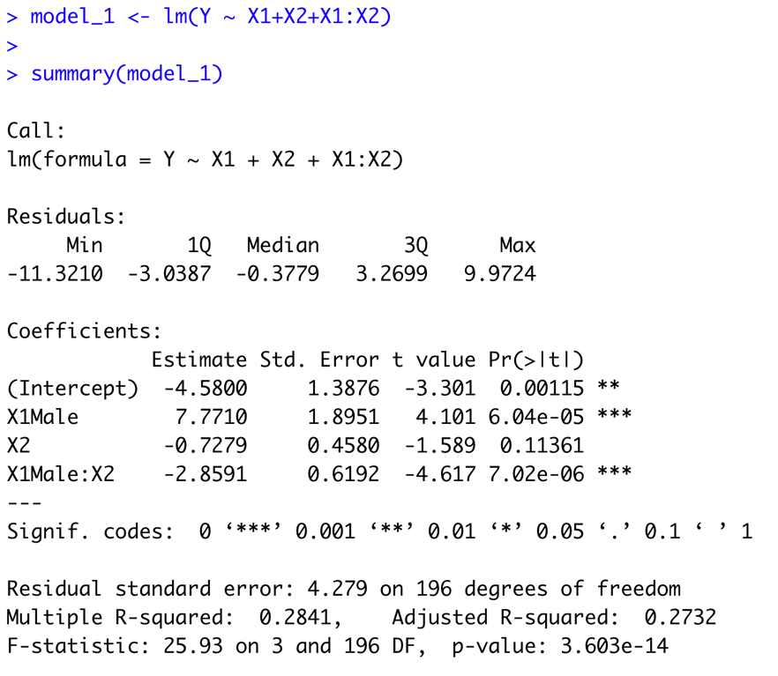

The appropriate contrast to provide a confidence interval for the slope (for X2) specifically for males is

        - (0,1,0,1)
        - (0,1,1,1)
        - (0,0,1,1)
        - (0,1,0,0)
        - (0,0,0,1)

X2 + (X1Male * X2) = Slope for Males

The Steve Bramhall Bonus Question (Pts based on quality of response. Can be worth up to 1.5 test problems)
A data set X has 100 observations, and 4 variables. Consider the following matrix:

. In class and in HW we discussed what happens when we multiply the two matrices together, XC, this creates a new data set. Answer the following questions about the new data set.

- How many observations are in this new data set?
  - There would be 100 Observations. (From the X dataset)

- How many columns are in this new data set?
  - There would be 3 columns (From the C Dataset)

- Provide a brief description of what each column in the new data set is. Bonus points for carefully worded answers.
  - The new dataset XC would be a 100 X 3 Matrix. Using “C”, as a reference. The First column would be the sum of each variable of each observation.
The Second column would be the sum of the quarter of each variable of each observation
The third column would only have the third variable of each observation.
  - Assuming that X was only 1 observation.
    - X = [X1 X2 X3 X4]

XC = [((X1 *1)+(X2*1)+(X3 *1)+(X4*1)) ((X1 *1/4)+(X2*1/4)+(X3 *1/4)+(X4*1/4)) ((X1 *0)+(X2*0)+(X3 *1)+(X4*0))]

XC = [(X1 +X2 + X3 + X4) 1/4(X1 +X2 +X3 + X4) X3) ← Each Column Separately Colored.

