DS 6371 Final Exam-Summer 2025
HONOR CODE: By taking this test and typing your name below, you are agreeing on your honor and in accordance with the SMU Honor Code (but more importantly, on your honor) to not have communicated with anyone, during the exam, in this class or outside of this class, that could have helped obtain answers to these questions. “Communicated” means by any medium including talking, phone, Slack, email, text, Facetime, Instagram, snap chat, etc. Also, all answers should be the work of the student … no answers should be copied and pasted from solutions, the internet, etc. Finally, by signing this exam, you are committing to not using ChatGPT or any other generative AI to help with this final exam.
Please type your name here (which serves as your signature) ____________________Johnny Vogt__________________
Directions and Submission: Simply save your answers to this document and upload them to the Final Exam assignment on Canvas with your name in the file name. You should type your answers directly into this document. You may do any mathematical work by hand and include a picture of that work in this document or simply type those calculations into this document.
Unless otherwise specified, assume and 95% confidence.
The Final Exam Begins Here!
- (5 pts) An experiment sampled 16 students at random and recorded their grade on their test, how much they studied (in hours) and how long they meditated (in minutes). Below are plots that reflect these data. The numbers on the middle plot represent Study Hours and the numbers on the far right plot represent the Meditation times.
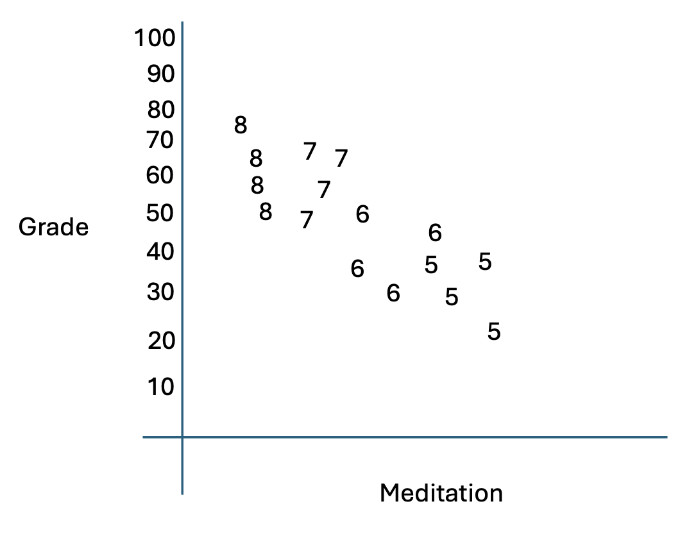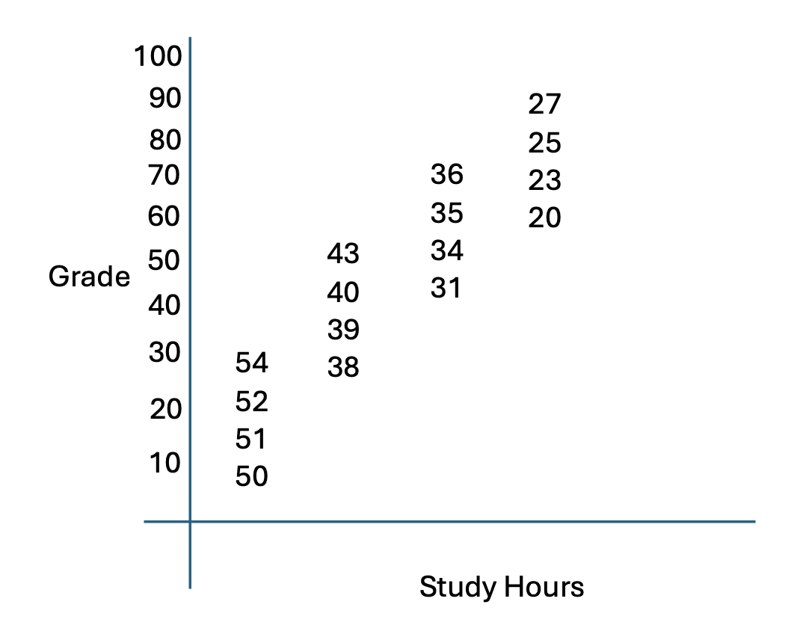
Which of the following parameter estimate tables best describes the associations reflected in the scatter plots above? Just put the letter of your answer here: D.
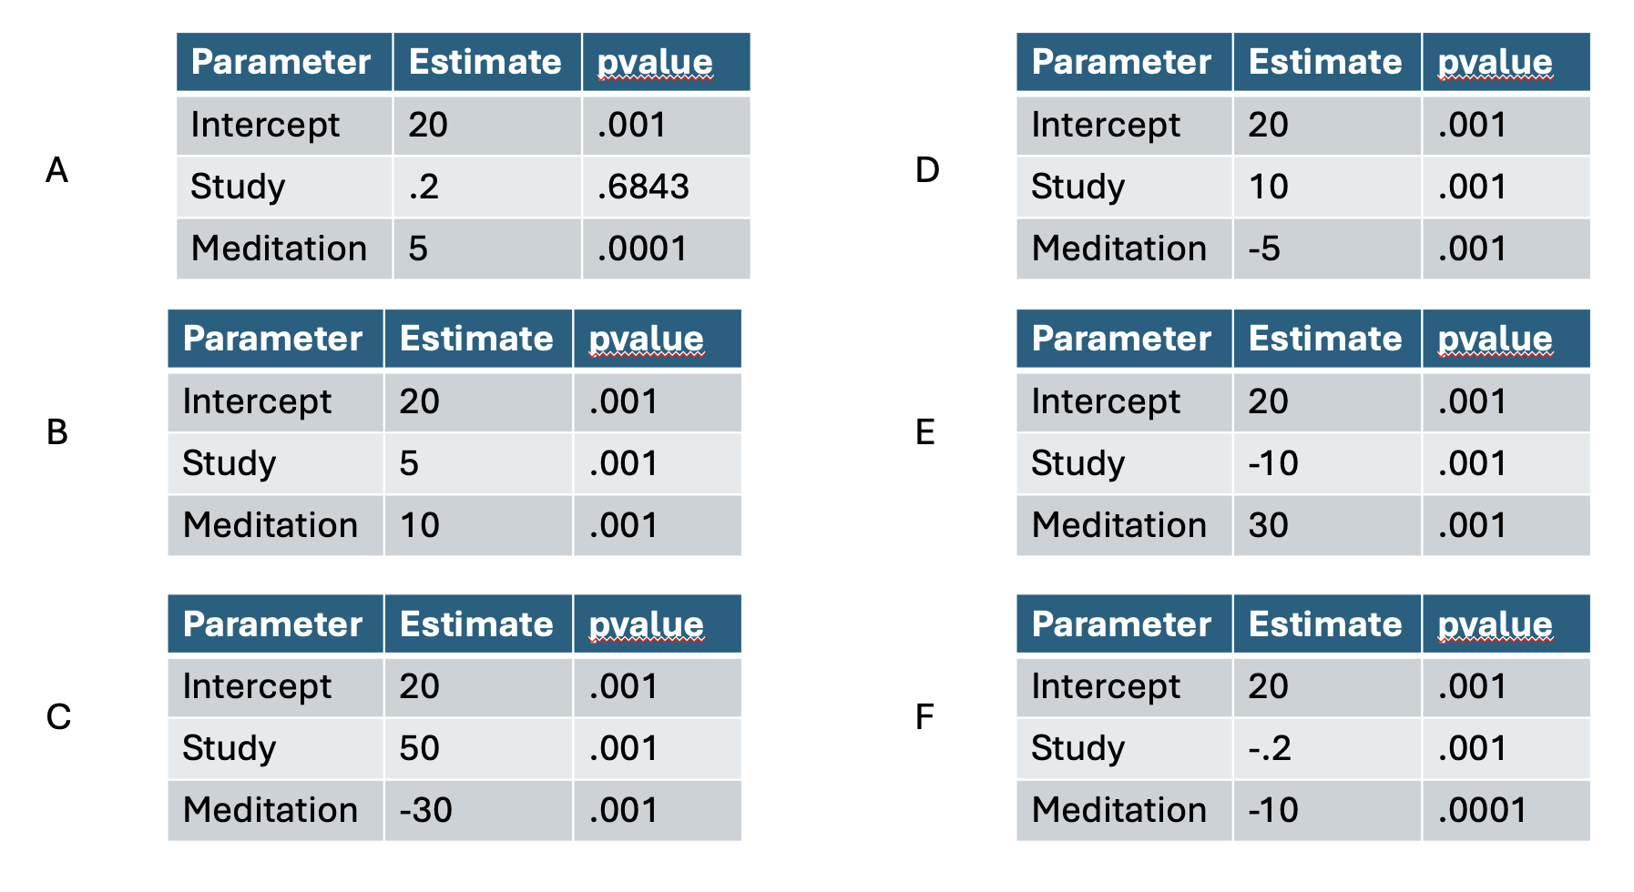
- (4 pts) Match the letter of the point on the Residual/Leverage plot to the most appropriate number on the Cook’s D plot. Note, only two letters will be used.
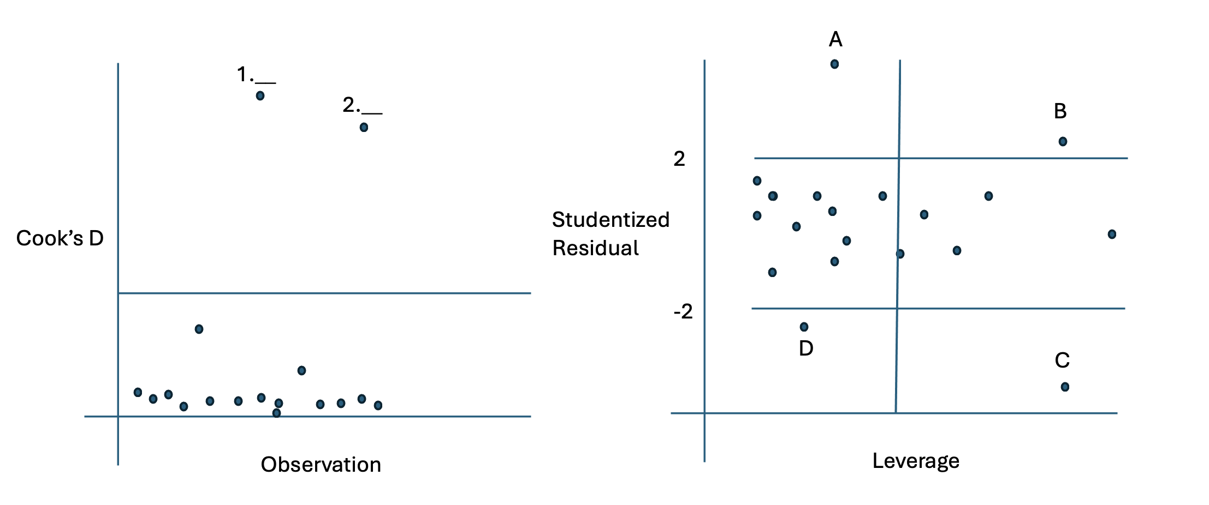
Please put the Letters of you answer here (3 pts each): Answer 1: A Answer 2. C

- (5 pts) Below is a linear-log fit of a response variable y and the explanatory variable x. There were 100 observations.

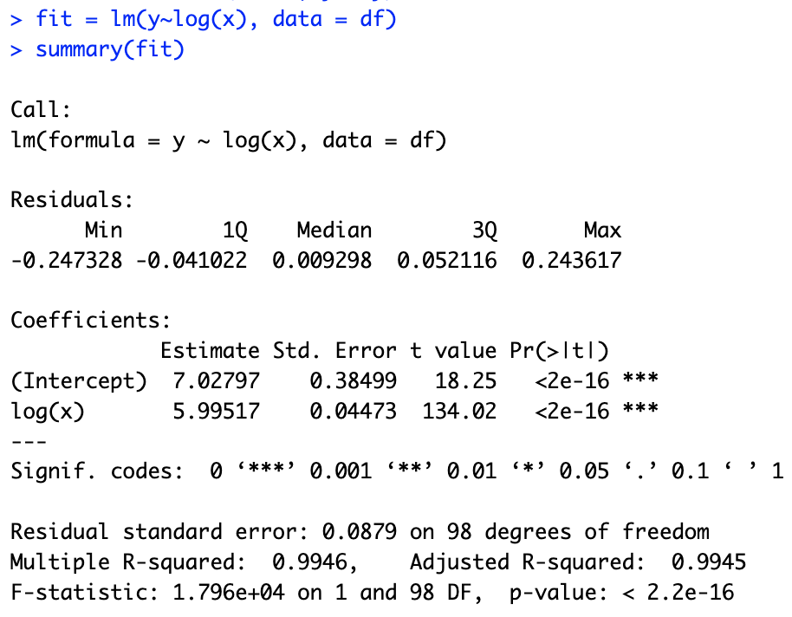

Interpret the slope of the log(x) term in the model. Provide a 95% confidence interval as well. (You will need to calculate this, please show your work (math calcuations) in calculating the confidence interval.
Estimate(log(x)): 5.99517
Confidence Interval: (5.906426, 6.083914)
- 5.99517 +/- Critical Value (1.984) * Standard Error (0.04473)
  - MOE: 1.984 * 0.04473 = 0.08874432
  - 5.99517 – 0.08874432 = 5.906426
  - 5.99517 + 0.08874432 = 6.083914
Slope Interpretation: Per 1% increase of the to the explanatory variable is associated with a mean increase of 0.0599517 to the response variable. At 95% confidence, the associated raise to the response variable from the 1% increase of the explanatory variable will fall between 0.05906426 and 0.06083914 units.

- (9 pts) Below is a table that shows the fit of 7 different models. The first column contains three simple linear regression models. The second column are models that have two variables and the last column is the model with all the variables in the model.
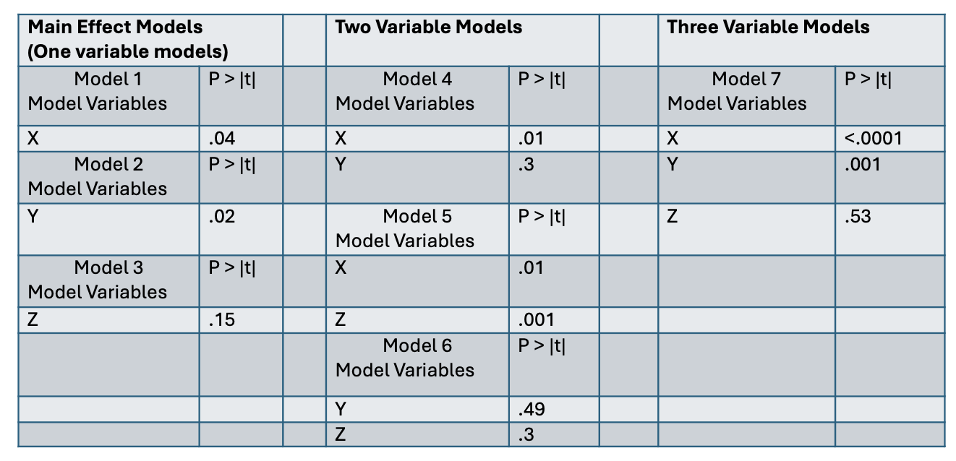
Conduct a forward selection using the parameter estimate table above. Assume the alpha to enter the model is 0.15. Simply write down the variables in the final model (3 pts) : XY
Conduct a backward elimination using the parameter estimate table above. Assume the alpha to exit the model is .05. Simply write down the variables in the final model (3 pts) : X
Next conduct a stepwise selection using the parameter estimate table above. Assume the alpha to enter and leave the model is .05. Simply write down the variables in the final model (3 pts) : XY

- (1pts) Who originally said, “All models are wrong but some are useful.”?
  - George E.P. Box

Analysis Question: The Study of Bacteria in the Oceans!

Scientists study the bacteria levels in the ocean to study phenonmeon like climate change and its potential effects on the environemnt. The file OceanBaterica.csv has the recodings of the levels of bacteria in three different oceans over four different seasons. The data also contains the temperature of the water (in Fahrenheit) and the oxygen level of the water.

- Start Simple …. Fit a simple linear regression model of Bacteria (response) versus Temperature: .
  - Write the estimated model specification. That is, write the model in equation form with the estimated slope and estimated intercept. (5 pts)

  - Interpret the Slope in sentence form including a 95% confidence interval. (5 pts)
    - The temperature of the ocean has an associated relationship to the bacteria level in the ocean. For every unit of increase to the temperature, there is an associated increase of 2.105 to the mean bacteria level measured at that observed temperature. At 95% Confidence, the associated increase will be in between 1.96621326 and 2.24346240. (Used 1a Screenshot)
  - Interpret the intercept if it is practical. Include a 95% confidence interval if practical. Explain why or why not you felt the intercept had a practical (5 pts) interpretation.
    - When the temperature drops to 0, the mean bacteria level of the ocean is calculated to be at 66.4. At 95% confidence, the intercept will be in between 58.157 and 74.64. In some cases, having the explanatory variable drop to 0 is only theoretical. Although temperature have the possibility of reaching zero and even below zero, ocean water starts to freeze at 28.4 degrees Fahrenheit causing the intercept to be impractical. Although creating the conditions to make ocean water to be zero degrees is possible in the lab, it’s extremely unlikely to find that naturally occuring.

  - Address the assumptions of the model and include relevant plots in your address. (6 pts)
    - Linearity: The scatterplot with Bacteria and Temperature appears to have a rough but positive linear relationship.
    - Homoscedasticity: Viewing the Residual plot of bacterias, the errors appears to have constant variance
    - Normality: The residuals of the dataset does follow a normal distribution with a slight right skew from a single point.
    - Independence: From what we are given from the prompt, we are given no reason to believe that each data point is independent from each other. We will proceed cautiously with any future test.

  - Do there appear to be any significantly influential points in this dataset? Why or why not? (5 pts)
    - From the Cook’s D plot, there is one point that has a value above 0.06. The same point is clearly visible on the scatter plot with a single point at a high temperature having a high bacteria level, well above the regression line. There are also a number of observations that are outside the 95% confidence limits of the regression.

- The scientists were curious if the season was associated with a change above and beyond the temperature of the water. Add season to the linear regression model above and fit the model. You do not need to address the assumptions for these problems.
  - Is there evidence that the season is a significant variable in predicting Bacteria after accounting for temperature? Briefly describe that evidence in one or two sentences. (5 pts)
    - Yes, there is evidence from the glm model output that shows that Season is significant in predicting Bacteria Level when accounting for temperature. In the Type III SS test, Season has a P-Value that is lower than a .05, indicating statistical significance.
  - Is there reason to believe that the relationship (slope) between bacterial levels and temperature is different between the seasons? Provide clear statistical evidence one way or the other. (5 pts)
    - Yes, there is sufficient evidence for us to believe that the slope between bacteria and temperature is different between the season. The Type I and Type III tests indicates that “Temperature*Season” variable has a P-Value of lower than 0.05 in both instances, showing that it’s statistically significant.
  - Specify your model for Fall and Summer. That is, write the regression models with the estimated intercepts and slopes for Fall and Summer (two different regression models). (5 pts)
Made both Summer and Fall the Reference used their respective outputs to make an equation to make it the equation smaller
    - Summer: Bacteria = 38.32587161 + 2.52134960(Temperature)
    - Fall: Bacteria = 100.5730110 + 1.5366363(Temperature)
  - Provide a plot of your four estimated regression lines with the points (observations) also on the plot. (5 pts)
    - The Analysis of Covariance should provide all the points on the plot as well as the four regression lines separated by color (season)
  - Scientists are interested in knowing the estimated difference in mean bacteria levels between the Fall and Summer when the temperature is 60 degrees Fahrenheit. Provide them with an estimate. Include a 95% confidence interval. (5 pts)
    - Summer: 189.6249 = 38.32587161 + 2.52134960 * 60
      - 95% CI:(137.2329,241.9808)
    - Fall: 192.7712 = 100.5730110 + 1.58366363 * 60
      - 95% CI:(138.4301, 247.1122)

- One of the scientists mentioned that she had read a paper that suggested that bacteria levels may be affected by oxygen levels and that the relationship may be exponential to either the second or third degree. With respect to the model you fit above in question 2 (the model with both temperature and season in the model) perform an analysis to assess if a linear (adding just to the model in question 2), quadratic (adding ), or cubic relationship (adding is useful to add to the model. Assess this using at least the adjusted R² and AIC. You do not need to address the assumptions for this problem. (10 pts)
  - Overall, adjusting the model to include Oxygen, whether its Linear, Quadratic, or Cubic greatly increases the Adjusted R^2. Out of the three, the Quadratic relationship has the highest adjusted R^2, slightly more than the Cubic relationship. Although the Cubic Relationship has a higher AIC, the difference between the Cubic and Quadratic scores are not large enough to assume that the model with the Cubic Relationship fits better than the Quadratic Model.

- Another scientist had read a paper that there may be a relationship between bacteria levels and the ocean the bacteria are in after accounting for the temperature, oxygen and the season. Conduct an extra sum of squares test to see if there is significant evidence to conclude that the mean bacteria level depends on the ocean it is in after accounting for temperature, oxygen level and season. You do not need to address the assumptions for this problem. (15 pts)

Source of Variation | Degrees of Freedom (df) | Sum of Squares (SS) | Mean Squares (MS) | F-Value | p-value
Between Groups (Ocean) | 2 | 4.7382 | 2.3691 | 0.13705 | .87
Within Groups (Error) | 834 | 14416.8481 | 17.2864
Full | 836 | 14421.5862
  - At a default significance level (a=0.05), there is not enough sufficient evidence to determine that the mean bacteria level is different between oceans, when accounting for the temperature, oxygen level and the season.

Appendix

1.
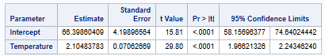

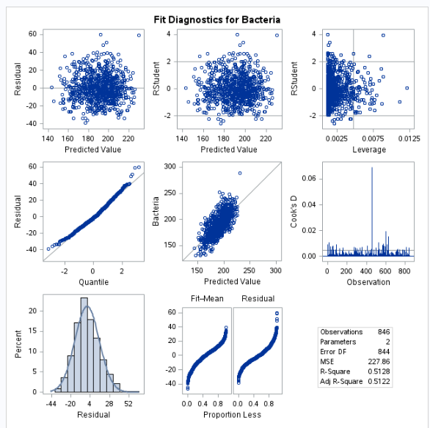
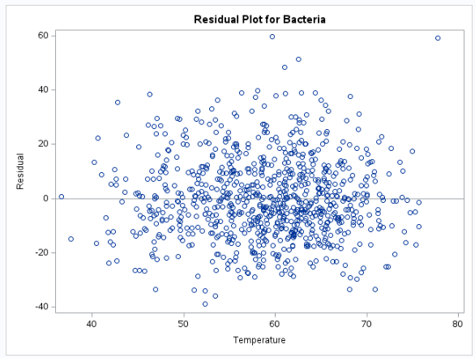
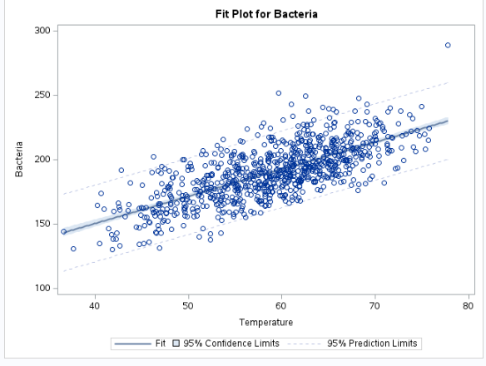

2:
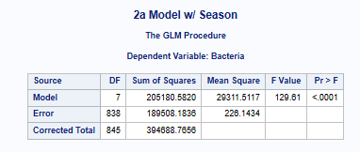
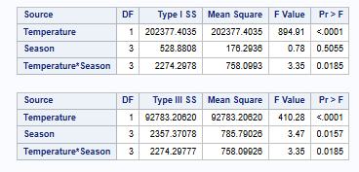
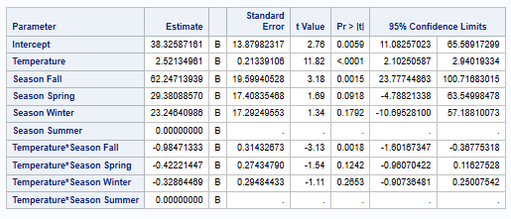

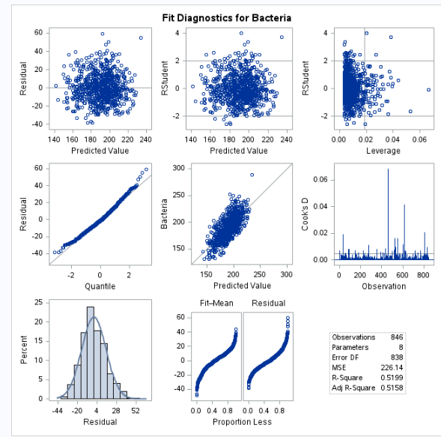

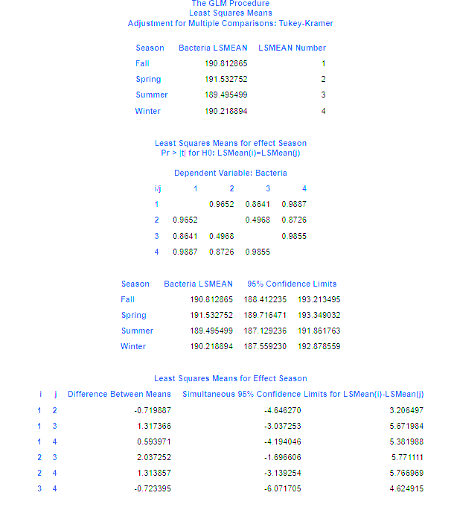
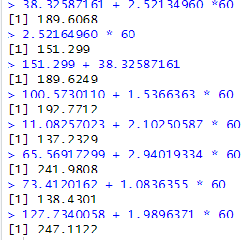

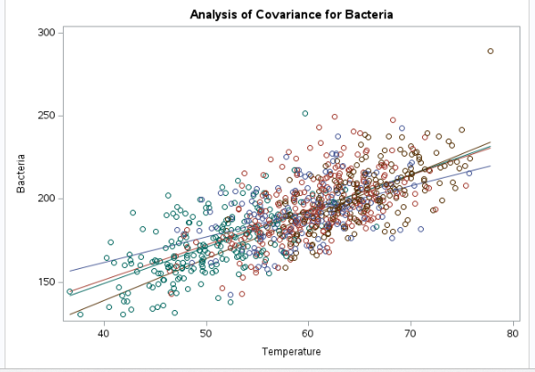

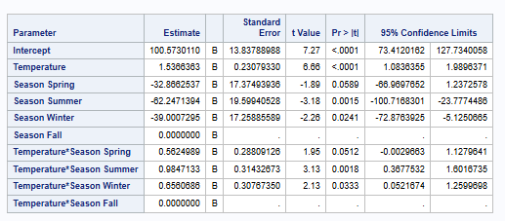

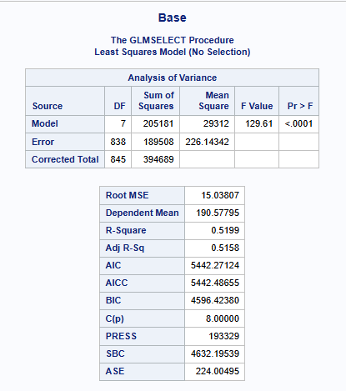
3.
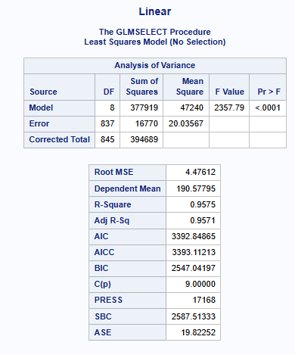

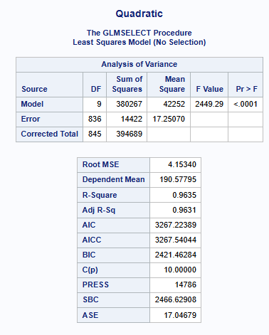
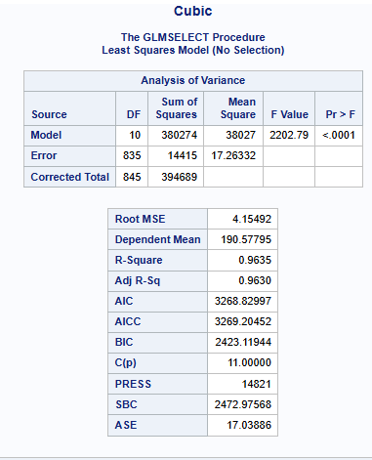

4.

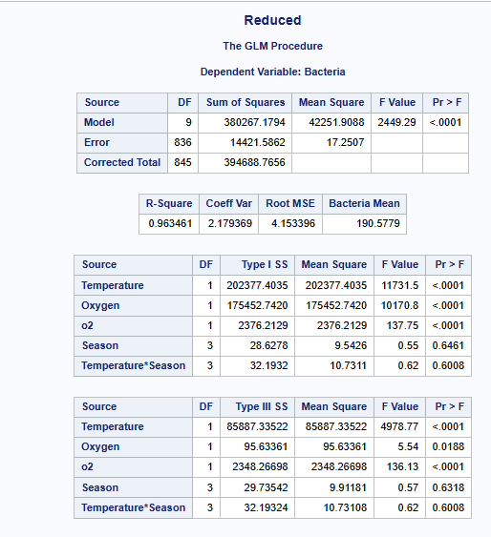
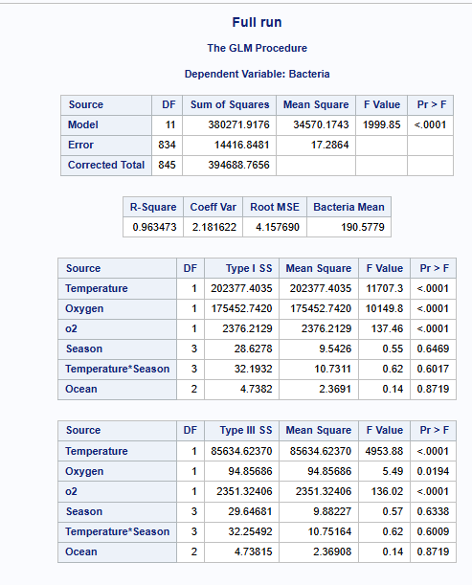

Code (SAS)
/*Final*/
FILENAME REFFILE '/home/u64096638/sasuser.v94/Uploaded_Data/OceanBacteria.csv';

PROC IMPORT DATAFILE=REFFILE
DBMS=CSV
OUT=WORK.final_bacteria;
GETNAMES=YES;
RUN;

PROC CONTENTS DATA=WORK.final_bacteria; RUN;

/* Checking out the data with univariate*/
proc univariate data=work.final_bacteria;
run;

/*Start 1a*/
proc glm data = WORK.final_bacteria plots = All;
model Bacteria = Temperature / solution clparm;
title "1A Inital Model";
run;
/*End 1a*/

/* 1d */
proc sgplot data=WORK.final_bacteria;
scatter x=Temperature y=Bacteria;
reg x=Temperature y=Bacteria;
title "Raw Data Scatter Plot";
run;

/*End 1d*/

/* 2a */
proc glm data = WORK.final_bacteria plots = All;
class Season(ref="Summer");
model Bacteria = Temperature Season Temperature*Season /solution clparm;
title "2a Model w/ Season";
run;
/*End 2a*/

/* 2b*/
proc glm data = work.final_bacteria;
class Season;
model Bacteria = Temperature Season Temperature*Season;
lsmeans Season / pdiff cl adjust=tukey alpha=0.05;
run;
/* END 2b */

/* 2C */
proc glm data = WORK.final_bacteria plots = All;
class Season(ref="Fall");
model Bacteria = Temperature Season Temperature*Season /solution clparm;
title "2a Model w/ Season";
run;
/* END 2c */

/* 2d */
proc glm data = WORK.Final_Bacteria;
class Season;
model Bacteria = Temperature Season Temperature*Season;
output out=preds p=Predicted;
run;

proc sgplot data=preds;
scatter x=Temperature y = Bacteria/ group=Season transparency=0.2;
series x=Temperature y=Predicted /group=Season lineattrs=(thickness=2);
run;
/*End 2d*/

/*2e*/
proc glm data = WORK.final_bacteria plots = All;
class Season(ref="Summer");
model Bacteria = Temperature Season Temperature*Season /solution clparm;
title "2a Model w/ Season";
run;

proc glm data = WORK.final_bacteria plots = All;
class Season(ref="Fall");
model Bacteria = Temperature Season Temperature*Season /solution clparm;
title "2a Model w/ Season";
run;
/*End 2e*/

/*3*/
/*make polynomials*/
data work.final_bacteria_poly;
set work.final_bacteria;
o2 = Oxygen * Oxygen;
o3 = o2 * Oxygen;
run;

/*Running GLMSelect to see if their useful */
proc glmselect data=work.final_bacteria_poly plots=none;
class Season;
model Bacteria = Temperature Season Temperature*Season
/selection=none showpvalues stats=all;
title "Base";
run;

proc glmselect data=work.final_bacteria_poly plots=none;
class Season;
model Bacteria = Temperature Season Temperature*Season Oxygen
/selection=none showpvalues stats=all;
title "Linear";
run;

proc glmselect data=work.final_bacteria_poly plots=none;
class Season;
model Bacteria = Temperature Season Temperature*Season Oxygen O2
/selection=none showpvalues stats=all;
title "Quadratic";
run;

proc glmselect data=work.final_bacteria_poly plots=none;
class Season;
model Bacteria = Temperature Season Temperature*Season Oxygen O2 O3
/selection=none showpvalues stats=all;
title "Cubic";
run;
/* End 3*/

/*4*/
/*Reduced*/
proc glm data=work.final_bacteria_poly;
class Season Ocean;
model Bacteria = Temperature Oxygen O2 Season Season*Temperature;
title "Reduced";
run;

/*Full */
proc glm data=work.final_bacteria_poly;
class Season Ocean;
model Bacteria = Temperature Oxygen O2 Season Season*Temperature Ocean ;
title "Full";
run;
/*End 4*/

