Introduction
There are so many factors that go into the decision to buy a home, but one of the largest aspect of purchasing a home is the price. The price of a house can vary due to multitudes of reason, whether its the square footage, amount of rooms, or the type of wood the front door uses. In this study, we’ve collected over 1000 houses across the city of Ames, Iowa to train our Sales Price Model. We will conduct 2 analyses, the first one being a commission for “Century 21 Ames” to take the data from three neighborhoods and provide a model based on the Square footage of the living area to predict what the price of the sale. We will also provide a Rshiny app for Century 21 Ames to visually analyze each neighborhood’s Living Area Square footage and Sale Price relationship on a scatterplot Our second analyses will ingest ALL of the homes in Ames and create a total of three models; a simple linear regression model and 2 multiple linear regression model(SalePrice ~ GrLivArea + FullBath) (SalePrice ~ ModelZoneing etc.) We will provide the adjusted R^2, CVPRESS, and Kaggle Score for each model. Most of our coding will be done in SAS, with the exception of the Rshiny App.

1.
Problem:
Century 21 Ames is a Real Estate company in Ames, Iowa looking for an analyses on their respective neighborhoods that they primarily sell in; North Ames, Edwards, and BrookSide. They are coming to us to create a model that that would estimate the sale of a house based on the General Living Area (Sq. Ft) with respect to their neighborhood. Since real estate companies prefer to talk about sq. ft. in increments of 100, we will transform the data with respect to that. We will create and fit a model that will estimate the sales price of a house based on sq ft. of the Living Area per neighborhood. We will also provide a written analyses along with a conclusion for the customer.

Regression Equation:
SalesPrice = β0 + β1(GrLiArea) + β2(Nbrhood)

Transformed → log(SalesPrice) = β0 + β1(log(GrLivArea)) + β2(Nbrhood)

Assumption: See Appendix for plots
Each data point should have independence from each other far as we can tell from the data we are given. After plotting the raw data without any transformation , the data looks to violate a few assumptions. Plotting the data, its difficult to determine if there is a linear relationship, since there is a lot of crowding with values that seem to look like outlierss. A visual look at the Residual plot, we can observe there is already crowding towards the left of the plot with a slight fanning out as it goes towards the right and of the right of the plot there seems to be an outlier. The QQ Plot indicates that the data does deviate from a normal distribution. The raw data does seem to have homeoscedasticity. After Log-Transforming the both the SquareFootage and the Sale price the data the fit diagnostics show us a distribution that fit the assumptions better than before the transformation. The points on the residual plot seem to seem to be randomized and the histogram of the residuals follows a normal distribution. The QQ plot points follow the reference line a lot more closely than the pre-transformed data. The largest point of concern is that the Cook’s D plot has an observation that is significantly larger than the other points. After observing the data point, I’m unable to determine if the data was an error or not. We will proceed with the observation in the set, keeping it in mind with the model.

Model Selection: Screen shots in Appendix
After finding the CVPRESS between both Models (Pre-Transformation and Post-Log Transformation), the Post-Log Transformed model hold a significantly lower CVPRESS Value. Which would indicate that the model is a MUCH better fit than the model we made for the pre-transformed data.

Parameters: See Appendix
Using the North Ames (NAmes) as the reference, the Sales Price would increase by 8.95% for every 200 Sq. Ft. that the house increase. When you add in the adjustments for each neighborhood, BrookSide’s percentage increase is 16.13% and Edwards is 9.94% for every 200 Sq. Ft. that the house increases. When you revert the intercept back to the original scale, a house with 0 Sq. Ft., the house/property should sell for $4865.87 in North Ames. When you adjust the intercept for each neighborhood, the intercept for BrookSide is $368.07 and Edwards is $2981.

Confidence Interval: See Appendix for Intervals
Examining all the intervals for each coefficient, the Edwards neighborhood’s influences does not seem to be statistically significant due to zero being within the interval. At a 95% confidence, we are unable to reject the hypothesis that the median value of homes in the Edwards neighborhood is different than the houses in North Ames. BrookSide’s influence and adjustment to the intercept and slope does seem to be statistically significant for us to be 95% confident that the median value of Brookside and North Ames is different from each other.

Conclusion:
Century21 commissioned an analysis of how much of the value of the homes are affected by the Square Footage of the Living Areas of home and how much does it differ between the three neighborhoods that they sell in; BrookSide, Edwards, and North Ames. Upon examining the raw data, it presented violations (Homoscedasticity and Normality of Errors) to a linear regression model. These violations encouraged us to transform the data in order to fit a linear regression model. After we used the natural logarithm of the Sale Price and the square footage of Living Areas, the distribution fit better than it did prior to the transformation. The choice of the model was validated by the value of CVPRESS and we proceeded with our “Log-Log” Model. Overall there is a strong relationship with the sale value of a house and the Living area with the sale value approximately growing .38% - .56%, averaging at .47%, for every 1% increase of the square footage of the house using North Ames neighborhood as a reference for the model. From the analysis, we are able to say with 95% confidence that the BrookSide Neighborhood’s adjustment and influence to the intercept and slope of the model are statistically significant enough to say they are different. The same cannot be said for the Edwards neighborhood, as the adjustments are not that far off from the reference Intercept and Slope. Both neighborhoods (BrookSide and Edwards) do have lower estimated baseline (Intercept) home values, when the theoretical square footage falls to zero, but both neighborhoods have steeper estimated increases (Slopes) to the overall value than North Ames. It is important to restate that BrookSides adjustment to the intercept and slope are statistically significant at a 95% confidence level and that Edwards was not significant enough at a 95% confidence level for use to truly claim that the median value of the houses are different.

R-Shiny in Appendix
https://johnny-jovorsky.shinyapps.io/Home_Prices_Ames_IA/

2.
Problem:
On the second analysis, we are to build models to predict the sale value of homes for the whole city of Ames, Iowa. In total there will be 3 models for the sale prices; a Simple Linear Regression Model and 2 Multiple Linear Regression Models. We are given the explanatory variables for one of the Multiple Linear Regression Models, but we will choose the explanatory variable for the Simple Linear Regression Model and the 2nd Multiple Linear Regression Model. There will be a table (Appendix) that will include the Adjusted R^2, CV PRESS and Kaggle Score.

Regression Equations:
Simple Linear Regression: logSalePrice = β0 + β1(MSZoning)
Multiple Linear Regression(1): logSalePrice = β0 + β1(logGrLivArea) + β2(FullBath)
Multiple Linear Regression(2): logSalePrice = β0 + β1(OverallQual) + β2(logGrLivArea ) + β3(Neighborhood) +β4(GarageCars)+ β5(logbsmtsqft) + β6(MSZoning) +β6(BldgType) +β7(Heating)

Assumptions: (See Appendix for Graphs)
SLR: We had learned from the previous analysis that the SalePrice values has the potential to create outliers, so we’ve already primed the data to compare the two models to determine how well the models fit. Comparing the two GLM Outputs, the Fit Diagnostics fit better for the “logSalePrice” than it does for “SalePrice”. The QQ Plot suggests that the distribution follows a theoretical normal distribution. The distributions of residuals are normal as well, showing that the errors are normally distributed along with homoscedasticty. Each point, from what data we are given do not have any relation to each other.

MLR(1): The first Multiple Linear Regression Model fit the models pretty well. Oberving the Residual Plot, there seems to be a lot of randomization and its difficult to discern any pattern from it. The points on the QQ Plot follow the reference pretty closely, but shows that there may be some outliers, which is supported by the distribution of the residual. Aside from the left skew, the data does follow a normal distribution. From the first analysis, we were able to know that we needed to log-transform both the SalePrice and Living Area Square Footage in order to fit the data better. The outlier is shown in the cook’s D Plot, but after finding the Outlier, I was unable to ascertain if the point should be deleted or not. Since the point doesn’t seem to be too egregious, we should be okay keeping it in, as long as we keep that in mind with the model.

MLR(2): The second model has just a few more variables added to it, so I was a little bit more lenient with fitting it. Before checking the fit, we needed to use the natural log for the Square Footage of basements. Due to possiblity that some houses may not have any Basements, we needed to make sure that the instead of an empty value, we put in a zero instead. For the Test set, there was also a some NA entries for MSZoning and an empty entry for GarageCars. I replaced the empty entry with 0 for Garage Cars and replaced the NA with the Mode (RL) for MSZoning. Similar to the previous MLR, the Fit Diagnostics are similar, even down to the Cook’s D plot that shows the outlier. Although the outlier seems to have less of an effect, but there are a few more outliers than befroe. The QQ plot is similar to the first MLR, following a normal distribution, but with a slight skew. The homoscedasticity of the errors seem to show constant variance for variable through the residual plots. The errors do show a farily normal distribution, but with a left skew as well. The violations are not egregious enough to throw this model, so we will proceed with caution knowing that the outliers would skew the model slightly.

Model Comparison:
We had created three models to predict the logarithm of the SalePrice based based off of different variables for each model. The first model was based on the Neighborhoods. The second was based on 2 variables, the logarithm of the Square Footage of the Living Area and how many Full Bathrooms are in the house. Lastly, the third model was based on 8 variables; Overall Quality, Log(GrLivArea), Neighborhood, GarageCar, Log(bsmtsqft), MSZoning, BldgType, Heating. Moving forward, I’ll be referring to them as SLR, MLR1, and MLR2 for ease. For the adjusted R^2, the SLR had the weakest variable at .5380 and MLR2 had the strongest at .8588. The adjusted R^2 increases it’s value only when new variables increases the accuracy of the model, and the value itself is the measurement of the proportion of variance that the model has. The CVPRESS is a statistic that measure s how well the model does with potential test data. The lower the value, the less errors the model makes with new data points. MLR2 has the lowest CVPRESS at 33.12 and the SLR has an extremely high value at 4.3907868E12. We had taken each model and had them predict using the test data from Kaggle. MLR1 had the worst Kaggle score with .28445 and MLR2 had the best score at .16389

Parameters:
SLR: Any reference to the response variable will be the natural logarithm of the original baseline. Using “NAmes” as a reference, three neighborhoods (Sawyer, NpkVill, and Blueste) do not have any noticeable effect/difference to the adjustment of the slope. Every Other neighborhood has a statistically different effect on the slope. When a house is in NAmes, the SalePrice the median house in the neighborhood is $142,635

MLR1: Like the previous model, the Response model is the logarithm of the SalePrice. The first MLR uses the logarithm of the Living Area Square Footage and the amount of bathrooms. Every 1% increase of the of the Living Area Sq. Footage is associated with an increase between 0.6568% and 0.7708%, averaging of 0.71% increase to the median of the SalePrice. Given that the Square Footage is held at a constant, the SalePrice increases between 12.3% and 19.9% averaging out to an increase of 16% for every bathroom.

MLR2: In this model, the response model is still the natural logarithm of the SalePrice. Using NAmes as a reference, most neighborhoods show a statistically significant difference in the SalePrice. The model uses multiple predictors, some having larger effects than others. Some of largest influences being Overall Quality and the log-transformed Living Area. Every 1% increase of the Living Area, the sale price would grow between 0.24 – 0.5% and in Overall Quality, every unit of increase for that variable, the sale price would increase by 13.4 – 17.4%.

Conclusion:
In this analysis, three regression models were created to predict the natural logarithm of the SalePrice of homes in Ames, Iowa; one simple and two multiple. In the Simple Linear Regression(SLR), we had based that model on the Zoning of the houses. The first Multiple Linear Regression model, we used two variables, the natural logarithm of the Square Footage of the General Living Area and the amount of Full Bathrooms in a home. The third model, we were allowed create a model based on as many predictors that we can use; Overall Quality, Neighborhood, Garage Car Capacity, log(Basement Sq. Ft), Zoning, building type, and the type of heating a home used.
The SLR Model using only the zoning of the house, were only allowed to create sale prices for each zone. This created a very limited amount of prices that each house could choose from, demonstrating that this model had very poor predicitng power due to its limitations. Interestingly enough, the first MLR Model performed poorly on the kaggle scores, even though the model had “better” CVPRESS and Adjusted R^2 values than the SLR. The second MLR Model performed significantly better than the other two with all three measuring value (Adjusted R^2, CVPRESS, and Kaggle).

The SLR Model compared the Logarithm of the SalePrice to each Neighborhood in Ames using North Ames as the reference. Nearly every neighborhood had a statistically significant difference adjustment to the intercept, allowing us to claim with a 95% confidence level that all but 3 neigborhood’s adjustment to the intercept is different than North Ames’ adjustment.

In the first MLR, we created a log-log relationship between the Living Area and the Sale Price, allowing us to make a muliplicative interpretation. For ever 1% of Square footage to the Living Area, the Sale Price should increase between 0.66% and 0.77%, given that we hold the amount of Full Bathrooms for a house. Inversely, the addition of a Full Bathroom has an associated increase of 12.3% to 19.9% to the Sale Price. The model had some outliers and the residual distribution had a left skew, suggesting that the model may have some limitations. Despite the violations, they were not egregious enough to throw the model out in favor of a new one.

The second MLR Model was the most comprehensive model out of the three models using 7 predictors. The variables were chosen through a series of steps that determine correlation and best fit for the model. Initally, we plotted the data against the log(saleprice) to view the linearity of the relationship, any data that had a violation, we would log-transform the variable and continue. Running the “corr” process in SAS, all of the numerical variables were measured for correlation against the log(saleprice), any variable that had a significant correlation value was thrown in to a GLM Select StepWise Selection process to determine which values were a best fit to predict the the log(saleprice). Adding the categorical variables were not as in-depth, using our own domain knowledge, we chose variables that should have an effect on the price of a house. All of those variables were thrown in a the same GLMselect process and the output was chosen to go to the final glmselect Process. The final GLMSelect Process was the output of both the categorical and numerical GLM Select outputs into one. This model did fit well against the assumptions although there were outliers that should’ve only had a minor impact to the regression. Overall Quality and the Living Area Sq. Ft. had a large influence to the Sale Price. Every one unit increase to the Overall Quality Score was associated to raising the median Sale Price by 13.4% - 17.4%. Every 1% increase of the Living Area was associated with 0.24% - 0.5% increase to the median Sale Price.

Given the three models, the most comprehensive model also turned out to be the most accurate model. The predictors in the third MLR model explain for 85.88% of the variance of the distribution residuals (Adj. R^2) and performs well predicting with data that’s not trained on (CVPRESS). The efficacy of the model was shown by testing it in Kaggle and scored significancantly better than the other two models.

Appendix
Analysis 1
Raw Data (Pre-Transformation)
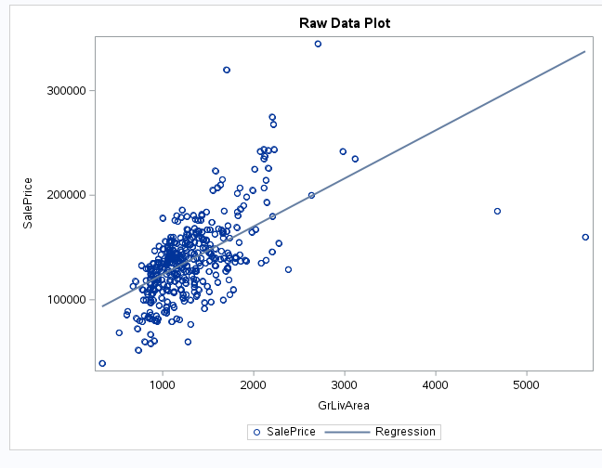
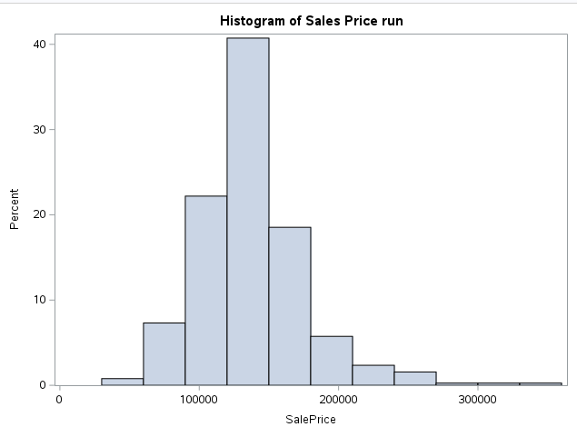
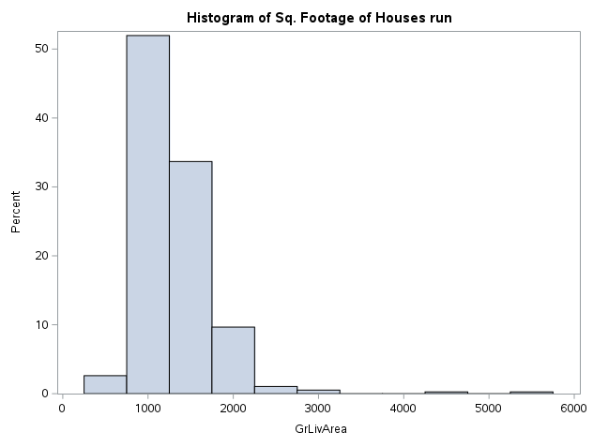
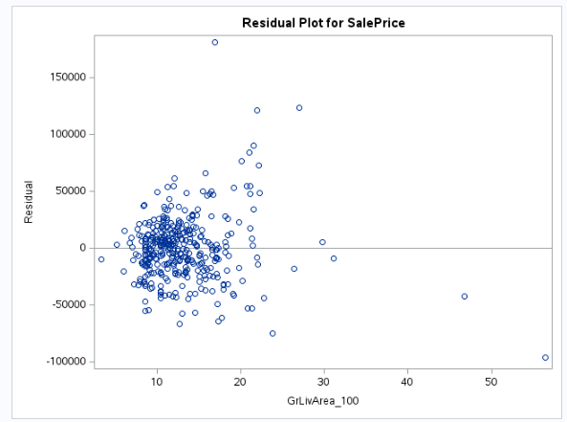
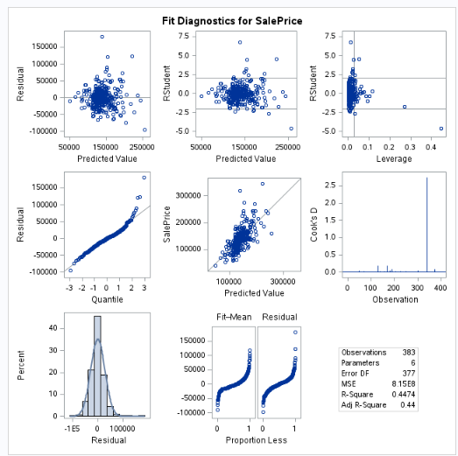

Data Post Log-Log Transformation
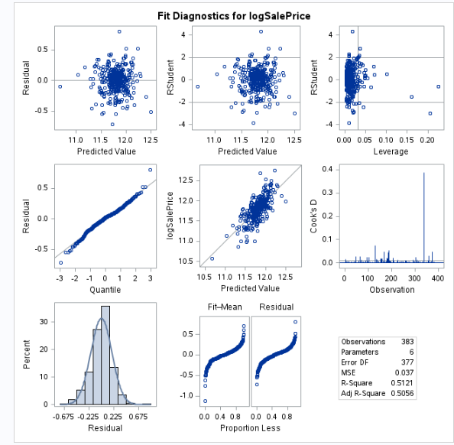
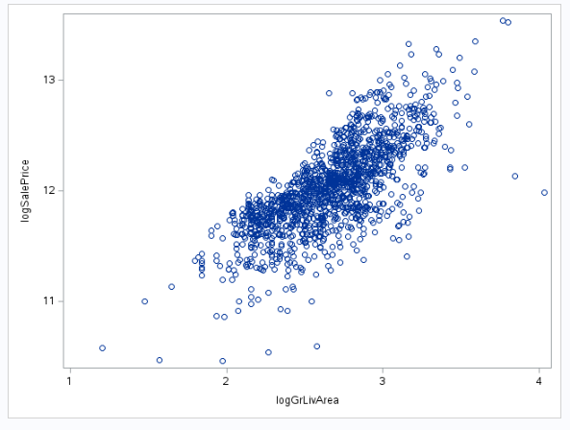

Model Selection Variables
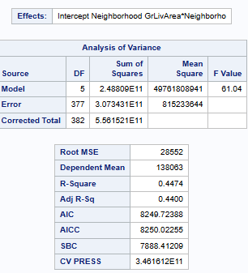
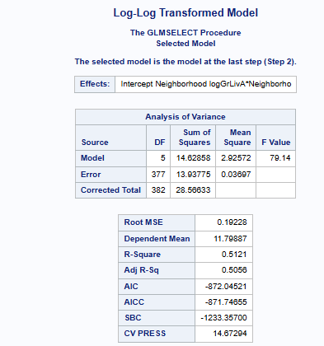

Parameters:
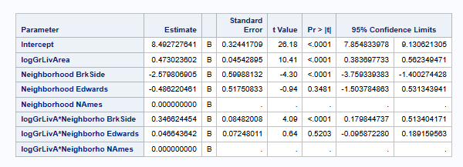

Question 2:
SLR:
ScatterPlot of MSZone
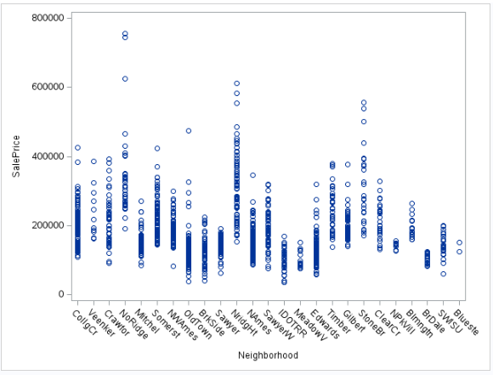

Fit/Assumption (Pre-Transform):

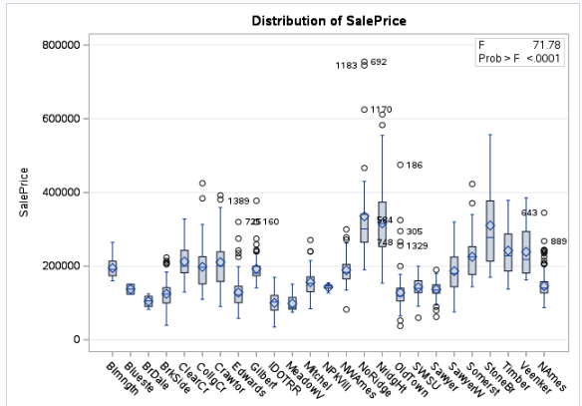
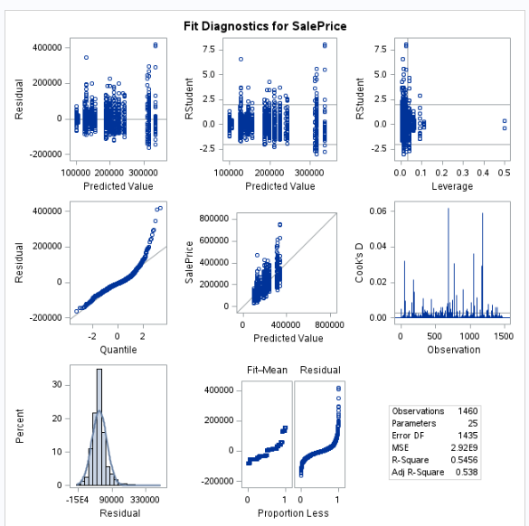

Fit/Assumpttion (Post Transformation):
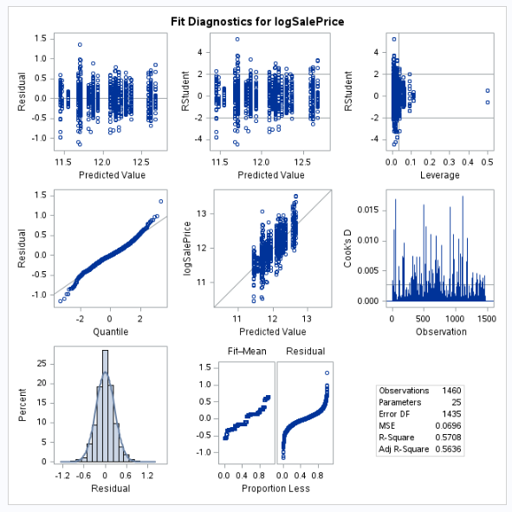
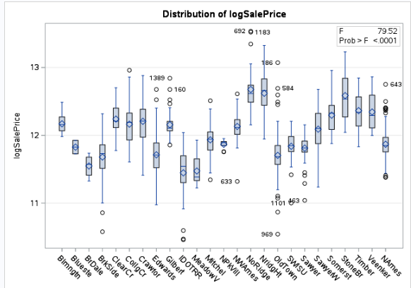

Parameter Table (Post-Transformation):
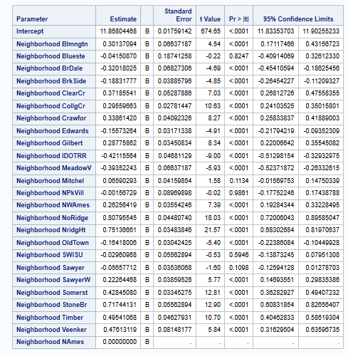
MLR 1:
ScatterPlots:
logSalePrice vs FullBath and logsaleprice vs logGrLivArea:
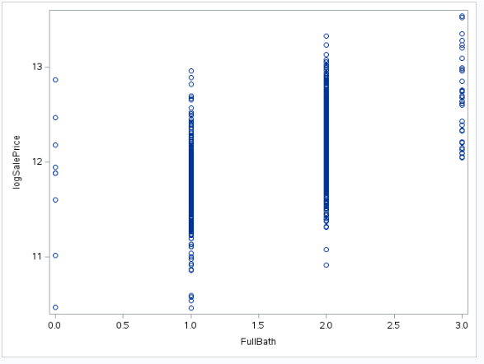
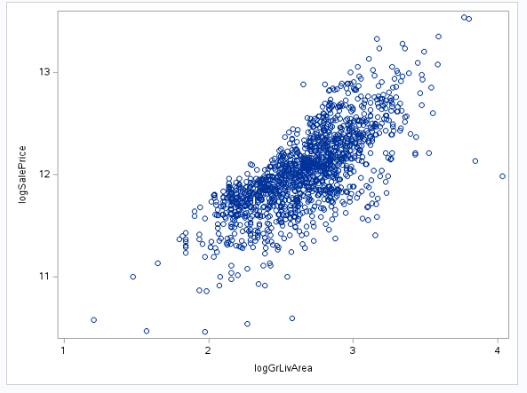
Fit/Assumption
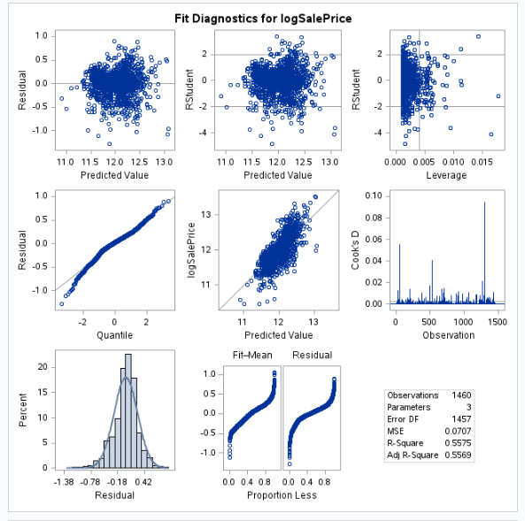
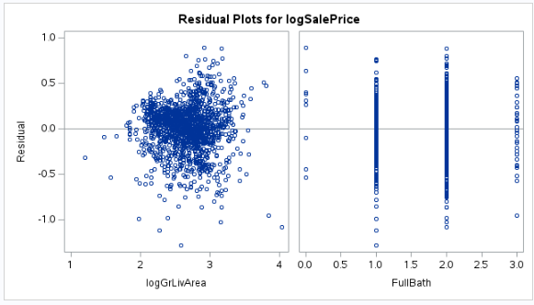

Parameter Estimates:
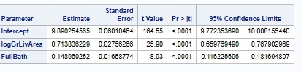

MLR 2:
Strongly Correlated Variables (Numerical) / GLMSelect Outputs of Categorical Variables
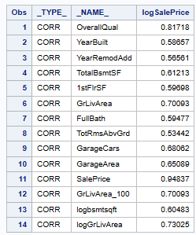
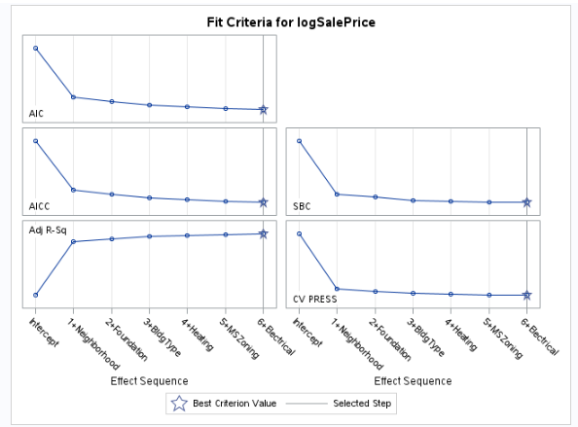

GLMSelect(Both Numerical and Categorical)
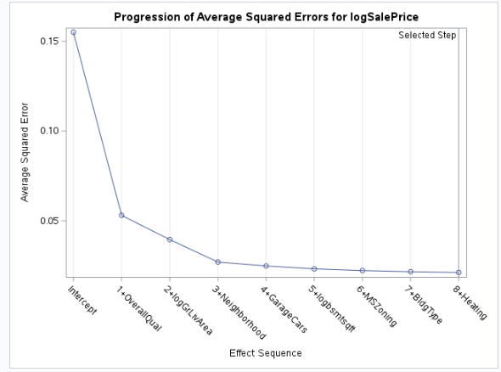
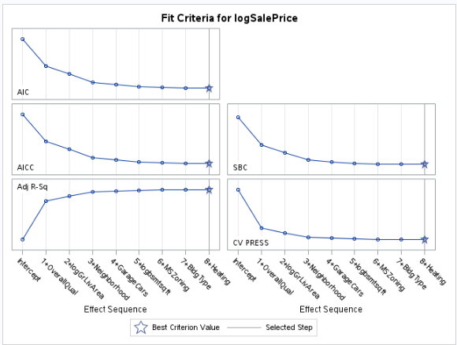

Fit/Assumptions:
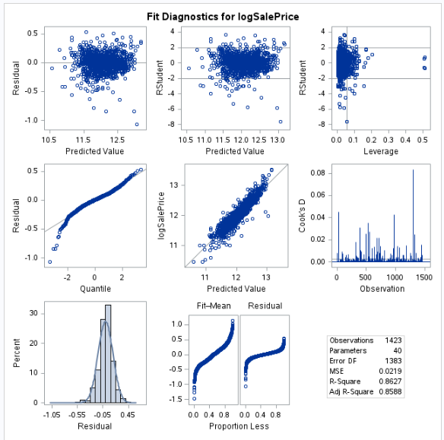
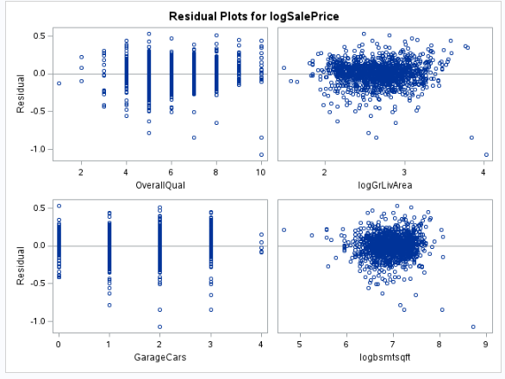

Adj. R^2/CVPress/Kaggle Score Table:
Predictive Models | Adjusted R2 | CV PRESS | Kaggle Score
logSalePrice = β0 + β1(Neighborhood) | .5380 | 4.390768E12 | 0.26717
logSalePrice = β0 + β1(logGrLivArea) + β2(FullBath) | .5569 | 103.75788 | 0.28445
logSalePrice = β0 + β1(OverallQual) + β2(logGrLivArea ) + β3(Neighborhood) +β4(GarageCars)+ β5(logbsmtsqft) + β6(MSZoning) +β6(BldgType) +β7(Heating) | .8588 | 33.11787 | 0.16389

Code:
Rshiny Code
library(shiny)
library(bslib)
library(ggplot2)
library(plotly)
library(DT)
library(scales)
df <- read.csv("data/train.csv")
ui <- navbarPage(
"Ames Explorer",
tabPanel(
"Overview",
sidebarLayout(
sidebarPanel(
h4("Filter Neighborhoods"),
selectInput("input1", "Neighborhood(s):",
choices = unique(df$Neighborhood),
selected = c("NAmes", "Edwards", "BrkSide"),
multiple = TRUE
),
br(),
sliderInput("input2", "Overall Quality (1–10):",
min = min(df$OverallQual, na.rm = TRUE),
max = max(df$OverallQual, na.rm = TRUE),
value = range(df$OverallQual, na.rm = TRUE),
step = 1,
ticks = FALSE
),
helpText("Use the dropdown and slider to filter the data below.")
),
mainPanel(
fluidRow(
column(4, value_box(
title = "Oldest Home",
value = textOutput("oldest_home"),
theme = "bg-primary"
)),
column(4, value_box(
title = "Common Quality",
value = textOutput("top_quality"),
theme = "bg-primary"
)),
column(4, value_box(
title = "Total Homes",
value = textOutput("home_count"),
theme = "bg-primary"
))
),
br(),
fluidRow(
column(6, plotlyOutput("price_hist")),
column(6, plotlyOutput("scatter_plot"))
)
)
)
),
tabPanel(
"Data",
fluidPage(
h4("Data"),
DTOutput("datatable")
)
)
)
server <- function(input, output) {
# data
filtered_data <- reactive({
req(input$input1)
df[df$Neighborhood %in% input$input1 &
df$OverallQual >= input$input2[1] &
df$OverallQual <= input$input2[2], ]
})
# summary
output$oldest_home <- renderText({
formatC(min(filtered_data()$YearBuilt, na.rm = TRUE), format = "d")
})
output$top_quality <- renderText({
as.character(names(sort(table(filtered_data()$OverallQual), decreasing = TRUE))[1])
})
output$home_count <- renderText({
formatC(nrow(filtered_data()), format = "d", big.mark = ",")
})
# histogram
output$price_hist <- renderPlotly({
ggplotly(
ggplot(filtered_data(), aes(SalePrice)) +
geom_histogram(fill = "#ff9933", color = "white", bins = 25) +
scale_x_continuous(labels = dollar_format()) +
theme_minimal() +
labs(title = "How Prices Stack Up", x = "Sale Price", y = "Frequency")
)
})
# scatter
output$scatter_plot <- renderPlotly({
ggplotly(
ggplot(filtered_data(), aes(x = GrLivArea, y = SalePrice, color = Neighborhood)) +
geom_point(size = 2) +
scale_y_continuous(labels = dollar_format()) +
scale_x_continuous(labels = comma_format()) +
theme_minimal() +
labs(title = "Bigger = Pricier?", x = "Living Area (sq ft)", y = "Price")
)
})
# data
output$datatable <- renderDataTable({
datatable(df, options = list(pageLength = 10), rownames = FALSE)
})
}
shinyApp(ui, server)

SAS Code
/* Project */

%web_drop_table(WORK.project_train);

FILENAME REFFILE '/home/u64096638/sasuser.v94/Uploaded_Data/Project_train.csv';

PROC IMPORT DATAFILE=REFFILE
DBMS=CSV
OUT=WORK.project_train
replace;
guessingrows=max;
GETNAMES=YES;
RUN;

PROC CONTENTS DATA=WORK.project_train; RUN;

%web_open_table(WORK.project_train);

/*
proc print data=WORK.project_train;
run;
*/

/*Creating dataset for Question 1*/

data question_1;
set WORK.project_train;
if Neighborhood in ("NAmes", "Edwards","BrkSide");
GrLivArea_100 = GrLivArea / 100;
run;

/*raw data */
proc sgplot data=QUESTION_1;
scatter x=GrLivArea y=SalePrice;
reg x=GrLivArea y=SalePrice;
title "Raw Data Plot";
run;

proc sgplot data=Question_1;
histogram SalePrice;
title "Histogram of Sales Price"
run;

proc sgplot data=Question_1;
histogram GrLivArea;
title "Histogram of Sq. Footage of Houses"
run;

proc glm data=question_1 plots = All;
class Neighborhood(ref='NAmes');
model SalePrice = GrLivArea_100 Neighborhood GrLivArea_100*Neighborhood/ solution clparm;
title "Regression Model";
run;
/* END RAW DATA ANALYSIS */

/*Transforming the Data*/

data log_question_1;
set question_1;
logSalePrice = log(SalePrice);
logGrLivArea = log(GRlivArea_100);
run;
/* END Data Transformation */
/*Plotting Transformed Data */
proc sgplot data=log_question_1;
scatter x=logGrLivArea y=logSalePrice;
reg x=logGrLivArea y=logSalePrice;
title "Raw Data Plot";
run;

proc sgplot data=log_question_1;
histogram logSalePrice;
title "Histogram of Sales Price"
run;

proc sgplot data=log_question_1;
histogram logGrLivArea;
title "Histogram of Sq. Footage of Houses"
run;

proc glm data = log_question_1 plots = All;
class Neighborhood(ref='NAmes');
model logSalePrice = GrLivArea Neighborhood GrLivArea*Neighborhood / solution clparm ;
title "Log-Linear Transformed Model";
run;

proc glm data = log_question_1 plots = All;
class Neighborhood(ref='NAmes');
model SalePrice = logGrLivArea Neighborhood logGrLivArea*Neighborhood / solution clparm;
title "Linear-Log Transformed Model";
run;

proc glm data = log_question_1 plots = All;
class Neighborhood(ref='NAmes');
model logSalePrice = logGrLivArea Neighborhood logGrLivArea*Neighborhood / solution clparm;
run;
/* End Q1 CVPress */

proc glmselect data = log_question_1 plots = All;
class Neighborhood(ref='NAmes');
model logSalePrice = logGrLivArea Neighborhood logGrLivArea*Neighborhood;
title "Log-Log Transformed Model";
run;
/* CV Press for Q1 */
proc glmselect data=question_1 plots = All;
class Neighborhood(ref='NAmes');
model SalePrice = GrLivArea_100 Neighborhood GrLivArea_100*Neighborhood/ selection = Stepwise(stop=CV) cvmethod=random(5) stats=adjrsq;
title "Regression Model";
run;

proc glmselect data = log_question_1 plots = All;
class Neighborhood(ref='NAmes');
model logSalePrice = logGrLivArea Neighborhood logGrLivArea*Neighborhood / selection=Stepwise(stop=CV) cvmethod=random(5) stats=adjrsq;
title "Log-Log Transformed Model";
run;
/* End Q1 CVPress */
/* End Q1*/

/*Question 2 (Q2) */
data question_2;
set WORK.project_train;
GrLivArea_100 = GrLivArea / 100;
run;

/*Simple Linear Regression Model*/

/*Transform Y Log-Log SLR*/
data log_question_2;
set question_2;
if SalePrice > 0 then logSalePrice = log(SalePrice);
else logSalePrice = .;
if TotalBsmtSF > 0 then logbsmtsqft = log(TotalBsmtSF);
else logbsmtsqft = .;
GrLivArea_100 = GrLivArea / 100;
logSalePrice = log(SalePrice);
logGrLivArea = log(GRlivArea_100);
logbsmtsqft = log(TotalBsmtSF);
run;

/*Plotting Question 2 Raw Data Simple Linear Regression*/
proc sgplot data=QUESTION_2;
scatter x=Neighborhood y=SalePrice;
run;

proc glmselect data=question_2 plots = All;
class Neighborhood(ref='NAmes');
model SalePrice = Neighborhood / selection=Stepwise(stop=CV) cvmethod=random(5) stats=adjrsq;
run;

proc glm data=question_2 plots = All;
class Neighborhood(ref='NAmes');
model SalePrice = Neighborhood / solution clparm;
run;

/* END Question 2 Raw Data SLR */

proc glm data=log_question_2 plots = All;
class Neighborhood(ref='NAmes');
model logSalePrice = Neighborhood / solution clparm;
run;

/* END Q2 SLR */

/* Q2 1st MLR */
proc sgplot data=log_QUESTION_2;
scatter x=FullBath y=logSalePrice;
run;

proc sgplot data=log_QUESTION_2;
scatter x=GrLivArea y=logSalePrice;
run;

proc sgplot data=log_QUESTION_2;
scatter x=logGrLivArea y=logSalePrice;
run;

proc glmselect data=log_question_2 plots = All;
model logSalePrice = logGrLivArea FullBath/ selection=Stepwise(stop=CV) cvmethod=random(5) stats=adjrsq;
run;

proc glm data=log_question_2 plots = All;
model logSalePrice = logGrLivArea FullBath/ solution clparm;
output out=reg_out p=pred rstudent=rstud h=leverage;
run;
/* END Q2 1st MLR*/

/*Q2 2nd MLR */
/*Q2 Choose Explanatory Variable by Correlation */
proc corr data=log_question_2(where=(SalePrice ne .));
var logSalePrice;
with _NUMERIC_;
ods select PearsonCorr;
run;

proc corr data=log_question_2(where=(SalePrice ne .)) noprint outp=corrout;
var logSalePrice;
with _NUMERIC_;
run;

data strong;
set corrout;
if abs(logSalePrice) >= 0.5 and _TYPE_="CORR" and _NAME_ ne "logSalePrice";
run;

proc print data=strong;
run;

proc glmselect data=log_question_2 plots=all;
class MSZoning Neighborhood BldgType Foundation Heating Street Electrical Fence SaleType;
model logSalePrice = MSZoning Neighborhood BldgType Foundation Heating Street Electrical Fence SaleType/ selection=Stepwise(stop=CV) cvmethod=random(5) stats=adjrsq;
output out=with_dummies p=pred;
run;

/*Q2 End Choosing Strongest Correlated Variables */
/*Q2 Run GLM Stepwise for best Regression Equation */
/* Couldn't get this working
proc glmselect data=log_question_2 plots=all;
model logSalePrice = OverallQual log_YearsSinceBuilt log_YearsSinceRemodAdd
logbsmtsqft '1stFlrSF'n FullBath
TotRmsAbvGrd GarageCars GarageArea
logGrLivArea
/ selection=Stepwise(stop=CV) cvmethod=random(5) stats=adjrsq;
run;
*/

proc glmselect data=log_question_2 plots=all;
class MSZoning Neighborhood BldgType Foundation Heating Electrical;
model logSalePrice = OverallQual logbsmtsqft '1stFlrSF'n
FullBath TotRmsAbvGrd GarageCars
logGrLivArea MSZoning Neighborhood
BldgType Foundation Heating Electrical
/ selection=Stepwise(stop=CV) cvmethod=random(5) stats=adjrsq;
run;

/* Q2 End Stepwise CV */

/* Q2 Assumptions, Fits, and Models "OH MY" */
proc glm data=log_question_2 plots=all;
class MSZoning Neighborhood BldgType Heating ;
model logSalePrice = OverallQual logGrLivArea Neighborhood
GarageCars logbsmtsqft MSZoning BldgType
Heating/ solution clparm;
run;
quit;

/*End Q2 */

/*Kaggle Kaggle*/
/*Import and Logging Data*/
%web_drop_table(WORK.Test);

FILENAME REFFILE '/home/u64096638/sasuser.v94/Uploaded_Data/Project_test.csv';

PROC IMPORT DATAFILE=REFFILE
DBMS=CSV
OUT=WORK.Test;
guessingrows=max;
GETNAMES=YES;
RUN;

PROC CONTENTS DATA=WORK.Test; RUN;

%web_open_table(WORK.Test);

data log_test;
set WORK.Test;
if SalePrice > 0 then logSalePrice = log(SalePrice);
else logSalePrice = .;
if TotalBsmtSF > 0 then logbsmtsqft = log(TotalBsmtSF);
else logbsmtsqft = .;
GrLivArea_100 = GrLivArea / 100;
logGrLivArea = log(GRlivArea_100);
run;

data test;
set log_test;
SalePrice = .;
logSalePrice = .;
;

/* End Import & Log*/

/*SLR*/
data sl_test;
set log_test;
SalePrice = .;
;

data log_question_2_clean;
set log_question_2;
BsmtFinSF1_num = input(BsmtFinSF1, best12.);
BsmtFinSF2_num = input(BsmtFinSF2, best12.);
BsmtUnfSF_num = input(BsmtUnfSF, best12.);
TotalBsmtSF_num = input(TotalBsmtSF, best12.);
BsmtFullBath_num = input(BsmtFullBath, best12.);
BsmtHalfBath_num = input(BsmtHalfBath, best12.);
GarageCars_num = input(GarageCars, best12.);
GarageArea_num = input(GarageArea, best12.);
drop BsmtFinSF1 BsmtFinSF2 BsmtUnfSF TotalBsmtSF BsmtFullBath BsmtHalfBath GarageCars GarageArea;
rename
BsmtFinSF1_num=BsmtFinSF1
BsmtFinSF2_num=BsmtFinSF2
BsmtUnfSF_num=BsmtUnfSF
TotalBsmtSF_num=TotalBsmtSF
BsmtFullBath_num=BsmtFullBath
BsmtHalfBath_num=BsmtHalfBath
GarageCars_num=GarageCars
GarageArea_num=GarageArea;
run;

data sl_test_clean;
set sl_test;
BsmtFinSF1_num = input(BsmtFinSF1, best12.);
BsmtFinSF2_num = input(BsmtFinSF2, best12.);
BsmtUnfSF_num = input(BsmtUnfSF, best12.);
TotalBsmtSF_num = input(TotalBsmtSF, best12.);
BsmtFullBath_num = input(BsmtFullBath, best12.);
BsmtHalfBath_num = input(BsmtHalfBath, best12.);
GarageCars_num = input(GarageCars, best12.);
GarageArea_num = input(GarageArea, best12.);
drop BsmtFinSF1 BsmtFinSF2 BsmtUnfSF TotalBsmtSF BsmtFullBath BsmtHalfBath GarageCars GarageArea;
rename
BsmtFinSF1_num=BsmtFinSF1
BsmtFinSF2_num=BsmtFinSF2
BsmtUnfSF_num=BsmtUnfSF
TotalBsmtSF_num=TotalBsmtSF
BsmtFullBath_num=BsmtFullBath
BsmtHalfBath_num=BsmtHalfBath
GarageCars_num=GarageCars
GarageArea_num=GarageArea;
run;

data sl_train2;
set log_question_2_clean sl_test_clean;
run;

proc glm data = sl_train2 plots = all;
class Neighborhood(ref='NAmes');
model logSalePrice = Neighborhood / solution clparm;
output out = sl_results p = sl_Predict;
run;

data sl_results2;
set sl_results;
sl_predict_exp = exp(sl_Predict);
SalePrice = sl_Predict_exp;
keep Id SalePrice;
where Id > 1460;
;

proc means data = sl_results;
var SalePrice;
run;
/*MLR1*/
data MLR1_test;
set log_test;
SalePrice = .;
;

data log_question_2_clean;
set log_question_2;
BsmtFinSF1_num = input(BsmtFinSF1, best12.);
BsmtFinSF2_num = input(BsmtFinSF2, best12.);
BsmtUnfSF_num = input(BsmtUnfSF, best12.);
TotalBsmtSF_num = input(TotalBsmtSF, best12.);
BsmtFullBath_num = input(BsmtFullBath, best12.);
BsmtHalfBath_num = input(BsmtHalfBath, best12.);
GarageCars_num = input(GarageCars, best12.);
GarageArea_num = input(GarageArea, best12.);
drop BsmtFinSF1 BsmtFinSF2 BsmtUnfSF TotalBsmtSF BsmtFullBath BsmtHalfBath GarageCars GarageArea;
rename
BsmtFinSF1_num=BsmtFinSF1
BsmtFinSF2_num=BsmtFinSF2
BsmtUnfSF_num=BsmtUnfSF
TotalBsmtSF_num=TotalBsmtSF
BsmtFullBath_num=BsmtFullBath
BsmtHalfBath_num=BsmtHalfBath
GarageCars_num=GarageCars
GarageArea_num=GarageArea;
run;

data MLR1_test_clean;
set MLR1_test;
BsmtFinSF1_num = input(BsmtFinSF1, best12.);
BsmtFinSF2_num = input(BsmtFinSF2, best12.);
BsmtUnfSF_num = input(BsmtUnfSF, best12.);
TotalBsmtSF_num = input(TotalBsmtSF, best12.);
BsmtFullBath_num = input(BsmtFullBath, best12.);
BsmtHalfBath_num = input(BsmtHalfBath, best12.);
GarageCars_num = input(GarageCars, best12.);
GarageArea_num = input(GarageArea, best12.);
drop BsmtFinSF1 BsmtFinSF2 BsmtUnfSF TotalBsmtSF BsmtFullBath BsmtHalfBath GarageCars GarageArea;
rename
BsmtFinSF1_num=BsmtFinSF1
BsmtFinSF2_num=BsmtFinSF2
BsmtUnfSF_num=BsmtUnfSF
TotalBsmtSF_num=TotalBsmtSF
BsmtFullBath_num=BsmtFullBath
BsmtHalfBath_num=BsmtHalfBath
GarageCars_num=GarageCars
GarageArea_num=GarageArea;
run;

data MLR1_train2;
set log_question_2_clean MLR1_test_clean;
run;

proc glm data = MLR1_train2 plots = all;
model logSalePrice = logGrLivArea FullBath/ solution clparm;
output out=reg_out p=pred rstudent=rstud h=leverage;
output out = MLR1_results p = MLR1_Predict;
run;

data MLR1_results2;
set MLR1_results;
MLR1_predict_exp = exp(MLR1_Predict);
SalePrice = MLR1_Predict_exp;
keep Id SalePrice;
where Id > 1460;
;

proc means data = MLR1_results2;
var SalePrice;
run;

/*MLR2*/
data MLR2_test;
set log_test;
SalePrice = .;
;

data log_question_2_clean;
set log_question_2;
if missing(GarageCars) then GarageCars = 0;
BsmtFinSF1_num = input(BsmtFinSF1, best12.);
BsmtFinSF2_num = input(BsmtFinSF2, best12.);
BsmtUnfSF_num = input(BsmtUnfSF, best12.);
TotalBsmtSF_num = input(TotalBsmtSF, best12.);
BsmtFullBath_num = input(BsmtFullBath, best12.);
BsmtHalfBath_num = input(BsmtHalfBath, best12.);
GarageCars_num = input(GarageCars, best12.);
GarageArea_num = input(GarageArea, best12.);
drop BsmtFinSF1 BsmtFinSF2 BsmtUnfSF TotalBsmtSF BsmtFullBath BsmtHalfBath GarageCars GarageArea;
rename
BsmtFinSF1_num=BsmtFinSF1
BsmtFinSF2_num=BsmtFinSF2
BsmtUnfSF_num=BsmtUnfSF
TotalBsmtSF_num=TotalBsmtSF
BsmtFullBath_num=BsmtFullBath
BsmtHalfBath_num=BsmtHalfBath
GarageCars_num=GarageCars
GarageArea_num=GarageArea;
if missing(logbsmtsqft) then logbsmtsqft = 0;
run;

data MLR2_test_clean;
set MLR2_test;
if MSZoning = "NA" then MSZoning = "RL";
BsmtFinSF1_num = input(BsmtFinSF1, best12.);
BsmtFinSF2_num = input(BsmtFinSF2, best12.);
BsmtUnfSF_num = input(BsmtUnfSF, best12.);
TotalBsmtSF_num = input(TotalBsmtSF, best12.);
BsmtFullBath_num = input(BsmtFullBath, best12.);
BsmtHalfBath_num = input(BsmtHalfBath, best12.);
GarageCars_num = input(GarageCars, best12.);
GarageArea_num = input(GarageArea, best12.);
drop BsmtFinSF1 BsmtFinSF2 BsmtUnfSF TotalBsmtSF BsmtFullBath BsmtHalfBath GarageCars GarageArea;
rename
BsmtFinSF1_num=BsmtFinSF1
BsmtFinSF2_num=BsmtFinSF2
BsmtUnfSF_num=BsmtUnfSF
TotalBsmtSF_num=TotalBsmtSF
BsmtFullBath_num=BsmtFullBath
BsmtHalfBath_num=BsmtHalfBath
GarageCars_num=GarageCars
GarageArea_num=GarageArea;
if missing(logbsmtsqft) then logbsmtsqft = 0;
run;

data MLR2_test_clean;
set MLR2_test_clean;
if missing(GarageCars) then GarageCars = 0;
if missing(logbsmtsqft) then logbsmtsqft = 0;
run;

data MLR2_train2;
set log_question_2_clean MLR2_test_clean;
run;

proc glm data = MLR2_train2 plots = all;
class MSZoning Neighborhood BldgType Heating ;
model logSalePrice = OverallQual logGrLivArea Neighborhood
GarageCars logbsmtsqft MSZoning BldgType
Heating/ solution clparm;
output out = MLR2_results p = MLR2_Predict;
run;

data MLR2_results2;
set MLR2_results;
MLR2_predict_exp = exp(MLR2_Predict);
SalePrice = MLR2_Predict_exp;
keep Id SalePrice;
where Id > 1460;
;

proc means data = MLR2_results2;
var SalePrice;
run;
/*End Kaggle*/

