

Data Science and Business Analytics

Supervised Learning Classification: Logistic Regression - Week 1

Income Group Classification Case Study

Problem Statement

Context
DeltaSquare is an NGO that works with the government on matters of social policy to bring about a change in the lives of underprivileged sections of society. They are given a task of coming up with a policy framework using a dataset that the government received from WHO.

Objective
You, as a Data Scientist at DeltaSquare, are tasked with analyzing the data provided to identify the different factors that influence the income of an individual, build a prediction model that can help the government formulate policies for the right pockets of the society, and share a proposal for the government.

Dataset
The data contains characteristics of the people
- age: continuous - age of a Person
- workclass: Where does a person works - categorical - (Private, Self-emp-not-inc, Self-emp-inc, Federal-gov, Local-gov, State-gov, Without-pay, Never-worked, Unknown)
- fnlwgt: continuous - Weight assigned by Current Population Survey (CPS) - People with similar demographic characteristics should have similar weights since it is a feature aimed to allocate similar weights to people with similar demographic characteristics.
- education: Degree the person has - categorical - (Bachelors, Some-college, 11th, HS-grad, Prof-school, Assoc-acdm, Assoc-voc, 9th, 7th-8th, 12th, Masters, 1st-4th, 10th, Doctorate, 5th-6th, Preschool)
- education-num: no. of years a person studied - continuous.
- marital-status: categorical - (Married, Never-married, Not-married)
- occupation: categorical - (Tech-support, Craft-repair, Other-service, Sales, Exec-managerial, Prof-specialty, Handlers-cleaners, Machine-op-inspct, Adm-clerical, Farming-fishing, Transport-moving, Priv-house-serv, Protective-serv, Armed-Forces, Unknown)
- race: categorical - (White, Asian-Pac-Islander, Amer-Indian-Eskimo, Other, Black)
- sex: categorical - (Female, Male)
- capital-gain: Investment gain of the person other than salary - continuous
- capital-loss: Loss from investments - continuous
- hours-per-week: No. of hours a person works - continuous.
- native-contienent: categorical - (North America, Asia, Other, Europe, South America)
- salary: >50K, <=50K (dependent variable, the salary is in Dollars per year)

# let colab access my google drive
from google.colab import drive
drive.mount('/content/drive')
Mounted at /content/drive

Loading Libraries

# this will help in making the Python code more structured automatically (good coding practice)
#%load_ext nb_black

import warnings

warnings.filterwarnings("ignore")
from statsmodels.tools.sm_exceptions import ConvergenceWarning

warnings.simplefilter("ignore", ConvergenceWarning)

# Libraries to help with reading and manipulating data

import pandas as pd
import numpy as np

# Library to split data
from sklearn.model_selection import train_test_split

# libaries to help with data visualization
import matplotlib.pyplot as plt
import seaborn as sns

# Removes the limit for the number of displayed columns
pd.set_option("display.max_columns", None)
# Sets the limit for the number of displayed rows
pd.set_option("display.max_rows", 200)

# To build model for prediction
import statsmodels.stats.api as sms
from statsmodels.stats.outliers_influence import variance_inflation_factor
import statsmodels.api as sm
from statsmodels.tools.tools import add_constant
from sklearn.linear_model import LogisticRegression

# To get diferent metric scores
from sklearn.metrics import (
f1_score,
accuracy_score,
recall_score,
precision_score,
confusion_matrix,
roc_auc_score,
plot_confusion_matrix,
precision_recall_curve,
roc_curve,
)

Loading data

who = pd.read_csv('/content/drive/MyDrive/03Supervised_Learning/Wk3/MLS1/who_data.csv')

# copying data to another variable to avoid any changes to original data
data = who.copy()

Overview of the data

View the first and last 5 rows of the dataset.

data.head()

 | age | workclass | fnlwgt | education | education_no_of_years | marital_status | occupation | race | sex | capital_gain | capital_loss | working_hours_per_week | native_contienent | salary
0 | 39 | State-gov | 77516 | Bachelors | 13 | Never-married | Adm-clerical | White | Male | 2174 | 0 | 40 | north_america | <=50K
1 | 50 | Self-emp-not-inc | 83311 | Bachelors | 13 | married | Exec-managerial | White | Male | 0 | 0 | 13 | north_america | <=50K
2 | 38 | Private | 215646 | HS-grad | 9 | not_married | Handlers-cleaners | White | Male | 0 | 0 | 40 | north_america | <=50K
3 | 53 | Private | 234721 | 11th | 7 | married | Handlers-cleaners | Black | Male | 0 | 0 | 40 | north_america | <=50K
4 | 28 | Private | 338409 | Bachelors | 13 | married | Prof-specialty | Black | Female | 0 | 0 | 40 | north_america | <=50K

data.tail()

 | age | workclass | fnlwgt | education | education_no_of_years | marital_status | occupation | race | sex | capital_gain | capital_loss | working_hours_per_week | native_contienent | salary
32526 | 27 | Private | 257302 | Assoc-acdm | 12 | married | Tech-support | White | Female | 0 | 0 | 38 | north_america | <=50K
32527 | 40 | Private | 154374 | HS-grad | 9 | married | Machine-op-inspct | White | Male | 0 | 0 | 40 | north_america | >50K
32528 | 58 | Private | 151910 | HS-grad | 9 | not_married | Adm-clerical | White | Female | 0 | 0 | 40 | north_america | <=50K
32529 | 22 | Private | 201490 | HS-grad | 9 | Never-married | Adm-clerical | White | Male | 0 | 0 | 20 | north_america | <=50K
32530 | 52 | Self-emp-inc | 287927 | HS-grad | 9 | married | Exec-managerial | White | Female | 15024 | 0 | 40 | north_america | >50K

- The dataset contains information about different types of people.

Understand the shape of the dataset.

data.shape
(32531, 14)

- The dataset has 32531 rows and 14 columns

Check the data types of the columns for the dataset.

data.info()
<class 'pandas.core.frame.DataFrame'>
RangeIndex: 32531 entries, 0 to 32530
Data columns (total 14 columns):
# Column Non-Null Count Dtype
--- ------ -------------- -----
0 age 32531 non-null int64
1 workclass 32531 non-null object
2 fnlwgt 32531 non-null int64
3 education 32531 non-null object
4 education_no_of_years 32531 non-null int64
5 marital_status 32531 non-null object
6 occupation 32531 non-null object
7 race 32531 non-null object
8 sex 32531 non-null object
9 capital_gain 32531 non-null int64
10 capital_loss 32531 non-null int64
11 working_hours_per_week 32531 non-null int64
12 native_contienent 32531 non-null object
13 salary 32531 non-null object
dtypes: int64(6), object(8)
memory usage: 3.5+ MB

- Dependent variable is the salary which is of categorical type.
- age, fnlwgt, education_no_of_years, capital gain, capital loss and working_hours_per_week are of integer type while other variables are of categorical type.
- There are no missing values in the dataset.

Checking for duplicate values

data.duplicated().sum()
0

- There are no duplicate values in the dataset.

Checking for missing values

data.isnull().sum()
age 0
workclass 0
fnlwgt 0
education 0
education_no_of_years 0
marital_status 0
occupation 0
race 0
sex 0
capital_gain 0
capital_loss 0
working_hours_per_week 0
native_contienent 0
salary 0
dtype: int64

- There are no missing values in the dataset

Statistical summary

data.describe().T

 | count | mean | std | min | 25% | 50% | 75% | max
age | 32531.0 | 38.588362 | 13.637644 | 17.0 | 28.0 | 37.0 | 48.0 | 90.0
fnlwgt | 32531.0 | 189788.230826 | 105564.168325 | 12285.0 | 117815.0 | 178370.0 | 237019.0 | 1484705.0
education_no_of_years | 32531.0 | 10.081953 | 2.571842 | 1.0 | 9.0 | 10.0 | 12.0 | 16.0
capital_gain | 32531.0 | 1078.642649 | 7388.624210 | 0.0 | 0.0 | 0.0 | 0.0 | 99999.0
capital_loss | 32531.0 | 87.384341 | 403.137260 | 0.0 | 0.0 | 0.0 | 0.0 | 4356.0
working_hours_per_week | 32531.0 | 40.441025 | 12.347506 | 1.0 | 40.0 | 40.0 | 45.0 | 99.0

- age: Average age of people in the dataset is around 38 years, age has a wide range from 17 to 90 years.
- education_no_of_years: The average number of years spent in education is ~10 years. There's a large difference between the minimum value and 25th percentile which indicates that there might be outliers present in this variable.
- capital_gain: There's a huge difference in the 75th percentile and maximum value of capital_gain indicating the presence of outliers. Also, 75% of the observations are 0.
- capital_loss: Same as capital gain there's a huge difference in the 75th percentile and maximum value indicating the presence of outliers. Also, 75% of the observations are 0.
- working_hours_per_week: On average people work for 40 hours a week. A vast difference in minimum value and 25th percentile, as well as 75th percentile and the maximum value, indicates that there might be outliers present in the variable.

Exploratory Data Analysis (EDA) Summary

Note: The EDA section has been covered multiple times in the previous case studies. In this case study, we will mainly focus on the model building aspects. We will only be looking at the key observations from EDA. The detailed EDA can be found in the appendix section.

The below functions need to be defined to carry out the EDA.

def histogram_boxplot(data, feature, figsize=(15, 10), kde=False, bins=None):
"""
Boxplot and histogram combined

data: dataframe
feature: dataframe column
figsize: size of figure (default (15,10))
kde: whether to show the density curve (default False)
bins: number of bins for histogram (default None)
"""
f2, (ax_box2, ax_hist2) = plt.subplots(
nrows=2, # Number of rows of the subplot grid= 2
sharex=True, # x-axis will be shared among all subplots
gridspec_kw={"height_ratios": (0.25, 0.75)},
figsize=figsize,
) # creating the 2 subplots
sns.boxplot(
data=data, x=feature, ax=ax_box2, showmeans=True, color="violet"
) # boxplot will be created and a triangle will indicate the mean value of the column
sns.histplot(
data=data, x=feature, kde=kde, ax=ax_hist2, bins=bins
) if bins else sns.histplot(
data=data, x=feature, kde=kde, ax=ax_hist2
) # For histogram
ax_hist2.axvline(
data[feature].mean(), color="green", linestyle="--"
) # Add mean to the histogram
ax_hist2.axvline(
data[feature].median(), color="black", linestyle="-"
) # Add median to the histogram

# function to create labeled barplots

def labeled_barplot(data, feature, perc=False, n=None):
"""
Barplot with percentage at the top

data: dataframe
feature: dataframe column
perc: whether to display percentages instead of count (default is False)
n: displays the top n category levels (default is None, i.e., display all levels)
"""

total = len(data[feature]) # length of the column
count = data[feature].nunique()
if n is None:
plt.figure(figsize=(count + 2, 6))
else:
plt.figure(figsize=(n + 2, 6))

plt.xticks(rotation=90, fontsize=15)
ax = sns.countplot(
data=data,
x=feature,
palette="Paired",
order=data[feature].value_counts().index[:n],
)

for p in ax.patches:
if perc == True:
label = "{:.1f}%".format(
100 * p.get_height() / total
) # percentage of each class of the category
else:
label = p.get_height() # count of each level of the category

x = p.get_x() + p.get_width() / 2 # width of the plot
y = p.get_height() # height of the plot

ax.annotate(
label,
(x, y),
ha="center",
va="center",
size=12,
xytext=(0, 5),
textcoords="offset points",
) # annotate the percentage

plt.show() # show the plot

def stacked_barplot(data, predictor, target):
"""
Print the category counts and plot a stacked bar chart

data: dataframe
predictor: independent variable
target: target variable
"""
count = data[predictor].nunique()
sorter = data[target].value_counts().index[-1]
tab1 = pd.crosstab(data[predictor], data[target], margins=True).sort_values(
by=sorter, ascending=False
)
print(tab1)
print("-" * 120)
tab = pd.crosstab(data[predictor], data[target], normalize="index").sort_values(
by=sorter, ascending=False
)
tab.plot(kind="bar", stacked=True, figsize=(count + 5, 5))
plt.legend(
loc="lower left", frameon=False,
)
plt.legend(loc="upper left", bbox_to_anchor=(1, 1))
plt.show()

### function to plot distributions wrt target

def distribution_plot_wrt_target(data, predictor, target):

fig, axs = plt.subplots(2, 2, figsize=(12, 10))

target_uniq = data[target].unique()

axs[0, 0].set_title("Distribution of target for target=" + str(target_uniq[0]))
sns.histplot(
data=data[data[target] == target_uniq[0]],
x=predictor,
kde=True,
ax=axs[0, 0],
color="teal",
stat="density",
)

axs[0, 1].set_title("Distribution of target for target=" + str(target_uniq[1]))
sns.histplot(
data=data[data[target] == target_uniq[1]],
x=predictor,
kde=True,
ax=axs[0, 1],
color="orange",
stat="density",
)

axs[1, 0].set_title("Boxplot w.r.t target")
sns.boxplot(data=data, x=target, y=predictor, ax=axs[1, 0], palette="gist_rainbow")

axs[1, 1].set_title("Boxplot (without outliers) w.r.t target")
sns.boxplot(
data=data,
x=target,
y=predictor,
ax=axs[1, 1],
showfliers=False,
palette="gist_rainbow",
)

plt.tight_layout()
plt.show()

df = data.copy()

Univariate Analysis

Observations on hours_per_week

histogram_boxplot(df, "working_hours_per_week", bins=50)
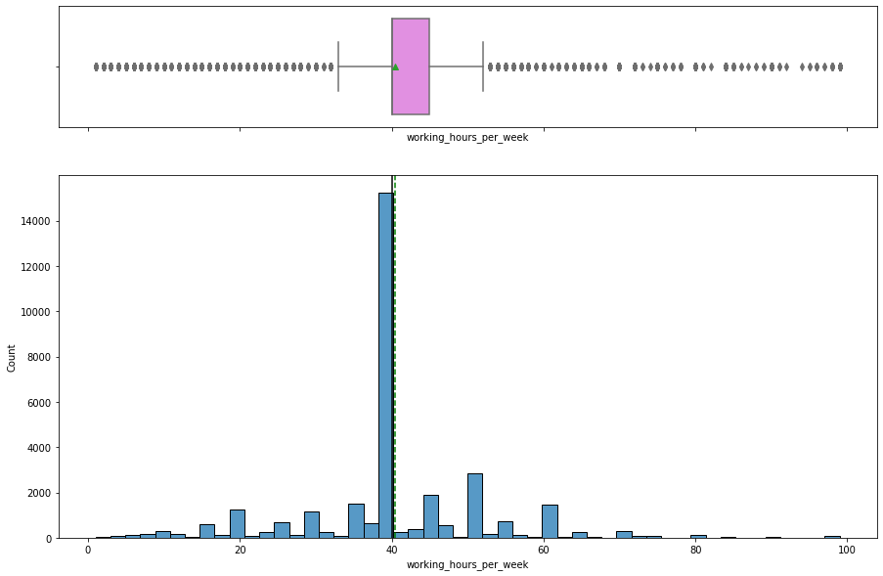

- Most of the data is concentrated around 40 working hours this gives a sense that most of the observations in data might be salaried employees working 8hrs 5 days a week.
- Some of the observations are clear outliers which needs to be treated.

Observations on workclass

labeled_barplot(df, "workclass", perc=True)
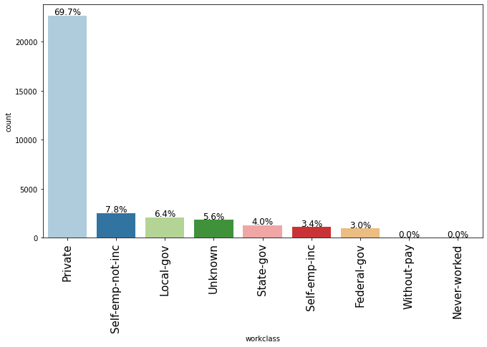

- ~70% of the observations are from the Private sector working class.
- As expected from the number of hours per week.

Observations on native_country

labeled_barplot(df, "native_contienent", perc=True)
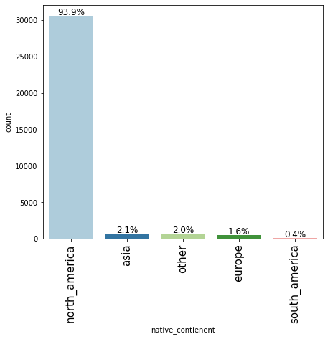

- ~94% of the people are native to north_america followed by 2.1% Asians.

Observations on salary

labeled_barplot(df, "salary", perc=True)
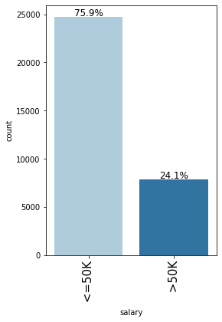

- ~24% of the observations have a salary above 50K and while ~76% have a salary below 50K

Bivariate analysis

Correlation check

plt.figure(figsize=(15, 7))
sns.heatmap(df.corr(), annot=True, vmin=-1, vmax=1, fmt=".2f", cmap="Spectral")
plt.show()
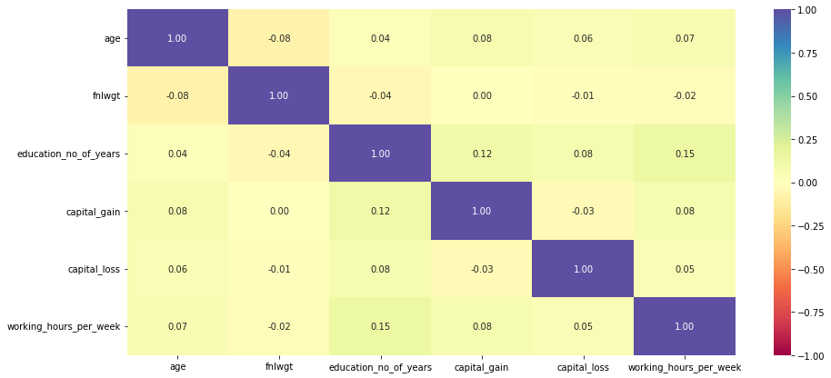

- There is no significant correlation between the columns.

salary vs sex

stacked_barplot(df, "sex", "salary")
salary <=50K >50K All
sex
All 24692 7839 32531
Male 15113 6660 21773
Female 9579 1179 10758
------------------------------------------------------------------------------------------------------------------------
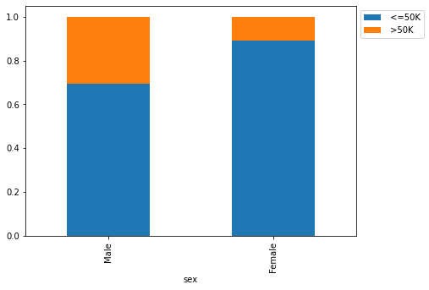

- ~30% of the males have salary >50K whereas only ~10% of the females have salary >50K.
- This shows the pay gap that exists in society and the government should investigate further on it to formulate policy to ensure equal pay.

salary vs education

stacked_barplot(df, "education", "salary")
salary <=50K >50K All
education
All 24692 7839 32531
Bachelors 3132 2221 5353
HS-grad 8816 1674 10490
Some-college 5894 1386 7280
Masters 763 959 1722
Prof-school 153 423 576
Assoc-voc 1021 361 1382
Doctorate 107 306 413
Assoc-acdm 802 265 1067
10th 871 62 933
11th 1115 60 1175
7th-8th 605 40 645
12th 400 33 433
9th 487 27 514
5th-6th 316 16 332
1st-4th 160 6 166
Preschool 50 0 50
------------------------------------------------------------------------------------------------------------------------
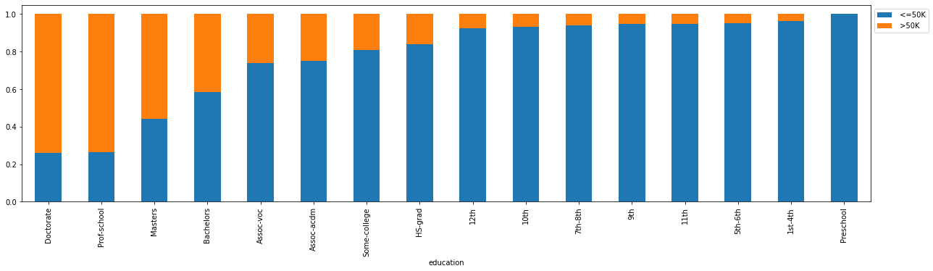

- ~70% of the people of are Doctorate, graduate from Professional school program (Prof-school) have a salary above $50K.
- This clearly shows a positive relationship between education and salary, the higher the education higher is the salary.

salary vs occupation

stacked_barplot(df, "occupation", "salary")
salary <=50K >50K All
occupation
All 24692 7839 32531
Exec-managerial 2097 1968 4065
Prof-specialty 2278 1858 4136
Sales 2666 983 3649
Craft-repair 3164 929 4093
Adm-clerical 3259 507 3766
Transport-moving 1277 320 1597
Tech-support 644 283 927
Machine-op-inspct 1750 249 1999
Protective-serv 438 211 649
Unknown 1652 191 1843
Other-service 3153 137 3290
Farming-fishing 877 115 992
Handlers-cleaners 1283 86 1369
Armed-Forces 8 1 9
Priv-house-serv 146 1 147
------------------------------------------------------------------------------------------------------------------------
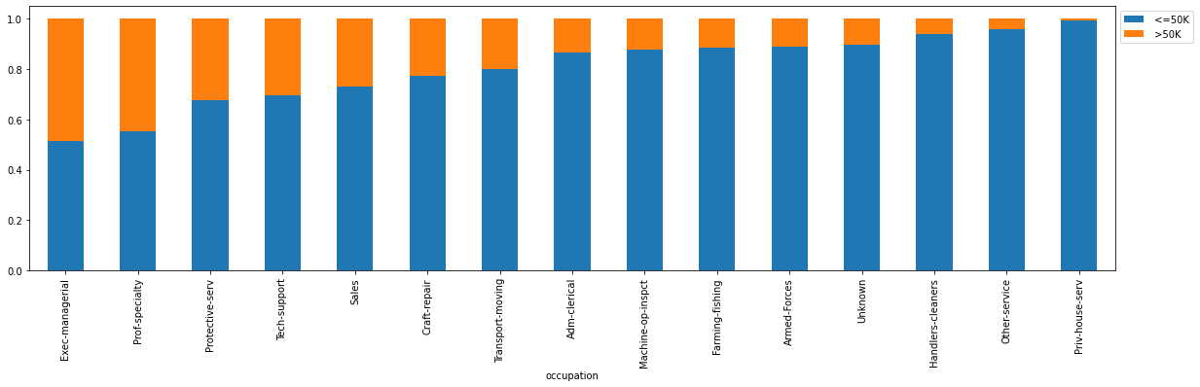

- ~50% of the people whose occupation is of Executive Manager, Professor-speciality have a salary above $50,000
- People with occupations like Private house service,handlers-cleaners, farming-fishing have a higher likelihood of having below 50K salary.

salary vs workclass

stacked_barplot(df, "workclass", "salary")
salary <=50K >50K All
workclass
All 24692 7839 32531
Private 17706 4961 22667
Self-emp-not-inc 1816 724 2540
Self-emp-inc 494 622 1116
Local-gov 1476 617 2093
Federal-gov 589 371 960
State-gov 945 353 1298
Unknown 1645 191 1836
Never-worked 7 0 7
Without-pay 14 0 14
------------------------------------------------------------------------------------------------------------------------
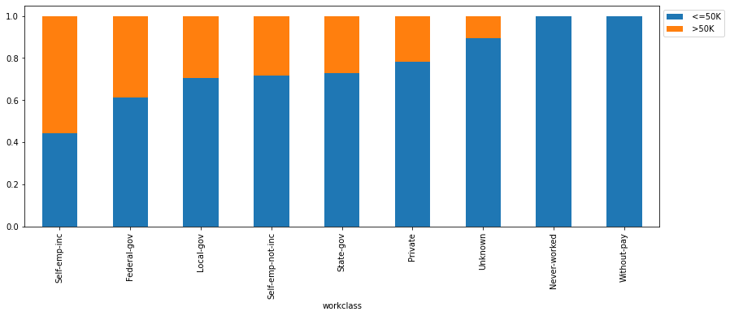

- ~50% of the self-employed people have a salary above 50K followed by ~40% of the federal govt employee who has salary more than 50K.
- ~20% of the people working in the private sector earn more than 50K.

salary vs age

distribution_plot_wrt_target(df, "age", "salary")
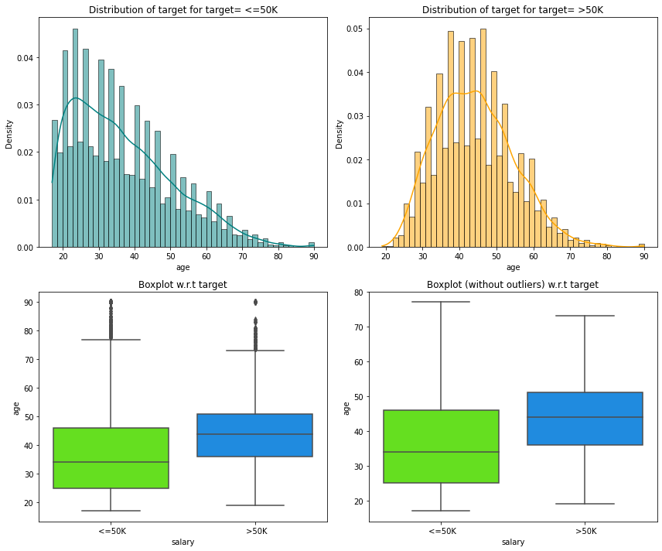

- People who more than 50K salary are generally older having an average age of around 48 years.
- People who have less than 50K salary have an average age of around 36.

salary vs working_hours_per_week

distribution_plot_wrt_target(df, "working_hours_per_week", "salary")
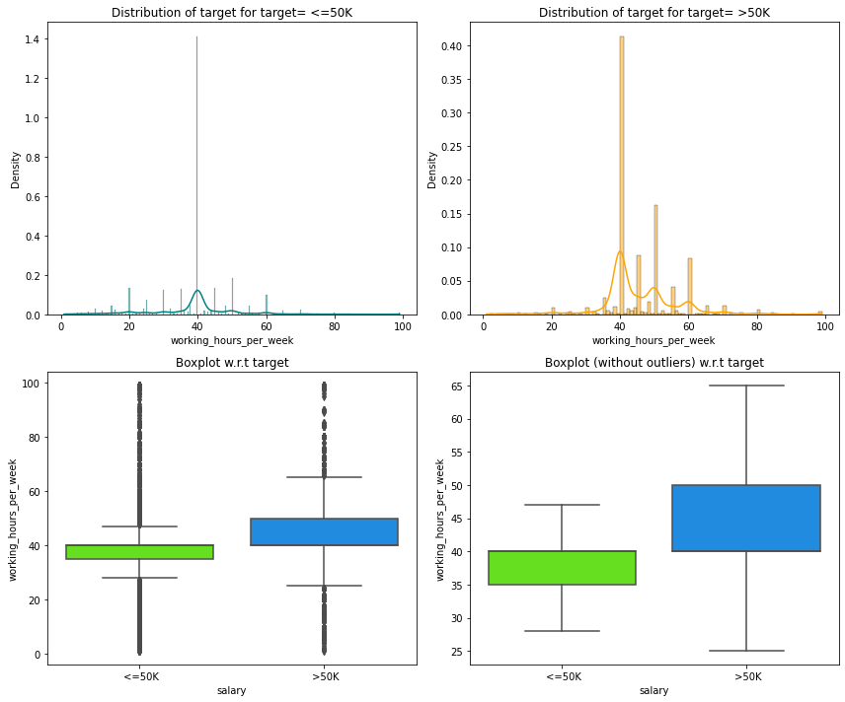

- Majority of people having above 50K salary work around 40 hours per week.
- Those having >50K salary have a higher range of working hours as compared to the ones with <=50K, but there are outliers present.

# lets see how working hours per week vary across different occupation
plt.figure(figsize=(15, 12))
sns.boxplot(
y="workclass", x="working_hours_per_week", data=df, hue="salary", showfliers=False
)
plt.show()
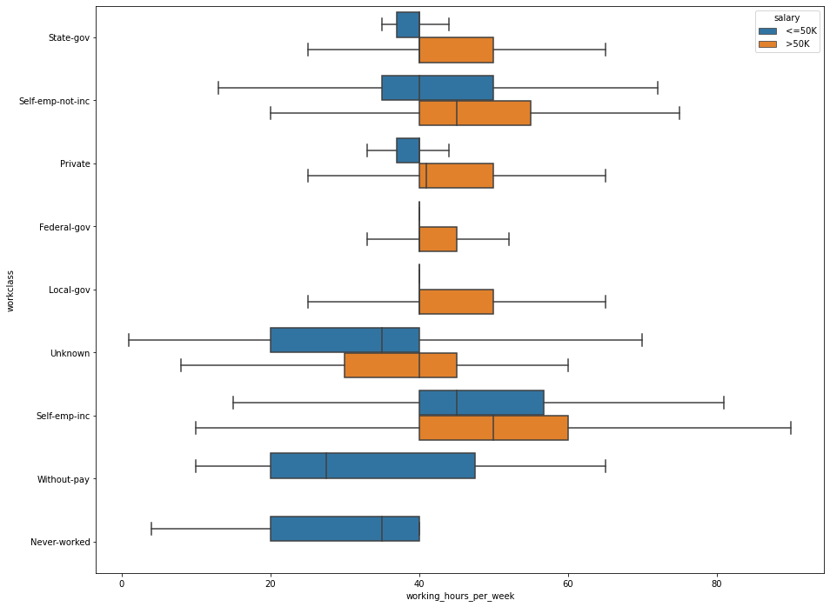

- Private sector employees work for more hours to get a salary above 50K.
- There's large variability in the working hours of self-employed people which makes sense as they might be working at their ease.
- Without pay and never worked will have no income or less than 50K income.
- The number of working hours for many government employees is concentrated at 40 hrs a week, which makes sense as government employees generally have fixed working hours.

Actions for data pre-processing:
- Many variables have outliers that need to be treated.
- We can drop capital_gain and capital_loss as most of the observations are 0 in these variables, and if the government already knows a person's capital gain or loss it will be easier for them to classify a person into a salary group.

Data Preprocessing

- We can drop capital_gain and capital_loss as most of the observations are 0 in these variables, and if the government already knows a person's capital gain or loss it will be easier for them to classify a person into a salary group
- There are many outliers in the data which we will treat (perform capping of outliers)
  - All the values smaller than the lower whisker will be assigned the value of the lower whisker, and all the values above the upper whisker will be assigned the value of the upper whisker.

Dropping capital_gain and capital_loss

data.drop(["capital_gain", "capital_loss"], axis=1, inplace=True)

Outlier Detection

numerical_col = data.select_dtypes(include=np.number).columns.tolist()
plt.figure(figsize=(20, 30))

for i, variable in enumerate(numerical_col):
plt.subplot(5, 4, i + 1)
plt.boxplot(data[variable], whis=1.5)
plt.tight_layout()
plt.title(variable)

plt.show()
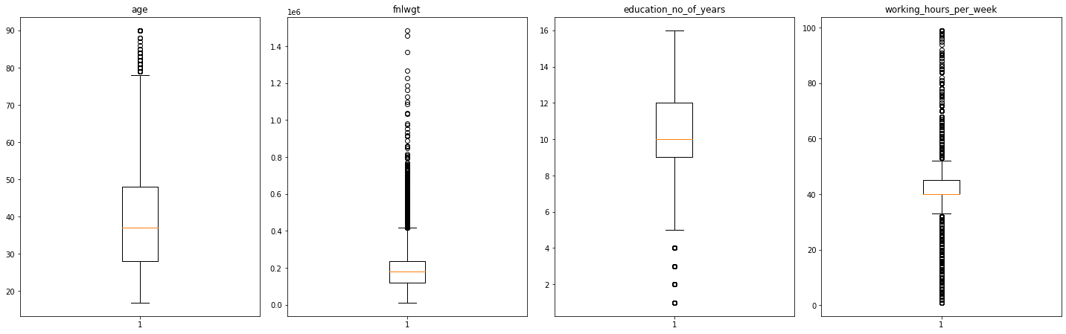

- Age and fnlwgt have upper outliers.
- education_no_years has lower outliers.
- working_hours_per_week has both upper and lower outliers.

Outlier Treatment

# functions to treat outliers by flooring and capping

def treat_outliers(df, col):
"""
Treats outliers in a variable

df: dataframe
col: dataframe column
"""
Q1 = df[col].quantile(0.25) # 25th quantile
Q3 = df[col].quantile(0.75) # 75th quantile
IQR = Q3 - Q1
Lower_Whisker = Q1 - 1.5 * IQR
Upper_Whisker = Q3 + 1.5 * IQR

# all the values smaller than Lower_Whisker will be assigned the value of Lower_Whisker
# all the values greater than Upper_Whisker will be assigned the value of Upper_Whisker
df[col] = np.clip(df[col], Lower_Whisker, Upper_Whisker)

return df

def treat_outliers_all(df, col_list):
"""
Treat outliers in a list of variables

df: dataframe
col_list: list of dataframe columns
"""
for c in col_list:
df = treat_outliers(df, c)

return df

numerical_col = data.select_dtypes(include=np.number).columns.tolist()
data = treat_outliers_all(data, numerical_col)

# let's look at box plot to see if outliers have been treated or not
plt.figure(figsize=(20, 30))

for i, variable in enumerate(numerical_col):
plt.subplot(5, 4, i + 1)
plt.boxplot(data[variable], whis=1.5)
plt.tight_layout()
plt.title(variable)

plt.show()
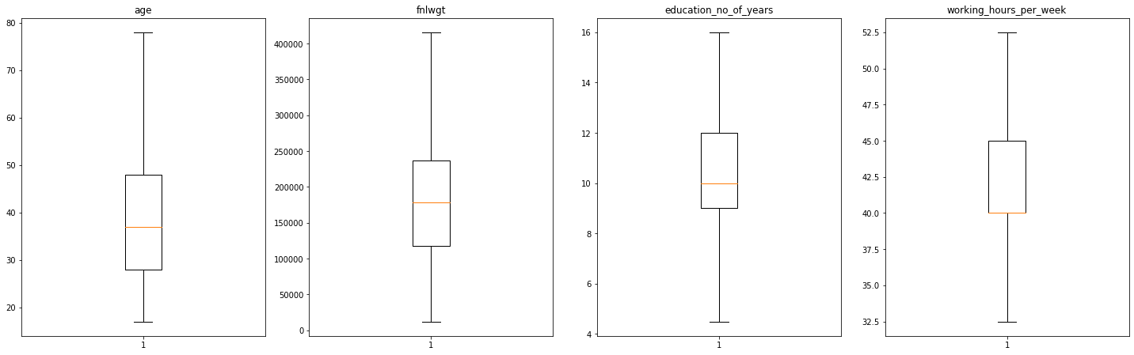

Data Preparation for Modeling

Encoding >50K as 0 and <=50K as 1 as government wants to find underprivileged section of society.

data["salary"] = data["salary"].apply(lambda x: 1 if x == " <=50K" else 0)

Creating training and test sets.

# specifying the independent and dependent variables
X = data.drop(["salary"], axis=1)
Y = data["salary"]

# adding a constant to the independent variables
X = sm.add_constant(X)

# creating dummy variables
X = pd.get_dummies(X, drop_first=True)

# splitting data in train and test sets
X_train, X_test, y_train, y_test = train_test_split(
X, Y, test_size=0.30, random_state=1
)

print("Shape of Training set : ", X_train.shape)
print("Shape of test set : ", X_test.shape)
print("Percentage of classes in training set:")
print(y_train.value_counts(normalize=True))
print("Percentage of classes in test set:")
print(y_test.value_counts(normalize=True))
Shape of Training set : (22771, 53)
Shape of test set : (9760, 53)
Percentage of classes in training set:
1 0.758026
0 0.241974
Name: salary, dtype: float64
Percentage of classes in test set:
1 0.761373
0 0.238627
Name: salary, dtype: float64

Model Building - Logistic Regression

- We will now perform logistic regression using statsmodels, a Python module that provides functions for the estimation of many statistical models, as well as for conducting statistical tests, and statistical data exploration.
- Using statsmodels, we will be able to check the statistical validity of our model - identify the significant predictors from p-values that we get for each predictor variable.

# fitting logistic regression model
logit = sm.Logit(y_train, X_train.astype(float))
lg = logit.fit(disp=False)

print(lg.summary())
Logit Regression Results
==============================================================================
Dep. Variable: salary No. Observations: 22771
Model: Logit Df Residuals: 22720
Method: MLE Df Model: 50
Date: Mon, 21 Nov 2022 Pseudo R-squ.: 0.3678
Time: 01:43:56 Log-Likelihood: -7965.8
converged: False LL-Null: -12600.
Covariance Type: nonrobust LLR p-value: 0.000
===================================================================================================
coef std err z P>|z| [0.025 0.975]
---------------------------------------------------------------------------------------------------
const 9.5200 8.78e+05 1.08e-05 1.000 -1.72e+06 1.72e+06
age -0.0314 0.002 -17.126 0.000 -0.035 -0.028
fnlwgt -6.146e-07 2.13e-07 -2.881 0.004 -1.03e-06 -1.96e-07
education_no_of_years -0.1961 1.46e+05 -1.34e-06 1.000 -2.87e+05 2.87e+05
working_hours_per_week -0.0655 0.004 -18.686 0.000 -0.072 -0.059
workclass_Local-gov 0.7669 0.127 6.061 0.000 0.519 1.015
workclass_Never-worked 15.2669 7.18e+06 2.13e-06 1.000 -1.41e+07 1.41e+07
workclass_Private 0.5196 0.105 4.972 0.000 0.315 0.724
workclass_Self-emp-inc 0.2891 0.137 2.105 0.035 0.020 0.558
workclass_Self-emp-not-inc 0.9751 0.123 7.899 0.000 0.733 1.217
workclass_State-gov 0.9400 0.141 6.667 0.000 0.664 1.216
workclass_Unknown -7.0008 7.18e+06 -9.76e-07 1.000 -1.41e+07 1.41e+07
workclass_Without-pay 16.5922 1637.028 0.010 0.992 -3191.924 3225.109
education_11th 0.1667 1.46e+05 1.14e-06 1.000 -2.87e+05 2.87e+05
education_12th -0.0044 2.93e+05 -1.49e-08 1.000 -5.74e+05 5.74e+05
education_1st-4th 1.3125 2.2e+05 5.98e-06 1.000 -4.3e+05 4.3e+05
education_5th-6th 0.2103 2.2e+05 9.57e-07 1.000 -4.3e+05 4.3e+05
education_7th-8th 0.3224 2.2e+05 1.47e-06 1.000 -4.3e+05 4.3e+05
education_9th 0.4116 1.46e+05 2.81e-06 1.000 -2.87e+05 2.87e+05
education_Assoc-acdm -0.0898 8.78e+05 -1.02e-07 1.000 -1.72e+06 1.72e+06
education_Assoc-voc -0.3665 7.32e+05 -5.01e-07 1.000 -1.43e+06 1.43e+06
education_Bachelors -0.5915 1.02e+06 -5.77e-07 1.000 -2.01e+06 2.01e+06
education_Doctorate -0.9450 1.46e+06 -6.45e-07 1.000 -2.87e+06 2.87e+06
education_HS-grad -0.1775 4.39e+05 -4.04e-07 1.000 -8.61e+05 8.61e+05
education_Masters -0.7982 1.17e+06 -6.82e-07 1.000 -2.3e+06 2.3e+06
education_Preschool 12.0896 2.2e+05 5.51e-05 1.000 -4.3e+05 4.3e+05
education_Prof-school -1.3568 1.32e+06 -1.03e-06 1.000 -2.58e+06 2.58e+06
education_Some-college -0.2672 5.86e+05 -4.56e-07 1.000 -1.15e+06 1.15e+06
marital_status_married -2.5742 0.069 -37.060 0.000 -2.710 -2.438
marital_status_not_married -0.4045 0.084 -4.806 0.000 -0.569 -0.240
occupation_Armed-Forces 0.5322 1.529 0.348 0.728 -2.465 3.530
occupation_Craft-repair 0.0011 0.088 0.013 0.990 -0.172 0.175
occupation_Exec-managerial -0.6952 0.085 -8.199 0.000 -0.861 -0.529
occupation_Farming-fishing 1.0593 0.157 6.763 0.000 0.752 1.366
occupation_Handlers-cleaners 0.8354 0.162 5.169 0.000 0.519 1.152
occupation_Machine-op-inspct 0.4118 0.115 3.573 0.000 0.186 0.638
occupation_Other-service 0.9811 0.135 7.294 0.000 0.718 1.245
occupation_Priv-house-serv 2.3843 1.091 2.185 0.029 0.245 4.524
occupation_Prof-specialty -0.4583 0.089 -5.143 0.000 -0.633 -0.284
occupation_Protective-serv -0.4979 0.143 -3.475 0.001 -0.779 -0.217
occupation_Sales -0.1410 0.091 -1.555 0.120 -0.319 0.037
occupation_Tech-support -0.5943 0.123 -4.815 0.000 -0.836 -0.352
occupation_Transport-moving 0.1759 0.112 1.572 0.116 -0.043 0.395
occupation_Unknown 8.2661 7.18e+06 1.15e-06 1.000 -1.41e+07 1.41e+07
race_Asian-Pac-Islander -0.2499 0.287 -0.871 0.384 -0.812 0.312
race_Black -0.2403 0.251 -0.958 0.338 -0.732 0.251
race_Other 0.4680 0.401 1.167 0.243 -0.318 1.254
race_White -0.3346 0.238 -1.403 0.161 -0.802 0.133
sex_Male -0.0661 0.059 -1.129 0.259 -0.181 0.049
native_contienent_europe -0.2102 0.241 -0.871 0.384 -0.683 0.263
native_contienent_north_america -0.2393 0.191 -1.251 0.211 -0.614 0.136
native_contienent_other 0.2389 0.218 1.097 0.272 -0.188 0.666
native_contienent_south_america 1.0479 0.526 1.992 0.046 0.017 2.079
===================================================================================================

Observations
- Negative values of the coefficient show that the probability of a person having a salary less than 50K decreases with the increase of the corresponding attribute value.
- Positive values of the coefficient show that the probability of a person having a salary less than 50K increases with the increase of the corresponding attribute value.
- p-value of a variable indicates if the variable is significant or not. If we consider the significance level to be 0.05 (5%), then any variable with a p-value less than 0.05 would be considered significant.

Model Performance Evaluation

Model can make wrong predictions as:
- Predicting a person has a salary <=50K but in reality the salary of the person is >50K.
- Predicting a person doesn't have a salary <=50K but in reality the salary of the person is <=50k.
Which case is more important?
- Both the cases are important as:
  - If we predict a person has a salary <=50K but actually the salary is >50K then a wrong person will be getting the benefits of the scheme and government might lose resources.
  - If we predict a person doesn't have a salary <=50K but actually the salary is <=50K that person will not be able to avail the benefits of the scheme constituting to opportunity loss.
How to reduce this loss?
- We need to reduce both False Negatives and False Positives
- f1_score should be maximized as the greater the f1_score, the higher the chances of reducing both False Negatives and False Positives and identifying both the classes correctly
  - fi_score is computed as f1_score=2∗Precision∗RecallPrecision+Recall

First, let's create functions to calculate different metrics and confusion matrix so that we don't have to use the same code repeatedly for each model.
- The model_performance_classification_statsmodels function will be used to check the model performance of models.
- The confusion_matrix_statsmodels function will be used to plot confusion matrix.

# defining a function to compute different metrics to check performance of a classification model built using statsmodels
def model_performance_classification_statsmodels(
model, predictors, target, threshold=0.5
):
"""
Function to compute different metrics to check classification model performance

model: classifier
predictors: independent variables
target: dependent variable
threshold: threshold for classifying the observation as class 1
"""

# checking which probabilities are greater than threshold
pred_temp = model.predict(predictors) > threshold
# rounding off the above values to get classes
pred = np.round(pred_temp)

acc = accuracy_score(target, pred) # to compute Accuracy
recall = recall_score(target, pred) # to compute Recall
precision = precision_score(target, pred) # to compute Precision
f1 = f1_score(target, pred) # to compute F1-score

# creating a dataframe of metrics
df_perf = pd.DataFrame(
{"Accuracy": acc, "Recall": recall, "Precision": precision, "F1": f1,},
index=[0],
)

return df_perf

# defining a function to plot the confusion_matrix of a classification model

def confusion_matrix_statsmodels(model, predictors, target, threshold=0.5):
"""
To plot the confusion_matrix with percentages

model: classifier
predictors: independent variables
target: dependent variable
threshold: threshold for classifying the observation as class 1
"""
y_pred = model.predict(predictors) > threshold
cm = confusion_matrix(target, y_pred)
labels = np.asarray(
[
["{0:0.0f}".format(item) + "\n{0:.2%}".format(item / cm.flatten().sum())]
for item in cm.flatten()
]
).reshape(2, 2)

plt.figure(figsize=(6, 4))
sns.heatmap(cm, annot=labels, fmt="")
plt.ylabel("True label")
plt.xlabel("Predicted label")

confusion_matrix_statsmodels(lg, X_train, y_train)
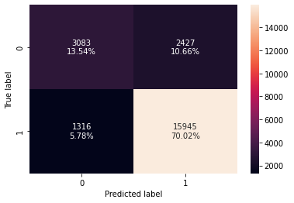

print("Training performance:")
model_performance_classification_statsmodels(lg, X_train, y_train)
Training performance:

 | Accuracy | Recall | Precision | F1
0 | 0.835624 | 0.923759 | 0.867897 | 0.894957

Observations
- The f1_score of the model is ~0.89 and we will try to maximize it further
- The variables used to build the model might contain multicollinearity, which will affect the p-values
- We will have to remove multicollinearity from the data to get reliable coefficients and p-values

Detecting and Dealing with Multicollinearity

There are different ways of detecting (or testing for) multicollinearity. One such way is using the Variation Inflation Factor (VIF).
- Variance Inflation factor: Variance inflation factors measure the inflation in the variances of the regression coefficients estimates due to collinearities that exist among the predictors. It is a measure of how much the variance of the estimated regression coefficient βk
- is "inflated" by the existence of correlation among the predictor variables in the model.
- General Rule of thumb:
- If VIF is 1 then there is no correlation among the k
th predictor and the remaining predictor variables, and hence the variance of βk
  - is not inflated at all
  - If VIF exceeds 5, we say there is moderate multicollinearity
  - If VIF is equal or exceeding 10, it shows signs of high multi-collinearity
- The purpose of the analysis should dictate which threshold to use

vif_series = pd.Series(
[variance_inflation_factor(X_train.values, i) for i in range(X_train.shape[1])],
index=X_train.columns,
dtype=float,
)
print("Series before feature selection: \n\n{}\n".format(vif_series))
Series before feature selection:

const 0.000000
age 1.531401
fnlwgt 1.037491
education_no_of_years inf
working_hours_per_week 1.237162
workclass_Local-gov 3.041470
workclass_Never-worked inf
workclass_Private 7.717533
workclass_Self-emp-inc 2.217152
workclass_Self-emp-not-inc 3.487046
workclass_State-gov 2.317984
workclass_Unknown inf
workclass_Without-pay 1.015562
education_11th inf
education_12th inf
education_1st-4th inf
education_5th-6th inf
education_7th-8th inf
education_9th inf
education_Assoc-acdm inf
education_Assoc-voc inf
education_Bachelors inf
education_Doctorate inf
education_HS-grad inf
education_Masters inf
education_Preschool inf
education_Prof-school inf
education_Some-college inf
marital_status_married 1.971883
marital_status_not_married 1.714786
occupation_Armed-Forces 1.010066
occupation_Craft-repair 2.133802
occupation_Exec-managerial 2.046469
occupation_Farming-fishing 1.401571
occupation_Handlers-cleaners 1.440475
occupation_Machine-op-inspct 1.577192
occupation_Other-service 1.750404
occupation_Priv-house-serv 1.054692
occupation_Prof-specialty 2.317960
occupation_Protective-serv 1.253107
occupation_Sales 1.891884
occupation_Tech-support 1.239360
occupation_Transport-moving 1.509398
occupation_Unknown inf
race_Asian-Pac-Islander 5.305020
race_Black 10.196674
race_Other 1.878501
race_White 13.494644
sex_Male 1.520198
native_contienent_europe 2.424319
native_contienent_north_america 5.250971
native_contienent_other 2.331141
native_contienent_south_america 1.328881
dtype: float64

- education_no_of_years, education, and some categorical levels of workclass, native_country, and race exhibit high multicollinearity
- We see that some variables have inf values for VIF
  - The inf values for VIF indicate perfect correlation between variables
- As we saw in our earlier analysis that wherever workclass has unknown values occupation is also unknown.
  - The high correlation between these variables has been highlighted in the VIF values as well
- We will drop occupation_Unknown as we get the same information from workclass_Unknown

Removing occupation_Unknown

X_train1 = X_train.drop("occupation_Unknown", axis=1)

vif_series2 = pd.Series(
[variance_inflation_factor(X_train1.values, i) for i in range(X_train1.shape[1])],
index=X_train1.columns,
)
print("Series before feature selection: \n\n{}\n".format(vif_series2))
Series before feature selection:

const 0.000000
age 1.531401
fnlwgt 1.037491
education_no_of_years inf
working_hours_per_week 1.237162
workclass_Local-gov 3.041470
workclass_Never-worked 1.012785
workclass_Private 7.717533
workclass_Self-emp-inc 2.217152
workclass_Self-emp-not-inc 3.487046
workclass_State-gov 2.317984
workclass_Unknown 3.039325
workclass_Without-pay 1.015562
education_11th inf
education_12th inf
education_1st-4th inf
education_5th-6th inf
education_7th-8th inf
education_9th inf
education_Assoc-acdm inf
education_Assoc-voc inf
education_Bachelors inf
education_Doctorate inf
education_HS-grad inf
education_Masters inf
education_Preschool inf
education_Prof-school inf
education_Some-college inf
marital_status_married 1.971883
marital_status_not_married 1.714786
occupation_Armed-Forces 1.010066
occupation_Craft-repair 2.133802
occupation_Exec-managerial 2.046469
occupation_Farming-fishing 1.401571
occupation_Handlers-cleaners 1.440475
occupation_Machine-op-inspct 1.577192
occupation_Other-service 1.750404
occupation_Priv-house-serv 1.054692
occupation_Prof-specialty 2.317960
occupation_Protective-serv 1.253107
occupation_Sales 1.891884
occupation_Tech-support 1.239360
occupation_Transport-moving 1.509398
race_Asian-Pac-Islander 5.305020
race_Black 10.196674
race_Other 1.878501
race_White 13.494644
sex_Male 1.520198
native_contienent_europe 2.424319
native_contienent_north_america 5.250971
native_contienent_other 2.331141
native_contienent_south_america 1.328881
dtype: float64

- education_no_of_years and education also capture similar information and hence, it is understandable that they have high VIF values
- We will be dropping education_no_of_years and education one at a time, building separate models, and checking their performances to see which variable has a significant impact on the model's performance

Dropping education_no_of_years

X_train2 = X_train1.drop("education_no_of_years", axis=1)
vif_series3 = pd.Series(
[variance_inflation_factor(X_train2.values, i) for i in range(X_train2.shape[1])],
index=X_train2.columns,
)
print("Series before feature selection: \n\n{}\n".format(vif_series3))
Series before feature selection:

const 326.271888
age 1.531401
fnlwgt 1.037491
working_hours_per_week 1.237162
workclass_Local-gov 3.041470
workclass_Never-worked 1.012785
workclass_Private 7.717533
workclass_Self-emp-inc 2.217152
workclass_Self-emp-not-inc 3.487046
workclass_State-gov 2.317984
workclass_Unknown 3.039325
workclass_Without-pay 1.015562
education_11th 2.147415
education_12th 1.422410
education_1st-4th 1.188352
education_5th-6th 1.338683
education_7th-8th 1.655272
education_9th 1.524978
education_Assoc-acdm 2.105382
education_Assoc-voc 2.374490
education_Bachelors 5.939193
education_Doctorate 1.564790
education_HS-grad 8.112679
education_Masters 2.978449
education_Preschool 1.064098
education_Prof-school 1.811978
education_Some-college 6.857574
marital_status_married 1.971883
marital_status_not_married 1.714786
occupation_Armed-Forces 1.010066
occupation_Craft-repair 2.133802
occupation_Exec-managerial 2.046469
occupation_Farming-fishing 1.401571
occupation_Handlers-cleaners 1.440475
occupation_Machine-op-inspct 1.577192
occupation_Other-service 1.750404
occupation_Priv-house-serv 1.054692
occupation_Prof-specialty 2.317960
occupation_Protective-serv 1.253107
occupation_Sales 1.891884
occupation_Tech-support 1.239360
occupation_Transport-moving 1.509398
race_Asian-Pac-Islander 5.305020
race_Black 10.196674
race_Other 1.878501
race_White 13.494644
sex_Male 1.520198
native_contienent_europe 2.424319
native_contienent_north_america 5.250971
native_contienent_other 2.331141
native_contienent_south_america 1.328881
dtype: float64

- Dropping education_no_of_years fixes the multicollinearity in education column.

logit2 = sm.Logit(y_train, X_train2.astype(float))
lg2 = logit2.fit(disp=False)

print("Training performance:")
model_performance_classification_statsmodels(lg2, X_train2, y_train)
Training performance:

 | Accuracy | Recall | Precision | F1
0 | 0.835624 | 0.923759 | 0.867897 | 0.894957

- No significant change in the model performance.

Observations:
- Dropping education_no_of_years, race_ White doesn't have a significant impact on the model performance.
- We can choose any model to proceed to the next steps.
- Some of the categorical levels of a variable have VIF>5 which can simply be ignored.

print(lg2.summary())
Logit Regression Results
==============================================================================
Dep. Variable: salary No. Observations: 22771
Model: Logit Df Residuals: 22720
Method: MLE Df Model: 50
Date: Mon, 21 Nov 2022 Pseudo R-squ.: 0.3678
Time: 01:44:39 Log-Likelihood: -7965.8
converged: False LL-Null: -12600.
Covariance Type: nonrobust LLR p-value: 0.000
===================================================================================================
coef std err z P>|z| [0.025 0.975]
---------------------------------------------------------------------------------------------------
const 8.3433 0.405 20.584 0.000 7.549 9.138
age -0.0314 0.002 -17.126 0.000 -0.035 -0.028
fnlwgt -6.146e-07 2.13e-07 -2.881 0.004 -1.03e-06 -1.96e-07
working_hours_per_week -0.0655 0.004 -18.686 0.000 -0.072 -0.059
workclass_Local-gov 0.7669 0.127 6.061 0.000 0.519 1.015
workclass_Never-worked 16.5407 5517.857 0.003 0.998 -1.08e+04 1.08e+04
workclass_Private 0.5196 0.105 4.972 0.000 0.315 0.724
workclass_Self-emp-inc 0.2891 0.137 2.105 0.035 0.020 0.558
workclass_Self-emp-not-inc 0.9751 0.123 7.899 0.000 0.733 1.217
workclass_State-gov 0.9400 0.141 6.667 0.000 0.664 1.216
workclass_Unknown 1.2653 0.156 8.118 0.000 0.960 1.571
workclass_Without-pay 16.5958 1640.005 0.010 0.992 -3197.754 3230.946
education_11th -0.0294 0.239 -0.123 0.902 -0.497 0.438
education_12th -0.3966 0.293 -1.352 0.176 -0.972 0.178
education_1st-4th 1.6066 0.742 2.166 0.030 0.153 3.060
education_5th-6th 0.5044 0.364 1.385 0.166 -0.209 1.218
education_7th-8th 0.6165 0.265 2.325 0.020 0.097 1.136
education_9th 0.6077 0.310 1.963 0.050 0.001 1.214
education_Assoc-acdm -1.2664 0.199 -6.376 0.000 -1.656 -0.877
education_Assoc-voc -1.3471 0.190 -7.088 0.000 -1.720 -0.975
education_Bachelors -1.9643 0.176 -11.133 0.000 -2.310 -1.619
education_Doctorate -2.9061 0.238 -12.200 0.000 -3.373 -2.439
education_HS-grad -0.7659 0.172 -4.463 0.000 -1.102 -0.430
education_Masters -2.3671 0.188 -12.583 0.000 -2.736 -1.998
education_Preschool 16.5732 2562.495 0.006 0.995 -5005.825 5038.971
education_Prof-school -3.1219 0.224 -13.961 0.000 -3.560 -2.684
education_Some-college -1.0517 0.174 -6.035 0.000 -1.393 -0.710
marital_status_married -2.5742 0.069 -37.060 0.000 -2.710 -2.438
marital_status_not_married -0.4045 0.084 -4.806 0.000 -0.569 -0.240
occupation_Armed-Forces 0.5322 1.529 0.348 0.728 -2.465 3.530
occupation_Craft-repair 0.0011 0.088 0.013 0.990 -0.172 0.175
occupation_Exec-managerial -0.6952 0.085 -8.199 0.000 -0.861 -0.529
occupation_Farming-fishing 1.0593 0.157 6.763 0.000 0.752 1.366
occupation_Handlers-cleaners 0.8354 0.162 5.169 0.000 0.519 1.152
occupation_Machine-op-inspct 0.4118 0.115 3.573 0.000 0.186 0.638
occupation_Other-service 0.9811 0.135 7.294 0.000 0.718 1.245
occupation_Priv-house-serv 2.3843 1.091 2.185 0.029 0.245 4.524
occupation_Prof-specialty -0.4583 0.089 -5.143 0.000 -0.633 -0.284
occupation_Protective-serv -0.4979 0.143 -3.475 0.001 -0.779 -0.217
occupation_Sales -0.1410 0.091 -1.555 0.120 -0.319 0.037
occupation_Tech-support -0.5943 0.123 -4.815 0.000 -0.836 -0.352
occupation_Transport-moving 0.1759 0.112 1.572 0.116 -0.043 0.395
race_Asian-Pac-Islander -0.2499 0.287 -0.871 0.384 -0.812 0.312
race_Black -0.2403 0.251 -0.958 0.338 -0.732 0.251
race_Other 0.4680 0.401 1.167 0.243 -0.318 1.254
race_White -0.3346 0.238 -1.403 0.161 -0.802 0.133
sex_Male -0.0661 0.059 -1.129 0.259 -0.181 0.049
native_contienent_europe -0.2102 0.241 -0.871 0.384 -0.683 0.263
native_contienent_north_america -0.2393 0.191 -1.251 0.211 -0.614 0.136
native_contienent_other 0.2389 0.218 1.097 0.272 -0.188 0.666
native_contienent_south_america 1.0479 0.526 1.992 0.046 0.017 2.079
===================================================================================================

Removing high p-value variables

- For other attributes present in the data, the p-values are high only for few dummy variables and since only one (or some) of the categorical levels have a high p-value we will drop them iteratively as sometimes p-values change after dropping a variable. So, we'll not drop all variables at once.
- Instead, we will do the following repeatedly using a loop:
  - Build a model, check the p-values of the variables, and drop the column with the highest p-value.
  - Create a new model without the dropped feature, check the p-values of the variables, and drop the column with the highest p-value.
  - Repeat the above two steps till there are no columns with p-value > 0.05.
Note: The above process can also be done manually by picking one variable at a time that has a high p-value, dropping it, and building a model again. But that might be a little tedious and using a loop will be more efficient.

# initial list of columns
cols = X_train2.columns.tolist()

# setting an initial max p-value
max_p_value = 1

while len(cols) > 0:
# defining the train set
X_train_aux = X_train2[cols]

# fitting the model
model = sm.Logit(y_train, X_train_aux).fit(disp=False)

# getting the p-values and the maximum p-value
p_values = model.pvalues
max_p_value = max(p_values)

# name of the variable with maximum p-value
feature_with_p_max = p_values.idxmax()

if max_p_value > 0.05:
cols.remove(feature_with_p_max)
else:
break

selected_features = cols
print(selected_features)
['const', 'age', 'fnlwgt', 'working_hours_per_week', 'workclass_Local-gov', 'workclass_Private', 'workclass_Self-emp-not-inc', 'workclass_State-gov', 'workclass_Unknown', 'education_1st-4th', 'education_7th-8th', 'education_9th', 'education_Assoc-acdm', 'education_Assoc-voc', 'education_Bachelors', 'education_Doctorate', 'education_HS-grad', 'education_Masters', 'education_Prof-school', 'education_Some-college', 'marital_status_married', 'marital_status_not_married', 'occupation_Exec-managerial', 'occupation_Farming-fishing', 'occupation_Handlers-cleaners', 'occupation_Machine-op-inspct', 'occupation_Other-service', 'occupation_Priv-house-serv', 'occupation_Prof-specialty', 'occupation_Protective-serv', 'occupation_Sales', 'occupation_Tech-support', 'race_Other', 'race_White', 'native_contienent_other', 'native_contienent_south_america']

X_train3 = X_train2[selected_features]

logit3 = sm.Logit(y_train, X_train3.astype(float))
lg3 = logit3.fit(disp=False)

print(lg3.summary())
Logit Regression Results
==============================================================================
Dep. Variable: salary No. Observations: 22771
Model: Logit Df Residuals: 22735
Method: MLE Df Model: 35
Date: Mon, 21 Nov 2022 Pseudo R-squ.: 0.3666
Time: 01:44:52 Log-Likelihood: -7980.7
converged: True LL-Null: -12600.
Covariance Type: nonrobust LLR p-value: 0.000
===================================================================================================
coef std err z P>|z| [0.025 0.975]
---------------------------------------------------------------------------------------------------
const 8.0557 0.233 34.544 0.000 7.599 8.513
age -0.0314 0.002 -17.178 0.000 -0.035 -0.028
fnlwgt -6.273e-07 2.12e-07 -2.964 0.003 -1.04e-06 -2.12e-07
working_hours_per_week -0.0650 0.003 -19.014 0.000 -0.072 -0.058
workclass_Local-gov 0.6101 0.103 5.930 0.000 0.408 0.812
workclass_Private 0.3585 0.072 4.976 0.000 0.217 0.500
workclass_Self-emp-not-inc 0.8012 0.094 8.485 0.000 0.616 0.986
workclass_State-gov 0.7793 0.121 6.466 0.000 0.543 1.016
workclass_Unknown 1.0881 0.132 8.229 0.000 0.829 1.347
education_1st-4th 1.5989 0.729 2.192 0.028 0.169 3.029
education_7th-8th 0.6164 0.229 2.687 0.007 0.167 1.066
education_9th 0.5931 0.279 2.123 0.034 0.046 1.141
education_Assoc-acdm -1.2818 0.146 -8.791 0.000 -1.568 -0.996
education_Assoc-voc -1.3671 0.134 -10.168 0.000 -1.631 -1.104
education_Bachelors -1.9848 0.114 -17.449 0.000 -2.208 -1.762
education_Doctorate -2.9087 0.196 -14.845 0.000 -3.293 -2.525
education_HS-grad -0.7808 0.108 -7.260 0.000 -0.992 -0.570
education_Masters -2.3806 0.131 -18.149 0.000 -2.638 -2.124
education_Prof-school -3.1388 0.178 -17.616 0.000 -3.488 -2.790
education_Some-college -1.0739 0.111 -9.666 0.000 -1.292 -0.856
marital_status_married -2.5792 0.067 -38.449 0.000 -2.711 -2.448
marital_status_not_married -0.3935 0.084 -4.711 0.000 -0.557 -0.230
occupation_Exec-managerial -0.7135 0.063 -11.324 0.000 -0.837 -0.590
occupation_Farming-fishing 1.0603 0.142 7.450 0.000 0.781 1.339
occupation_Handlers-cleaners 0.7954 0.149 5.340 0.000 0.503 1.087
occupation_Machine-op-inspct 0.3845 0.097 3.967 0.000 0.195 0.575
occupation_Other-service 0.9771 0.122 8.026 0.000 0.738 1.216
occupation_Priv-house-serv 2.4240 1.082 2.240 0.025 0.303 4.545
occupation_Prof-specialty -0.4775 0.072 -6.675 0.000 -0.618 -0.337
occupation_Protective-serv -0.5487 0.130 -4.205 0.000 -0.804 -0.293
occupation_Sales -0.1563 0.068 -2.299 0.021 -0.290 -0.023
occupation_Tech-support -0.6295 0.110 -5.700 0.000 -0.846 -0.413
race_Other 0.6816 0.329 2.069 0.039 0.036 1.327
race_White -0.1545 0.067 -2.301 0.021 -0.286 -0.023
native_contienent_other 0.4532 0.149 3.041 0.002 0.161 0.745
native_contienent_south_america 1.2598 0.489 2.576 0.010 0.301 2.218
===================================================================================================

Now no categorical feature has p-value greater than 0.05, so we'll consider the features in X_train3 as the final ones and lg3 as final model.

Coefficient Interpretations

- Coefficient of some levels of education, workclass, and native country are positive an increase in these will lead to increase in chances of a person having <=50K salary.
- Coefficient of age, fnlwgt, marital_status, working_hours_per_week, some levels of education, workclass, and native country are negative increase in these will lead to decrease in chances of a person having <=50K salary.

Converting coefficients to odds
- The coefficients (β
s) of the logistic regression model are in terms of log(odds)
- and to find the odds, we have to take the exponential of the coefficients
- Therefore, odds=exp(β)
- The percentage change in odds is given as (exp(β)−1)∗100

# converting coefficients to odds
odds = np.exp(lg3.params)

# finding the percentage change
perc_change_odds = (np.exp(lg3.params) - 1) * 100

# removing limit from number of columns to display
pd.set_option("display.max_columns", None)

# adding the odds to a dataframe
pd.DataFrame({"Odds": odds, "Change_odd%": perc_change_odds}, index=X_train3.columns).T

 | const | age | fnlwgt | working_hours_per_week | workclass_Local-gov | workclass_Private | workclass_Self-emp-not-inc | workclass_State-gov | workclass_Unknown | education_1st-4th | education_7th-8th | education_9th | education_Assoc-acdm | education_Assoc-voc | education_Bachelors | education_Doctorate | education_HS-grad | education_Masters | education_Prof-school | education_Some-college | marital_status_married | marital_status_not_married | occupation_Exec-managerial | occupation_Farming-fishing | occupation_Handlers-cleaners | occupation_Machine-op-inspct | occupation_Other-service | occupation_Priv-house-serv | occupation_Prof-specialty | occupation_Protective-serv | occupation_Sales | occupation_Tech-support | race_Other | race_White | native_contienent_other | native_contienent_south_america
Odds | 3151.769230 | 0.969130 | 0.999999 | 0.937106 | 1.840620 | 1.431156 | 2.228214 | 2.180033 | 2.968489 | 4.947805 | 1.852163 | 1.809587 | 0.277548 | 0.254854 | 0.137414 | 0.054548 | 0.458036 | 0.092492 | 0.043336 | 0.341689 | 0.075834 | 0.674683 | 0.489944 | 2.887110 | 2.215304 | 1.468939 | 2.656708 | 11.291126 | 0.620316 | 0.577698 | 0.855304 | 0.532832 | 1.976960 | 0.856834 | 1.573320 | 3.524735
Change_odd% | 315076.922967 | -3.086978 | -0.000063 | -6.289395 | 84.062005 | 43.115618 | 122.821364 | 118.003275 | 196.848948 | 394.780514 | 85.216306 | 80.958691 | -72.245187 | -74.514571 | -86.258563 | -94.545220 | -54.196379 | -90.750752 | -95.666411 | -65.831123 | -92.416624 | -32.531684 | -51.005637 | 188.710981 | 121.530367 | 46.893899 | 165.670835 | 1029.112563 | -37.968373 | -42.230185 | -14.469579 | -46.716755 | 97.696049 | -14.316591 | 57.332018 | 252.473541

Coefficient interpretations
- age: Holding all other features constant a 1 unit change in Age will decrease the odds of a person having salary <=50k by ~0.97 times or a ~3% decrease in odds of having salary <=50K.
- working_hours_per_week: Holding all other features constant a 1 unit change in the working_hours_per_week will decrease the odds of a person having salary <=50k by ~0.94 times or a decrease of ~6.3% decrease in odds of having salary <=50K.
- marital_status: The odds of a person whose marital status is married having a salary <=50K is ~0.076 less than the person who was never married or ~92.4% fewer odds of having salary <=50K than the person who was never married. Similarly, the odds of a person whose marital status is not_married having a salary <=50K is ~0.67 times less than the person who was never married or ~32.5% less odds of having a salary <=50K than the person who was never married. [the dropped category Never_married is taken as a reference level]
- education: The odds of a person who is HS-grad having salary <=50K is ~0.45 times less than the person who has done education 1st-9th, 11th or Preschool or ~54.1% fewer odds of having salary <=50K. Similarly, The odds of a person who has a Doctorate having a salary <=50K is 0.05 times less than the person who has done education 1st-9th or Preschool or ~95.00% less odds of having a salary <=50K. [the dropped categories education_ 1st-4th,education_ 5th-6th, education_ 7th-8th, education_ 9th, education_ 11th, education_ Preschool are taken as a reference level]
Interpretation for other attributes can be done similarly.

Checking performance of the new model

Training set performance

# creating confusion matrix
confusion_matrix_statsmodels(lg3, X_train3, y_train)
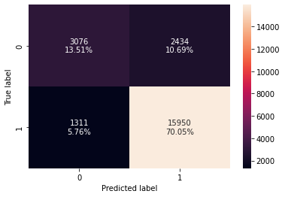

log_reg_model_train_perf = model_performance_classification_statsmodels(
lg3, X_train3, y_train
)

print("Training performance:")
log_reg_model_train_perf
Training performance:

 | Accuracy | Recall | Precision | F1
0 | 0.835536 | 0.924048 | 0.867602 | 0.894936

Test set performance
- We have to first drop the columns from the test set that were dropped from the training set.

X_test3 = X_test[list(X_train3.columns)]

# creating confusion matrix
confusion_matrix_statsmodels(lg3, X_test3, y_test)
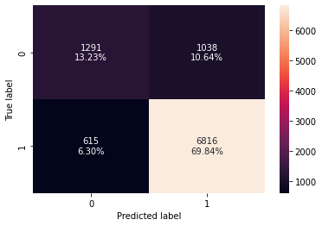

log_reg_model_test_perf = model_performance_classification_statsmodels(
lg3, X_test3, y_test
)

print("Test performance:")
log_reg_model_test_perf
Test performance:

 | Accuracy | Recall | Precision | F1
0 | 0.830635 | 0.917239 | 0.867838 | 0.891855

- The model is giving a good f1_score of ~0.895 and ~0.892 on the train and test sets respectively
- As the train and test performances are comparable, the model is not overfitting
- Moving forward we will try to improve the performance of the model

Model Performance Improvement

- Let's see if the f1_score can be improved further by changing the model threshold
- First, we will check the ROC curve, compute the area under the ROC curve (ROC-AUC), and then use it to find the optimal threshold
- Next, we will check the Precision-Recall curve to find the right balance between precision and recall as our metric of choice is f1_score

ROC Curve and ROC-AUC

- ROC-AUC on training set

logit_roc_auc_train = roc_auc_score(y_train, lg3.predict(X_train3))
fpr, tpr, thresholds = roc_curve(y_train, lg3.predict(X_train3))
plt.figure(figsize=(7, 5))
plt.plot(fpr, tpr, label="Logistic Regression (area = %0.2f)" % logit_roc_auc_train)
plt.plot([0, 1], [0, 1], "r--")
plt.xlim([0.0, 1.0])
plt.ylim([0.0, 1.05])
plt.xlabel("False Positive Rate")
plt.ylabel("True Positive Rate")
plt.title("Receiver operating characteristic")
plt.legend(loc="lower right")
plt.show()
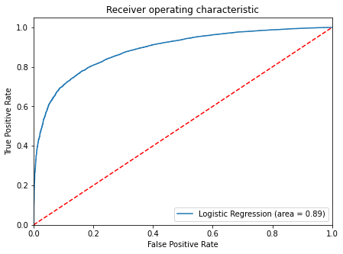

- Logistic Regression model is giving a good performance on training set.

Optimal threshold using AUC-ROC curve

# Optimal threshold as per AUC-ROC curve
# The optimal cut off would be where tpr is high and fpr is low
fpr, tpr, thresholds = roc_curve(y_train, lg3.predict(X_train3))

optimal_idx = np.argmax(tpr - fpr)
optimal_threshold_auc_roc = thresholds[optimal_idx]
print(optimal_threshold_auc_roc)
0.7579399407330089

Checking model performance on training set

# creating confusion matrix
confusion_matrix_statsmodels(
lg3, X_train3, y_train, threshold=optimal_threshold_auc_roc
)
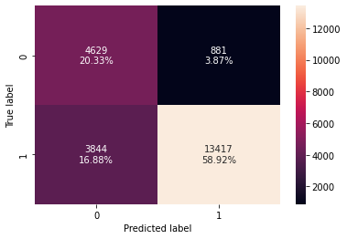

# checking model performance for this model
log_reg_model_train_perf_threshold_auc_roc = model_performance_classification_statsmodels(
lg3, X_train3, y_train, threshold=optimal_threshold_auc_roc
)
print("Training performance:")
log_reg_model_train_perf_threshold_auc_roc
Training performance:

 | Accuracy | Recall | Precision | F1
0 | 0.792499 | 0.777301 | 0.938383 | 0.85028

- Precision of model has increased but the other metrics have reduced.
- The model is still giving a good performance.

Checking model performance on test set

logit_roc_auc_train = roc_auc_score(y_test, lg3.predict(X_test3))
fpr, tpr, thresholds = roc_curve(y_test, lg3.predict(X_test3))
plt.figure(figsize=(7, 5))
plt.plot(fpr, tpr, label="Logistic Regression (area = %0.2f)" % logit_roc_auc_train)
plt.plot([0, 1], [0, 1], "r--")
plt.xlim([0.0, 1.0])
plt.ylim([0.0, 1.05])
plt.xlabel("False Positive Rate")
plt.ylabel("True Positive Rate")
plt.title("Receiver operating characteristic")
plt.legend(loc="lower right")
plt.show()
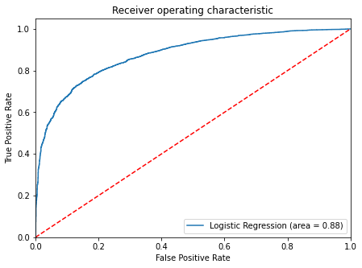

# creating confusion matrix
confusion_matrix_statsmodels(lg3, X_test3, y_test, threshold=optimal_threshold_auc_roc)
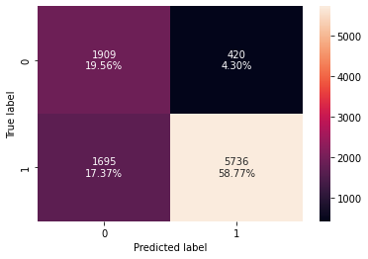

# checking model performance for this model
log_reg_model_test_perf_threshold_auc_roc = model_performance_classification_statsmodels(
lg3, X_test3, y_test, threshold=optimal_threshold_auc_roc
)
print("Test performance:")
log_reg_model_test_perf_threshold_auc_roc
Test performance:

 | Accuracy | Recall | Precision | F1
0 | 0.783299 | 0.771901 | 0.931774 | 0.844336

Precision-Recall Curve

y_scores = lg3.predict(X_train3)
prec, rec, tre = precision_recall_curve(y_train, y_scores,)

def plot_prec_recall_vs_tresh(precisions, recalls, thresholds):
plt.plot(thresholds, precisions[:-1], "b--", label="precision")
plt.plot(thresholds, recalls[:-1], "g--", label="recall")
plt.xlabel("Threshold")
plt.legend(loc="upper left")
plt.ylim([0, 1])

plt.figure(figsize=(10, 7))
plot_prec_recall_vs_tresh(prec, rec, tre)
plt.show()
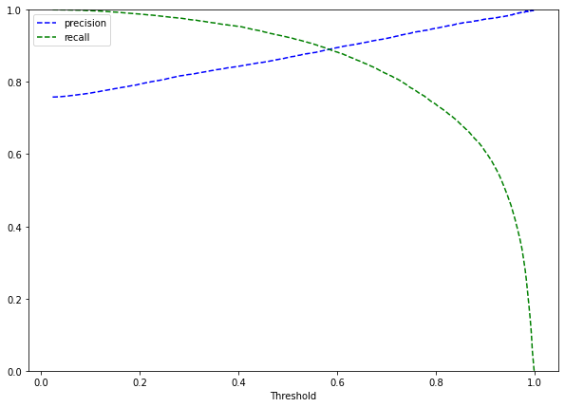

- At the threshold of 0.58, we get balanced recall and precision.

# setting the threshold
optimal_threshold_curve = 0.58

Checking model performance on training set

# creating confusion matrix
confusion_matrix_statsmodels(lg3, X_train3, y_train, threshold=optimal_threshold_curve)
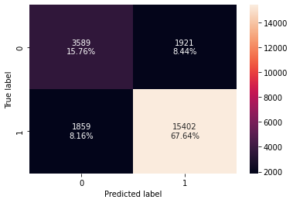

log_reg_model_train_perf_threshold_curve = model_performance_classification_statsmodels(
lg3, X_train3, y_train, threshold=optimal_threshold_curve
)
print("Training performance:")
log_reg_model_train_perf_threshold_curve
Training performance:

 | Accuracy | Recall | Precision | F1
0 | 0.833999 | 0.892301 | 0.889107 | 0.890701

- Model is performing well on training set.
- There's not much improvement in the model performance as the default threshold is 0.50 and here we get 0.58 as the optimal threshold.

Checking model performance on test set

# creating confusion matrix
confusion_matrix_statsmodels(lg3, X_test3, y_test, threshold=optimal_threshold_curve)
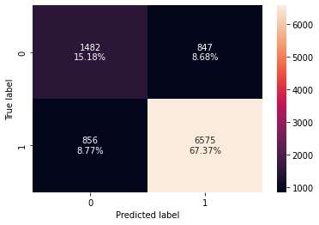

log_reg_model_test_perf_threshold_curve = model_performance_classification_statsmodels(
lg3, X_test3, y_test, threshold=optimal_threshold_curve
)
print("Test performance:")
log_reg_model_test_perf_threshold_curve
Test performance:

 | Accuracy | Recall | Precision | F1
0 | 0.825512 | 0.884807 | 0.88588 | 0.885343

Model Performance Comparison and Final Model Selection

# training performance comparison

models_train_comp_df = pd.concat(
[
log_reg_model_train_perf.T,
log_reg_model_train_perf_threshold_auc_roc.T,
log_reg_model_train_perf_threshold_curve.T,
],
axis=1,
)
models_train_comp_df.columns = [
"Logistic Regression-default Threshold (0.5)",
"Logistic Regression-0.76 Threshold",
"Logistic Regression-0.58 Threshold",
]

print("Training performance comparison:")
models_train_comp_df
Training performance comparison:

 | Logistic Regression-default Threshold (0.5) | Logistic Regression-0.76 Threshold | Logistic Regression-0.58 Threshold
Accuracy | 0.835536 | 0.792499 | 0.833999
Recall | 0.924048 | 0.777301 | 0.892301
Precision | 0.867602 | 0.938383 | 0.889107
F1 | 0.894936 | 0.850280 | 0.890701

# testing performance comparison

models_test_comp_df = pd.concat(
[
log_reg_model_test_perf.T,
log_reg_model_test_perf_threshold_auc_roc.T,
log_reg_model_test_perf_threshold_curve.T,
],
axis=1,
)
models_test_comp_df.columns = [
"Logistic Regression-default Threshold (0.5)",
"Logistic Regression-0.76 Threshold",
"Logistic Regression-0.58 Threshold",
]

print("Test set performance comparison:")
models_test_comp_df
Test set performance comparison:

 | Logistic Regression-default Threshold (0.5) | Logistic Regression-0.76 Threshold | Logistic Regression-0.58 Threshold
Accuracy | 0.830635 | 0.783299 | 0.825512
Recall | 0.917239 | 0.771901 | 0.884807
Precision | 0.867838 | 0.931774 | 0.885880
F1 | 0.891855 | 0.844336 | 0.885343

- Almost all the three models are performing well on both training and test data without the problem of overfitting
- The model with a default threshold (0.5) is giving the best F1 score. Therefore it can be selected as the final model

Conclusions and Recommendations

- We have been able to build a predictive model that can be used by the government to find the citizens having less than 50K salary with an f1_score of 0.89 on the training set and formulate policies accordingly.
- All the logistic regression models have given a generalized performance on the training and test set.
- Coefficient of some levels of education, workclass, and native country are positive an increase in these will lead to increase in chances of a person having <=50K salary.
- Coefficient of age, fnlwgt, marital_status, working_hours_per_week,some levels of education, workclass, and native country are negative increase in these will lead to decrease in chances of a person having <=50K salary.

- The government should promote education among citizens, they should make policies to make education accessible to all, as we say in our analysis that people who have higher education are more likely to have a salary above 50,000 Dollars.
- Working hours is one of the significant predictors of salary, The government should implement laws to ensure that people are paid fairly for their work and are not overworked for the increase in salaries. This would improve work-life balance.
- Reforms should be made for private-sector employees so that they are paid fairly for their work.
- Policy formulated by the government should be considerate of equal pay and counter the pay gap that exists in society.

Appendix: Detailed Exploratory Data Analysis (EDA)

Univariate Analysis

Observations on fnlwgt

histogram_boxplot(df, "fnlwgt", bins=100)
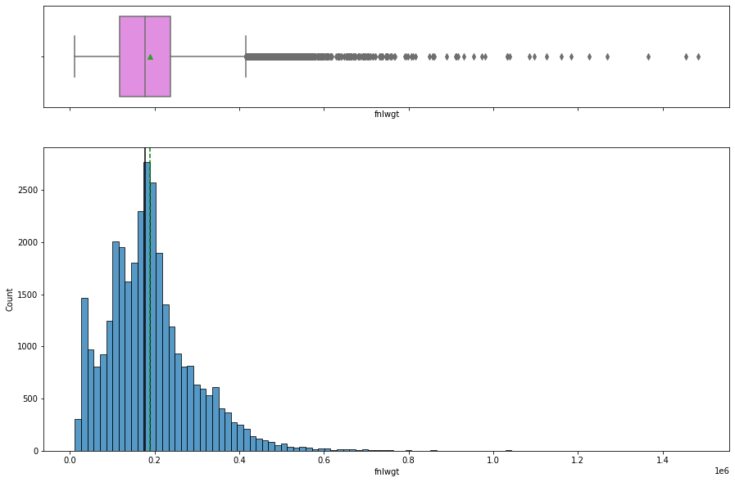

- fnlwght is right-skewed. It has lots of outliers on the right side.

Observations on workclass

labeled_barplot(df, "workclass", perc=True)

- ~70% of the observations are from the Private sector working class.
- As expected from the number of hours per week.

Observations on marital_status

labeled_barplot(df, "marital_status", perc=True)
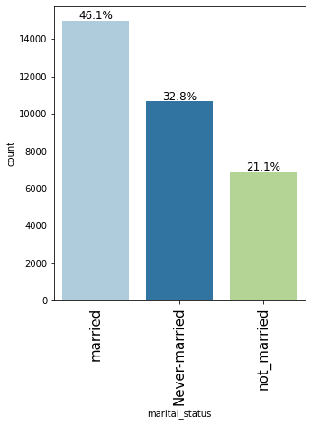

- 46.1% of the observations in the dataset are married followed by 32.8% of the people who never married.

Observations on salary

labeled_barplot(df, "salary", perc=True)

- ~24% of the observations have a salary above 50K and while ~76% have a salary below 50K

Bivariate analysis

Correlation Check

plt.figure(figsize=(15, 7))
sns.heatmap(df.corr(), annot=True, vmin=-1, vmax=1, fmt=".2f", cmap="Spectral")
plt.show()

- There is no significant correlation between the columns.

salary vs sex

stacked_barplot(df, "sex", "salary")
salary <=50K >50K All
sex
All 24692 7839 32531
Male 15113 6660 21773
Female 9579 1179 10758
------------------------------------------------------------------------------------------------------------------------

- ~30% of the males have salary >50K whereas only ~10% of the females have salary >50K.
- This shows the pay gap that exists in society and the government should investigate further on it to formulate policy to ensure equal pay.

salary vs education

stacked_barplot(df, "education", "salary")
salary <=50K >50K All
education
All 24692 7839 32531
Bachelors 3132 2221 5353
HS-grad 8816 1674 10490
Some-college 5894 1386 7280
Masters 763 959 1722
Prof-school 153 423 576
Assoc-voc 1021 361 1382
Doctorate 107 306 413
Assoc-acdm 802 265 1067
10th 871 62 933
11th 1115 60 1175
7th-8th 605 40 645
12th 400 33 433
9th 487 27 514
5th-6th 316 16 332
1st-4th 160 6 166
Preschool 50 0 50
------------------------------------------------------------------------------------------------------------------------

- ~70% of the people of are Doctorate, graduate from Professional school program (Prof-school) have a salary above $50K.
- This clearly shows a positive relationship between education and salary, the higher the education higher is the salary.

salary vs occupation

stacked_barplot(df, "occupation", "salary")
salary <=50K >50K All
occupation
All 24692 7839 32531
Exec-managerial 2097 1968 4065
Prof-specialty 2278 1858 4136
Sales 2666 983 3649
Craft-repair 3164 929 4093
Adm-clerical 3259 507 3766
Transport-moving 1277 320 1597
Tech-support 644 283 927
Machine-op-inspct 1750 249 1999
Protective-serv 438 211 649
Unknown 1652 191 1843
Other-service 3153 137 3290
Farming-fishing 877 115 992
Handlers-cleaners 1283 86 1369
Armed-Forces 8 1 9
Priv-house-serv 146 1 147
------------------------------------------------------------------------------------------------------------------------

- ~50% of the people whose occupation is of Executive Manager, Professor-speciality have a salary above $50,000
- People with occupations like Private house service,handlers-cleaners, farming-fishing have a higher likelihood of having below 50K salary.

salary vs race

stacked_barplot(df, "race", "salary")
salary <=50K >50K All
race
All 24692 7839 32531
White 20674 7115 27789
Black 2735 387 3122
Asian-Pac-Islander 762 276 1038
Amer-Indian-Eskimo 275 36 311
Other 246 25 271
------------------------------------------------------------------------------------------------------------------------
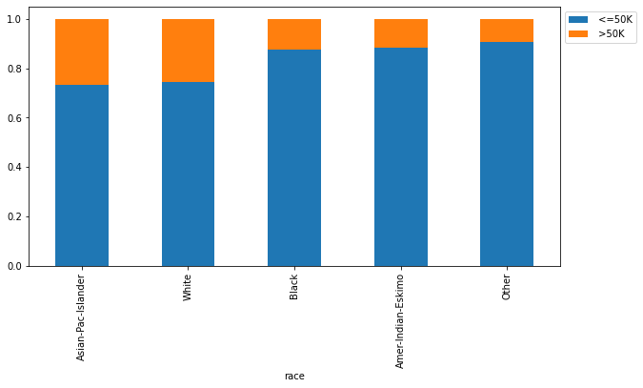

- 25% of the White and Asia-Pacific people have a salary more than 50K salary as compared to people from other race.

salary vs workclass

stacked_barplot(df, "workclass", "salary")
salary <=50K >50K All
workclass
All 24692 7839 32531
Private 17706 4961 22667
Self-emp-not-inc 1816 724 2540
Self-emp-inc 494 622 1116
Local-gov 1476 617 2093
Federal-gov 589 371 960
State-gov 945 353 1298
Unknown 1645 191 1836
Never-worked 7 0 7
Without-pay 14 0 14
------------------------------------------------------------------------------------------------------------------------

- ~50% of the self-employed people have a salary above 50K followed by ~40% of the federal govt employee who has salary more than 50K.
- ~20% of the people working in the private sector earn more than 50K.

salary vs marital_status

stacked_barplot(df, "marital_status", "salary")
salary <=50K >50K All
marital_status
All 24692 7839 32531
married 8293 6700 14993
not_married 6229 648 6877
Never-married 10170 491 10661
------------------------------------------------------------------------------------------------------------------------
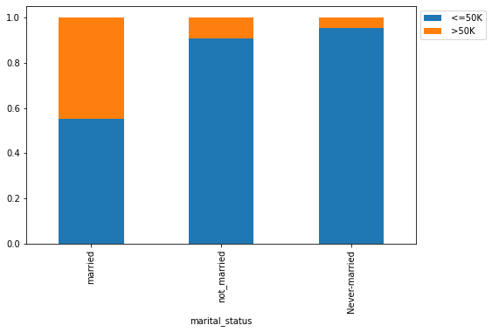

- Married people have a higher likelihood of getting a salary above 50K compared to Never Married and Not married people.

salary vs age

distribution_plot_wrt_target(df, "age", "salary")

- People who more than 50K salary are generally older having an average age of around 48 years.
- People who have less than 50K salary have an average age of around 36.

salary vs working_hours_per_week

distribution_plot_wrt_target(df, "working_hours_per_week", "salary")

- Majority of people having above 50K salary work around 40 hours per week.
- Those having >50K salary have a higher range of working hours as compared to the ones with <=50K, but there are outliers present.

# lets see how working hours per week vary across different occupation
plt.figure(figsize=(15, 12))
sns.boxplot(
y="workclass", x="working_hours_per_week", data=df, hue="salary", showfliers=False
)
plt.show()

- Private sector employees work for more hours to get a salary above 50K.
- There's large variability in the working hours of self-employed people which makes sense as they might be working at their ease.
- Without pay and never worked will have no income or less than 50K income.
- The number of working hours for many government employees is concentrated at 40 hrs a week, which makes sense as government employees generally have fixed working hours.

To jump back to the EDA summary section, click here.

