Mini Project 5
Johnny Vogt

Question 1.
https://www.w3schools.com (For examples of syntax usage for EXISTs, LIKE, Joins, and Queries)
1.
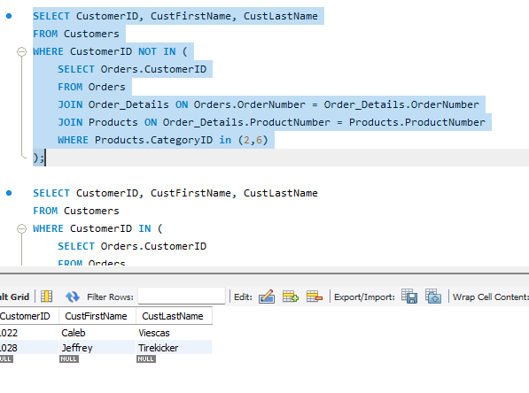

2.
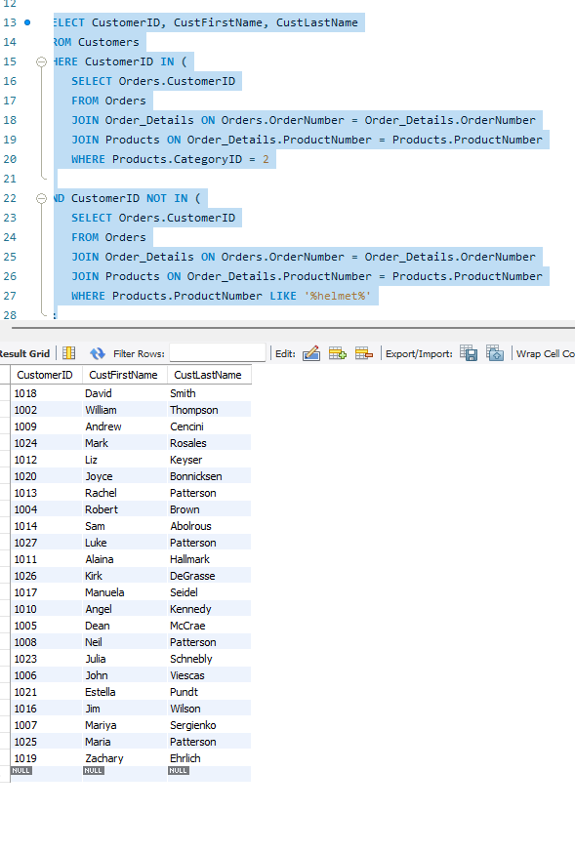

3.
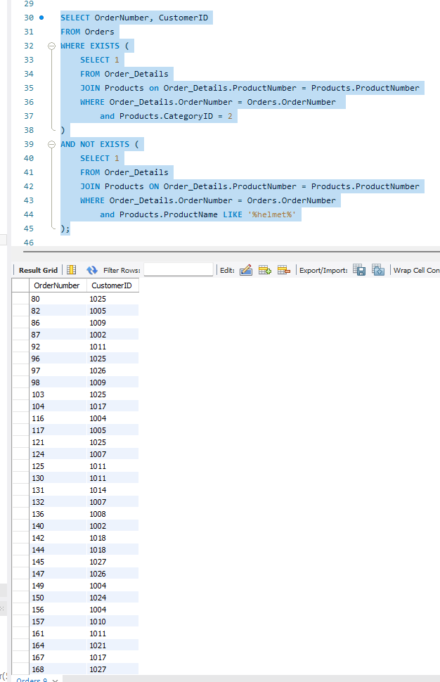

4.
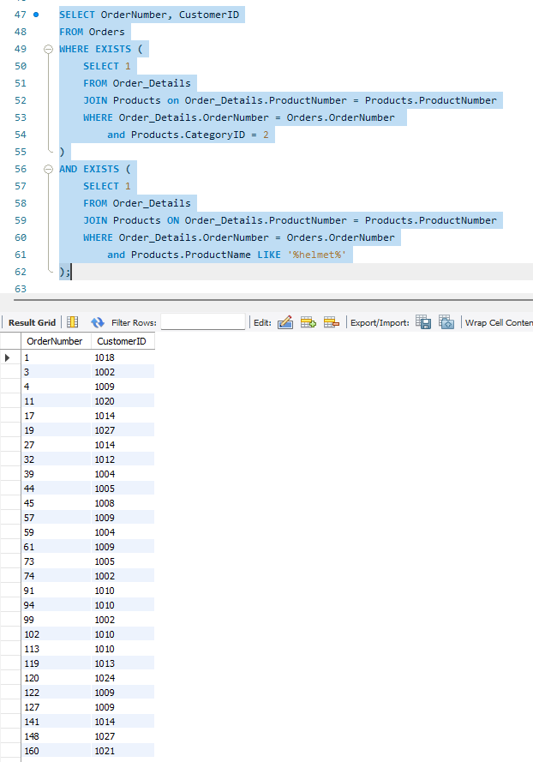

Question 2:

import mysql.connector

conn = mysql.connector.connect(
host=’localhost’
user=’root’
password=’nottellingya’
database=’salesordersexampletest’
)

cursor = conn.cursor()

query1 = “””
SELECT CustomerID, CustFirstName, CustLastName
FROM Customers
WHERE CustomerID NOT IN (
SELECT Orders.CustomerID
FROM Orders
JOIN Order_Details ON Orders.OrderNumber = Order_Details.OrderNumber
JOIN Products ON Order_Details.ProductNumber = Products.ProductNumber
WHERE Products.CategoryID IN (2,6)
)
“””

cursor.execute(query1)
resutl1 = cursor.fetchall()
for row in result1:
print(row)

query2 = “””
SELECT CustomerID, CustFirstName, CustLastName
FROM Customers
WHERE CustomerID IN (
SELECT Orders.CustomerID
FROM Orders
JOIN Order_Details ON Orders.OrderNumber = Order_Details.OrderNumber
JOIN Products ON Order_Details.ProductNumber = Products.ProductNumber
WHERE Products.CategoryID = 2 )
AND CustomerID NOT IN (
SELECT Orders.CustomerID
FROM Orders
JOIN Order_Details ON Orders.OrderNumber = Order_Details.OrderNumber
JOIN Products ON Order_Details.ProductNumber = Products.ProductNumber
WHERE Products.ProductName LIKE '%helmet%' )
“””

cursor.execute(query2)
resutl2 = cursor.fetchall()
for row in result2:
print(row)

cursor.close()
conn.close()

Question 3
https://dev.mysql.com/doc/connector-python/en/connector-python-api-mysqlcursor-callproc.html
