Task 1: Design Game Optimisations

There are many optimisation techniques that would be viable for this application, including a Spatial tree for collision calculations and the use of the Factory Pattern for creating the critters or destroyers. However, the most simple and effective optimisations for this project would be the implementation of:
- Object Pooling
- Smart Pointers
- Resource Manager

Object Pooling
Allocating a collection of reusable objects when a level loads and deallocate when it unloads is a design pattern called an Object Pool .
Being able to reuse the critters rather than allocating and deallocating constantly can prevent a lot of fragmentation and improve performance. It also improves memory use by reusing the critters from a fixed pool instead of allocating and freeing them individually
Basically, creating a collection of objects with a way of knowing if each object is active or not.
When requesting an allocation , find the first inactive critter. When deallocating, simply deactivate the critter.
A simple method for an Object Pool implementation:
Allocate an array of the maximum critter count and flag all critters as inactive
– Allocating a critter:
• Find the first inactive critter and flag it as active
– Deallocate a critter:
• Simply flag the critter as inactive
Below is a very basic diagram of the Object Pool:

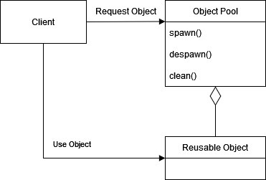

Smart Pointers
Smart pointers are used to allocate critters on the stack.
• Smart pointers use reference counting to allow a resource to be shared. Reference counting is a programming technique of storing a number to a resource, such as an object, in this case, the critters.
The reference counts are used to deallocate critters that are no longer needed.
• When a smart pointer goes out of scope, the raw pointer is deleted. When all references have been destroyed the raw pointer will be deleted.

Resource manager
A Resource Manager is used to abstract the details of loading and unloading, ensuring that no texture is ever loaded twice.
• The Resource Manager will automatically unload the critter texture upon exit, and can automatically unload unneeded critters during the game’s execution. This essentially makes use of the smart pointers.
Below is a diagram of how the Resource Manager can be implemented

