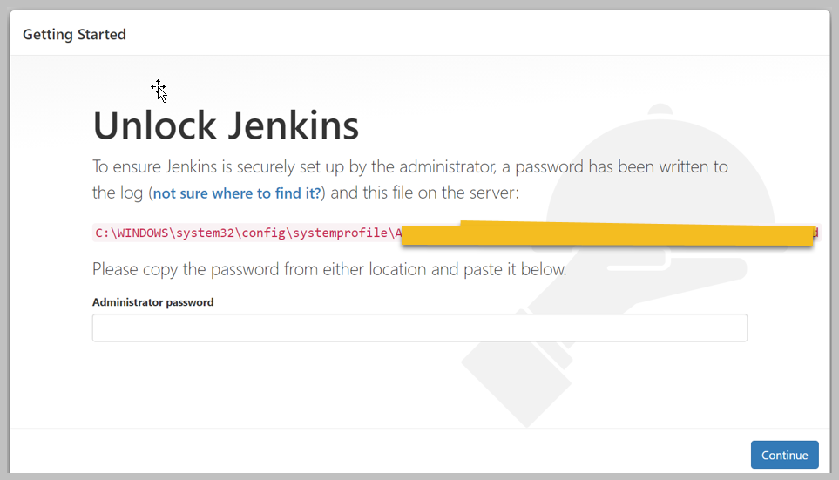

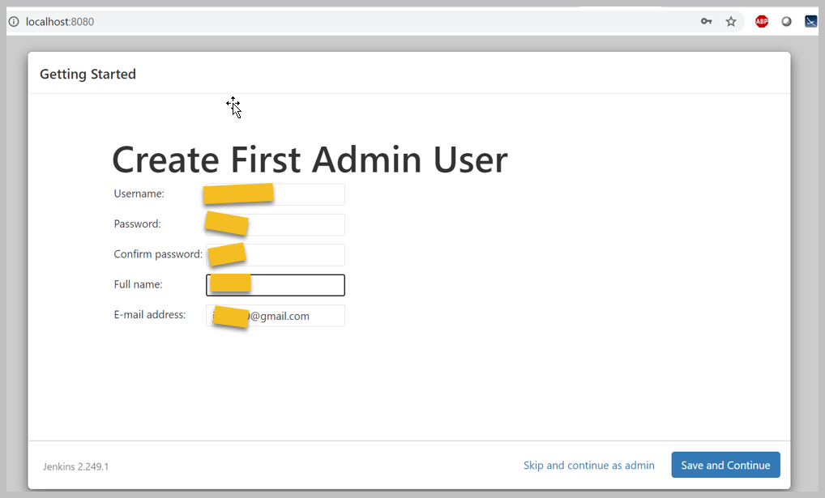

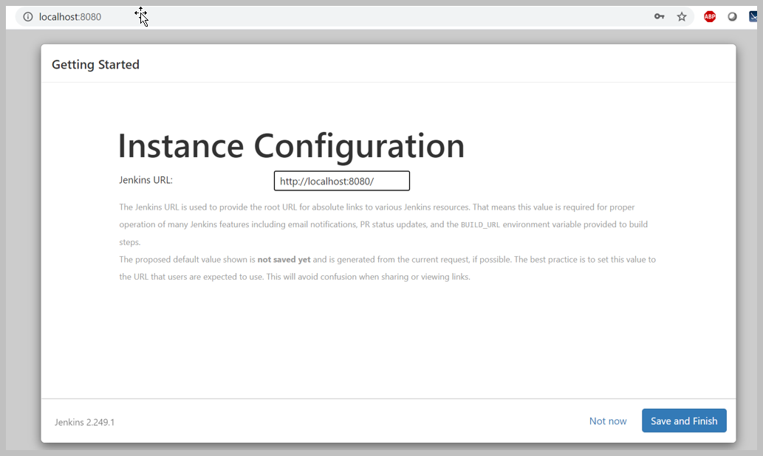

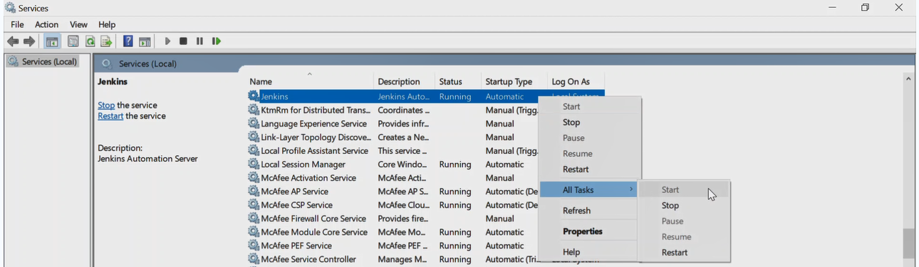

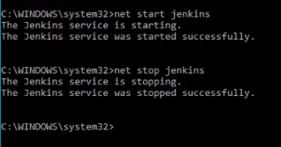

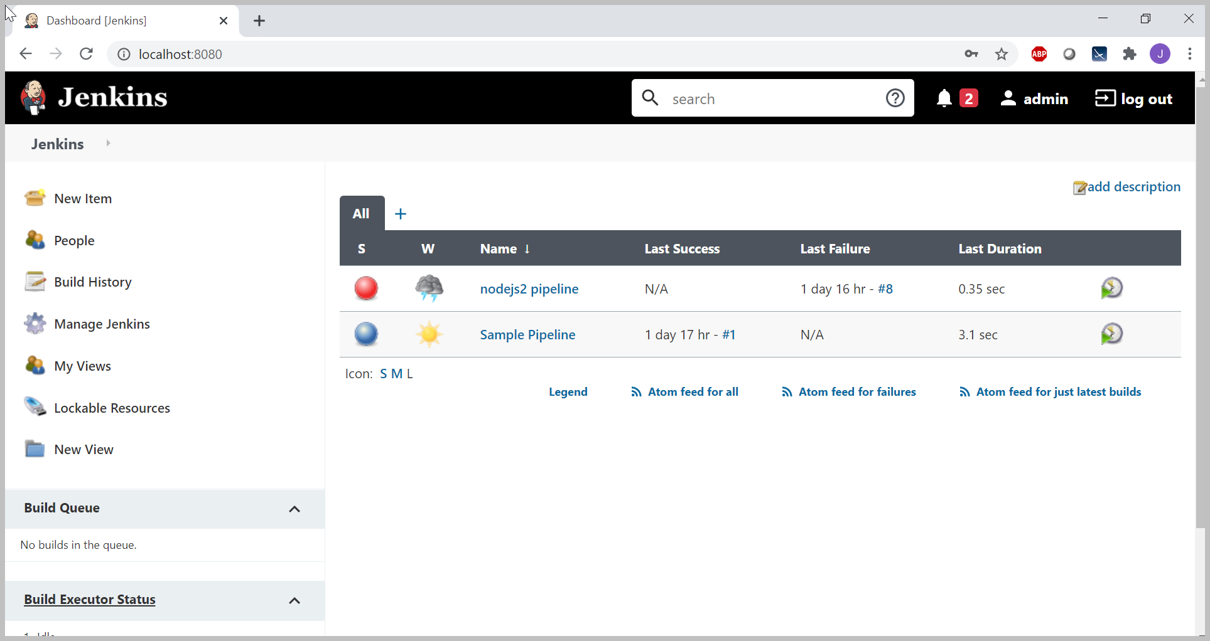

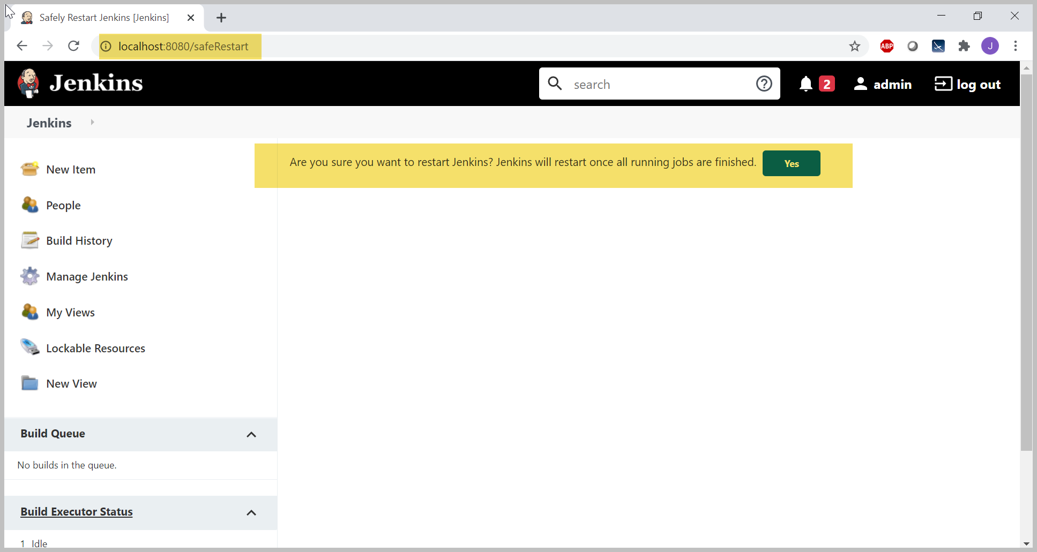

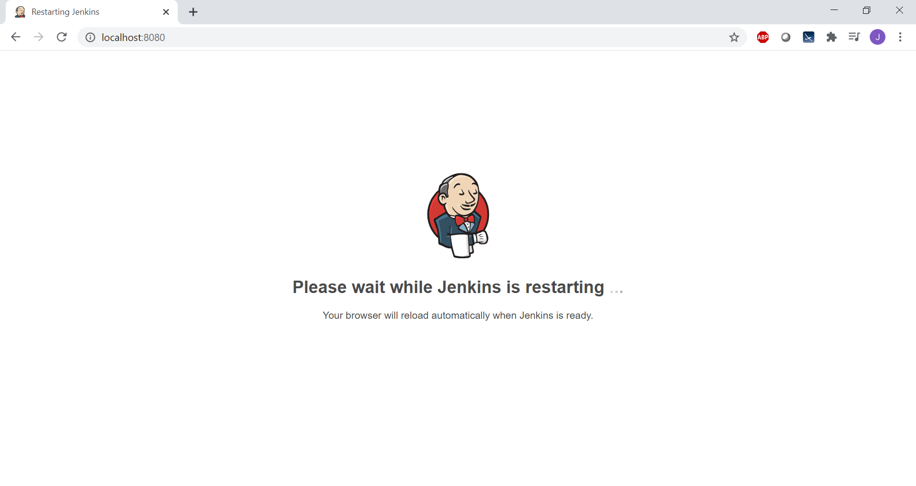

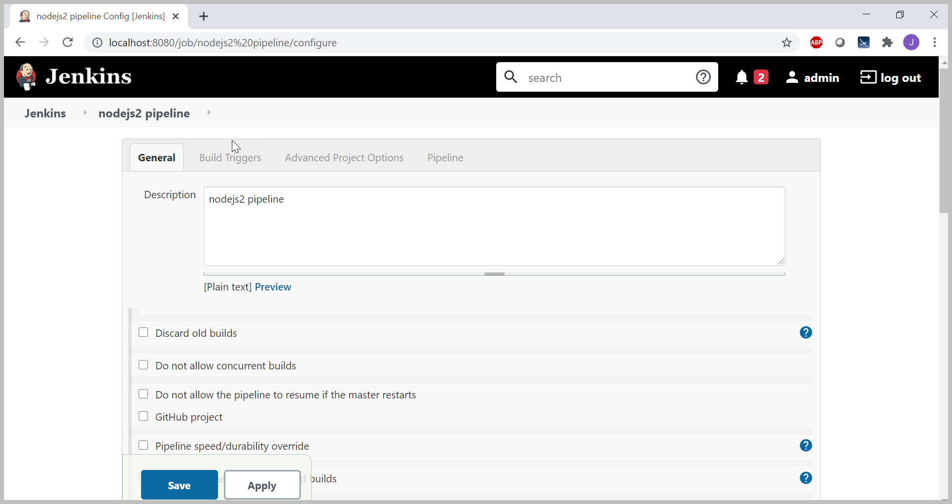

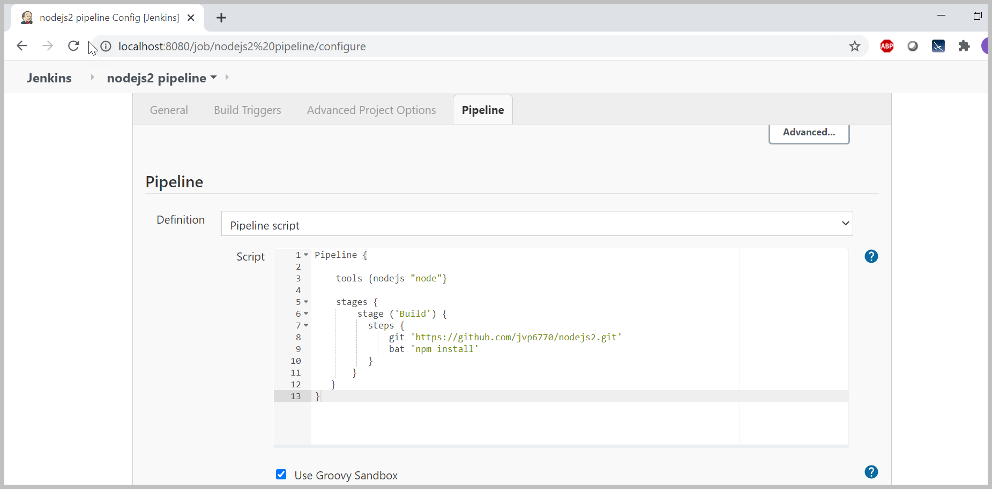

**Scripts for Build & Test.**

pipeline {

agent any

stage('Build') {

steps {

sh 'npm install'

}

}

stage('Test') {

steps {

sh './jenkins/scripts/testone.sh'

}

}

stage('Deploy') {

steps {

sh './jenkins/scripts/deploy.sh'

input message: 'Successfully Deploy' (Click "Proceed" to continue)'

}

}

}

}

Note : It it is unix then sh file and if it is window bat file.