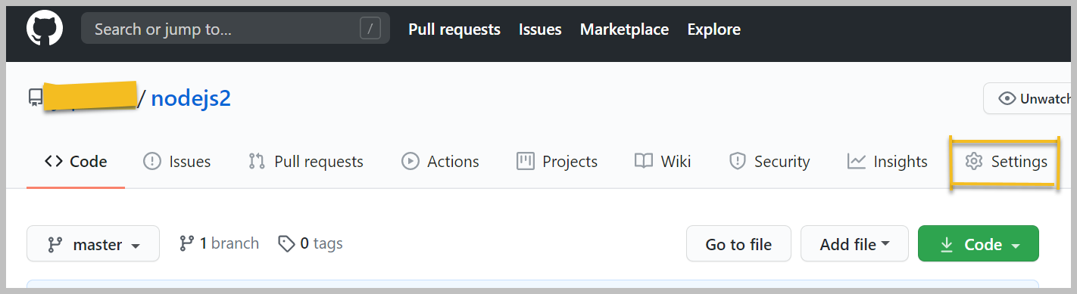

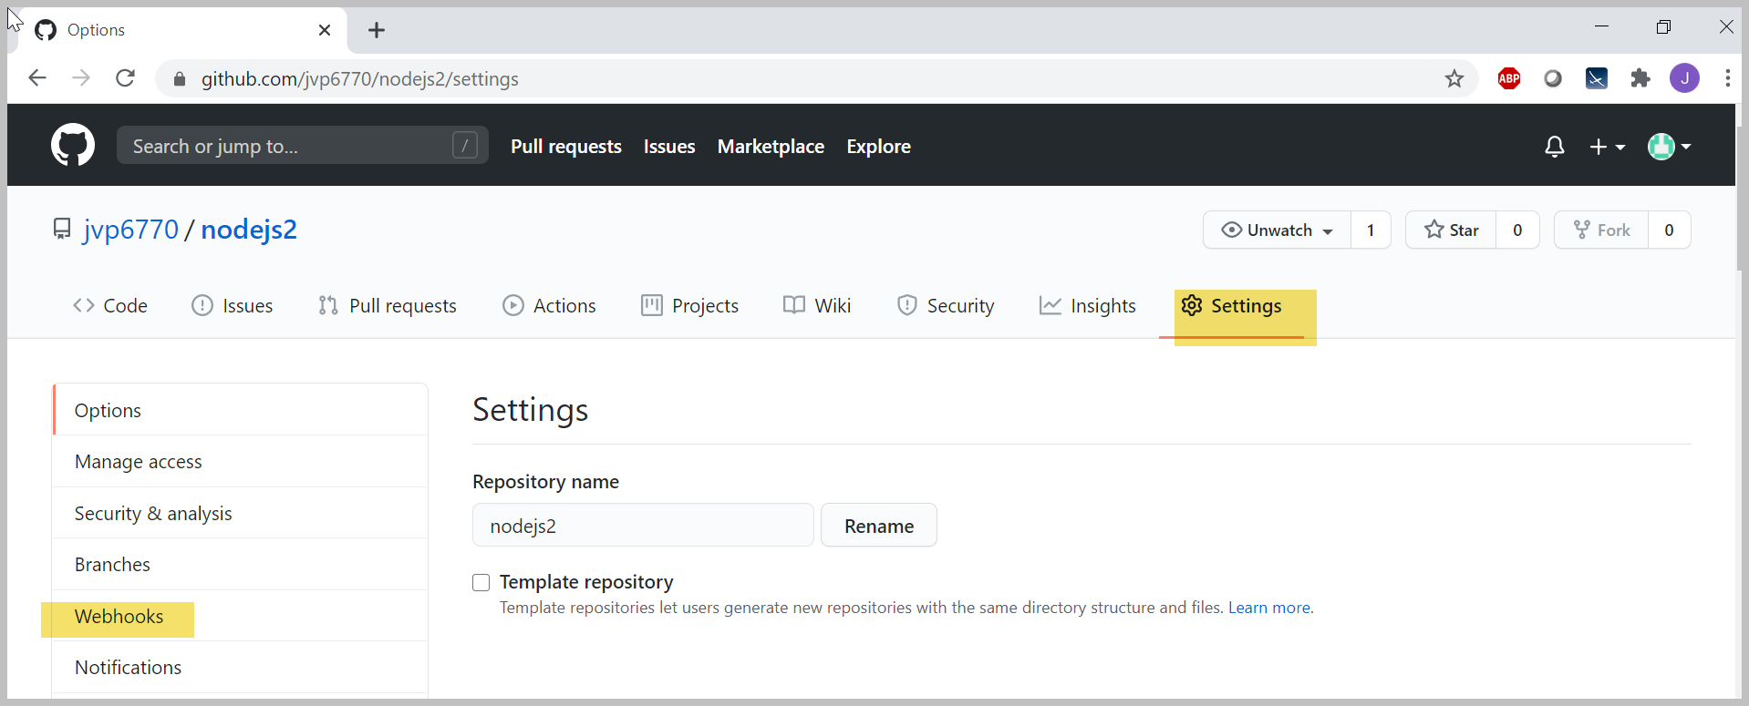

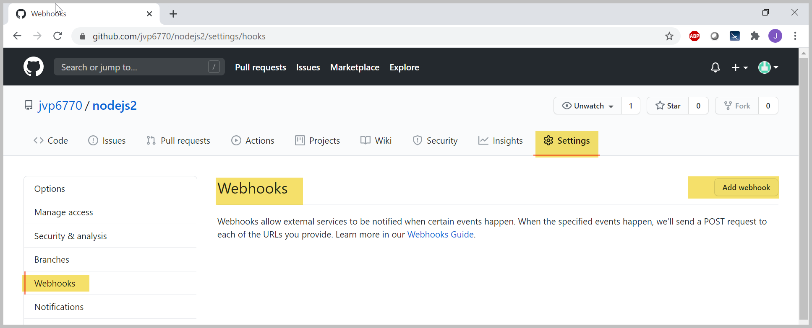

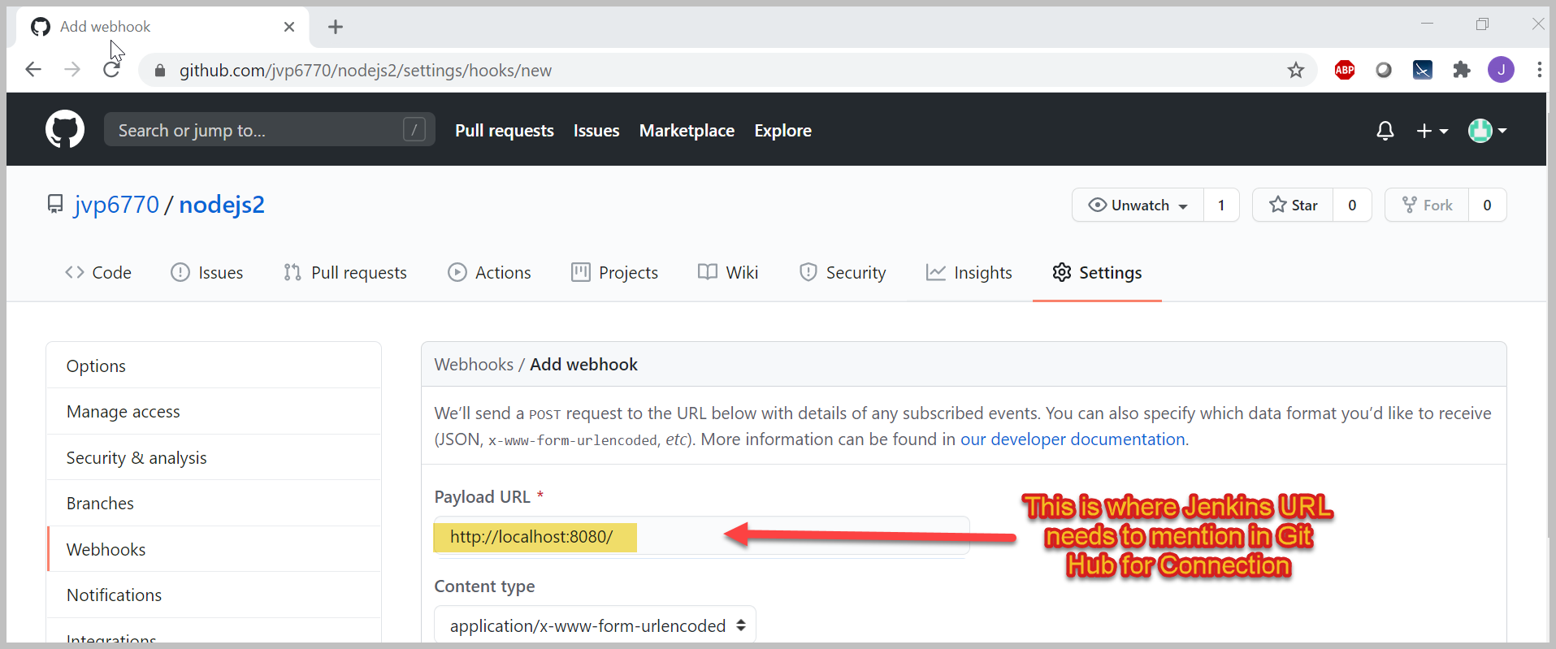

Below pipeline scripts steps will help to connect Jenkins and GitHub which is included in pipeline.

git 'https://github.com/jvp6770/nodejs2.git'