DNS- Domain Name System
Q.1 Use the filtering functionality of Wireshark by typing “dns” in
the filtering field, new window will appear:

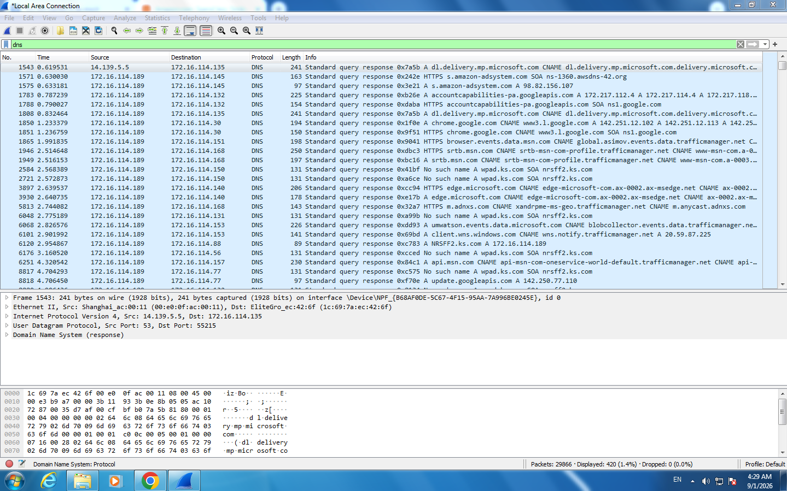

Q.2 Let’s try now to find out what are those packets contain by
following one of the conversations (also called network flows),
select one of the packets and press the right mouse button, you
should see another screen appear.
Click on Follow UDP Stream, and then you will see another
screen showing content https://www.amazon.com/

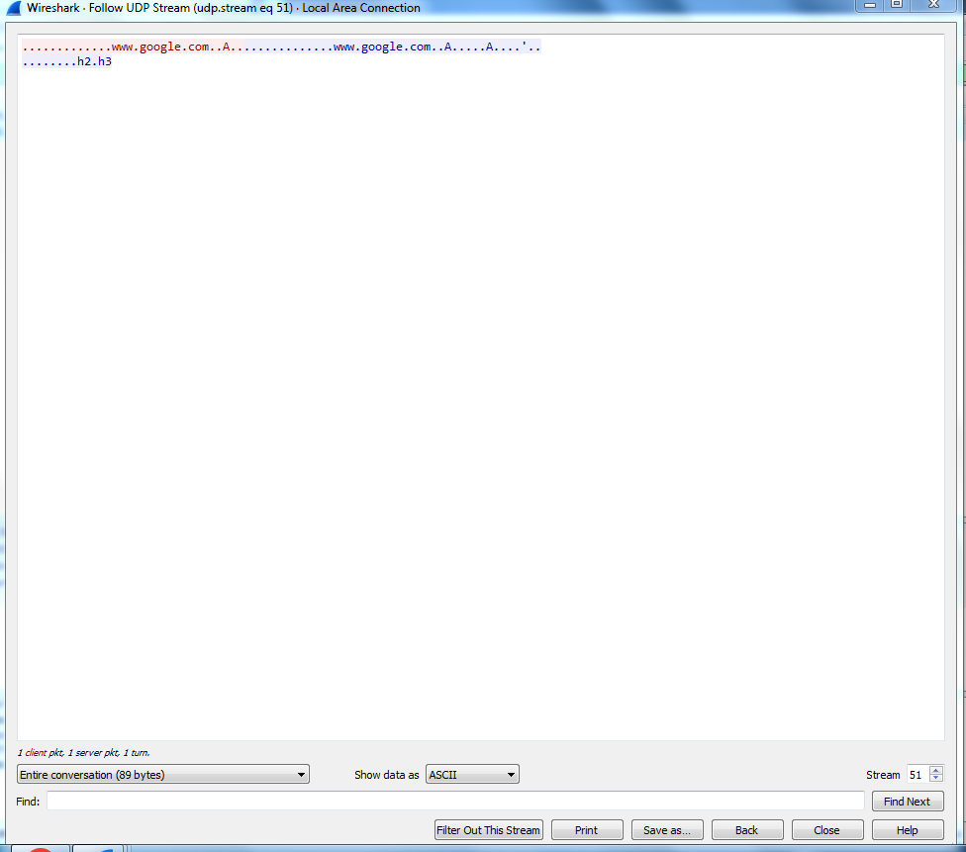

Q.3 At Command prompt ; Nslookup https://www.amazon.com/

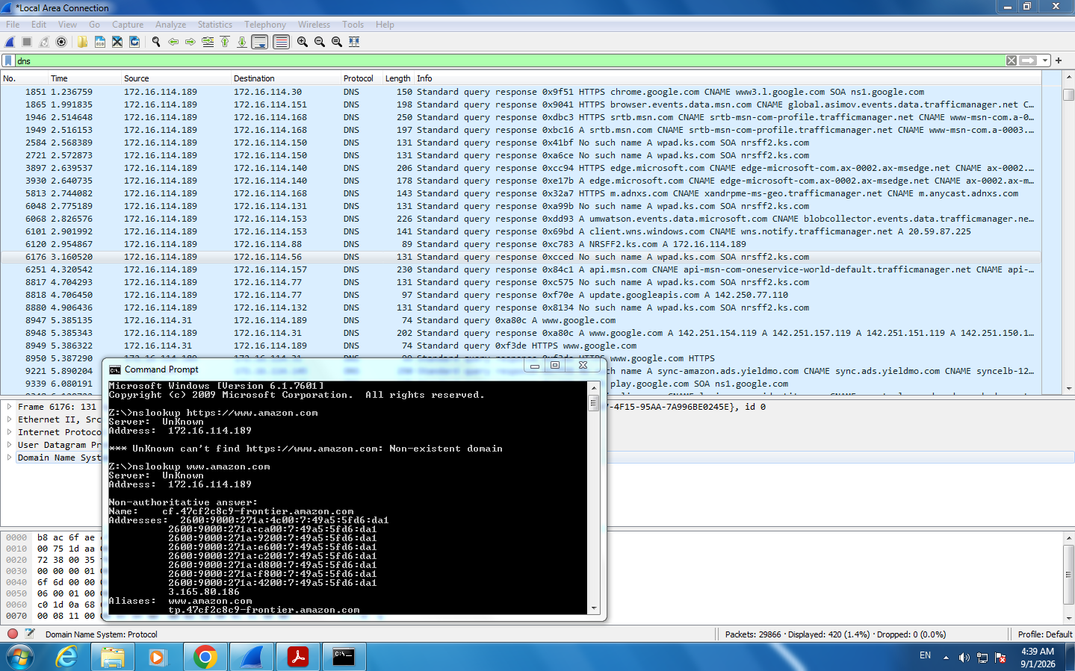

Q.4 Locate the DNS Query and Response message, Are they sent on
UDP or TCP
ANS: The DNS Query and DNS Response are sent using the UDP protocol
(Protocol 17).

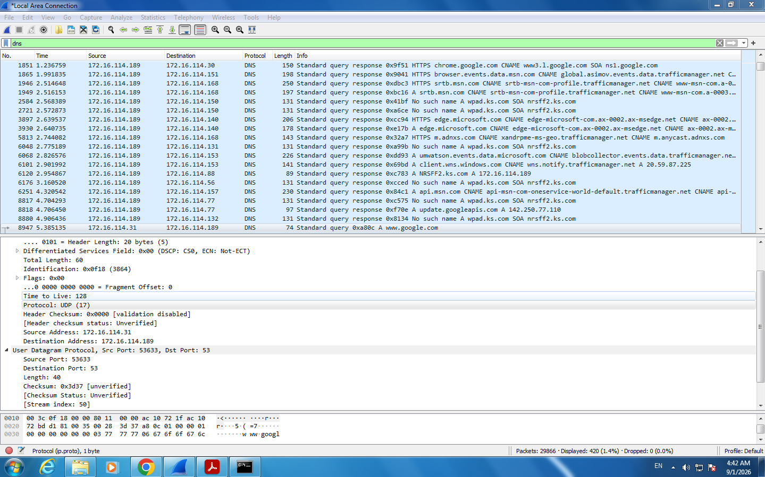

Q.5 What is the destination port for the DNS query message ? What
is the source port of of DNS response message?

The destination port for the DNS Query message is Port 53, and the source port for the DNS
Response message is also Port 53.
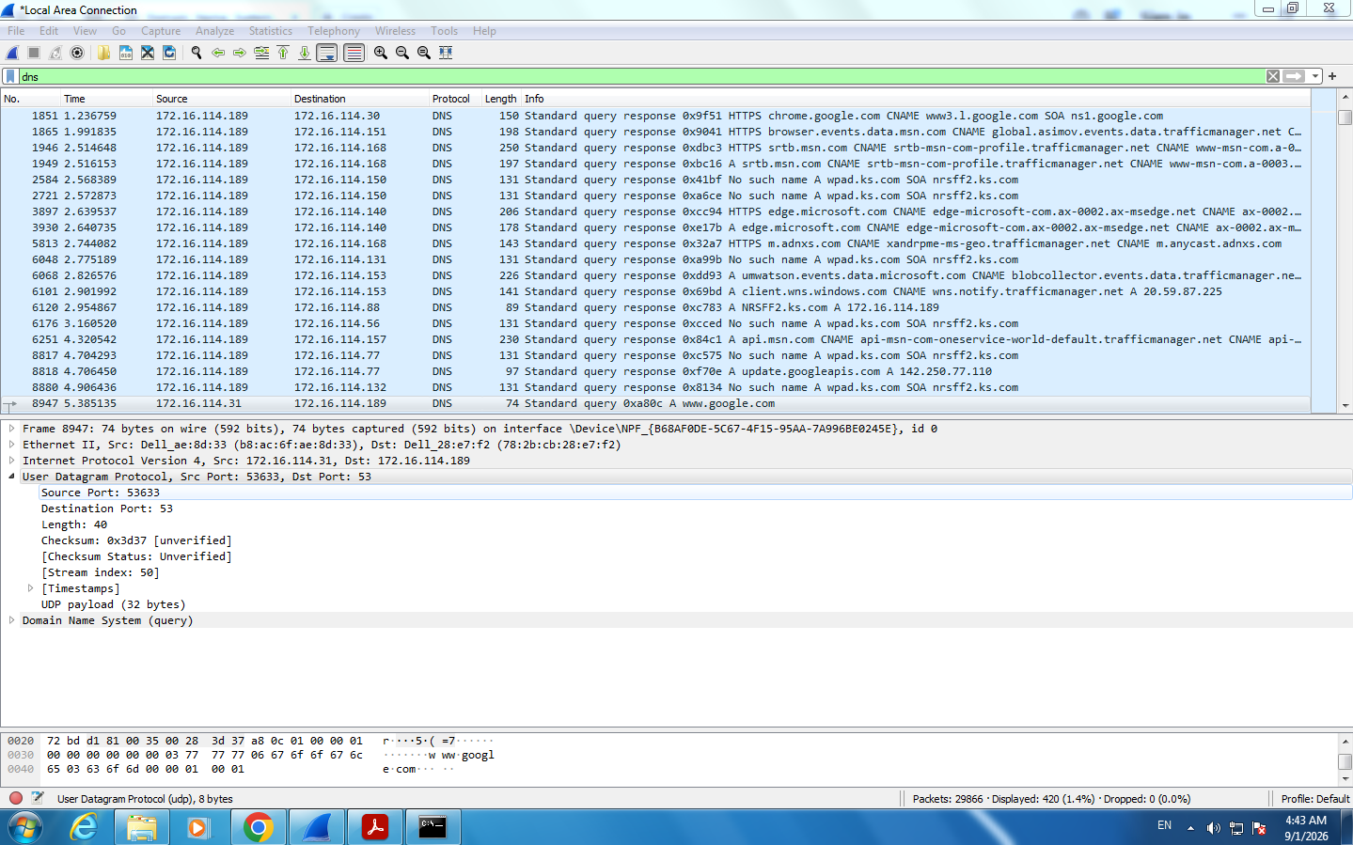
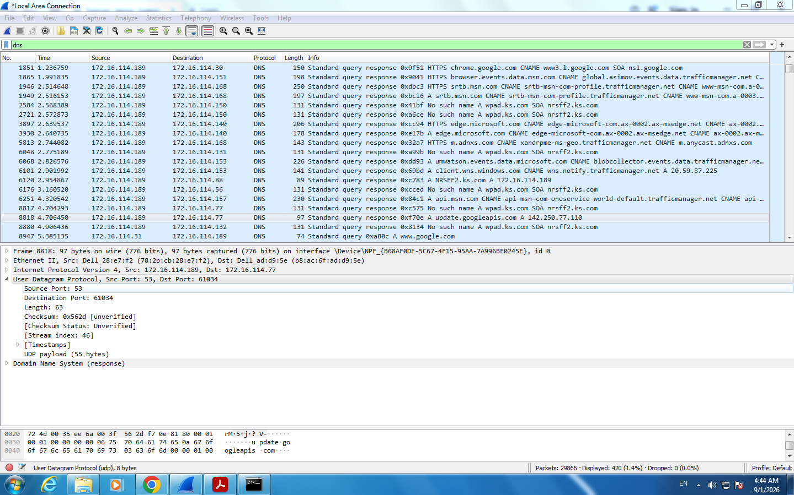

Q.6 What is the source IP address of the DNS Query message? Is it the
IP address of your computer? Verify using ipconfig. Are these two
IP address the same?
- Yes, it is same ip 172.16.114.31
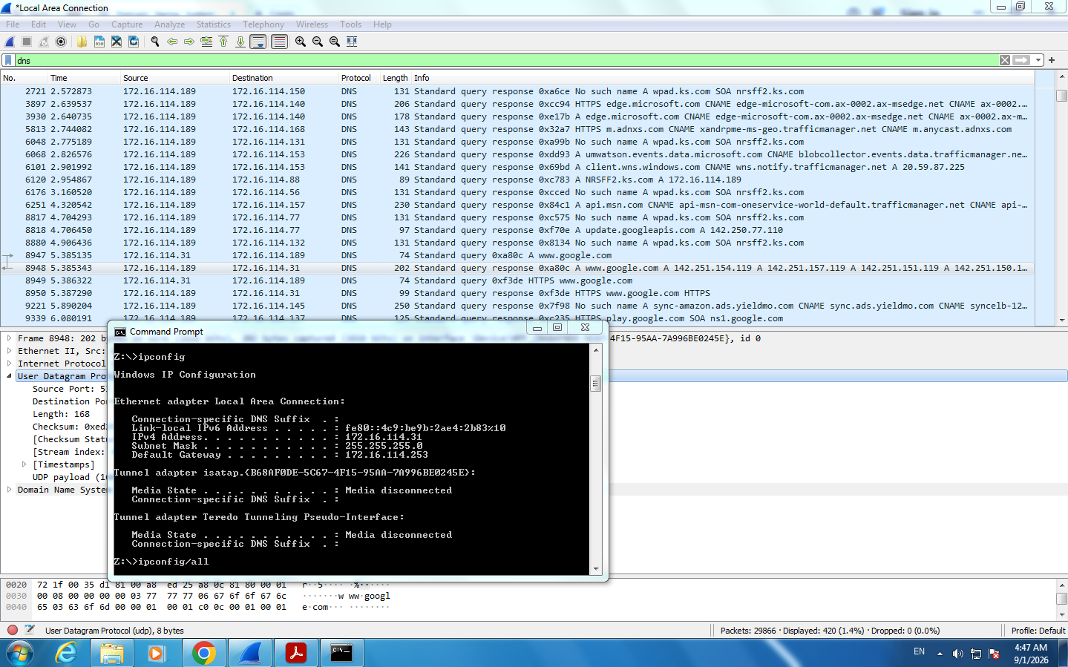

Q.7 What is the destination IP address of the DNS Query message? Is it
the IP address of your local DNS server? Verify using ipconfig. Are
these two IP address the same?
- Yes, it is same DNS ip 172.16.114.189
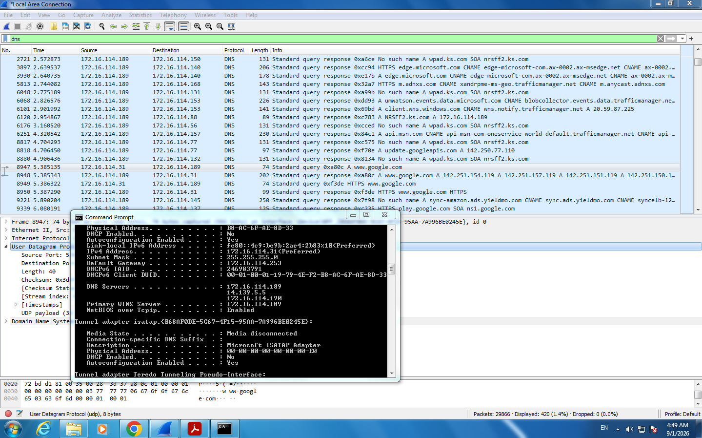

Q.8 Examine the DNS query message. What “Type” of DNS query is
it? Does the query message contain any “answers”?
yes, same destoination ip = 172.16.114.189
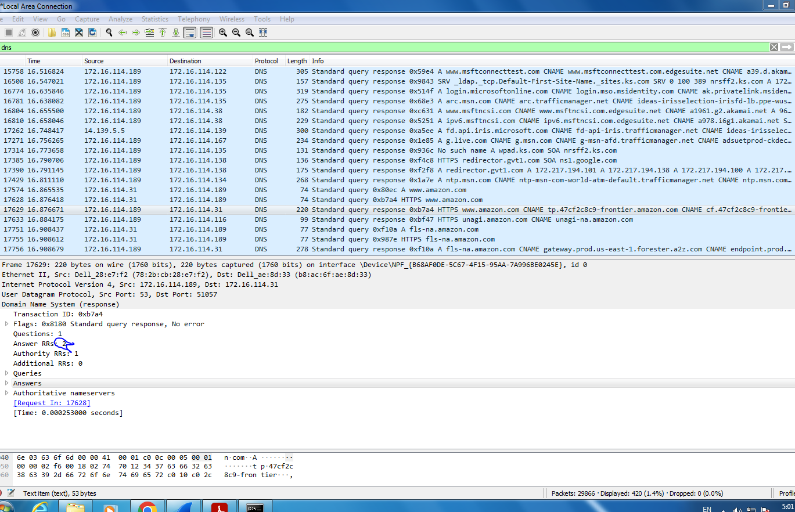

Q.9 Examine the DNS response message. How many “answers” are
provided? What do each of these answers contain?
name
Type
Class
TTL
Data Length
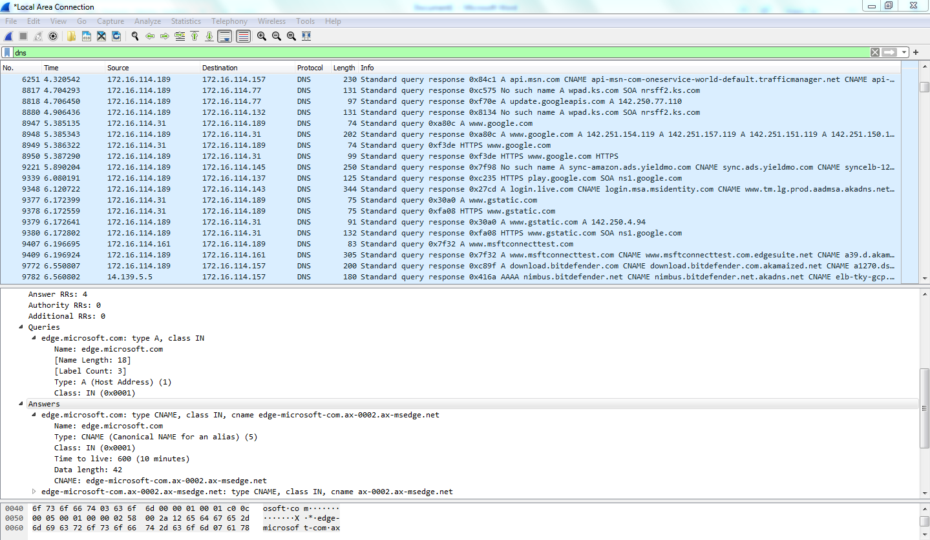

Q.10 What Protocol use in Payload? How many bytes use in Payload?
Protocol : UDP
Payload : 39 byte
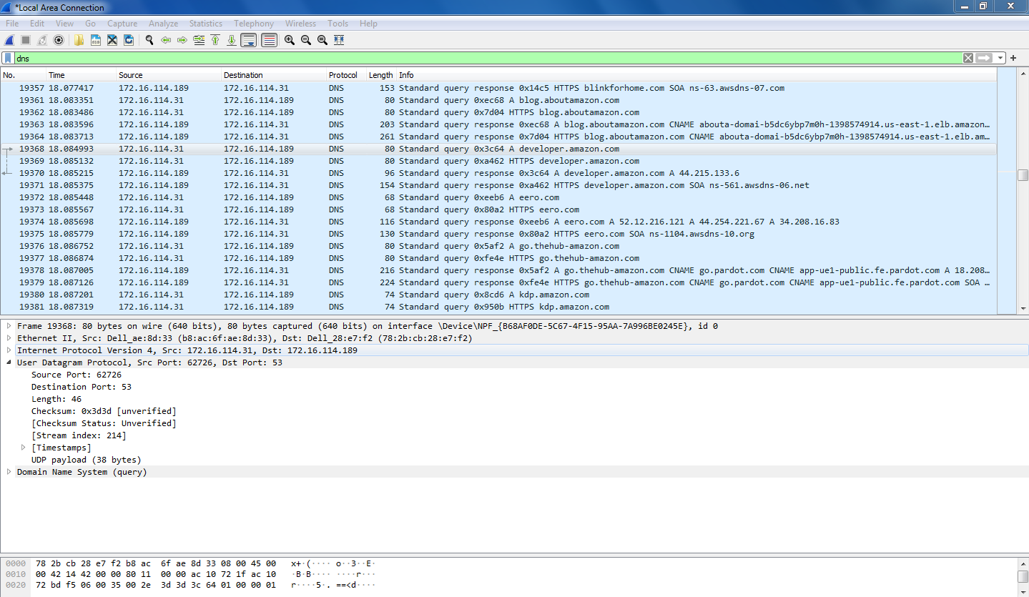
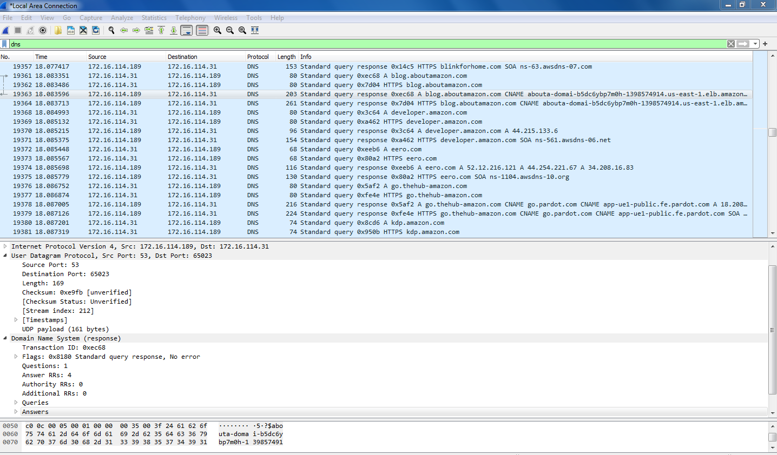
Protocol : UPD
Payload : 55 byte

Q.11 Find stream index and stream packet number of DNS Response.

