CNAM_Assignment_1

1.List up to IO different protocols that appear in the Protocol column in the
unfiltered packet-listing window.
ANS:-
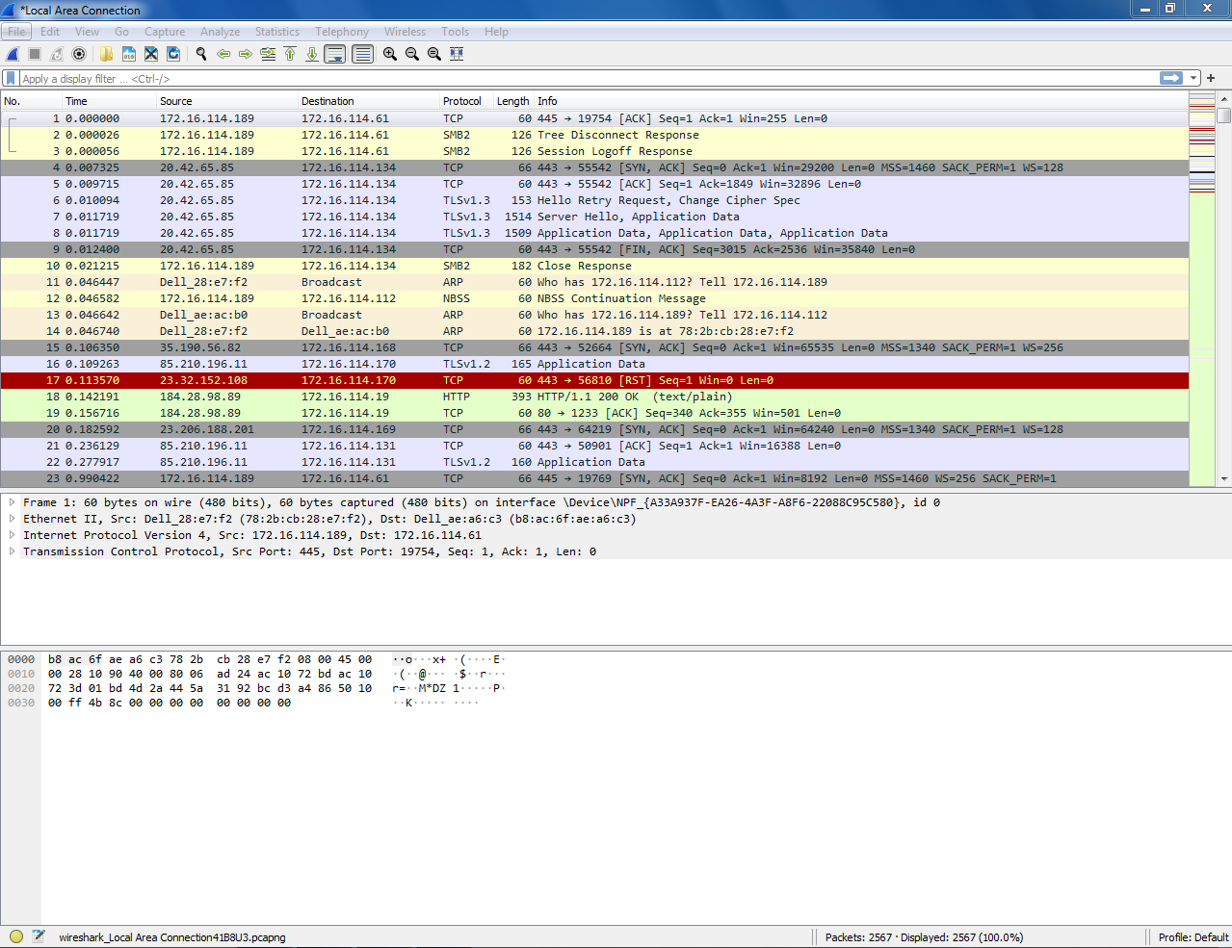

2. What is the Internet address of the www.google.com ? What is the
Internet address of your computer?
Nslookup www.gujaratuniversity.ac.in
ANS:-
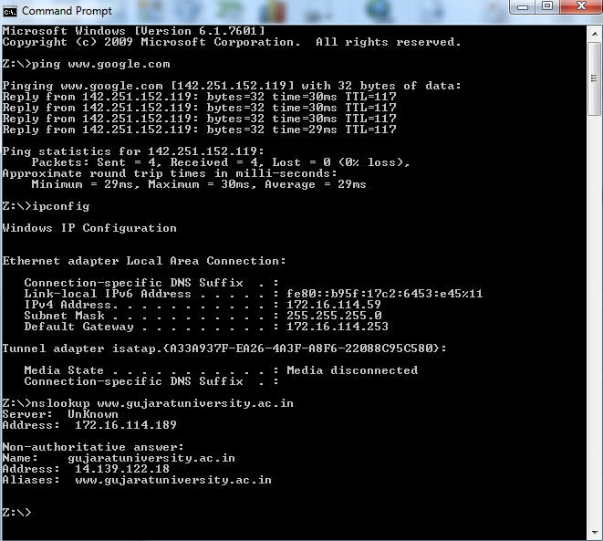
3. http protocol only with Wireshark running on your computer.
ANS:- Total http:201
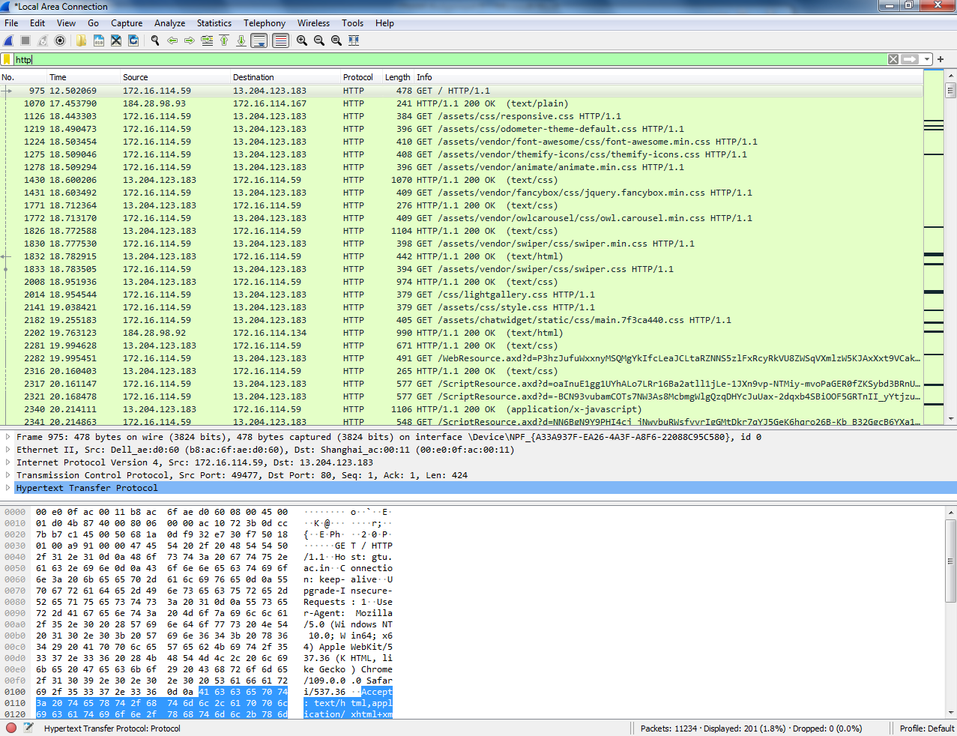

4. How many packets did you capture (total of all protocols, not just
HTTP)?
ANS:-Total packets:11234
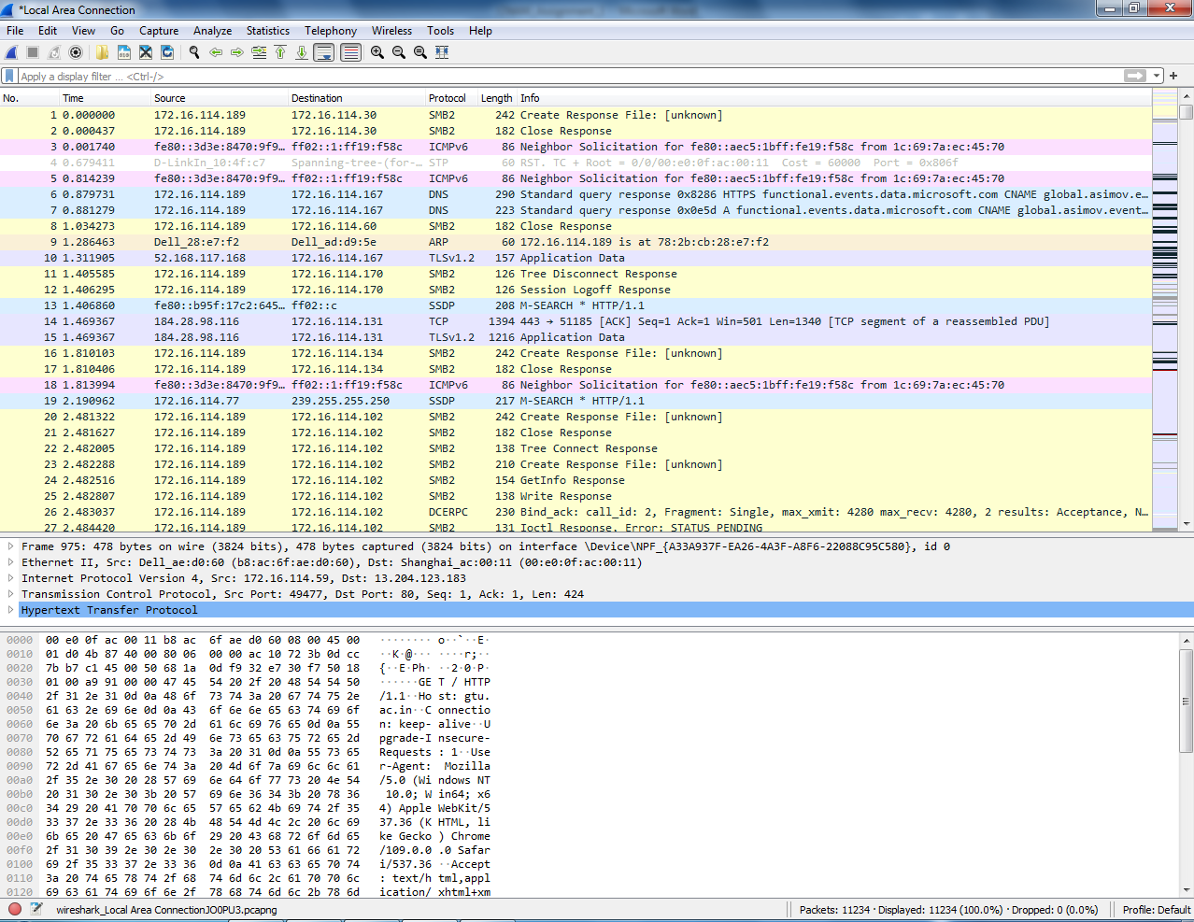
5. Now, use display filters to determine how many packets contain your ip
address (hint: Use ip.addr instead of the clumsy ip.src or ip.dst format).
ANS:- ip.addr==172.16.114.59
Ip address:9168 packets
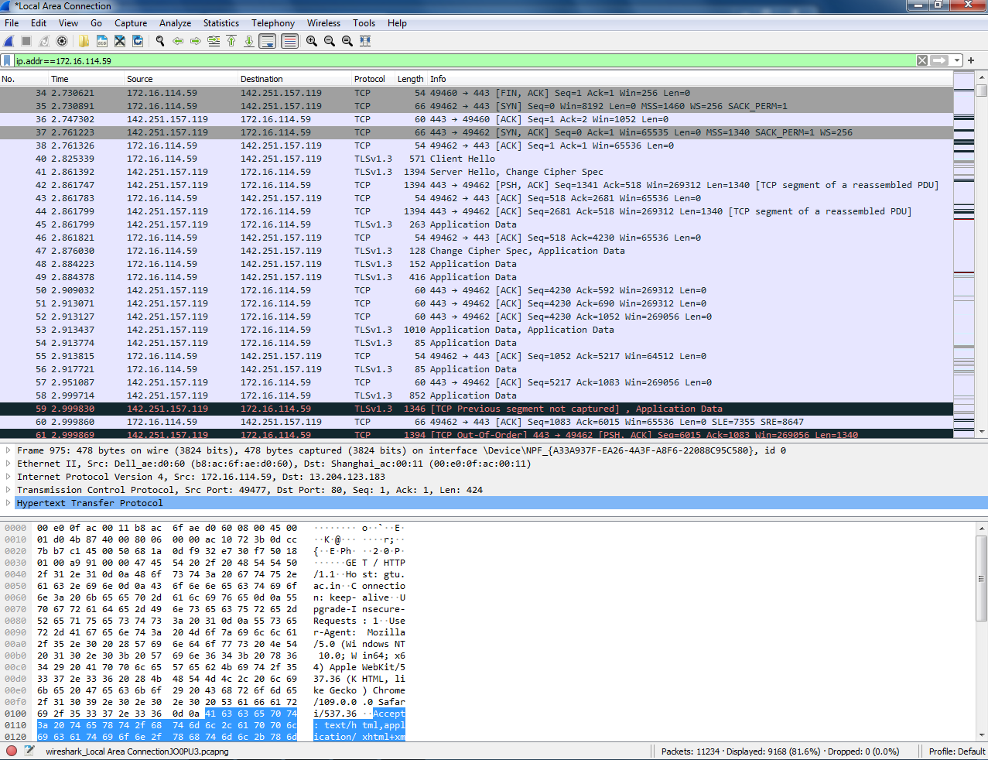
6. What is this filter you used? Now, reverse the filter to
determine how many packets don’t contain your ip address.

ANS:- !ip.addr==172.16.114.59
Ip address: 2066 packets
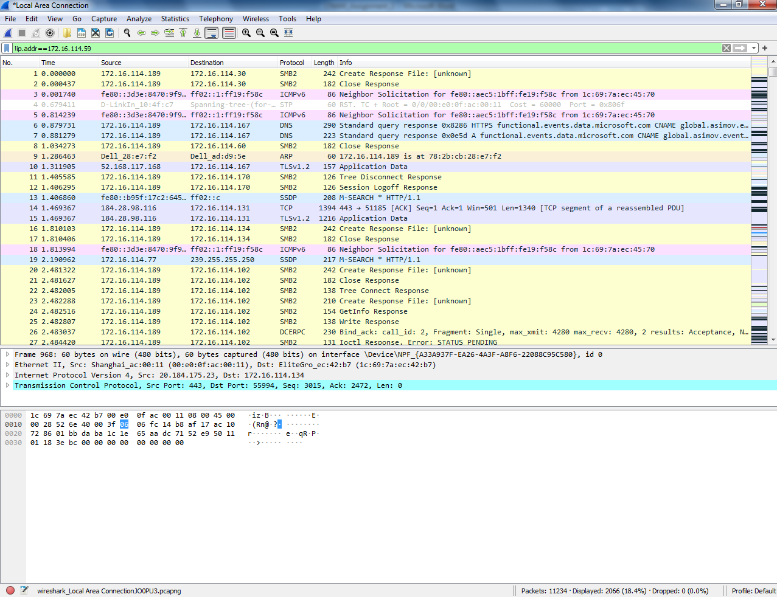

7. What is the IP address of your computer? Of the gtu.ac.in server?
(nslookup gtu.ac.in)

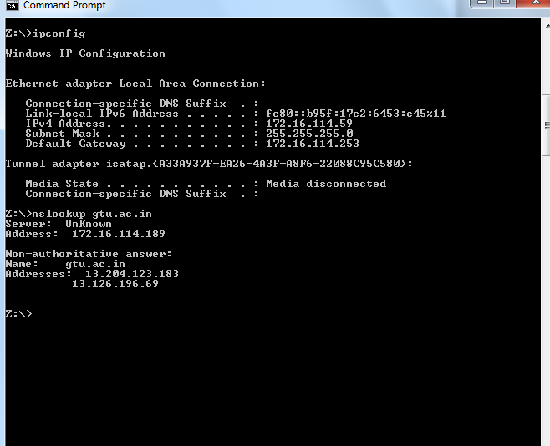

8. What HTTP version is your browser running? What version of HTTP is
the server running?
( HTTP browser request line (GET / HTTP/1.1)& HTTP server response
line (HTTP/1.1 200 OK)
( http.request.method == "GET") (http.response)
ANS:-Request Version 1.1
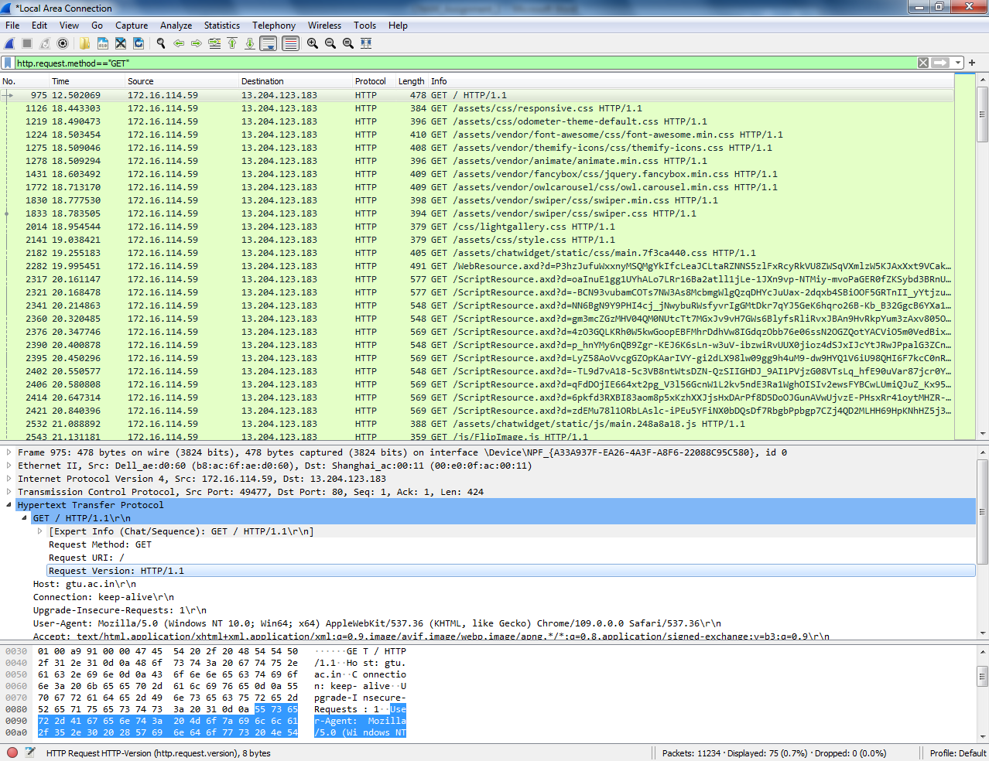

Response Version 1.1

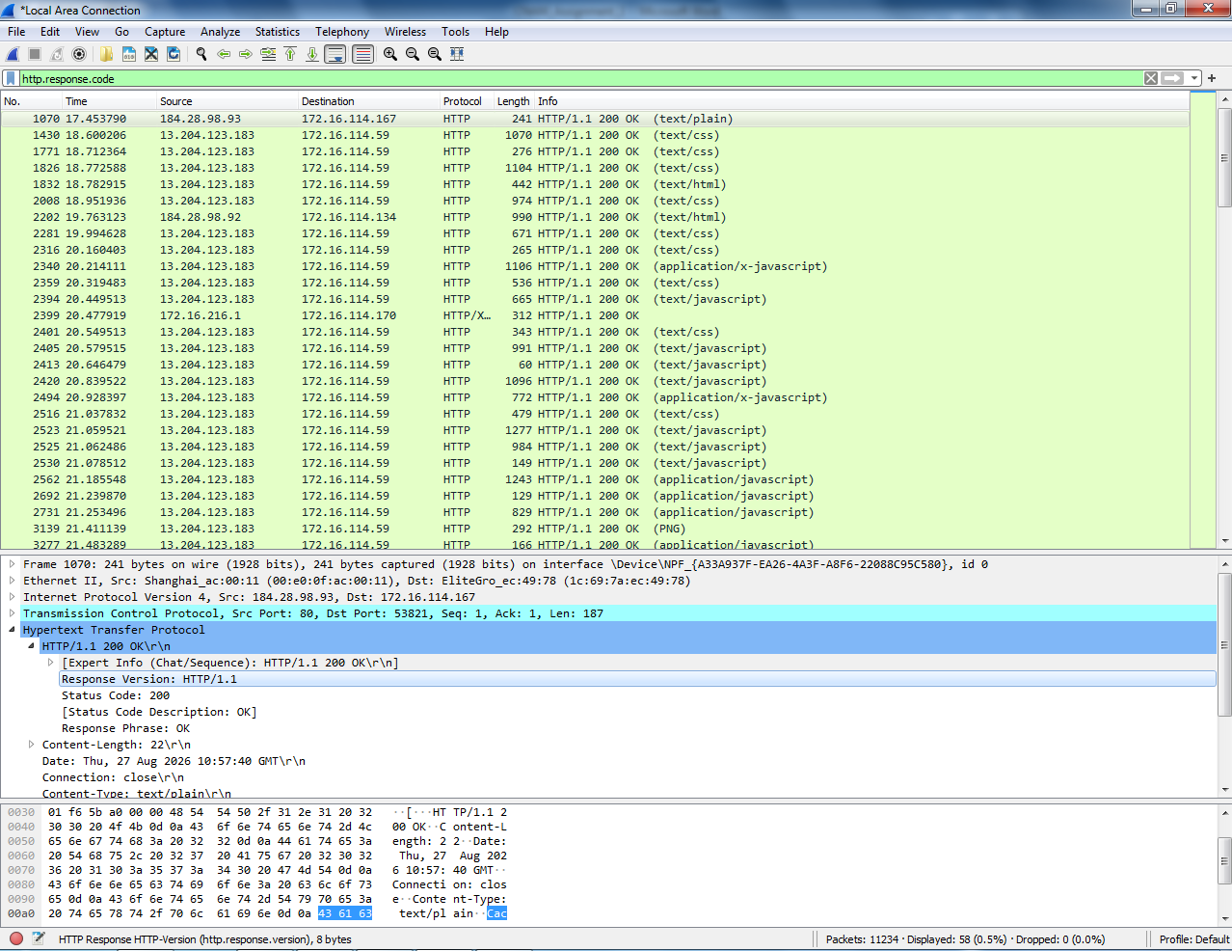

9. What is the status code and phrase returned from the server to your
browser?( http.response.code)
ANS:- Status Code :-200
Response Phrase:OK

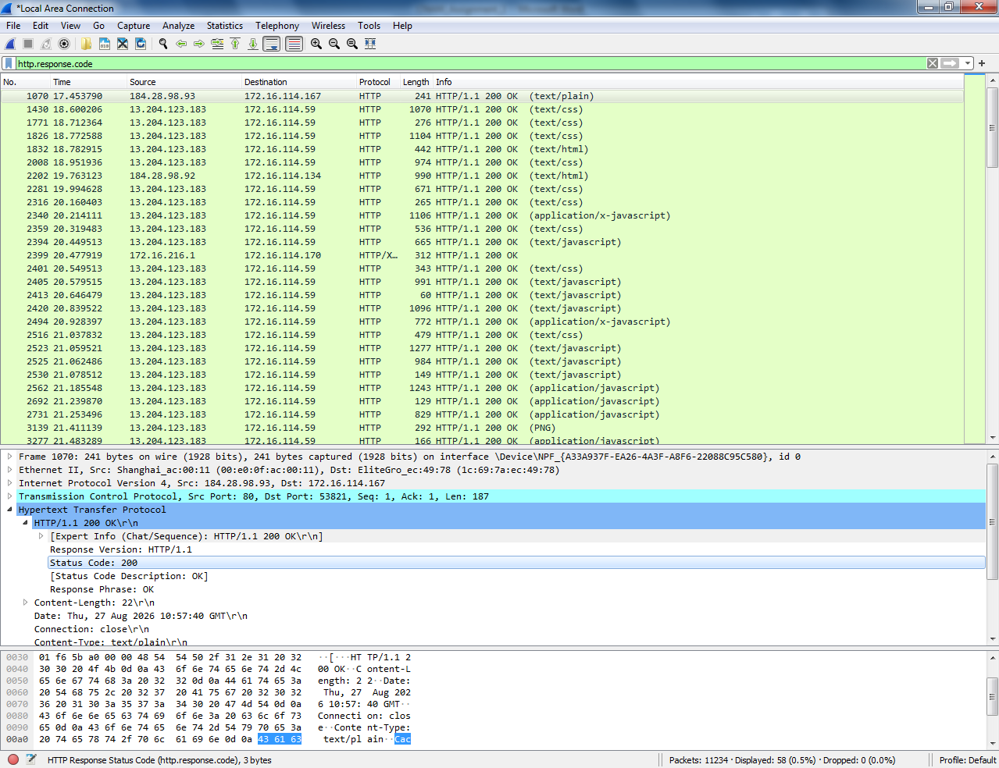
10. What languages does your browser indicate to the server that it can accept?
Which header line is used to indicate this information?
http.request or http.accept_language
ANS:-en-US,en;q=0.9\r\n

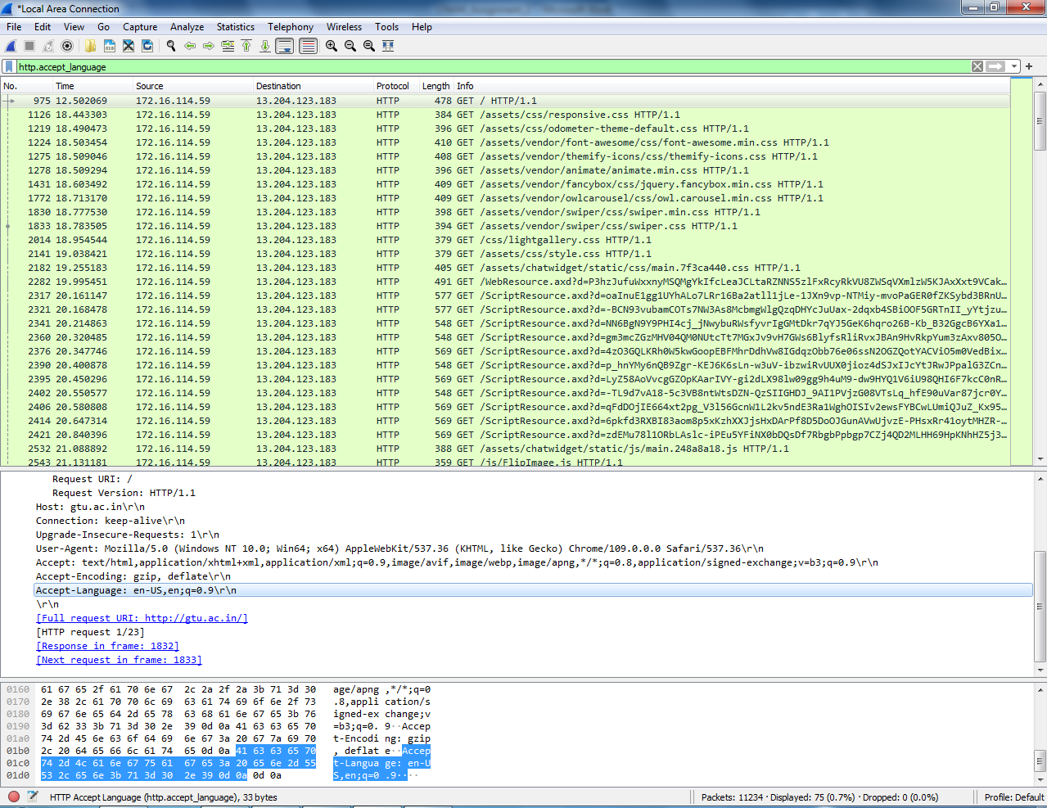
11.When was the HTML-file, that you have retrieved, last modified at the server?
Which header line is used to indicate this information?
(When was this webpage last updated on the server)
http.response.code == 200 && http.last_modified
ANS:-Last_Modified: Thu,12 May 2022 13:04:26 GMT\r\n
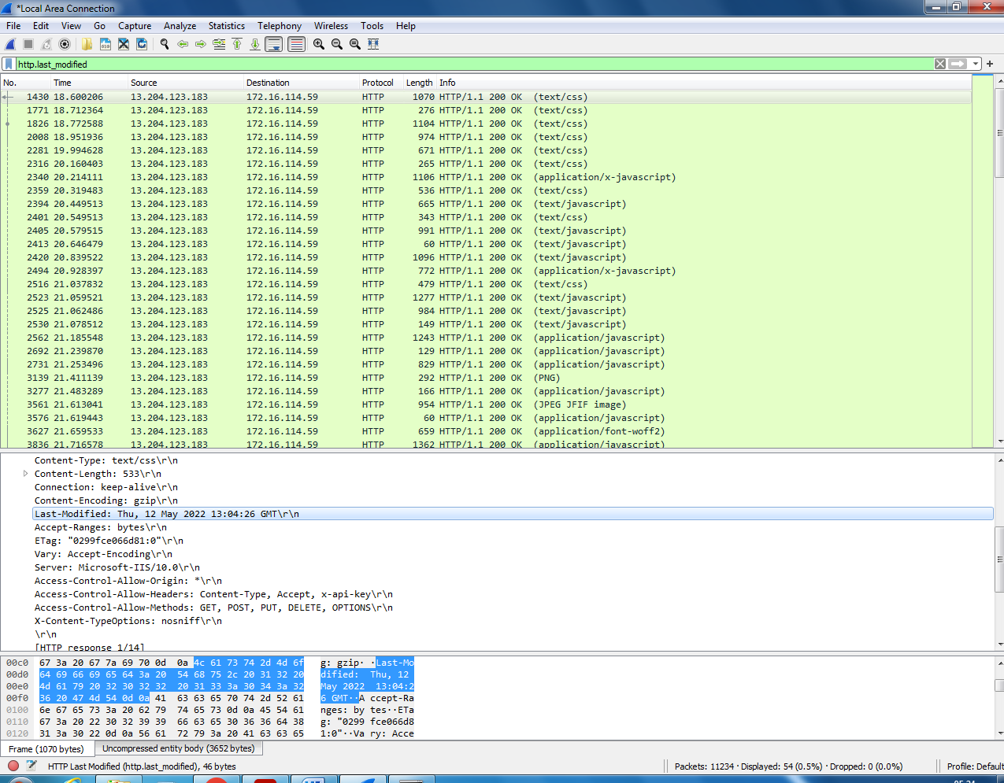

12.How many bytes of content (size of file) are returned to your browser?
Which header line is used to indicate this information?
(When the server sends the webpage (HTML file) to your browser, what is the size of
that file?)
ANS:- Content-Length: 23603\r\n
Header line : Content length
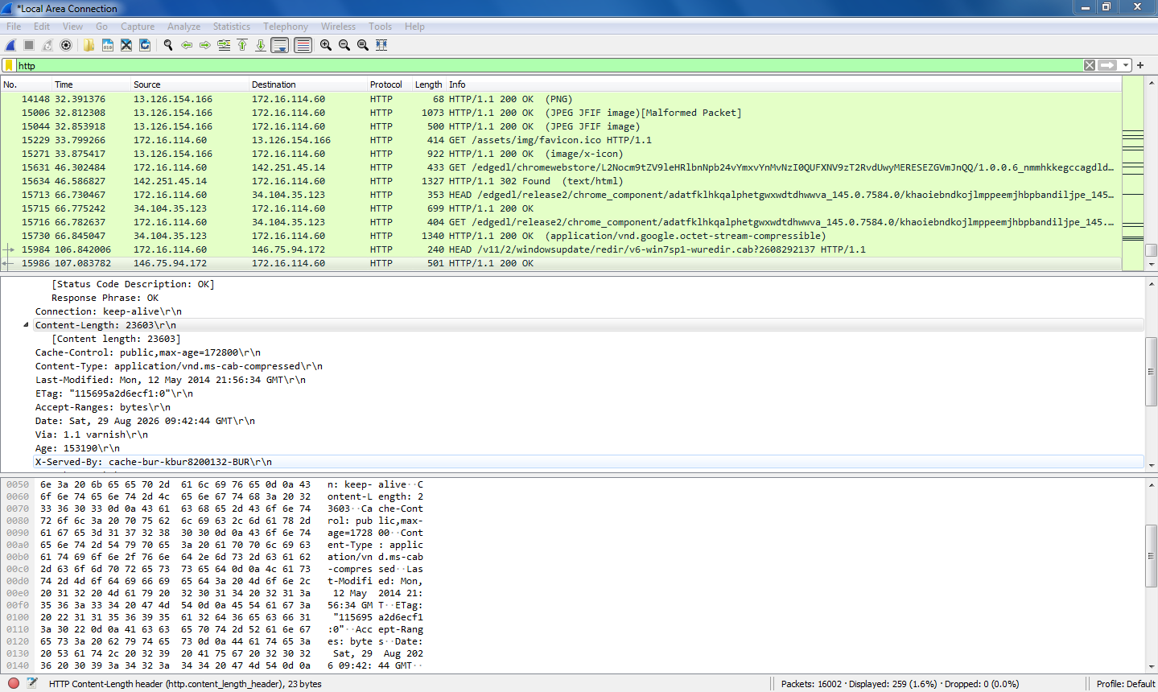

HTTP Conditional GET/Response Interaction
13. Start up the Wireshark packet sniffer, and make sure that “http” is in the
displayfilter, so that only captured HTTP messages will be displayed in the
packet-list pane.
14. Enter the following URL into your browser:
http://gaia.cs.umass.edu/wireshark-labs/HTTP-wireshark-file1.html
Your browser should display a very simple HTML file.
15. Quickly enter the same URL into your browser again (or simply select the
refresh button on your browser).
16. Stop Wireshark packet capture.
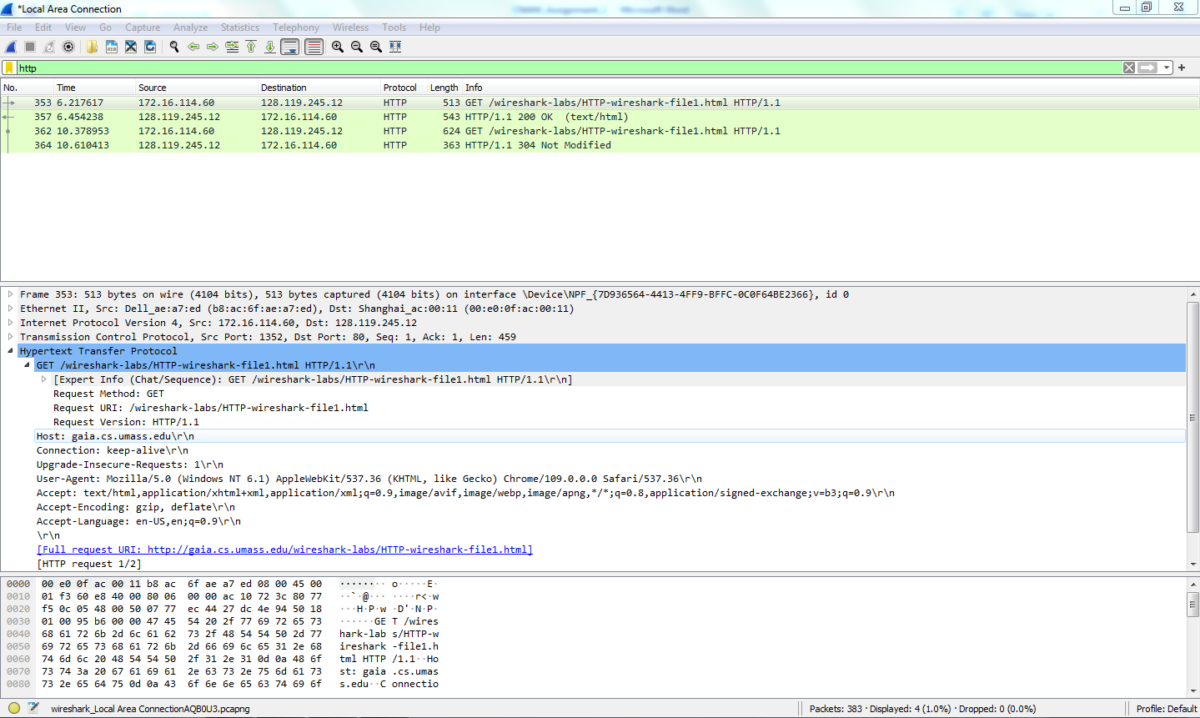

Answer the following questions. Please explain how you can find the answers
17. Inspect the contents of the first HTTP GET request from your browser to
the server. Is there an “IF-MODIFIED-SINCE” header line in the HTTP
GET message? Why or why not? (1st link - no)
No. If-Modified-Since is not present because the browser is requesting the page for the first
time. It has no previous copy of the page, so it simply asks the server to send the page.
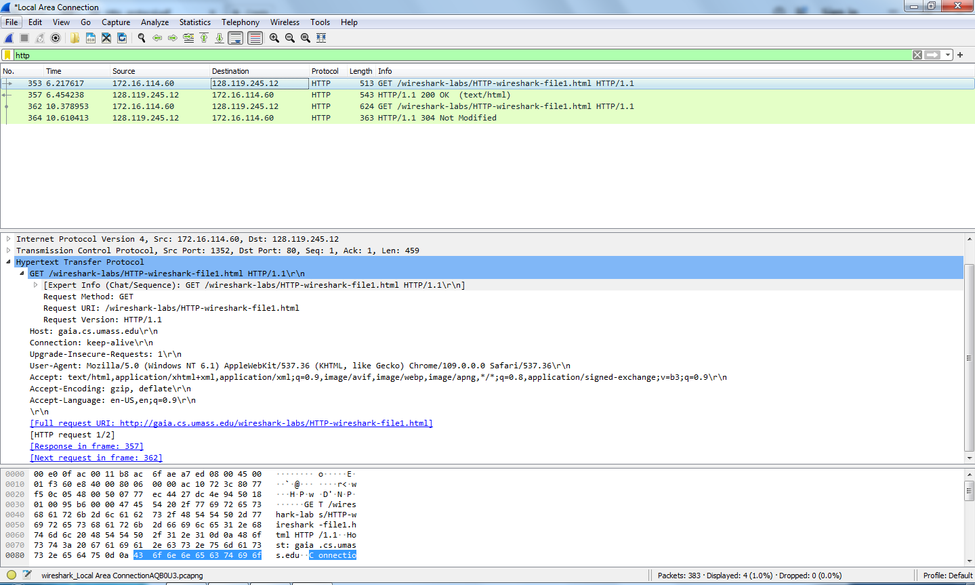

18. Inspect the contents of the server response. Has the server explicitly
returned the contents of the file? How can you tell?
ANS:- Yes, the server has returned the contents of the file.
Extend line based text data: Congratulation you’ve download the file
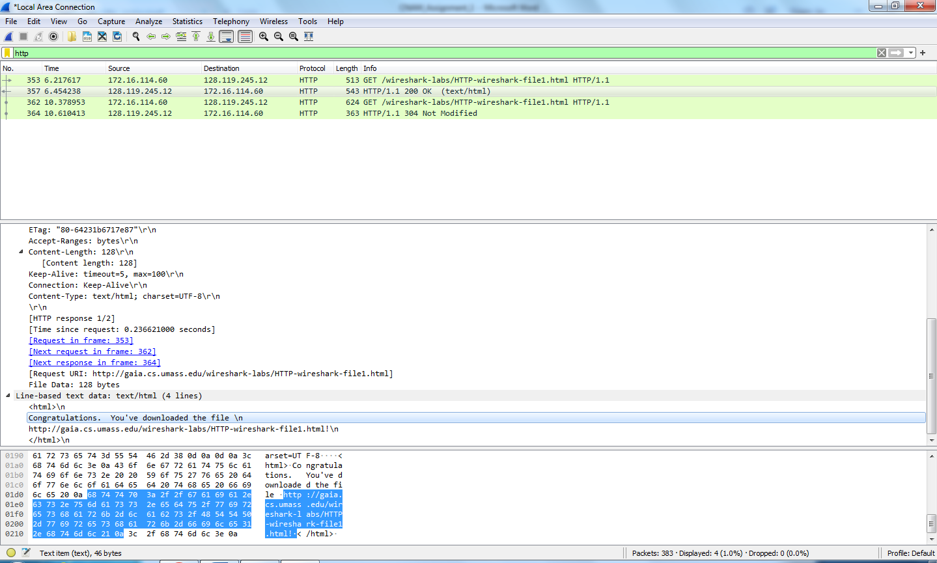

19. Now inspect the contents of the second HTTP GET request from your
browser to the server. Is there an “IF-MODIFIED-SINCE:” header line in
the HTTP GET message? If so, what information follows the “IFMODIFIED-
SINCE:” header line? (second link - yes)

Yes. If-Modified-Since is present because the browser already has a copy of the page. It
asks the server whether the page has changed since the last time it was downloaded. If it has
not changed, the server replies with 304 Not Modified.
If yes, the server sends the updated file (200 OK).
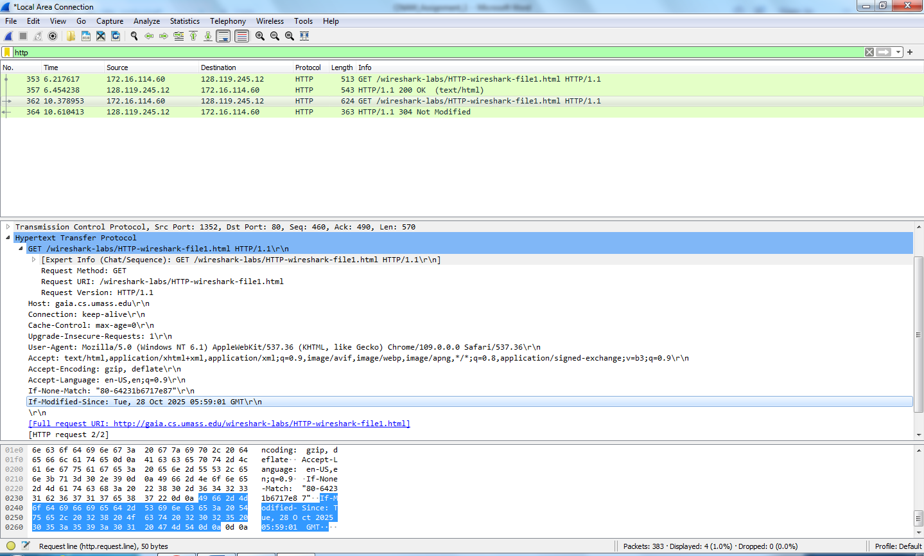

20. What is the HTTP status code and phrase returned from the server in
response to this second HTTP GET? Has the server explicitly returned the
contents of the file? Explain.
ANS:- Status code:304
Response Phrase: Not Modified
No, the server has not returned the contents of the file as it it is the response of the
Second request sent by the browser.
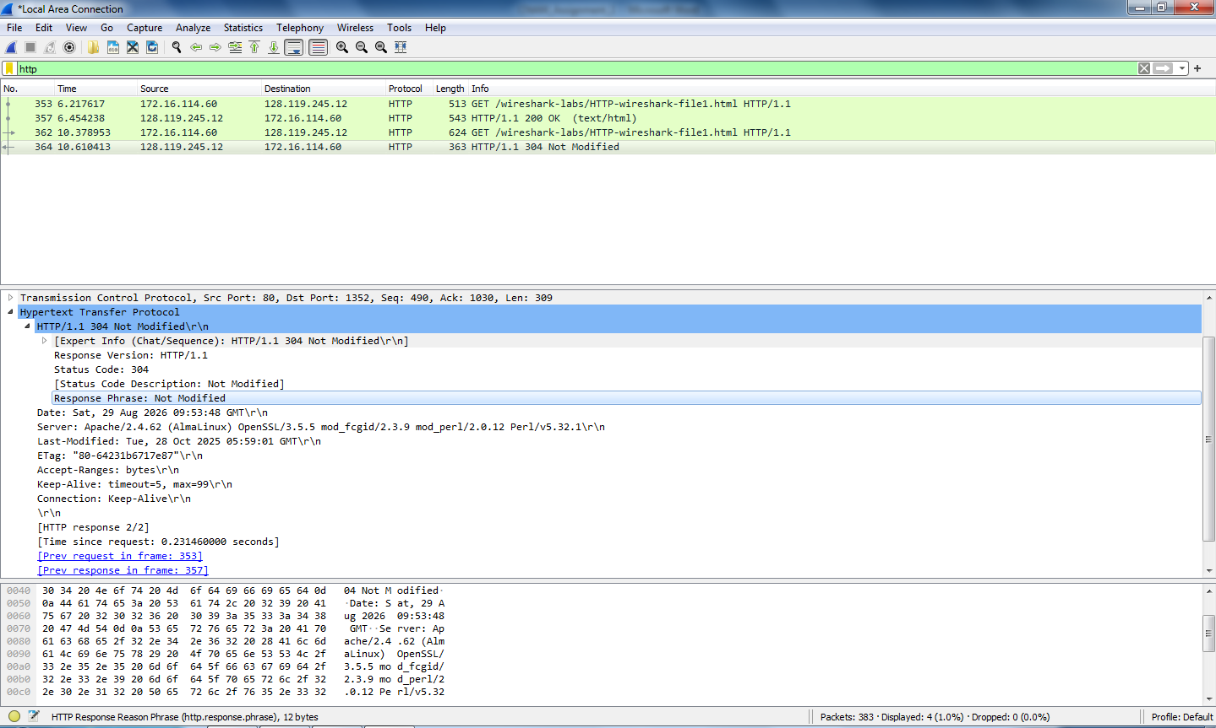

21. How many HTTP GET request messages has your browser sent? Which
packet in the trace contains the request for the Bill of Rights?
http.request.method=="GET"
(The packet number of that HTTP GET packet is the answer.)
Total HTTP GET request messages :- 2
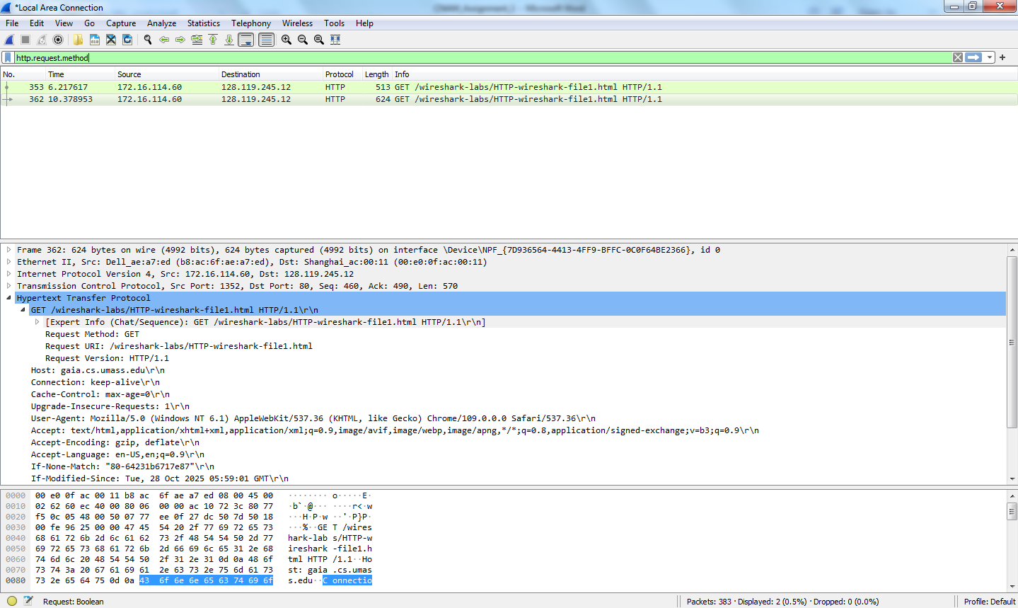

ANS:- packet num is 353 of get request
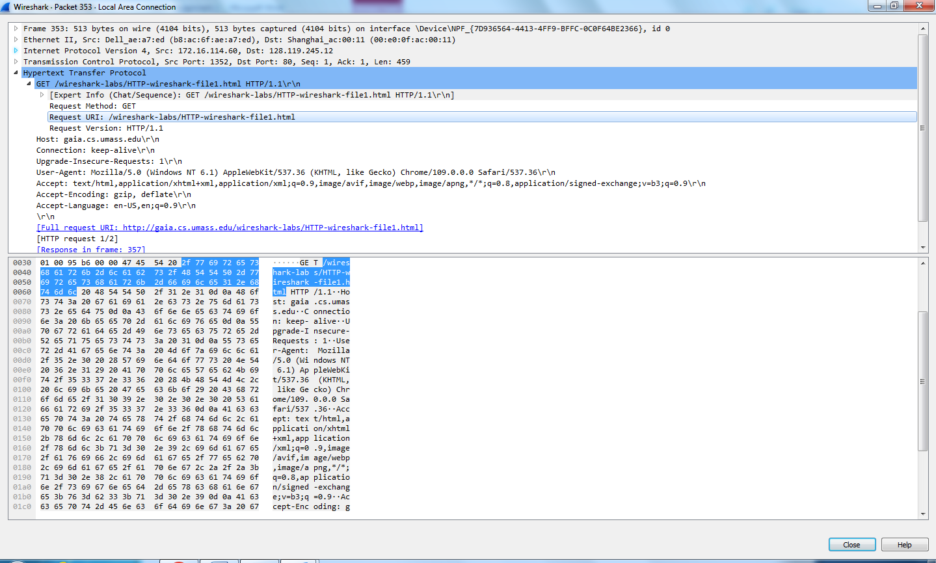

22. Which packet in the trace contains the status code and phrase associated
with the response to the HTTP GET request? What is the status code and
phrase in the response?
or (Which packet contains the server's response to the HTTP GET request? What is the
status code and status phrase in that response?)
ANS:- Status Code :- 200 , Response Phrase :- OK
Packet no of server response is : 357
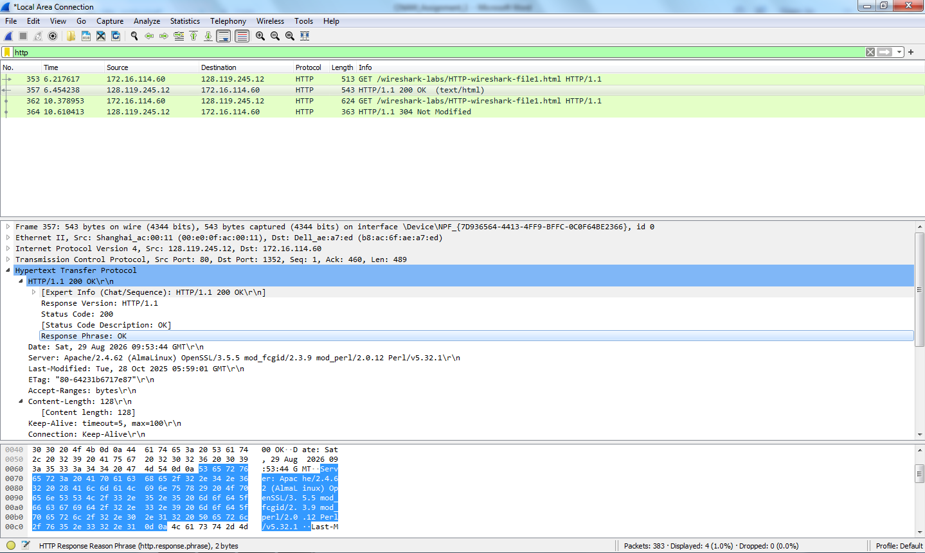

23.Discuss http GET and RESPONSE.
HTTP GET Request:
An HTTP GET request is sent by the browser (client) to the server to request a web page or
other resource. It contains information such as the requested URL, HTTP version, and request
headers.
HTTP Response:
An HTTP Response is sent by the server back to the browser after receiving the GET
request. It contains the status code (such as 200 OK or 304 Not Modified), response
headers, and, if required, the requested web page or file

24.Count the total number of HTTP GET requests.
Ans.: Enter in filter: http.request.method==GET , then count total ------
marked.
ANS:-Displayed: 2
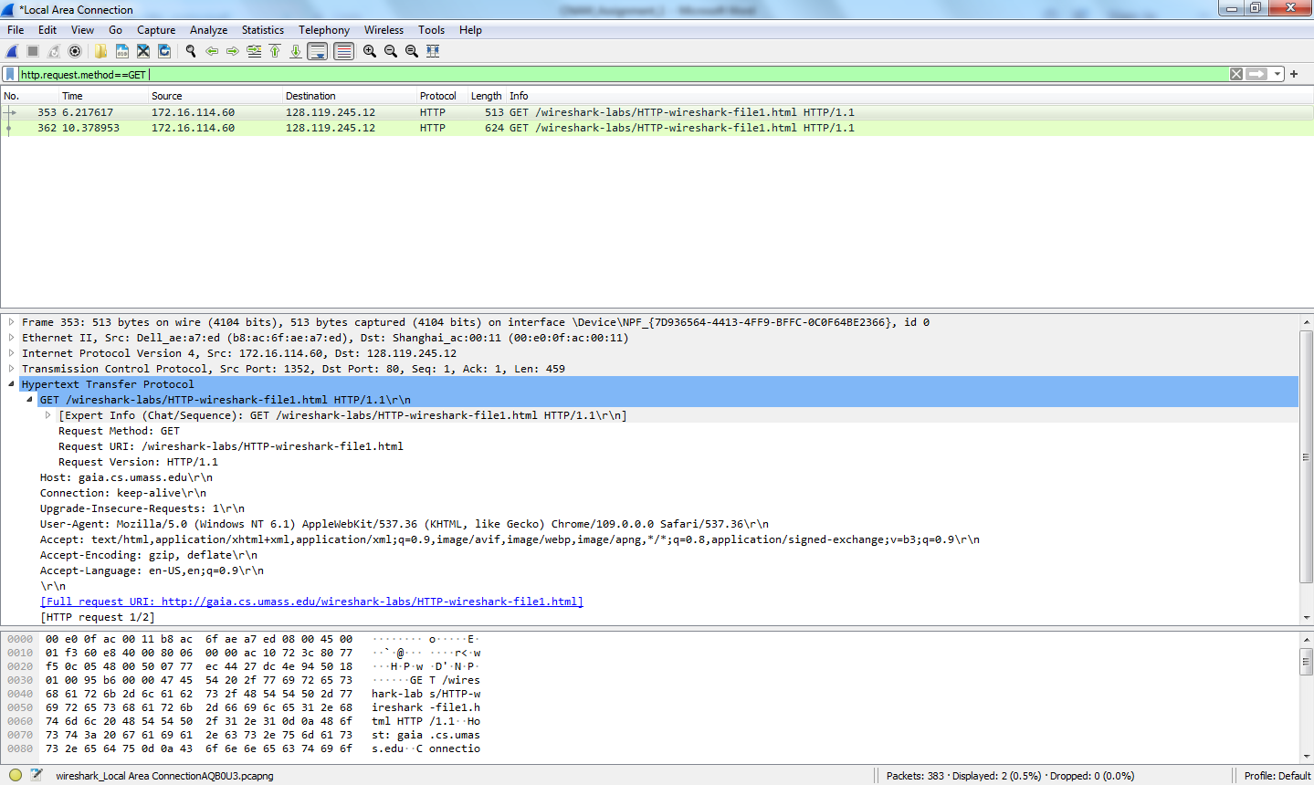

25.How much time elapsed between the first HTTP GET request from client
and the HTTP response (OK) from server?
Ans.: http.request.method==GET || http.response
(Response Time − GET Time = Elapsed Time)
(How much time did the server take to reply after the browser sent the first HTTP GET
request?)
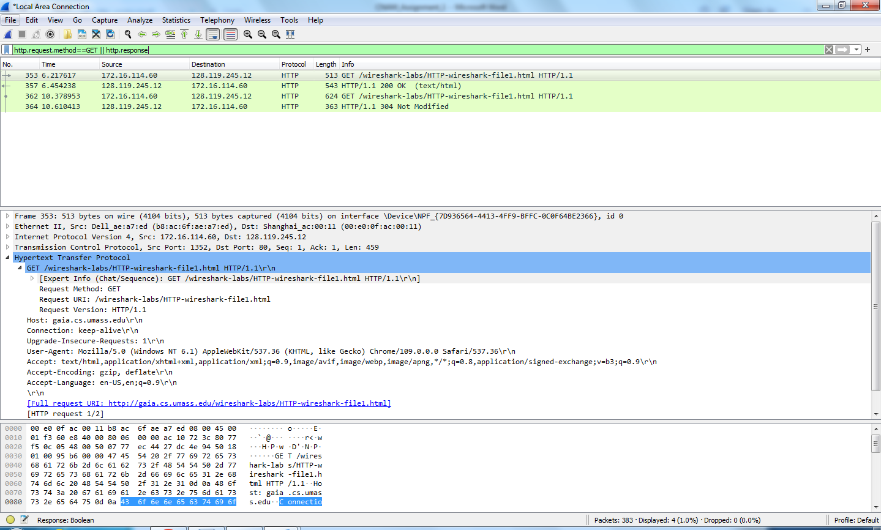

Response Time is:6.454238
Request Time is:6.217617
Elapsed Time is:0.236621

26. Identify the source and destination ports used to transfer the first HTTP
GET request
ANS:- Source port: 1352
Destination port: 80
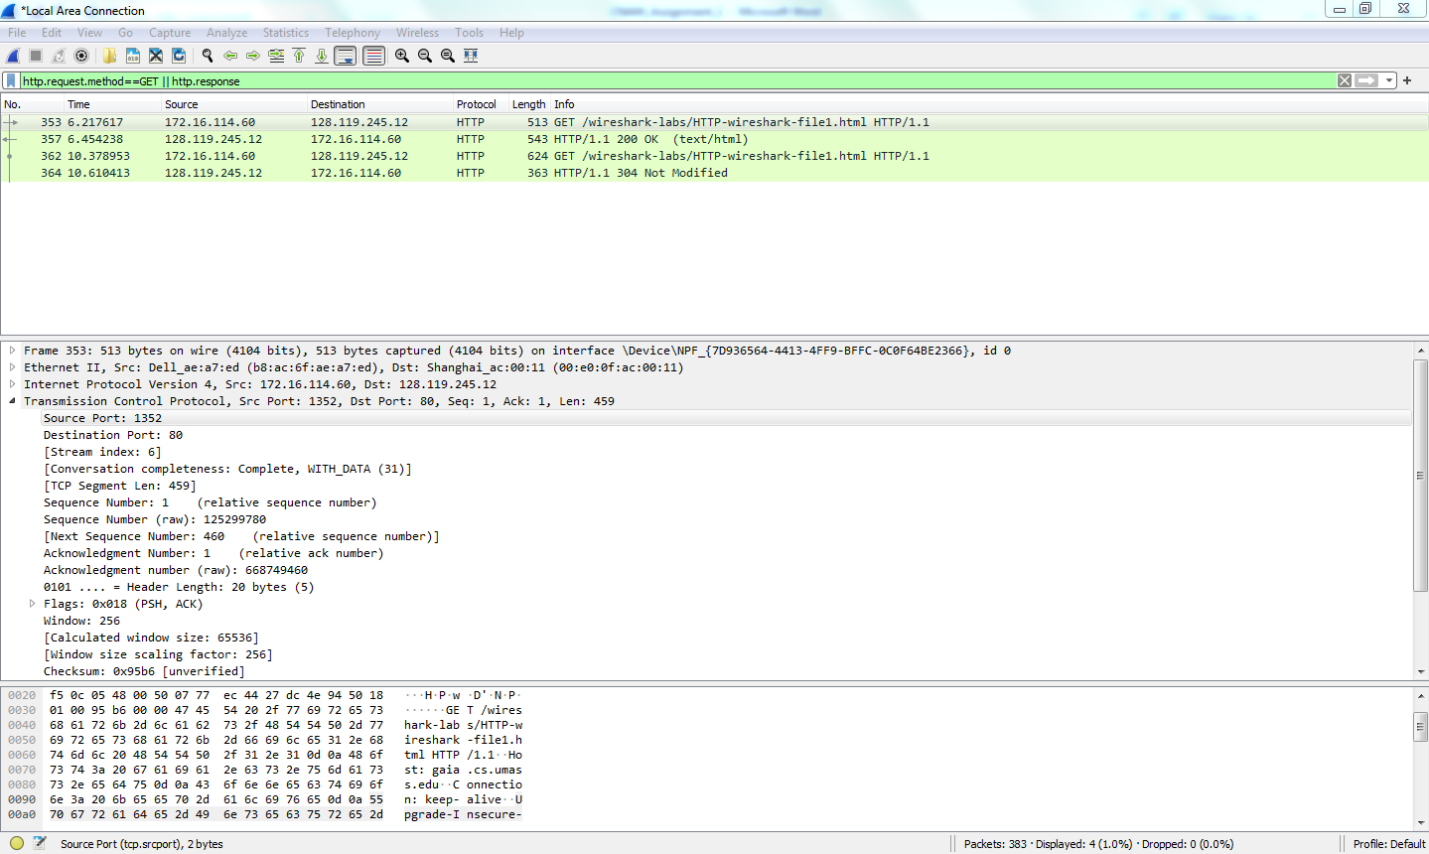

27.Identify the client and server ip address in the first HTTP GET request?
Ans.: Apply filter http.request.method==GET, see the IP , within this you
will find source ip address and destination ip address.
Source Address:172.16.114.60
Destination Address: 128.119.245.12
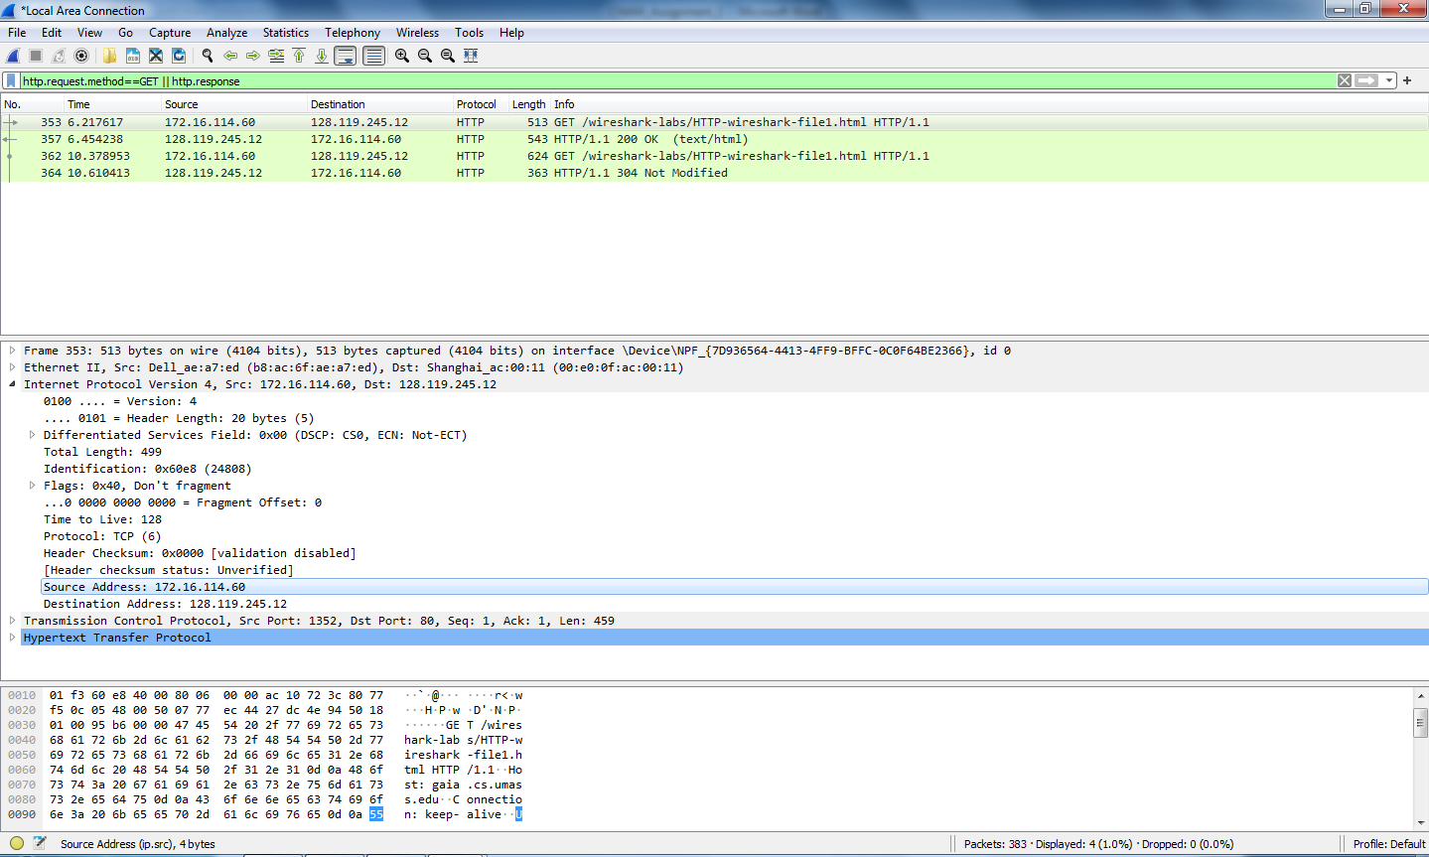

28. Identify the client and server MAC address in the first HTTP GET request?
Ans.: Apply filter http.request.method==GET, see the Ethernet , within this
you will find source MAC and destination MAC
Source MAC :- Dell_ae:a7:ed(b8:ac:6f:ae:a7:ed)
Destination MAC :- Shanghai_ac:00:11 (00:e0:0f:ac:00:11)
