TCP – Transmission Control Protocol
Q.1 What is the IP address and TCP port number used by the client computer (source) that is transferring the file to gaia.cs.umass.edu?

Source add = 172.16.114.17
Source port = 1240
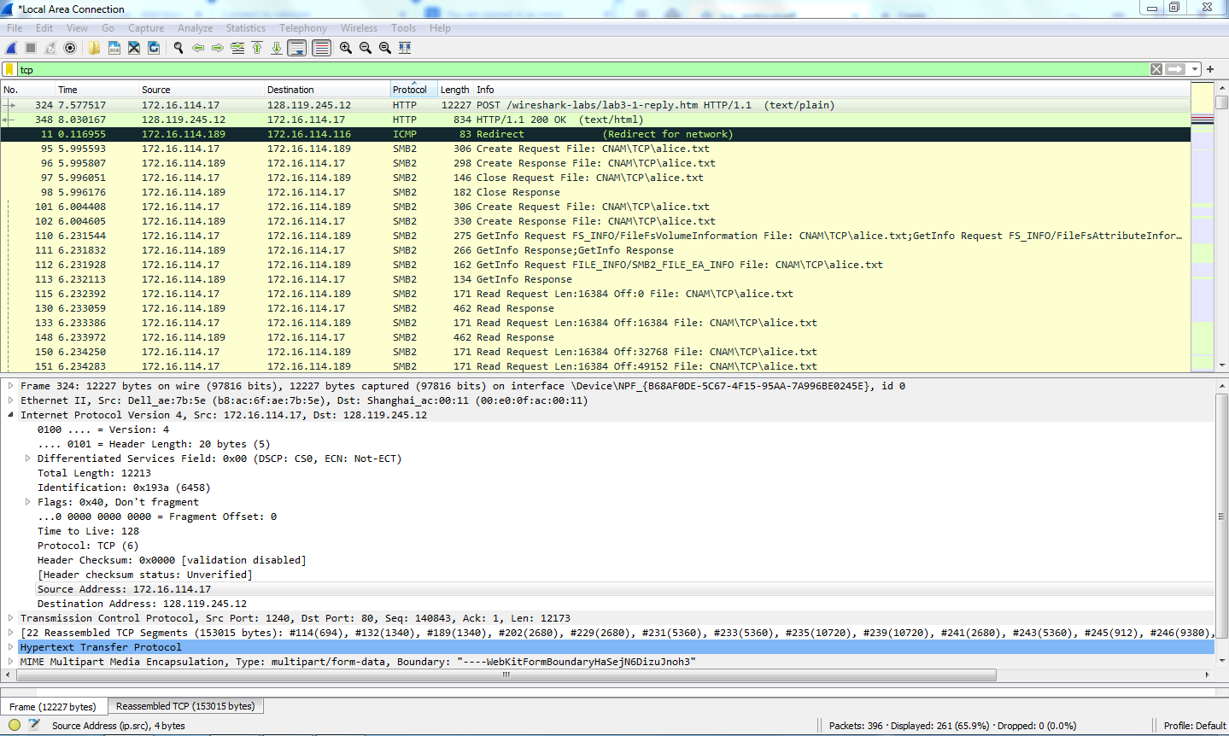

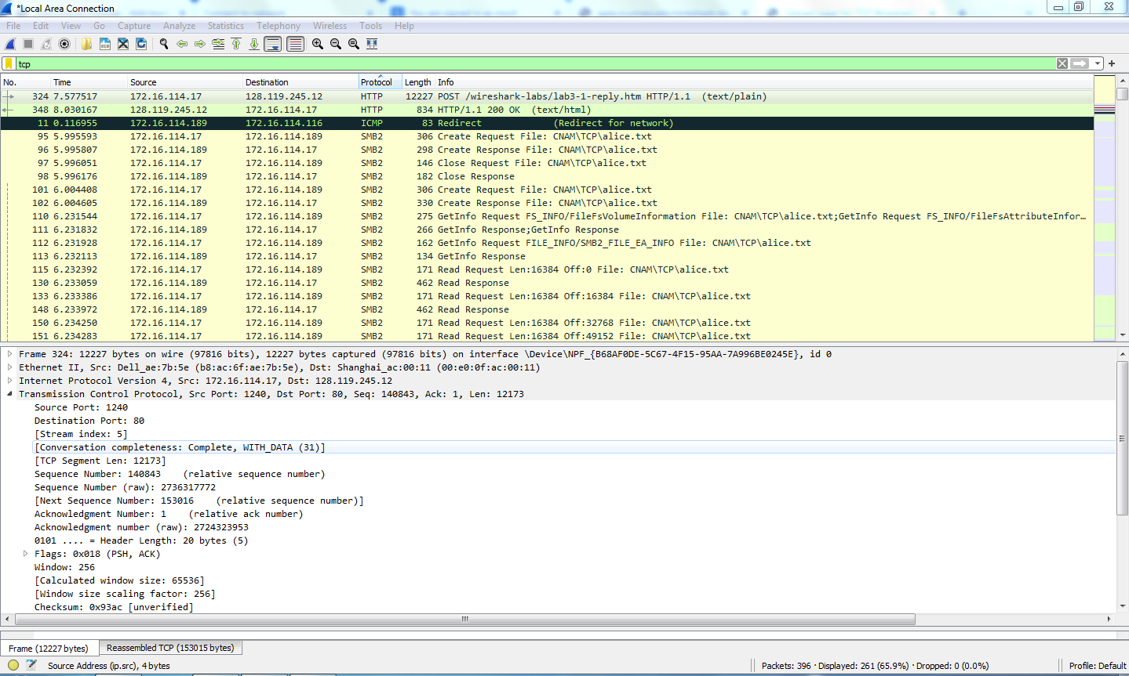

Q.2 What is the IP address of gaia.cs.umass.edu? On what port number is it sending and receiving TCP segments for this connection?

Source add = 128.119.245.12
Source port = 80
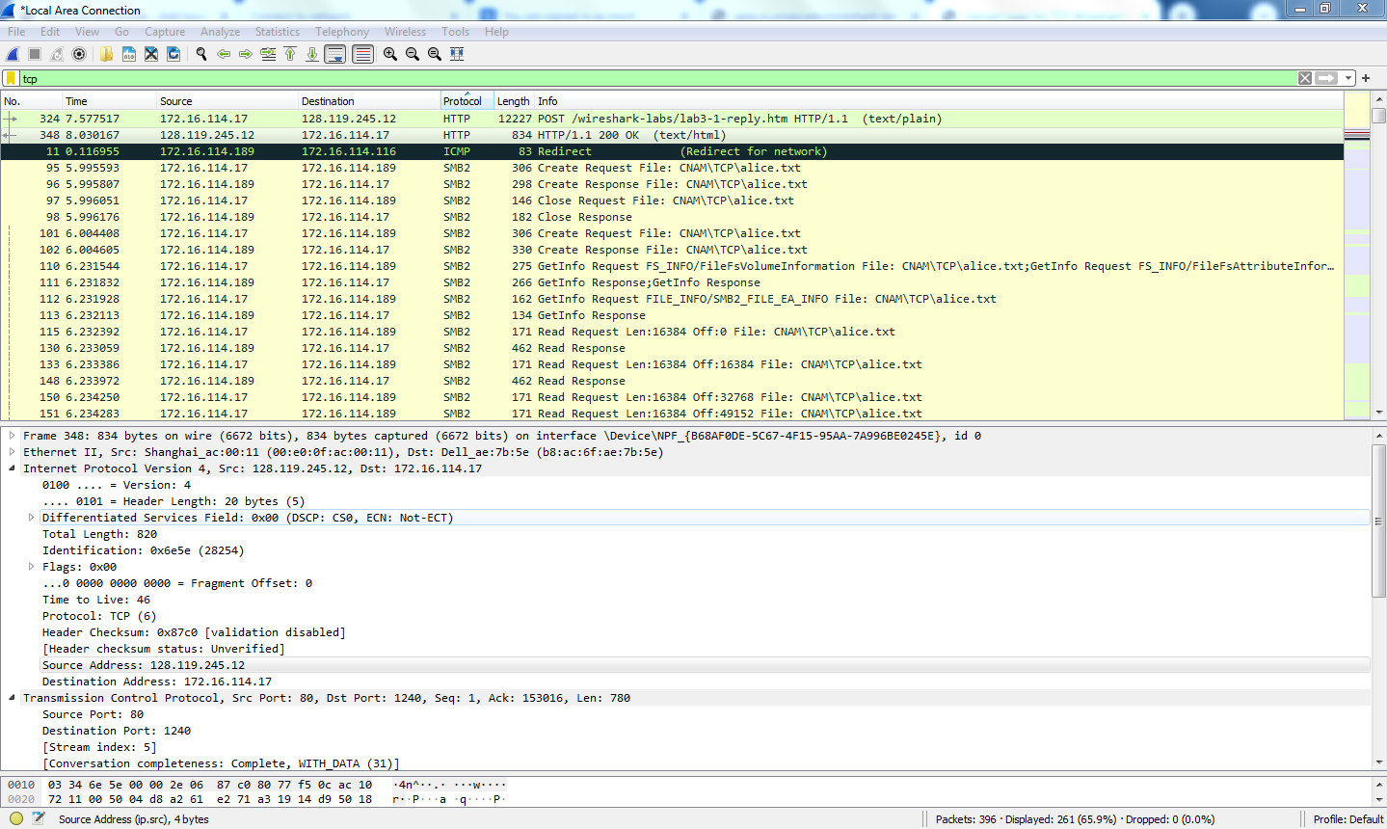

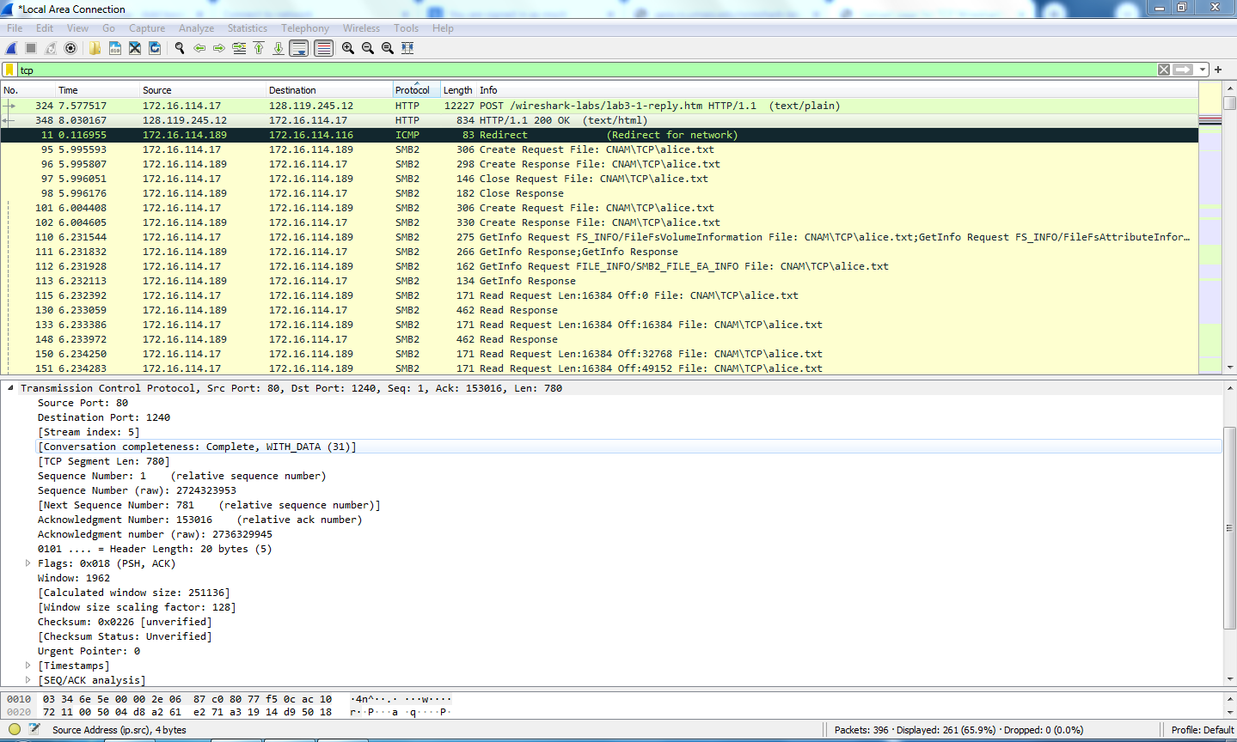

Q.3 What is the IP address and TCP port number used by your client computer (source)
to transfer the file to gaia.cs.umass.edu?

Source add = 172.16.114.17
Source port = 1240

Q.4 What is the sequence number of the TCP SYN segment that is used to initiate
the TCP connection between the client computer and gaia.cs.umass.edu? What
is it in the segment that identifies the segment as a SYN segment?

Ip of server: 128.119.245.12
source port :54851 (this is client port num)
Destination port :80 (this is server port num)
->sequence num:0
->Flags: 0x002 (SYN)

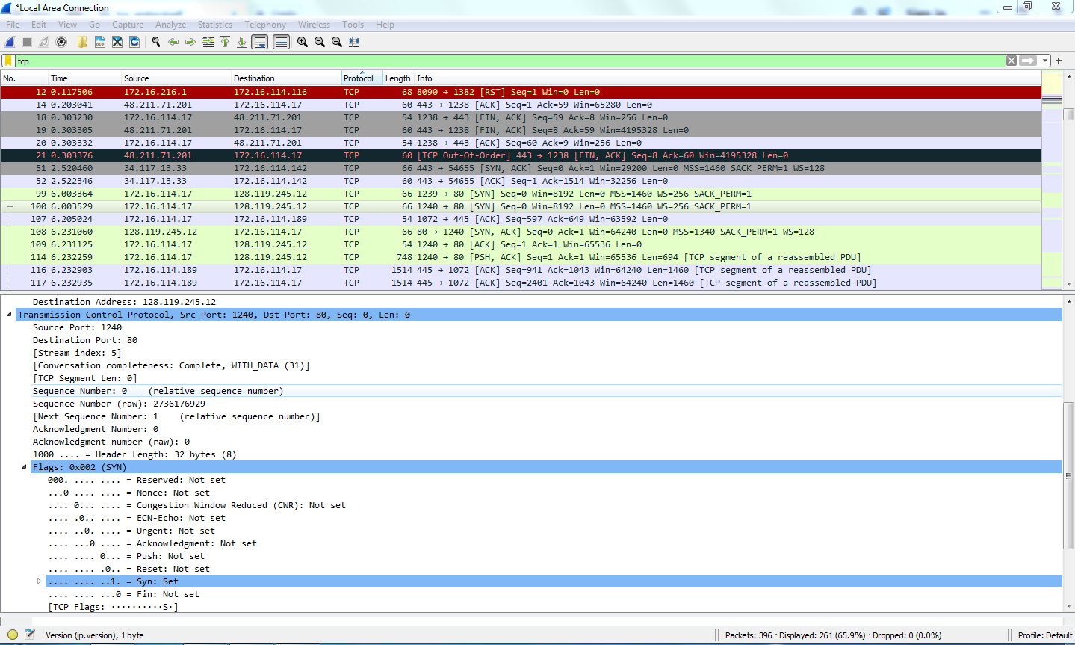

Q.5 What is the sequence number of the SYNACK segment sent by gaia.cs.umass.edu to the client computer in reply to the SYN? What is the value
of the Acknowledgement field in the SYNACK segment? How did
gaia.cs.umass.edu determine that value? What is it in the segment that identifies
the segment as a SYNACK segment?

Sequence Number: 0 (relative). The Sequence Number of the SYN-ACK packet is 0.
Acknowledgement Number: 1 (relative). The Acknowledgement Number of the SYN-ACK
packet is 1.
ACK = 1 because the client sent a SYN packet with Sequence Number 0. The server
acknowledges the next expected Sequence Number, so it sends ACK = 1.
The packet is identified as a SYN-ACK packet because the TCP Flags field contains both
SYN and ACK flags (Flags = SYN, ACK / 0x012).

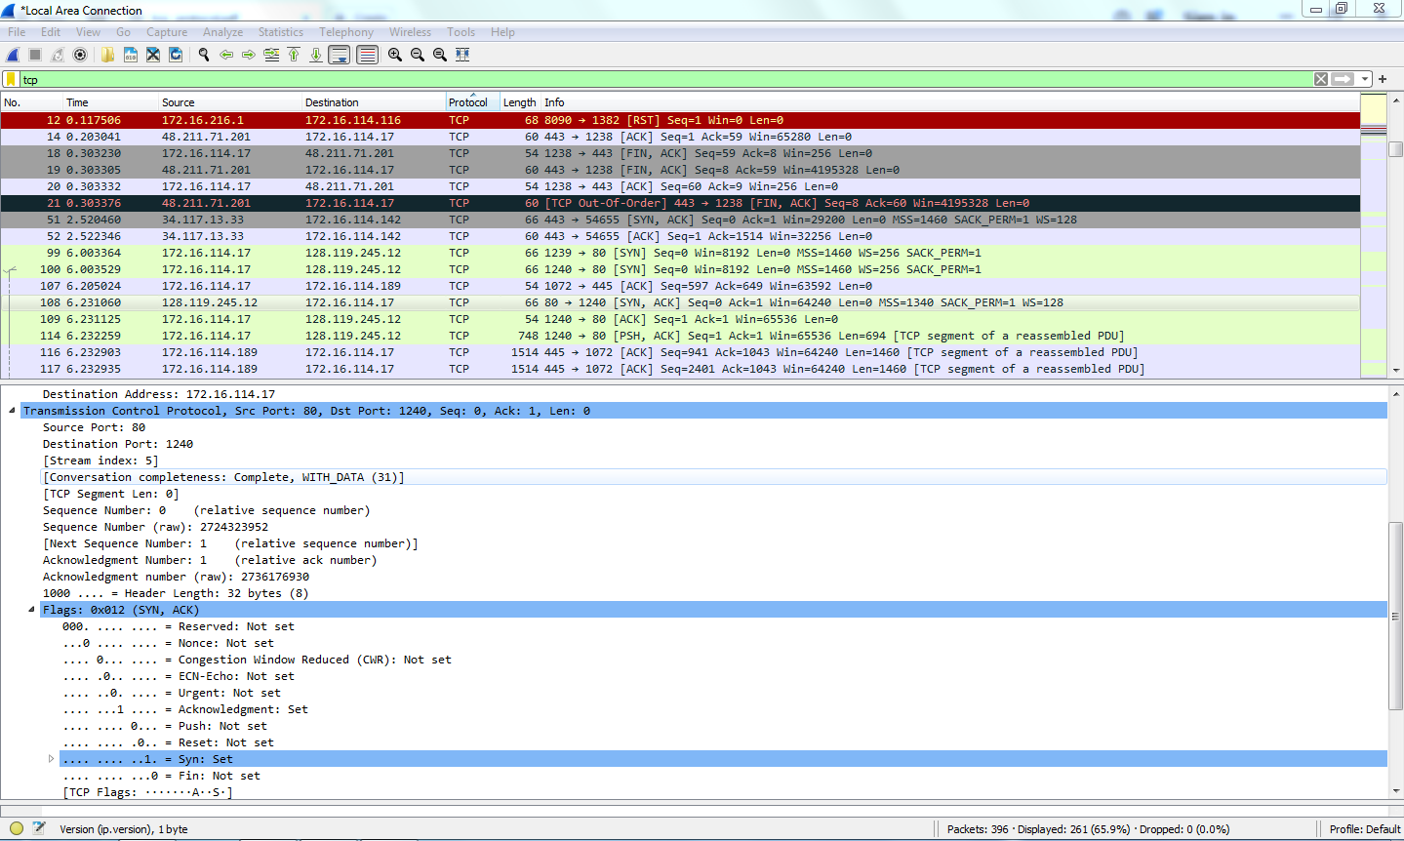

Q.6 Find the TCP packet that contains the HTTP POST command. What is its Sequence
Number?

Seq num =140843
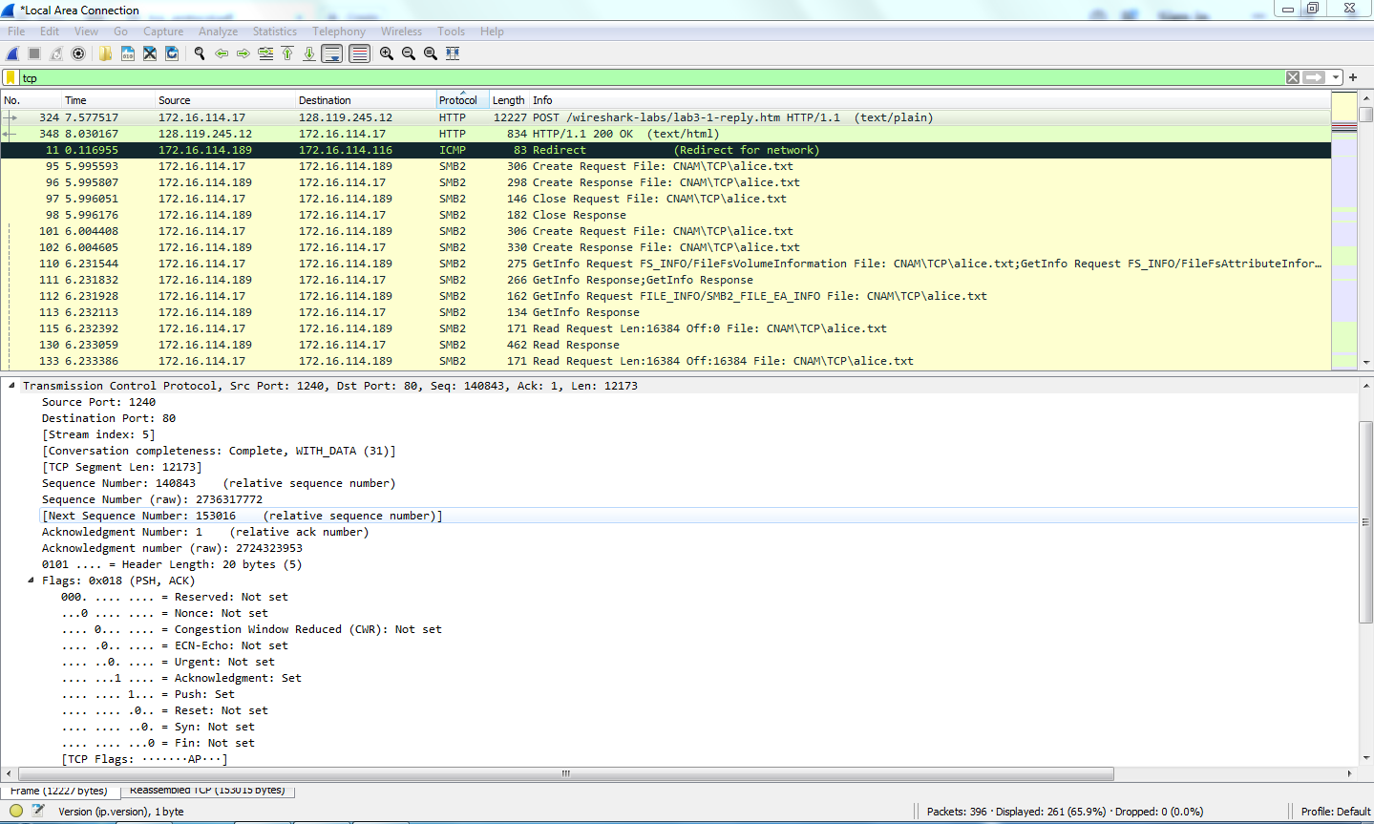

Q.7 What is the length of each of the first six TCP segments?

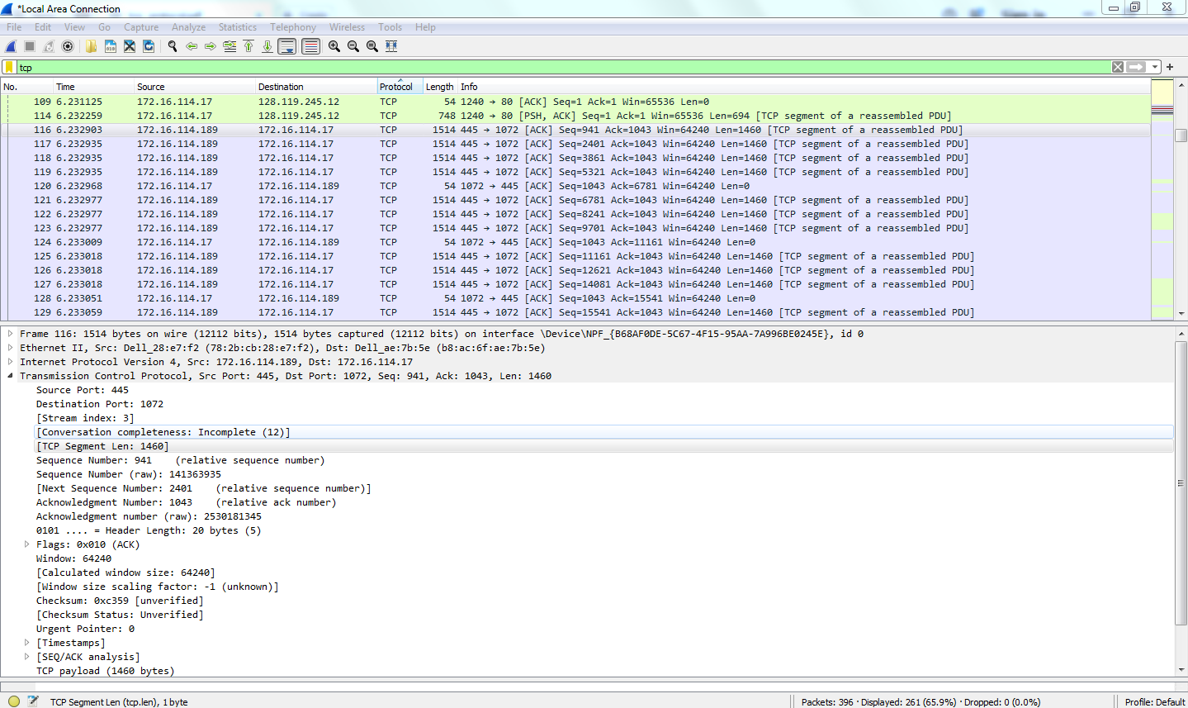
All in sequence has like
0
1400
0
0
0
0

