1. Select one UDP packet from your trace. From this packet, determine how many fields there
are in the UDP header.Name these fields.
Determine the length (in bytes) of the each of the udp header fields.
4 UDP Header fields : Source port – 2 byte
Destination port – 2 byte
Length – 2byte
Checksum – 2 byte

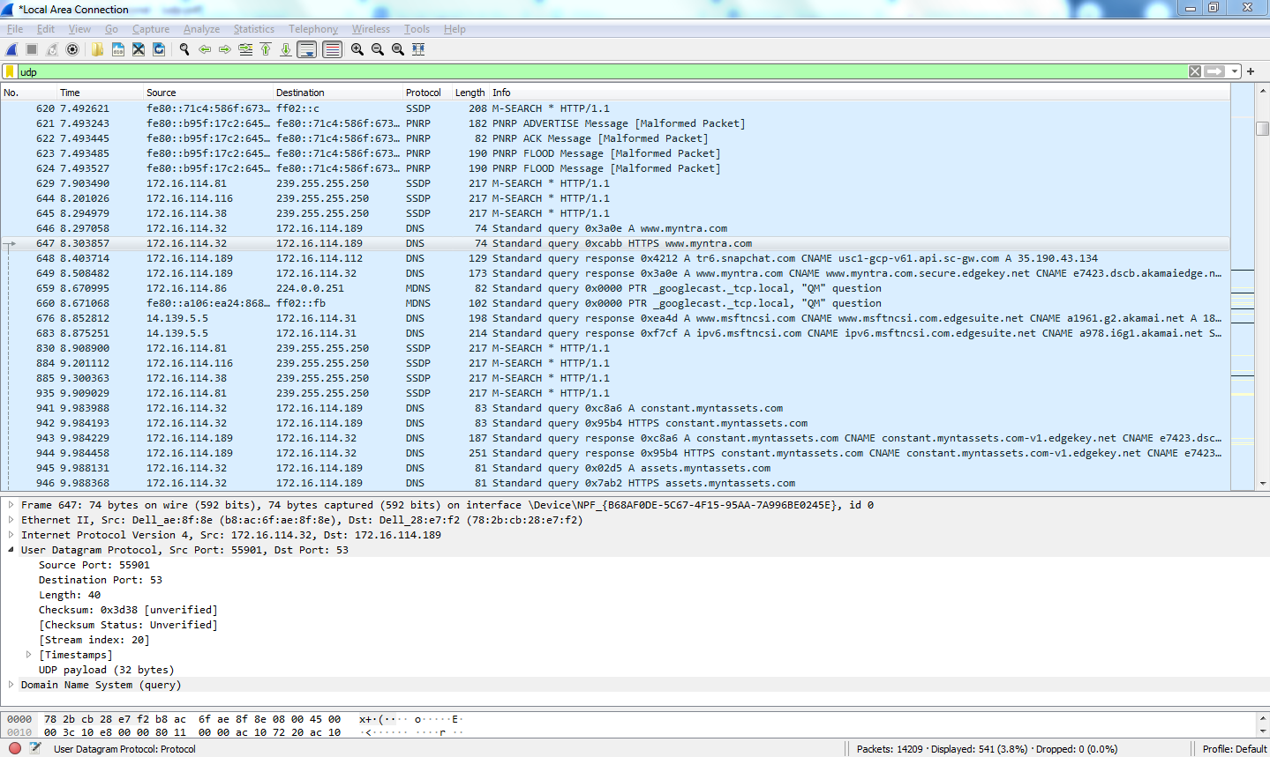

2. The value in the Length field is the length of what? (You can consult the text for this
answer). Verify your claim with your captured UDP packet.

For query length :40 (UDP payload + UDP header = 32 + 8 = 40 )
For response length : 203 ( 195 + 8 = 203 )
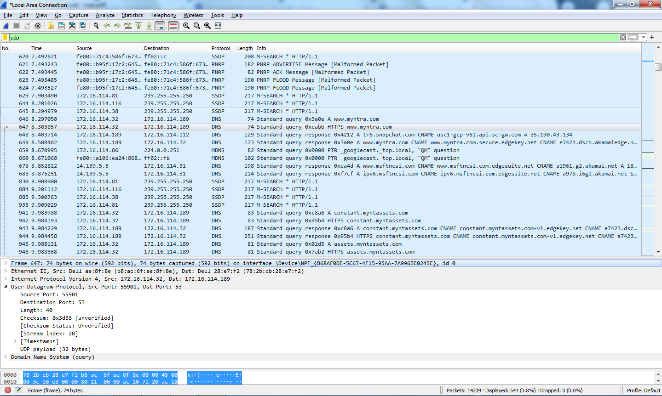
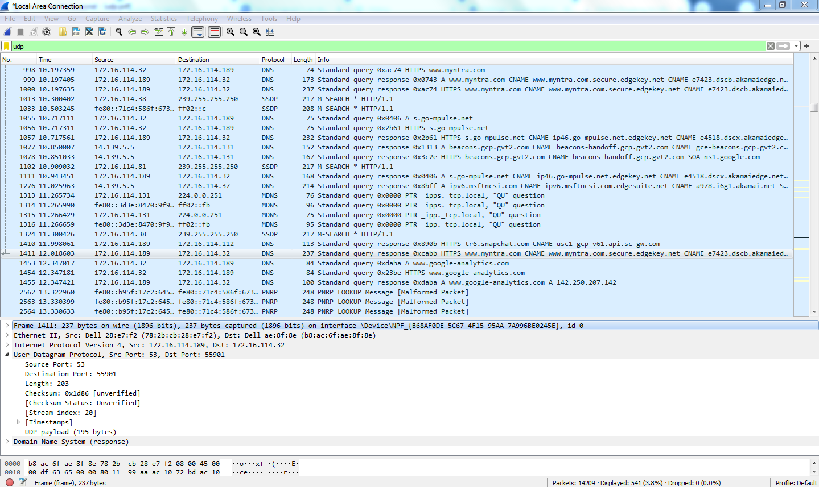

3. What is the maximum number of bytes that can be included in a UDP payload? (Hint: the
answer to this question can be determined by your answer to 2. above)

ANS: The maximum number of bytes that can be in the payload is 2^16-1 the bytes already
being used by the header field (8 bytes). Maximum payload is 65535-8= 65527 bytes
UDP Maximum Payload: 65,527 bytes (due to UDP header subtraction).

4.What is the largest possible source port number? (Hint: see the hint in 3.)
Ans: The largest possible source port number is (2^16 – 1) = 65535

5. What is the protocol number for UDP? Give your answer in both hexadecimal and decimal
notation. To answer this question, you’ll need to look into the Protocol field of the IP datagram
containing this UDP segment .
UDP IN Decimal = 17
UDP IN Hexa = 11
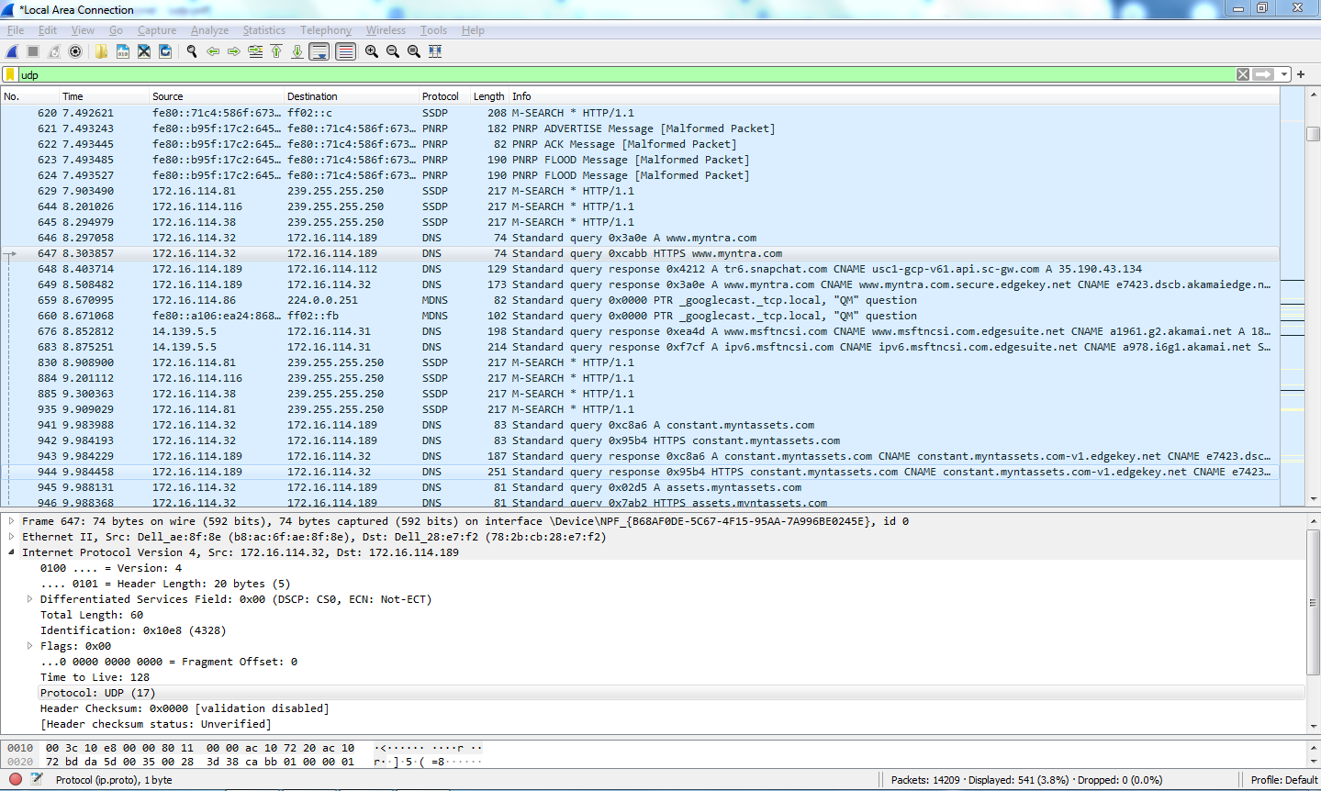

6. Examine a pair of UDP packets. The first packet is sent by your host, and the second packet is
the reply to the first packet. Compare the source and destination port numbers of both packets.
What is the relationship between them?
In query side - source port = 55901, destination port = 53
In response side – source port = 53, destination port = 55901

