ICMP – Internet Control Message Protocol
1.What is the IP address of your host? What is the IP address of the destination host?

Source add = 172.16.114.32
Destination add = 104.20.44.68
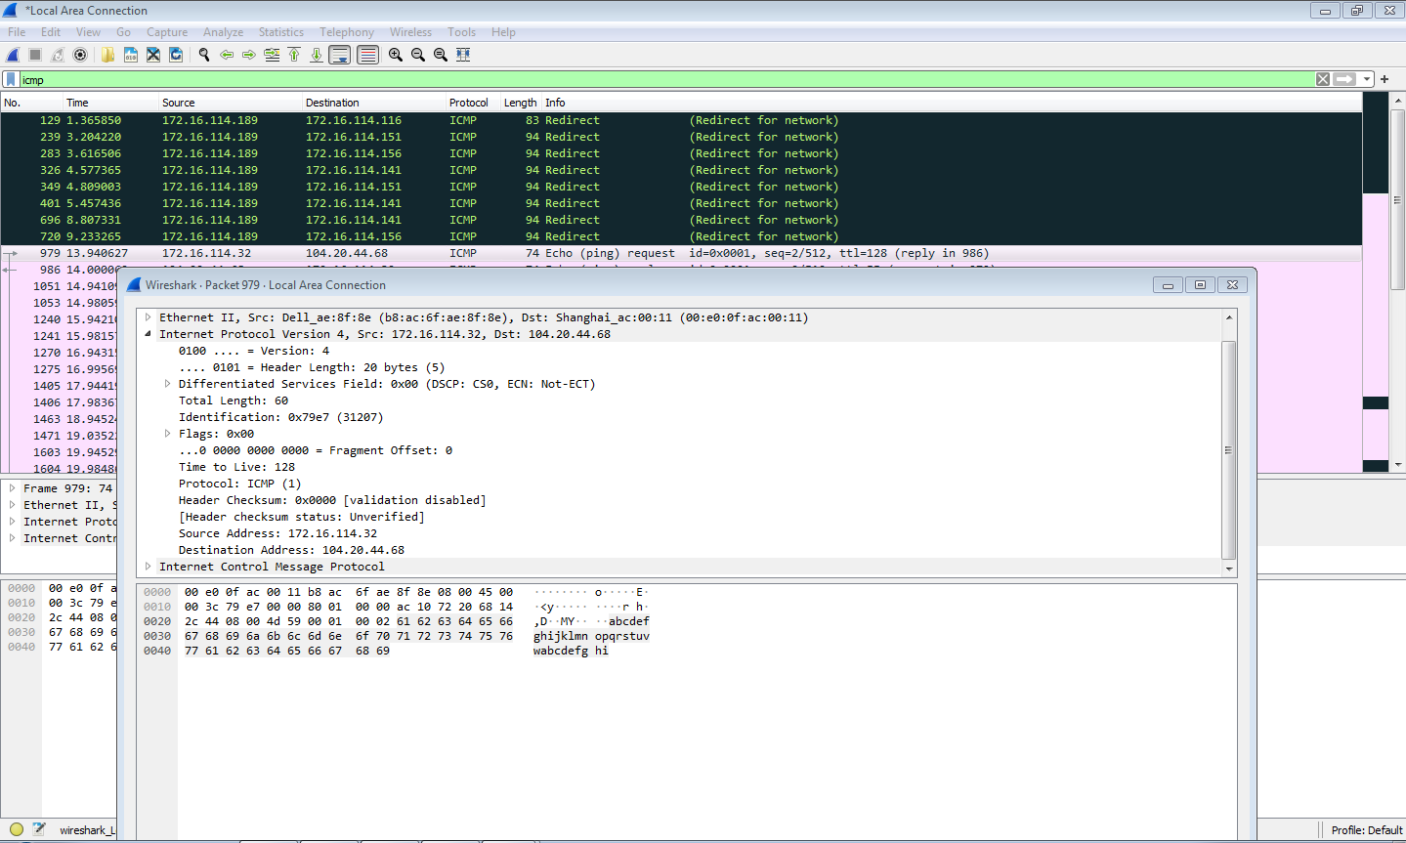

2.Why doesn't an ICMP packet have source and destination port numbers?

ICMP does not have source and destination port numbers because it is a network layer protocol for sending error messages and checking network
connectivity, not a transport layer protocol like TCP or UDP. It uses only IP addresses to identify the source and destination.

3. Examine one of the ping request packets sent by your host. What are the ICMP type and code numbers? What other fields does this ICMP packet have? How many bytes are the checksum, sequence number and identifier
fields?

• ICMP Type = 8 (Echo Request)
• ICMP Code = 0

Checksum = 2 bytes
Identifier = 2 bytes
Sequence Number = 2 bytes
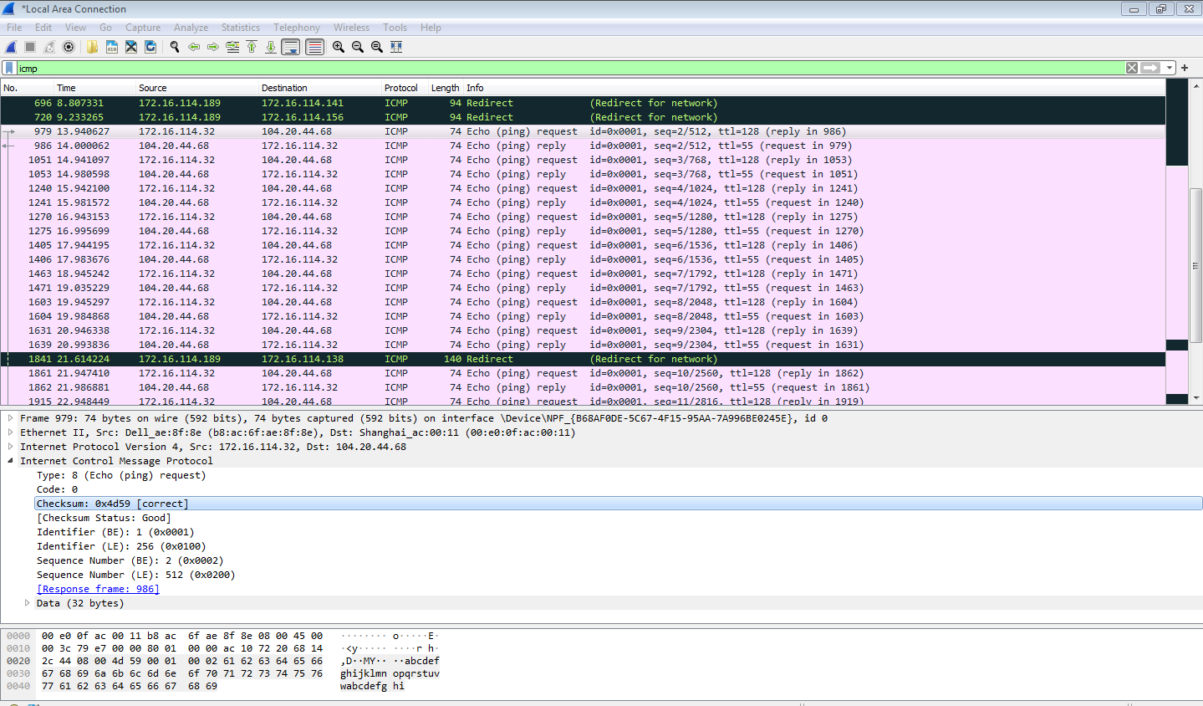

4. What is the IP address of your host? What is the IP address of the target destination host? (using tracert command)

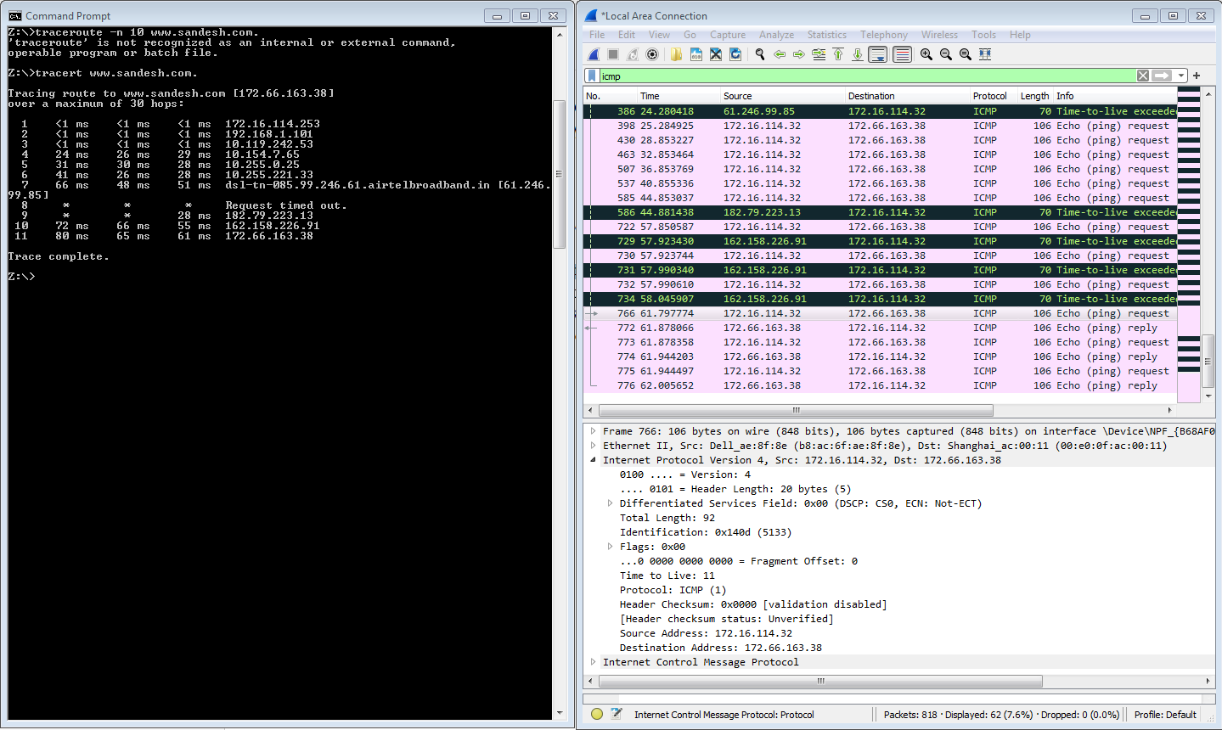

5) If ICMP uses UDP packets instead, will the Protocol Number still be 1?
If not, what will it be?

-> No. The protocol number will be 17 because UDP uses Protocol Number 17, while ICMP uses Protocol Number 1.

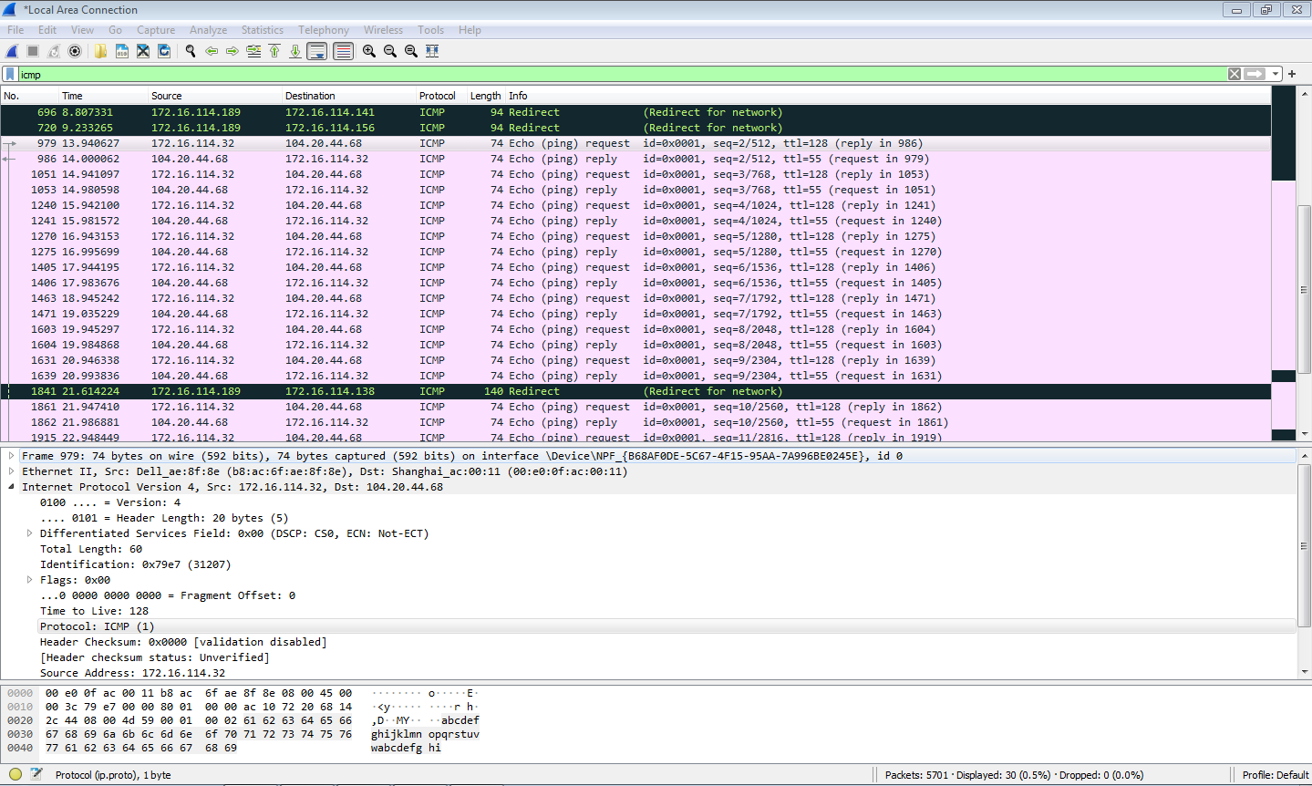

6)Look at the last three ICMP packets received by your computer. How are
they different from the ICMP Error packets? Why are they different?

The last three ICMP packets are different because they are sent by the destination host, not by intermediate routers. They are normal reply packets, whereas the ICMP Error packets are sent by routers before the packet reaches
the destination.

7) What is the ICMP Type and Code for Echo Reply

Type = 0
Code = 0
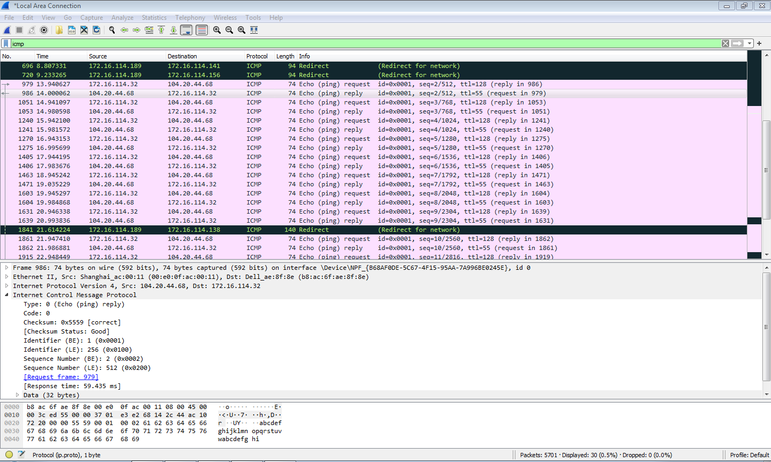

8) What is the purpose of the tracert command? What is the
purpose of the ping command?

The tracert command maps the exact physical path and intermediate routers (hops) that data packets take to reach a destination, while the ping command tests basic end-to-end network connectivity and measures response time.

