Opções para remuneração dos títulos (get_storage_by_indexer)

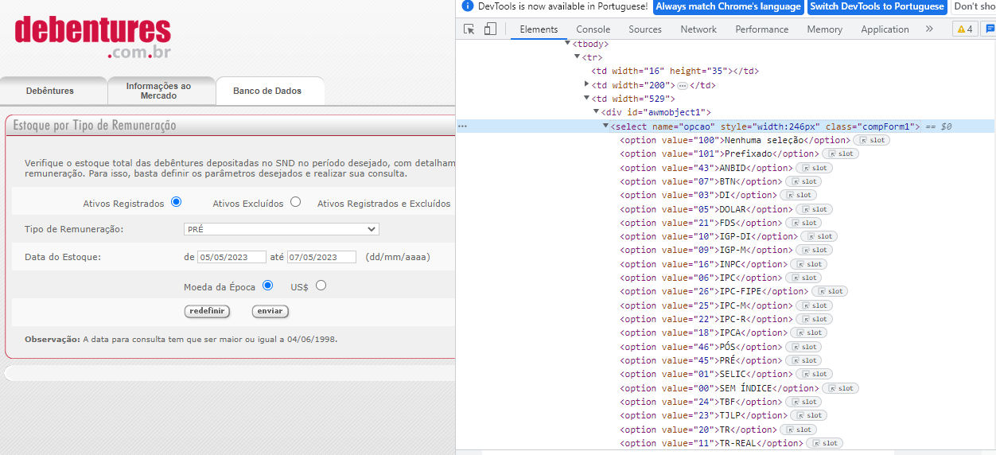

<select name="opcao" style="width:246px" class="compForm1">

<option value="100">Nenhuma seleção</option>

<option value="101">Prefixado</option>

<option value="43">ANBID</option>

<option value="07">BTN</option>

<option value="03">DI</option>

<option value="05">DOLAR</option>

<option value="21">FDS</option>

<option value="10">IGP-DI</option>

<option value="09">IGP-M</option>

<option value="16">INPC</option>

<option value="06">IPC</option>

<option value="26">IPC-FIPE</option>

<option value="25">IPC-M</option>

<option value="22">IPC-R</option>

<option value="18">IPCA</option>

<option value="46">PÓS</option>

<option value="45">PRÉ</option>

<option value="01">SELIC</option>

<option value="00">SEM ÍNDICE</option>

<option value="24">TBF</option>

<option value="23">TJLP</option>

<option value="20">TR</option>

<option value="11">TR-REAL</option>

<option value="02">UFIR</option>

<option value="15">US$ COMERCIAL</option>

</select>