KIOSK

Geno, Joshua

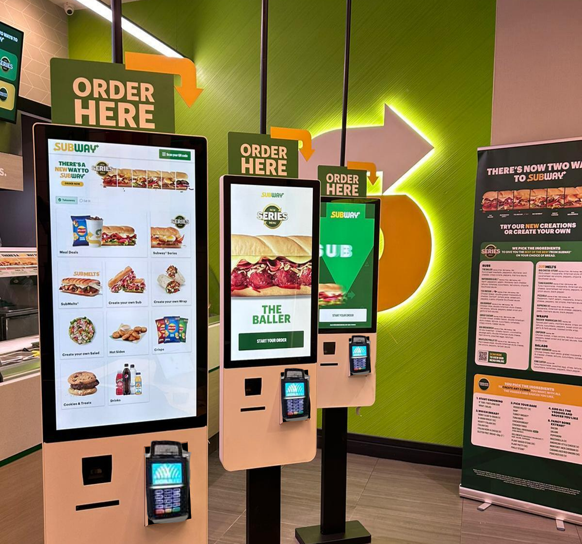

Analyse:

* What is visible before you start placing an order?

A screen with ORDER HERE.

* How do you start an order, and are there different options at the start?

When you start ordering there are 2 options 1. Take away 2. Eat at said restaurant.

* How do you add an item to your order?

By clicking on the the item you want, you than have a choice to either take a menu or just take the item you clicked on. Ones you choose one of the option you get to choose which type of bread you want and than you can click add to order.

* How do you remove an item from your order?

Ones you choose 1 item or more you can a option to view your order, here you can add the item 1x more or remove/edit it.

* How are the items displayed or located?

You have a sidebar where you see different categories, each categorie has items that are displayed in a grid.

* How does the interaction proceed? Do you only have to click, or is scrolling also possible?

You can click and scroll vertical. You can zoom in.

* How does the checkout process work?

You click on check order, ones you are in that menu you can see checkout bottom right of the screen. Ones you have clicked checkout you get a pop up about any alergies, and if you have some you have to let the staff know about it.

After you clicked proceed, it loads your order and you get the option to pay now or cancel order. Ones you clicked proceed it loads on the ATM, you get a big pop up with pay now if the ATM is ready. Ones paid you get your order number.

* What does the design look like?

Simple, clean, modern. This way its easy for the customer to navigate. Its in the colors of the subway logo.

* What do the images and lettering look like?

They look “big” and clear so you know what it is about. There using normal lettering it looks like.

* How is the image quality?

The image quality is very good so you can see how tasty said subway looks.

* How big is the screen?

Good size.

* What is the screen ratio and position?
* Where and how is the kiosk positioned in relation to its surroundings?

One was faced right at the door when entering, and 2 further in the back for if its busy.

* How many kiosks are present?

3

|  |
| --- |
| Functionality Design |
| [Geef de ondertitel van het document op] |
|  |
|  |
|  |

**Introduction**

We are developing a self-service kiosk for Happy Herbivore, a vegan fast-food restaurant, with the goal of making the ordering process as simple and seamless as possible. Our concept is centered around ease of navigation and a smooth purchasing experience for customers.

The kiosk will feature a large introduction screen with a clear "Start Your Order" button, ensuring customers immediately understand that they can place an order. Once they tap to begin, they will be presented with a curated list of our best vegan menu items alongside a sidebar with category filters for selecting specific dishes.

Customers will also have the option to view detailed information about each product, including ingredients and nutritional facts. If a dish is customizable, users will be able to edit their selection before finalizing their order. Our goal is to make ordering delicious, plant-based fast food as effortless and enjoyable as possible.

**User friendliness(user cases):**

**Actors:**

* Customer (Primary Actor)
* POS System (Secondary Actor)

**Preconditions:**

* The kiosk is operational.
* The menu is updated with available items.
* The customer has a valid payment method.

**Steps:**

* The **customer** approaches the kiosk and taps the screen to start.
* The kiosk displays the **menu** with food categories.
* The customer **browses** the menu and selects items.
* The kiosk shows customization options (e.g., add cheese, remove onions).
* The customer **reviews** the order and makes changes if necessary.
* The kiosk prompts the customer to **select a payment method** (card, mobile payment, cash).
* The customer completes the **payment** through the kiosk.
* The kiosk generates an **order number/receipt**.
* The order is sent to the **kitchen system**, and the customer waits for fulfillment.

**Postconditions:**

* The customer's order is successfully placed.
* The kitchen staff receives the order for preparation.
* The kiosk resets for the next customer.

**Target Group**

Our primary target group consists of health-conscious individuals, environmentally aware consumers, and those seeking convenient plant-based food options. This includes:

* Vegans & Vegetarians – Customers who follow a plant-based diet and are looking for quick, accessible, and delicious vegan fast food.
* Flexitarians & Health-Conscious Eaters – People who may not be fully vegan but want to incorporate more plant-based meals into their diet for health benefits.
* Eco-Conscious Consumers – Individuals who prioritize sustainability and ethical food choices, reducing their environmental footprint by choosing plant-based options.
* Busy Professionals & Students – Those who need fast, hassle-free ordering without compromising on quality or dietary preferences.

By designing the kiosk to be intuitive and efficient, we aim to provide a smooth and enjoyable experience for anyone looking for a quick, delicious, and sustainable meal.

**Wireframes:**