Internal Practical Exam:

Name:Bhos ViveK

Class:FYMCA

Div:A

Roll: 51005

Course:LP-II

Elective:Machine Learning

1)To write a program to create a network connection between 2 nodes using UDP

udp_server.py

*import* socket

def **start_server**():

*# Create a UDP socket*

    server_socket = socket.socket(socket.AF_INET, socket.SOCK_DGRAM)

*# Bind the socket to a specific address and port*

    server_address = ('localhost', 12345)

    server_socket.bind(server_address)

    print(f"UDP Server is listening on {server_address}")

*while* True:

*try*:

*# Receive data from client*

            data, client_address = server_socket.recvfrom(1024)

            print(f"Received message from {client_address}: {data.decode()}")

*# Send response back to client*

            response = f"Server received: {data.decode()}"

            server_socket.sendto(response.encode(), client_address)

*except* Exception *as* e:

            print(f"Error: {e}")

*break*

    server_socket.close()

*if* __name__ == "__main__":

    start_server()

udp_client.py

*import* socket

def **start_client**():

*# Create a UDP socket*

    client_socket = socket.socket(socket.AF_INET, socket.SOCK_DGRAM)

*# Server address*

    server_address = ('localhost', 12345)

*try*:

*while* True:

*# Get message from user*

            message = input("Enter message to send (or 'quit' to exit): ")

*if* message.lower() == 'quit':

*break*

*# Send data to server*

            client_socket.sendto(message.encode(), server_address)

*# Receive response from server*

            data, _ = client_socket.recvfrom(1024)

            print(f"Server response: {data.decode()}")

*except* Exception *as* e:

        print(f"Error: {e}")

*finally*:

        client_socket.close()

*if* __name__ == "__main__":

    start_client()

Output:

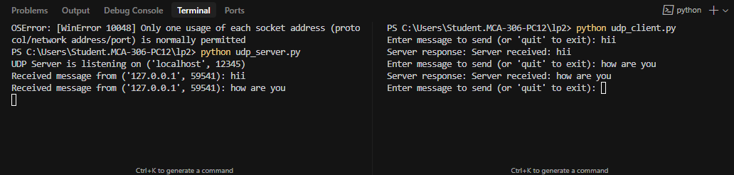

2) *import* pandas *as* pd

*from* sklearn.model_selection *import* train_test_split

*import* numpy *as* np

def **split_dataset**(*data_path*, *test_size*=0.2, *random_state*=42):

    """

    Split a dataset into training and test sets.

    Parameters:

    data_path (str): Path to the dataset file (CSV format)

    test_size (float): Proportion of the dataset to include in the test split (default: 0.2)

    random_state (int): Random seed for reproducibility (default: 42)

    Returns:

    tuple: (X_train, X_test, y_train, y_test)

    """

*try*:

*# Read the dataset*

        df = pd.read_csv(*data_path*)

*# Assuming the last column is the target variable*

        X = df.iloc[:, :-1]  *# Features (all columns except the last one)*

        y = df.iloc[:, -1]   *# Target variable (last column)*

*# Split the dataset*

        X_train, X_test, y_train, y_test = train_test_split(

            X, y, *test_size*=*test_size*, *random_state*=*random_state*

        )

        print("\nDataset splitting summary:")

        print(f"Total samples: {len(df)}")

        print(f"Training samples: {len(X_train)} ({(1-*test_size*)*100}%)")

        print(f"Testing samples: {len(X_test)} ({*test_size*\*100}%)")

*return* X_train, X_test, y_train, y_test

*except* Exception *as* e:

        print(f"Error: {str(e)}")

*return* None

*# Example usage*

*if* __name__ == "__main__":

*# Using our sample dataset*

    data_path = "sample_dataset.csv"

*try*:

        X_train, X_test, y_train, y_test = split_dataset(data_path)

*if* X_train is not None:

            print("\nShape of split datasets:")

            print(f"X_train shape: {X_train.shape}")

            print(f"X_test shape: {X_test.shape}")

            print(f"y_train shape: {y_train.shape}")

            print(f"y_test shape: {y_test.shape}")

            print("\nFeature names:")

            print(X_train.columns.tolist())

*except* FileNotFoundError:

        print(f"\nError: Could not find {data_path}. Please make sure the file exists in the current directory.")

Output:

