Hypercisor:

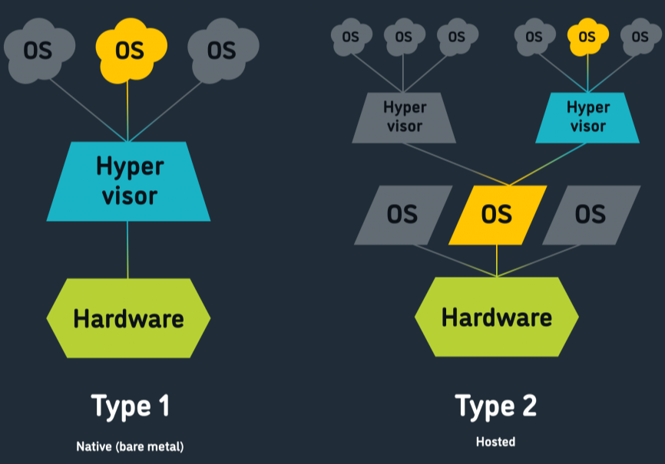

Virtual machine vs containers

Types of virtualization:

ec2 instance types

aws storage types:

Ebs volume types:

ebs vs efs vs instance store

