Vpc component diagram:

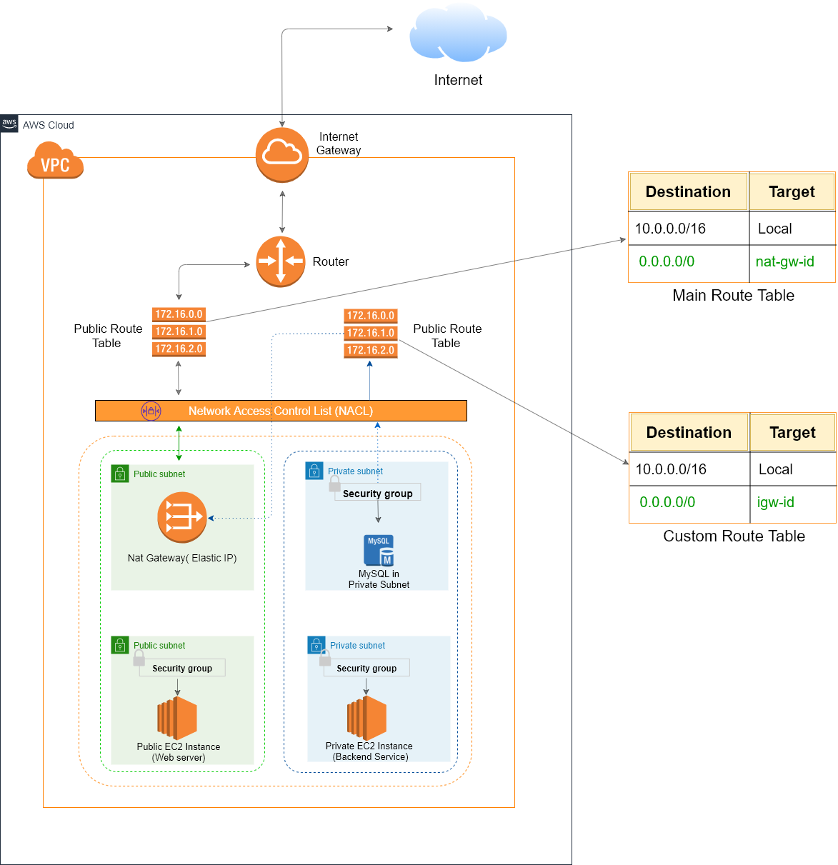

Bastion host:

Ec2 instance in public subnet connected to private subnet.

User can ssh into public subnet and then to private subnet by bastion host.

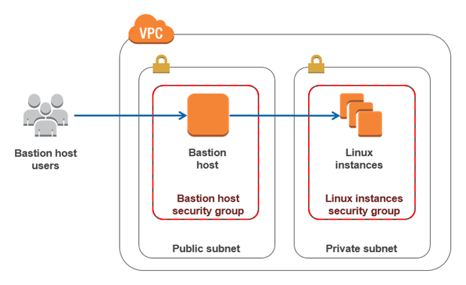

Difference between nat gatway and nat instance

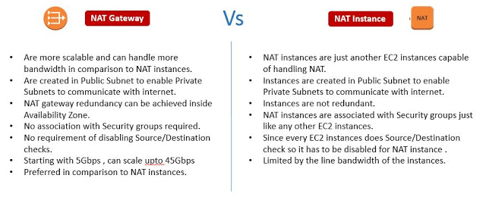

difference between nacl and security group:

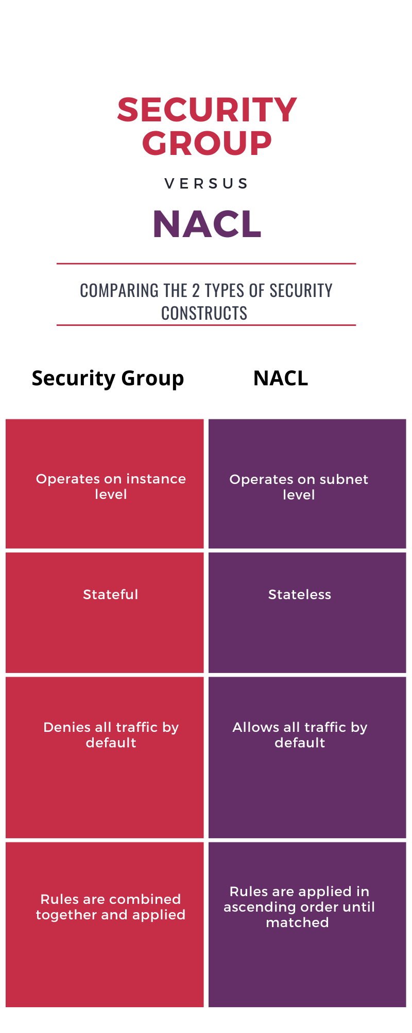

Vpc peering:

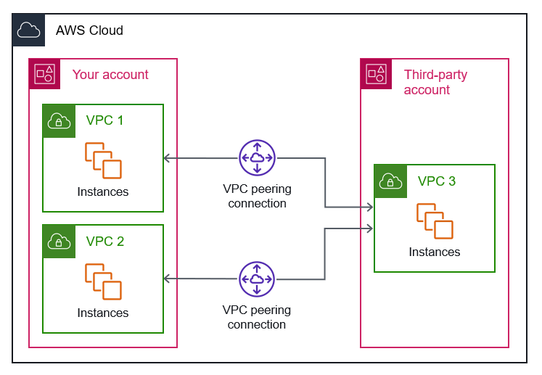

Vpc endpoints:

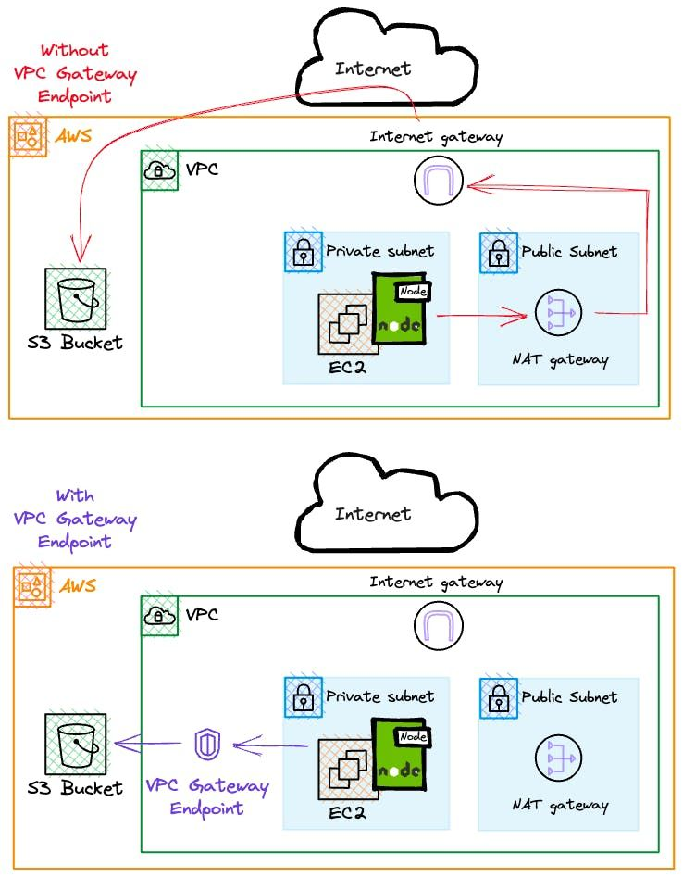

Vpc flow logs architecture:

difference between transit gateway and direct connect gateway and virtual private gateway

site to site vpn connection and direct connect


        Site-to-Site VPN connection with AWS Direct Connect
