TABLE OF CONTENTS
ABSTRACT
1. INTRODUCTION
1.1 Motivation
1.2 Problem Statement
1.3 Objective of the Project
1.4 Scope
1.5 Project Introduction (Bank Management System Overview)
2. LITERATURE SURVEY
2.1 Related Work
3. SYSTEM ANALYSIS
3.1 Existing System
3.2 Disadvantages
3.3 Proposed System
3.4 Advantages
3.5 Work Flow of Proposed System
4. REQUIREMENT ANALYSIS
4.1 Functional & Non-Functional Requirements
4.2 Hardware Requirements
4.3 Software Requirements
4.4 Architecture
5. SYSTEM DESIGN
5.1 Introduction of Input Design
5.2 UML Diagrams
- Class Diagram
- Use Case Diagram
- Sequence Diagram
- Collaboration Diagram
- Deployment Diagram
- Activity Diagram
- ER Diagram
- Component Diagram
5.3 Data Flow Diagram (DFD)
6. IMPLEMENTATION AND RESULTS
6.1 Modules
6.2 Implementation
6.3 Output Screens
7. METHODOLOGY
ECC – Error Checking and Correction
8. SYSTEM STUDY AND TESTING
8.1 Feasibility Study
8.2 Types of Test & Test Cases
9. CONCLUSION
10. FUTURE ENHANCEMENT
11. REFERENCES

ABSTRACT
The Bank Management System is a web-based application developed to automate and simplify core banking operations such as customer account management, transaction processing, and record maintenance. The primary objective of this project is to provide a secure, efficient, and user-friendly platform that reduces manual workload and increases the accuracy of banking activities.
This system is developed using Python, Django, HTML, CSS, MySQL, and GitHub for version control. The application allows administrators to manage customer details, create and update accounts, perform deposits and withdrawals, view transaction history, and generate reports. The system also incorporates validation and security measures to ensure safe handling of sensitive financial data.
By digitalizing banking operations, the Bank Management System offers improved reliability, faster processing, easy data retrieval, and enhanced customer service. This project demonstrates how modern web technologies can be effectively used to streamline banking processes, minimize errors, and provide a scalable solution suitable for small to medium-sized financial institutions.

1. INTRODUCTION
The banking sector plays a crucial role in the financial stability and economic growth of any country. With the rapid growth of technology, traditional banking operations have increasingly shifted toward digital platforms to improve accuracy, speed, and security. A Bank Management System provides an efficient solution for managing customer accounts, processing transactions, and maintaining financial records. The goal of this project is to design and develop a reliable and secure system that automates common banking activities using modern web technologies such as Python, Django, MySQL, HTML, and CSS.

1.1 Motivation
In many banking environments, customer data and transactions are still managed using semi-manual methods, leading to delays, errors, and inefficiencies. As the number of customers grows, maintaining accurate records becomes increasingly challenging. The motivation behind this project is to create an automated platform that makes banking operations faster, more accurate, and more user-friendly. This system aims to reduce the workload on employees, minimize human errors, and provide a better experience for both administrators and customers.

1.2 Problem Statement
Traditional banking systems often rely on manual processes for maintaining accounts, updating transaction details, and storing customer information. These processes can lead to issues such as:
- Data inconsistency
- Slow processing time
- Difficulty in retrieving records
- High chances of human error
- Lack of centralized and secure data storage
Therefore, there is a need for a digital solution that efficiently manages customer accounts, transactions, and data while ensuring security, accuracy, and ease of access.

1.3 Objective of the Project
The main objectives of the Bank Management System are:
- To develop a secure, automated system for managing customer information and bank accounts.
- To ensure fast and accurate processing of deposits, withdrawals, and transfers.
- To provide an easy-to-use interface for administrators to manage all banking operations.
- To maintain a centralized database for reliable data storage and retrieval.
- To reduce manual workload and minimize errors.
- To enhance security through authentication and validation mechanisms.

1.4 Scope
The scope of the Bank Management System includes:
- Admin login and authentication
- Customer registration and management
- Creation and management of bank accounts
- Handling of transactions (deposit, withdrawal, transfer)
- Viewing and maintaining transaction history
- Storing all records in a secure MySQL database
- System accessible on any device with a web browser
The system is designed for small to medium-sized financial organizations, training purposes, and educational demonstrations.

1.5 Project Introduction (Bank Management System Overview)
The Bank Management System is a web-based application developed using Python (Django framework) for backend processing and MySQL for database management. The frontend interface is created with HTML and CSS, offering a clean and user-friendly experience. This system enables administrators to efficiently manage customer records, account information, and financial transactions. It incorporates error checking, validation, and security measures to ensure the accuracy and confidentiality of sensitive data.
Overall, the project demonstrates how modern technologies can be used to build a secure, scalable, and efficient banking solution that replaces traditional manual processes and improves operational performance.

2. LITERATURE SURVEY
A literature survey is an essential part of software development, as it provides insight into existing solutions, technologies, and research findings relevant to the proposed system. For banking applications, numerous systems and models have been developed to manage customer information, perform transactions, and maintain secure financial records. This chapter reviews the existing banking software systems, digital banking advancements, and research studies that contribute to the development of a reliable Bank Management System.
Traditional banking systems relied heavily on manual record-keeping, which often resulted in delays, errors, and inconsistencies. Over the years, computerized systems have been introduced to automate these processes, improving accuracy and efficiency. With the rapid growth of web technologies, modern banking systems now operate through online platforms, enabling real-time transactions, secure data management, and easy accessibility.
Several research studies emphasize the importance of user-friendly interfaces, secure authentication, encrypted transactions, and centralized databases to ensure safe and efficient banking operations. Technologies like Python, Django, and MySQL have been widely adopted due to their scalability, performance, and robustness, making them suitable for developing applications like the Bank Management System.

2.1 Related Work
Several existing systems and research works related to bank management and digital transaction software have influenced the design and development of this project:
1. Traditional Core Banking Systems
Large banks use core banking software such as Flexcube, Finacle, and T24, which provide centralized banking operations. These systems inspired the need for automation, secure transactions, and efficient data handling in smaller-scale banking solutions.

2. Web-Based Banking Applications
Many studies and existing web applications demonstrate how digital platforms enable customers to manage accounts, view statements, and perform transactions online. These systems highlight the importance of usability, data privacy, and secure access.
3. Database-Driven Account Management Systems
Research works on database management emphasize the use of structured databases like MySQL for maintaining large datasets, retrieving information quickly, and ensuring data consistency—key requirements for a Bank Management System.
4. Python & Django-Based Management Systems
Several student-level and enterprise-level projects have been developed using Django due to its powerful ORM, built-in security features, and rapid development capabilities. These works support the choice of technologies used in this project.
5. Transaction Security Studies
Research on secure transaction processing stresses the need for proper validation, encryption, and error-handling mechanisms. This influenced the inclusion of authentication, data validation, and controlled access in the proposed system.

3. SYSTEM ANALYSIS
System analysis is the process of examining and understanding the existing banking process, identifying its limitations, and determining how a new system can overcome these challenges. This chapter analyzes the current situation and presents the need for an automated Bank Management System using modern technologies such as Python, Django, and MySQL.

3.1 Existing System
In many traditional banking environments, essential tasks such as maintaining customer records, updating account balances, and recording transactions are still performed using manual or semi-manual methods. Some banks use outdated software systems that require significant human involvement for routine operations.
The existing system typically involves:
- Manual entry of customer details
- Physical ledgers or spreadsheets for account data
- Transaction processing handled by bank employees
- Hard-copy documentation for verification
- Slower data retrieval due to lack of centralized storage
Although these methods may function adequately for small workloads, they become inefficient and error-prone as the number of customers and transactions increases.

3.2 Disadvantages of Existing System
The limitations of traditional and semi-manual banking systems include:
- High Chances of Human Error
Mistakes in record entry, calculation errors, and mismanagement are common.
- Time-Consuming Processes
Manual verification and processing of transactions cause delays.
- Lack of Data Security
Physical documents and loosely maintained records are vulnerable to loss or misuse.
- Difficulty in Record Retrieval
Searching for customer or transaction data takes significant time.
- Limited Accuracy and Reliability
Manual systems lack real-time updating and consistent accuracy.
- No Centralized Database
Data stored in multiple files or registers leads to inconsistency and duplication.

3.3 Proposed System
The proposed Bank Management System is a fully automated, web-based application designed to overcome the limitations of traditional systems. It provides an efficient platform for managing customer accounts, handling transactions, and maintaining financial records.
Key features of the proposed system include:
- Digital storage of customer and account information
- Real-time transaction processing (deposit, withdrawal, transfer)
- Secure authentication for admin login
- Centralized MySQL database for efficient data management
- User-friendly interface developed using HTML and CSS
- Backend implemented with Python and Django
The proposed system ensures fast, reliable, and secure banking operations with minimal human involvement.

3.4 Advantages of Proposed System
The new system offers several significant advantages:
- Automation of Banking Operations
Eliminates manual processing and improves efficiency.
- Increased Accuracy
Automated calculations and validations reduce errors.
- Enhanced Security
User authentication, SQL database security, and data validation ensure protection of sensitive information.
- Centralized and Organized Database
MySQL database stores all customer and transaction records in a structured and retrievable manner.
- Faster Processing and Easy Access
Data retrieval and transaction processing are instantaneous.
- User-Friendly Interface
Clean and simple UI developed using HTML/CSS.
- Scalability
System can be expanded with new features without major redesign.

3.5 Work Flow of Proposed System
The workflow of the Bank Management System follows a structured process to ensure smooth operations:
- Admin Login
The admin logs into the system using secure authentication credentials.
- Customer Management
Admin can add, edit, view, or delete customer details.
- Account Management
After adding a customer, the admin creates or manages bank accounts connected to that customer.
- Transaction Processing
The system allows deposit, withdrawal, and fund transfer operations.
All transactions are validated and stored in the database.
- Transaction History
The system maintains a complete record of all transactions for later viewing.
- Database Update
Every operation updates the MySQL database automatically and in real-time.
- Report Generation
Admin can view summaries, account details, and transaction logs.
This workflow ensures that all banking operations are handled efficiently, securely, and with minimal human effort.

4. REQUIREMENT ANALYSIS
Requirement analysis is the process of identifying and documenting the functional and non-functional needs of the system. It ensures that the system is developed according to user expectations and operates smoothly in the intended environment. This chapter outlines the functional requirements, hardware and software needs, and the overall architecture of the proposed Bank Management System.

4.1 Functional & Non-Functional Requirements
A. Functional Requirements
Functional requirements specify what the system should do. The Bank Management System must support the following functionalities:
- Admin Authentication
  - Secure login for administrators
  - Password validation
- Customer Management
  - Add new customer
  - Edit customer details
  - View customer information
  - Delete customer from database
- Account Management
  - Create new bank accounts
  - View account details
  - Update account status
  - Link accounts with customers
- Transaction Management
  - Deposit money
  - Withdraw money
  - Transfer funds between accounts
  - Validate balance before withdrawal
  - Automatically update account balance
- Transaction History
  - Store all transaction records
  - Allow admin to view transaction history
- Database Operations
  - Save customer, account, and transaction details in a secured database
  - Fetch data as per user request
- Error Handling
  - Display user-friendly messages for invalid inputs or failed operations

B. Non-Functional Requirements
Non-functional requirements define how the system performs and behaves.
- Performance Requirements
  - Fast processing of transactions
  - Quick retrieval of customer/account data
- Security Requirements
  - Authorized admin access
  - Protection of sensitive information
  - Secure storage using MySQL database
- Usability Requirements
  - User-friendly interface
  - Easy navigation
  - Proper instructions and error messages
- Reliability Requirements
  - System should work accurately without failure
  - Maintain consistency of data
- Availability Requirements
  - Accessible through any web browser
  - Minimal downtime
- Scalability Requirements
  - System should support additional modules in future
- Maintainability
  - Code should be easy to modify and update

4.2 Hardware Requirements
Hardware requirements describe the physical components needed to run the system.
Hardware Component | Minimum Requirement
Processor | Dual Core or higher
RAM | 4 GB (8 GB recommended)
Storage | 250 GB HDD or SSD
Display | 1024×768 resolution
Input Devices | Keyboard, Mouse

4.3 Software Requirements
The Bank Management System requires the following software components:
Software | Version/Description
Operating System | Windows / Linux / macOS
Python | Python 3.x
Django | Django Framework
MySQL Server | MySQL 5.7 or higher
MySQL Connector | For Django-MySQL connectivity
Frontend Tools | HTML, CSS
IDE/Editor | VS Code / PyCharm / Sublime Text
Browser | Chrome / Firefox
Git & GitHub | Version control

4.4 Architecture
The architecture of the Bank Management System follows a three-tier architecture, ensuring modularity, scalability, and security.
1. Presentation Layer (Frontend)
- Built using HTML and CSS
- Allows admin to interact with the system
- Handles input forms for customer, account, and transaction operations
2. Application Layer (Backend)
- Developed using Python and Django Framework
- Contains business logic
- Manages customer data, transactions, and authentication
- Communicates with the database using Django ORM
3. Data Layer (Database)
- Uses MySQL to store:
  - Customer details
  - Account information
  - Transaction records
- Ensures secure and consistent data management
Architectural Flow:
- Admin interacts with frontend interface
- Requests are sent to Django backend
- Backend processes the logic
- Database operations are performed in MySQL
- Results are returned and displayed to the admin
This architecture provides a clear separation of concerns and helps in maintaining and scaling the system efficiently.

5. SYSTEM DESIGN
System design is the process of translating requirements into a blueprint for constructing the system. It focuses on designing the architecture, interfaces, data structures, and flow of information. In the Bank Management System, system design ensures that all components work together efficiently and securely.

5.1 Introduction of Input Design
Input design plays a crucial role in any software system as it ensures that the user provides valid, accurate, and useful data to the system. In the Bank Management System, input design focuses on creating user-friendly forms that help the admin enter customer and account details without errors.
Objectives of Input Design:
- To provide easy-to-use interfaces for data entry.
- To minimize user mistakes by using validation rules.
- To ensure accurate and complete data is entered before submission.
- To improve readability and usability through simple layouts.
Inputs in the Bank Management System include:
- Admin login credentials (username & password)
- Customer details (name, address, contact, email)
- Account information (account type, account number, opening balance)
- Transaction inputs (amount to deposit/withdraw, account number, date, etc.)
All inputs are validated through Django backend checks to ensure security and correctness.

5.2 UML DIAGRAMS
Unified Modeling Language (UML) diagrams help visualize the structure and behavior of the Bank Management System. Below are the essential UML diagrams included in the project.

A. Class Diagram
The Class Diagram represents the static structure of the system by showing classes, attributes, methods, and relationships.
Main classes in the Bank Management System:
- Customer
Attributes: customer_id, name, address, contact
- Account
Attributes: account_number, account_type, balance
- Transaction
Attributes: transaction_id, date, amount, type
- Admin
Attributes: username, password

Relationships:
- One customer can have multiple accounts.
- One account can have multiple transactions.

B. Use Case Diagram
Use Case Diagrams describe the interaction between the user (admin) and the system.
Actors:
- Admin
Major use cases:
- Login
- Manage customers
- Manage accounts
- Perform transactions
- View transaction history
- Logout

C. Sequence Diagram
Sequence Diagrams show how objects interact over time.
Example: Deposit Transaction Sequence
- Admin enters account number and amount
- System validates account
- System updates balance
- Confirmation displayed to admin

D. Collaboration Diagram
This diagram shows the relationships and message flow between objects.
Objects involved:
- Admin
- Customer module
- Account module
- Transaction module
- Database

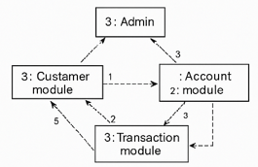

E. Deployment Diagram
Represents the physical deployment of the system.
Nodes:
- Client Machine: browser interface (HTML/CSS)
- Application Server: Django backend
- Database Server: MySQL database
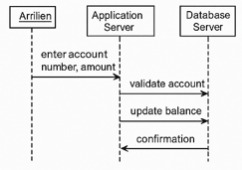

F. Activity Diagram
Describes the flow of operations in the system.
Example: Account Creation Activity:
- Start
- Enter customer details
- Validate information
- Save to database
- Display confirmation
- End
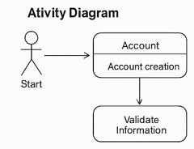

G. ER Diagram (Entity–Relationship Diagram)
Shows the database structure used in the system.
Entities:
- Customer
- Account
- Transaction
Relationships:
- Customer —< Account
- Account —< Transaction
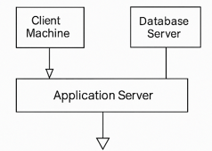
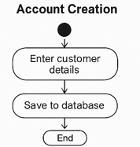

H. Component Diagram
Shows how the system is divided into components.
Main components:
- UI Component (Front-end)
- Business Logic Component (Django Views & Models)
- Database Component (MySQL)
- Authentication Component
- Transaction Component
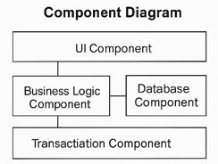

5.3 Data Flow Diagram (DFD)
Data Flow Diagrams represent how data moves through the system.

DFD Level 0 (Context Diagram)
Shows the system as a single process interacting with external entities.
Entities:
- Admin
Process:
- Bank Management System
Data Stores:
- Customer Database
- Account Database
- Transaction Database
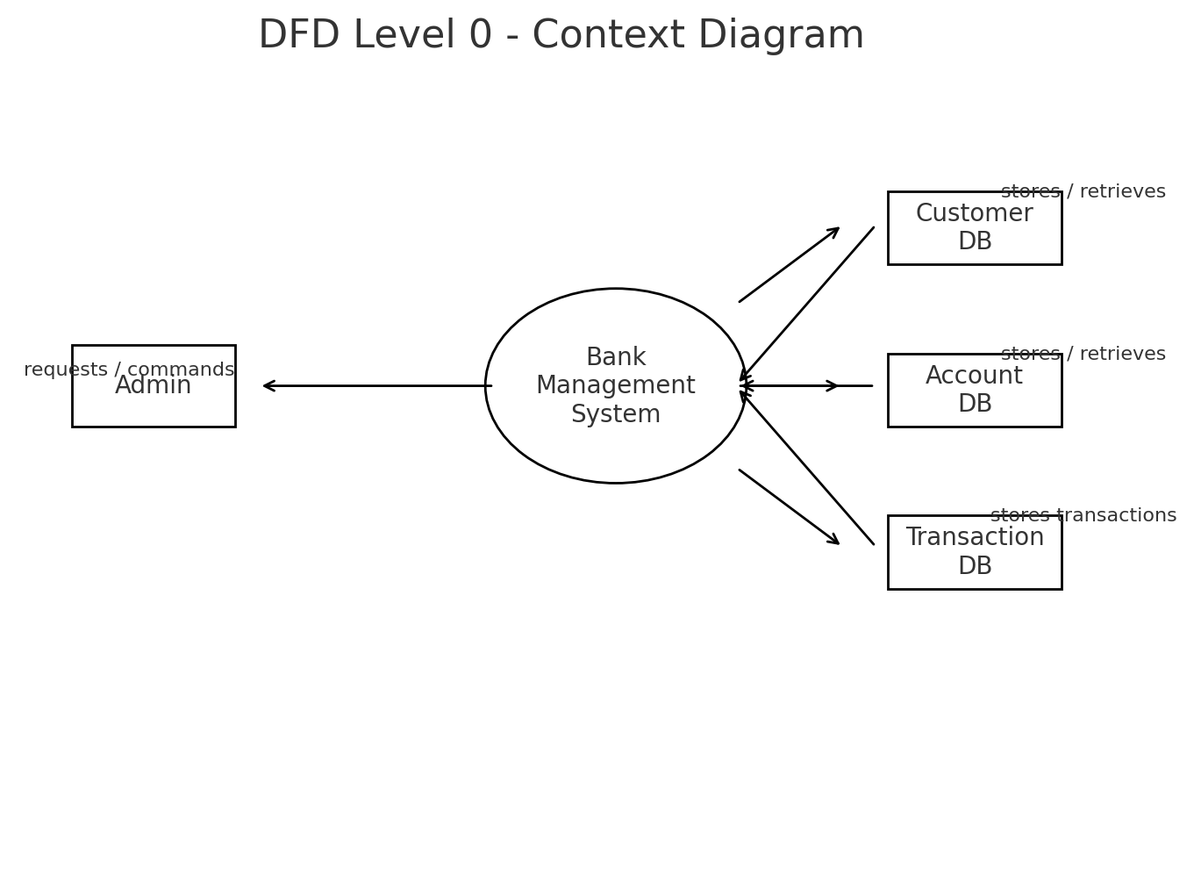

DFD Level 1
Breaks down the system into modules:
- Customer Management
  - Input: Customer details
  - Output: Customer records
- Account Management
  - Input: Account information
  - Output: Account data
- Transaction Management
  - Input: Deposit/withdraw/transfer details
  - Output: Updated balance & transaction history
- Authentication
  - Input: Login credentials
  - Output: Access permission
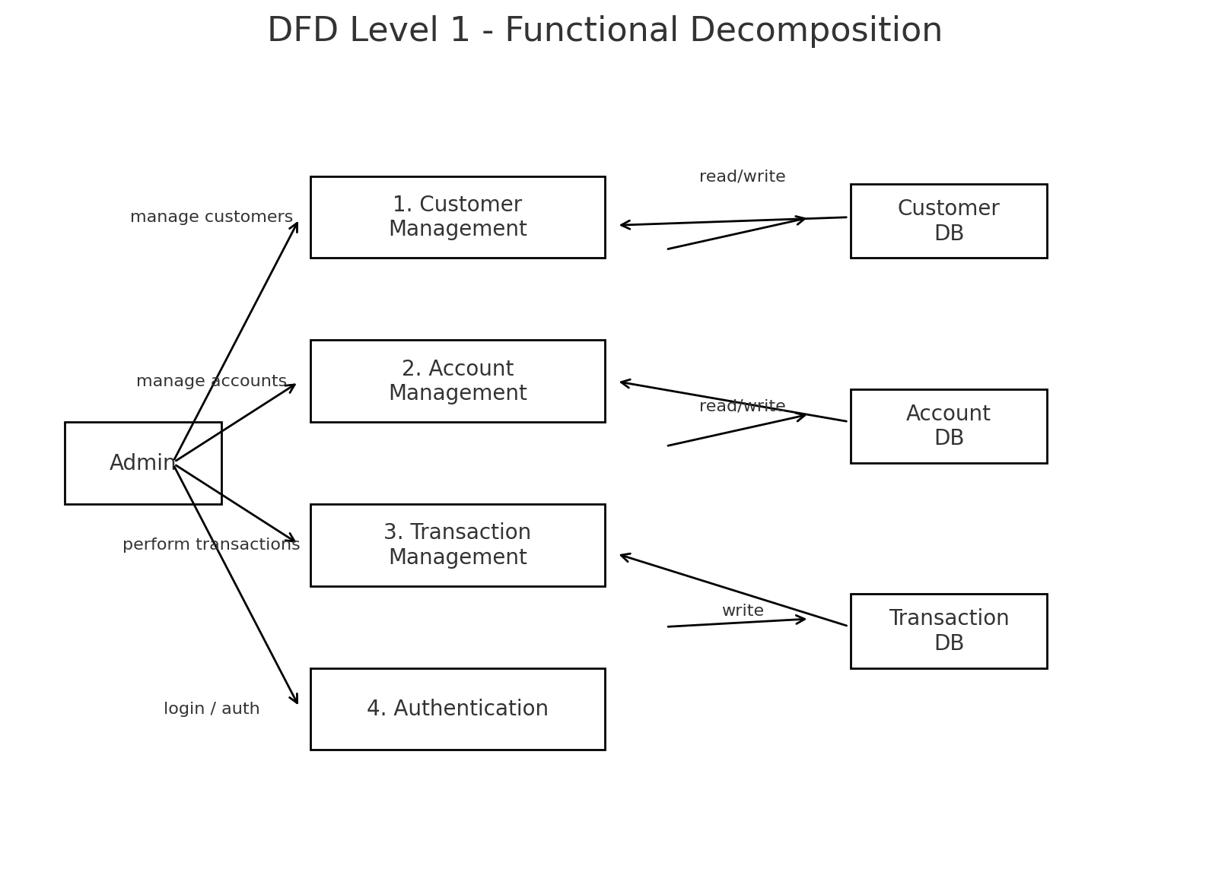

6. IMPLEMENTATION AND RESULTS
Implementation is the process of converting the system design into an operational software solution. The Bank Management System is developed using Python, Django, HTML, CSS, MySQL, and GitHub for version control. This chapter explains the implementation of various modules, the functioning of the system, and the output screens generated during execution.

6.1 Modules
The system is divided into four main modules to simplify development and improve maintainability.

1. Admin Authentication Module
This module ensures that only authorized personnel can access the system.
Features:
- Admin login page
- Username and password verification
- Redirects to dashboard after successful login
- Protects all admin operations

2. Customer Management Module
This module handles all operations related to customers.
Functionality:
- Add new customer
- Edit customer details
- View customer list
- Delete customer records
- Validate inputs before saving

3. Account Management Module
This module handles account-related operations.
Functionality:
- Create new bank account for customers
- View account details (account number, type, balance)
- Update or close accounts
- Link account with customer profile

4. Transaction Management Module
Handles all financial transactions of the bank.
Functionality:
- Deposit money into customer account
- Withdraw money (with balance validation)
- Transfer funds between accounts
- Store transaction details in database
- Generate transaction history

5. Database Management Module
This module uses MySQL to store and manage all backend information.
Data stored:
- Customer details
- Account details
- Transaction logs
- Admin credentials

6.2 Implementation
The Bank Management System is implemented using a combination of frontend, backend, and database technologies.

Backend Implementation (Python + Django)
Key parts:
- Models: Define tables for Customer, Account, and Transaction
- Views: Handle requests, perform business logic
- URLs: Route user actions to the correct functions
- Forms: Manage user input and validation
- Django ORM: Interacts with MySQL database securely
Example model structure:
class Customer(models.Model):
customer_id = models.AutoField(primary_key=True)
name = models.CharField(max_length=100)
contact = models.CharField(max_length=15)
class Account(models.Model):
account_number = models.AutoField(primary_key=True)
customer = models.ForeignKey(Customer, on_delete=models.CASCADE)
balance = models.FloatField()

Frontend Implementation (HTML + CSS)
- User-friendly interface for admin
- Clean forms for entering customer and account details
- Responsive design for better usability
Included pages:
- HOME page
- Contact Us page
- Register Form
- Login Form
- Dash Board
- Statement

Database Implementation (MySQL)
- Database created using Django migrations
- Structured tables for customer, account, and transactions
- Supports fast search and retrieval

GitHub Version Control
- Entire project pushed to GitHub
- Tracks changes and helps with backup
- Enables collaboration and version tracking

6.3 Output Screens
The following are the main output screens generated during execution of the Bank Management System:

- Home Screen


2. Login Screen
- Admin enters username and password
- Redirects to dashboard upon successful login
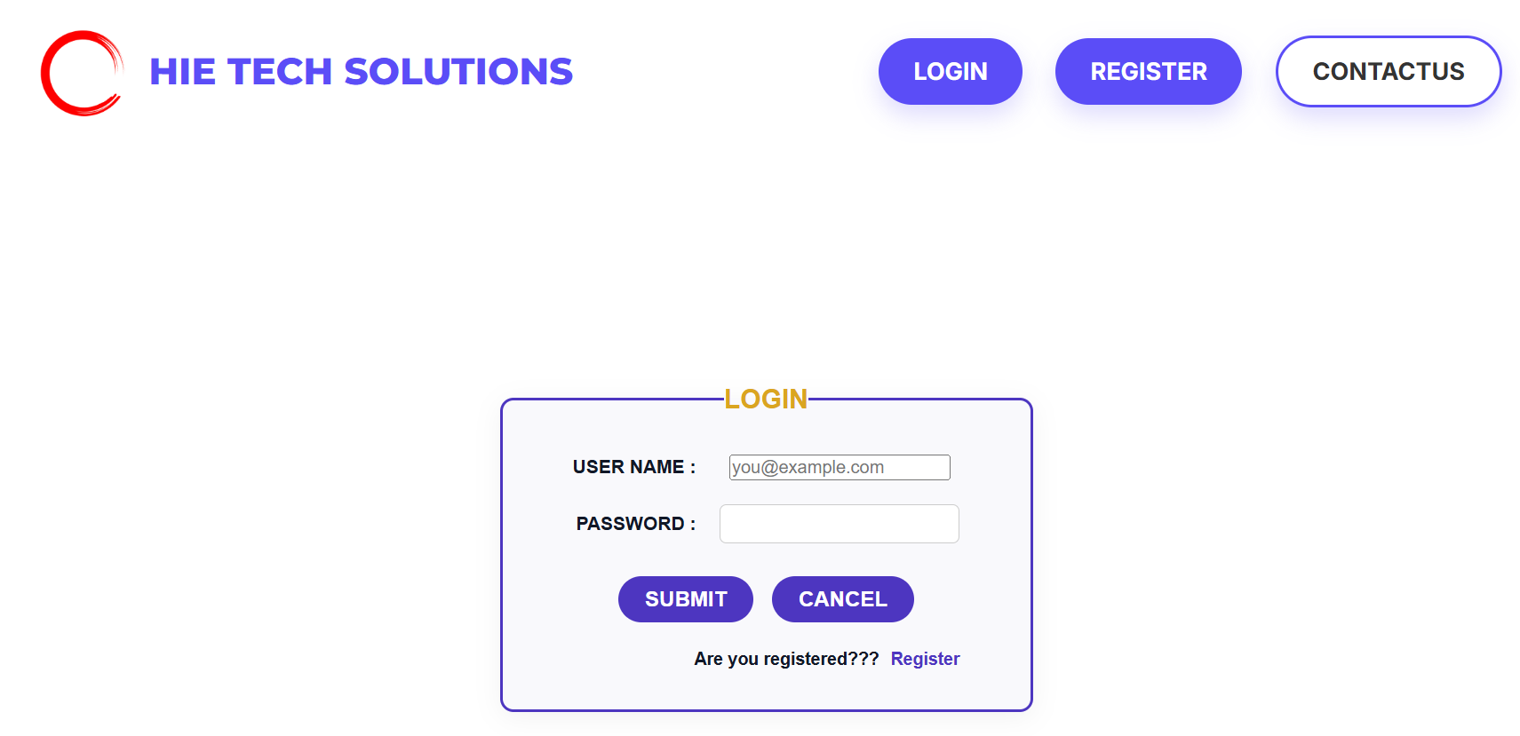

3. Dashboard
- Displays links to all major modules:
Customer Management, Account Management, Transaction Management
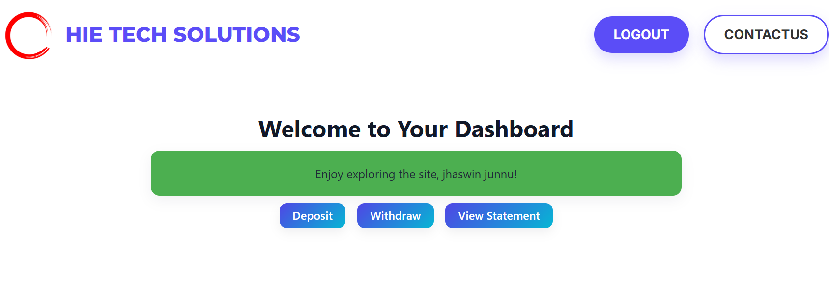
3. Contact Us Screen
- Form to input customer complaint details
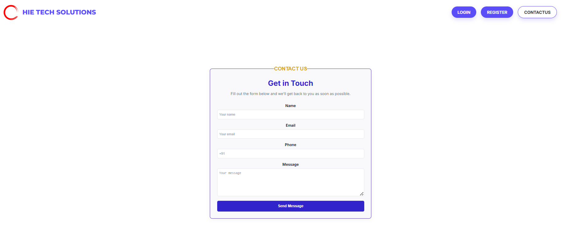
5. Register Screen
- Form to create new accounts
- Assigns unique account number automatically
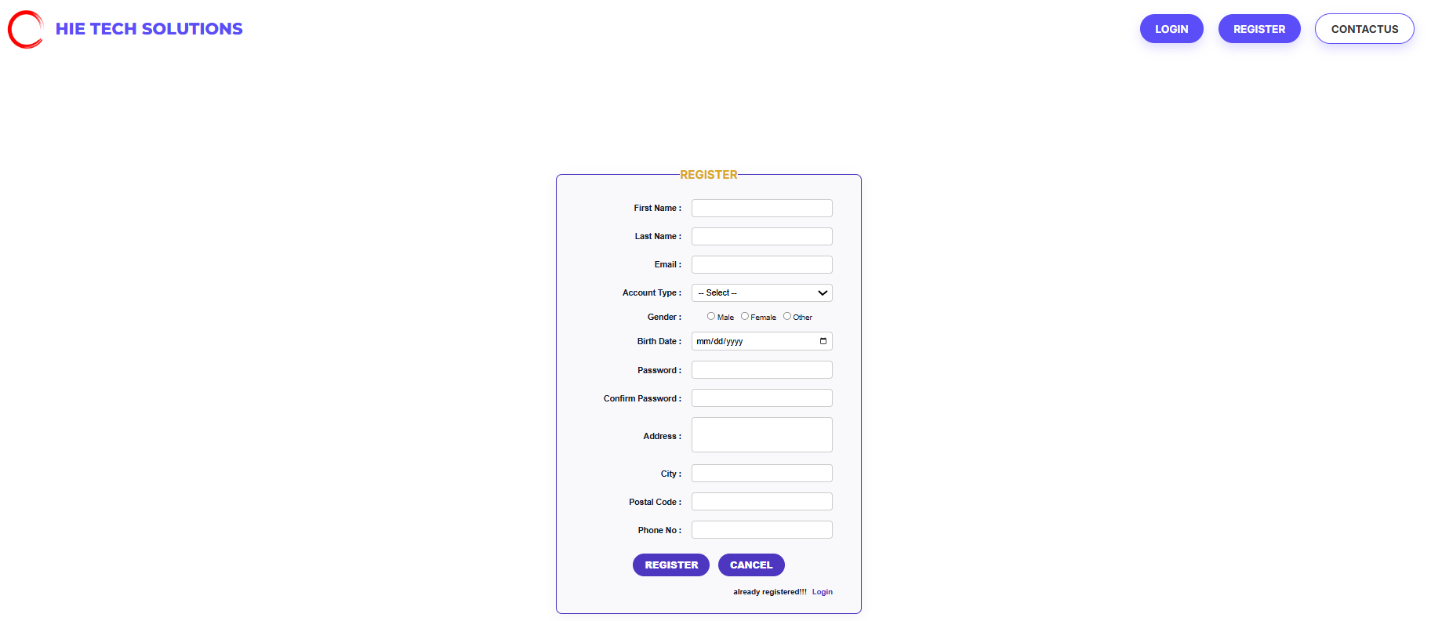

6. Transaction Screens
- Deposit form
- Withdrawal form
- Transfer funds interface
- Displays updated balance
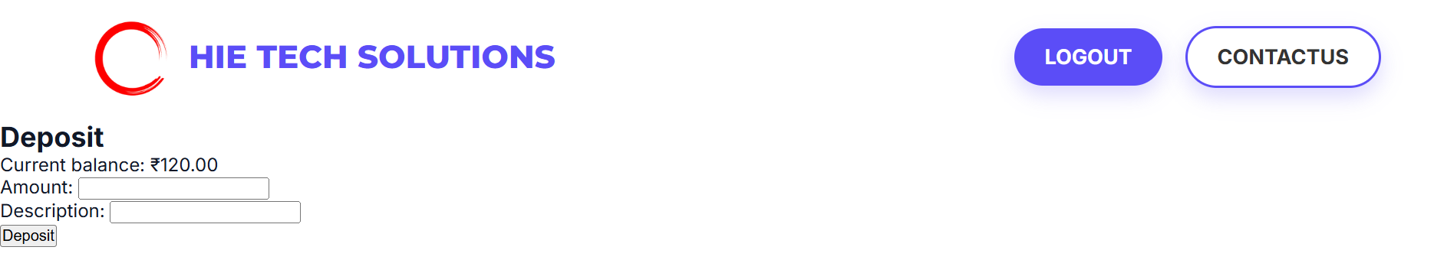
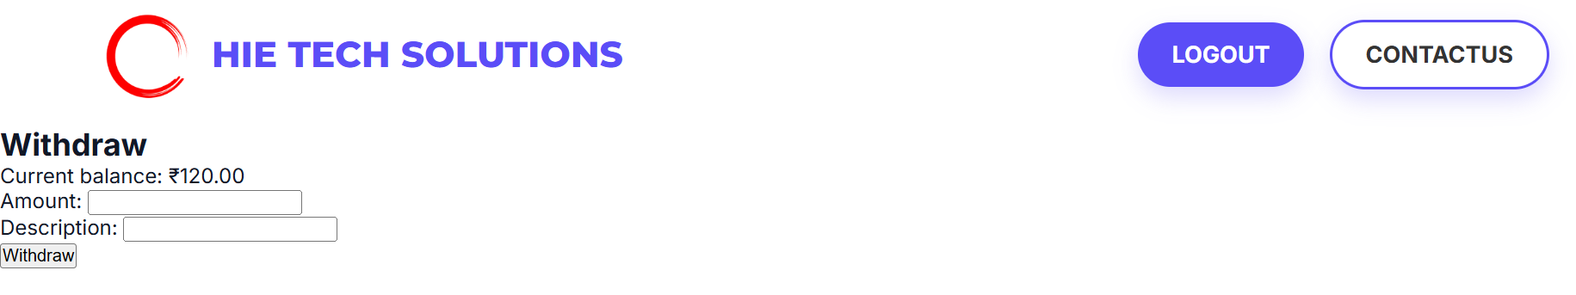
8. Statement Screen
- List of all financial operations
- Includes date, time, amount, and type of transaction
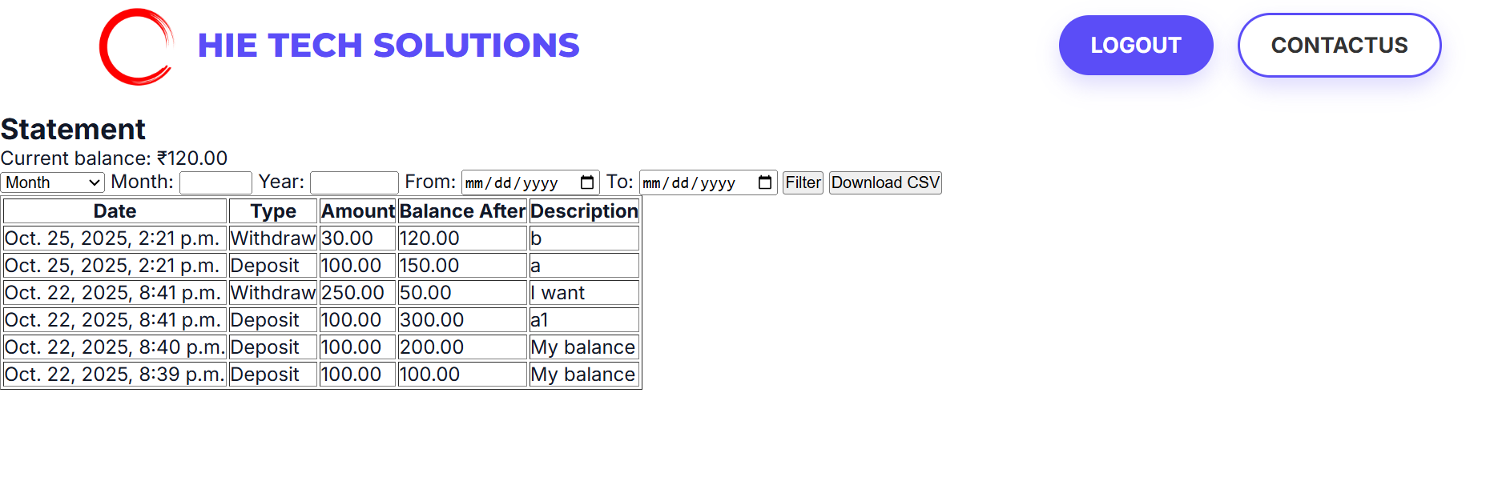

7. METHODOLOGY
ECC – Error Checking and Correction
Methodology describes the approach used in developing the system to ensure accuracy, reliability, and smooth functioning. In the Bank Management System, the ECC (Error Checking and Correction) methodology plays an essential role in validating user inputs, preventing system failures, and maintaining data integrity. Since banking operations handle sensitive information and financial transactions, implementing strong error-checking mechanisms is crucial.
ECC ensures that incorrect or incomplete information is detected before processing, and appropriate correction steps are applied to avoid data corruption, financial miscalculations, or system errors.

7.1 Purpose of ECC in the System
ECC is used to:
- Identify invalid user inputs
- Prevent inaccurate data from being stored in the database
- Ensure safe and error-free transactions
- Maintain consistency in customer, account, and transaction records
- Protect the system from accidental or malicious incorrect entries
- Improve system reliability

7.2 Error Checking Techniques Used
The Bank Management System uses several error-checking techniques:
1. Input Validation
Ensures that all user inputs are correct before processing.
Examples:
- Valid account number
- Valid customer ID
- Amount must be positive
- Sufficient balance before withdrawal
- Correct username & password
2. Data Type Validation
Ensures data types match expected formats.
Examples:
- Numeric values for amount
- String values for customer name
- Valid email format
3. Exception Handling
Python and Django’s exception-handling blocks prevent the system from crashing.
Examples:
- Incorrect SQL queries
- Missing fields
- Page not found errors
- Division or arithmetic errors
4. Duplicate Entry Checking
System checks for:
- Duplicate customer entries
- Duplicate account numbers
- Repeated transactions
5. Database Constraints
MySQL constraints ensure:
- Primary keys are unique
- Foreign keys maintain relationships
- Null values are restricted

7.3 Error Correction Techniques Used
Once an error is detected, the system applies correction techniques:
1. Displaying Error Messages
Clear and user-friendly messages guide the user on how to fix mistakes.
Examples:
- “Invalid account number”
- “Insufficient balance”
- “Please enter a valid email address”
2. Highlighting Incorrect Fields
HTML/CSS highlights the fields to be corrected.
3. Re-prompting the User
The system keeps the user on the same form and asks for correction.
4. Auto-correction Where Possible
Some fields can be auto-corrected:
- Trimming whitespace
- Auto-formatting phone numbers
- Auto-generating account numbers
5. Logging Errors
All critical errors are stored in log files for debugging and system improvement.

7.4 Importance of ECC in Banking Applications
Using ECC in Bank Management Systems is vital because:
- Banking data must always be error-free
- Financial calculations must be accurate
- Protects system from invalid operations
- Ensures security and data integrity
- Prevents financial losses
- Improves customer trust

8. SYSTEM STUDY AND TESTING
System study and testing ensure that the developed Bank Management System is feasible, reliable, efficient, and error-free. This chapter explains the feasibility of the project in terms of technical, operational, and economic aspects, along with various testing techniques and sample test cases used to validate the system.

8.1 Feasibility Study
A feasibility study evaluates the practicality and viability of the Bank Management System before implementation. It helps determine whether the system can be developed with the available resources and will function effectively.

1. Technical Feasibility
Technical feasibility determines whether the required technology, tools, and skills are available.
Findings:
- The project uses Python, Django, MySQL, HTML, and CSS, which are easily available and widely supported.
- Hardware requirements such as a basic computer with 4GB RAM are sufficient.
- Tools used include VS Code/PyCharm, MySQL Workbench, and GitHub, all of which are free and reliable.
- The development team possesses adequate knowledge of the technologies.
Conclusion:
The project is technically feasible.

2. Operational Feasibility
Operational feasibility checks if the system will operate smoothly in the user environment.
Findings:
- The system has a user-friendly interface for admin users.
- Data entry forms are simple, reducing input errors.
- Processes like account management and transactions are fully automated.
- Reduces workload and improves efficiency for banking staff.
- Requires minimal training.
Conclusion:
The system is operationally feasible because it improves accuracy, speed, and efficiency.

3. Economic Feasibility
Economic feasibility determines whether the project is cost-effective.
Findings:
- All technologies used are open-source and free.
- Low maintenance cost.
- Reduces time spent on manual banking operations.
- Eliminates paper-based systems, saving operational cost.
Conclusion:
The system is economically feasible because the development and maintenance costs are low.

4. Schedule Feasibility
Schedule feasibility evaluates whether the project can be completed within the given time frame.
Findings:
- Project modules were divided into manageable tasks.
- Development followed a proper plan including design, coding, testing, and deployment.
- Work was completed within typical industrial training duration.
Conclusion:
The system is schedule feasible.

8.2 Types of Test & Test Cases
Testing ensures that the Bank Management System is free from defects and works according to requirements. Several types of tests were performed to validate the system.

Types of Testing Used

1. Unit Testing
- Testing individual functions or components.
- Example: Testing deposit and withdrawal functions.
2. Integration Testing
- Ensures modules like Customer, Account, and Transactions work together smoothly.
3. Functional Testing
- Verifies whether the system performs expected operations.
- Example: Adding a customer or processing a transaction.
4. Validation Testing
- Ensures all inputs and outputs are correct.
- Example: Invalid email or negative amount validation.
5. User Interface (UI) Testing
- Checks forms, buttons, and navigation flow.
6. Database Testing
- Ensures data is stored, updated, and retrieved correctly.
- Tests foreign keys, primary keys, constraints.
7. Security Testing
- Checks login authentication and unauthorized access prevention.

Sample Test Cases
Below are example test cases for critical banking operations:

Test Case 1: Admin Login
Test Case ID | TC001
Test Case Name | Admin Login Validation
Input | Username, Password
Expected Output | Successful login if credentials correct
Actual Output | As expected
Status | Passed

Test Case 2: Add Customer
Test Case ID | TC002
Input | Customer name, contact, email
Expected Output | Customer record saved successfully
Actual Output | As expected
Status | Passed

Test Case 3: Create Account
Test Case ID | TC003
Input | Customer ID, account type, deposit amount
Expected Output | Account created with unique account number
Actual Output | As expected
Status | Passed

Test Case 4: Deposit Amount
Test Case ID | TC004
Input | Account number, deposit amount
Expected Output | Updated account balance
Actual Output | As expected
Status | Passed

Test Case 5: Withdraw Amount (Insufficient Funds)
Test Case ID | TC005
Input | Account number, withdrawal amount > balance
Expected Output | Error: “Insufficient balance”
Actual Output | As expected
Status | Passed

9. CONCLUSION
The Bank Management System developed using Python, Django, MySQL, HTML, and CSS successfully automates essential banking operations such as customer management, account handling, and transaction processing. The system provides a secure, efficient, and user-friendly platform that reduces manual workloads and minimizes human errors.
Through the implementation of various modules—such as admin authentication, account management, and transaction handling—the system ensures fast processing, easy data retrieval, and accurate record maintenance. The use of validation techniques and ECC (Error Checking and Correction) further enhances reliability and security.
This project strengthened the understanding of full-stack web development concepts, database integration, and software engineering methodologies. The system meets its objectives and serves as a reliable prototype for small or medium-scale banking operations.

10. FUTURE ENHANCEMENT
Although the current system meets the basic requirements of a banking management application, there is significant scope for further enhancement:
1. Customer Login Portal
Provide customers secure access to:
- View account balance
- Check transaction history
- Download statements
2. Online Banking Features
Add functionalities like:
- Online fund transfers
- Bill payments
- Mobile banking
3. ATM Simulation Module
Enable:
- ATM card authentication
- PIN-based login
- Instant withdrawal/deposit simulation
4. Integration with UPI/Payment Gateways
Enable digital payment features for real-time banking.
5. SMS/Email Notification System
Send automated alerts for:
- Deposits
- Withdrawals
- Low balance
- Account updates
6. Improved Security Measures
Enhance authentication through:
- Two-factor authentication (2FA)
- OTP verification
- Encryption of sensitive data
7. AI-Based Fraud Detection
Analyze suspicious transactions and notify the admin automatically.
8. Cloud Deployment
Allow high availability, scalability, and remote access.
These enhancements can make the system more robust, scalable, and suitable for commercial use.

11. REFERENCES
Below are the recommended references used during the development and documentation of the Bank Management System:
- Python Official Documentation
https://docs.python.org
- Django Web Framework Documentation
https://docs.djangoproject.com
- MySQL Reference Manual
https://dev.mysql.com/doc
- HTML & CSS Tutorials – W3Schools
https://www.w3schools.com
- Git & GitHub Documentation
https://docs.github.com

