ADITYA DIPLOMA COLLEGE
DEPARTMENT OF COMPUTER SCIENCE AND ENGINEERING
PROJECT REPORT
ON
STUDENT ATTENDANCE MANAGEMENT SYSTEM
Submitted by
A VINESH
Roll No.: 123456
Under the Guidance of
J V RAMA KRISHNA RAO
Submitted to
ADIKAVI NANNAYA UNIVERSITY
Academic Year 2026–2027

CERTIFICATE
This is to certify that A VINESH, bearing Roll No. 123456, a student of the Department of Computer Science and Engineering, Aditya Diploma College, has successfully completed the project entitled “STUDENT ATTENDANCE MANAGEMENT SYSTEM” during the academic year 2026–2027.
The project has been carried out under the guidance and supervision of J V RAMA KRISHNA RAO and is submitted to Adikavi Nannaya University in partial fulfillment of the requirements of the course.
The work presented in this project report is a record of the project work carried out by the student during the academic year 2026–2027.
Project Guide
J V RAMA KRISHNA RAO
Signature: __________________
Head of the Department
Department of Computer Science and Engineering
Signature: __________________
Principal
Aditya Diploma College
Signature: __________________
Date: __________________
Place: __________________

DECLARATION
I, A VINESH, bearing Roll No. 123456, student of the Department of Computer Science and Engineering, Aditya Diploma College, hereby declare that the project entitled “STUDENT ATTENDANCE MANAGEMENT SYSTEM” is my original project work carried out during the academic year 2026–2027 under the guidance of J V RAMA KRISHNA RAO.
I further declare that this project report has been prepared for academic purposes and that the work presented in this report has not been submitted previously, in whole or in part, for the award of any other degree, diploma, or academic qualification.
All sources of information and technologies used in the development of the project have been appropriately acknowledged in the report.
Name: A VINESH
Roll No.: 123456
Department: Computer Science and Engineering
Signature: __________________
Date: __________________
Place: __________________

ACKNOWLEDGEMENT
I would like to express my sincere gratitude to everyone who supported and guided me in successfully completing the project entitled “STUDENT ATTENDANCE MANAGEMENT SYSTEM.”
First, I express my sincere thanks to the management and principal of Aditya Diploma College for providing the necessary facilities and academic environment required to complete this project.
I am deeply grateful to my project guide, J V RAMA KRISHNA RAO, for valuable guidance, continuous encouragement, constructive suggestions, and support throughout the development of this project.
I would also like to thank the faculty members of the Department of Computer Science and Engineering for their valuable assistance and encouragement during the project.
I am thankful to Adikavi Nannaya University for providing the academic framework and opportunity to undertake this project as part of my course.
Finally, I express my heartfelt gratitude to my family, friends, and everyone who directly or indirectly supported me during the development and completion of this project.
A VINESH

ABSTRACT
The Student Attendance Management System is a web-based application developed using Python and Django to provide a secure and efficient method for managing student attendance. The system uses DeepFace-based facial verification to authenticate students during attendance submission and reduces the dependency on traditional manual attendance methods.
The application allows students to register by providing their personal details and a face image. Newly registered student accounts remain pending until they are approved by the Superadmin. After approval, students can log in and submit attendance through the system. During attendance submission, the student’s camera captures a face image, which is compared with the registered face image using the DeepFace facial verification library. TensorFlow is used as the underlying machine-learning framework, while OpenCV supports the image and camera processing workflow.
When the captured face is successfully verified, the system creates an attendance record with the current attendance date and assigns it a PENDING status. An Admin or Superadmin can review the attendance request and either approve or reject it. Once an attendance record is approved, the system updates its status to APPROVED and sends an email notification to the student. Students can log in to view their attendance history and the current status of their attendance records.
The system is implemented using Django for backend development, HTML, CSS, JavaScript, and Bootstrap for the frontend, and MySQL for database management. Additional technologies include TensorFlow, OpenCV, Python mysqlclient, Django Authentication, SMTP, Git, GitHub, WhiteNoise, and Gunicorn.
The proposed system provides a structured approach to student attendance management by combining web-based authentication, facial verification, role-based access control, attendance approval, and email notifications in a single application.

CHAPTER 1
INTRODUCTION
1.1 Background
Attendance management is an important activity in educational institutions because regular attendance records help institutions monitor student participation and maintain academic records. Traditional attendance methods commonly depend on manual registers or conventional digital entry systems. These approaches may require considerable time, involve repetitive work, and can make attendance management more difficult when records have to be reviewed or maintained over a long period.
The development of web technologies and facial verification techniques provides an opportunity to improve the process of attendance management. A web-based attendance application can centralize student information, authentication, attendance records, approval activities, and notifications within a single system.
The Student Attendance Management System is developed as a Django-based web application that uses DeepFace for facial verification during attendance submission. Students register their details and provide a face image. After approval by the Superadmin, a student can log in and submit attendance. The system captures a face image through the camera and compares it with the registered face image using DeepFace. When verification is successful, an attendance record is created with a PENDING status for administrative review.
The system also provides role-based access for Students, Admins, and Superadmins. Admins and Superadmins can review attendance requests and approve or reject them. Approved attendance records are stored in the database and an email notification is sent to the student. Students can view their attendance history and the status of their attendance records.
1.2 Problem Statement
Managing student attendance manually can be time-consuming and may require significant administrative effort. Maintaining physical attendance registers, verifying student identity, updating records, and communicating attendance status can make the overall process less efficient.
A system is therefore required to provide a centralized and structured method for student registration, identity verification, attendance submission, attendance approval, record management, and notification. The system should also provide appropriate access control so that students can manage their own attendance activities while authorized administrators can review and manage attendance records.
The Student Attendance Management System addresses these requirements by combining Django web application functionality with DeepFace-based facial verification, MySQL database management, role-based authentication, attendance approval, and email notification.
1.3 Motivation
The main motivation for developing the Student Attendance Management System is to provide a convenient and organized approach to attendance management. Facial verification can be used as an additional identity verification mechanism during attendance submission, helping the system compare the student's current captured face with the face image registered in the student's profile.
Another motivation is to provide a workflow in which attendance is not immediately finalized without administrative review. The system creates a PENDING attendance record after successful face verification, allowing an Admin or Superadmin to approve or reject the request. This provides a clear status-based workflow for attendance records.
The web-based design also allows student information, attendance records, approval activities, and notifications to be managed through a common application instead of relying on separate manual processes.
1.4 Objectives
The main objectives of the Student Attendance Management System are:
1. To develop a web-based student attendance management application using Python and Django.
2. To provide student registration with personal information and a registered face image.
3. To implement student account approval through the Superadmin.
4. To use DeepFace-based facial verification during attendance submission.
5. To capture the student's face through a camera and compare it with the registered face image.
6. To create an attendance record after successful face verification.
7. To maintain attendance records using PENDING, APPROVED, and REJECTED statuses.
8. To provide Admin and Superadmin functionality for reviewing attendance requests.
9. To send email notifications to students when attendance is approved.
10. To allow students to view their attendance history and attendance status.
11. To maintain application data using a MySQL database.
12. To provide role-based access for Student, Admin, and Superadmin users.
1.5 Scope of the Project
The scope of the Student Attendance Management System covers student registration, face image registration, student account approval, authentication, camera-based face verification, attendance submission, attendance approval and rejection, attendance history, user profile management, and email notification.
The system is designed to support three primary roles: Student, Admin, and Superadmin. Students can register, log in, submit attendance after successful facial verification, view attendance history, and view their profile. Admins can review attendance requests and perform attendance approval or rejection. Superadmins can manage student approvals and attendance approvals.
The facial verification component uses one registered face image for each student. During attendance submission, the system compares the captured face image with the student's registered image. The current implementation is designed for one student face at a time.
The project currently focuses on attendance management and does not include face-training or face-encoding functionality, Excel/CSV attendance export, or multiple class/subject management.
1.6 Significance of the Project
The Student Attendance Management System provides a centralized platform for managing attendance-related activities. It brings student registration, identity verification, attendance submission, administrative review, attendance history, and email notification together in one web application.
The use of DeepFace for facial verification provides a mechanism for comparing a student's captured face with the registered face image during attendance submission. The status-based attendance workflow provides a clear distinction between submitted, approved, and rejected attendance records.
The system also demonstrates the integration of several technologies in a practical web application. Django provides the application framework and authentication functionality, MySQL provides persistent data storage, HTML, CSS, JavaScript, and Bootstrap support the user interface, and SMTP is used for email communication. TensorFlow and OpenCV support the facial verification and image-processing workflow.

CHAPTER 2
EXISTING AND PROPOSED SYSTEM
2.1 Existing System
In a conventional student attendance process, attendance is commonly recorded manually using paper registers or basic digital entry systems. In a manual process, the faculty member or authorized person records the presence of students and maintains the attendance information for future reference.
Manual attendance management requires regular data entry and record maintenance. When attendance information has to be reviewed, corrected, or communicated to students, additional administrative effort may be required. The process may also involve separate activities for maintaining student information and attendance records.
Traditional systems may not provide an integrated mechanism for verifying the identity of a student at the time of attendance submission. They may also lack a structured workflow for submitting attendance for administrative review, approving or rejecting attendance, and automatically notifying students about the result.
2.2 Limitations of Existing System
• Manual attendance recording can require considerable time, especially when attendance has to be maintained for many students.
• Maintaining physical attendance registers requires continuous record management and storage.
• Manual data entry can result in incorrect or incomplete attendance records.
• Traditional attendance processes may not provide an integrated face-based identity verification mechanism.
• Student registration, attendance recording, approval, and notification may be handled as separate activities.
• Attendance review and approval may require additional communication between students and administrators.
• Students may not have a centralized interface for viewing attendance history and attendance status.
• Manual notification of attendance decisions can increase administrative effort.
2.3 Proposed System
The proposed Student Attendance Management System is a web-based application developed using Python and Django. The system integrates student registration, face image registration, user authentication, camera-based facial verification, attendance management, administrative approval, attendance history, and email notification.
A student first creates an account by entering the required registration details and providing a face image. The newly registered account remains pending until it is approved by the Superadmin. After approval, the student can log in to the application.
During attendance submission, the system accesses the student's camera and captures a face image. The captured image is compared with the student's registered face image using the DeepFace facial verification library. TensorFlow is used as the underlying machine-learning framework, and OpenCV supports the image and camera processing workflow.
If the face is successfully verified, the system creates an attendance record with the attendance date and a PENDING status. An Admin or Superadmin can review the pending attendance request and either approve or reject it. When attendance is approved, the system updates the record to APPROVED and sends an email notification to the student. If the attendance is rejected, the status is updated to REJECTED.
Students can access their attendance history and view the current status of their attendance records. The system uses MySQL for persistent storage and Django Authentication for user authentication and access control.
2.4 Advantages of the Proposed System
• Provides a centralized web-based platform for attendance management.
• Uses DeepFace-based facial verification during attendance submission.
• Maintains student information and attendance records in a MySQL database.
• Provides role-based access for Student, Admin, and Superadmin users.
• Supports student account approval before attendance submission.
• Creates a PENDING attendance record after successful face verification.
• Allows Admin and Superadmin users to approve or reject attendance requests.
• Maintains APPROVED and REJECTED attendance statuses.
• Provides students with access to their attendance history.
• Sends email notifications when attendance is approved.
• Reduces the need for separate manual attendance and notification processes.
• Provides a structured workflow for attendance submission and administrative review.
2.5 System Features
The major features of the Student Attendance Management System are described below.
2.5.1 Student Registration
The system allows a student to create an account by entering the required personal and login information and providing a face image. The registered account remains pending until it is approved by the Superadmin.
2.5.2 Face Image Registration
A registered student provides one face image that is stored with the student's profile. This image is used as the reference image during attendance face verification.
2.5.3 Student Approval
The Superadmin can review newly registered student accounts and approve them. Only an approved student account can proceed to use the attendance functionality.
2.5.4 User Authentication
The application uses Django Authentication to provide login and access control. User roles distinguish the functions available to Students, Admins, and Superadmins.
2.5.5 Camera-Based Face Verification
During attendance submission, the system captures the student's face using the camera. The captured image is compared with the registered face image using DeepFace. The current workflow is designed for one student face at a time.
2.5.6 Attendance Submission
After successful face verification, the system creates an attendance record for the student and stores the attendance date. The initial attendance status is set to PENDING.
2.5.7 Attendance Approval and Rejection
Admins and Superadmins can review pending attendance requests. An attendance request can be approved or rejected. Approved records receive an APPROVED status, while rejected records receive a REJECTED status.
2.5.8 Email Notification
When attendance is approved, the system sends an email notification to the student using SMTP email functionality.
2.5.9 Attendance History
Students can view their attendance history and check the status of their attendance records through the application.
2.5.10 User Profile
The system provides a user profile area where students can view their registered account information and profile details.
2.5.11 Role-Based Access
The system provides different functions according to the user's role. SUPERADMIN can manage student approvals and attendance approvals; ADMIN can manage attendance approvals; STUDENT can register, log in, submit attendance, view attendance history, and view the profile.
2.6 Comparison of Existing and Proposed Systems
The following comparison summarizes the major differences between a conventional attendance process and the proposed Student Attendance Management System.
Parameter | Existing System | Proposed System
Attendance Entry | Manual or conventional digital entry | Web-based attendance submission with face verification
Identity Verification | Usually manual | DeepFace-based facial verification
Student Registration | Separate/manual process | Integrated student registration
Account Approval | May be manual or unavailable | Superadmin approval
Attendance Review | Manual or informal | Admin/Superadmin review
Attendance Status | Basic presence record | PENDING, APPROVED, REJECTED
Notification | Manual communication | Email notification
Attendance History | Manual records or separate system | Available through student account
Database | Registers or basic storage | MySQL database
Access Control | Limited or manual | Role-based Django authentication

CHAPTER 3
REQUIREMENTS ANALYSIS
3.1 Requirements Analysis
Requirements analysis identifies the functions, resources, technologies, and operating conditions required for the successful development and use of the Student Attendance Management System. The requirements of the proposed system are divided into functional requirements, non-functional requirements, hardware requirements, software requirements, and technology requirements.
3.2 Functional Requirements
Functional requirements describe the operations that the Student Attendance Management System must perform.
ID | Requirement | Description
FR-01 | Student Registration | The system shall allow a student to create an account by entering the required registration details and providing a face image.
FR-02 | Student Approval | The system shall allow the Superadmin to review and approve newly registered student accounts.
FR-03 | User Authentication | The system shall authenticate users through Django Authentication and provide access according to their assigned role.
FR-04 | Role-Based Access | The system shall provide different functions to Student, Admin, and Superadmin users.
FR-05 | Face Image Storage | The system shall store the registered face image with the student's profile.
FR-06 | Camera Capture | The system shall access the student's camera during attendance submission to capture a face image.
FR-07 | Face Verification | The system shall compare the captured face image with the student's registered face image using DeepFace.
FR-08 | Attendance Creation | The system shall create an attendance record after successful face verification.
FR-09 | Attendance Date | The system shall store the attendance date with the attendance record.
FR-10 | Pending Status | The system shall initially assign the PENDING status to a successfully submitted attendance record.
FR-11 | Attendance Approval | The system shall allow authorized Admin or Superadmin users to approve pending attendance requests.
FR-12 | Attendance Rejection | The system shall allow authorized Admin or Superadmin users to reject pending attendance requests.
FR-13 | Email Notification | The system shall send an email notification to the student when attendance is approved.
FR-14 | Attendance History | The system shall allow students to view their attendance records and statuses.
FR-15 | User Profile | The system shall allow students to view their profile information.
FR-16 | Database Management | The system shall store student and attendance information in the MySQL database.
3.3 Non-Functional Requirements
Requirement | Description
Performance | The system should process normal user requests and attendance submissions within a reasonable response time under the expected project workload.
Security | The system should protect user authentication information and restrict administrative functions to authorized roles.
Usability | The web interface should provide clear navigation and understandable forms for students and administrators.
Reliability | The system should maintain attendance and student information consistently in the database.
Maintainability | The application should be organized into manageable Django components so that future changes can be implemented efficiently.
Scalability | The system architecture should allow additional students and attendance records to be stored as the application grows.
Availability | The application should be accessible whenever the configured web server and supporting services are running.
Compatibility | The application should operate in a supported web browser environment on the configured Windows development system.
Privacy | Student profile and face-image information should be accessible only through authorized application functions.
Accuracy | Attendance should be created only after successful comparison of the captured face with the registered face image.
3.4 Hardware Requirements
The following hardware resources are required for development and operation of the system.
• A computer or laptop capable of running Python, Django, MySQL, and the required machine-learning and image-processing libraries.
• Web camera for capturing the student's face during attendance submission.
• Minimum 4 GB RAM; 8 GB or more is recommended for smoother operation of the development environment and face-verification libraries.
• Processor capable of running the Windows operating system, Python, TensorFlow, and OpenCV.
• Sufficient storage space for the application, database, dependencies, and registered face images.
• Internet or network connectivity when the application is deployed as a web service or when email services are used.
3.5 Software Requirements
Software/Technology | Purpose
Operating System | Windows
Programming Language | Python
Backend Framework | Django
Frontend | HTML, CSS, JavaScript, Bootstrap
Database | MySQL
Face Verification | DeepFace
Machine Learning Framework | TensorFlow
Image/Camera Processing | OpenCV
Database Connector | Python mysqlclient
Authentication | Django Authentication
Email Service | SMTP
Development Environment | Visual Studio Code
Version Control | Git and GitHub
Static File Support | WhiteNoise
Deployment Server | Gunicorn
3.6 Technology Stack
The Student Attendance Management System uses a combination of web-development, database, authentication, facial-verification, image-processing, and deployment technologies.
3.6.1 Python
Python is the primary programming language used to develop the application. It is used for Django application logic, database operations, authentication-related functionality, and integration with DeepFace and other libraries.
3.6.2 Django
Django is the backend web framework used to develop the application. It manages URL routing, views, models, templates, authentication, database interaction, and application-level functionality.
3.6.3 HTML, CSS, JavaScript and Bootstrap
HTML provides the structure of the web pages, CSS is used for presentation and styling, JavaScript provides client-side interaction and camera-related browser functionality, and Bootstrap supports responsive user-interface design.
3.6.4 MySQL
MySQL is used as the relational database management system. It stores user information, student profile information, attendance records, roles, approval information, and other application data managed by Django.
3.6.5 DeepFace
DeepFace is used for facial verification. During attendance submission, the captured face image is compared with the registered face image associated with the student. The result of this verification determines whether attendance submission can proceed.
3.6.6 TensorFlow
TensorFlow is used as the machine-learning framework supporting the facial-verification workflow through the DeepFace library.
3.6.7 OpenCV
OpenCV is used as part of the image and camera processing workflow. It supports operations required for handling captured face images.
3.6.8 Django Authentication
Django Authentication provides user login and authentication functionality. The application uses role-based access so that Student, Admin, and Superadmin users can access the functions assigned to them.
3.6.9 SMTP Email
SMTP is used for sending email notifications. When an attendance request is approved, the system sends a notification to the associated student.
3.6.10 Git and GitHub
Git is used for version control during development, while GitHub can be used to store and manage the project's source code repository.
3.6.11 WhiteNoise and Gunicorn
WhiteNoise supports static-file serving in deployment environments, while Gunicorn can be used as the application server for running the Django application in a deployment environment.
3.7 User Requirements
The system provides three primary user roles with different responsibilities.
• Student: Registers an account, provides a face image, logs in after approval, submits attendance through camera-based face verification, views attendance history, and views profile information.
• Admin: Logs into the system and reviews attendance requests, including approving or rejecting attendance according to the application's permissions.
• Superadmin: Manages student account approval and attendance approval or rejection and has administrative access to the relevant system functions.
3.8 System Constraints
• The current system uses one registered face image for each student.
• The attendance verification workflow is designed for one student face at a time.
• The system depends on camera access during attendance submission.
• Face verification depends on the successful operation of the DeepFace and supporting machine-learning environment.
• Email notification depends on the availability and correct configuration of the SMTP service.
• The current implementation does not include Excel or CSV attendance export.
• The current implementation does not provide multiple class or subject management.
• The current implementation does not use a separate face-training or face-encoding module.
3.9 Summary
The requirements analysis defines the functional and non-functional requirements, hardware and software resources, technology stack, user roles, and constraints of the Student Attendance Management System. These requirements provide the foundation for the system design and implementation described in the following chapters.

CHAPTER 4
SYSTEM DESIGN
4.1 System Design
System design defines the structure, components, interactions, data flow, and database relationships of the Student Attendance Management System. The design is based on a Django web application connected to a MySQL database and integrated with DeepFace for facial verification, OpenCV for image and camera processing, and SMTP for email notification.
4.2 System Architecture
The system follows a web-based architecture in which students and administrators interact with the Django application through a web browser. The Django application manages authentication, business logic, attendance processing, database operations, and communication with external services. MySQL stores application data, DeepFace performs face verification, OpenCV supports image processing, and SMTP is used for email notification.
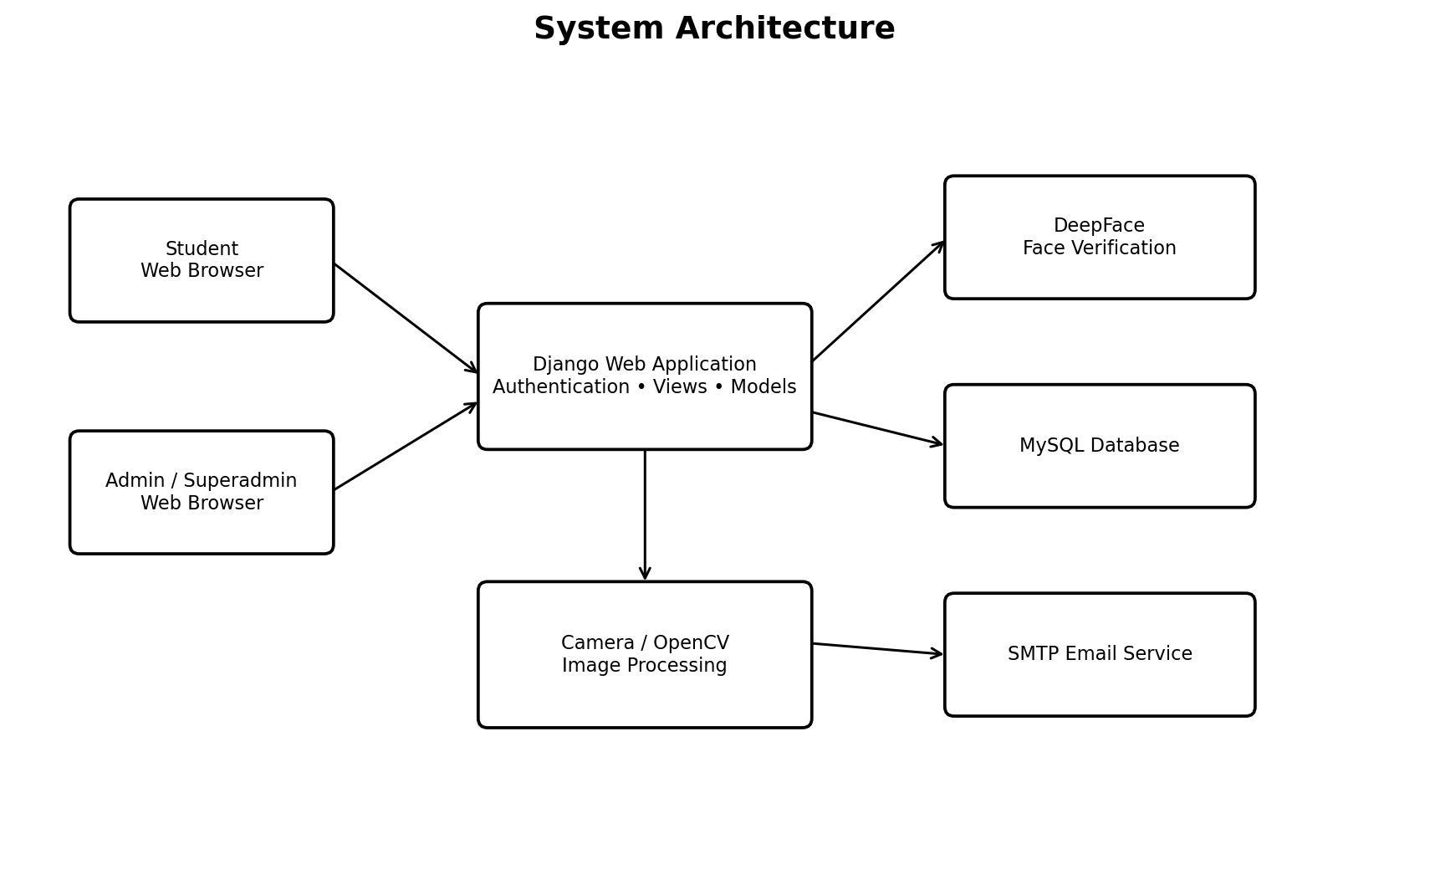
Figure 4.1. System Architecture
4.3 Overall System Workflow
The overall workflow begins with student registration and face-image registration. The Superadmin approves the student account. After login, the student submits attendance through the camera. The captured face is verified against the registered face image using DeepFace. If verification is successful, the attendance record is created with PENDING status. An Admin or Superadmin reviews the request and changes the status to APPROVED or REJECTED. An approval generates an email notification to the student.
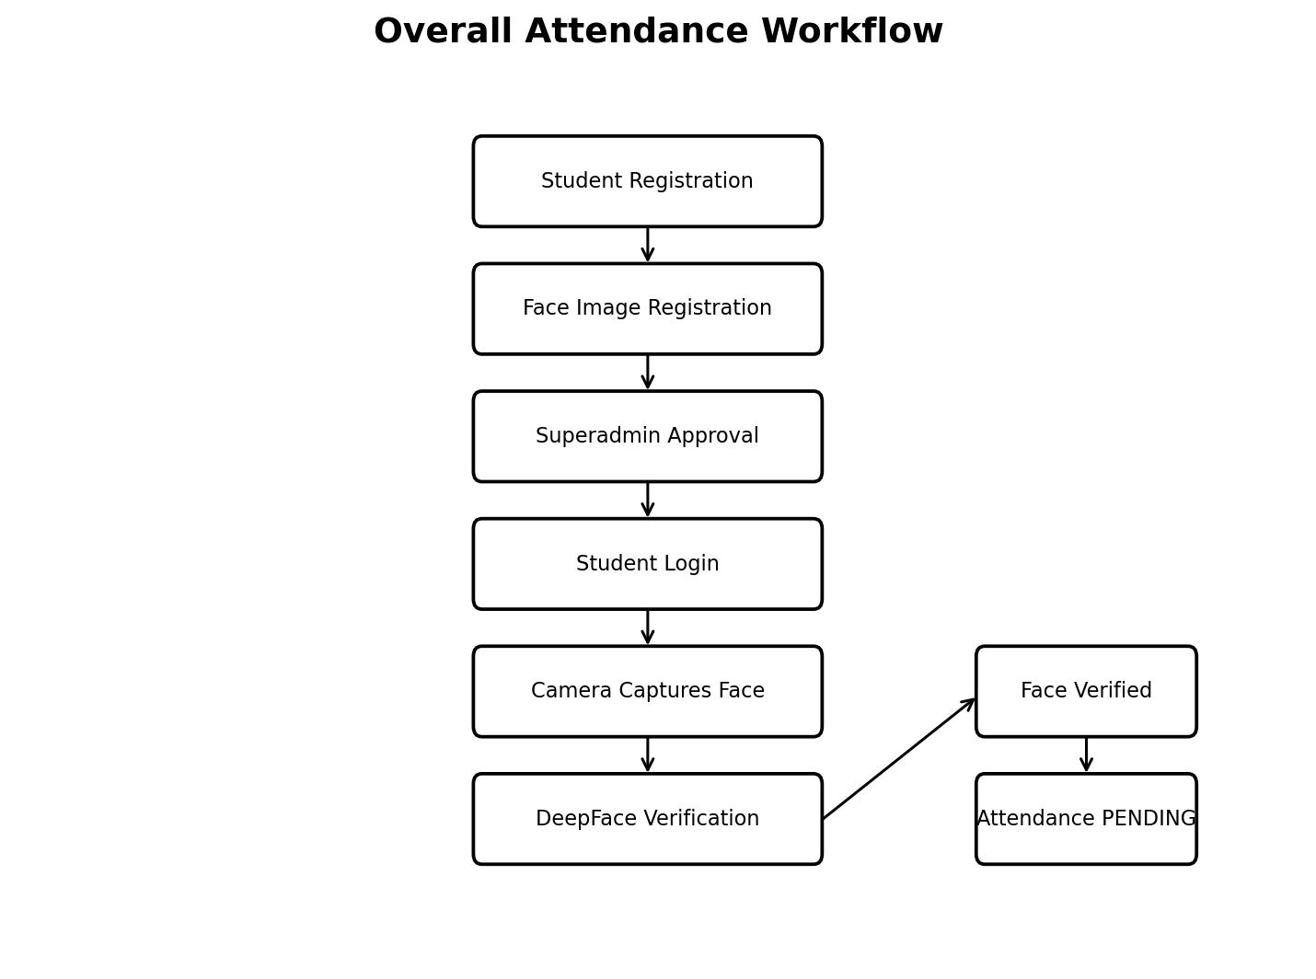
Figure 4.2. Overall Attendance Workflow
4.4 User Roles
The system contains three primary user roles. Each role has specific permissions and responsibilities.
Role | Responsibilities
STUDENT | Register account, provide face image, log in after approval, submit attendance, view attendance history, and view profile.
ADMIN | Log in and review attendance requests; approve or reject attendance according to assigned permissions.
SUPERADMIN | Approve student registrations and review, approve, or reject attendance requests.
4.5 Use Case Diagram
The use case diagram represents the interactions between the three system roles and the major functions provided by the application.
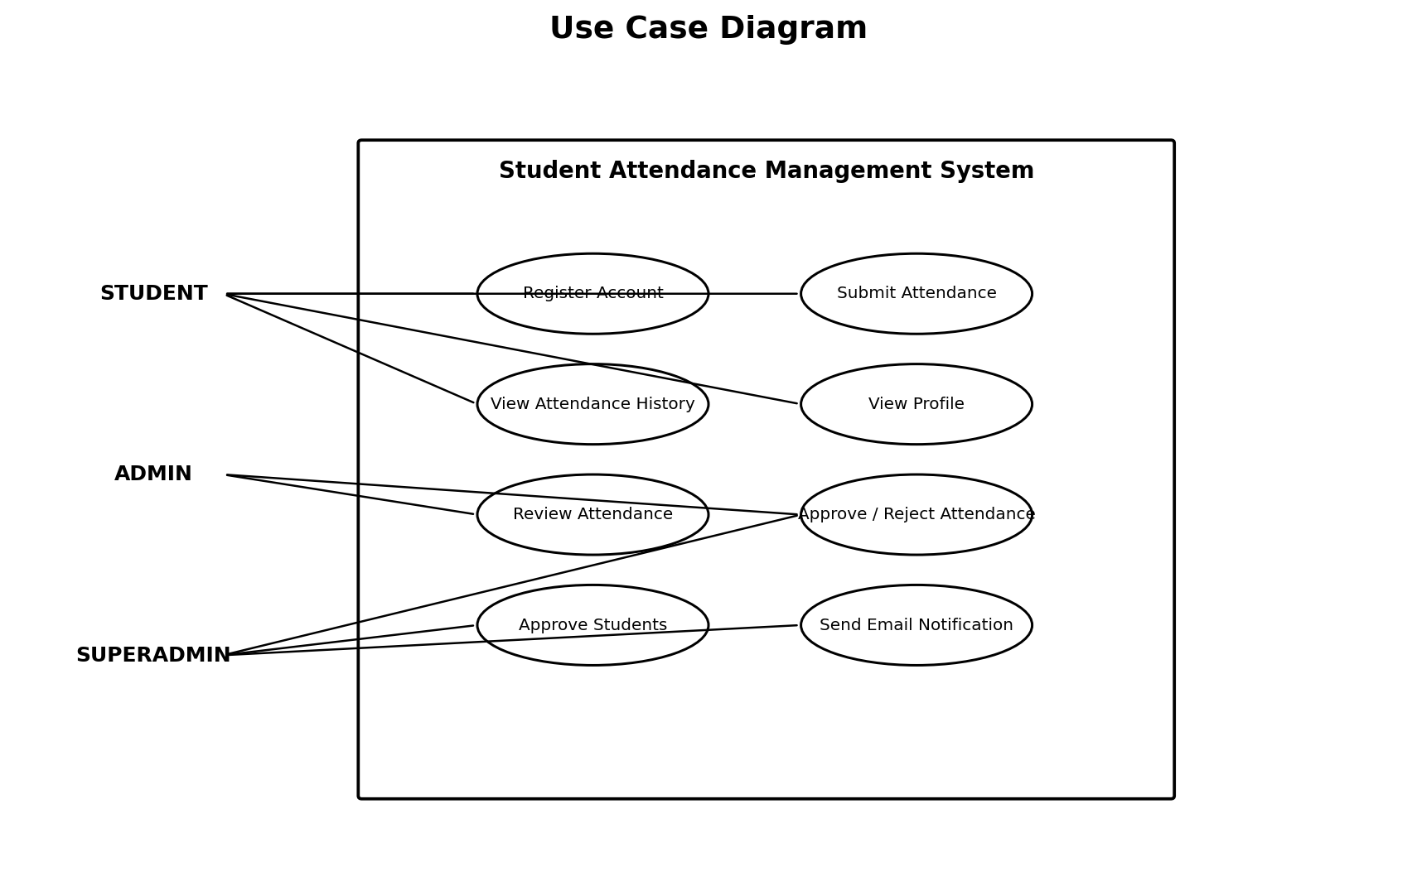
Figure 4.3. Use Case Diagram
4.6 Data Flow Diagram
The data flow diagram shows the movement of student registration information, attendance information, approval information, database operations, and email notification between external users and the Student Attendance Management System.
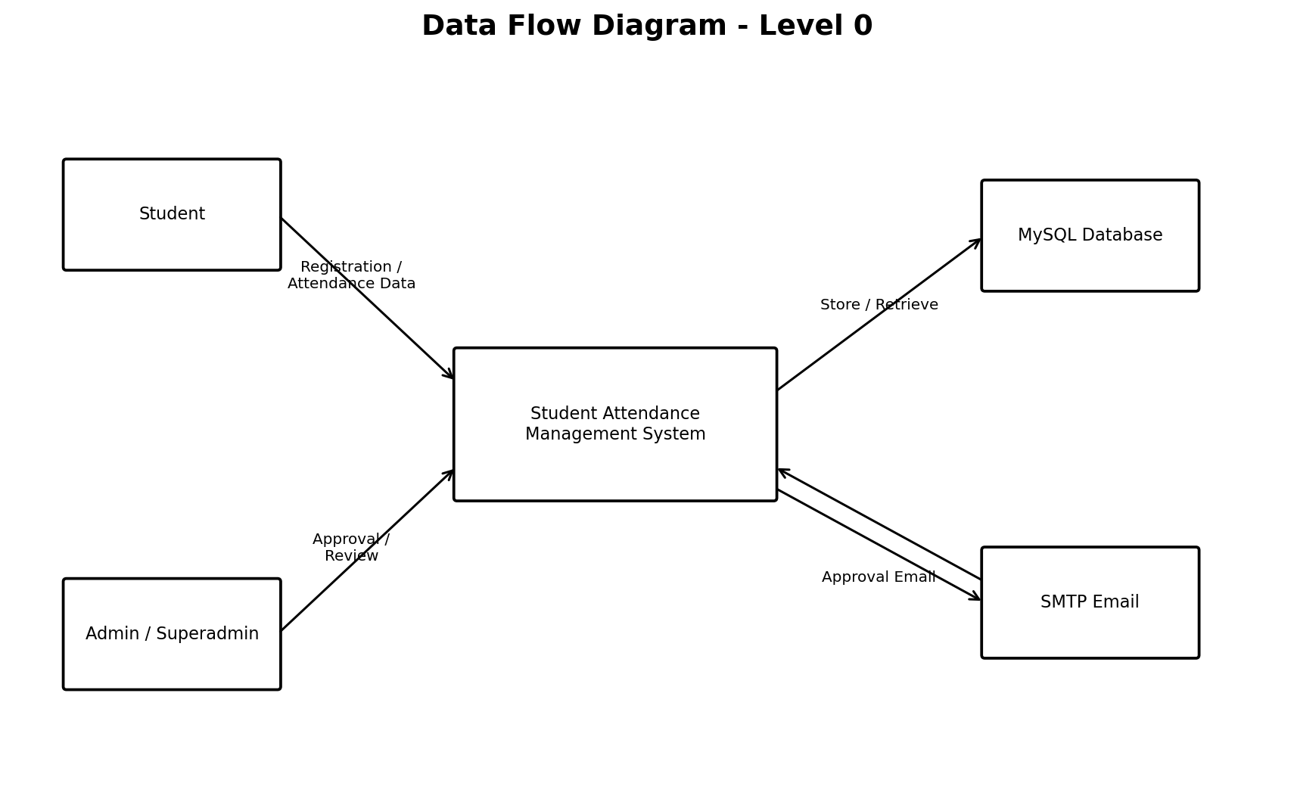
Figure 4.4. Data Flow Diagram - Level 0
4.7 Activity Diagram
The activity diagram describes the sequence of activities performed when a student submits attendance. The process includes login, opening the attendance page, capturing the face, DeepFace verification, creation of a pending attendance record, and administrative review.
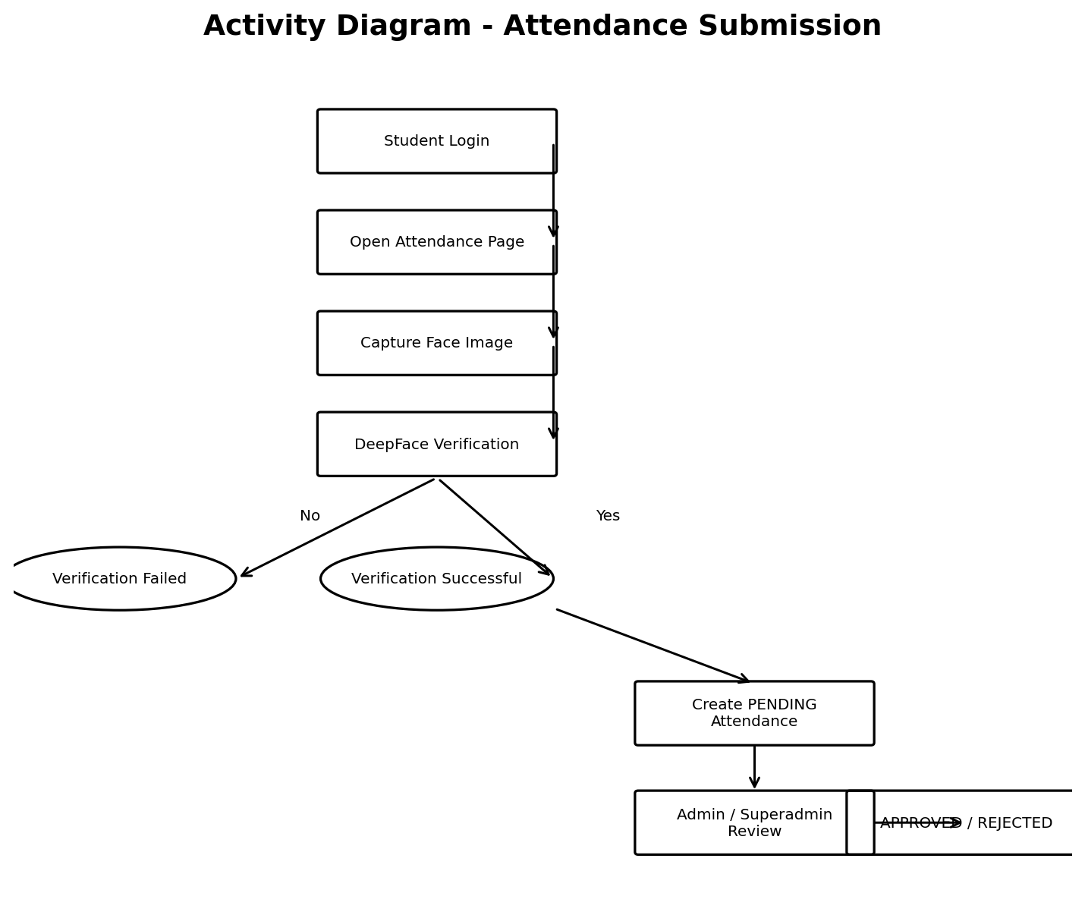
Figure 4.5. Activity Diagram - Attendance Submission
4.8 Sequence Diagram
The sequence diagram describes the interaction between the student, browser, Django application, DeepFace verification component, MySQL database, and administrator during attendance submission and review.
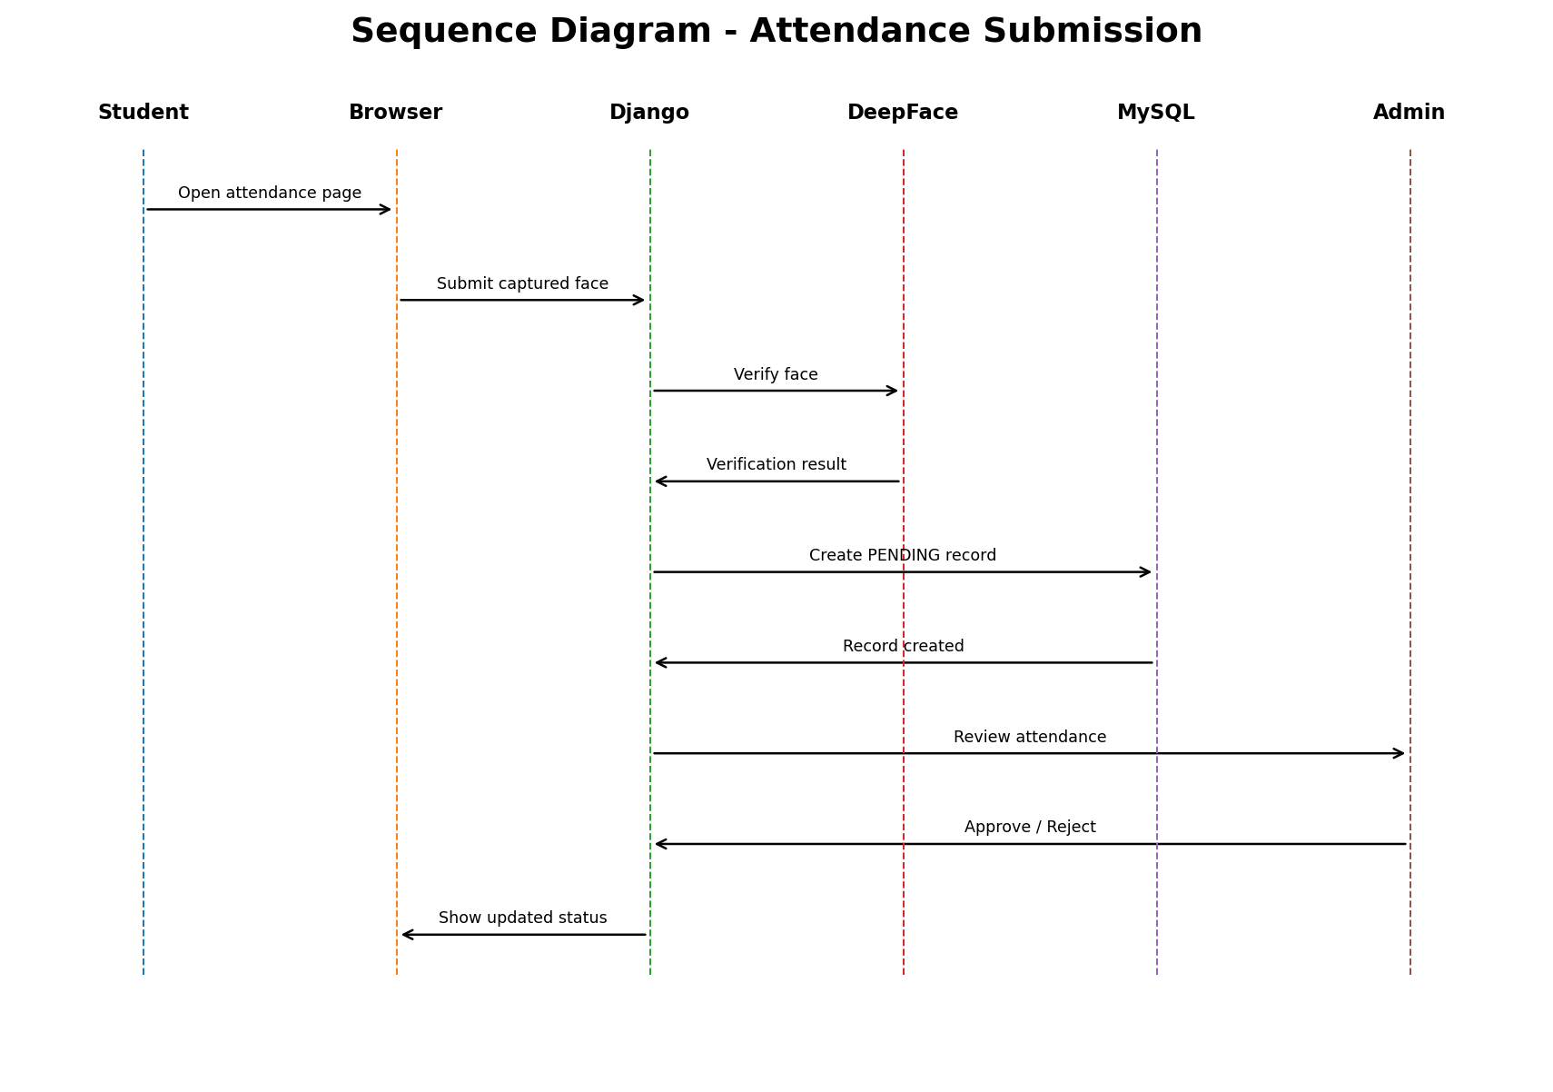
Figure 4.6. Sequence Diagram - Attendance Submission
4.9 Database Design
The system uses MySQL as its relational database. The main application data is represented through the User/Student and Attendance entities. The User/Student entity stores account and profile information including role, approval status, and face image. The Attendance entity stores the student reference, attendance date, and attendance status.
One student can have multiple attendance records. Therefore, the relationship between the User/Student entity and the Attendance entity is one-to-many. Each attendance record belongs to one student.
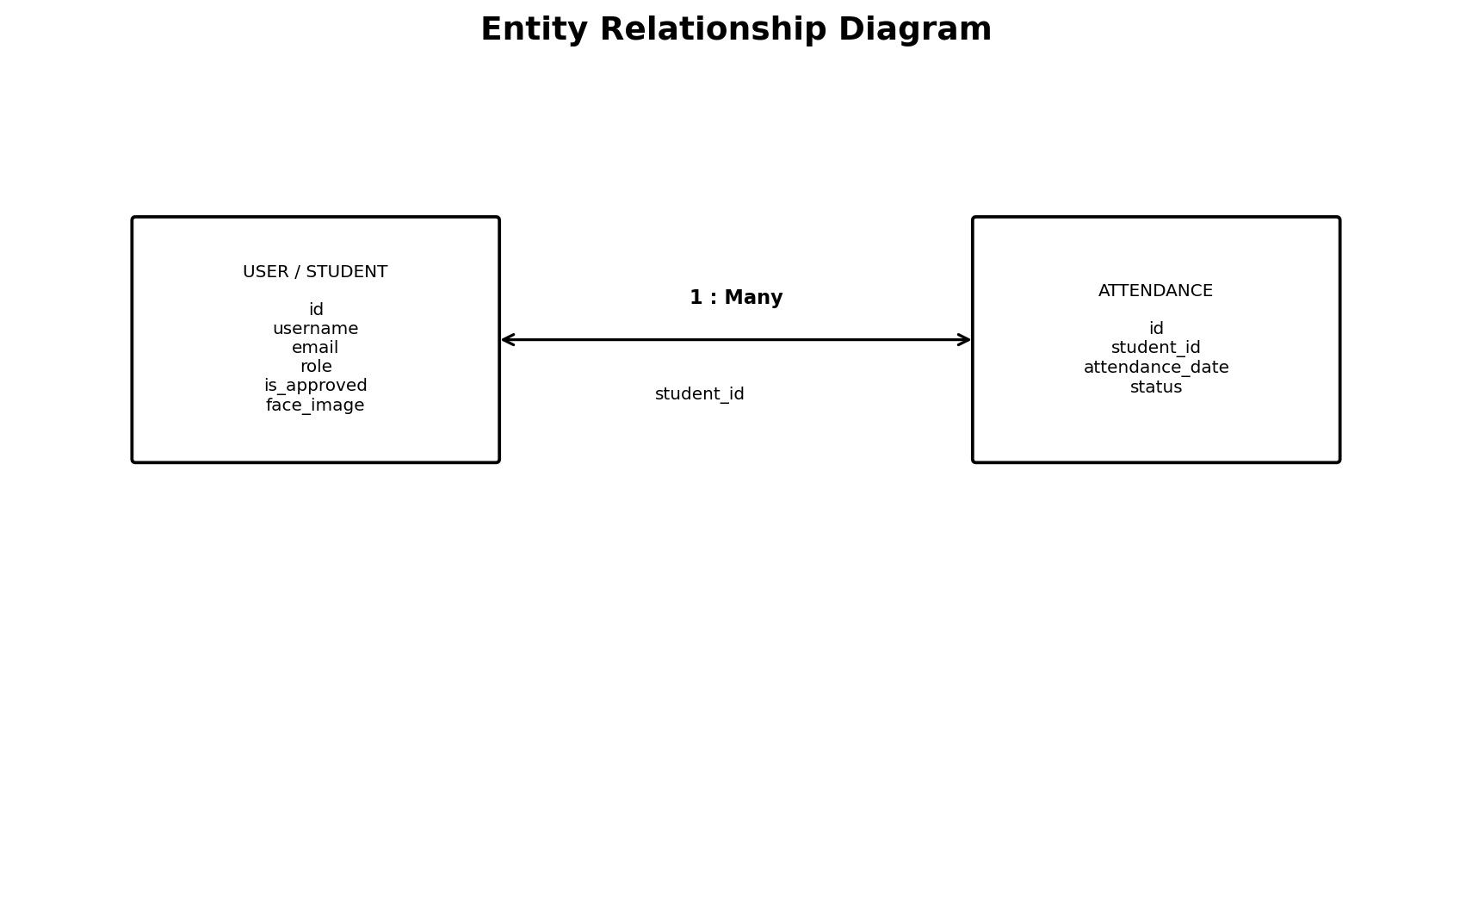
Figure 4.7. Entity Relationship Diagram
4.10 Database Entities
4.10.1 User / Student Entity
The User/Student entity represents registered users of the application. It contains information such as username, first name, last name, email, password-related authentication information, role, approval status, and registered face image.
4.10.2 Attendance Entity
The Attendance entity stores attendance records associated with students. Important attributes include the student reference, attendance date, and status. The attendance status can be PENDING, APPROVED, or REJECTED.
4.10.3 Django Authentication Data
Django Authentication also maintains standard authentication-related information such as users, groups, permissions, and sessions according to the configured Django application and authentication setup.
4.11 Attendance Status Design
The attendance status follows a simple state-based workflow:
PENDING→APPROVED
PENDING → REJECTED
A successfully verified attendance submission is initially stored as PENDING. An authorized Admin or Superadmin then reviews the request. The record is changed to APPROVED when accepted or REJECTED when not accepted.
4.12 Face Verification Design
The face verification process uses the registered face image as the reference image. During attendance submission, the student's camera captures a current face image. The system passes the relevant images to DeepFace for verification. When the verification result indicates a successful match, the attendance record is created with PENDING status. When verification fails, attendance submission is not accepted.
4.13 System Design Summary
The system design combines web application components, facial verification, database management, role-based access, attendance status management, and email notification into a single workflow. The architecture and diagrams presented in this chapter provide the design foundation for the implementation described in the next chapter.

CHAPTER 5
METHODOLOGY
5.1 Introduction
The methodology of the Student Attendance Management System describes the sequence of operations followed by the application from student registration to attendance submission, verification, administrative review, and notification. The system combines Django web application functionality, MySQL database management, camera-based image capture, DeepFace facial verification, role-based authentication, and SMTP email notification.
5.2 Student Registration
The student begins the process by creating an account through the registration interface. The student provides the required personal information and account credentials along with a face image. The submitted information is stored in the application database.
A newly registered student account is not immediately treated as an approved account. The account remains pending until the Superadmin reviews and approves the registration. This approval step controls access to the attendance functionality.
5.3 Face Image Registration
During registration, the student provides one face image. The image is associated with the student's profile and is stored as the reference face image for later attendance verification.
The current implementation does not perform a separate face-training or face-encoding process. Instead, the registered image is used as the reference image during DeepFace verification.
5.4 Student Approval
The Superadmin reviews newly registered student accounts. When the registration information is accepted, the Superadmin approves the student account. An approved student can then log in and use the attendance submission functionality.
The approval mechanism ensures that the attendance workflow is available only to registered and approved student accounts.
5.5 Student Login
After approval, the student logs in through the application using the configured authentication mechanism. Django Authentication is used to manage login and authenticated user sessions.
The application identifies the user's role and provides access to the functions associated with the Student role. Unauthorized users cannot directly access student attendance functions.
5.6 Attendance Submission
The student opens the attendance submission function after successful login. The system requests access to the device camera and captures the student's current face image.
The captured image is processed as part of the facial verification workflow. The student's registered face image is retrieved from the profile and used as the reference for comparison.
5.7 Camera Capture and Image Processing
The browser camera is used to obtain the current face image during attendance submission. OpenCV is used as part of the image and camera processing workflow. The captured image is prepared for the facial verification operation.
The current attendance workflow is designed for one student face at a time. The system compares the captured face with the registered face image belonging to the logged-in student.
5.8 DeepFace Face Verification
DeepFace is the facial verification library used by the system. The application uses DeepFace to compare the captured face image with the student's registered face image.
TensorFlow provides the underlying machine-learning framework used in the DeepFace-based verification workflow. The verification result determines whether the attendance submission can proceed.
The verification process can be represented as follows:
Registered Face Image + Captured Face Image → DeepFace Verification → Verification Result
If the captured face successfully matches the registered face image, the system proceeds to attendance creation. If the face does not successfully match, the attendance submission is not accepted.
5.9 Attendance Record Creation
After successful facial verification, the system creates an attendance record associated with the authenticated student. The attendance date is stored with the record.
The initial attendance status is set to PENDING. This means that successful face verification creates an attendance request, but the attendance is not considered finally approved until an authorized administrator reviews it.
5.10 Attendance Approval and Rejection
The Admin or Superadmin can access pending attendance requests through the administrative interface. The administrator reviews the submitted attendance record and chooses the appropriate action.
• APPROVED: The attendance request is accepted and the attendance record status is changed to APPROVED.
• REJECTED: The attendance request is not accepted and the attendance record status is changed to REJECTED.
The status-based workflow provides a clear distinction between an attendance request that has been submitted and an attendance record that has been reviewed.
5.11 Email Notification
When an attendance request is approved, the system sends an email notification to the associated student. SMTP is used for the email communication functionality.
The notification informs the student about the approval of the attendance record. The email functionality reduces the need for separate manual communication of the attendance decision.
5.12 Attendance History
Students can access their attendance history through the application. The history contains the attendance records associated with the student's account and displays the corresponding attendance date and status.
The attendance status allows students to distinguish between pending, approved, and rejected attendance records.
5.13 Role-Based Methodology
The system uses three primary roles to organize access to the application.
• Student: Registers an account, provides a face image, logs in after approval, submits attendance using face verification, views attendance history, and views profile information.
• Admin: Reviews attendance requests and performs attendance approval or rejection according to the configured permissions.
• Superadmin: Approves student registrations and performs attendance approval or rejection.
5.14 Attendance Verification Logic
The attendance verification logic follows the sequence below:
• The student must have an approved account.
• The student logs into the system.
• The student opens the attendance submission page.
• The camera captures the student's current face image.
• The system retrieves the student's registered face image.
• DeepFace compares the captured image with the registered image.
• If verification succeeds, the attendance record is created with PENDING status.
• If verification fails, the attendance submission is not accepted.
• An Admin or Superadmin reviews the pending attendance record.
• The attendance record is changed to APPROVED or REJECTED.
• When approved, an email notification is sent to the student.
5.15 Attendance Status Flow
The attendance status follows two possible review paths after successful face verification:
PENDING → APPROVED
PENDING → REJECTED
PENDING is the initial state after successful face verification. APPROVED indicates that the attendance has been accepted by an authorized administrator. REJECTED indicates that the attendance request has been rejected.
5.16 Data Storage Methodology
The system uses MySQL for persistent storage. Student account and profile information is stored through the configured Django user model, while attendance information is stored through the Attendance model.
The User/Student data includes account information, role, approval status, and face image. Attendance data includes the associated student, attendance date, and attendance status.
Django manages communication between the application and MySQL database through its model and database framework.
5.17 Security and Access Control
Django Authentication is used to control access to authenticated functions. Role-based access ensures that student and administrative functions are separated.
Student users can access their own attendance-related functions, while administrative functions such as student approval and attendance review are restricted to the appropriate administrative roles.
5.18 Methodology Summary
The methodology provides an integrated workflow beginning with student registration and approval and continuing through face verification, attendance creation, administrative review, and email notification. The combination of Django, MySQL, DeepFace, TensorFlow, OpenCV, Django Authentication, and SMTP provides the technical foundation for the implemented attendance management process.

CHAPTER 6
IMPLEMENTATION
6.1 Introduction
The implementation of the Student Attendance Management System is carried out as a web application using Python and Django. The frontend is developed using HTML, CSS, JavaScript, and Bootstrap. MySQL is used for database storage, while DeepFace, TensorFlow, and OpenCV support the face-verification workflow. Django Authentication provides user authentication and role-based access, and SMTP is used for email notification.
6.2 Development Environment
The project is developed in a Windows environment using Visual Studio Code as the primary integrated development environment. Python is used to execute the Django application and supporting libraries. MySQL provides the relational database environment used by the application.
• Operating System: Windows
• Programming Language: Python
• IDE: Visual Studio Code
• Database: MySQL
• Backend Framework: Django
• Frontend Technologies: HTML, CSS, JavaScript, Bootstrap
• Face Verification Library: DeepFace
• Machine Learning Framework: TensorFlow
• Image Processing: OpenCV
• Database Connector: mysqlclient
• Authentication: Django Authentication
• Email: SMTP
• Version Control: Git and GitHub
• Static File Support: WhiteNoise
• Application Server: Gunicorn
6.3 Django Application Structure
The application follows the Django project structure in which configuration, URL routing, views, models, templates, static resources, and supporting utility functions are organized into appropriate project and application components.
The project contains an attendance application component. The face verification functionality is implemented through the face_utils.py file within the attendance application. This utility is used as part of the DeepFace verification process.
6.4 User Model Implementation
The application uses a custom user model to manage account information and role-based access. The user data includes information such as username, first name, last name, email, password-related authentication information, role, approval status, and face image.
The role field identifies whether the user is a STUDENT, ADMIN, or SUPERADMIN. The is_approved field is used to control whether a student account has been approved for system use.
6.5 Student Registration Implementation
The student registration module provides a form through which a student enters the required account and profile information and provides a face image. The submitted information is validated and stored in the database.
The newly created student account remains pending until it is approved by the Superadmin. This prevents an unapproved account from directly entering the attendance workflow.
6.6 Student Approval Implementation
The Superadmin interface provides access to newly registered student accounts. The Superadmin can review the registration information and approve the student account. The approval state is stored in the user record.
After approval, the student can authenticate and access the functions available to the Student role.
6.7 Authentication and Role-Based Access
Django Authentication is used to manage user login and authenticated sessions. After authentication, the application determines the user's role and provides the corresponding functionality.
• STUDENT: Attendance submission, attendance history, and profile.
• ADMIN: Attendance review and approval or rejection.
• SUPERADMIN: Student approval and attendance review and approval or rejection.
Role-based access helps prevent users from accessing functions that are outside their assigned responsibilities.
6.8 Face Image Storage
The student provides one registered face image during account registration. The image is stored with the student's profile and becomes the reference image for attendance verification.
The current implementation does not use a separate face-training or face-encoding process. The registered image is directly used as the reference for the DeepFace verification operation.
6.9 Camera and Image Capture
During attendance submission, the student's web browser accesses the camera and captures the current face image. The captured image is passed through the application's image-processing workflow.
OpenCV is used as part of the image and camera processing functionality. The attendance process is designed for one student face at a time.
6.10 DeepFace Verification Implementation
The face verification functionality is implemented in the attendance application through the face_utils.py utility. DeepFace is used to compare the student's captured face image with the registered face image.
The verification process uses the DeepFace verification functionality supported by the configured machine-learning environment. TensorFlow is used as the underlying machine-learning framework.
The implementation follows the following logic:
• Receive the captured face image.
• Retrieve the registered face image associated with the authenticated student.
• Pass the relevant images to the DeepFace verification process.
• Obtain the verification result.
• Allow attendance creation only when the verification succeeds.
• Reject the attendance submission when the verification does not succeed.
6.11 Attendance Model Implementation
The Attendance model represents attendance records in the system. Each attendance record is associated with a student and contains the attendance date and status.
The attendance status is represented using three states: PENDING, APPROVED, and REJECTED.
• PENDING: Attendance has been successfully submitted after face verification and is awaiting administrative review.
• APPROVED: Attendance has been accepted by an authorized administrator.
• REJECTED: Attendance has been rejected by an authorized administrator.
6.12 Attendance Submission Implementation
After successful DeepFace verification, the application creates a new Attendance record for the authenticated student. The current attendance date is stored and the initial status is set to PENDING.
The pending record becomes available to the Admin or Superadmin for review. If face verification fails, the application does not create an accepted attendance record through the successful verification path.
6.13 Attendance Approval and Rejection Implementation
Administrative users can view pending attendance records through the administrative interface. The administrator can select the appropriate action for each pending attendance request.
• Approval changes the attendance status from PENDING to APPROVED.
• Rejection changes the attendance status from PENDING to REJECTED.
The updated status is stored in MySQL and is reflected in the student's attendance history.
6.14 Email Notification Implementation
The system uses SMTP email functionality to notify students when their attendance is approved. The application sends the notification to the email address associated with the student's account.
The email notification is triggered as part of the attendance approval workflow and provides the student with information about the approved attendance.
6.15 Attendance History Implementation
The student attendance history page retrieves attendance records associated with the authenticated student. The records display attendance dates and their current status.
Because each attendance record is linked to the corresponding student, a student can view the attendance information associated with their own account.
6.16 Database Integration
Django provides the database layer used to communicate with MySQL. The application stores user and attendance information in the configured database. The main application entities are the User/Student model and the Attendance model.
The user record contains account, role, approval, and face-image information. The attendance record contains the student reference, attendance date, and status.
6.17 Frontend Implementation
The frontend is implemented using HTML, CSS, JavaScript, and Bootstrap. HTML templates provide the structure of the pages, CSS supports page styling, JavaScript provides client-side interaction, and Bootstrap provides responsive interface components.
The interface includes pages and components for registration, login, student dashboard, attendance submission, administrative review, attendance history, and profile information.
6.18 Static Files and Deployment Support
WhiteNoise is included to support static-file handling in deployment environments. Gunicorn is included as an application server for running the Django application in a deployment environment. Git and GitHub are used for source-code version control and repository management.
6.19 Implementation Workflow
The implemented system follows the workflow below:
• Student creates an account and provides a face image.
• Superadmin reviews and approves the student account.
• Student logs in using Django Authentication.
• Student opens the attendance submission page.
• Camera captures the student's face.
• The application compares the captured face with the registered face using DeepFace.
• Successful verification creates a PENDING attendance record.
• Admin or Superadmin reviews the pending attendance.
• The attendance is marked APPROVED or REJECTED.
• An approval triggers an email notification to the student.
• The student can view the updated attendance history.
6.20 Implementation Summary
The implementation integrates Django, MySQL, DeepFace, TensorFlow, OpenCV, frontend technologies, Django Authentication, SMTP, and supporting deployment tools into a single attendance management application. The implemented modules work together to provide student registration, approval, facial verification, attendance submission, administrative review, attendance history, and email notification.

CHAPTER 7
USER INTERFACE
7.1 Introduction
The Student Attendance Management System provides a web-based user interface for students, Admins, and Superadmins. The interface is designed to provide access to registration, authentication, attendance submission, attendance history, profile information, student approval, and attendance approval functions according to the user's role.
The following sections present the major screens of the implemented application. The screenshots show the actual user interface of the Student Attendance Management System.
7.2 Base Page
The base page provides the common layout of the application. It contains the Student Attendance Management System branding, navigation menu, account options, and the main content area. The navigation options displayed to a user depend on the user's authentication status and role.
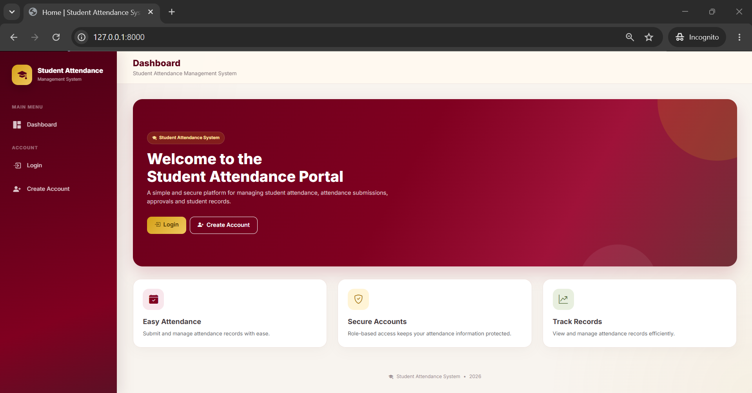
Figure 7.1. Student Attendance Management System Base Page
7.3 Login Page
The login page allows registered users to sign in to the Student Attendance Management System. The user enters a username and password and selects the Login option. Django Authentication is used to authenticate the user's credentials and establish an authenticated session.
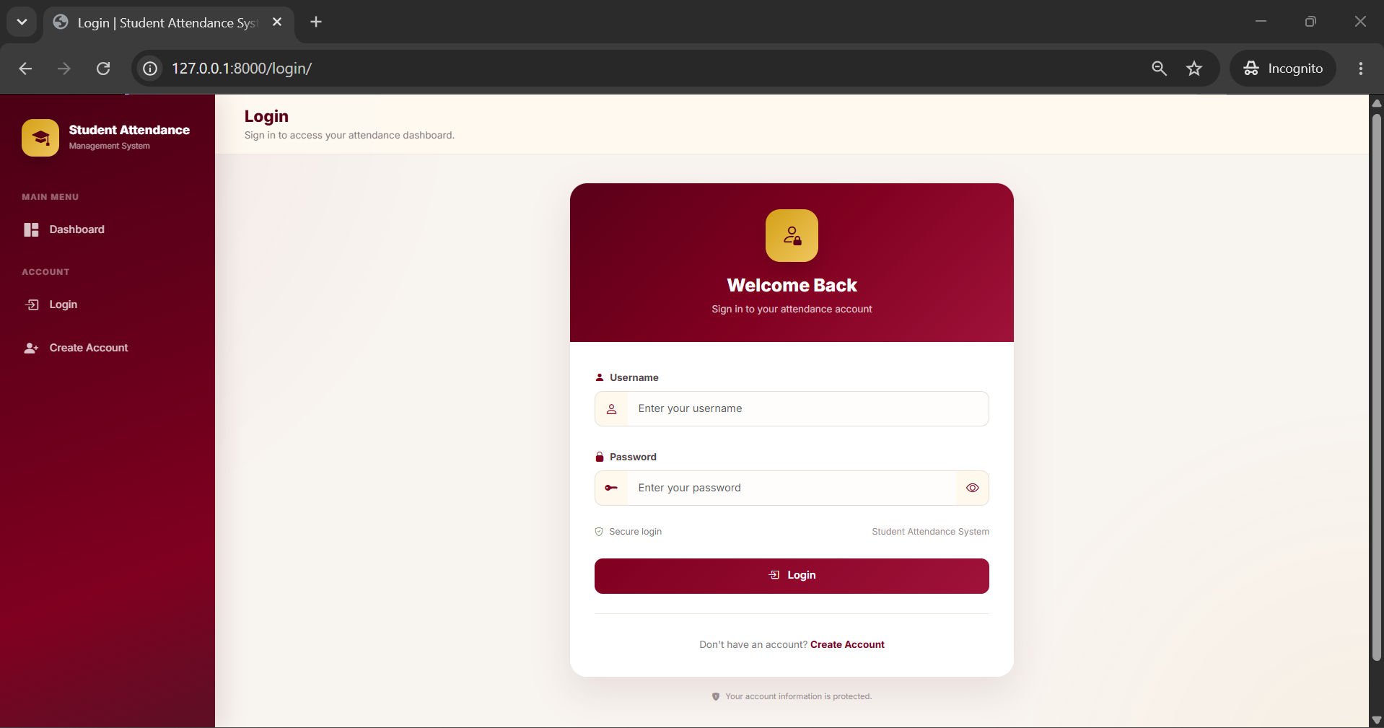
Figure 7.2. User Login Page
7.4 Student Registration Page
The student registration page allows a new student to create an account. The form collects the username, email address, first name, last name, face image, password, and password confirmation. The registration page also informs the student that the account requires approval before it can be used.
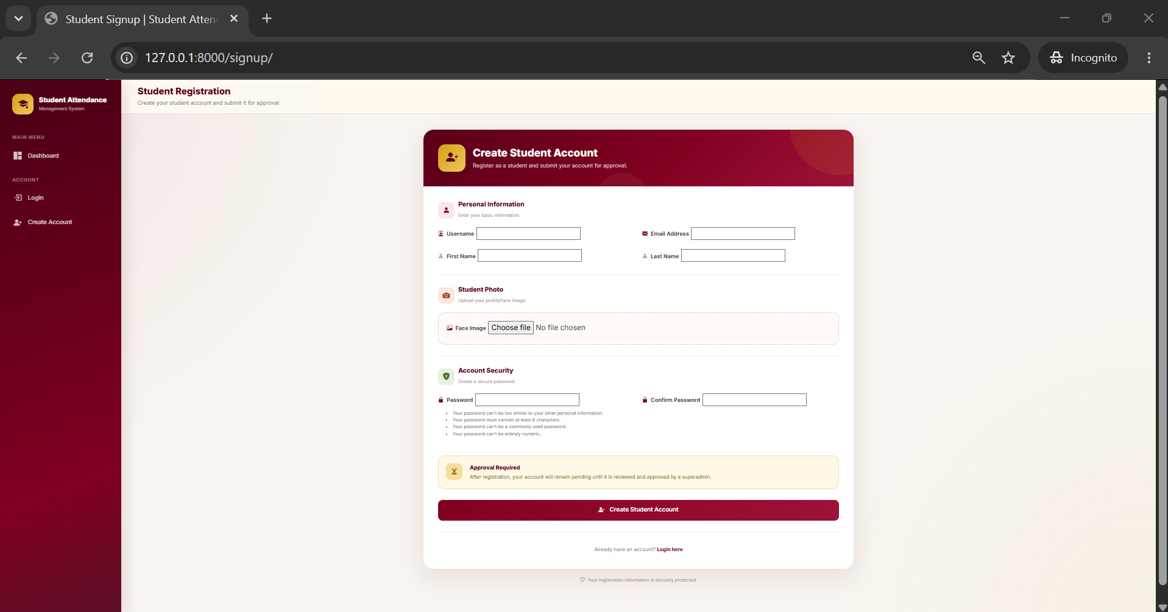
Figure 7.3. Student Registration Page
7.5 Student Dashboard
The Student Dashboard is the main interface displayed after a student logs in. It identifies the account role and account status and provides access to attendance-related functions. The dashboard contains options for submitting attendance, viewing attendance records, and accessing the student profile.
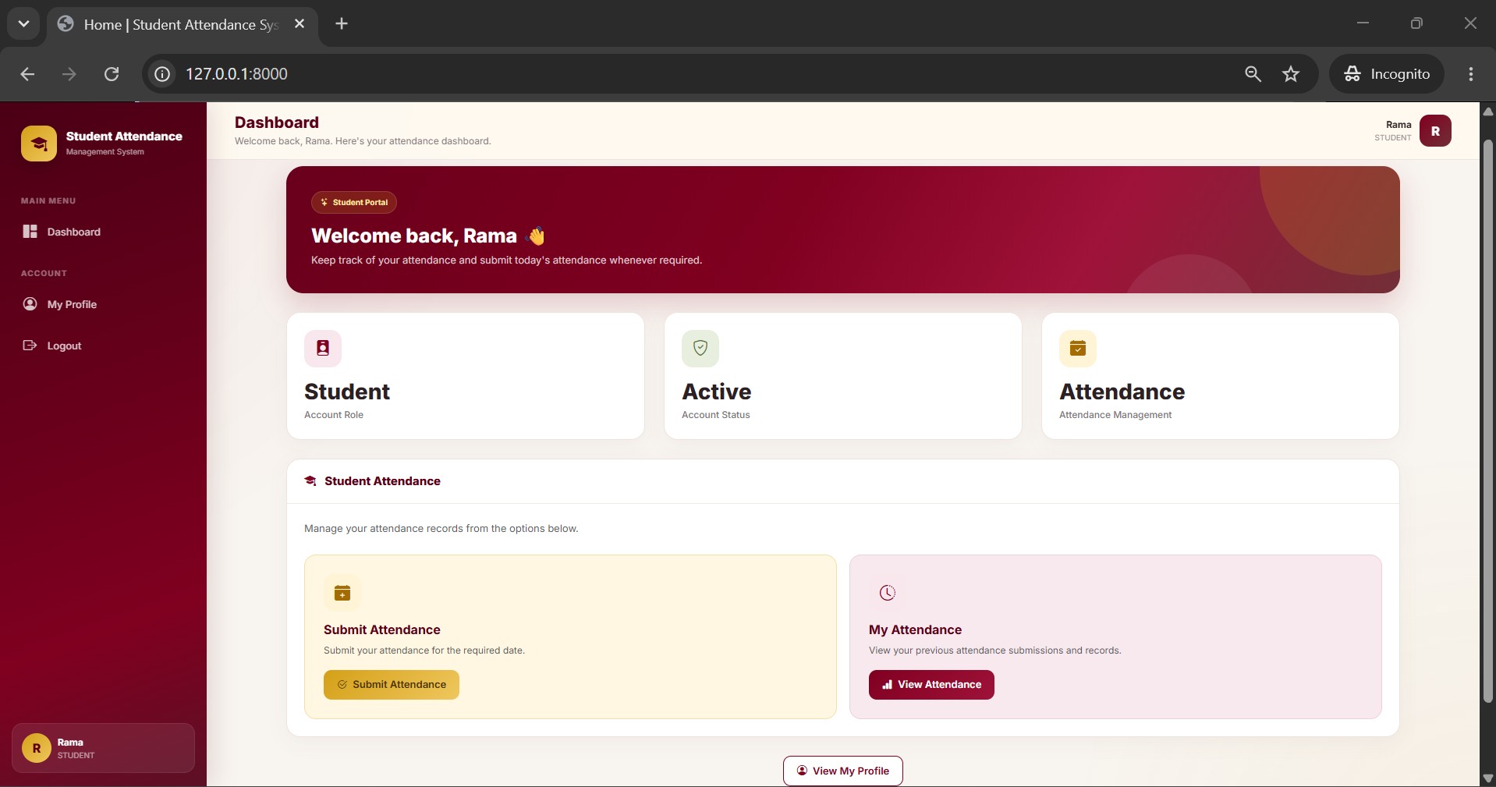
Figure 7.4. Student Dashboard
7.6 Student Attendance Page
The student attendance page provides access to the attendance management functions available to the student. The student can submit attendance and view previously submitted attendance records through the corresponding options.
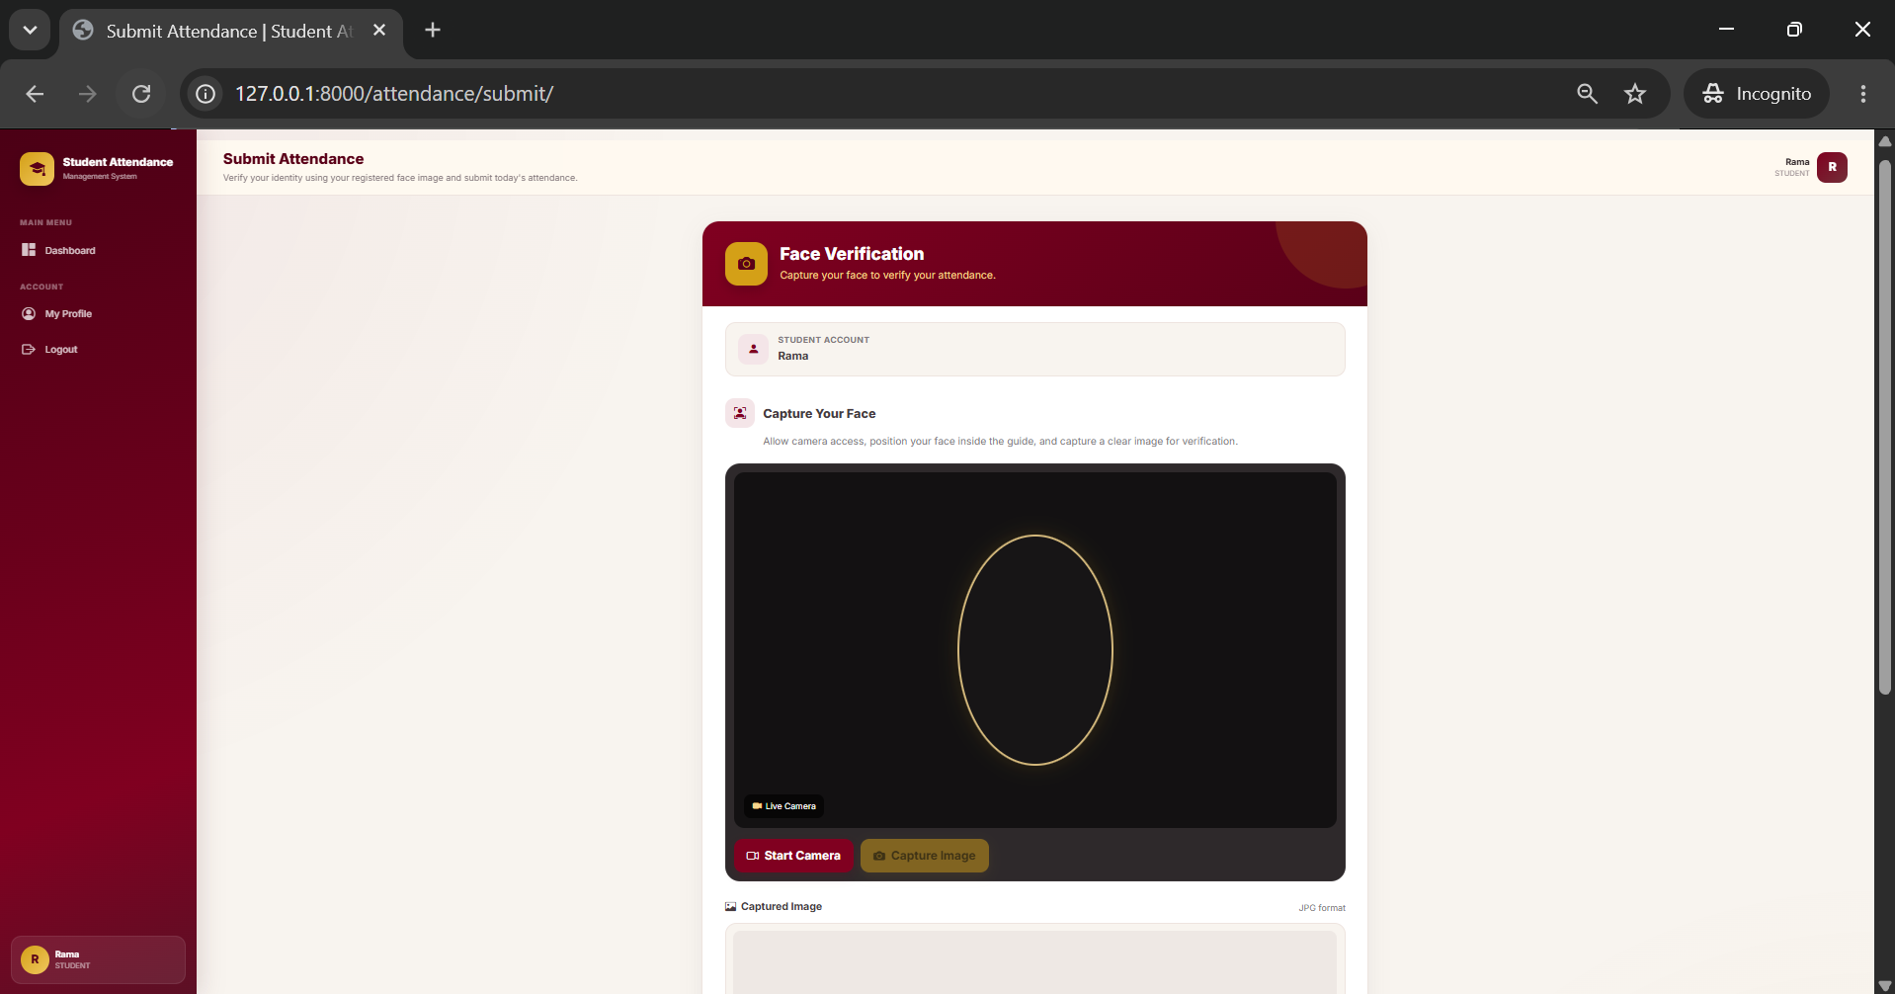
Figure 7.5. Student Attendance Page
7.7 Attendance Submission and Face Verification Page
The attendance submission page provides the face verification interface. The page identifies the logged-in student and provides a camera area for capturing the student's face. The student starts the camera, positions the face inside the displayed guide, and captures an image for verification.
The captured face image is used for comparison with the student's registered face image through the DeepFace verification workflow. Successful verification allows the attendance submission process to continue.
Figure 7.6. Attendance Submission and Face Verification Page
7.8 Student Profile Page
The student profile page displays the personal information associated with the student's account. The interface provides information such as username, email address, first name, last name, account role, account approval status, and the registered face image.
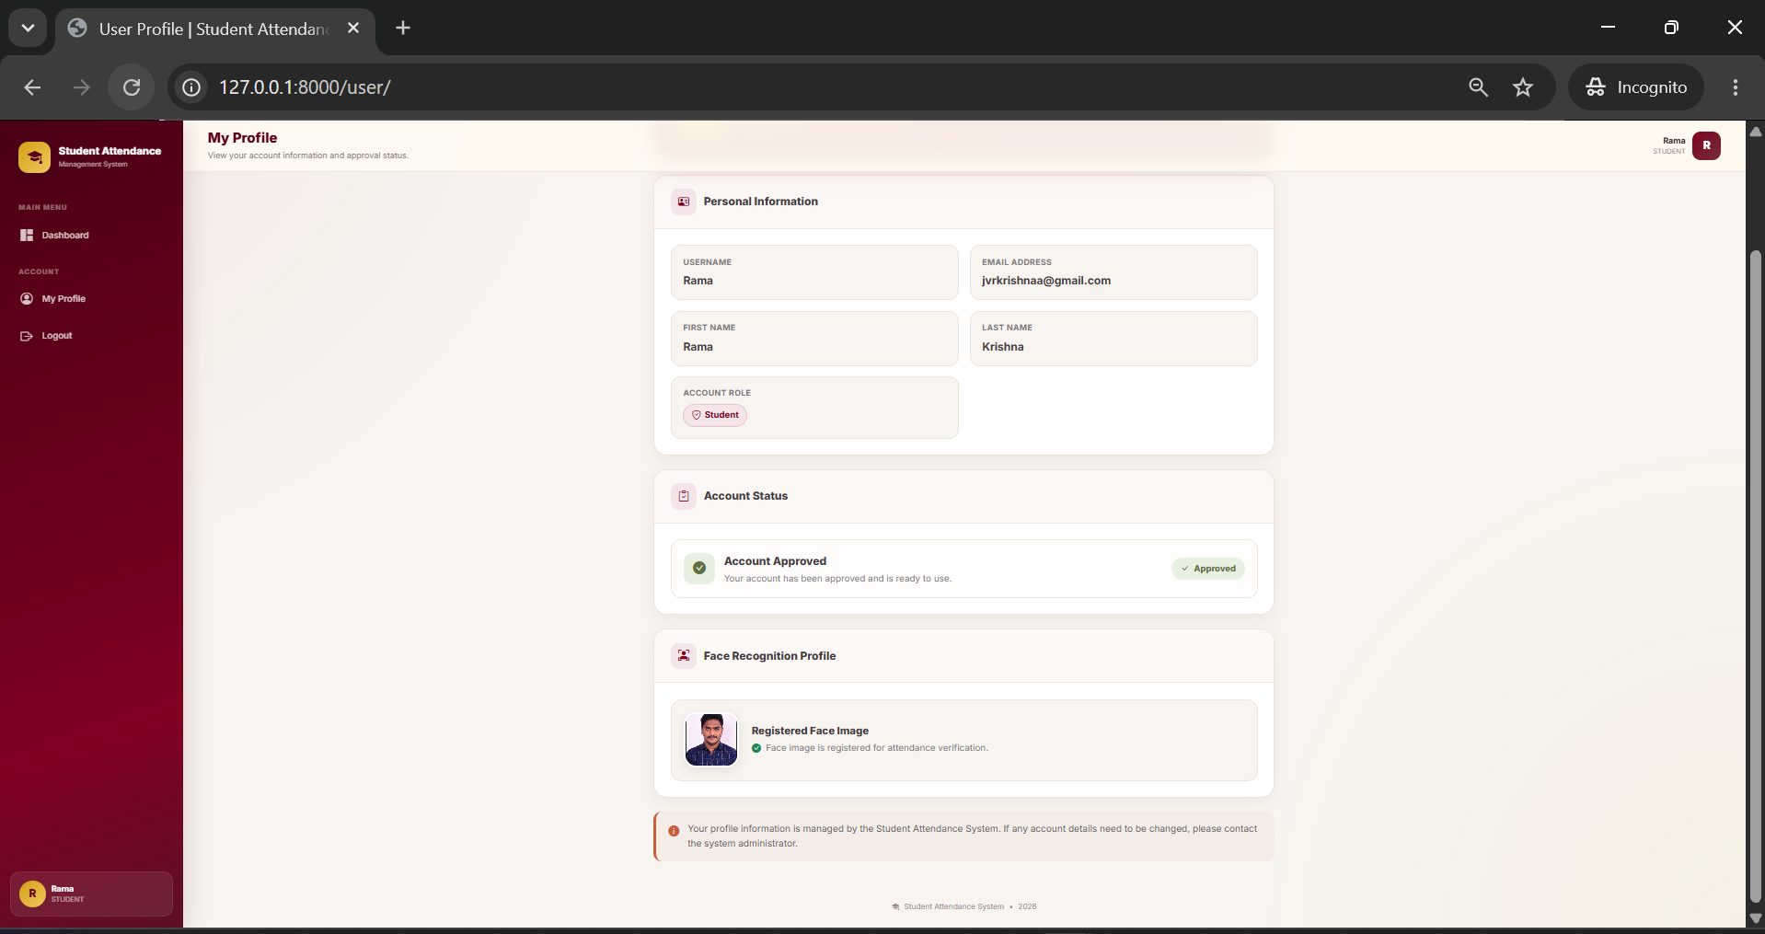
Figure 7.7. Student Profile Page
7.9 Student User Profile
The user profile interface provides the student's registered profile and face-recognition information. The registered face image is displayed as the reference image used for attendance verification.
Figure 7.8. Student User Profile and Face Recognition Information
7.10 Admin Dashboard
The Admin Dashboard provides administrative access to attendance management. The dashboard identifies the user as an Admin and provides an Attendance Approvals section for reviewing and managing submitted attendance records.
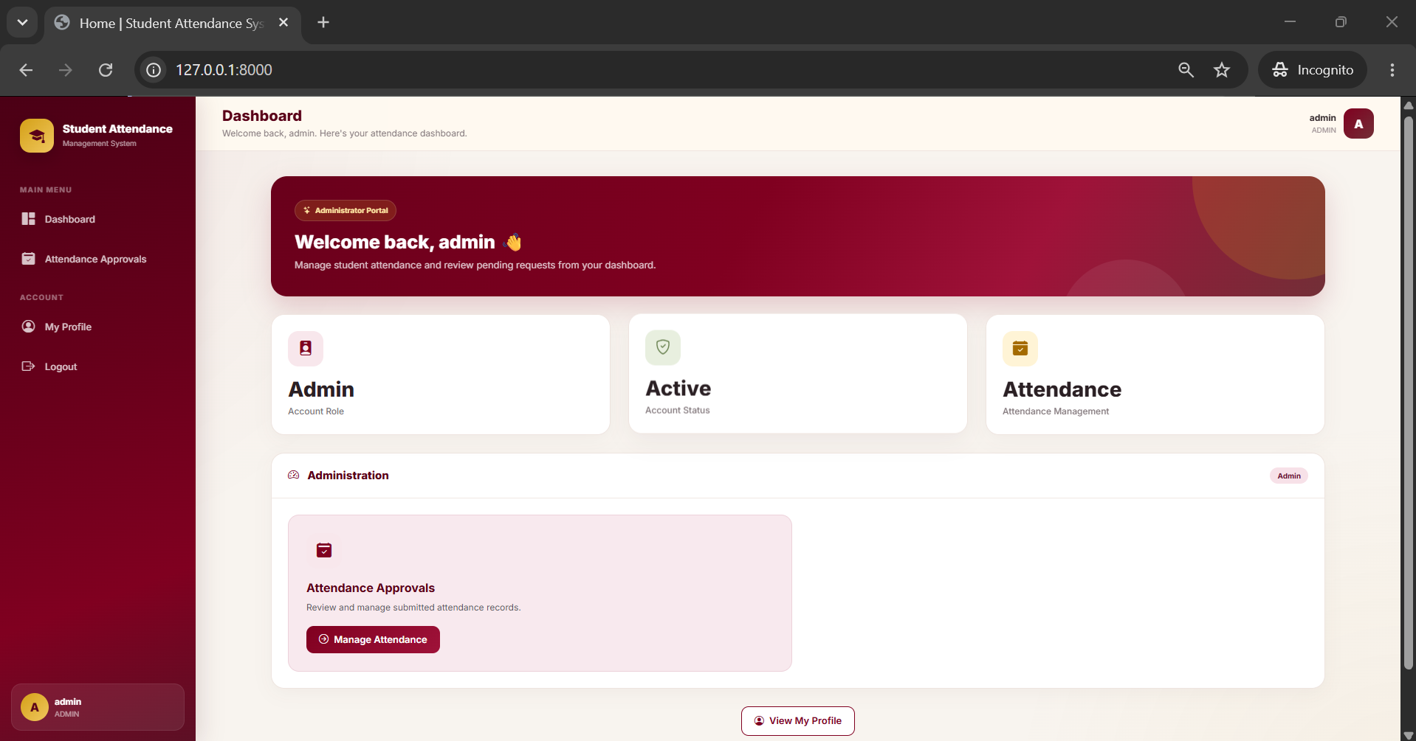
Figure 7.9. Admin Dashboard
7.11 Superadmin Dashboard
The Superadmin Dashboard provides the administrative functions available to the Superadmin role. It provides access to Attendance Approvals and Student Approvals. Student Approvals allows the Superadmin to review and approve new student registrations, while Attendance Approvals provides access to submitted attendance records.
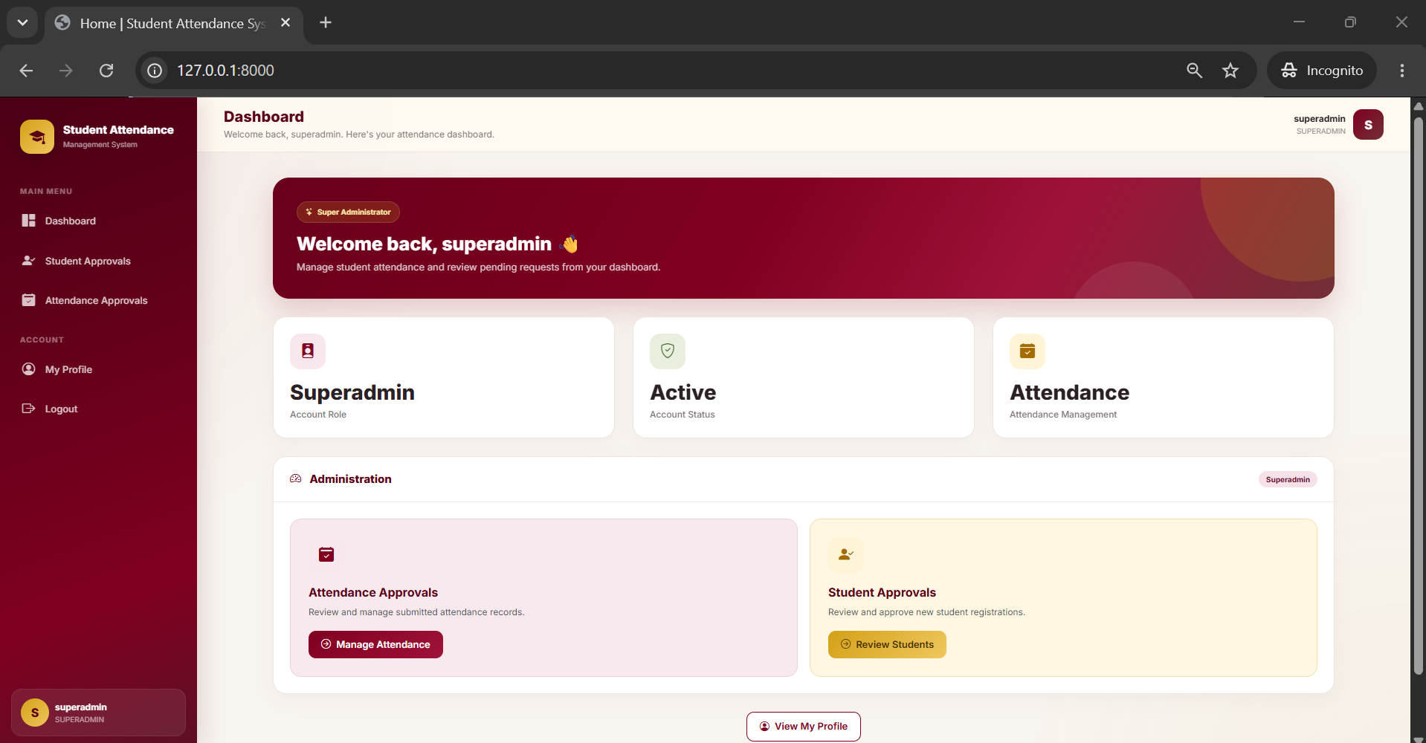
Figure 7.10. Superadmin Dashboard
7.12 User Interface Summary
The implemented user interface provides separate functionality according to the user's role. Students can register, log in, submit attendance through face verification, view attendance information, and access their profile. Admins can review attendance submissions, while Superadmins can manage student approvals in addition to attendance approvals.
The interface integrates the major functions of the system into a consistent web-based design and provides the screens required for student and administrative attendance management.

CHAPTER 8
SYSTEM TESTING
8.1 Introduction
System testing is performed to verify that the Student Attendance Management System operates according to the specified requirements. The testing process checks the major functions of the application, including registration, authentication, student approval, face verification, attendance submission, attendance approval, attendance rejection, profile access, attendance history, and email notification.
8.2 Testing Objectives
• Verify that students can register using the required information and face image.
• Verify that users can log in using valid authentication credentials.
• Verify that invalid login credentials are not accepted.
• Verify that Superadmin approval is required for newly registered students.
• Verify that the camera-based attendance submission interface operates correctly.
• Verify that the captured face is checked against the registered face image.
• Verify that successful face verification creates a PENDING attendance record.
• Verify that failed face verification does not accept the attendance submission.
• Verify that Admin and Superadmin users can approve or reject attendance.
• Verify that students can view their attendance history and profile.
• Verify that an approval notification is sent through the configured SMTP service.
8.3 Testing Method
The system is tested by providing different inputs to each major module and observing the resulting application behavior. The expected result of each test case is compared with the actual result produced by the system. Testing covers normal inputs, invalid inputs, access restrictions, face verification outcomes, and attendance status changes.
8.4 Functional Test Cases
Test ID | Module | Test Input / Action | Expected Result | Status
TC-01 | Home Page | Open the application home page. | The Student Attendance Management System home page is displayed. | PASS
TC-02 | Registration | Enter valid student details and upload a face image. | Student account is created and remains pending for approval. | PASS
TC-03 | Registration | Submit registration without required information. | Validation prevents incomplete registration. | PASS
TC-04 | Login | Enter valid username and password. | User is authenticated and redirected to the appropriate dashboard. | PASS
TC-05 | Login | Enter invalid username or password. | Authentication fails and access is not granted. | PASS
TC-06 | Student Approval | Superadmin reviews a pending student registration. | Student account can be approved. | PASS
TC-07 | Student Access | Approved student logs in. | Student dashboard is displayed with student functions. | PASS
TC-08 | Attendance Page | Student opens attendance submission page. | Face verification and camera interface are displayed. | PASS
TC-09 | Camera | Allow camera access and start camera. | Live camera interface becomes available for face capture. | PASS
TC-10 | Face Verification | Capture a face matching the registered student face image. | DeepFace verification succeeds and attendance can proceed. | PASS
TC-11 | Face Verification | Capture a non-matching face. | Face verification fails and attendance is not accepted. | PASS
TC-12 | Attendance Creation | Submit attendance after successful face verification. | Attendance record is created with PENDING status. | PASS
TC-13 | Attendance Approval | Admin or Superadmin approves a pending attendance record. | Attendance status changes to APPROVED. | PASS
TC-14 | Attendance Rejection | Admin or Superadmin rejects a pending attendance record. | Attendance status changes to REJECTED. | PASS
TC-15 | Email Notification | Approve an attendance record with SMTP configured. | Approval notification is sent to the student's email address. | PASS
TC-16 | Attendance History | Student opens attendance history. | Student's attendance records and statuses are displayed. | PASS
TC-17 | Profile | Student opens profile page. | Student profile and registered face information are displayed. | PASS
TC-18 | Role Access | Student attempts to access administrative functions. | Administrative functions are restricted from the student role. | PASS
TC-19 | Admin Access | Admin opens the dashboard. | Admin dashboard and attendance approval functions are displayed. | PASS
TC-20 | Superadmin Access | Superadmin opens the dashboard. | Superadmin dashboard, student approval, and attendance approval functions are displayed. | PASS
8.5 Student Registration Testing
The registration module is tested by submitting valid student information, a face image, and account credentials. The system is also tested with incomplete information to verify that required fields are validated. A successfully registered student remains pending until the Superadmin approves the account.
8.6 Authentication Testing
Authentication testing verifies that valid users can access the system with correct credentials and that invalid credentials do not provide access. The system also verifies that authenticated users are directed to functions appropriate to their assigned roles.
8.7 Face Verification Testing
Face verification is tested using the registered face image and a non-matching face. When the captured face matches the registered face, the verification process succeeds and attendance creation is permitted. When the captured face does not successfully match the registered face, the attendance submission is not accepted.
The test also verifies that the attendance workflow is designed for one student face at a time and uses the student's registered face image as the reference image.
8.8 Attendance Workflow Testing
Attendance testing verifies the complete workflow from camera capture through face verification and attendance record creation. After successful verification, the record is stored with PENDING status. The administrative review process is then tested by changing the record to APPROVED or REJECTED.
8.9 Role-Based Access Testing
Role-based access testing verifies the permissions assigned to Student, Admin, and Superadmin users.
• Student access includes attendance submission, attendance history, and profile functions.
• Admin access includes attendance review and approval or rejection.
• Superadmin access includes student approval and attendance review, approval, or rejection.
The tests confirm that administrative functions are separated from normal student functions.
8.10 Database Testing
Database testing verifies that user and attendance information is stored and retrieved correctly from MySQL. The tests verify that student information is associated with the correct account and that attendance records contain the corresponding student, attendance date, and status.
• User registration information is stored correctly.
• Student approval status is stored correctly.
• Registered face image information is associated with the student profile.
• Attendance records are associated with the correct student.
• Attendance dates are stored with attendance records.
• PENDING, APPROVED, and REJECTED statuses are stored correctly.
8.11 Email Notification Testing
Email notification testing verifies the approval notification workflow. When an authorized administrator approves an attendance record, the application uses the configured SMTP service to send a notification to the student's registered email address.
8.12 User Interface Testing
The user interface is tested to verify that pages, navigation elements, forms, buttons, dashboard sections, and role-specific functions are displayed correctly. The registration, login, student dashboard, attendance submission, profile, Admin dashboard, and Superadmin dashboard interfaces are checked for functional navigation.
8.13 Security Testing
Security-related testing verifies authentication and role-based access restrictions. The system requires authenticated access for protected functions and separates student functions from administrative functions. Password authentication is handled through Django Authentication.
8.14 Test Results
The functional test cases cover the major modules of the Student Attendance Management System. The tested workflow includes student registration, approval, login, camera capture, face verification, attendance creation, administrative review, status update, email notification, attendance history, and profile access.
8.15 System Testing Summary
The testing process verifies the major functional requirements of the Student Attendance Management System. The results demonstrate the expected operation of the implemented modules under the tested conditions. The application supports role-based access, face-based attendance verification, attendance status management, student approval, attendance approval and rejection, attendance history, and email notification.

CHAPTER 9
RESULTS AND DISCUSSION
9.1 Introduction
The Student Attendance Management System was implemented as a Django-based web application with camera-based face verification. This chapter presents the results obtained from the implemented modules and discusses the operation of the major system functions.
9.2 Registration Results
The student registration module provides a web form for entering the required account information and uploading one face image. After registration, the student account remains pending until it is reviewed and approved by the Superadmin.
• Student details can be entered through the registration interface.
• A registered face image can be associated with the student account.
• The account approval state is maintained by the system.
• The registration process separates account creation from account approval.
9.3 Authentication Results
The authentication module allows registered users to log in using their configured credentials. After successful authentication, the application provides a dashboard based on the user's role.
• Students receive access to student attendance functions.
• Admins receive access to attendance management functions.
• Superadmins receive access to student and attendance approval functions.
9.4 Face Verification Results
The implemented attendance workflow uses DeepFace to verify the student's captured face against the registered face image. The camera interface allows the student to capture an image for verification.
When the captured face successfully matches the registered face image, the system proceeds with attendance creation. When verification does not succeed, the attendance submission is not accepted through the successful verification path.
The current implementation uses one registered face image per student and is designed for one student face at a time.
9.5 Attendance Submission Results
Successful face verification results in the creation of an attendance record. The record is associated with the authenticated student and stores the attendance date. The initial status of the record is PENDING.
This workflow separates face verification from administrative approval. A successful verification therefore represents a valid attendance submission for review rather than an immediate final approval.
9.6 Attendance Approval Results
The Admin and Superadmin interfaces provide access to submitted attendance records. An authorized administrator can review a pending attendance record and change its status.
• PENDING → APPROVED when the attendance is accepted.
• PENDING → REJECTED when the attendance is not accepted.
The updated status is stored in the database and becomes available to the student through the attendance history interface.
9.7 Email Notification Results
The application includes SMTP-based email notification as part of the attendance approval workflow. When attendance is approved, the system sends an email notification to the student's registered email address, subject to the configured SMTP service.
9.8 Attendance History Results
The student can view previously submitted attendance records through the attendance history interface. The displayed records contain the attendance date and the current status, allowing the student to identify pending, approved, and rejected submissions.
9.9 Profile Results
The profile interface displays the student's registered account information, account role, approval status, and registered face image. The registered face image is identified as the reference image used for attendance verification.
9.10 Administrative Results
The administrative interfaces provide role-specific management functions. The Admin dashboard provides attendance approval functionality. The Superadmin dashboard provides both student approval and attendance approval functionality.
The role-based arrangement ensures that student registration approval and attendance review are handled through the appropriate administrative interface.
9.11 Database Results
MySQL successfully serves as the persistent database for the application. The main application data consists of user or student information and attendance records. The user data contains account and role information, approval status, and the registered face image. Attendance data contains the associated student, attendance date, and status.
The relationship between a student and attendance records supports multiple attendance entries for the same student.
9.12 Technology Integration Results
The implemented application integrates the selected technologies into a single workflow.
• Python provides the primary programming language.
• Django manages the web application, authentication, views, models, and application logic.
• HTML, CSS, JavaScript, and Bootstrap provide the user interface.
• MySQL stores persistent application data.
• DeepFace provides facial verification.
• TensorFlow supports the machine-learning workflow used by DeepFace.
• OpenCV supports image and camera processing.
• Django Authentication manages user authentication.
• SMTP provides email notification.
• Git and GitHub support source-code version control.
• WhiteNoise and Gunicorn provide deployment-related support.
9.13 Discussion
The implemented system combines identity verification and administrative review in the attendance workflow. Instead of creating a final attendance status immediately after camera capture, the system first verifies the student's face and creates a PENDING attendance record. Administrative users then review the request and determine the final status.
The separation of Student, Admin, and Superadmin roles provides different access levels for attendance submission and administrative management. The student interface focuses on attendance and profile functions, while administrative interfaces provide approval and review operations.
The use of a registered face image as the verification reference provides a direct connection between the student's account and the face used during attendance submission. The current implementation is based on face verification rather than a separate face-training or face-encoding module.
9.14 Current System Limitations
• The current system stores one registered face image per student.
• The attendance verification workflow is designed for one student face at a time.
• The system does not currently provide Excel or CSV attendance export.
• The system does not currently provide multiple class or subject management.
• The system does not use a separate face-training or face-encoding module.
• Email notification depends on correct SMTP configuration and service availability.
• Camera-based attendance requires the user's browser and device to provide camera access.
9.15 Result Summary
The implemented Student Attendance Management System provides the major functions defined for the project. The system supports student registration and approval, authenticated role-based access, registered face-image storage, camera-based face verification using DeepFace, attendance creation with PENDING status, administrative approval or rejection, attendance history, profile access, and email notification.
The completed implementation provides an integrated web-based workflow for managing student attendance through facial verification and administrative review.

CHAPTER 10
CONCLUSION AND FUTURE SCOPE
10.1 Conclusion
The Student Attendance Management System is a Django-based web application developed to manage student attendance using camera-based facial verification. The system combines student registration, account approval, authentication, face-image storage, DeepFace verification, attendance management, administrative review, attendance history, and email notification in a single application.
The system uses DeepFace with TensorFlow for facial verification. During attendance submission, the student's camera captures a current face image and the application compares it with the student's registered face image. When verification is successful, an attendance record is created with PENDING status. The Admin or Superadmin can then review the attendance and change the status to APPROVED or REJECTED.
The application uses MySQL for persistent data storage and Django Authentication for user authentication and role-based access. The Student, Admin, and Superadmin roles provide different functions according to their responsibilities.
The implemented system provides a structured workflow for managing attendance from student registration through final attendance review. The project demonstrates the integration of web technologies, database management, image processing, facial verification, authentication, and email communication in an attendance management application.
10.2 Achievement of Project Objectives
The implemented system provides the major functions defined for the project objectives.
• Student registration with required account information and face image.
• Superadmin approval of newly registered student accounts.
• Secure user authentication using Django Authentication.
• Role-based access for Student, Admin, and Superadmin users.
• Camera-based face capture during attendance submission.
• Face verification using DeepFace and TensorFlow.
• Attendance record creation after successful face verification.
• PENDING, APPROVED, and REJECTED attendance status management.
• Administrative attendance approval and rejection.
• Student attendance history and profile access.
• Email notification through SMTP after attendance approval.
• MySQL-based storage of application and attendance information.
10.3 Advantages of the Implemented System
• Provides a web-based interface for student attendance management.
• Uses facial verification as an additional identity-verification step during attendance submission.
• Separates student functions from administrative functions through role-based access.
• Maintains attendance status throughout the review process.
• Allows administrators to review attendance before final approval.
• Allows students to view their attendance history and profile information.
• Provides email notification when attendance is approved.
• Uses a centralized MySQL database for persistent application data.
10.4 Current Limitations
• One registered face image is currently used for each student.
• The attendance workflow is designed for one student face at a time.
• The current implementation does not include Excel or CSV attendance export.
• The current implementation does not include multiple class or subject management.
• The system uses face verification and does not include a separate face-training or face-encoding module.
• Camera access is required during attendance submission.
• Email notification depends on the availability and correct configuration of the SMTP service.
10.5 Future Scope
The Student Attendance Management System can be extended with additional features to support larger deployments and more detailed attendance management.
• Multiple face images can be supported for each student to provide additional reference images for verification.
• Attendance can be extended to support multiple classes, subjects, departments, and academic sections.
• Attendance records can be exported in Excel, CSV, or PDF formats.
• Detailed attendance reports can be generated for students, classes, subjects, and date ranges.
• Dashboard charts and statistical summaries can be added for attendance analysis.
• The system can be extended with improved face-quality checks and additional verification controls.
• A dedicated face-embedding or face-encoding storage mechanism can be introduced if required by a future implementation.
• Additional notification methods such as SMS or other messaging services can be integrated.
• Cloud deployment and scalable database infrastructure can be introduced for larger numbers of users.
• Additional audit logs can be implemented to record administrative actions such as student approval and attendance status changes.
• Password reset and account recovery functionality can be expanded according to deployment requirements.
10.6 Final Summary
The Student Attendance Management System demonstrates a complete attendance-management workflow using modern web-development and facial-verification technologies. The integration of Python, Django, MySQL, DeepFace, TensorFlow, OpenCV, HTML, CSS, JavaScript, Bootstrap, Django Authentication, and SMTP provides the foundation for the implemented system.
The project provides student registration and approval, authenticated access, camera-based face verification, attendance submission, administrative approval and rejection, attendance history, profile management, and email notification. The system can be further enhanced with reporting, multiple academic structures, additional verification capabilities, and deployment-oriented features.

CHAPTER 11
REFERENCES
11.1 References
1. Django Software Foundation, Django Documentation, documentation for the Django web framework, including models, views, templates, authentication, and database management.
2. DeepFace Documentation and Source Repository, documentation related to facial recognition and facial verification using the DeepFace library.
3. TensorFlow Documentation, documentation for the TensorFlow machine-learning framework used in the facial-verification environment.
4. OpenCV Documentation, documentation for computer vision, image processing, and camera-related operations.
5. Oracle Corporation, MySQL Documentation, documentation for the MySQL relational database management system.
6. Python Software Foundation, Python Documentation, documentation for the Python programming language and standard library.
7. Bootstrap Documentation, documentation for responsive web-interface components and frontend development.
8. Git Documentation, documentation for distributed version control and source-code management.
9. GitHub Documentation, documentation for repository hosting and collaborative source-code management.
10. Gunicorn Documentation, documentation for the Python WSGI HTTP server used for Django application deployment.
11. WhiteNoise Documentation, documentation for serving static files in Python web applications.
12. Mozilla Developer Network (MDN) Web Docs, documentation for HTML, CSS, JavaScript, browser APIs, and camera access through web applications.
13. Django Authentication Documentation, documentation for user authentication, sessions, permissions, and access control in Django applications.
14. SMTP-related Python and Django email documentation, documentation for sending application-generated email notifications.
11.2 Technologies Used in the Project
The following technologies and development resources were used in the implementation of the Student Attendance Management System:
Technology | Application in the Project
Python | Primary programming language.
Django | Backend web framework and application logic.
HTML | Structure of web pages.
CSS | Page styling and presentation.
JavaScript | Client-side interaction and camera-related browser functionality.
Bootstrap | Responsive frontend interface components.
MySQL | Relational database management and persistent storage.
DeepFace | Facial verification during attendance submission.
TensorFlow | Machine-learning framework supporting the DeepFace workflow.
OpenCV | Image and camera processing.
mysqlclient | Python database connector for MySQL.
Django Authentication | User authentication and role-based access.
SMTP | Email notification after attendance approval.
Git | Source-code version control.
GitHub | Repository and source-code management.
WhiteNoise | Static-file support for deployment.
Gunicorn | Application server support for deployment.
Visual Studio Code | Development environment.
Windows | Development operating system.
11.3 Project Documentation Sources
The technical descriptions, implementation details, system workflow, database design, face-verification process, and testing procedures presented in this report are based on the implemented Student Attendance Management System and the technologies used in its development.

