CHAPTER 4
SYSTEM DESIGN
4.1 System Design
System design defines the structure, components, interactions, data flow, and database relationships of the Student Attendance Management System. The design is based on a Django web application connected to a MySQL database and integrated with DeepFace for facial verification, OpenCV for image and camera processing, and SMTP for email notification.
4.2 System Architecture
The system follows a web-based architecture in which students and administrators interact with the Django application through a web browser. The Django application manages authentication, business logic, attendance processing, database operations, and communication with external services. MySQL stores application data, DeepFace performs face verification, OpenCV supports image processing, and SMTP is used for email notification.
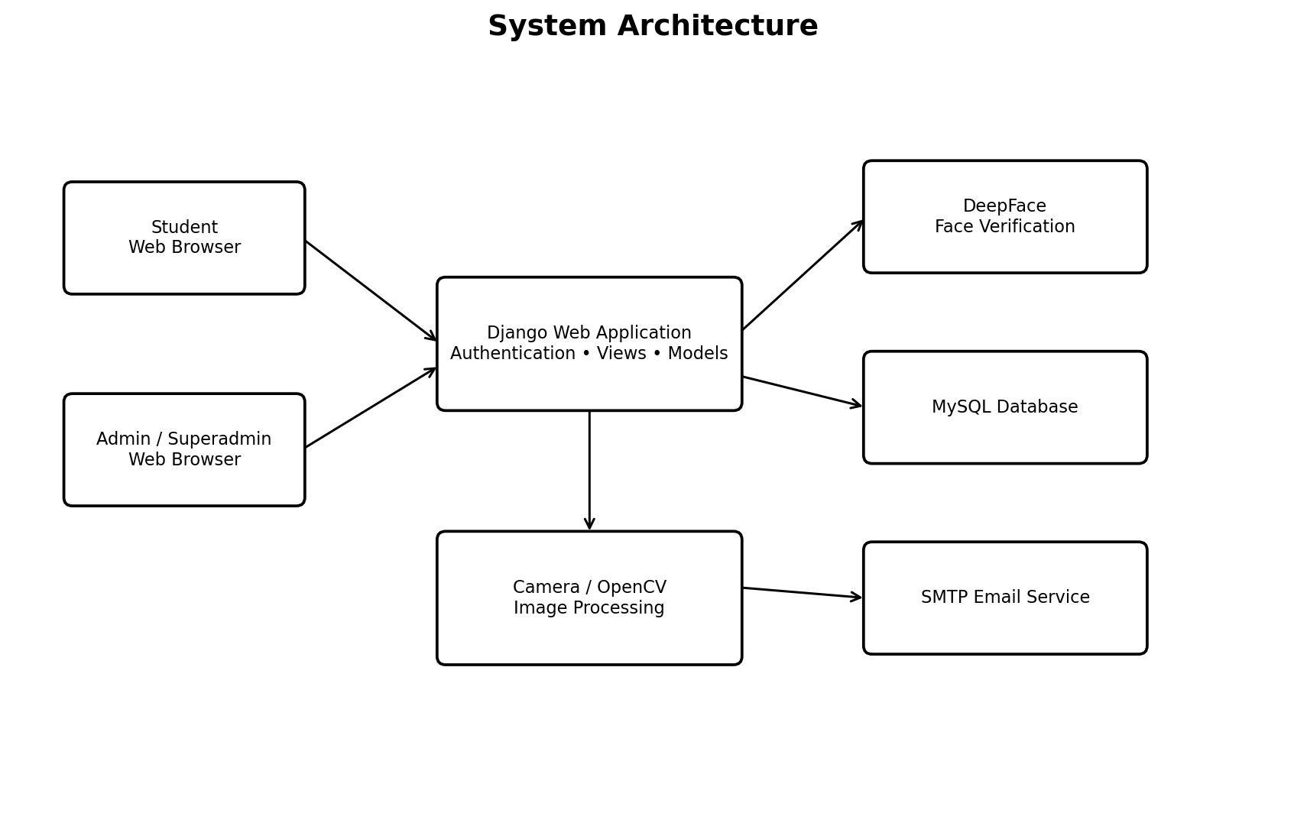
Figure 4.1. System Architecture
4.3 Overall System Workflow
The overall workflow begins with student registration and face-image registration. The Superadmin approves the student account. After login, the student submits attendance through the camera. The captured face is verified against the registered face image using DeepFace. If verification is successful, the attendance record is created with PENDING status. An Admin or Superadmin reviews the request and changes the status to APPROVED or REJECTED. An approval generates an email notification to the student.
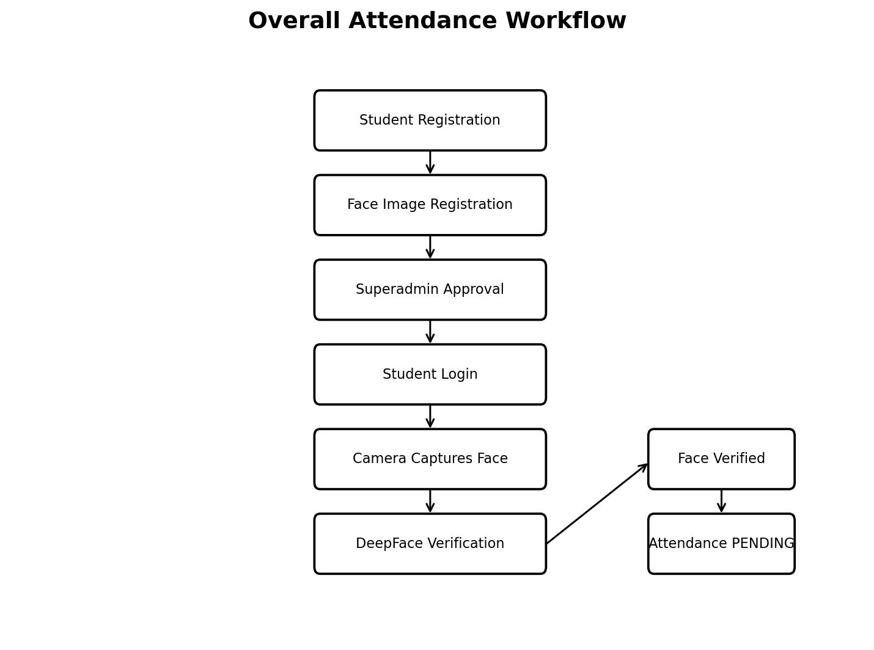
Figure 4.2. Overall Attendance Workflow
4.4 User Roles
The system contains three primary user roles. Each role has specific permissions and responsibilities.
Role | Responsibilities
STUDENT | Register account, provide face image, log in after approval, submit attendance, view attendance history, and view profile.
ADMIN | Log in and review attendance requests; approve or reject attendance according to assigned permissions.
SUPERADMIN | Approve student registrations and review, approve, or reject attendance requests.
4.5 Use Case Diagram
The use case diagram represents the interactions between the three system roles and the major functions provided by the application.
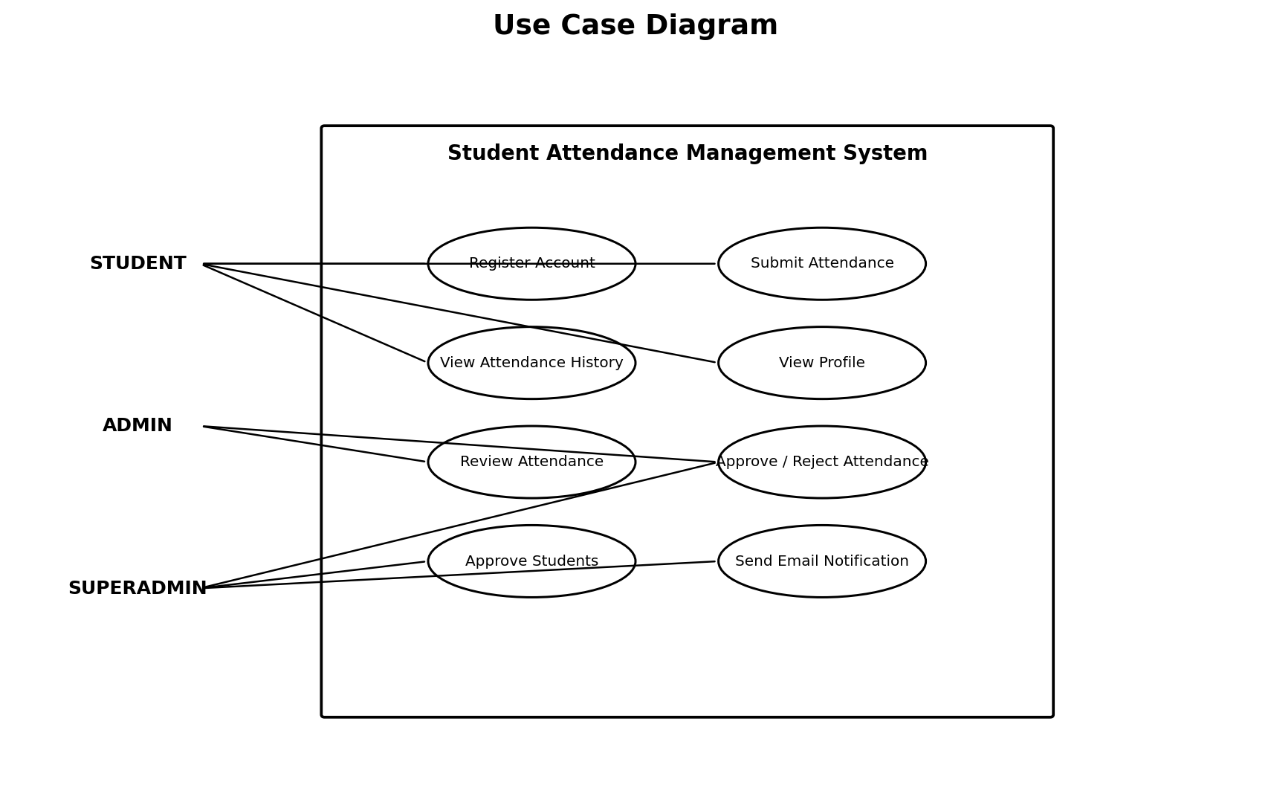
Figure 4.3. Use Case Diagram
4.6 Data Flow Diagram
The data flow diagram shows the movement of student registration information, attendance information, approval information, database operations, and email notification between external users and the Student Attendance Management System.
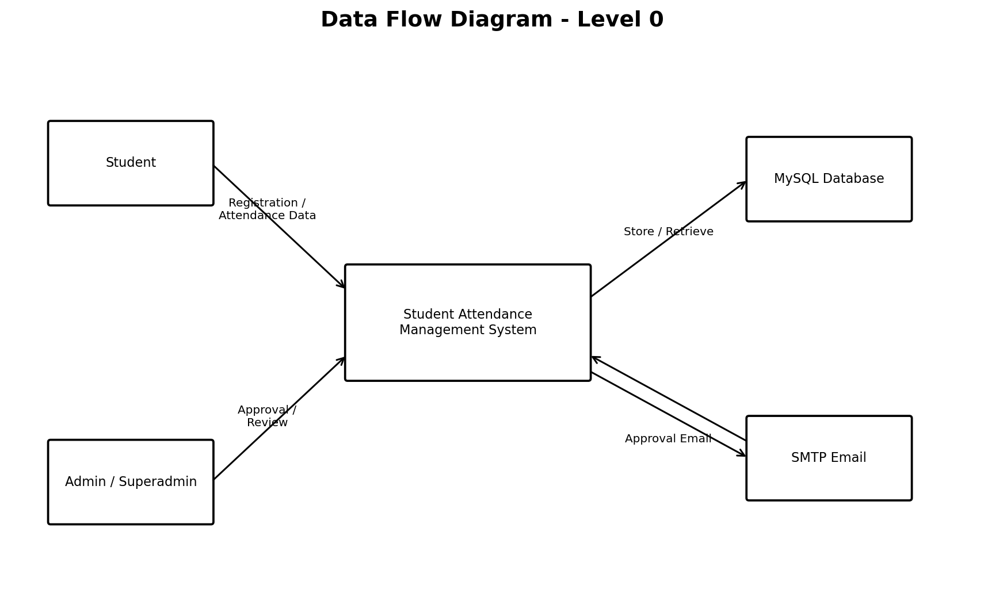
Figure 4.4. Data Flow Diagram - Level 0
4.7 Activity Diagram
The activity diagram describes the sequence of activities performed when a student submits attendance. The process includes login, opening the attendance page, capturing the face, DeepFace verification, creation of a pending attendance record, and administrative review.
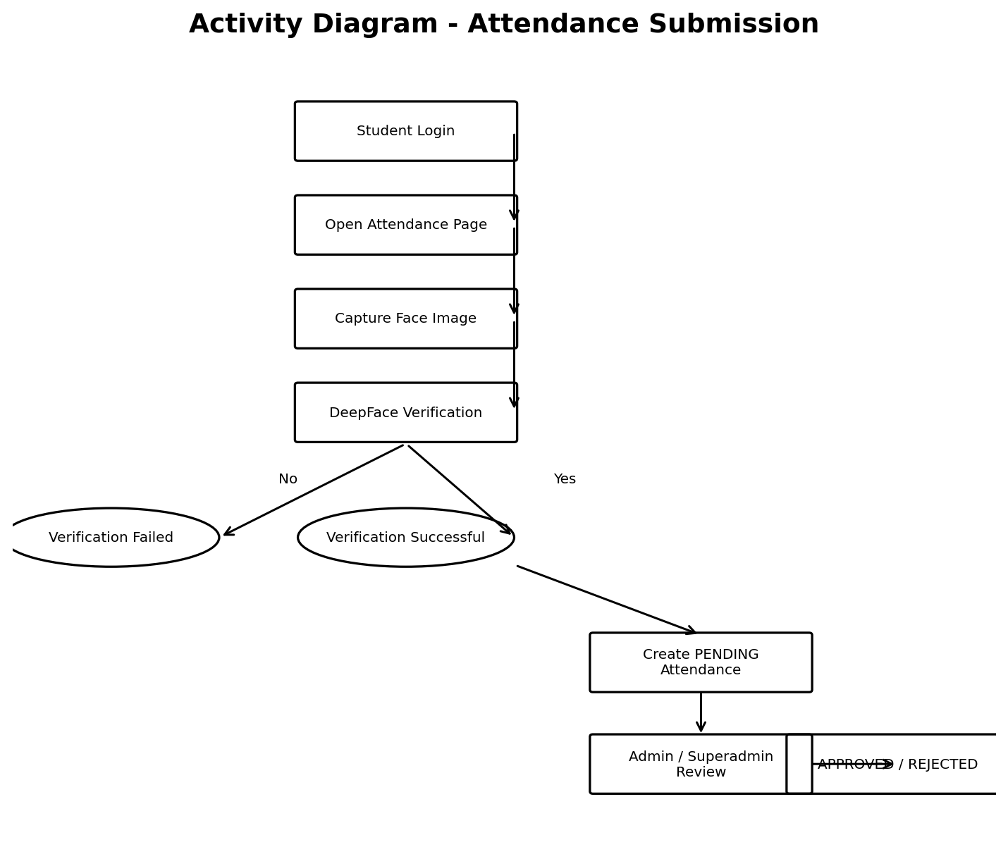
Figure 4.5. Activity Diagram - Attendance Submission
4.8 Sequence Diagram
The sequence diagram describes the interaction between the student, browser, Django application, DeepFace verification component, MySQL database, and administrator during attendance submission and review.
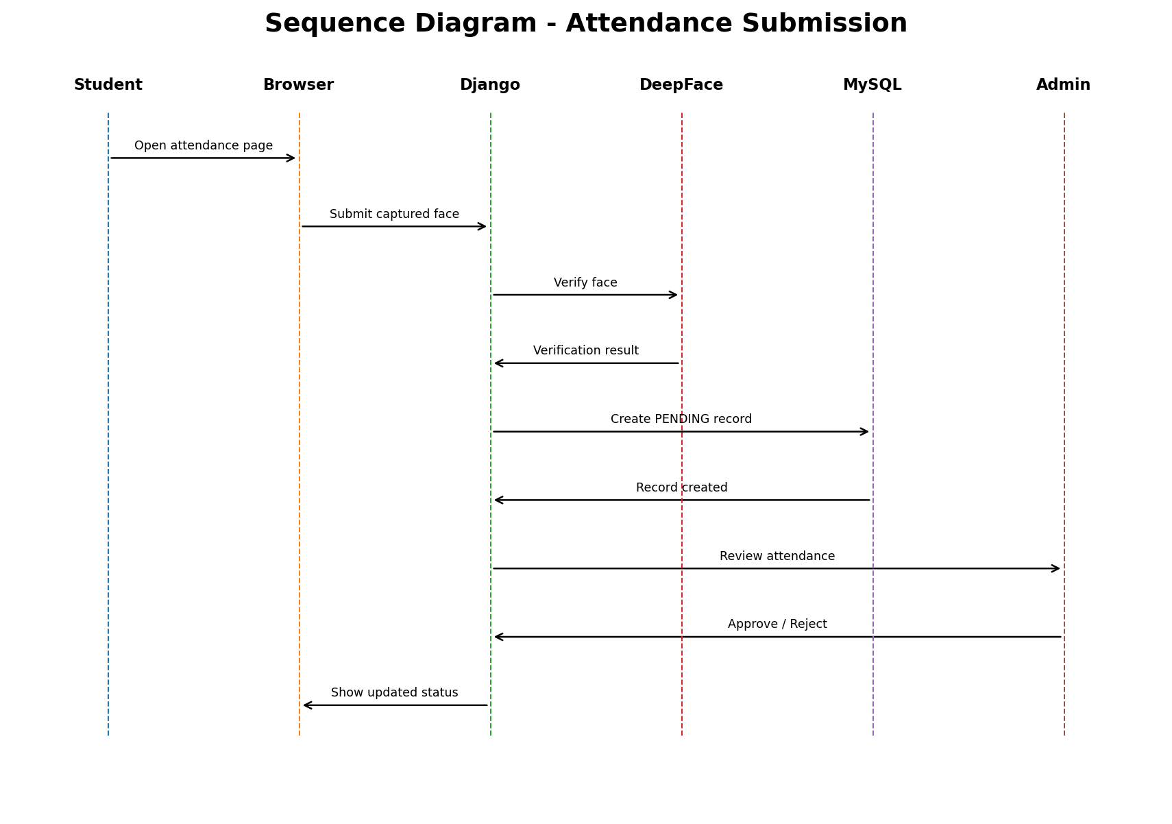
Figure 4.6. Sequence Diagram - Attendance Submission
4.9 Database Design
The system uses MySQL as its relational database. The main application data is represented through the User/Student and Attendance entities. The User/Student entity stores account and profile information including role, approval status, and face image. The Attendance entity stores the student reference, attendance date, and attendance status.
One student can have multiple attendance records. Therefore, the relationship between the User/Student entity and the Attendance entity is one-to-many. Each attendance record belongs to one student.
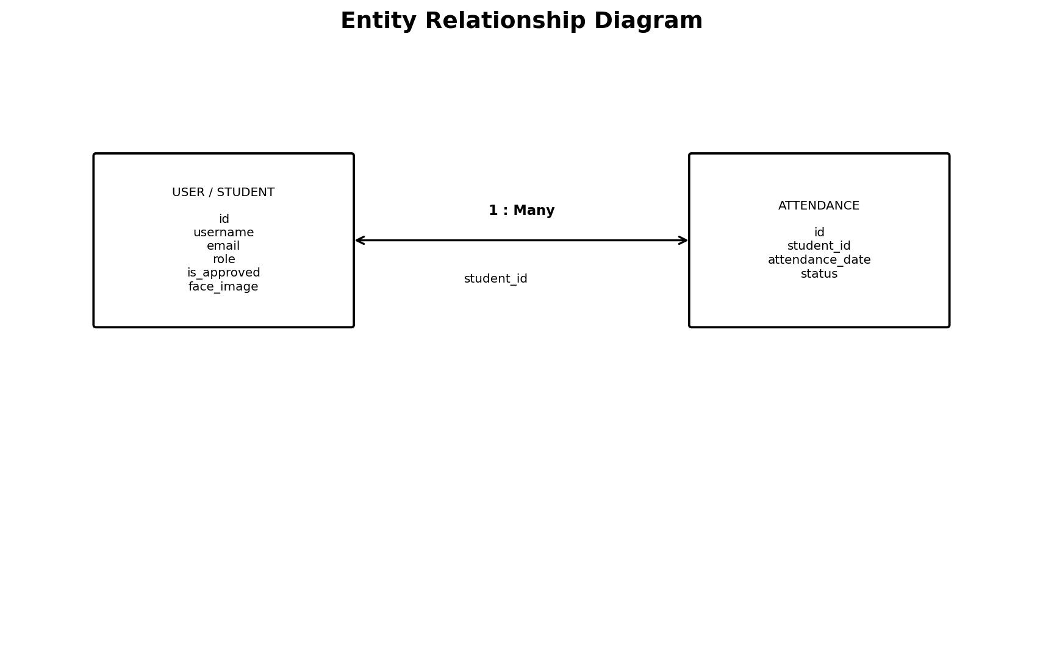
Figure 4.7. Entity Relationship Diagram
4.10 Database Entities
4.10.1 User / Student Entity
The User/Student entity represents registered users of the application. It contains information such as username, first name, last name, email, password-related authentication information, role, approval status, and registered face image.
4.10.2 Attendance Entity
The Attendance entity stores attendance records associated with students. Important attributes include the student reference, attendance date, and status. The attendance status can be PENDING, APPROVED, or REJECTED.
4.10.3 Django Authentication Data
Django Authentication also maintains standard authentication-related information such as users, groups, permissions, and sessions according to the configured Django application and authentication setup.
4.11 Attendance Status Design
The attendance status follows a simple state-based workflow:
PENDING → APPROVED
PENDING → REJECTED
A successfully verified attendance submission is initially stored as PENDING. An authorized Admin or Superadmin then reviews the request. The record is changed to APPROVED when accepted or REJECTED when not accepted.
4.12 Face Verification Design
The face verification process uses the registered face image as the reference image. During attendance submission, the student's camera captures a current face image. The system passes the relevant images to DeepFace for verification. When the verification result indicates a successful match, the attendance record is created with PENDING status. When verification fails, attendance submission is not accepted.
4.13 System Design Summary
The system design combines web application components, facial verification, database management, role-based access, attendance status management, and email notification into a single workflow. The architecture and diagrams presented in this chapter provide the design foundation for the implementation described in the next chapter.

