CHAPTER 7
USER INTERFACE
7.1 Introduction
The Student Attendance Management System provides a web-based user interface for students, Admins, and Superadmins. The interface is designed to provide access to registration, authentication, attendance submission, attendance history, profile information, student approval, and attendance approval functions according to the user's role.
The following sections present the major screens of the implemented application. The screenshots show the actual user interface of the Student Attendance Management System.
7.2 Base Page
The base page provides the common layout of the application. It contains the Student Attendance Management System branding, navigation menu, account options, and the main content area. The navigation options displayed to a user depend on the user's authentication status and role.
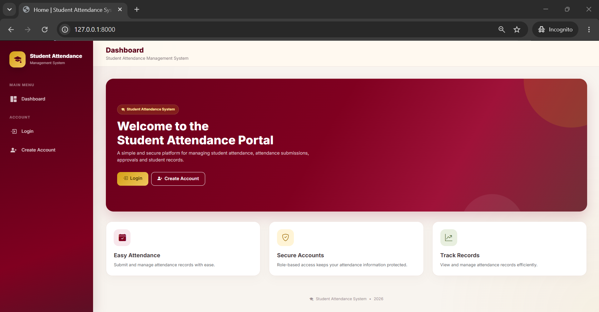
Figure 7.1. Student Attendance Management System Base Page
7.3 Login Page
The login page allows registered users to sign in to the Student Attendance Management System. The user enters a username and password and selects the Login option. Django Authentication is used to authenticate the user's credentials and establish an authenticated session.
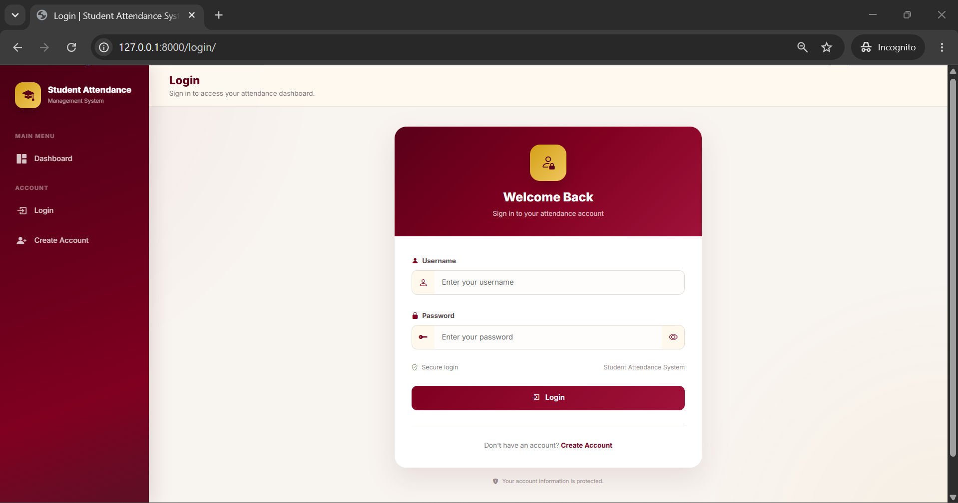
Figure 7.2. User Login Page
7.4 Student Registration Page
The student registration page allows a new student to create an account. The form collects the username, email address, first name, last name, face image, password, and password confirmation. The registration page also informs the student that the account requires approval before it can be used.
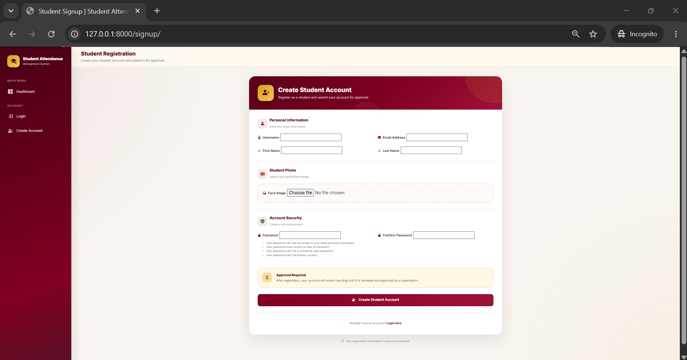
Figure 7.3. Student Registration Page
7.5 Student Dashboard
The Student Dashboard is the main interface displayed after a student logs in. It identifies the account role and account status and provides access to attendance-related functions. The dashboard contains options for submitting attendance, viewing attendance records, and accessing the student profile.
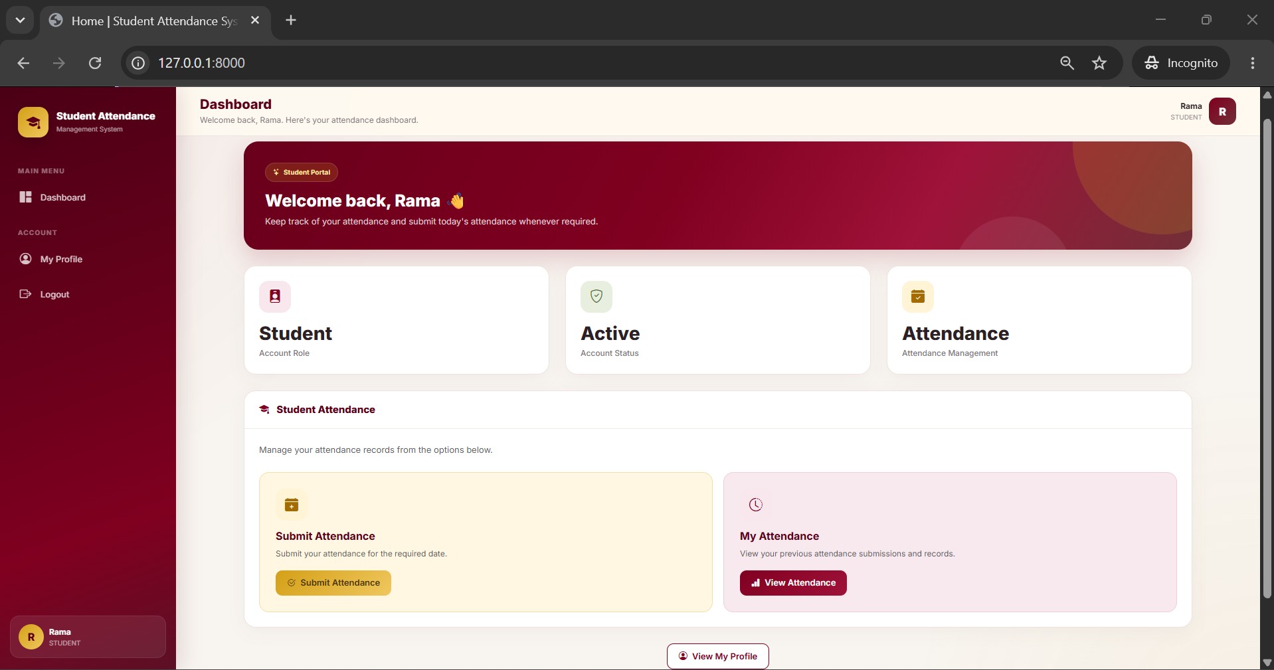
Figure 7.4. Student Dashboard
7.6 Student Attendance Page
The student attendance page provides access to the attendance management functions available to the student. The student can submit attendance and view previously submitted attendance records through the corresponding options.
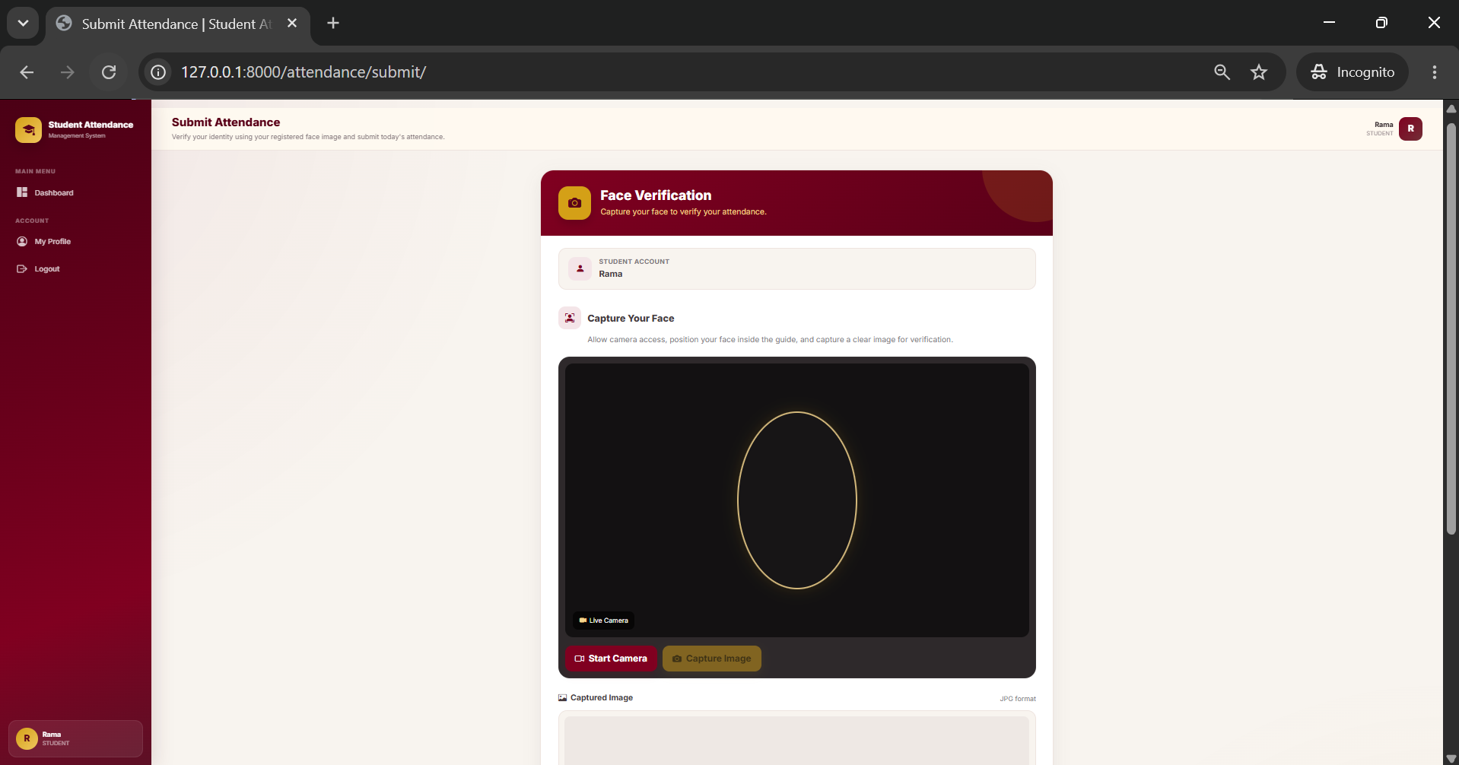
Figure 7.5. Student Attendance Page
7.7 Attendance Submission and Face Verification Page
The attendance submission page provides the face verification interface. The page identifies the logged-in student and provides a camera area for capturing the student's face. The student starts the camera, positions the face inside the displayed guide, and captures an image for verification.
The captured face image is used for comparison with the student's registered face image through the DeepFace verification workflow. Successful verification allows the attendance submission process to continue.
Figure 7.6. Attendance Submission and Face Verification Page
7.8 Student Profile Page
The student profile page displays the personal information associated with the student's account. The interface provides information such as username, email address, first name, last name, account role, account approval status, and the registered face image.
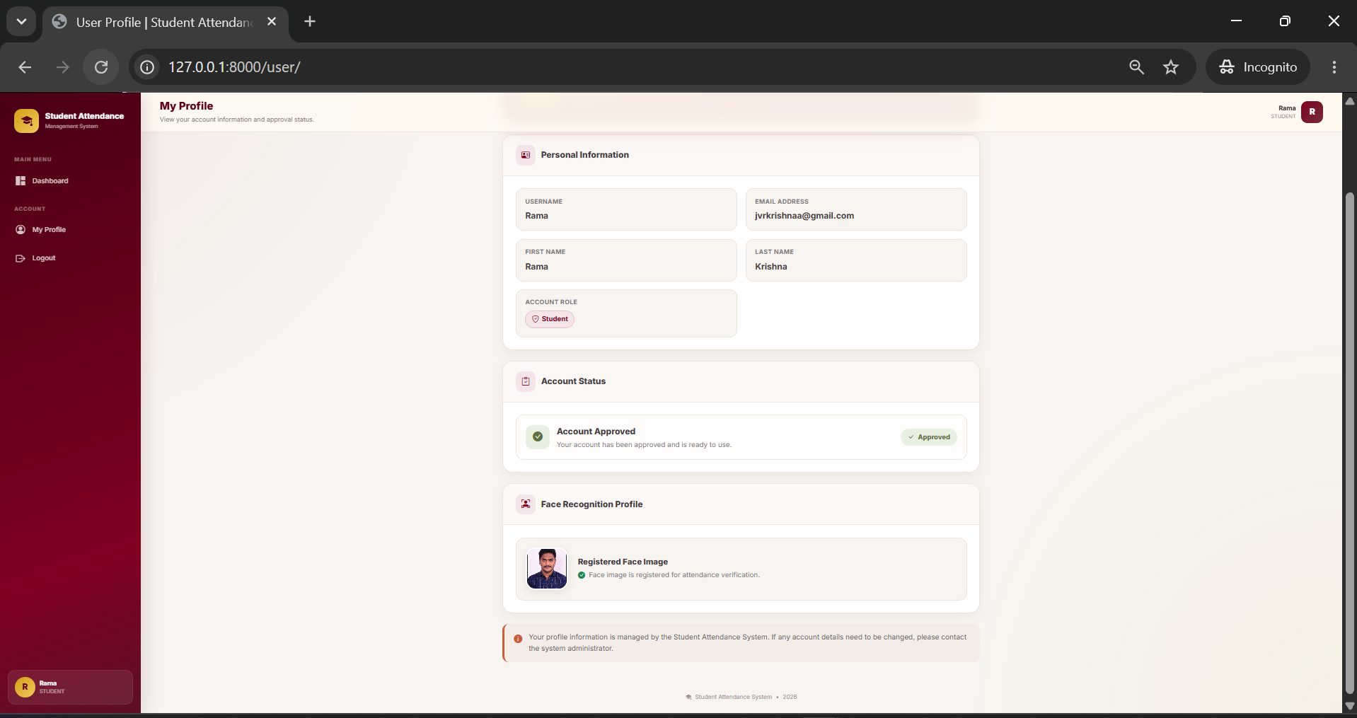
Figure 7.7. Student Profile Page
7.9 Student User Profile
The user profile interface provides the student's registered profile and face-recognition information. The registered face image is displayed as the reference image used for attendance verification.
Figure 7.8. Student User Profile and Face Recognition Information
7.10 Admin Dashboard
The Admin Dashboard provides administrative access to attendance management. The dashboard identifies the user as an Admin and provides an Attendance Approvals section for reviewing and managing submitted attendance records.
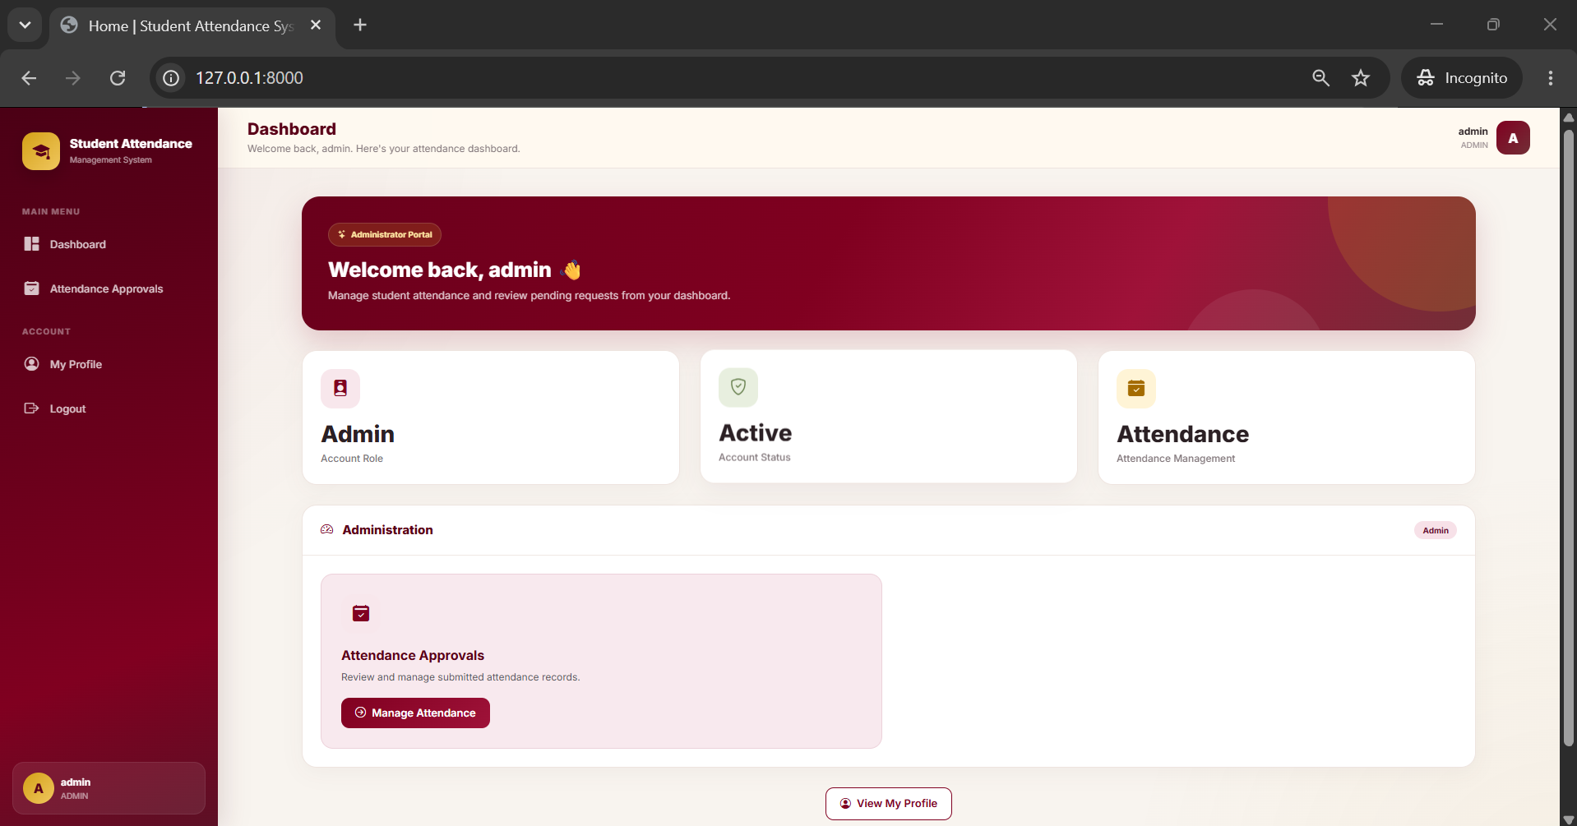
Figure 7.9. Admin Dashboard
7.11 Superadmin Dashboard
The Superadmin Dashboard provides the administrative functions available to the Superadmin role. It provides access to Attendance Approvals and Student Approvals. Student Approvals allows the Superadmin to review and approve new student registrations, while Attendance Approvals provides access to submitted attendance records.
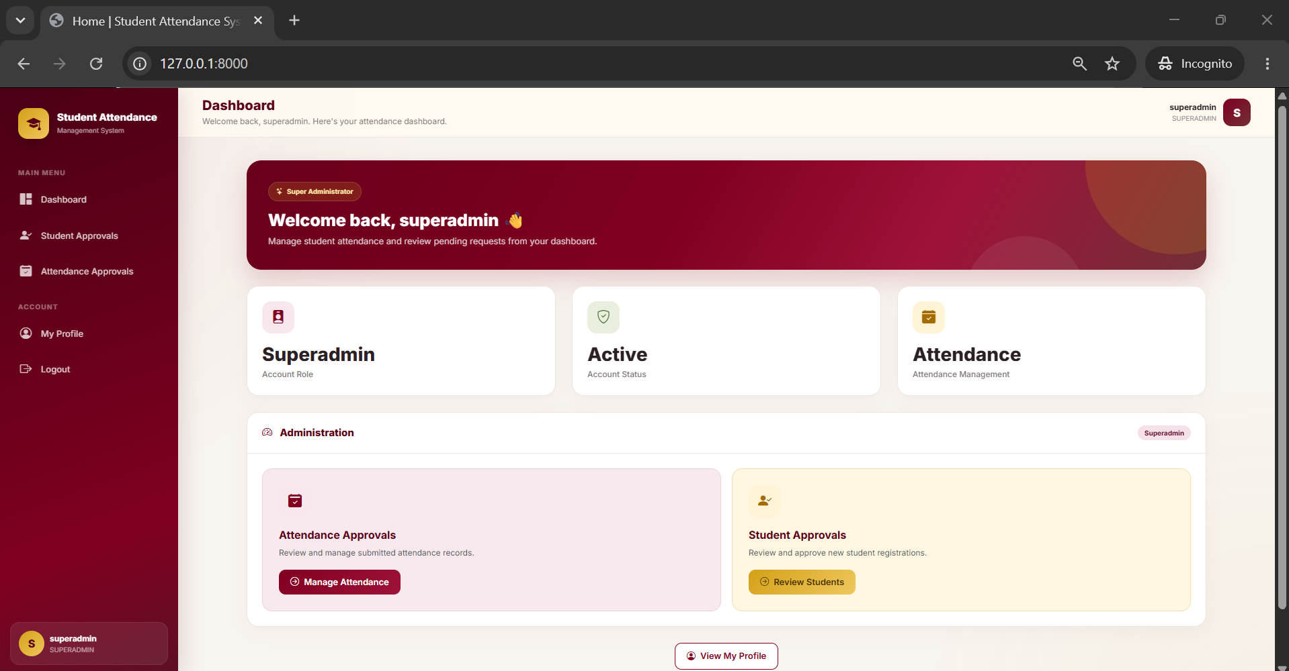
Figure 7.10. Superadmin Dashboard
7.12 User Interface Summary
The implemented user interface provides separate functionality according to the user's role. Students can register, log in, submit attendance through face verification, view attendance information, and access their profile. Admins can review attendance submissions, while Superadmins can manage student approvals in addition to attendance approvals.
The interface integrates the major functions of the system into a consistent web-based design and provides the screens required for student and administrative attendance management.

