**Баланc по I2**

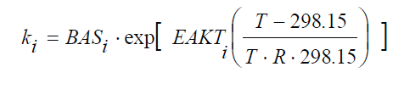

Без учета конденсации пара.

d I2G /dt = - k(4) I2G Spaint,G/VG + k(62) Iwall Spaint,G/(VG·1000)

d Iwall /dt = + k(4) I2G 1000 - k(62) Iwall

BAS(4) 4.0E-3 (m/s), EAKT(4) = 0

BAS(62) 5.0E-9 (1/s), EAKT(62) = 8.22E+4 (J/mol)

SPAINT,G painted surface area (m2)

VG volume of gaseous phase (m3)

Iwall- (mol/m2)

I2g- (mol/l)

С учетом конденсации пара

d I2G /dt = - k(4_1) I2G (SPAINT,G/VG) + k(6_2) Iwall Spaint,G/(VG*1000)

d Iwall /dt = + k(4_1)(1-X) I2G 1000 - k(62) Iwall

d I2w /dt = + k(4_1) X I2G (SPAINT,G/VS)

BAS(4_1) 3.1E-3 (m/s), EAKT(4_1) = 0

BAS(6_2) 8.8E-8 (1/s), EAKT(6_2) = 2.72E+4 (J/mol)

X-0.68 (default), Х- fraction of deposit I2 onto paint which washed down in sump

SPAINT,G -painted surface area (m2)

VG -volume of gaseous phase (m3)

VS -volume of sump (m3)

I2w- concertation in sump (mol/l)

**Образование CH3I**

d CH3IG /dt = + k(14) (2*Iwall)g (SPAINT,G/(VG·1000))

d Iwall /dt = - k(14) (2*Iwall)g (1/2)

BAS(14) = 3E-12 (mol0.5/(m*s)), EAKT(14) = 7.84E+4 (J/mol)

g = 0.5

**Распределение между водным и газовым объемом для не кипящего бассейна**

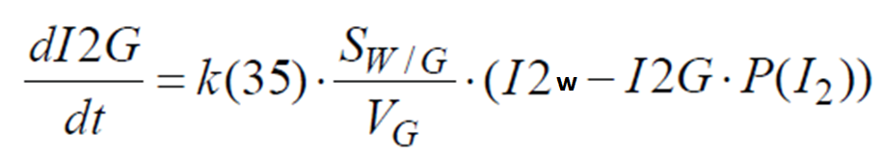

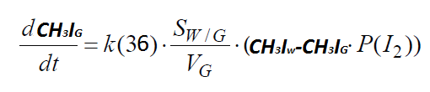

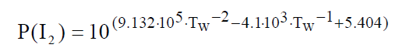

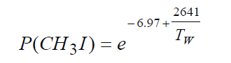

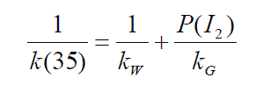

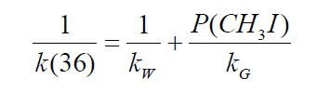

СН3Iw – concentration of methyl iodide in sump (mol/l)

SW/G – interfacial surface area water/gas (m2)

VG -volume of gaseous phase (m3)

Tw – sump temperature (K)

KG -1.4E-3 (m/s)

Kw – 1.0E-5(m/s)