📄 Project Assignment Report: Traffic Signal Synchronization System
Project Title: Traffic Signal Synchronization System Using Chinese Remainder Theorem
Course / Assignment: Number Theory & Discrete Mathematics Application
Team Leadership: Justin Joe Mathew (Team Lead)

💡 Does Traffic Signal Synchronization Demo CRT or just LCM/GCD?

Mathematical Distinction:
- LCM (Least Common Multiple) / GCD:
Used when all signals start at Minute 0 with NO remainder/offset. If Signal 1 (3 min), Signal 2 (5 min), and Signal 3 (7 min) all turn green at Minute 0, the next simultaneous green light is simply $\text{LCM}(3, 5, 7) = 105$ minutes.
- CRT (Chinese Remainder Theorem):
REQUIRED when signals have DIFFERENT REMAINDERS / OFFSETS.
In our project scenario:
- Signal 1 (3-min cycle) turned green 2 minutes ago $\rightarrow x \equiv 2 \pmod 3$
- Signal 2 (5-min cycle) turned green 3 minutes ago $\rightarrow x \equiv 3 \pmod 5$
- Signal 3 (7-min cycle) turned green 2 minutes ago $\rightarrow x \equiv 2 \pmod 7$
Because the remainders ($2, 3, 2$) are non-zero and distinct, LCM cannot solve this problem. The system requires the Chinese Remainder Theorem (Extended Euclidean Algorithm & Modular Inverses) to solve for the unique green wave minute ($x = 23$).
👉 Conclusion: The project is a genuine demonstration of CRT, specifically showcasing why CRT is needed over simple LCM when real-world cycles start at different offsets.

📷 Physical Hardware Prototype & Digital Twin Interface
The project includes both a physical Arduino Nano breadboard circuit and a full digital twin web simulator.
👉 Interactive Web App & Project Repository: https://github.com/jvstin47/CRT--Chinese-Reminder-Theorem (Local Dev Server: http://localhost:5173/)
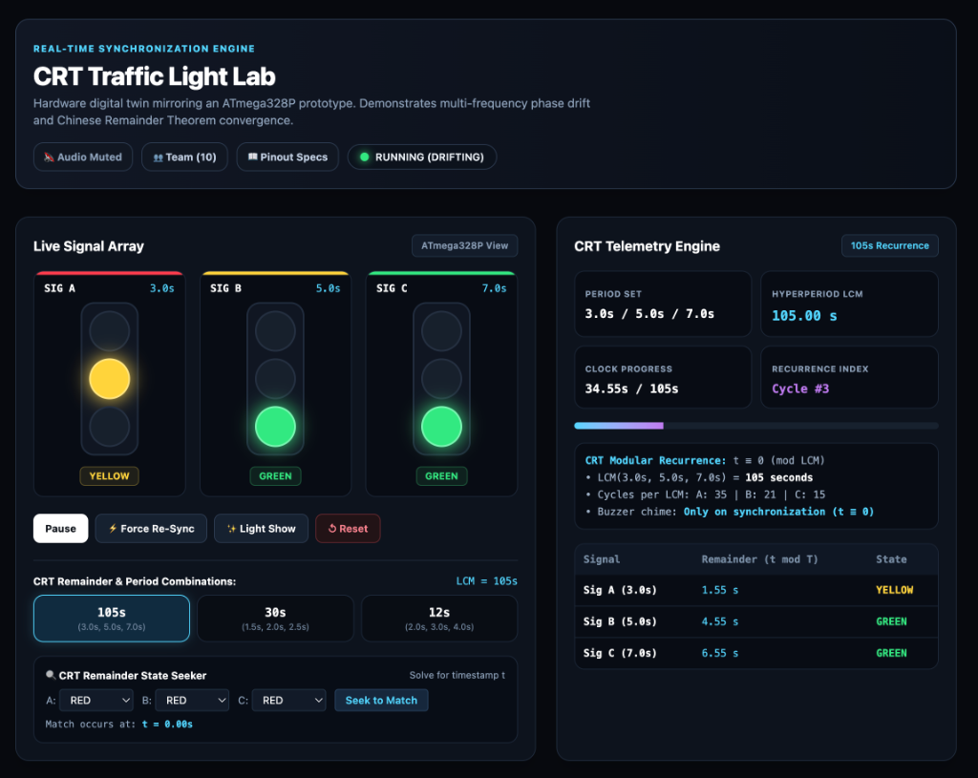
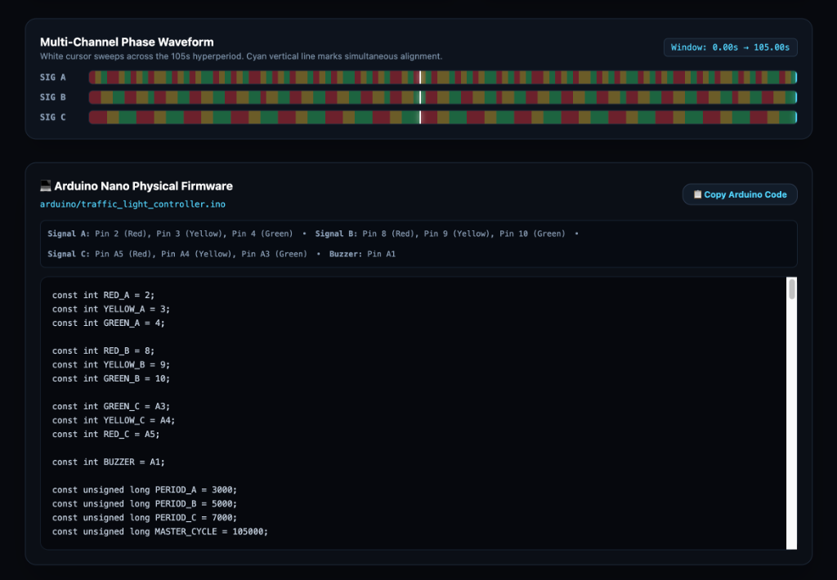
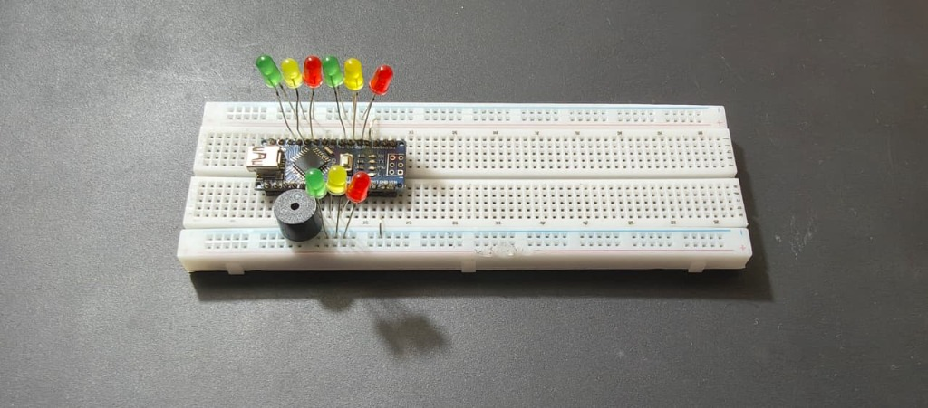
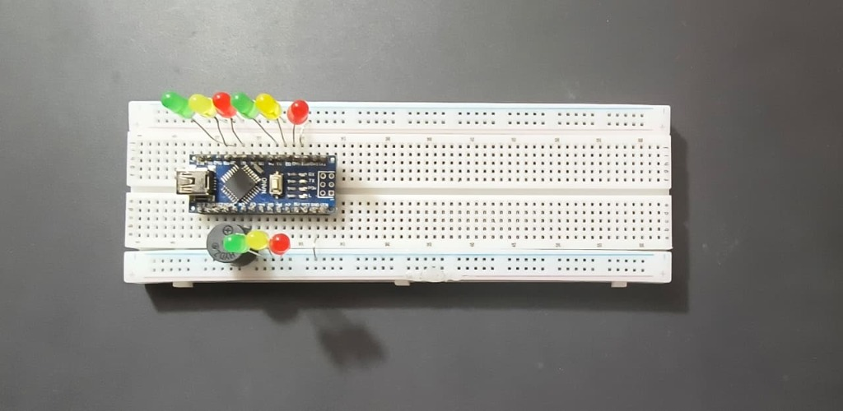

👥 Group Member Roles & Work Division (10 Members)
┌────────────────────────────────────────────────────────────────────────────────────────┐
│ PROJECT TEAM STRUCTURE │
├─────────────────────────────────────┬──────────────────────────────────────────────────┤
│ 1. Project Leadership & Model │ Justin Joe Mathew (Team Lead) & Jyothis Liju │
│ 2. Hardware Sourcing & Build Testing│ Joseph Alex & Joseph J │
│ 3. Web Design & Frontend │ Johan Geo & Johaan Sam │
│ 4. Presentation & Showcase │ Joel Geo Manuel │
│ 5. Mathematics & Applications │ Joel Duke, Jyothika Prakash, & Jose Alex │
└─────────────────────────────────────┴──────────────────────────────────────────────────┘

📝 Detailed Team Member Contribution Breakdown

1. Project Leadership & Working Model Construction
👥 Team Members: Justin Joe Mathew (Team Lead) & Jyothis Liju
- Justin Joe Mathew (Team Lead): Led overall system architecture, physical 3-intersection breadboard prototype assembly, and written C++ firmware (traffic_light_controller.ino) for Arduino Nano timing and acoustic chime feedback. Established full integration with the digital twin web app.
- Jyothis Liju: Co-developed the physical working model, wiring digital output pins (Pins 2–10) and analog pins (A1, A3–A5), conducted real-time signal timing tests against C++ firmware modulo logic, and verified acoustic piezo chime synchronization.

2. Hardware Sourcing, Bench Testing & Application Design
👥 Team Members: Joseph Alex & Joseph J
- Joseph Alex: Selected and acquired physical electronic components, including Arduino Nano microcontrollers, breadboards, 220Ω resistors, 9 LED traffic clusters, and piezo buzzers. Executed bench testing, GPIO voltage verification, and continuity checks.
- Joseph J: Handled part procurement, assembly testing, and application domain research. Mapped CRT modular congruences to real-world intelligent transportation systems (ITS), fiber-optic telecommunications multiplexing, and parallel computing architectures.

3. Web Design & Frontend Engine Development
👥 Team Members: Johan Geo & Johaan Sam
- Johan Geo: Designed the complete visual layout, dark laboratory aesthetic, and responsive layout system using Tailwind CSS v4. Created custom SVG circular monitor displays, interactive dial controls, and status panels.
- Johaan Sam: Engineered the interactive web application frontend and state engine using React 19 and TypeScript. Developed 60 FPS animation loops, telemetry sweep cursors, dynamic CRT remainder solver, and Framer Motion transitions.

4. Presentation Pacing & Showcase Lead
👥 Team Member: Joel Geo Manuel
- Joel Geo Manuel: Authored the 2-speaker presentation script between driver Alex and tech lead Sam, structured demo pacing around 3s/5s/7s signal cycles, prepared the slide deck visual layout, and coordinated acoustic chime feedback during live demonstrations.

5. Mathematics, Proofs & Pedagogical Systems
👥 Team Members: Joel Duke, Jose Alex, & Jyothika Prakash
- Joel Duke: Researched linear congruences for traffic signal timing cycles. Formulated 3-intersection system equations for 3s, 5s, 7s cycles with non-zero remainder offsets, proved coprimality of moduli ($\gcd=1$), and computed modular inverses ($y_1=2, y_2=1, y_3=1$).
- Jose Alex: Verified mathematical proofs and uniqueness bounds modulo $M=105$. Conducted formal Extended Euclidean Algorithm inverse calculations, validated remainder offset equations against theoretical bounds, and analyzed boundary edge cases.
- Jyothika Prakash: Developed the pedagogical system, progressive 3-tier educational hint engine, and explanatory learning modules. Authored step-by-step documentation translating abstract modulo congruences $x \equiv a_i \pmod{m_i}$ into intuitive traffic light timing concepts.

