DEVELOPMENT OF A LOST AND FOUND SYSTEM FOR UNIVERSITY INHABITANTS

By

EZEMA JUSTIN
(2021/243894)

A BSC PROJECT REPORT SUBMITTED IN PARTIAL FULFILLMENT OF THE REQUIREMENTS FOR THE AWARD OF BACHELOR OF SCIENCE (BSC) DEGREE IN COMPUTER SCIENCE

DEPARTMENT OF COMPUTER SCIENCE
UNIVERSITY OF NIGERIA, NSUKKA

PROJECT SUPERVISOR:
DR MRS UJU EZUGWU

OCTOBER, 2025

DECLARATION

I hereby declare that this Project report is original and written by me. It is an accurate record of my research work and has not been presented previously for the award of any other degree. All information from other sources has been acknowledged by means of references.
Should I be convicted of having cheated in this work, I shall accept the verdict of the university.

Ezema Justin
Date:

APPROVAL

This project work has been approved by the Department of Computer Science, University of Nigeria, Nsukka as meeting the requirements for the award of Bachelor of Science degree in Computer Science

Dr Mrs Uju Ezugwu Date
Supervisor

Prof. C. N. Udanor Date
Head of Department

Prof. P. M. Ejikeme Date
Dean, Faculty of Physical Sci.

DEDICATION
This project is dedicated to Almighty God, for His infinite mercy and grace throughout my academic journey,
And to everyone who stood by me through every challenge.
This work is for you.

ACKNOWLEDGEMENTS
I want to express my deep gratitude to my supervisor, Dr. Mrs. Uju Ezugwu, for her patience, helpful guidance, constructive criticism, and strong support from the proposal stage to the end of this project. Her expertise and timely feedback were essential.

I also appreciate the Head of the Department of Computer Science, Prof. C. N. Udanor, and all the lecturers whose classes laid the groundwork for this work.

I am thankful to my parents for their prayers, financial support, and encouragement during my time at the University of Nigeria, Nsukka.

I sincerely thank my friends and classmates for their cooperation, suggestions, and support.

Finally, I thank everyone who played a part in the success of this project. May God bless you all.

ABSTRACT
The regular loss of personal belongings on university campuses, especially at the University of Nigeria, Nsukka, has been a constant issue due to the lack of an organised and effective recovery system. Traditional methods like notice-board postings, word-of-mouth, and scattered social-media announcements are slow. They are hard to search, lack verification processes, and do not protect privacy. This leads to low recovery rates and increased stress for students and staff.

To address this problem, I developed FindHub, a web-based Lost and Found Management System specifically for the UNN community. The system operates on a “found-items-only” model. Only authorised administrators can register found items, while the public can search for and view them without needing any authorisation. Key features include a responsive Progressive Web App (PWA) with offline access, privacy controls to hide location and date found, optional encrypted security questions using AES-256-GCM, the ability to upload up to 10 images for each item, status tracking with an audit trail, and a secure admin dashboard.

The application was built using the Better-T Stack monorepo architecture, which includes Bun runtime, Next.js 16, Hono, Drizzle ORM, PostgreSQL, Supabase Storage, TailwindCSS, shadcn/ui, and Better-Auth. We used Agile methods and UML diagrams, including use-case, activity, class, sequence, and ER diagrams during the analysis and design phases. End-to-end testing was done with Playwright to ensure it works well, responds quickly, and is secure.

FindHub offers a clear, open, and verifiable platform that greatly improves the recovery of lost items, lowers the administrative workload, and builds trust within the UNN community. The system is ready for use and should be deployed by the university administration as soon as possible.

TABLE OF CONTENTS
APPROVAL ii
DEDICATION iii
ACKNOWLEDGEMENTS iv
ABSTRACT v
TABLE OF CONTENTS vi
LIST OF FIGURES viii
LIST OF TABLES ix
1.1 Background to the Study 1
1.2 Statement of Problem 2
1.3 Aim and Objectives of the Study 2
1.4 Scope of the Study 3
1.5 Significance of the Study 3
1.6 Limitations of the Study 4
1.7 Definition of Terms 4
2.0 Introduction 7
2.1 Theoretical Background 7
2.1.1 Concepts 7
2.1.2 Technology 8
2.2 Review of Related Literature 9
3.1 Research Methodology 14
3.2 Systems Analysis 14
3.2.1 Description of the Existing System 14
3.2.1.1 Weaknesses of the Existing System 15
3.2.2 Analysis of the Proposed System 16
a) System Architecture 17
b) Database Design 17
c) Input Design 18
d) Output Design 18
e) Algorithm / Process Design 18
f) UML Requirements Analysis Diagrams 19
3.4 Design of the Proposed System 20
3.4.1 Use Case Diagram 21
3.4.2 Activity Diagram 25
3.4.3 Class Diagram 27
3.4.4 Sequence Diagram 29
3.4.6 Database Design (logical overview) 30
Input Design (Forms & Validation) 38
D) Output Design (Screens & Responses) 39
4.0 Introduction 40
4.1 Choice of Development Environment 40
Software & Tools: 40
4.2 Implementation Architecture 41
4.2.1 Main Menu / Control Centre The system has two entry points: 42
4.2.2 Sub-menus (Admin Dashboard) 42
4.4 Input/Output Formats 42
4.5 Overall Data Flow Diagram of Proposed (Implemented) Solution 44
4.6 Software Testing 46
4.7 Documentation 46
4.7.1 Data Dictionary (Selected Tables) 46
4.7.2 User Manual (Excerpt) 47
4.8 Source Code Listing 47
5.0 Summary of Achievements 49
5.1 Conclusion 49
5.2 Recommendations 49
5.3 Suggestions for Further Work 50

LIST OF FIGURES

LIST OF TABLES

Chapter ONE
Introduction

Background to the Study
In university environments, losing personal belongings, such as identity cards, mobile devices, keys, books, and other valuables, is a common challenge for students and staff. At the University of Nigeria, Nsukka (UNN), this problem worsens due to the absence of a central platform for reporting and retrieving lost items. Traditional recovery methods, like word-of-mouth, notice board postings, and social media, are scattered, ineffective, and do not ensure that items are returned to their rightful owners (RepoApp, n.d.).

These informal methods have several drawbacks. They reach a limited audience and lack verification systems, which makes them open to fraudulent claims. Their follow-up procedures are also inconsistent. These issues lead to frustration, loss of trust, and anxiety, especially when important items remain lost (Sadiku, Ogundokun, & Abikoye, 2019).

The current approaches to handling lost and found issues at the university are mostly informal. Students and staff typically rely on word-of-mouth, announcements via friends, handwritten notes on departmental or hostel notice boards, and social media platforms like WhatsApp and Facebook to share information about lost items. Although these methods sometimes succeed, they are fragmented, lack proper organisation, and are not easy to search. Most importantly, they do not ensure verification of ownership or responsibility in the recovery process (RepoApp, n.d.). Consequently, the process is often slow, inefficient, and uncertain, leaving many lost items permanently unrecovered.

To tackle these challenges, this project creates FindHub, a lost-and-found management system aimed at UNN. Unlike informal reporting methods, FindHub offers a structured, searchable web platform that everyone can access. It allows students to browse items that campus administrators have found and documented. The system includes modern features like offline support through Progressive Web App (PWA) technology, optional security questions for sensitive items, privacy controls, and a well-organized dashboard for administrators.
With its centralised setup, FindHub provides a more efficient, clear, and secure way to manage lost items on campus.

Statement of Problem
The lack of an official, centralised lost-and-found system at the University of Nigeria, Nsukka has made recovering lost items slow and unreliable. Students and staff use fragmented methods like noticeboard postings, personal announcements, and social media messages. These methods lack permanence, structure, and any standard record-keeping. As a result, owners often have difficulty locating important items, and many found belongings go unclaimed.

Additionally, the absence of a formal reporting structure makes it hard for the university administration to ensure accountability. Sensitive or high-value items, such as identity cards, electronics, or wallets, require secure handling. However, the current informal system does not provide a consistent way to verify or protect privacy.

If these issues are not addressed, the university community will continue to face unnecessary stress, reduced trust, and preventable losses. There is a clear need for a centralised digital system that allows for efficient documentation of found items, offers an easy-to-use search interface for the public, and provides administrative tools for secure management.

FindHub aims to address this gap by providing a structured web-based solution. This system enables administrators to record found items accurately while allowing students to search for them easily.

1.3 Aim and Objectives of the Study
The aim of this study is to design and develop a UNN lost and found web application.

Specific Objectives:
- Develop an administrative interface that allows authorised staff to register found items. This should include images, categories, locations, and the date found.
- Implement a responsive public web interface where users can easily search for, filter, and view details about found items.
- Integrate privacy controls that let administrators hide sensitive information, such as the location or date found, when needed.
- Incorporate optional item security questions with encrypted answers to support verification during physical item collection.
- Build Progressive Web App (PWA) features that allow offline access to cached search results on mobile devices.
- Provide a well-structured database system for storing item details, images, categories, and status updates.

1.4 Scope of the Study
This project focuses on the design and implementation of FindHub, a lost-and-found management system for the University of Nigeria, Nsukka. Its scope includes:

- A public-facing website where users can search for lost items without needing to log in.
- An administrative dashboard for creating, updating, or deleting item records.
- A database system for storing item details, categories, security questions, images, and status history.
- Progressive Web App (PWA) functionality, which allows offline access to previously loaded data.
- Privacy and security features, including optional encrypted security questions and hidden fields.

The system does not include mobile apps, AI image recognition, user accounts for students, or automated claim verification. Retrieval of items still happens in person at the designated campus office. By clearly defining these boundaries, the study maintains a focused approach that meets the immediate lost-and-found needs among UNN students and staff.

1.5 Significance of the Study
The development of FindHub helps the university community in several ways.

For students, the system offers a reliable and convenient way to find lost items without relying on scattered announcements or unreliable social media posts. It helps reduce the emotional and financial stress that comes with losing items permanently.

For staff and administrators, FindHub creates an organised workflow for documenting found items, managing privacy preferences, and responding to inquiries. The use of security questions helps ensure safer and more accurate verification, especially for personal or valuable belongings.

The university gains improved accountability, better record-keeping, and a system that supports digital transformation efforts. FindHub shows how modern, safe web technologies, such as Next.js, TailwindCSS, PostgreSQL, and Turborepo, can be used to address real institutional problems.

Academically, this project contributes to local research on campus information systems and highlights a practical application of full-stack web development practices.

1.6 Limitations of the Study
FindHub offers a central solution for managing lost and found items at the University of Nigeria, Nsukka. However, it has significant limitations. The system only works on the UNN campus and does not include off-campus or inter-university situations. Development occurred under tight time and budget limits, which restricted testing and improvements. Reliable usage data may also be hard to find unless users consistently engage with the platform, making it tough to evaluate long-term use and satisfaction. Additionally, even with security measures, risks like false reporting or data tampering still exist. Recognising these limitations points out areas for future work, such as expanding coverage, improving resources, conducting longer assessments, and enhancing security.

1.7 Definition of Terms
- Activity Diagram: a UML behaviour diagram, shows workflows with actions, control flows, and decisions.
- Activity Partition (Swimlane): groups actions by responsible party, for example, User or System.
- Agile Development: A method for software development that involves building FindHub in iterations. This approach allows for incremental feature implementation and improvement based on user feedback.
- Authentication: The process of confirming a user's identity before allowing access to the system. FindHub uses authentication to ensure that only members of the UNN community can report or claim items.
- Better Auth: A simple authentication library built into FindHub for managing secure user login, registration, and session handling.
- Bun: A fast JavaScript runtime that executes FindHub’s backend code. It improves development speed and runtime efficiency.
- Client-Server Architecture: A software model where the client (front-end) requests services from the server (back-end). FindHub uses this model to securely process lost and found reports.
- Database Schema: The organisation structure of data within a database. In FindHub, PostgreSQL and Drizzle ORM manage the schema for items, users, and reports.
- Drizzle ORM: A TypeScript-first Object-Relational Mapping tool that interacts with FindHub’s PostgreSQL database safely.
- Lost-and-Found System: An information system that helps report, store, and retrieve lost or found items within a community. FindHub uses this concept for the UNN campus.
- Monorepo (Turborepo): An approach where multiple projects and packages are managed in a single repository. FindHub uses Turborepo to simplify builds and deployments for its front-end and back-end services.
- Next.js: A React-based framework for creating server-rendered and statically generated web applications. In FindHub, it powers the front end and ensures quick rendering.
- PostgreSQL: An open-source relational database management system that stores FindHub’s records, including user profiles, item details, and recovery logs.
- Responsive Design: A design approach that makes a web application work well across devices such as desktops, tablets, and mobile phones. FindHub is developed to ensure responsiveness and accessibility.
- ShadCN UI: A set of reusable UI components that promote consistency, accessibility, and quicker development for FindHub’s user interface.
- TailwindCSS: A utility-first CSS framework used to style FindHub’s interface, allowing for rapid prototyping and custom designs.
- TypeScript: A superset of JavaScript that adds static typing. FindHub uses it to enhance code reliability and maintainability.
- User Verification: The process of confirming that a user claiming or reporting an item is genuine. FindHub performs verification through secure logins linked to UNN credentials.
- Decision/Merge Node: splits and recombines alternate flows, represented by a diamond.
- Fork/Join Node: starts and ends concurrent flows, indicated by a thick bar.

Chapter TWO
Literature Review

2.0 Introduction
This chapter provides a detailed review of the literature that supports the design and implementation of the FindHub lost-and-found web application. It starts with the theoretical background, defining and discussing key concepts and technologies for information systems and community-driven platforms. Next, it looks at related works, including existing digital and analogue solutions for lost-and-found systems, especially in educational settings. Finally, it points out the research gap, highlighting how FindHub’s approach, which is tailored to the University of Nigeria, Nsukka, addresses the shortcomings of current systems.

By examining the development of lost-and-found systems, both traditional, such as notice-board methods, and digital, like university-based web and mobile applications, this chapter places the current study within a wider scholarly and practical conversation. In this context, FindHub is seen not just as a technological solution but also as a relevant innovation in campus informatics and building trust within the community.

2.1 Theoretical Background
This section looks at important ideas and the technology behind FindHub, a community-driven lost-and-found web application for the University of Nigeria, Nsukka. The background is as follows:

2.1.1 Concepts
- Community Informatics provides a foundational perspective for FindHub. This interdisciplinary field explores how information and communication technologies can empower communities, build social connections, and support culturally relevant development (Gurstein, 2007; What is Community Informatics?, n.d.). FindHub embodies this principle by aiming to bring together the UNN community, including students, staff, and administration, into a participatory ecosystem for reporting and recovering lost items.

- Systems Theory also influences FindHub’s design. It views organisations or communities as cohesive systems with interacting and dependent components. This view emphasises how changes in one part can affect the entire system (Systems Theory, 2025). FindHub works within the university system by integrating users, authentication, reporting processes, and database workflows into one unified information system.

2.1.2 Technology
- Web-based lost-and-found systems have been used in different institutions. For example, Tan and Chong (2023) created a web and mobile system at the National University of Malaysia (UKM). It includes secure login, item listings, image attachments, and automation for handling unclaimed items. This system improved retrieval efficiency and authenticity. ResearchGate. Similarly, the CampusTrace system provides a centralised database, image uploads, and a user-friendly interface. These features improve reporting workflows and recovery rates (Abhiram et al., 2024). irojournals.com.
- Information Architecture (IA) deals with the structural design of shared information environments. It outlines how information is categorized, stored, labeled, and retrieved in a way that enhances findability.
For FindHub, IA is important because users must be able to search through items efficiently. The system uses:
- structured categories (ID cards, electronics, documents, keys, etc.),
- filters and sorting,
- a search-first layout,
- consistent metadata (date found, location, status),
- and clear item detail pages.
Effective information architecture reduces search time and improves accuracy—crucial for a lost-and-found environment where urgency is often high.

In summary, these technologies contribute to the technical framework of FindHub. They combine secure authentication, centralised database design, web and mobile integration, user experience, and accountability into a unified system designed for campus needs.

2.2 Review of Related Literature
UKM Lost-and-Found (Tan & Chong, 2024) - This project created a web and mobile system for the National University of Malaysia. It features login capabilities, item listings, images, security questions for each post, and a disposal policy after one month. The technology stack includes PHP and MySQL. This shows the benefits of a centralised campus system. However, it uses generic security questions and legacy LAMP tools. It also mixes lost and found postings without typed end-to-end APIs or clear matching and audit trails. FindHub addresses these issues with UNN-verified authentication, a “found-only” intake, evidence-based claims, and a type-safe stack.

AppalLOCATE (Wilson, 2023) - This is a Vue.js web prototype for Appalachian State University. It lets users report items with specific locations and explore notifications based on proximity along with cloud storage options. It validates the campus use case but does not have UNN-style identity verification, typed contracts, or a governed claim workflow. FindHub adds structured matching, audit logs, and a restricted “found-only” reporting model to reduce spam and ease moderation.

IFOUND (Sadiku et al., 2019) - This web system for a Nigerian university connects to campus security. Administrators upload found items, while owners search for them and answer identity questions to claim their possessions. While it shows the Nigerian context, it focuses on administrative data entry and manual verification. FindHub improves this with verified user accounts, automated scoring for claim evidence, searchable indexes, and complete audit trails using a modern TS/PostgreSQL stack.

CampusTrace (2024) - This platform is built with PHP and MySQL. Anyone can report items without logging in, admins verify these reports, and users contact admins to claim items. It demonstrates the workflow but does not ensure identity assurance, typed APIs, or detailed audit trails. FindHub enhances this with Better-Auth using UNN emails, role-based review, and a combined “found-only + search” approach to reduce fraudulent postings while maintaining transparency.

IJRASET Lost & Found Web App (2024) - This app employs modern web technology, including Next.js, NextAuth, Tailwind, and Prisma/MongoDB, for community lost-and-found efforts with direct contact numbers in listings. While innovative, it lacks campus governance, UNN-specific verification, structured matching, and an auditable claims chain. FindHub maintains a modern user experience while incorporating campus verification, evidence checks, and PostgreSQL-backed audit logs.

Cal Poly Pomona Lost-and-Found (Kaur, 2017) - This early distributed web service helped students post and search for lost and found items. It emphasises database-backed listings and basic authentication. While historically useful, it predates typed stacks, objective match scoring, and privacy-aware claim verification. FindHub moves forward with type safety using TypeScript and oRPC, a found-only intake process, and governed claim decisions.

Cavite State University System (Canonigo & Oribello, 2022) - This undergraduate thesis developed a web-based information system for campus lost-and-found efforts. It highlights the need within the institution but provides little detail on verification, auditability, or typed interfaces. FindHub offers stronger identity verification through Better-Auth, structured claims, and robust data modelling using Drizzle ORM and PostgreSQL.

VNR VJIET Campus System (IJERT, 2022) - This platform allows only admins to post found items. Users must log in to claim items, and it includes email notifications and basic string-matching search methods. It has a donation/disposal policy for unclaimed items. FindHub’s “found-only” intake is similar but includes typed APIs, objective matching scores, and precise reviewer roles and audit logs.

“LostAndFound” for College Campus (IJFANS, 2024) - This Django/MySQL app is designed for college settings. It has email notifications and general posting for lost and found items. However, it does not clarify campus-level identity proof, reviewer roles, or evidence-weighted claim checks. FindHub streamlines the process by using a found-only system, verifying users, and recording clear decision trails for accountability.

UiTM Web-Based Lost-and-Found (Muhamad Ilias, 2021) - This proposal outlines a web system for tracking and managing lost-and-found items on campus. It emphasises the need for digital solutions but is focused on methodology. It lacks specific, type-safe implementation details and verified claim workflows. FindHub addresses these gaps with Next.js and TypeScript, Hono plus oRPC, and Drizzle schemas that utilise campus-verified identities.
These works show that although digital lost-and-found systems are appearing in universities and communities, few of them offer a solution designed for UNN. None exists within Nigeria. FindHub stands out by filling this gap. It provides a modern, safe, community-focused, and effective system.

Table 2.1 Comparison of exisiting systems vs FindHub
Work (Year) | Context & Key Features | Gaps vs. FindHub | How FindHub Fills Them
UKM Lost-and-Found (Tan & Chong, 2024) | Web + mobile system; login; item listings; images; security questions; one-month disposal policy; PHP/MySQL. | Uses generic security questions; mixed lost & found posting; legacy LAMP tools; lacks typed APIs and audit trails. | Provides encrypted, item-specific security questions; uses a found-only intake; adopts type-safe TS/PostgreSQL stack; maintains full audit logs.
AppalLOCATE (Wilson, 2023) | Vue.js prototype; users report items with exact locations; proximity-based notifications; cloud storage. | Lacks UNN identity verification; no typed contracts; no governed claim workflow; user-generated postings increase spam. | Uses UNN-verified Better-Auth; adopts typed oRPC APIs; employs reviewer-based verification; limits posting to admins to prevent spam.
IFOUND (Sadiku et al., 2019) | Nigerian university context; admins upload found items; owners search and answer identity questions. | Manual verification; no evidence scoring; basic database workflows; lacks indexes and typed stack. | Adds encrypted security questions, automated evidence scoring, searchable indexes, structured claims, and a TS/PostgreSQL architecture.
CampusTrace (2024) | PHP/MySQL; public can report items without login; admins verify; users contact admins to claim. | No identity assurance; untyped APIs; weak auditability; open submissions lead to potential abuse. | Implements campus-verified Better-Auth; uses role-based review; produces end-to-end audit logs; restricts posts to verified admins.
IJRASET Lost & Found Web App (2024) | Next.js, NextAuth, Tailwind, Prisma/MongoDB; community-based listings; direct contact numbers displayed. | No campus governance; lacks structured matching; no claim accountability; exposes personal information. | Adds campus-controlled moderation; introduces evidence-weighted claims; maintains audit trails; hides sensitive details by default.
Cal Poly Pomona System (Kaur, 2017) | Early distributed web service; simple DB-backed listings; basic authentication. | Outdated technology; no typed stack; no PWA support; lacks privacy controls and claim scoring. | Uses modern Next.js + TS; integrates PWA features; hides sensitive metadata; enforces structured verification.
Cavite State Univ. System (Canonigo & Oribello, 2022) | Undergraduate thesis; digitalised listings of lost/found items; basic institutional workflow. | Minimal verification details; lacks typed interfaces; no auditability; unstructured claims. | Adds verified Better-Auth, structured claims, detailed audit logs, and typed API contracts via oRPC.
VNR VJIET System (IJERT, 2022) | Admin-only posting; email notifications; login required to claim; includes disposal policy. | Uses basic string-matching; no typed stack; unclear reviewer roles; no objective matching. | Offers objective match scoring; clear reviewer/action roles; typed TS/PostgreSQL stack; structured audit trails.
LostAndFound (IJFANS, 2024) | Django/MySQL app; email notifications; general lost + found posting; contact info displ

Chapter THREE
System Analysis & Design Methodology

3.1 Research Methodology
Several methods can be used for analysing and designing information systems. SSADM is a linear and documentation-heavy approach that models systems using ERDs and DFDs. While it is structured, it is often too rigid for modern, fast-changing web systems (Avison & Fitzgerald, 2006). The Prototyping Approach allows early user feedback by creating quick working models. However, it can lead to poor structure and scope creep if not controlled well (Sommerville, 2016).

This project uses the Object-Oriented Analysis and Design Methodology (OOADM). OOADM represents the system as interacting objects like User, LostItem, ItemImage, Category, and SecurityQuestion. It employs UML diagrams, including use case, class, activity, and sequence diagrams, to describe system behaviour and structure clearly (Booch, Rumbaugh & Jacobson, 2005).

OOADM works well for FindHub because the system is naturally object-based, with defined entities and relationships. It supports modularity, fits with the project’s TypeScript/Next.js/Hono architecture, and models workflows such as item registration, searching, verification, and status updates. This leads to a clean, maintainable, and well-structured design.

3.2 Systems Analysis

3.2.1 Description of the Existing System
Most Nigerian university campuses, including the University of Nigeria (UNN), manage lost and found items in an informal, decentralised, and inefficient way. The recovery process relies on:

- Word of mouth between students
- Handwritten posters on hostel or departmental notice boards
- Announcements in group chats (WhatsApp, Telegram, Facebook groups)
- Occasionally, intervention by security personnel or administrative staff

A common situation occurs when a student finds an item. They post a picture or description in a group chat or write a notice on a physical board. If the rightful owner sees the message, they try to contact the finder, and they arrange an informal handover. This system has several problems which lead to low recovery rates, high chances of miscommunication, and even potential security risks, especially for sensitive items like phones, ID cards, or keys.

The flaws in this manual and fragmented approach highlight the need for FindHub, a digital platform aimed at centralising, standardising, securing, and improving the lost-and-found process on campus.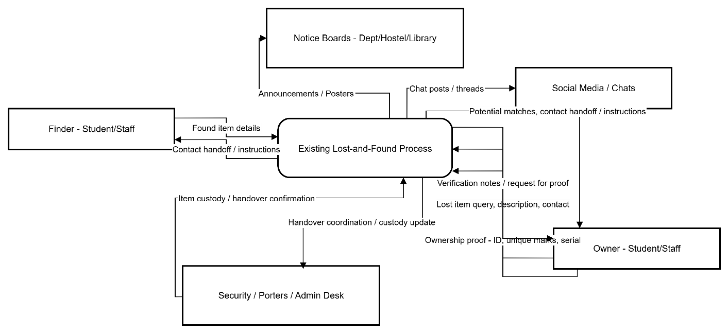
Figure 3.1: A context diagram of a manual lost and found system

3.2.1.1 Weaknesses of the Existing System
A review of the current lost-and-found process at the university shows multiple weaknesses. The system is manual, unstructured, and unreliable. Information about found items is scattered across group chats, handwritten notices, and informal conversations. These practices make recovering lost items inconsistent and inefficient. The main weaknesses identified are:

- Lack of Centralized Records:
There is no single place to document all found items. Students must rely on chance encounters with information on notice boards or in chat groups.

- Poor Information Retention:
Messages in social media groups can get buried or deleted, while physical posters may be taken down, damaged, or ignored. This results in the constant loss of important information.

- No Standard Verification Method:
Anyone can claim an item without a way to check ownership. This raises the risk of theft or misplaced handovers, especially for sensitive items like phones, ID cards, wallets, and keys.

- No Audit Trail or Accountability:
There are no records of when items were found, who found them, who claimed them, or if they were genuinely returned. This makes tracking and reporting impossible.

- High Reliance on Manual Effort:
Students have to physically move around hostels, departments, or security offices to check notices. This wastes time and reduces the chances of recovering items.

- Low Visibility and Inefficient Communication:
Many students may never find out that their lost item has been recovered due to the fragmented and inconsistent communication channels.

These weaknesses point to the need for a structured, secure, digital system that centralizes records, improves visibility, and introduces formal verification and accountability.

3.2.2 Analysis of the Proposed System
The proposed system, FindHub, is a web-based Lost and Found Management Platform that aims to centralize the entire process of reporting, viewing, and recovering lost items. The system eliminates fragmentation by providing a single platform for both administrators and students. It supports organized record-keeping, efficient searches, image uploads, verification through security questions, and a clear status lifecycle for each item.

This analysis uses the Object-Oriented Analysis and Design Methodology (OOADM), focusing on object interactions, use cases, and activity flows.

System Architecture
The system has a three-tier architecture:

- Frontend Layer (Next.js Web & Admin Apps):
  - Public interface for searching and viewing items.
  - Admin dashboard for item registration, status updates, and category management.
  - Built with React components, validated with Zod, and styled with TailwindCSS.

- Backend/API Layer (Hono Framework):
  - Manages item creation, search, image uploads, authentication, security questions, and privacy rules.
  - Implements business logic through service modules such as item.service, upload.service, and security-questions.service.

- Database & Storage Layer:
  - PostgreSQL database with Drizzle ORM schema models.
  - Supabase Storage for item images.
  - Encrypted storage for security question answers.

Database Design
The system includes well-structured entities such as:
  - User
  - LostItem
  - ItemImage
  - ItemCategory
  - SecurityQuestion
  - ItemStatusHistory

Relationships follow an object-oriented structure (e.g., LostItem to ItemImage is one-to-many).
The database ensures data integrity through foreign keys, status enums, timestamps, and indexes for quick searches.

Input Design
Inputs into the system include:
  - Admin forms for item registration (name, description, date found, category, location).
  - Image upload inputs (multiple images, validated by size and type).
  - Security question creation forms.
  - Search filters entered by public users (keyword, category, date range, location).
  - Admin login credentials.

All inputs are validated using Zod on both the client and server side.

Output Design
System outputs include:
  - Search results shown as item cards with images.
  - Detailed item pages that include item information, status, and a gallery.
  - Dashboard tables for admins displaying items, categories, and statuses.
  - Notifications for actions such as successful uploads or item updates.
  - Status history for tracking the item lifecycle.

All outputs are designed to be mobile-friendly and accessible.

Algorithm / Process Design

Key algorithms and processes include:
- Search Algorithm:
  - Filters items by keyword, category, location, status, and date using optimized SQL queries.
- Ownership Verification:
- Uses security questions with AES-256-GCM encrypted answers to protect sensitive data.
- Image Upload Process:
- Client-side validation.
- Upload to Supabase Storage.
- Save metadata (URL, size, MIME type).
- Item Status Workflow:
- Items move through defined states: unclaimed, claimed, returned, archived.
- Each change creates a history record.

UML Requirements Analysis Diagrams

Following OOADM, the system is analyzed using:
- Use Case Diagram
- Actors: Public User, Admin
- Use cases: Search items, View item, Create item, Upload images, Manage categories, Update status, Set security questions
- Activity Diagrams
- Search and filtering process
- Item registration workflow
- Item claim verification process
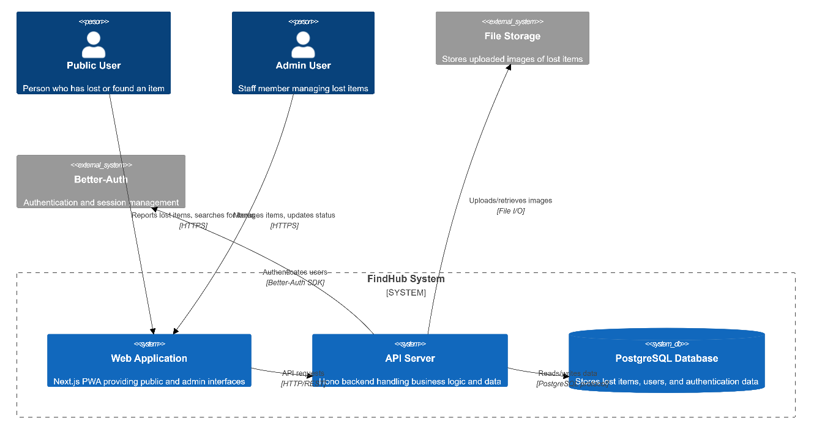

Figure 3.2: A context diagram of an improved lost and found system

3.4 Design of the Proposed System
We organise the design using four classic artefacts: database design, input design, output design, and home page design. This approach shows how the system will work on a computer and user interface. It also connects directly to implementation with Next.js, Hono, and PostgreSQL. Reliable guidance on design artefacts follows common software engineering texts and standards.

3.4.1 Use Case Diagram
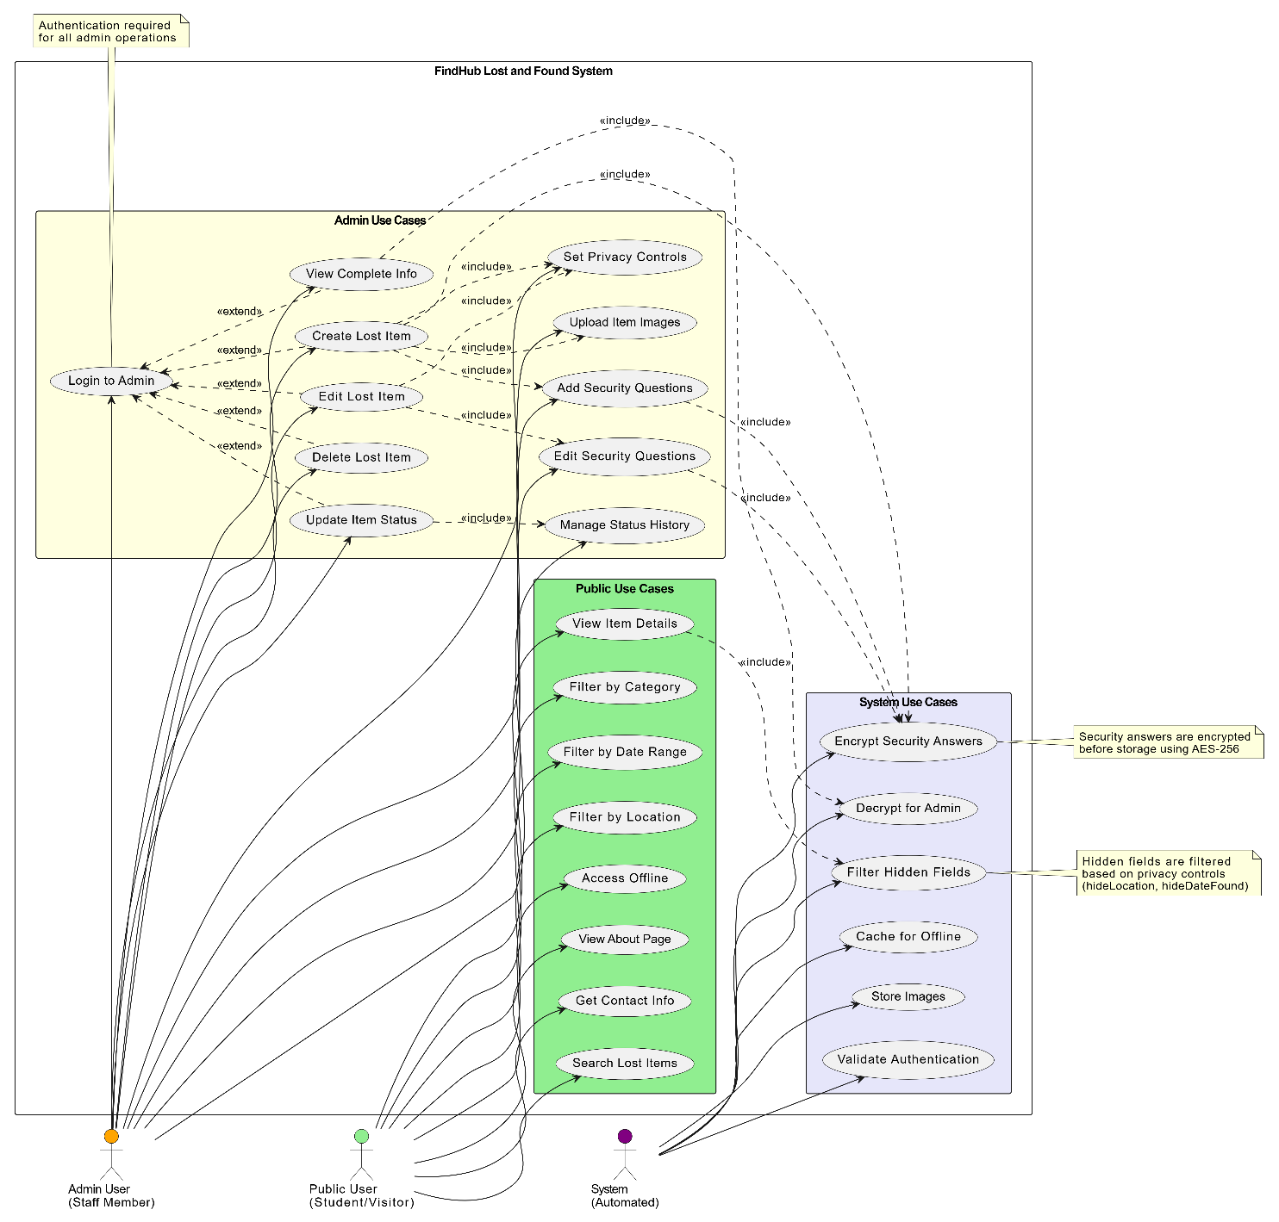

Figure 3.3: Use case diagram of FindHub, A lost and found system

Components of the Use Case Diagram
Table 3.1 Public User Use Cases
Use Case | Description | Requirements
Search Lost Items | Search for lost items using keywords | Basic functionality
View Item Details | View detailed information about a specific item | May show obscured fields
Filter by Category | Filter search results by item category | Search enhancement
Filter by Date Range | Filter items by date found range | Search enhancement
Filter by Location | Filter items by location found | Search enhancement
Access Offline | Access cached items when offline | PWA functionality
View About Page | View information about the service | Information access
Get Contact Info | Access admin office contact details | Support access

Table 3.2 Admin User Use Cases
Use Case | Description | Requirements
Login to Admin | Authenticate to access admin features | Req 8.1, 8.5
Create Lost Item | Register a new lost item in the system | Core functionality
Edit Lost Item | Update existing item information | Core functionality
Delete Lost Item | Remove an item from the system | Core functionality
Update Item Status | Change item status (unclaimed/claimed/disposed) | Status workflow
Upload Item Images | Upload photos of lost items | File handling
Add Security Questions | Create verification questions for items | Req 1.1-1.9
Set Privacy Controls | Hide location/date from public view | Req 3.1-3.7
View Complete Info | See all item details including hidden fields | Req 5.1-5.5
Edit Security Questions | Modify or remove existing security questions | Req 6.1-6.6
Manage Status History | Track and view item status changes | Status tracking

Table 3.3 System Use Cases
Use Case | Description | Requirements
Encrypt Security Answers | Encrypt answers before storing in database | Req 2.2, 2.8
Filter Hidden Fields | Remove hidden fields from public API responses | Req 4.1-4.6, 8.3
Decrypt for Admin | Decrypt security answers for admin view | Req 8.4
Cache for Offline | Store data in service worker cache | PWA functionality
Store Images | Save uploaded images to file storage | File handling
Validate Authentication | Verify admin user tokens | Req 8.5

Use Case Relationships
Includes Relationships
- View Item Details includes Filter Hidden Fields: System automatically filters hidden fields when public users view items
- Create Lost Item includes Upload Item Images, Add Security Questions, Set Privacy Controls, Encrypt Security Answers: Creating an item involves these sub-processes
- Edit Lost Item includes Edit Security Questions, Set Privacy Controls: Editing allows modification of these features
- Update Item Status includes Manage Status History: Status changes are tracked in history

Extends Relationships
- Login to Admin extends all admin use cases: Authentication is required before performing admin actions

System Triggers
- System automatically encrypts security answers when they are created or updated
- System automatically filters hidden fields for public API responses
- System automatically decrypts answers for authenticated admin users
- System automatically validates authentication tokens on protected endpoints

Actor Descriptions
Public User
- Role: Unauthenticated student or visitor
- Access: Public pages only
- Capabilities: Search, view (with restrictions), filter items
- Restrictions: Cannot see hidden fields or security questions
Admin User
- Role: Authenticated staff member
- Access: Admin dashboard and public pages
- Capabilities: Full CRUD operations, security questions, privacy controls
- Restrictions: Must authenticate before accessing admin features
System
- Role: Automated processes
- Responsibilities: Encryption, filtering, caching, validation
- Triggers: API requests, data operations, authentication checks

3.4.2 Activity Diagram
Below is the activity diagram of the FindHub platform core use cases. It shows the flow of core FindHub functionalities and what happens when each flow is followed
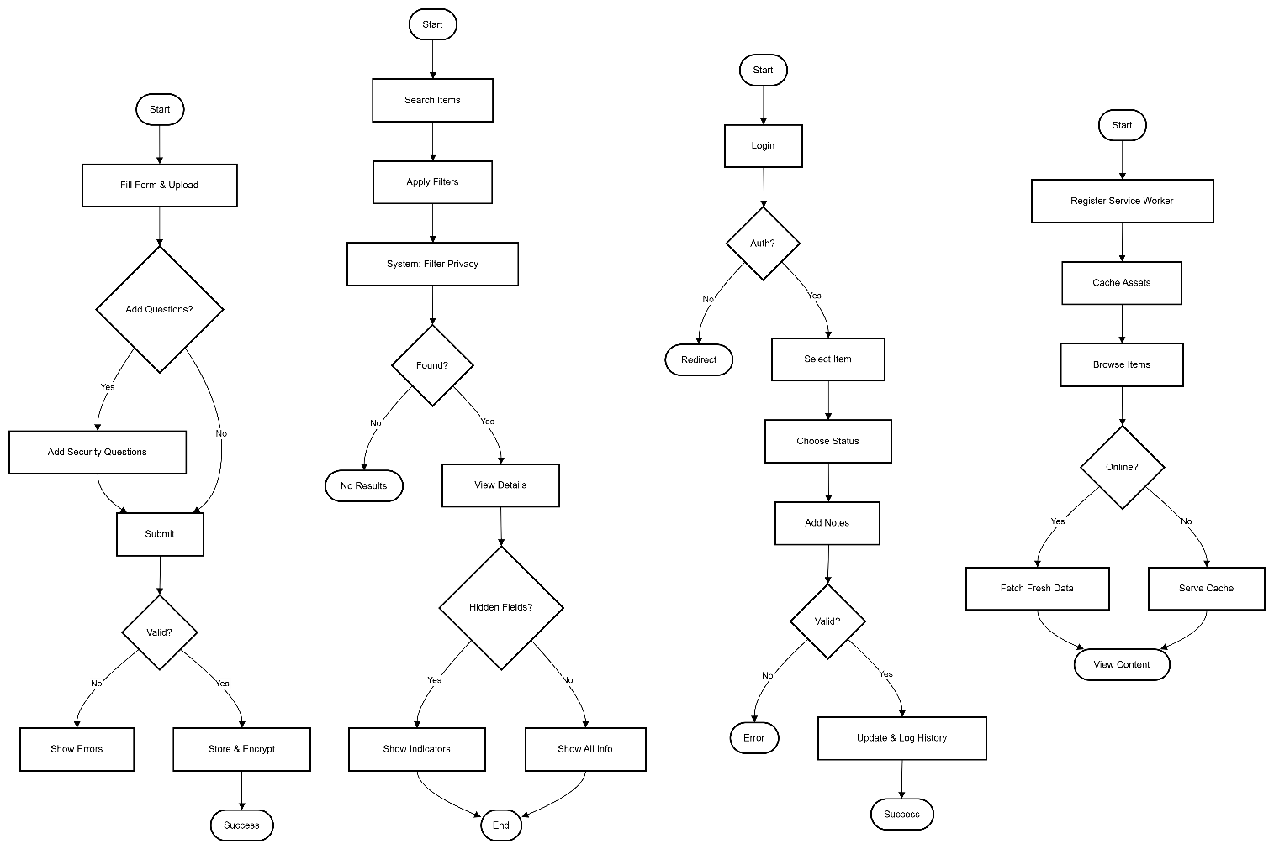

Figure 3.4: Activity diagrams (from left to right): (1) Admin creating a lost item with security questions, (2) Public user searching and viewing lost items, (3) Admin updating item status and logging history, (4) System offline functionality using Progressive Web App (PWA) features.

Activity Diagram Descriptions

1. Create Lost Item with Security Questions
Admin workflow for creating a new lost item with optional security questions and privacy controls. The system validates input, encrypts security answers, and stores everything in the database.

2. Public User Search and View
Public users search for items with filters. The system automatically filters hidden information based on privacy controls and excludes security questions from the response.

3. Update Item Status with History
Admin workflow for updating item status (unclaimed/claimed/disposed) with authentication validation. All status changes are tracked in history with timestamps and notes.

4. Offline Functionality (PWA)
Service worker enables offline browsing by caching assets and API responses. When offline, users can view cached content. When online, fresh data is fetched and cache is updated.

3.4.3 Class Diagram
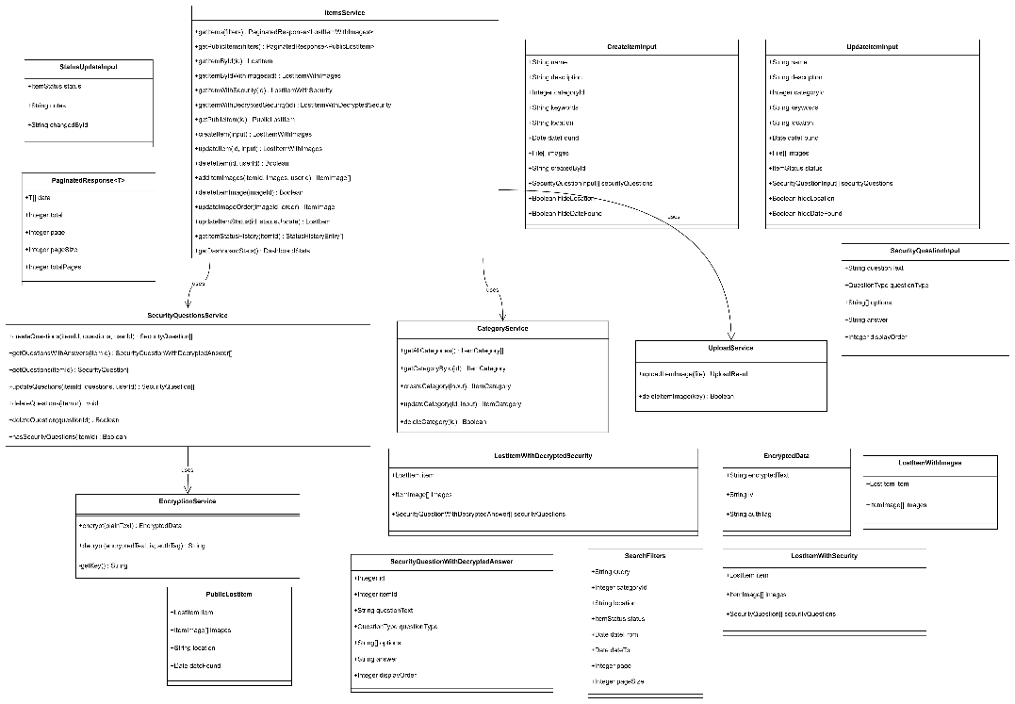

Figure 3.5 FindHub class diagram and DTOs

Class Relationships Summary

Entity Relationships
- User creates multiple LostItems, ItemImages, SecurityQuestions, and ItemStatusHistory entries
- LostItem belongs to one ItemCategory and has multiple ItemImages, SecurityQuestions, and ItemStatusHistory entries
- SecurityQuestion uses QuestionType enum (multiple_choice or free_text)
- LostItem uses ItemStatus enum (unclaimed, claimed, returned, archived)

Service Dependencies
- ItemsService orchestrates item management and depends on:
  - SecurityQuestionsService for security question operations
  - CategoryService for category validation
  - UploadService for image storage
- SecurityQuestionsService depends on EncryptionService for encrypting/decrypting answers

Data Flow
- CreateItemInput/UpdateItemInput → ItemsService → Database entities
- SecurityQuestionInput → SecurityQuestionsService → EncryptionService → SecurityQuestion (encrypted)
- Database entities → ItemsService → PublicLostItem (filtered for public) or LostItemWithDecryptedSecurity (admin view)

3.4.4 Sequence Diagram
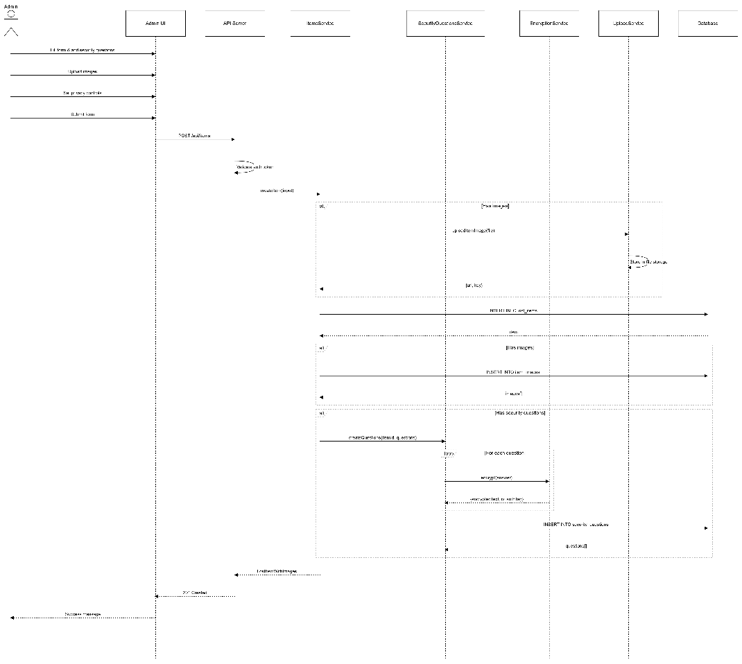

Figure 3.6 Sequence diagram to create an entry of a lost item

3.4.6 Database Design (logical overview)
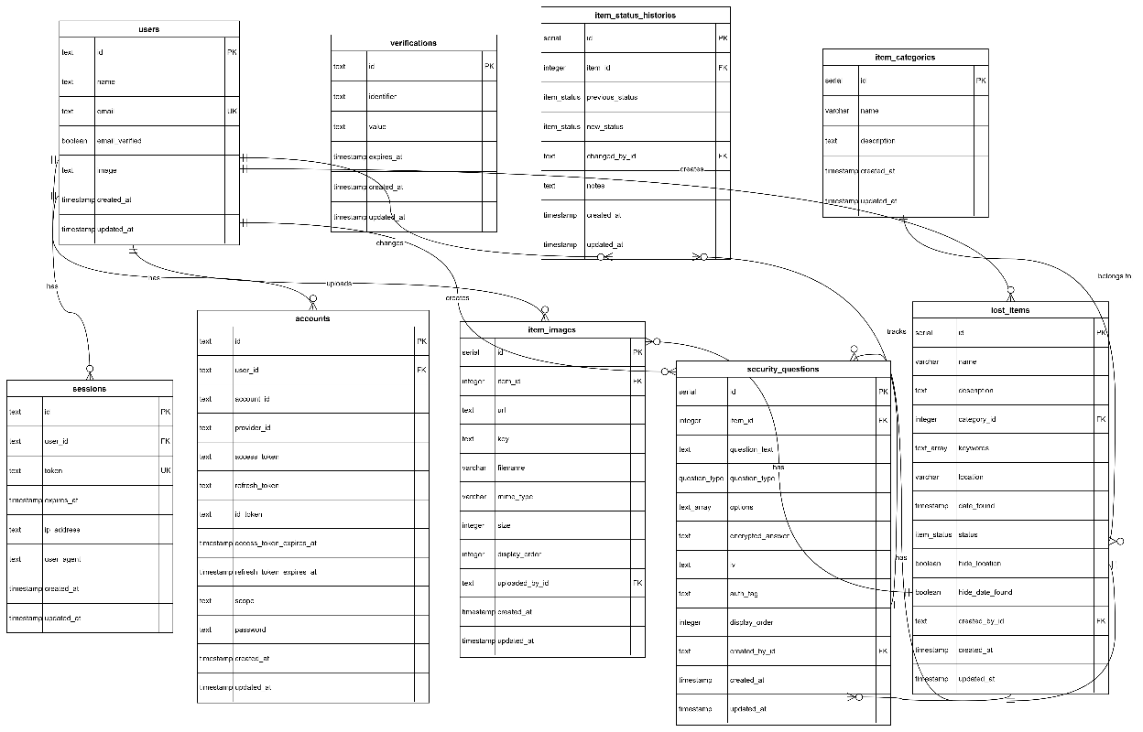
Figure 3.8 ERD of the FindHub system

Table 3.4 users schema
Attribute Name | Data Type | Length | Key | Foreign Key Reference | Constraints
id | text | - | PK | - | NOT NULL
name | text | - | - | - | NOT NULL
email | text | - | UK | - | NOT NULL, UNIQUE
email_verified | boolean | - | - | - | NOT NULL
image | text | - | - | - | NULL
created_at | timestamp | - | - | - | NOT NULL, DEFAULT NOW()
updated_at | timestamp | - | - | - | NOT NULL, DEFAULT NOW()

Table 3.5 sessions schema
Attribute Name | Data Type | Length | Key | Foreign Key Reference | Constraints
id | text | - | PK | - | NOT NULL
user_id | text | - | FK | users.id | NOT NULL, ON DELETE CASCADE
token | text | - | UK | - | NOT NULL, UNIQUE
expires_at | timestamp | - | - | - | NOT NULL
ip_address | text | - | - | - | NULL
user_agent | text | - | - | - | NULL
created_at | timestamp | - | - | - | NOT NULL, DEFAULT NOW()
updated_at | timestamp | - | - | - | NOT NULL, DEFAULT NOW()

Table 3.6: accounts schema
Attribute Name | Data Type | Length | Key | Foreign Key Reference | Constraints
id | text | - | PK | - | NOT NULL
user_id | text | - | FK | users.id | NOT NULL, ON DELETE CASCADE
account_id | text | - | - | - | NOT NULL
provider_id | text | - | - | - | NOT NULL
access_token | text | - | - | - | NULL
refresh_token | text | - | - | - | NULL
id_token | text | - | - | - | NULL
access_token_expires_at | timestamp | - | - | - | NULL
refresh_token_expires_at | timestamp | - | - | - | NULL
scope | text | - | - | - | NULL
password | text | - | - | - | NULL
created_at | timestamp | - | - | - | NOT NULL, DEFAULT NOW()
updated_at | timestamp | - | - | - | NOT NULL, DEFAULT NOW()

Table 3.7: verifications
Attribute Name | Data Type | Length | Key | Foreign Key Reference | Constraints
id | text | - | PK | - | NOT NULL
identifier | text | - | - | - | NOT NULL
value | text | - | - | - | NOT NULL
expires_at | timestamp | - | - | - | NOT NULL
created_at | timestamp | - | - | - | NULL
updated_at | timestamp | - | - | - | NULL

Table 3.8: lost_items schema
Attribute Name | Data Type | Length | Key | Foreign Key Reference | Constraints
id | serial | 4 bytes | PK | - | NOT NULL, AUTO INCREMENT
name | varchar | 255 | - | - | NOT NULL
description | text | - | - | - | NOT NULL
category_id | integer | 4 bytes | FK | item_categories.id | NULL
keywords | text[] | - | - | - | NULL
location | varchar | 255 | - | - | NOT NULL
date_found | timestamp | - | - | - | NOT NULL
status | item_status | - | - | - | NOT NULL, DEFAULT 'unclaimed'
hide_location | boolean | - | - | - | NOT NULL, DEFAULT false
hide_date_found | boolean | - | - | - | NOT NULL, DEFAULT false
created_by_id | text | - | FK | users.id | NOT NULL, ON DELETE CASCADE
created_at | timestamp | - | - | - | NOT NULL, DEFAULT NOW()
updated_at | timestamp | - | - | - | NOT NULL, DEFAULT NOW()

Indexes:
- lost_items_status_idx ON (status)
- lost_items_category_idx ON (category_id)
- lost_items_date_found_idx ON (date_found)
- lost_items_created_at_idx ON (created_at)

Table 3.9: item_images schema
Attribute Name | Data Type | Length | Key | Foreign Key Reference | Constraints
id | serial | 4 bytes | PK | - | NOT NULL, AUTO INCREMENT
item_id | integer | 4 bytes | FK | lost_items.id | NOT NULL, ON DELETE CASCADE
url | text | - | - | - | NOT NULL
key | text | - | - | - | NOT NULL
filename | varchar | 255 | - | - | NOT NULL
mime_type | varchar | 100 | - | - | NOT NULL
size | integer | 4 bytes | - | - | NOT NULL
display_order | integer | 4 bytes | - | - | NOT NULL, DEFAULT 0
uploaded_by_id | text | - | FK | users.id | NOT NULL, ON DELETE CASCADE
created_at | timestamp | - | - | - | NOT NULL, DEFAULT NOW()
updated_at | timestamp | - | - | - | NOT NULL, DEFAULT NOW()

Indexes:
- item_images_item_id_idx ON (item_id)
- item_images_display_order_idx ON (item_id, display_order)

Table 3.10: security_questions schema
Attribute Name | Data Type | Length | Key | Foreign Key Reference | Constraints
id | serial | 4 bytes | PK | - | NOT NULL, AUTO INCREMENT
item_id | integer | 4 bytes | FK | lost_items.id | NOT NULL, ON DELETE CASCADE
question_text | text | - | - | - | NOT NULL
question_type | question_type | - | - | - | NOT NULL
options | text[] | - | - | - | NULL
encrypted_answer | text | - | - | - | NOT NULL
iv | text | - | - | - | NOT NULL
auth_tag | text | - | - | - | NOT NULL
display_order | integer | 4 bytes | - | - | NOT NULL, DEFAULT 0
created_by_id | text | - | FK | users.id | NOT NULL, ON DELETE CASCADE
created_at | timestamp | - | - | - | NOT NULL, DEFAULT NOW()
updated_at | timestamp | - | - | - | NOT NULL, DEFAULT NOW()

Indexes:
- security_questions_item_id_idx ON (item_id)
- security_questions_display_order_idx ON (item_id, display_order)

Table 3.11: item_categories schema
Attribute Name | Data Type | Length | Key | Foreign Key Reference | Constraints
id | serial | 4 bytes | PK | - | NOT NULL, AUTO INCREMENT
name | varchar | 100 | - | - | NOT NULL
description | text | - | - | - | NULL
created_at | timestamp | - | - | - | NOT NULL, DEFAULT NOW()
updated_at | timestamp | - | - | - | NOT NULL, DEFAULT NOW()

Table 3.12: item_status_histories schema
Attribute Name | Data Type | Length | Key | Foreign Key Reference | Constraints
id | serial | 4 bytes | PK | - | NOT NULL, AUTO INCREMENT
item_id | integer | 4 bytes | FK | lost_items.id | NOT NULL, ON DELETE CASCADE
previous_status | item_status | - | - | - | NOT NULL
new_status | item_status | - | - | - | NOT NULL
changed_by_id | text | - | FK | users.id | NOT NULL, ON DELETE CASCADE
notes | text | - | - | - | NULL
created_at | timestamp | - | - | - | NOT NULL, DEFAULT NOW()
updated_at | timestamp | - | - | - | NOT NULL, DEFAULT NOW()

Enumeration Types
item_status
- unclaimed - Item is available and unclaimed
- claimed - Item has been claimed by owner
- returned - Item has been returned to owner
- archived - Item has been deleted (soft delete)
question_type
- multiple_choice - Question with predefined answer options
- free_text - Question with free-form text answer

3.4.7 Input Design (Forms & Validation)
- Admin Login Email + Password. Validation: RFC 5322 email, ≥8-char password, Better-Auth server check, rate limiting, HTTPS, session token.
- Register/Edit Lost Item (Admin) Fields: Name*, description*, category*, location*, date found*, keywords, images (≤10, ≤5MB, JPEG/PNG/WebP), security questions (≤10, free-text or MCQ with encrypted answers). Privacy: Hide location/date toggles. Validation: Client + Zod server-side, AES-256-GCM for answers, rollback on failure.
- Public Search Keyword + filters (category, location, status, date range), pagination. Privacy-aware: Hidden fields auto-excluded; safe SQL parameters.
- Update Status (Admin) New status + optional notes. Valid transitions only; auto history log.

3.4.8 Output Design (Screens & Responses)
- Public Listings Responsive cards: thumbnail, name, badges, short desc, location/date (or “Hidden”), pagination, offline banner.
- Public Item Detail Gallery + details; hidden fields shown as “Contact admin” with lock icon. “Claim” button.
- Admin Views Full data + decrypted security questions, status history timeline, Edit/Delete/Update actions. Dashboard: stats + recent items table.
- API Responses Public: hidden fields null, no security questions. Admin: full data + decrypted answers. Standard success/error JSON.
- Feedback & Offline (PWA) Green/red toasts, inline errors, loaders. Offline: banner, cached views, write actions disabled, auto-sync on reconnect.

Chapter FOUR
System Implementation and Documentation

4.0 Introduction
This chapter outlines the development of FindHub, the Lost and Found Management System for the University of Nigeria, Nsukka. The system has been fully implemented using a modern full-stack TypeScript monorepo architecture. It is functional, tested, and ready for deployment.

4.1 Choice of Development Environment
The project was developed using the Better-T Stack (Bun, Elysia/Hono, Next.js 16, Turborepo, Drizzle, React 19, TailwindCSS, Shadcn/UI, Better-Auth).

Software & Tools:
- Runtime & Package Manager: Bun v1.2.19 (chosen for 3 to 5 times faster installs and execution compared to npm, yarn, or pnpm)
- Monorepo Orchestration: Turborepo (cached builds, parallel tasks)
- Frontend Framework: Next.js 16.0.0 (App Router, React 19.2.0, Server Actions)
- Backend Framework: Hono v4 on Bun runtime
- Database ORM: Drizzle ORM (TypeScript-first, zero-cost abstractions)
- Database: PostgreSQL 16 (local via Docker, production-ready on Supabase)
- File Storage: Supabase Storage (public bucket “lost-items”)
- Authentication: Better-Auth v1.3.28 (email/password, session cookies)
- UI Components: shadcn/ui, TailwindCSS v4
- State Management: TanStack Query (React Query)
- Forms & Validation: React Hook Form, Zod v4.1.11
- PWA: @ducanh2912/next-pwa
- Testing: Playwright (End-To-End), Biome (lint/format)
- Version Control: Git, GitHub

This stack was chosen for its type safety, developer experience, performance, and readiness for production.

4.2 Implementation Architecture
FindHub is a monorepo with three applications and shared packages:
findhub/
├── apps/
│ ├── web/ → Public PWA (port 3001)
│ ├── admin/ → Protected dashboard (port 3002)
│ └── server/ → Hono API (port 3000)
├── packages/
│ ├── db/ → Drizzle schema + migrations + shared types
│ ├── auth/ → Better-Auth config
│ └── shared/ → Zod schemas, constants
└── e2e/ → Playwright tests

Overall Data Flow Diagram (Level 0 – Context Diagram of Implemented System)
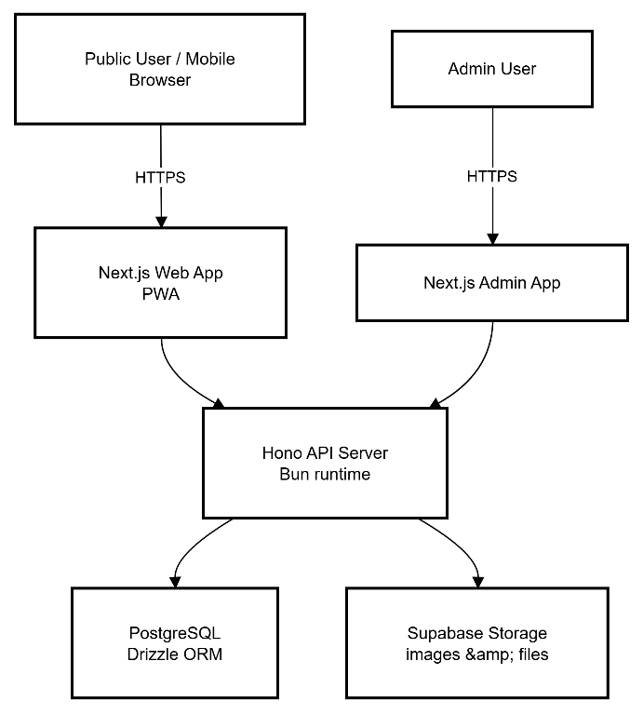
Figure 4.1 DFD Diagram of FindHub
All requests pass through the Hono server. Public routes require no authentication. Admin routes are protected by Better-Auth middleware that validates HTTP-only session cookies.

4.2.1 Main Menu / Control Centre The system has two entry points:
- Public Site (localhost:3001) Home | Search | About | Item Detail Pages
- Admin Dashboard (localhost:3002) Login → Dashboard

4.2.2 Sub-menus (Admin Dashboard)
- Items → List | New Item | Edit Item | Status History
- Categories → List | Create | Edit | Delete
- Profile & Logout

4.4 Input/Output Formats
Example input data to create a lost item(Create Item – multipart/form-data)
{
"name": "Blue Samsung Galaxy A54",
"description": "Found near Faculty of Physical Sciences",
"categoryId": 1,
"location": "Behind Old Library",
"dateFound": "2025-11-15T08:30:00Z",
"hideLocation": false,
"hideDateFound": true,
"securityQuestions": [
{
"questionText": "What is the phone model inside the pouch?",
"questionType": "free_text",
"answer": "Samsung A54"
}
],
"images": [File objects]
}
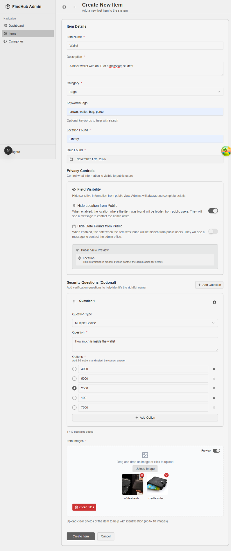
Figure 4.2: Form interface for creating a lost item
Example Output (Public Item Detail – privacy applied)
{
"id": 42,
"name": "Blue Samsung Galaxy A54",
"description": "Found near Faculty of Physical Sciences",
"location": null, // hidden
"dateFound": null, // hidden
"status": "unclaimed",
"images": ["https://...supabase.co/storage/v1/object/public/lost-items/abc123.jpg"],
"category": "Electronics"
}

4.5 Overall Data Flow Diagram of Proposed (Implemented) Solution
Level 1 DFD (simplified text representation)
Process 1.0 – Register Found Item
← (Item data + Images + Security Questions) – Admin
→ Stores in PostgreSQL + Supabase Storage
→ Returns Item ID

Process 2.0 – Search & View Items
← (keyword, filters) – Public User
→ Queries PostgreSQL (privacy filters applied in service layer)
→ Returns paginated items (cached by React Query + PWA)

Process 3.0 – Update Status
← (new status + notes) – Admin
→ Creates entry in item_status_histories
→ Updates lost_items.status
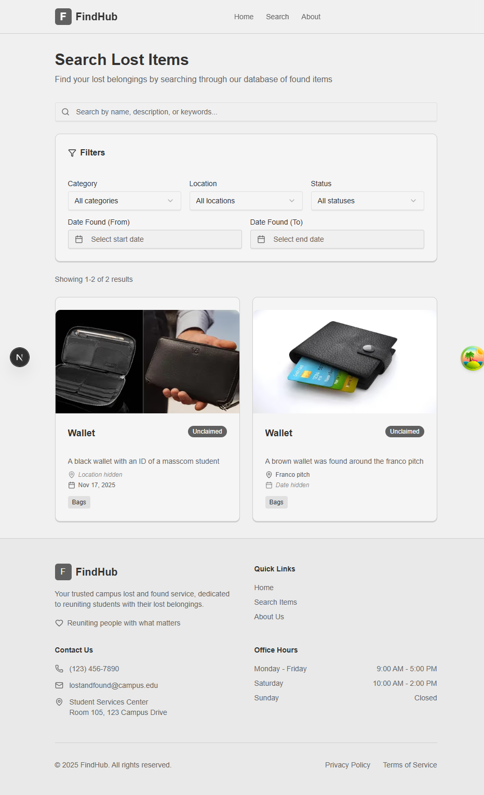
Figure 4.3: Public interface for search for lost items

4.6 Software Testing
Testing was comprehensive, and all tests passed.
Table 4.1: Testing done, their coverage and result
Test Type | Tool | Coverage | Result
End-to-End (E2E) | Playwright | 100% of user journeys (search, CRUD, offline, security questions, privacy) | Passed
Unit (Encryption) | Bun test | encrypt/decrypt, unique IVs, tamper detection | Passed
Integration (API) | Supertest + Bun | All routes, auth, validation errors | Passed
Visual Regression | Playwright | Desktop & mobile breakpoints | Passed

Sample Playwright command:
Bash
bun run test:e2e # headless
bun run test:e2e:ui # with UI

4.7 Documentation

4.7.1 Data Dictionary (Selected Tables)
Table 4.2: lost_items data dictionary
Field | Type | Description | Nullable
id | serial | Primary key | No
name | varchar(255) | Item name | No
description | text | Detailed description | No
category_id | integer | FK → item_categories.id | No
location | varchar(255) | Where found | No
date_found | timestamp | Date & time found | No
status | item_status enum | unclaimed | claimed
hide_location | boolean | Privacy control | No
hide_date_found | boolean | Privacy control | No
created_by_id | text | FK → users.id | No
created_at | timestamp | Default now() | No

Table 4.3: security_questions data dictionary
Field | Type | Description
id | serial | PK
item_id | integer | FK → lost_items.id
question_text | text | Question displayed to claimant
question_type | enum | multiple_choice / free_text
encrypted_answer | text | AES-256-GCM encrypted
iv | text | Initialization vector
auth_tag | text | GCM authentication tag

4.7.2 User Manual (Excerpt)
For Public Users
- Visit the homepage and click on search
- Use the search bar or filters (category, date range, etc.)
- Click any item to view details (note: some fields may be hidden for privacy)
- Contact the admin office with the item ID to claim
For Administrators
- Go to the admin web app url → Login with UNN email
- Dashboard → Items → New Item
- Fill all fields → upload up to 10 images → add security questions (optional) → Submit
- To update status: Items → select item → Change Status → add notes

4.8 Source Code Listing
Due to the humongous size of the code used in this project, only the folder and file structure will be listed. Complete source code can be found at the GitHub repository (https://github.com/jvstln/findhub).

Chapter FIVE
Summary, Recommendation & Conclusion

5.0 Summary of Achievements
FindHub, a modern and secure Lost and Found Management System, has been successfully designed, implemented, and tested for the University of Nigeria, Nsukka community. The system meets all outlined goals:
- Responsive public search interface that does not require a login
- Secure admin dashboard with full create, read, update, and delete operations
- Privacy controls to hide location and date
- Optional security questions with AES-256-GCM encrypted answers
- Progressive Web App with true offline capability
- Complete audit trail through a status history table
- Production-ready monorepo architecture using Bun, Next.js 16, Hono, Drizzle ORM, Supabase Storage, and Better-Auth
The application is fast, type-safe from end to end, mobile-friendly, and has passed strict Playwright end-to-end tests.

5.1 Conclusion
The development of FindHub shows that a campus lost-and-found system can be built using modern web technologies. It offers a better user experience, privacy, security, and administrative control than the informal methods currently used at UNN. By centralizing records, adding verification steps, and allowing offline access, the platform greatly improves the chances of recovering lost items. It also eases the administrative workload and minimizes fraudulent claims. This project effectively connects academic software engineering principles with the real needs of institutions.

5.2 Recommendations
- The University of Nigeria, Nsukka should adopt and deploy FindHub as the official lost-and-found platform.
- Administrative staff in Student Affairs or the Security Unit should be trained on the dashboard.
- Physical posters/notices should be placed in hostels and faculties directing students to the website.
- Quarterly reviews of unclaimed items should be conducted using the system’s status history.

5.3 Suggestions for Further Work
- Email/SMS notification system when matching items are found
- AI-powered image recognition for automatic categorisation
- Public security question verification portal (with rate limiting)
- Mobile apps (React Native or Flutter) with push notifications
- Integration with UNN student portal authentication (OAuth)
- Analytics dashboard showing recovery rates and popular categories

With these enhancements, FindHub can evolve into a university-wide asset recovery platform serving thousands of students and staff for years to come.

REFERENCES
Abhiram, T., Krishnan, E. B. A., Manjith, K. M., Vishnu, A. P., & Ambarish, A. (2024). CampusTrace—Application for lost and found items on campus. Journal of Trends in Computer Science and Smart Technology, 6(2), 168–179. https://doi.org/10.36548/jtcsst.2024.2.006
Avison, D. E., & Fitzgerald, G. (2006). Information systems development: Methodologies, techniques and tools (4th ed.). McGraw-Hill Education.
Booch, G., Rumbaugh, J., & Jacobson, I. (2005). The unified modeling language user guide (2nd ed.). Addison-Wesley.
CampusTrace. (2025). CampusTrace transforms the systems of lost and found items in campus environments. CampusTrace.
Canonigo II, R. J., & Oribello, J. F. (2022). Development of an online-based web application of lost and found items information system for Cavite State University [Undergraduate thesis]. Cavite State University Library.
Elmasri, R., & Navathe, S. B. (2016). Fundamentals of database systems (7th ed.). Pearson.
GitHub—mermaid-js. (2020–2025). Issues on activity diagrams & swimlanes (workarounds via subgraphs). https://github.com/mermaid-js/mermaid/issues/1674
Gurstein, M. (2007). What is community informatics? (And why does it matter). Polimetrica.
Ibrahim, A. O., et al. (2023). Design and implementation of web-based lost and found information system (Case study: ADUST). Scribd. https://www.scribd.com/document/722515371/
Incentive-centered design. (2025, January). In Wikipedia. https://en.wikipedia.org/wiki/Incentive-centered_design
Kanjalkar, P., Pingle, J., Sagar, A., Lohe, R., Patil, S., & Kanjalkar, J. (2024). Lost and found web application. International Journal for Research in Applied Science & Engineering Technology (IJRASET). https://doi.org/10.22214/ijraset.2024.65573
Kaur, H. (2017). Lost and found web application for Cal Poly Pomona students [Master's thesis]. California State Polytechnic University, Pomona.
Kumar, S., Bhatnagar, D., & Gahlot, D. (2022). Web-based lost and found system. MIT International Journal of Computer Science and Information Technology, 11(1). https://www.researchgate.net/publication/376856933_Web-Based_Lost_and_Found_System
Mermaid. (2025). Flowcharts – Basic syntax & diagram syntax. https://docs.mermaidchart.com/mermaid-oss/syntax/flowchart.html
Muhamad Ilias, N. F. (2021). A web-based system for lost and found management [Project report]. Universiti Teknologi MARA.
Nielsen, J. (2020). 10 usability heuristics for user interface design. Nielsen Norman Group. https://www.nngroup.com/articles/ten-usability-heuristics/ (Original work published 1994)
Object Management Group. (2017). Unified Modeling Language (UML) Version 2.5.1. https://www.omg.org/spec/UML/2.5.1/
RepoApp. (n.d.). Lost and found software for universities. https://www.repoapp.com/lost-found-software-universities/
Sadiku, P. O., Ogundokun, R. O., & Abikoye, O. C. (2019). IFOUND—An online lost item recovery application. I-Manager's Journal on Information Technology, 8(3), 1–8. https://doi.org/10.26634/jit.8.3.16535
Sommerville, I. (2016). Software engineering (10th ed.). Pearson.
Sparx Systems. (n.d.). UML 2 tutorial – Activity diagram. https://sparxsystems.com/resources/tutorials/uml2/activity-diagram.html
Systems theory. (2025, January). In Wikipedia. https://en.wikipedia.org/wiki/Systems_theory
Tan, S. Y., & Chong, C. R. (2023). An effective lost and found system in university campus. Journal of Information System and Technology Management, 8(32), 99–112. https://doi.org/10.35631/JISTM.832007
UML-Diagrams.org. (n.d.). Activity diagrams (controls, partitions). https://www.uml-diagrams.org/activity-diagrams.html
University of Uyo case study – Automated campus lost and found management system. (n.d.). https://nairaproject.com/projects/6177-automated-campus-lost-and-found-management-system-a-case-study-of-university-of-uyo.html
Vasavi, R., Reddy, S., Chakrapani, C., Samhitha, P., Vaishnavi, Y., & Vinay Datta, C. (2022). Lost and found system for VNR VJIET. International Journal of Engineering Research & Technology (IJERT), 11(6). https://doi.org/10.17577/IJERTV11IS060277
Veeru, B., Kranthi, S., Soumya, M., Amanpasha, M., Rakesh, K., & Krishna, B. (2024). Lost and found website for college campus. IJFANS International Journal of Food and Nutritional Sciences, 13(4).
W3C. (2024). Web Content Accessibility Guidelines (WCAG) 2.2. https://www.w3.org/TR/WCAG22/
Wilson, D. C. (2023). AppalLOCATE: A lost and found solution [Undergraduate honors thesis]. Appalachian State University.

