DEVELOPMENT OF A LOST AND FOUND SYSTEM FOR UNIVERSITY INHABITANTS

By

EZEMA JUSTIN
(2021/243894)

A BSC PROJECT REPORT SUBMITTED IN PARTIAL FULFILLMENT OF THE REQUIREMENTS FOR THE AWARD OF BACHELOR OF SCIENCE (BSC) DEGREE IN COMPUTER SCIENCE

DEPARTMENT OF COMPUTER SCIENCE
UNIVERSITY OF NIGERIA, NSUKKA

PROJECT SUPERVISOR:
DR MRS UJU EZUGWU

OCTOBER, 2025

DECLARATION

I hereby declare that this Project report is original and written by me. It is an accurate record of my research work and has not been presented previously for the award of any other degree. All information from other sources has been acknowledged by means of references.
Should I be convicted of having cheated in this work, I shall accept the verdict of the university.

Ezema Justin
Date:

APPROVAL

This project work has been approved by the Department of Computer Science, University of Nigeria, Nsukka as meeting the requirements for the award of Bachelor of Science degree in Computer Science

Dr Mrs Uju Ezugwu Date
Supervisor

Prof. C. N. Udanor Date
Head of Department

Prof. P. M. Ejikeme Date
Dean, Faculty of Physical Sci.

DEDICATION

ACKNOWLEDGEMENTS

(do not forget to commend your supervisor first)

ABSTRACT

(not more than 350 words in a single paragraph and not more than one page)
[Format for writing the Abstract is as follows:
Background statements (one or two statements)
Problem statements (one or two statements)
Aim statement
Methodology used
Platform/Tools used
Results (expected)
Conclusion]

TABLE OF CONTENTS
Title Page
Declaration Page
Certification Page
Dedication
Acknowledgements
Abstract
Table of Contents
List of Figures
List of Tables

Chapter 1: Introduction
1.1 Background to the Study
1.2 Statement of Problem
1.3 Aim and Objectives of the Study
1.4 Significance of the Study
1.5 Scope of the Study
1.6 Limitation of the Study
1.7 Definition of Terms

Chapter 2: Literature Review
2.0 Introduction
2.1 Theoretical Background
2.1.1 Concepts
2.1.2 Technology
2.2 Review of Related Literature
2.3 Research/Literature Gap

Chapter 3: System Analysis and Design
3.0 Introduction
3.1 Research Methodology
3.2 Description of the Existing System
3.2.1 Weaknesses of the Existing System
3.3 Analysis of the Proposed System
3.4 Design of the Proposed System
3.4.1 Use Case Diagram
3.4.2 Class Diagram
3.4.3 Sequence Diagram
3.4.4 Activity Diagram
3.4.5 Database Design

Chapter 4: System Implementation
4.0 Introduction
4.1 Choice of Development Environment
4.2 Implementation Architecture
4.2.1 Main Menu
4.2.2 Submenus
4.3 Software Testing
4.4 Documentation
4.4.1 User Manual
4.4.2 Source Code Listing (Appendix)

Chapter 5: Summary and Conclusion
5.0 Summary
5.1 Conclusion
5.2 Recommendation
5.3 Suggestions for Further Work

References

Appendices
Appendix A: Program Codes
Appendix B: Sample Program Outputs

LIST OF FIGURES

LIST OF TABLES

Chapter ONE
Introduction

Background to the Study
In university environments, losing personal belongings, such as identity cards, mobile devices, keys, books, and other valuables, is a common challenge for students and staff. At the University of Nigeria, Nsukka (UNN), this problem worsens due to the absence of a central platform for reporting and retrieving lost items. Traditional recovery methods, like word-of-mouth, notice board postings, and social media, are scattered, ineffective, and do not ensure that items are returned to their rightful owners (RepoApp, n.d.).

These informal methods have several drawbacks. They reach a limited audience and lack verification systems, which makes them open to fraudulent claims. Their follow-up procedures are also inconsistent. These issues lead to frustration, loss of trust, and anxiety, especially when important items remain lost (Sadiku, Ogundokun, & Abikoye, 2019).

The current approaches to handling lost and found issues at the university are mostly informal. Students and staff typically rely on word-of-mouth, announcements via friends, handwritten notes on departmental or hostel notice boards, and social media platforms like WhatsApp and Facebook to share information about lost items. Although these methods sometimes succeed, they are fragmented, lack proper organisation, and are not easy to search. Most importantly, they do not ensure verification of ownership or responsibility in the recovery process (RepoApp, n.d.). Consequently, the process is often slow, inefficient, and uncertain, leaving many lost items permanently unrecovered.

To bridge this gap, the proposed system, Foundly, will serve as a central, community-driven web application for managing lost and found items at UNN. It will enable users to report lost items and post found items, using authentication methods and structured data entry to facilitate matches. This will make the recovery process efficient, reliable, and transparent.

By integrating reporting, ensuring secure user verification, and offering a searchable database, Foundly will streamline the process of locating, authenticating, verifying, and returning lost items. It will also foster honesty, accountability, and community trust within the university environment.

Statement of Problem
This project aims to create a university environment where lost items are recovered quickly, securely, and openly, so that students and staff can trust the system to return their belongings. Everyone should be able to report lost or found items through a central platform. Rightful owners should reclaim their property without worrying about fraud or inefficiency.

Currently, recovering lost items at the University of Nigeria, Nsukka, relies on informal methods like word-of-mouth, notice board postings, and social media groups. These approaches are disorganised, hard to monitor, and lack verification, resulting in inefficiencies, unclaimed items, and sometimes fraudulent claims (RepoApp, n.d.). Ignoring this issue will cause the community to face ongoing frustration, wasted time, and potential financial or emotional losses from unrecovered belongings. This situation can also undermine trust among students and staff.

I will design and implement Foundly, a central, community-driven lost-and-found web application that uses authentication, structured reporting, and a searchable database. This solution will simplify item reporting, allow clear matching between lost and found reports, and promote accountability within the campus community.

1.3 Aim and Objectives of the Study
The goal of this study is to design and develop a UNN lost and found web application.

Specific Objectives:
- Develop a login and signup page that authenticates users and enables them to use the application.
- Design and develop an organised form interface for reporting found items, allowing users to upload item images and give identifying details.
- Design a searchable database that helps match lost and found item reports efficiently.
- Create a user-friendly interface that works on both desktop and mobile devices to include all students and staff.

1.4 Scope of the Study
This study focuses on the design and implementation of Foundly, a UNN lost-and-found web application created for the University of Nigeria, Nsukka (UNN). The study includes the following components:

- Lost-and-Found Management: The system allows students and staff to report lost items, post found items, and track the recovery process through a centralised platform.

- Web-based Platform: The system is built as a responsive web application. It works well on both desktop and mobile devices, but does not include standalone mobile apps.

- Geographic Scope: This project is limited to the University of Nigeria, Nsukka campus environment and does not cover other universities or off-campus locations.

- System Features: Key features include secure user registration and login, item reporting for both lost and found items, a searchable item database, and automated notifications for potential matches. More complex features, including artificial intelligence-based image recognition or connections with third-party social media platforms, are not included in this study.

By clearly defining these boundaries, the study maintains a focused approach that meets the immediate lost-and-found needs among UNN students and staff.

1.5 Significance of the Study
The development of Foundly, a community-driven lost-and-found web application for the University of Nigeria, Nsukka, is important because it solves a common problem for both students and staff.

For students, the system offers a reliable way to report and recover personal items like identity cards, academic materials, and electronic devices. This reduces the financial and emotional stress that comes with losing such belongings. Staff members benefit as well since they have a clear and trustworthy platform to report and return found items. This helps promote honesty and social responsibility within the campus community (RepoApp, n.d.).

The university administration also benefits from this system, as it creates a safer and more organised environment. It encourages accountability, builds trust, and allows campus operations to run more smoothly, reducing disruptions caused by lost belongings. Furthermore, the system supports the university’s digital transformation goals by showing how modern web technologies can solve real campus issues. This reinforces the university’s role as a centre for innovation.

From an academic viewpoint, this study is valuable to researchers and students of computer science. It demonstrates the use of full-stack web technologies, such as Next.js, Drizzle ORM, and PostgreSQL, to address local problems. It also adds to the understanding of how technology can create community-driven solutions in areas with limited resources (Tan & Chong, 2023). Ultimately, the importance of this study lies in its ability to improve the daily experiences of the UNN community, strengthen social ties, and serve as a model for other universities facing similar issues.

1.6 Limitations of the Study
Foundly offers a central solution for managing lost and found items at the University of Nigeria, Nsukka. However, it has significant limitations. The system only works on the UNN campus and does not include off-campus or inter-university situations. Development occurred under tight time and budget limits, which restricted testing and improvements. Reliable usage data may also be hard to find unless users consistently engage with the platform, making it tough to evaluate long-term use and satisfaction. Additionally, even with security measures, risks like false reporting or data tampering still exist. Recognising these limitations points out areas for future work, such as expanding coverage, improving resources, conducting longer assessments, and enhancing security.

1.7 Definition of Terms
- Activity Diagram: a UML behaviour diagram, shows workflows with actions, control flows, and decisions.
- Activity Partition (Swimlane): groups actions by responsible party, for example, User or System.
- Agile Development: A method for software development that involves building Foundly in iterations. This approach allows for incremental feature implementation and improvement based on user feedback.
- Authentication: The process of confirming a user's identity before allowing access to the system. Foundly uses authentication to ensure that only members of the UNN community can report or claim items.
- Better Auth: A simple authentication library built into Foundly for managing secure user login, registration, and session handling.
- Bun: A fast JavaScript runtime that executes Foundly’s backend code. It improves development speed and runtime efficiency.
- Client-Server Architecture: A software model where the client (front-end) requests services from the server (back-end). Foundly uses this model to securely process lost and found reports.
- Database Schema: The organisation structure of data within a database. In Foundly, PostgreSQL and Drizzle ORM manage the schema for items, users, and reports.
- Drizzle ORM: A TypeScript-first Object-Relational Mapping tool that interacts with Foundly’s PostgreSQL database safely.
- Lost-and-Found System: An information system that helps report, store, and retrieve lost or found items within a community. Foundly uses this concept for the UNN campus.
- Monorepo (Turborepo): An approach where multiple projects and packages are managed in a single repository. Foundly uses Turborepo to simplify builds and deployments for its front-end and back-end services.
- Next.js: A React-based framework for creating server-rendered and statically generated web applications. In Foundly, it powers the front end and ensures quick rendering.
- oRPC: An end-to-end type-safe API framework that integrates with OpenAPI. Foundly uses it for dependable communication between the front end and back end.
- PostgreSQL: An open-source relational database management system that stores Foundly’s records, including user profiles, item details, and recovery logs.
- Responsive Design: A design approach that makes a web application work well across devices such as desktops, tablets, and mobile phones. Foundly is developed to ensure responsiveness and accessibility.
- ShadCN UI: A set of reusable UI components that promote consistency, accessibility, and quicker development for Foundly’s user interface.
- TailwindCSS: A utility-first CSS framework used to style Foundly’s interface, allowing for rapid prototyping and custom designs.
- TypeScript: A superset of JavaScript that adds static typing. Foundly uses it to enhance code reliability and maintainability.
- User Verification: The process of confirming that a user claiming or reporting an item is genuine. Foundly performs verification through secure logins linked to UNN credentials.
- Decision/Merge Node: splits and recombines alternate flows, represented by a diamond.
- Fork/Join Node: starts and ends concurrent flows, indicated by a thick bar.

Chapter TWO
Literature Review

2.0 Introduction
This chapter provides a detailed review of the literature that supports the design and implementation of the Foundly lost-and-found web application. It starts with the theoretical background, defining and discussing key concepts and technologies for information systems and community-driven platforms. Next, it looks at related works, including existing digital and analogue solutions for lost-and-found systems, especially in educational settings. Finally, it points out the research gap, highlighting how Foundly’s approach, which is tailored to the University of Nigeria, Nsukka, addresses the shortcomings of current systems.

By examining the development of lost-and-found systems, both traditional, such as notice-board methods, and digital, like university-based web and mobile applications, this chapter places the current study within a wider scholarly and practical conversation. In this context, Foundly is seen not just as a technological solution but also as a relevant innovation in campus informatics and building trust within the community.

2.1 Theoretical Background
This section looks at important ideas and the technology behind Foundly, a community-driven lost-and-found web application for the University of Nigeria, Nsukka. The background is as follows:

2.1.1 Concepts
- Community Informatics provides a foundational perspective for Foundly. This interdisciplinary field explores how information and communication technologies can empower communities, build social connections, and support culturally relevant development (Gurstein, 2007; What is Community Informatics?, n.d.). Foundly embodies this principle by aiming to bring together the UNN community, including students, staff, and administration, into a participatory ecosystem for reporting and recovering lost items.

- Systems Theory also influences Foundly’s design. It views organisations or communities as cohesive systems with interacting and dependent components. This view emphasises how changes in one part can affect the entire system (Systems Theory, 2025). Foundly works within the university system by integrating users, authentication, reporting processes, and database workflows into one unified information system.

- Incentive-Centred Design (ICD) provides guidance on motivating user participation. ICD focuses on shaping system features so that individual user incentives match the broader goals of the system, such as honest item reporting and matching (Incentive-Centred Design, 2025). Foundly’s authentication processes and organised reporting promote accountability and trustworthy behaviour.

2.1.2 Technology
- Web-based lost-and-found systems have been used in different institutions. For example, Tan and Chong (2023) created a web and mobile system at the National University of Malaysia (UKM). It includes secure login, item listings, image attachments, and automation for handling unclaimed items. This system improved retrieval efficiency and authenticity. ResearchGate. Similarly, the CampusTrace system provides a centralised database, image uploads, and a user-friendly interface. These features improve reporting workflows and recovery rates (Abhiram et al., 2024). irojournals.com.
- Automated systems that integrate mobile apps and databases have also been studied. A study at the University of Uyo proposed an automated campus lost-and-found management system. It uses barcode scanning, mobile apps, real-time alerts, and centralised data storage. This setup increased the accuracy of item documentation, user access, and overall accountability in managing lost items (University of Uyo case study, n.d.). Naira Project.
- Architectural models and prototypes like AppalLOCATE demonstrate practical multi-platform applications. This system includes a mobile app, web client, and a cloud-based backend with search and proximity features. It improves object recovery workflows through contextual search and seamless platform interaction (Wilson, 2023). NC DOCKS.

In summary, these technologies contribute to the technical framework of Foundly. They combine secure authentication, centralised database design, web and mobile integration, user experience, and accountability into a unified system designed for campus needs.

2.2 Review of Related Literature
UKM Lost-and-Found (Tan & Chong, 2024) - This project created a web and mobile system for the National University of Malaysia. It features login capabilities, item listings, images, security questions for each post, and a disposal policy after one month. The technology stack includes PHP and MySQL. This shows the benefits of a centralised campus system. However, it uses generic security questions and legacy LAMP tools. It also mixes lost and found postings without typed end-to-end APIs or clear matching and audit trails. Foundly addresses these issues with UNN-verified authentication, a “found-only” intake, evidence-based claims, and a type-safe stack.

AppalLOCATE (Wilson, 2023) - This is a Vue.js web prototype for Appalachian State University. It lets users report items with specific locations and explore notifications based on proximity along with cloud storage options. It validates the campus use case but does not have UNN-style identity verification, typed contracts, or a governed claim workflow. Foundly adds structured matching, audit logs, and a restricted “found-only” reporting model to reduce spam and ease moderation.

IFOUND (Sadiku et al., 2019) - This web system for a Nigerian university connects to campus security. Administrators upload found items, while owners search for them and answer identity questions to claim their possessions. While it shows the Nigerian context, it focuses on administrative data entry and manual verification. Foundly improves this with verified user accounts, automated scoring for claim evidence, searchable indexes, and complete audit trails using a modern TS/PostgreSQL stack.

CampusTrace (2024) - This platform is built with PHP and MySQL. Anyone can report items without logging in, admins verify these reports, and users contact admins to claim items. It demonstrates the workflow but does not ensure identity assurance, typed APIs, or detailed audit trails. Foundly enhances this with Better-Auth using UNN emails, role-based review, and a combined “found-only + search” approach to reduce fraudulent postings while maintaining transparency.

IJRASET Lost & Found Web App (2024) - This app employs modern web technology, including Next.js, NextAuth, Tailwind, and Prisma/MongoDB, for community lost-and-found efforts with direct contact numbers in listings. While innovative, it lacks campus governance, UNN-specific verification, structured matching, and an auditable claims chain. Foundly maintains a modern user experience while incorporating campus verification, evidence checks, and PostgreSQL-backed audit logs.

Cal Poly Pomona Lost-and-Found (Kaur, 2017) - This early distributed web service helped students post and search for lost and found items. It emphasises database-backed listings and basic authentication. While historically useful, it predates typed stacks, objective match scoring, and privacy-aware claim verification. Foundly moves forward with type safety using TypeScript and oRPC, a found-only intake process, and governed claim decisions.

Cavite State University System (Canonigo & Oribello, 2022) - This undergraduate thesis developed a web-based information system for campus lost-and-found efforts. It highlights the need within the institution but provides little detail on verification, auditability, or typed interfaces. Foundly offers stronger identity verification through Better-Auth, structured claims, and robust data modelling using Drizzle ORM and PostgreSQL.

VNR VJIET Campus System (IJERT, 2022) - This platform allows only admins to post found items. Users must log in to claim items, and it includes email notifications and basic string-matching search methods. It has a donation/disposal policy for unclaimed items. Foundly’s “found-only” intake is similar but includes typed APIs, objective matching scores, and precise reviewer roles and audit logs.

“LostAndFound” for College Campus (IJFANS, 2024) - This Django/MySQL app is designed for college settings. It has email notifications and general posting for lost and found items. However, it does not clarify campus-level identity proof, reviewer roles, or evidence-weighted claim checks. Foundly streamlines the process by using a found-only system, verifying users, and recording clear decision trails for accountability.

UiTM Web-Based Lost-and-Found (Muhamad Ilias, 2021) - This proposal outlines a web system for tracking and managing lost-and-found items on campus. It emphasises the need for digital solutions but is focused on methodology. It lacks specific, type-safe implementation details and verified claim workflows. Foundly addresses these gaps with Next.js and TypeScript, Hono plus oRPC, and Drizzle schemas that utilise campus-verified identities.
These works show that although digital lost-and-found systems are appearing in universities and communities, few of them offer a solution designed for UNN. None exists within Nigeria. Foundly stands out by filling this gap. It provides a modern, safe, community-focused, and effective system.

Work (year) | Context & key features | Gaps vs. Foundly | How Foundly fills them
UKM Lost-and-Found (Tan & Chong, 2023/2024) (gaexcellence.com) | Campus web/mobile L&F for Universiti Kebangsaan Malaysia; central listings and disposal policy. | Legacy LAMP stack; mixed “lost+found” intake; generic security questions; light auditability. | UNN-verified auth (Better-Auth), found-only intake, evidence-based claims, audit logs, type-safe stack (Next.js/TS + Hono/oRPC + Drizzle/PostgreSQL).
AppalLOCATE (Wilson, 2023) (NC DOCKS) | University solution with Vue.js web app + mobile + cloud storage; report found items and search. | No campus-grade identity checks; limited claim governance/audits; no typed E2E contracts. | UNN email verification, role-based review (Verifier/Admin), auditable decisions, typed APIs with oRPC.
IFOUND (Sadiku et al., 2019) (i-manager publications) | Nigerian context; admins upload found items; owners search and answer questions to claim. | Heavy manual admin entry; weak objective verification; older tooling. | User-reported found items, evidence scoring, search indexes (GIN/trigram), modern TS/Postgres pipeline.
IJRASET Lost & Found Web App (2024) (IJRASET) | Modern web stack (Next.js, NextAuth, Tailwind, Prisma/MongoDB); general community use. | Not campus-governed; no UNN verification; no structured claim review/audits. | Campus-scoped RBAC, Better-Auth w/ UNN email, claim workflow + audit trail, PostgreSQL + Drizzle.
Cal Poly Pomona L&F (Kaur, 2017) (ScholarWorks) | Early campus web app; authentication + DB-backed listings. | Pre-typed stack; thin verification; no evidence-weighted claims. | Type-safe models, verified users, evidence attachments & scoring, stateful claim lifecycle.
VNR VJIET system (IJERT, 2022) (IJERT) | College platform; admins post found items, users claim; emails; basic keyword search. | Admin-only intake; basic string search; minimal roles/audits. | User intake (found-only), indexed search, Verifier/Admin roles, comprehensive audit logs.
Cavite State Univ. thesis (Canonigo & Oribello, 2022) (CVSU Library) | Campus L&F information system (thesis/library record). | Limited details on identity assurance, typed APIs, auditable claims. | Better-Auth verification, oRPC contracts, claims with reviewer notes & evidences.
Digital L&F Item Portal (IRJET, 2023) (irjet.net) | General web solution to streamline reporting/claims; highlights problems in manual boxes. | Generic community scope; process described, but review/audit specifics light. | UNN-scoped governance, claim verification workflow, logged decisions + notifications.
UiTM L&F (Muhamad Ilias, 2021) (UITM Institutional Repository) | Web-based system combining RFID + email notification at UiTM Arau. | Hardware-tag focus; not a searchable campus-wide found-items portal; limited claims process. | Search-centric web app, evidence-based claims, software-only deployment with low cost.
CampusTrace (2024) (IRO Journals) | Campus platform: users report; admins verify; authenticated admin interface, basic architecture. | Admin-centric workflow; light on typed interfaces, role granularity, and auditability. | Role-granular RBAC (User/Verifier/Admin), typed oRPC APIs, full audit trail across actions.

Chapter THREE
System Analysis & Design Methodology

3.1 Research Methodology
Systems can be analysed and designed using several methods. SSADM is a linear and document-heavy approach focused on logical data and process models. It uses ERD for entities and relationships and DFD for data flows. This method works well for large government and corporate projects, but it is often too rigid and slow for small, agile efforts (Avison & Fitzgerald, 2006).

The Prototyping approach provides working models iteratively. This helps when requirements are unclear by allowing early user feedback. However, if not managed properly, it can lead to scope creep and inconsistent documentation (Sommerville, 2016).

This project adopts OOADM (Object Oriented Analysis and Design Methodology), which models the domain as interacting objects like User, Item, Claim, and Notification. It uses UML diagrams such as use case, class, sequence, and activity for consistent analysis and design (Booch, Rumbaugh, & Jacobson, 2005). OOADM suits Foundly’s workflows, including reporting found items, searching and claiming, and verification. It also maps diagrams to implementation clearly, covering database schema, API endpoints, and UI flows. This results in a modular and maintainable system.

3.2 Systems Analysis

3.2.1 Description of the Existing System
At UNN, recovering lost items is done informally. People share information through word of mouth, handwritten notices on department and hostel boards, and group chats on social media or WhatsApp. The typical process goes like this: a student finds an item, posts a photo or message in a group chat, or pins a note on a board. The owner, if they see it, tries to contact the finder. Then, they arrange to hand over the item. There is no central registry for lost items, no standard record for where or when items were found, no method to confirm ownership, and no record of claims or handovers.
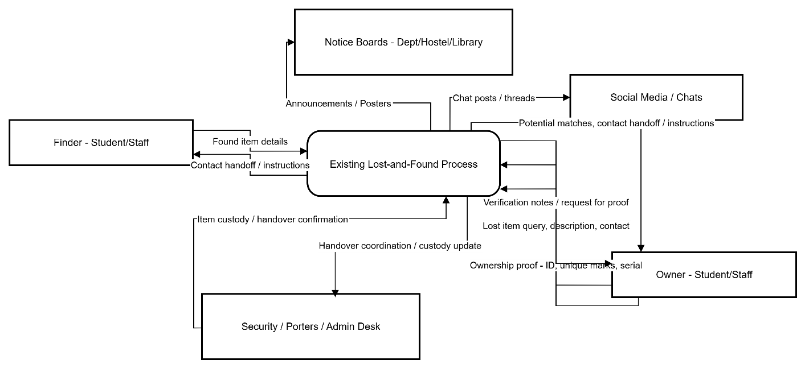
Figure 3.1. A context diagram of a manual lost and found system

3.2.1.1 Weaknesses of the Existing System
The current system for managing lost and found items at the University of Nigeria, Nsukka, relies on word-of-mouth, handwritten notices on departmental or hostel bulletin boards, and informal use of social media like WhatsApp and Facebook groups. Although this method sometimes works, it is inefficient, disjointed, and unreliable. Its shortcomings can be seen through users, input, output, process, and performance:

- Users of the System
The system relies mainly on individuals—students, staff, and occasionally security personnel—to voluntarily report lost or found items. Participation is inconsistent, and there are no set roles or accountability. There is also a risk of fraudulent claims because identity or ownership is not verified.
- Input
Information about lost or found items is unorganised and inconsistent. A finder might give vague descriptions like “phone found in hostel” without providing specific details such as brand, colour, or identifiers. Information may also be incomplete, handwritten (which can lead to readability issues), or sent in temporary chat messages that quickly disappear.
- Output
The output of the current system—announcements on bulletin boards, group messages, or word-of-mouth—is unreliable. Owners may never see the post or may see it too late. There is no standard way to search or filter outputs, and multiple conflicting claims can be hard to resolve.
- Process
The process of matching lost and found items is manual and prone to errors. Owners must continually check bulletin boards or group chats, hoping to find relevant information. Ownership verification is informal and usually relies on trust or superficial questioning. No central authority or database is managing these interactions, leading to inefficiency and disputes.
- Performance
The performance of the current system is poor in terms of speed, accuracy, and recovery rates. It can take days or weeks for an owner to reconnect with a lost item—if it happens at all. Many items go unclaimed, and there are no records of successful or failed recoveries. The system cannot handle the large population of students and staff, making it unsuitable for a university-wide solution.

3.2.2 Analysis of the Proposed System
The proposed Foundly platform fixes the problems with the current informal process by offering a centralised, verified, and automatic solution. It will make reporting, searching, claiming, and handover easier while keeping a record of all actions. Its improvements can be grouped into five areas: users, input, output, process, and performance.

1. Users of the System
Only verified UNN students and staff can access the system and claim lost items through authentication, which reduces fraud. Roles are clearly defined:
- Users report found items and make claims.
- Admins and moderators review disputed claims and manage categories.
- Security and porters confirm handovers.
This setup increases accountability and trust compared to the uncontrolled participation in the old system.

2. Input
Improvement: Inputs are standardized through structured web forms. When reporting found items, users must provide details like category, description, location, date, and at least one image. This ensures records are complete and consistent. Validation checks, such as required fields, file formats, and character limits, minimize vague or missing information.

3. Output
Improvement: The system produces clear outputs. Search results show item cards with images, categories, and status indicators. Detailed pages display all relevant item information. Claim outcomes—approved, rejected, or pending—are communicated through in-app notifications and optional email alerts, keeping owners informed quickly.

4. Process
Improvement: The reporting, searching, and claiming workflow is automated and transparent. Items are stored in a searchable database with indexing for quick retrieval. Claim verification uses evidence scoring—such as checking unique marks or serial numbers—and moderator review when needed. All actions—reports, claims, approvals, and rejections—are logged for accountability. This process removes the informal and error-prone manual checks of the old system.

5. Performance

Improvement: Search operations are optimized with full-text indexing, providing results in under a second, even as the database grows. Notifications are sent in real time, ensuring owners don’t miss potential matches. The structured workflow improves recovery rates, reduces the average time to reunion, and offers metrics—like the number of recovered items and claim success rate—that can be used for ongoing improvement.

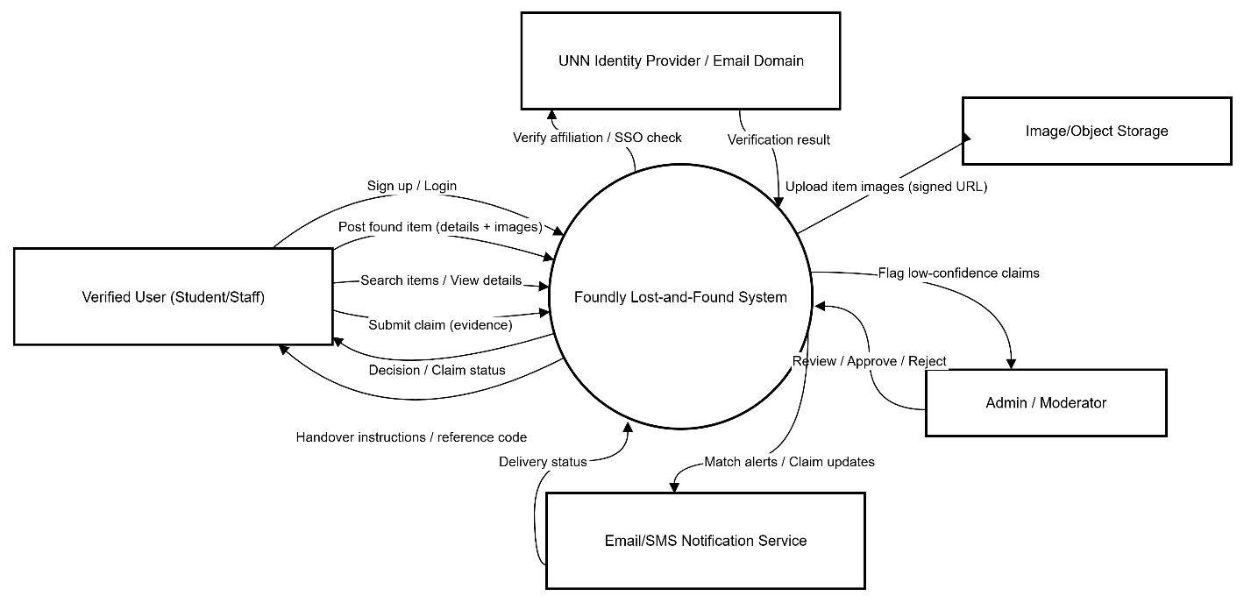
Figure 3.2.2 A context diagram of an improved lost and found system

3.4 Design of the Proposed System
We organise the design using four classic artefacts: database design, input design, output design, and home page design. This approach shows how the system will work on a computer and user interface. It also connects directly to implementation with Next.js, Hono, and PostgreSQL. Reliable guidance on design artefacts follows common software engineering texts and standards.

3.4.1 Use Case Diagram
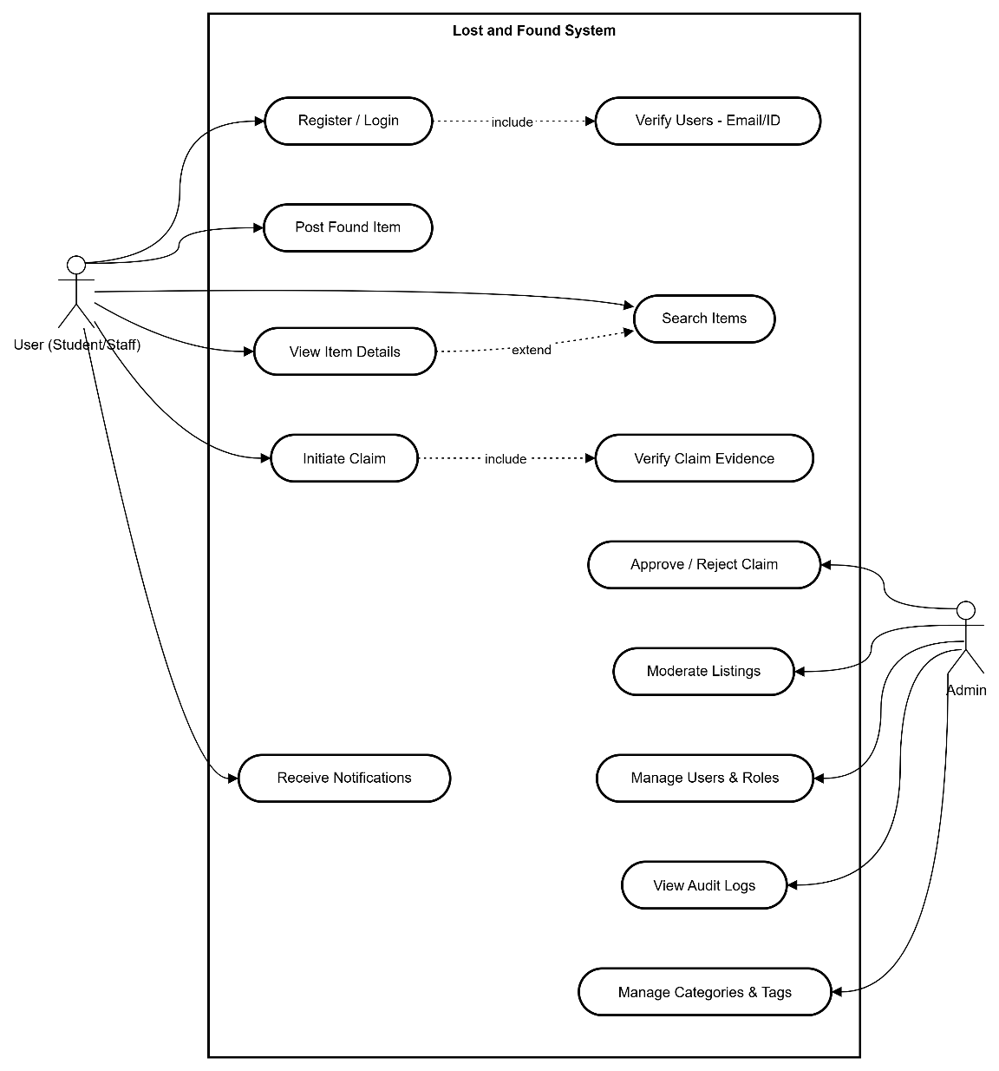
Fig 3.1 Use case diagram of Foundly, A lost and found system
Components of the Use Case Diagram
- Actors
- User (Student/Staff) – regular authenticated campus user
- Admin – manages users, categories, moderation, and audits
- Use-cases for each Actor
- User
  - Register / Login
  - Post Found ItemSearch Items → View Item Details
  - Initiate Claim (with evidence)
  - Receive Notifications (verification, matches, decisions)
- Admin
  - Approve / Reject Claim (policy or escalation)
  - Moderate Listings (remove duplicates/inappropriate posts)
  - Manage Users & Roles (promotions, disable accounts)
  - View Audit Logs (traceability)
  - Manage Categories & Tags (taxonomy hygiene)
- System Boundary
The “Foundly System” rectangle encloses all use cases accessible via the web app (Next.js frontend + Hono APIs). (UML guidance: use cases reside inside the boundary; actors are external.)
- Key Relationships
- Include:
  - Initiate Claim includes Verify Claim Evidence (evidence check is mandatory in the claim flow).
  - Register/Login includes Verify Users (email/ID verification step).
- Extend:
  - View Item Details extends Search Items (details are reached conditionally after a search).
(Include/extend semantics per UML practice.)

3.4.2 Activity Diagram
Below is the activity diagram of the Foundly platform core use cases. It shows the flow of core Foundly functionalities and what happens when each flow is followed
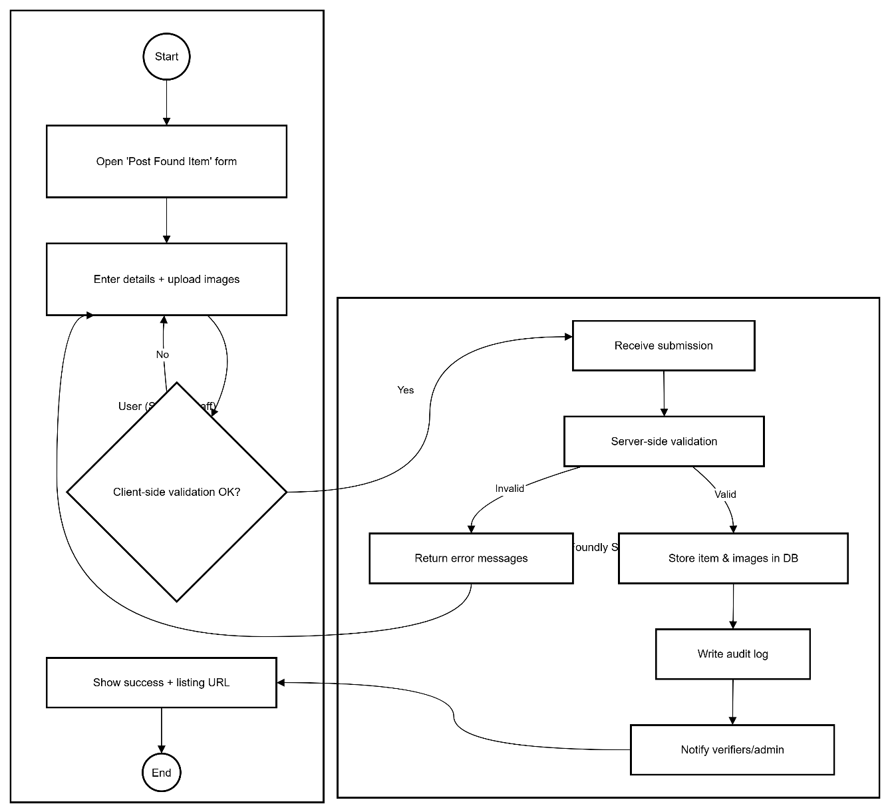
Figure 3.2 Activity diagram of creating a report of a found item in Foundly
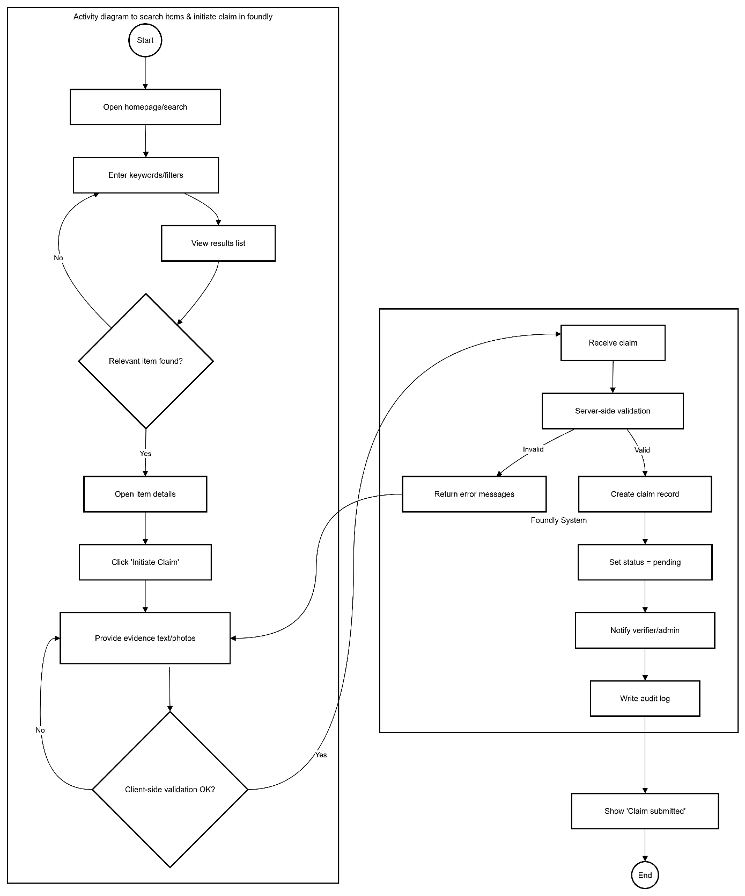
Figure 3.3 Activity diagram to search items & initiate claim in Foundly
Activity diagram of Foundly authentication system
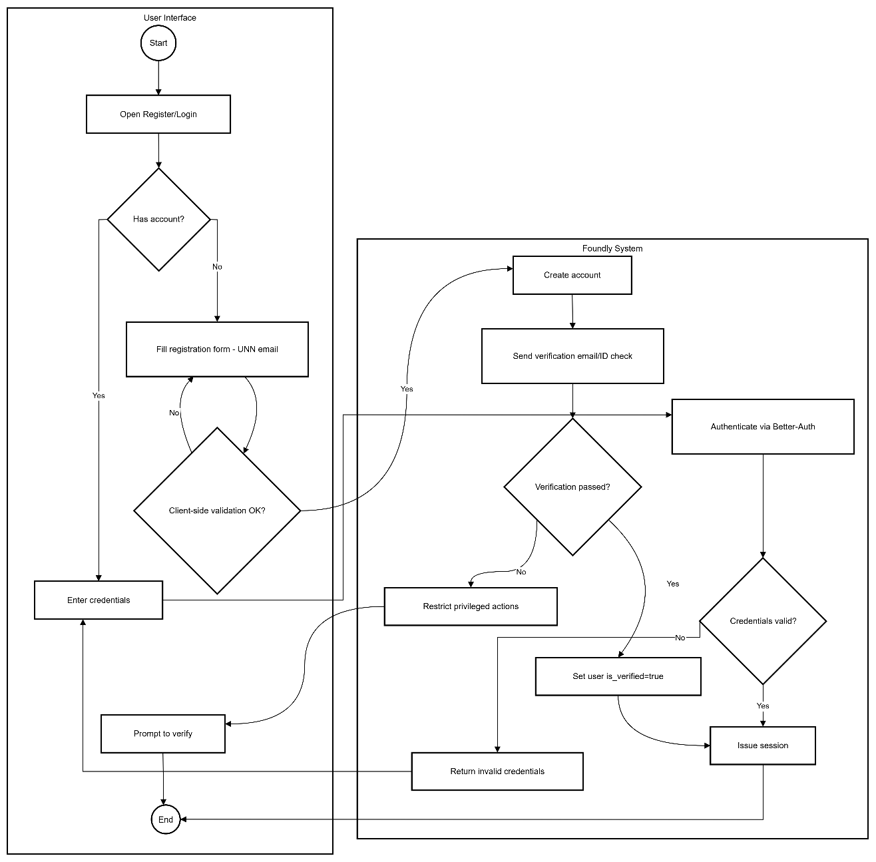
Figure 3.4 Activity diagram of Foundly authentication system

3.4.3 Class Diagram
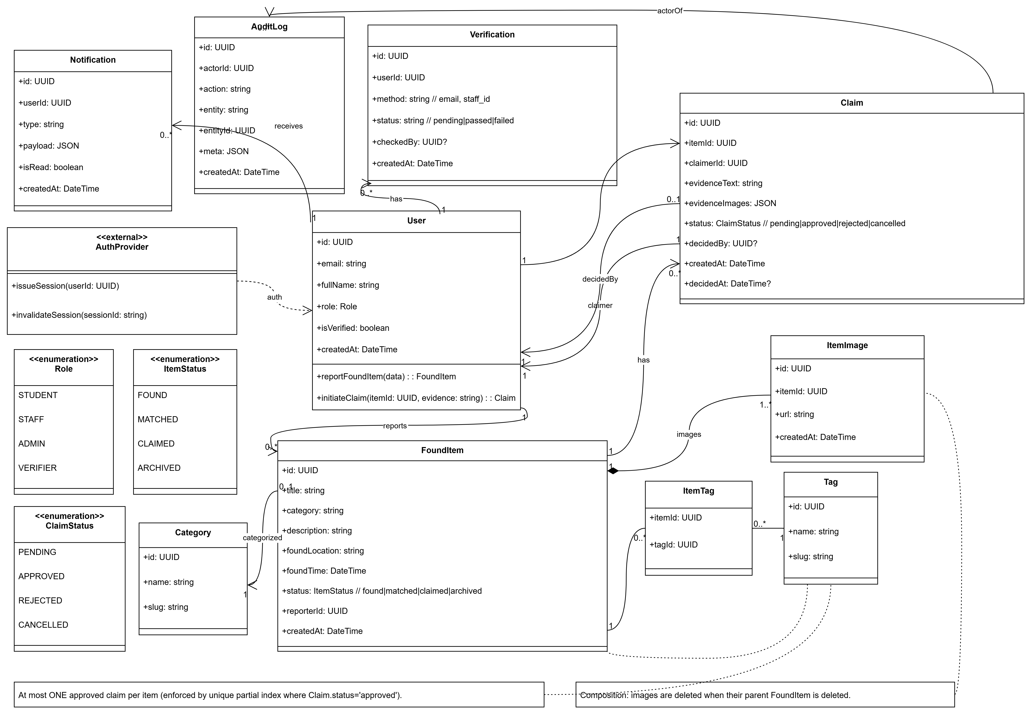
Figure 3.5 Foundly class diagram
Object mapping
- Scope alignment: There is no LostItem class or use case. Only FoundItem is posted. Owners search for and claim items with evidence.
- Core workflow: User → FoundItem → Claim with a maximum of one approved claim per item. This is enforced by a database-level unique index. ItemImage composition automatically deletes related images. (See UML composition, associations, and multiplicities per UML 2.5.1. Mermaid class syntax is used for rendering.)
- Platform mapping: Each class corresponds to one Drizzle table. Attributes match columns, and enums correspond to Postgres enums. This provides type-safe access and smooth migrations.
- Auth and roles: AuthProvider acts as an external layer for Better-Auth. Role determines authorisation for admin and verifier actions.

3.4.4 Sequence Diagram
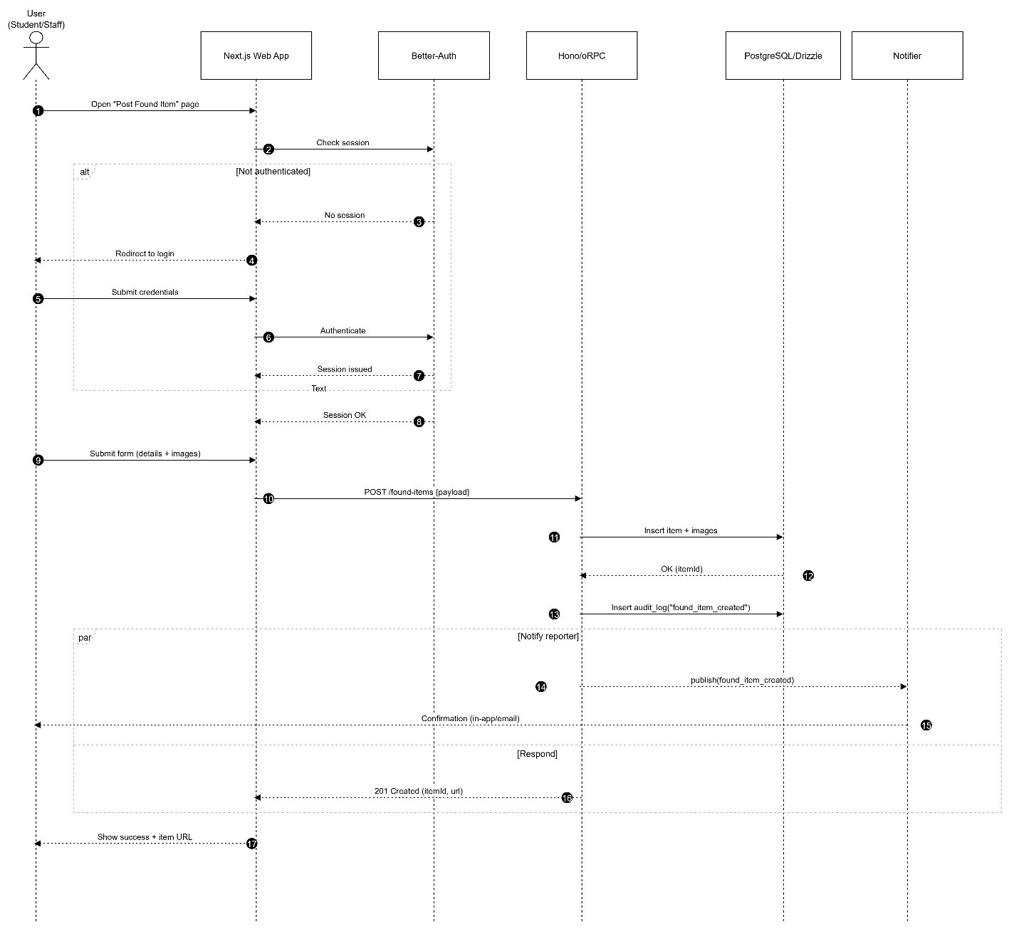
Figure 3.6 Sequence diagram to post a found item

3.4.5 System Architecture (high-level)
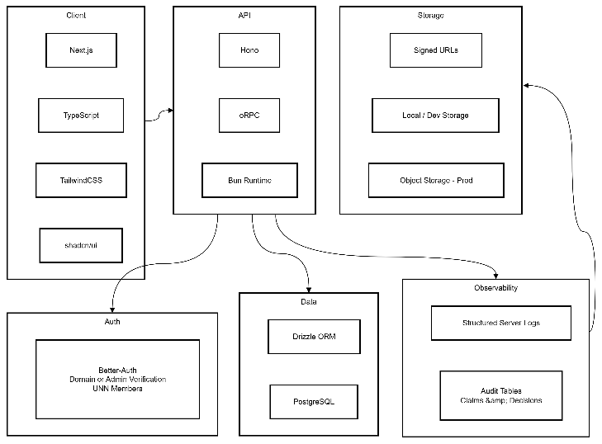
Figure 3.7 System architecture of Foundly

3.4.6 Database Design (logical overview)
Key entities and important fields (aligned to OOADM; Drizzle will enforce types and foreign keys):
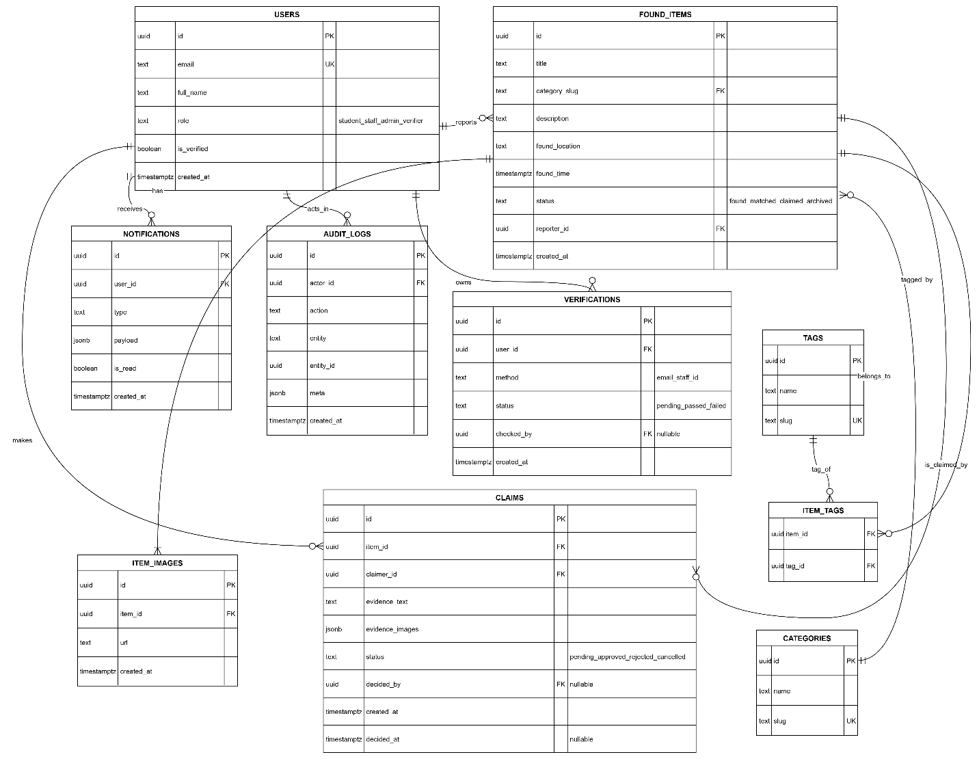
Figure 3.8 ERD of the Foundly system

USERS
Attribute name | Type of data | Length of data | Type of key | Foreign key referenced table
id | uuid | 36 | primary key | –
email | varchar | 254 | unique | –
full_name | varchar | 100 | – | –
role | enum(student,staff,admin,verifier) | – | – | –
is_verified | boolean | – | – | –
created_at | timestamptz | – | – | –

FOUND_ITEMS
Attribute name | Type of data | Length of data | Type of key | Foreign key referenced table
id | uuid | 36 | primary key | –
title | varchar | 120 | – | –
category_slug | varchar | 64 | foreign key | CATEGORIES.slug
description | text | – | – | –
found_location | varchar | 120 | – | –
found_time | timestamptz | – | – | –
status | enum(found,matched,claimed,archived) | – | – | –
item_image_url | varchar | 120
reporter_id | uuid | 36 | foreign key | USERS.id
created_at | timestamptz | – | – | –

CLAIMS
Attribute name | Type of data | Length of data | Type of key | Foreign key referenced table
id | uuid | 36 | primary key | –
item_id | uuid | 36 | foreign key | FOUND_ITEMS.id
claimer_id | uuid | 36 | foreign key | USERS.id
evidence_text | text | – | – | –
evidence_images | jsonb | – | – | –
status | enum(pending,approved,rejected,cancelled) | – | – | –
decided_by | uuid | 36 | foreign key | USERS.id
created_at | timestamptz | – | – | –
decided_at | timestamptz | – | – | –

NOTIFICATIONS
Attribute name | Type of data | Length of data | Type of key | Foreign key referenced table
id | uuid | 36 | primary key | –
user_id | uuid | 36 | foreign key | USERS.id
type | varchar | 32 | – | –
payload | jsonb | – | – | –
is_read | boolean | – | – | –
created_at | timestamptz | – | – | –

AUDIT_LOGS
Attribute name | Type of data | Length of data | Type of key | Foreign key referenced table
id | uuid | 36 | primary key | –
actor_id | uuid | 36 | foreign key | USERS.id
action | varchar | 50 | – | –
entity | varchar | 32 | – | –
entity_id | uuid | 36 | – | –
meta | jsonb | – | – | –
created_at | timestamptz | – | – | –

VERIFICATIONS
Attribute name | Type of data | Length of data | Type of key | Foreign key referenced table
id | uuid | 36 | primary key | –
user_id | uuid | 36 | foreign key | USERS.id
method | enum(email,staff_id) | – | – | –
status | enum(pending,passed,failed) | – | – | –
checked_by | uuid | 36 | foreign key | USERS.id
created_at | timestamptz | – | – | –

CATEGORIES
Attribute name | Type of data | Length of data | Type of key | Foreign key referenced table
id | uuid | 36 | primary key | –
name | varchar | 64 | – | –
slug | varchar | 64 | unique | –

TAGS
Attribute name | Type of data | Length of data | Type of key | Foreign key referenced table
id | uuid | 36 | primary key | –
name | varchar | 32 | – | –
slug | varchar | 32 | unique | –

C) Input Design (forms and validation)

Register/Login: email, password, optional full name, optional reg no, department, profile picture, UNN email/domain checks or admin verification.
Report Found Item: category, title, description, unique markings, colour/brand (optional), found location, found date, images (at least 1), contact preference. Client/server validation for required fields and file size/type.
Search Lost Items: keyword and filters (category, location, date range), sort by relevance or date.
Submit Claim: free-text evidence like serial number or identifiable scratch, optional proof image or document. There are constraints on length and format, plus PII minimisation.

D) Output Design (screens and responses)
- Item Listings: card or grid format with image thumbnail, category, location, date, and short description; badges indicate status.
- Item Detail: full description, multiple images, found metadata, and poster info (redacted), plus Claim action.
- Claim Status Views: PENDING, APPROVED, or REJECTED with a brief rationale; handover instructions provided upon approval.
- Notifications: in-app alerts and inbox messages; optional email for match or decision updates.

REFERENCES
Abhiram, T., Krishnan, E. B. A., Manjith, K. M., Vishnu, A. P., & Ambarish, A. (2024). CampusTrace—Application for lost and found items on campus. Journal of Trends in Computer Science and Smart Technology, 6(2), 168–179. https://doi.org/10.36548/jtcsst.2024.2.006
Avison, D. E., & Fitzgerald, G. (2006). Information systems development: Methodologies, techniques and tools (4th ed.). McGraw-Hill Education.
Booch, G., Rumbaugh, J., & Jacobson, I. (2005). The unified modeling language user guide (2nd ed.). Addison-Wesley.
CampusTrace. (2025). CampusTrace transforms the systems of lost and found items in campus environments. CampusTrace.
Canonigo II, R. J., & Oribello, J. F. (2022). Development of an online-based web application of lost and found items information system for Cavite State University [Undergraduate thesis]. Cavite State University Library.
Elmasri, R., & Navathe, S. B. (2016). Fundamentals of database systems (7th ed.). Pearson.
GitHub—mermaid-js. (2020–2025). Issues on activity diagrams & swimlanes (workarounds via subgraphs). https://github.com/mermaid-js/mermaid/issues/1674
Gurstein, M. (2007). What is community informatics? (And why does it matter). Polimetrica.
Ibrahim, A. O., et al. (2023). Design and implementation of web-based lost and found information system (Case study: ADUST). Scribd. https://www.scribd.com/document/722515371/
Incentive-centered design. (2025, January). In Wikipedia. https://en.wikipedia.org/wiki/Incentive-centered_design
Kanjalkar, P., Pingle, J., Sagar, A., Lohe, R., Patil, S., & Kanjalkar, J. (2024). Lost and found web application. International Journal for Research in Applied Science & Engineering Technology (IJRASET). https://doi.org/10.22214/ijraset.2024.65573
Kaur, H. (2017). Lost and found web application for Cal Poly Pomona students [Master's thesis]. California State Polytechnic University, Pomona.
Kumar, S., Bhatnagar, D., & Gahlot, D. (2022). Web-based lost and found system. MIT International Journal of Computer Science and Information Technology, 11(1). https://www.researchgate.net/publication/376856933_Web-Based_Lost_and_Found_System
Mermaid. (2025). Flowcharts – Basic syntax & diagram syntax. https://docs.mermaidchart.com/mermaid-oss/syntax/flowchart.html
Muhamad Ilias, N. F. (2021). A web-based system for lost and found management [Project report]. Universiti Teknologi MARA.
Nielsen, J. (2020). 10 usability heuristics for user interface design. Nielsen Norman Group. https://www.nngroup.com/articles/ten-usability-heuristics/ (Original work published 1994)
Object Management Group. (2017). Unified Modeling Language (UML) Version 2.5.1. https://www.omg.org/spec/UML/2.5.1/
RepoApp. (n.d.). Lost and found software for universities. https://www.repoapp.com/lost-found-software-universities/
Sadiku, P. O., Ogundokun, R. O., & Abikoye, O. C. (2019). IFOUND—An online lost item recovery application. I-Manager's Journal on Information Technology, 8(3), 1–8. https://doi.org/10.26634/jit.8.3.16535
Sommerville, I. (2016). Software engineering (10th ed.). Pearson.
Sparx Systems. (n.d.). UML 2 tutorial – Activity diagram. https://sparxsystems.com/resources/tutorials/uml2/activity-diagram.html
Systems theory. (2025, January). In Wikipedia. https://en.wikipedia.org/wiki/Systems_theory
Tan, S. Y., & Chong, C. R. (2023). An effective lost and found system in university campus. Journal of Information System and Technology Management, 8(32), 99–112. https://doi.org/10.35631/JISTM.832007
UML-Diagrams.org. (n.d.). Activity diagrams (controls, partitions). https://www.uml-diagrams.org/activity-diagrams.html
University of Uyo case study – Automated campus lost and found management system. (n.d.). https://nairaproject.com/projects/6177-automated-campus-lost-and-found-management-system-a-case-study-of-university-of-uyo.html
Vasavi, R., Reddy, S., Chakrapani, C., Samhitha, P., Vaishnavi, Y., & Vinay Datta, C. (2022). Lost and found system for VNR VJIET. International Journal of Engineering Research & Technology (IJERT), 11(6). https://doi.org/10.17577/IJERTV11IS060277
Veeru, B., Kranthi, S., Soumya, M., Amanpasha, M., Rakesh, K., & Krishna, B. (2024). Lost and found website for college campus. IJFANS International Journal of Food and Nutritional Sciences, 13(4).
W3C. (2024). Web Content Accessibility Guidelines (WCAG) 2.2. https://www.w3.org/TR/WCAG22/
Wilson, D. C. (2023). AppalLOCATE: A lost and found solution [Undergraduate honors thesis]. Appalachian State University.

