>touch guru{1..20}.txt

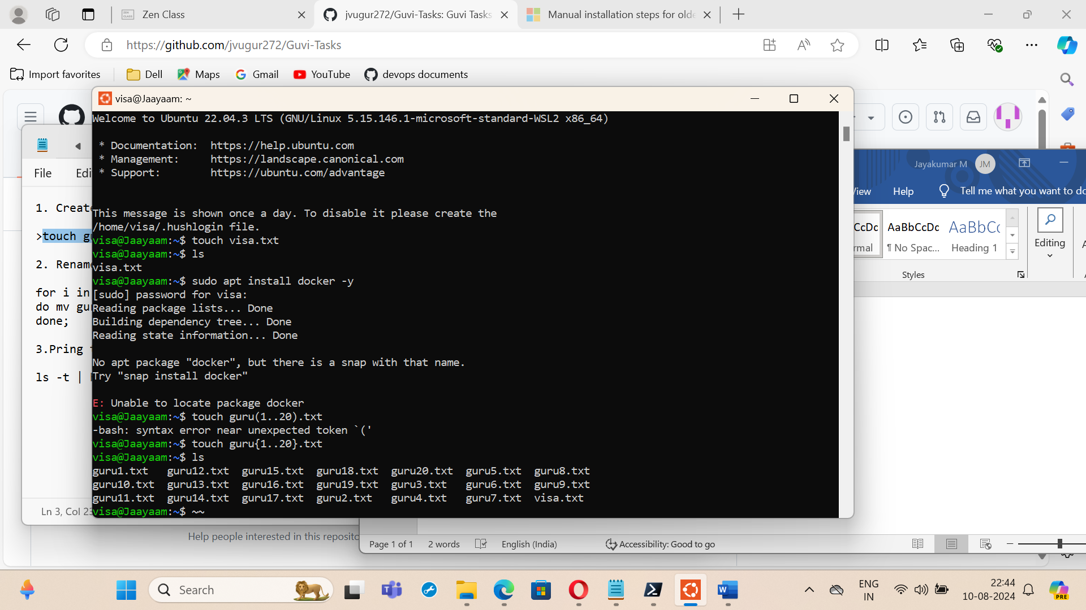

visa@Jaayaam:~$ for i in {1..5};

> do mv guru$i.txt guru$i.yml;

> done;

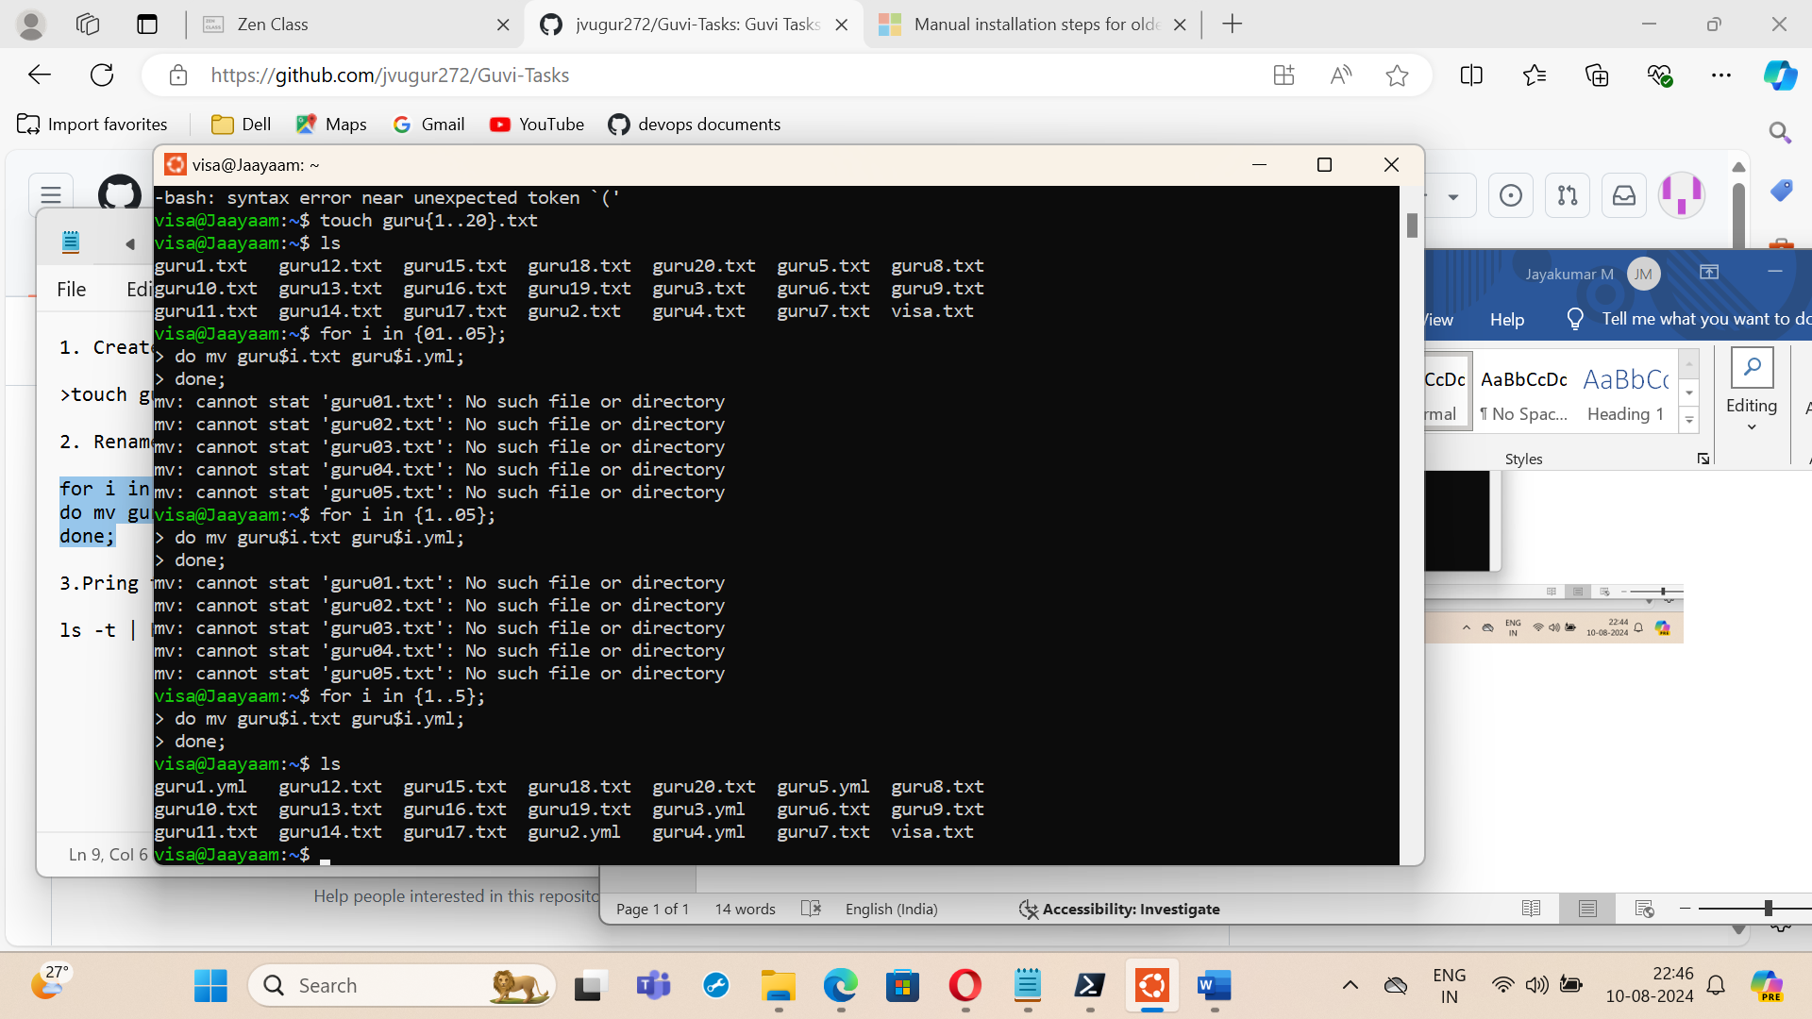

visa@Jaayaam:~$ ls -t | head -5

