visa@Jaayaam:~$ cat test1.sh

#! /bin/bash

file_path="./file.txt"

awk 'NR >= 5 {gsub(/give/,"learing")} /welcome/' "$file_path"

visa@Jaayaam:~$

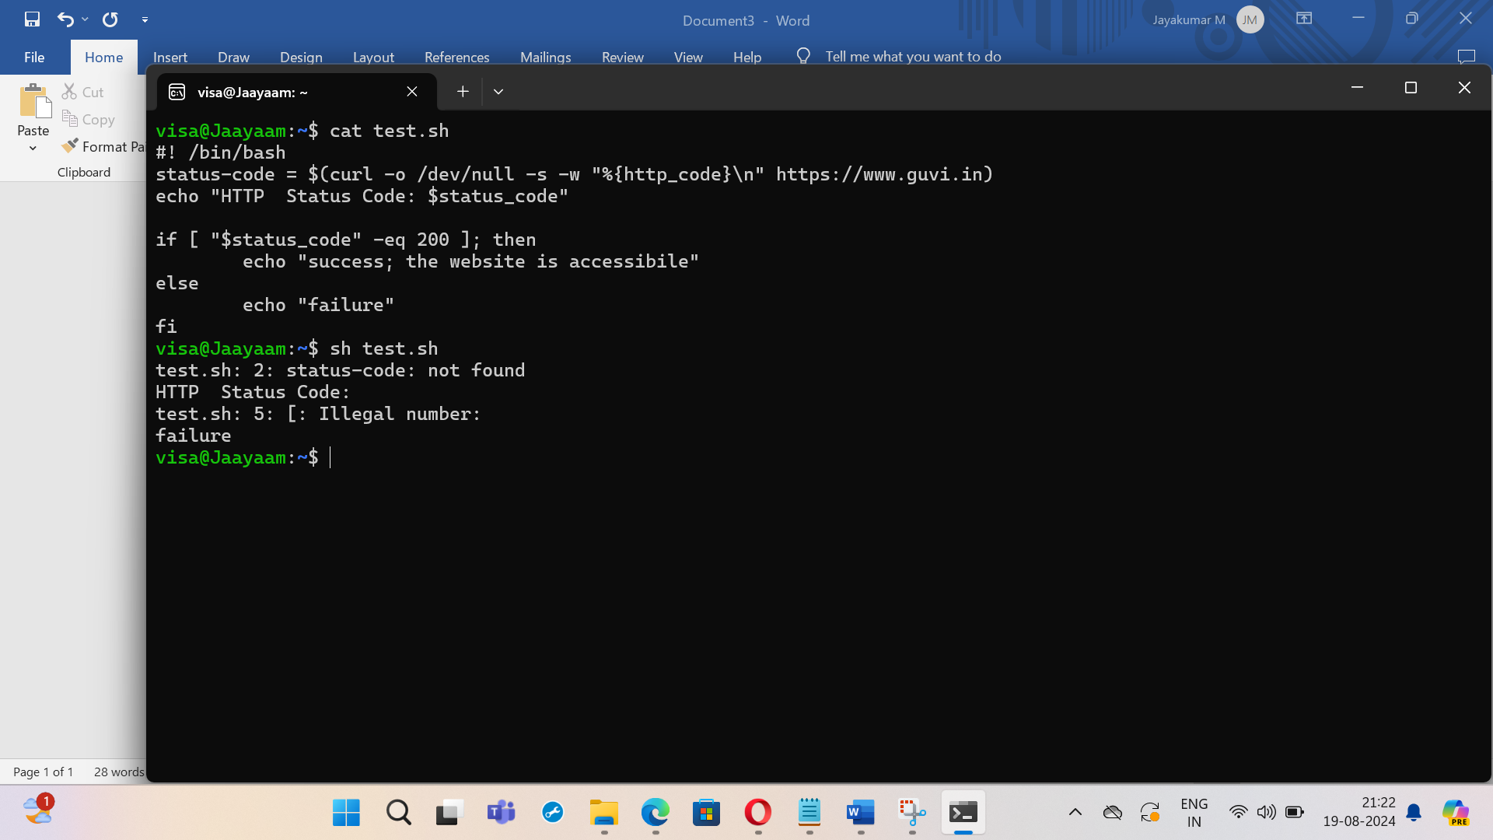

visa@Jaayaam:~$ cat test1.sh

#! /bin/bash

file_path="./file.txt"

awk 'NR >= 5 {gsub(/give/,"learing")} /welcome/' "$file_path"

visa@Jaayaam:~$

