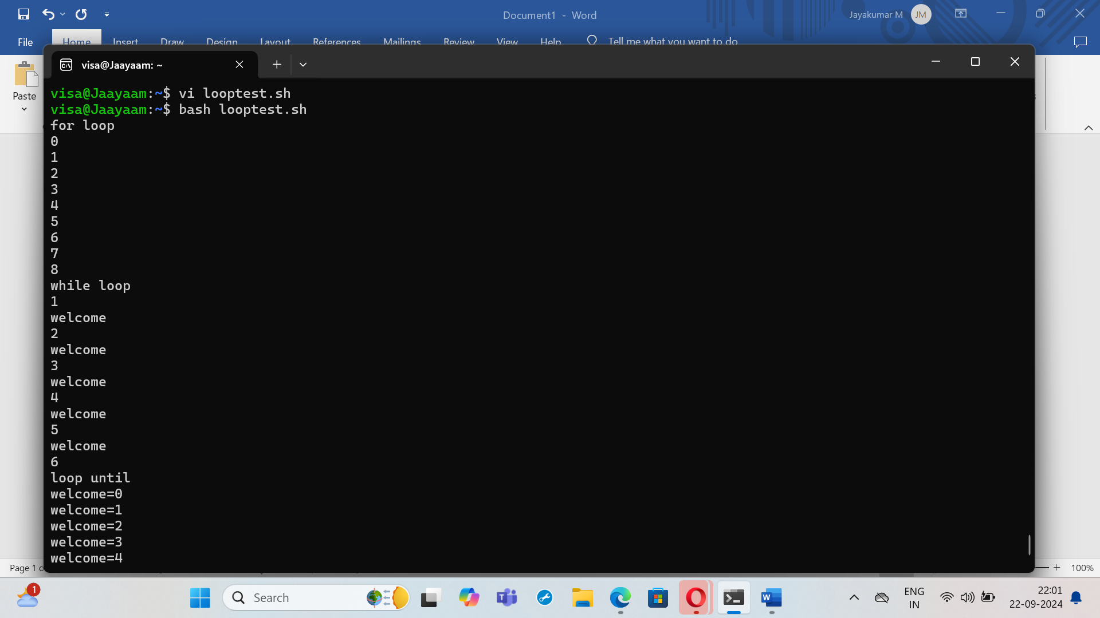

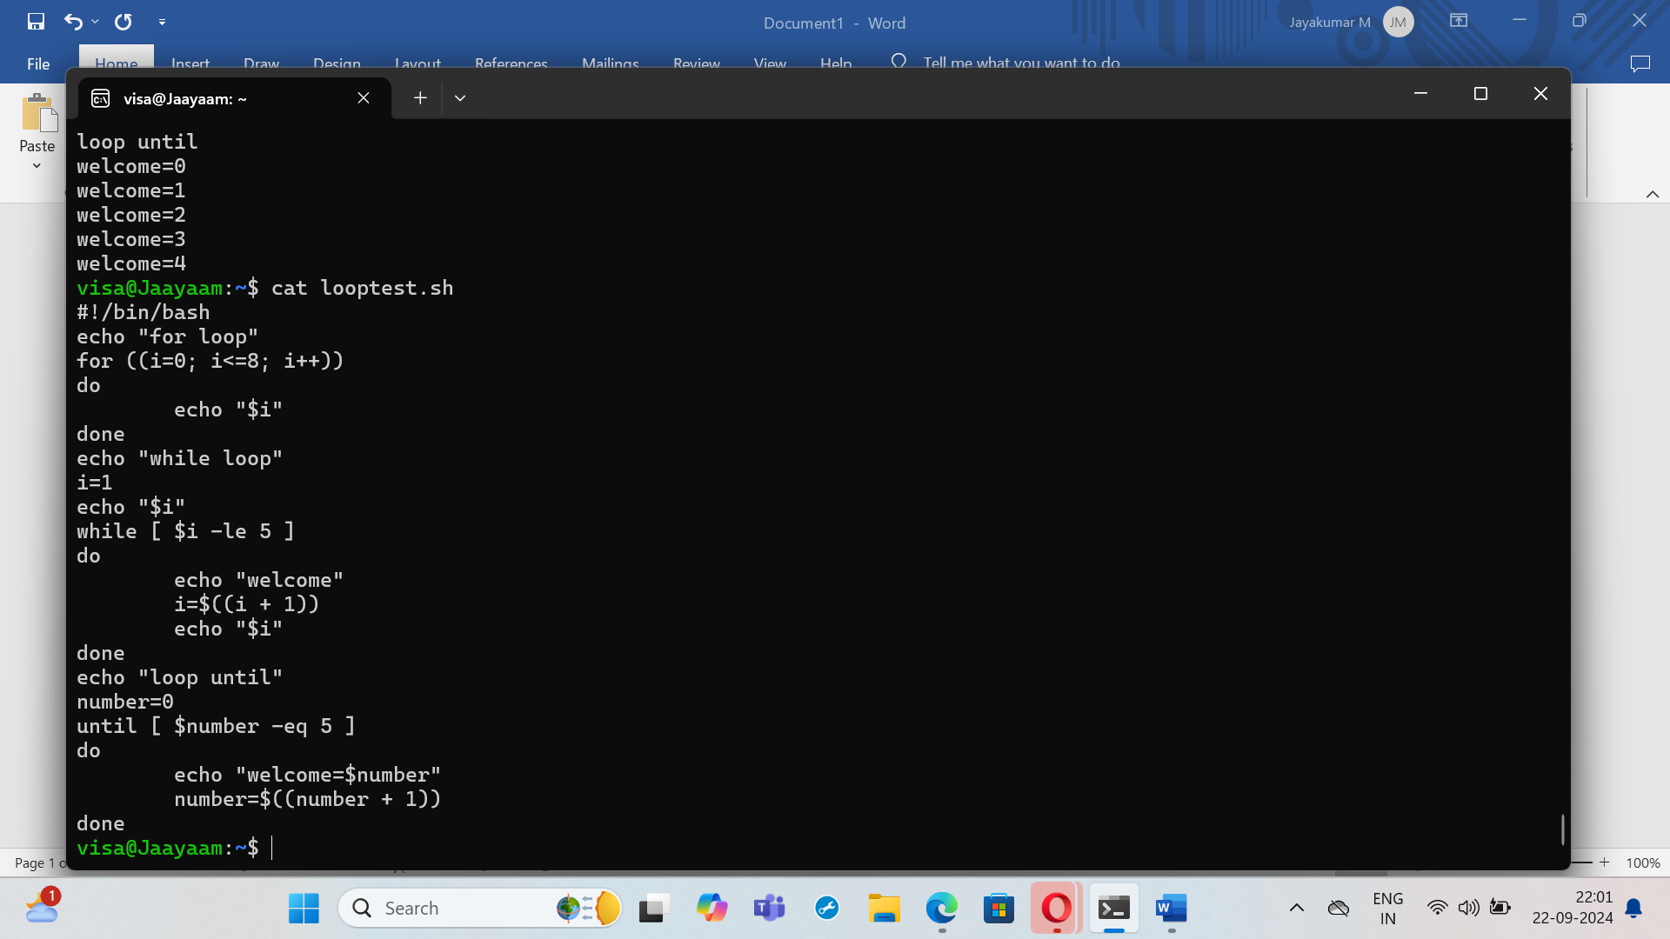

#!/bin/bash

echo "for loop"

for ((i=0; i<=8; i++))

do

echo "$i"

done

echo "while loop"

i=1

echo "$i"

while [ $i -ge 5 ]

do

echo "welcome"

i=i+1

echo "$i"

done