Text Feature Engineering on Real-world Dataset
Introduction
Text feature engineering is an important step in Natural Language Processing (NLP) that converts textual data into numerical form so that machine learning models can process it. This project focuses on applying different feature engineering techniques such as One Hot Encoding, Bag of Words (BoW), and TF-IDF on user-generated review data.

Dataset
A dataset of 100 user-generated product-style reviews was created to simulate real-world e-commerce reviews. The dataset contains a single column named review_text, which includes positive and negative opinions about products.

Task 1: Preprocessing
The text data was cleaned and standardized using the following steps:
- Converted all text to lowercase
- Removed punctuation and special characters
- Tokenized the text into words
- Removed stopwords such as “the”, “is”, and “and”
These steps help reduce noise and improve the quality of input data for feature extraction.
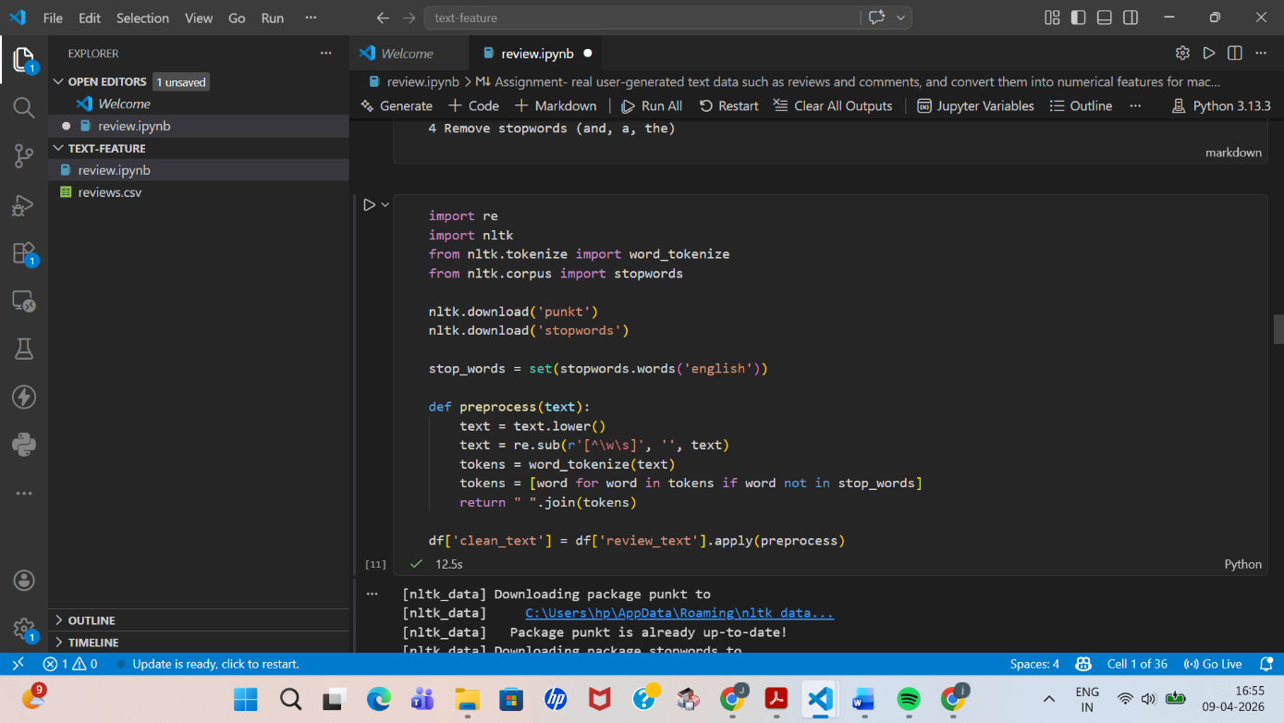

Task 2: Vocabulary Creation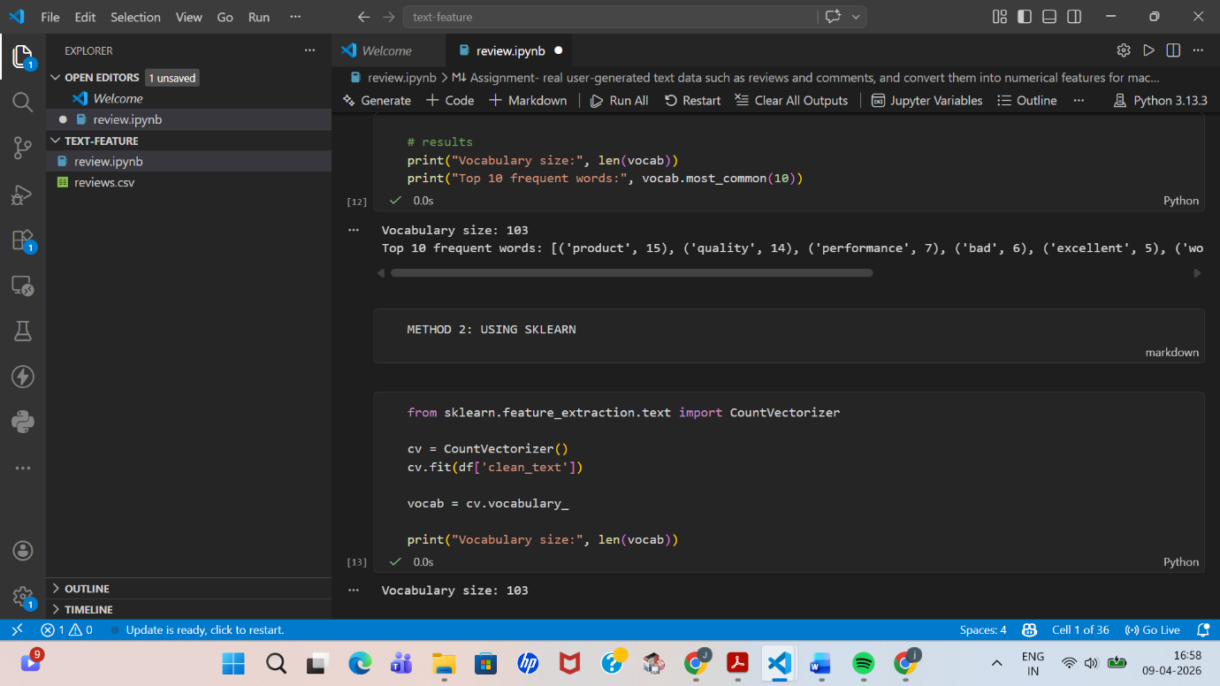

Task 3 : Feature Engineering
3.1 One Hot Encoding
One Hot Encoding represents text as binary vectors indicating the presence (1) or absence (0) of words in a document. However, it creates very large vectors and does not capture word importance.
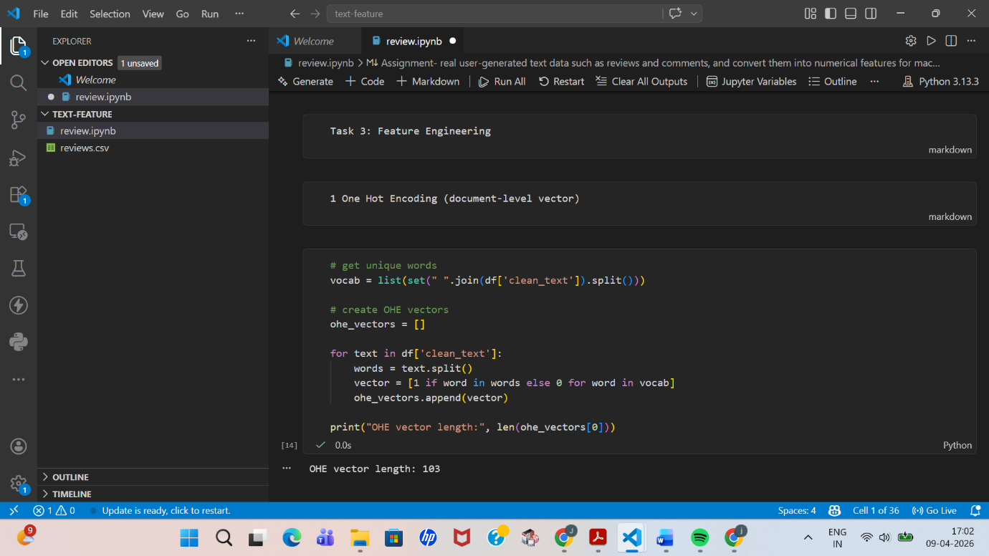

3.2 Bag of Words (BoW)
Bag of Words converts text into numerical form by counting the frequency of each word in a document. It is simple and effective but ignores word order and meaning.
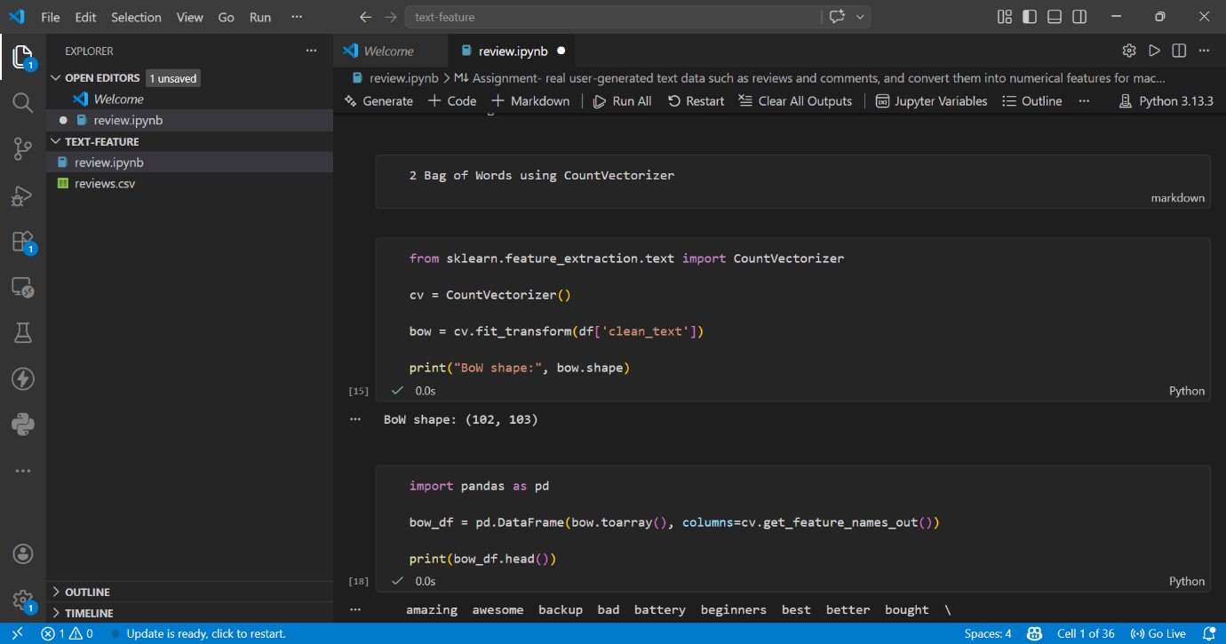

3.3 TF-IDF
TF-IDF (Term Frequency–Inverse Document Frequency) assigns importance to words based on how frequently they appear in a document and how rare they are across all documents. It reduces the weight of common words and highlights meaningful words.
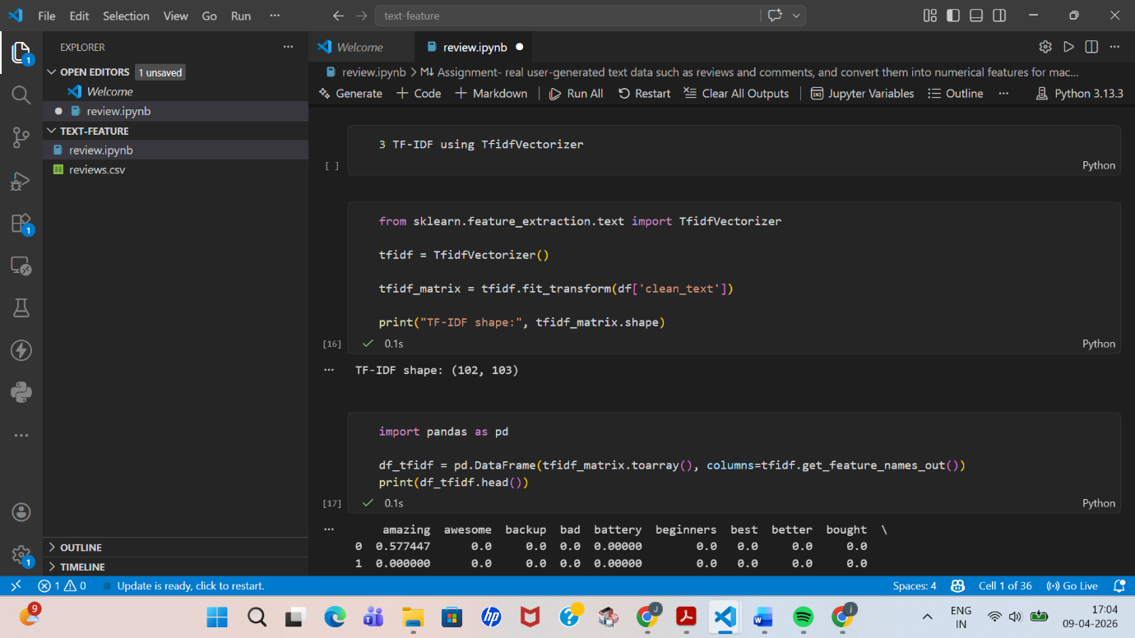

Task 4 : Comparison Analysis
Feature |  |  |  | One Hot Encoding |  |  |  |  | Bag of Words |  |  |  |  |  | TF-IDF
Meaning |  |  |  | Presence of words (0/1) |  |  |  |  | Frequency of words |  |  |  |  |  | Importance of words
Captures Frequency |  |  |  | No |  |  |  |  | Yes |  |  |  |  |  | Yes
Handles Importance |  |  |  | No |  |  |  |  | No |  |  |  |  |  | Yes
Size |  |  |  | Very large |  |  |  |  | Large |  |  |  |  |  | Large
Use Case |  |  |  | Simple tasks |  |  |  |  | Text classification |  |  |  |  |  | Search, ranking
Explanation:
TF-IDF performs better because it reduces the weight of common words like “product” and highlights meaningful words such as “excellent” or “poor”.

Task 5: Sparse Matrix Analysis
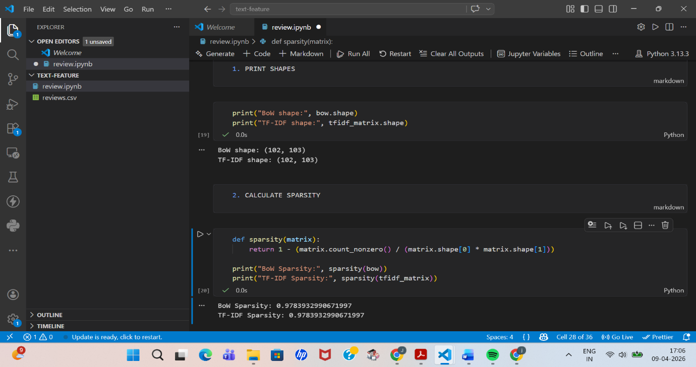
Results and Observations
- Vocabulary size was calculated and top frequent words were identified
- BoW and TF-IDF matrices were generated
- Both matrices were highly sparse (over 90% zero values)
- TF-IDF provided better feature representation than BoW
(Screenshots of outputs are included above)

The feature matrices generated using BoW and TF-IDF were sparse, meaning most values were zero. Sparse matrices are inefficient for large-scale systems because they consume memory unnecessarily and increase computational cost.
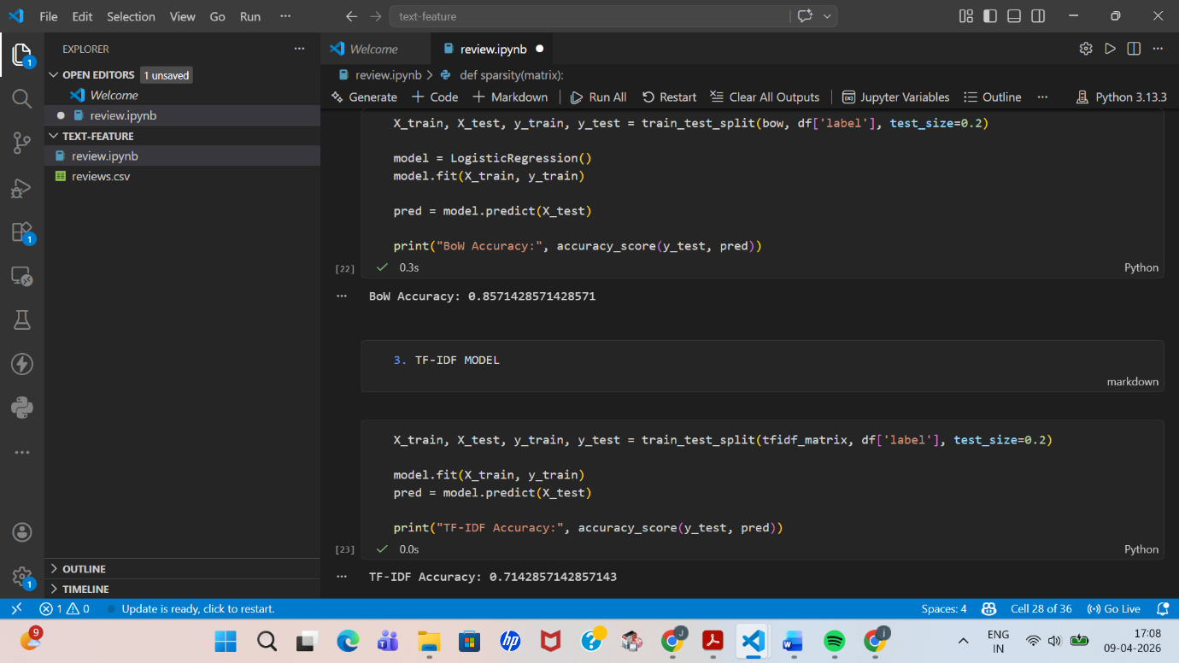

Task 6: Real-world Questions
1. Why Bag of Words fails in understanding semantic meaning
Bag of Words treats words independently and ignores context. For example, “good” and “excellent” have similar meanings but are treated as completely different features.

2. When to use Bag of Words and TF-IDF
Bag of Words is suitable for simple tasks and small datasets. TF-IDF is widely used in real-world applications such as search engines and document ranking because it highlights important words.

3. Limitations of TF-IDF
TF-IDF does not consider word order or context. It also fails in capturing deep semantic meaning, making it less effective for advanced NLP applications.

Task 7: Mini Use Case: Sentiment Classification
A sentiment classification model was built using Logistic Regression to classify reviews as positive or negative.
- BoW and TF-IDF features were used separately
- TF-IDF achieved slightly better performance due to better feature weighting

Conclusion
This project demonstrated how text data can be transformed into numerical features using different techniques. Among the methods used, TF-IDF proved to be more effective than Bag of Words as it captures the importance of words. However, both methods have limitations in understanding semantic meaning, which can be improved using advanced NLP techniques.

