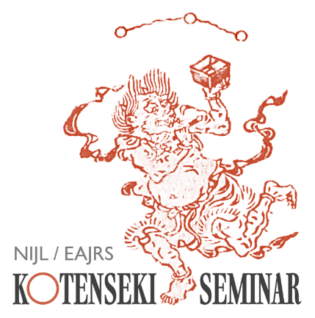

Exploring Variations in Edo-period Woodblock-Printed Editions
The National Institute of Japanese Literature (NIJL) and the European Association of Japanese Resource Specialists (EAJRS) are pleased to announce the next Kotenseki Seminar, to be held online via Zoom.
This seminar will focus on variations between Edo-period woodblock-printed editions.
Even where books share the same title and represent the same work, individual copies—even impressions from the same blocks—may display subtle differences in a variety of features, including the text, illustrations, title page, and colophon. Such variations are not merely matters of bibliography; they can also provide important clues to the practices of publishing and distribution, as well as to the wider culture of the book in the Edo period.
In this seminar, Professor Atsushi Iriguchi, Deputy Director-General of the National Institute of Japanese Literature, will examine variations in Edo-period woodblock-printed editions, drawing on specific examples from the Institute’s collections and related materials.

Date | 10:00-12:15 Central European Time  Tuesday, 20 October 2026  (There will be a break at around 11:00, and a Q&A session at the end)
Speaker | Professor IRIGUCHI Atsushi  (Deputy Director-General,  National Institute of Japanese Literature)
Format | Online via Zoom  The Zoom link will be sent to registered participants by email prior to the seminar
Admission | Free
Language | Japanese (no interpretation will be provided)
Application Form | Click here for the form
Deadline | Sunday, 11 Ocotber 2026

The seminar will be recorded and made available subsequently on YouTube via the EAJRS website.
Enquiries
Akira Hirano at: a.hirano@sainsbury-institute.org
We look forward to your participation.

