Received: dd/mm/yyyy Revised: dd/mm/yyyy Accepted: dd/mm/yyyy Published: dd/mm/yyyy
Original Article
Natural Landscape of Vietnam in the Documentary Film In the Year of the Pig
VIVIEN JIAQIAN ZHU¹
¹ Department of East Asian Languages and Cultures, University of California, Berkeley, California, USA
Author Mail id: jiaqian_zhu@berkeley.edu
ABSTRACT: This essay examines the cinematic landscape in Emile de Antonio’s 1968 documentary In the Year of the Pig, arguing that the film’s recurring sequences of Vietnam’s rivers, mountains, and land do more than frame the Vietnam War: they stage a shifting relation between beauty, looking, and military violence. Drawing on W. J. T. Mitchell’s theorization of landscape as a culturally specific medium and John Berger’s account of the de-centering movie camera, the analysis traces how the film’s opening and closing shots present a harmonious, pre-emancipatory landscape inhabited by Vietnamese boatmen, before this landscape is progressively militarized as American warships, tanks, and refugees enter the frame. Reading the camera eye through Paul Virilio’s theory of the sighting device, the essay shows how camera movement comes to mimic the trajectory of a weapon, transforming the act of looking into an act of military reconnaissance and destruction. The essay further situates this militarized looking within a broader problem of visual authority, asking who has the power to determine what counts as beautiful in a documentary about war, and closes by reading the film’s landscape imagery alongside the self-narration of aging and ravaged beauty in Marguerite Duras’s The Lover. The essay contends that the minor, subsidiary status of landscape within both the documentary genre and the mainstream art-historical canon makes it a productive site for uncovering the aesthetic and political stakes of colonial and wartime spectatorship, revealing how cinematic landscape carries the collective memory of a colonized nation.
KEYWORDS: documentary film; cinematic landscape; Vietnam War; visual culture; colonial gaze; Emile de Antonio
1. INTRODUCTION
Directed by Emile de Antonio, the 1968 American documentary film In the Year of the Pig employs various historical footage and many interviews to show American involvement in the Vietnam War. Besides sequences of interviews and news footage, the opening and ending of the film also shoot sequences of the natural landscape of the river and mountain in Vietnam. With intentional montages of the natural landscape in the documentation of war, In the Year of the Pig establishes a contrast between the beauty of nature and a keynote of fierce fighting, heavy injury and political speeches. Sequences of natural landscape thereby offers a soothing visual experience and evokes a sense of what the nature might be in Vietnam before the war. Camera movement transforms natural landscape in Vietnam into a cinematic landscape, a dynamic medium where visual elements of river, mountain and land are further reproduced and remodeled in other sequences such as American intrusion and refugees’ escape. In addition to capturing the landscape, moving camera also mimics moving weapon to impose a colonial and military perspective on the aesthetic looking and shows a military predation and destruction of Vietnam’s territory through intentional montage and superimposition of voice-overs on the visual landscape. The militarized relation between the camera eye and cinematic landscape further problematizes the relation between viewership and perception beauty in a colonial and wartime narration.
2. LANDSCAPE AS A CULTURAL MEDIUM: THEORETICAL FRAMEWORK
According to Mitchell, “landscape is a medium found in all cultures.” [1, p. 5] As opposed to a main western or Chinese tradition of landscape in painting, landscape in Vietnam more fits into the category of what Mitchell refers to as the “other hand” of landscape, in which “nature is pre- emancipatory, prior to the perception of nature as such.” [1, p. 12] Although footage of mountains, rivers, trees and lands in the film do not indicate any specific time, they still evoke a sense of history in the black-and-white tone and suggests a local beauty through misty pictorial contrasts among white, grey and black. Since shot and produced from an American perspective, In the Year of the Pig reduces a possible religious implication of mystic power of Vietnam’s natural landscape and calls attention to that pre-emancipatory state of the nature before the Vietnam War. Fast cuts of mountains, rivers, trees and lands in the film prevent the viewer from closely observing each landscape and de-centers a semiotic interpretation of the visual elements therein. Readability of the natural landscape does not rely on the visual elements or movements of visual element. On that account, “the invitation to look at a landscape suggests a look at nothing or a look at looking itself.” [1, p. viii]
In film, “the camera—and more particularly the movie camera—demonstrated that there was no centre.” [2, p. 18] The de-centered view produced by the movie camera allies with a look at the looking of landscape per se to constitute a look at a cinematic landscape and to invite a holistic look at a sequence of several landscape shots. Sights of the flowing of the river, the swaying of the tree and the movement of the movie camera are subjected to a looking on the entire natural landscape. This holistic looking at the cinematic landscape forms a poetic découpage along the documentary narrative and simultaneously foregrounds historical footage and interview conversations. Shot of each landscape is then reproduced and remolded as the background of military invasion and refugees’ sufferance throughout the film, producing a visual narrative that keeps uncovering a contrast between the primitive nature and military destruction during the Vietnam War.
3. MATERIALS AND METHODS
This essay undertakes a close visual analysis of Emile de Antonio’s In the Year of the Pig (1968), a black-and-white documentary that combines archival footage, interview testimony, and original cinematography of the Vietnamese countryside. The primary materials are six screenshots drawn from the film’s opening sequence, its depiction of the American military’s arrival, and its imagery of wartime destruction and refugee flight (Figs. 1–6), each read in relation to the film’s soundtrack and editing. The analytic method combines formal film analysis—attending to camera movement, montage, and the superimposition of voice-over—with a theoretical framework drawn from landscape studies (Mitchell), phenomenologies of the moving camera (Berger), the militarization of vision (Virilio), and the aesthetics of memory and the body (Duras, Benjamin), in order to trace how the film’s cinematic landscape shifts from a harmonious, pre-emancipatory register to a colonized and militarized one over the course of the documentary.
4. RESULTS AND DISCUSSION
4.1. THE HARMONIOUS LANDSCAPE BEFORE THE WAR
The happening of the Vietnam War violates the pre-emancipatory local landscape and affects the relation between human and the nature, the self and the other in the cinematic landscape. In both shots from the opening (Fig. 1) and the ending (Fig. 2) of the film, landscape of mountain and river also contains wood boats and Vietnamese boatmen, suggesting a harmonious interaction between the landscape and people therein. The organic environment of mountain and river indicates a traditional aesthetic of the local community, regardless of its poverty and underdevelopment in the reality. These two parallel shots produce a circular narrative in the film to stress on Vietnamese people’s dependence on the nature. As an agricultural country, water and land provide essential resources for the Vietnamese people to grow rice. Each thumb square of the land in Vietnam is more valuable than that of gold, for that small land is able to feed many people.
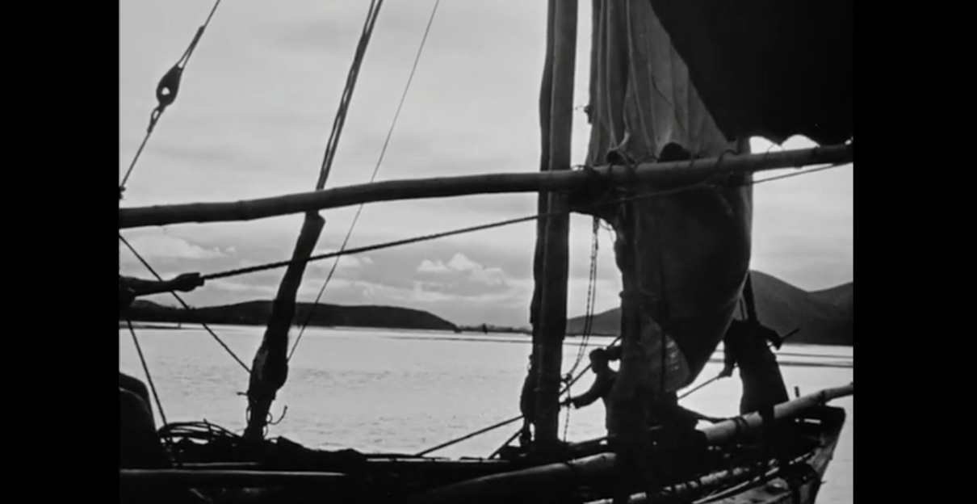
FIGURE 1 Screenshots from 0:06:26 of the film In the Year of the Pig.
(Source: In the Year of the Pig, dir. Emile de Antonio, Turin Film Corporation, 1968)
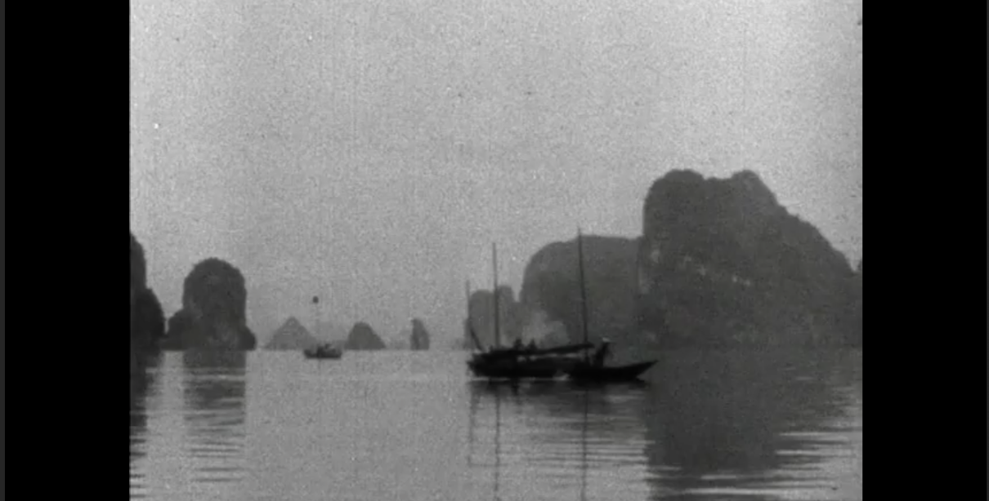
FIGURE 2 Screenshots from 1:40:48 of the film In the Year of the Pig.
(Source: In the Year of the Pig, dir. Emile de Antonio, Turin Film Corporation, 1968)
4.2. THE MILITARIZED LANDSCAPE AND THE COLONIAL GAZE
Yet both the landscape and the relation were affected as soon as the US army came ashore Vietnam (Fig. 3). A warship numbered 136 berths by the river and multiple warship berth on the other side of the river as well. Albert a shot also against the river, wood boats are substituted by advanced military vehicles and Vietnamese boatmen are replaced by the American navy. The natural landscape in the sequence loses its holistic representation of local beauty and undisturbed tranquility, but yields to serve as a platform for the US military to go ashore and to open the curtain of the Vietnam War. Foreign invasion dissolves the traditional landscape and transforms it into a colonial landscape that integrates foreign countries’ involvement in Vietnam into part of the natural landscape. Furthermore, take another sequence of the Vietnamese leader Ho Chi Minh on the river (Fig. 4) for instance. Foreign warship visually replaces the natural landscape and becomes the platform for Ho Chi Minh and foreign leaders. Given that Ho Chi Minh mostly stayed abroad and remained ironically unfamiliar with Vietnamese landscape, his presence actually alienates him from the Vietnamese landscape in the background, shifts the focus on colonial interrelations on the warship and disintegrates the pre-emancipatory landscape of the local.
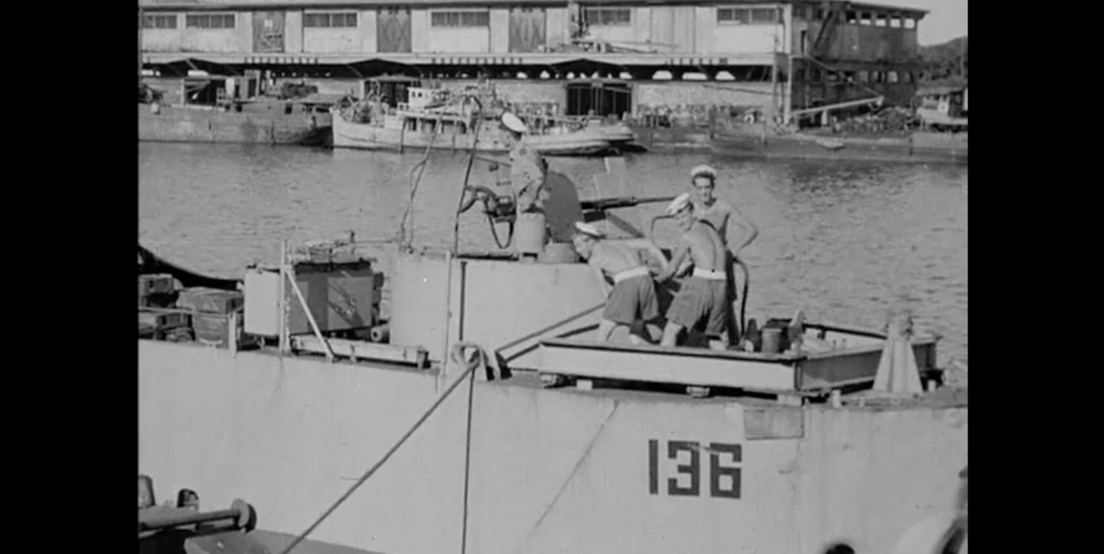
FIGURE 3 Screenshots from 0:11:48 of the film In the Year of the Pig.
(Source: In the Year of the Pig, dir. Emile de Antonio, Turin Film Corporation, 1968)
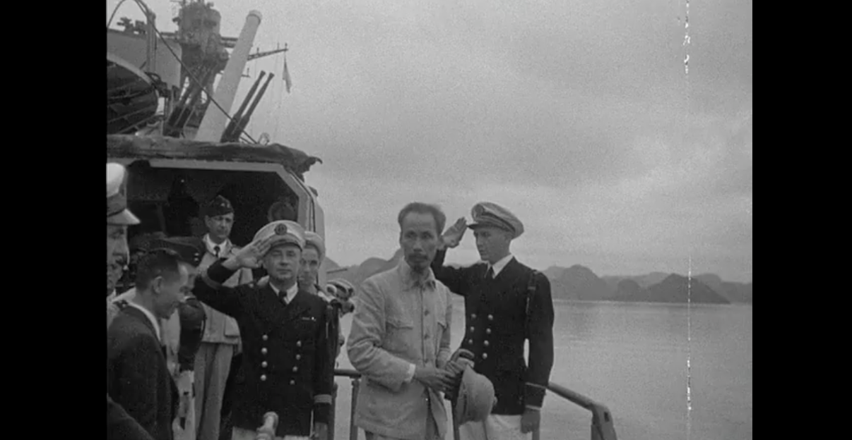
FIGURE 4 Screenshots from 0:13:17 of the film In the Year of the Pig.
(Source: In the Year of the Pig, dir. Emile de Antonio, Turin Film Corporation, 1968)
As soon as war begins, the colonial landscape immediately associates bomb and slaughter. A clash between American military invasion and Vietnamese resistance extends the colonial landscape to a representation of destruction and sufferance in the social landscape. A military perspective is therefore imposed onto the aesthetic and colonial looking, and further militarizes the relation between the nature and human, between the landscape and the camera eye, as well as between beauty and spectatorship. A close-up of tracks and gears of a tank (Fig. 5) on the grass indexes the American military power over the Vietnam territory and indicate a statement of victory from the American point of view. Suffering from war-ridden destruction, local cottages and lands are devoured by flames in the background. A shot of the escape of panic- stricken Vietnamese refugees (Fig. 6), on the other hand, shows their fear, despair and powerlessness. As smokes in the background index newly-dropped bombs, local landscape falls into colonial and military predomination and Vietnamese people have to escape from the place they live in. A comparison of these shots not only reveals the changed relation between human and natural landscape in Vietnam, but also highlights an unequal power between the US army and Vietnamese people against the same landscape. Whereas the US army is equipped with advanced military weapons and vehicles, Vietnamese refugees comprise of disadvantaged groups such as children, old people and women, and most of them still wear rags and suffer from starvation.
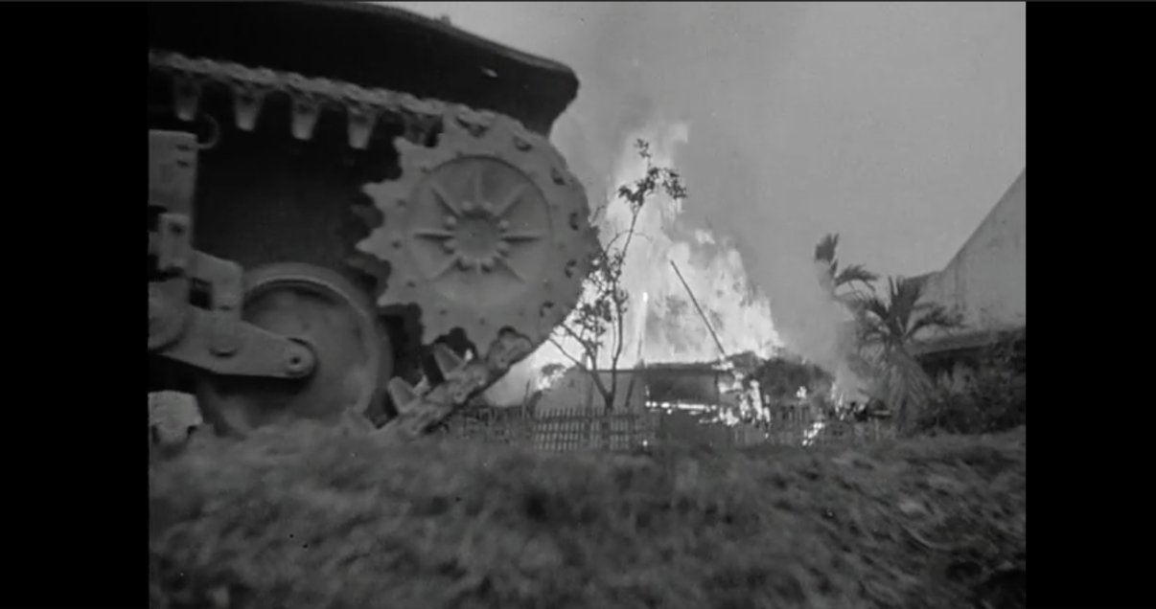
FIGURE 5 Screenshots from 0:15:33 of the film In the Year of the Pig.
(Source: In the Year of the Pig, dir. Emile de Antonio, Turin Film Corporation, 1968)
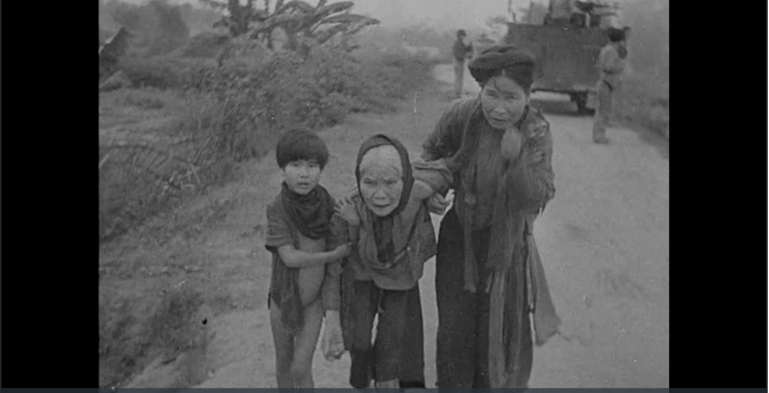
FIGURE 6 Screenshots from 0:15:51 of the film In the Year of the Pig.
(Source: In the Year of the Pig, dir. Emile de Antonio, Turin Film Corporation, 1968)
4.3. THE CAMERA AS WEAPON
Under such a wartime circumstance, the military perspective analogizes the camera eye to the vision of militants and analogies the camera movement to the movement of military weapons. “For men at war, the function of the weapon is the function of the eye.” [3, p. 20] Given this interrelation between looking and military conquer at war, the camera eye then similarly carries on a military obligation to reconnoiter the enemy, producing a military aggression through the action of looking. The scope of vision hence indicates the scale of conquerable territory. In In the Year of the Pig, the military looking elicits a predatory view through intentional montage of Vietnam’s natural landscape and a superimposition of voice-overs on the landscape sequence. The cinematic landscape lends itself to sequences of machine-guns, tanks and bombs as a conquerable visual prey, and victimizes itself through mechanical reproductions of the camera eye.
In the opening of the film, a sequence of Vietnam’s landscape is superimposed by the interview with Professor Paul Mus from Yale University. In the interview, he talks about Ho Chi Minh’s ironic alienation to the condition of his own country and retells Ho Chi Minh’s emphasis on the significance of village life and agriculture to Vietnamese. However, rather than insert a historical footage of Ho Chi Minh’s speech, the film appropriates footage of local landscape to fill the visual vacancy in the filmic narrative. As Paul Mus’s voice-over superimposes the sequence of Vietnam’s landscape, the soundtrack further alienates the fairly irreverent footage and overpowers it through the loud and uplifting tone of Paul Mus. Almost consumed by the soundtrack, the cinematic landscape thereby loses its visual efficacy to evoke an aesthetic look and only serves to suggest a connection with Vietnam.
In addition to a predatory view, the military looking also points to a gesture of military destruction. As W.J. Perry, the former US Under-Secretary of State for Defense, proclaims “Once you can see the target, you can expect to destroy it,” [3, p. 4] the camera eye therefore becomes a surrogate for military weapon to destroy what can be seen. “The camera’s peep hole [serves] as an indirect sighting device complementing those attached to the weapons of mass destruction. It thus prefigured a symptomatic shift in target-location and a growing derealization of military engagement.” [3, p. 1] Intentional montage of natural landscape then not only discloses a possible territory for military conquer, but also suggests a lost view that has been destroyed by the looking and the war. Thus, “What is perceived is already lost.” [3, p. 4] The lost landscape embodies a double perception of the cinematic landscape—a juxtaposition of the military dominance of American army with the powerlessness of Vietnamese refugees. “In Vietnamese, the word for water and the word for a nation, a country, and a homeland are one and the same: nước.” [6, p. 1] To Vietnamese people, natural elements, water for instance, not only serve as the basis of the agricultural society and pre-emancipatory living environment, but also constitute a spiritual force that glues the local community. In this regard, the militarized camera eye aims to destroy both the visible and invisible—or the spiritual, and to interweave the principle of deterrence with the filmic narrative.
4.4. VISUAL AUTHORITY AND THE POLITICS OF BEAUTY
Furthermore, since “the history of battle is primarily the history of radically changing fields of perception,” [3, p. 7] the analogy between a movie camera and a military sighting device not only militarizes the way of looking, but also affects human reaction and perception of identification and differentiation of objects. In In the Year of the Pig, the camera also militarizes the relation between viewership and the perception of natural beauty. The definition of what can be considered as beautiful in a documentary film about war requires the determination of a visual authority selected among the director or the viewers (American, Vietnamese or a neural perspective of neither). Who decides what can be considered as beautiful hence suggests another form of power relation in looking. Besides the visual authority, a distinctive aesthetic standard between the foreign audience and local Vietnamese also doubts whether an indigenous beauty can be perceived by and transmitted to foreign viewers, and whether foreigner viewers recognize the cinematic landscape as beautiful. It remains ambivalent whether the beauty of cinematic landscape relies on the its own sequence per se or on the main documentation of war. Given that Benjamin considers war as a culmination of “politics aesthetic,” [4, p. 241] the film poses a dialectic perspective for the viewer—to see the beauty through war or see the war through beauty.
The cinematic landscape of the local nature remains a subsidiary part of a documentary film like In the Year of the Pig, so does the Vietnamese landscape remain a secondary part of the mainstream discourse of landscape in the western and Chinese tradition. Yet, a close examination of the minor landscape points out an aesthetic perspective to approach the superimposed colonial and military narrative on the representation of Vietnam. A filmic narrative of the loss, wound and beauty of Vietnam’s landscape in In the Year of the Pig reminds me of the self-narration of female beauty in the opening of Duras’ The Lover:
One day, I was already old, in the entrance of a public place a man came up to me. He introduced himself and said, “I’ve known you for years. Everyone says you were beautiful when you were young, but I want to tell you I think you’re more beautiful now than then. Rather than your face as a young woman, I prefer your face as it is now. Ravaged.” [5, p. 3]
5. CONCLUSION
The passage offers a possible analogy between the beauty of nature and female beauty, between the body of a nation and that a female. The aged and ravaged beauty of the female protagonist elicits a look not at the present or the surface, but associates a coexistence of beauty and trauma with a relation of her childhood, the war and her pubescent romance. Like her face, the body of a city or of Vietnam also endures the ravage of war, time and human interaction, and forms a collective experience of the people therein. The natural landscape—a look at the looking of the city per se—distills the collective memory of the colonized Vietnam, and renders a distinctive beauty, regardless of primitive or ravaged, with traces of history.
CONFLICTS OF INTEREST
The author declares that there is no conflict of interest concerning the publication of this paper.
REFERENCES
[1] W. J. T. Mitchell, Landscape and Power, 2nd ed. Chicago: University of Chicago Press, 2002.
[2] J. Berger, Ways of Seeing. London: British Broadcasting Corporation and Penguin Books, 1990.
[3] P. Virilio, War and Cinema: The Logistics of Perception, trans. P. Camiller. London: Verso, 2000.
[4] W. Benjamin, Illuminations. New York: Schocken Books, 2007.
[5] M. Duras, The Lover, trans. B. Bray. New York: Pantheon Books, 1985.
[6] lê thi diem thúy, The Gangster We Are All Looking For. New York: Anchor Books, 2004.

