Aestheticizing the Leaf: Literary, Visual, and Cultural Consumption of Tea in East Asia
Vivien Jiaqian Zhu
Stanford University, United States
Abstract
This chapter theorizes the cultural transformation of Camellia sinensis from botanical matter into an aesthetic and symbolic medium in East Asia. Rather than treating tea as a passive commodity absorbed into pre-existing cultural practices, it approaches tea as a materially and sensorially active participant in processes of cultural production. Tracing practices of tea preparation and appreciation from premodern and early modern traditions through the contemporary period, the chapter examines how flavor, aroma, processing, brewing techniques, and teaware mediate relationships among botanical materiality, human agency, and cultural meaning. Drawing on literary treatises, visual representations, and material artifacts, it asks how cultivation, processing, tasting, and ritualization transform plant matter into aesthetic experience and embodied knowledge. Tea thus emerges not merely as an object of consumption but as a medium through which distinctions of taste, status, identity, and cultural sensibility are articulated and negotiated. The chapter develops a material-cultural account of aestheticization, demonstrating how the material affordances and sensory qualities of tea have shaped interconnected literary, visual, ritual, and consumer cultures across East Asia.
Keywords
Camellia sinensis; Tea Culture; East Asian Literature; Visual Arts; Material Culture; Cultural Consumption; Tea Ritual; Aroma; Tea Utensils; Aestheticization; Japanese Tea; Authenticity

1. Introduction
In his later years, the literatus Rai San’yō (1780–1832) built a small pavilion within his Kyoto residence and named it Sanshi Suimeisho—the Abode of Purple Mountains and Clear Water—a name distilled from the colors of the capital’s mountains at dusk and the glimmer of the Kamo River. There, San’yō gathered with close friends and family for poetry, painting, sake, and sencha, steeped green tea prepared and savored as an integral part of cultivated aesthetic life. The refined atmosphere of these gatherings survives in the kanshi (Sinitic poems) of his uncle, Rai Kyōhei, preserved in the manuscript album Jūjun kagetsu (One Hundred Days of Blossoms and the Moon). What San’yō and his circle enacted at Sanshi Suimeisho was not simply the consumption of tea, but the transformation of tea—its flavor and aroma, its modes of preparation, and the gestures and utensils it required—into an occasion for poetic composition, philosophical reflection, and the performance of cultivated taste [12, 21].
This scene offers a compact illustration of the argument developed throughout this chapter: that Camellia sinensis, as it moved through East Asian literary, visual, material, and ritual cultures, was not merely incorporated into pre-existing cultural practices as a passive commodity. Rather, tea functioned as a materially and sensorially active medium in the production of cultural meaning. The leaf’s physical properties—its flavor and aroma, the techniques through which it was processed and brewed, and the tactile and visual qualities of the vessels through which it was prepared and served—did not simply provide subject matter for poems, paintings, or rituals about tea. They helped shape the forms, practices, and social relations through which tea became culturally meaningful. To understand tea as an aesthetic medium, therefore, requires attention not only to the literary and artistic traditions that represented it, but also to the botanical materiality and sensory affordances through which those traditions were enacted.
This attention to materiality and sensory mediation also extends a methodological concern developed in my recent work. In The Visual Ethnographer’s Data Other: Secrets Unveiled for a Sociological J. M. Coetzee (2026), I examine how ephemeral sensory traces, embodied perception, and material forms complicate the conversion of lived cultural experience into textual and digital data [19]. That methodological orientation informs the present chapter’s approach to tea: rather than treating sensory qualities as secondary attributes attached to an already constituted cultural object, I consider taste, aroma, touch, gesture, and material form as constitutive of the processes through which cultural meaning emerges. Tea therefore provides a particularly productive case for examining how botanical matter becomes culturally intelligible through embodied practices of perception, mediation, and representation. In this sense, the study of tea extends the broader methodological question of how sensory and material phenomena—often partially resistant to verbal or symbolic capture—participate in the production of cultural knowledge.
The present chapter also extends a methodological trajectory developed in Sino-Japanese Literature in Perspective: A Short Communication to the World Literature (Eliva Press, 2026), which approaches Sino-Japanese literary discourse through comparative literary analysis, visual-cultural interpretation, and attention to cross-cultural exchange [20]. Whereas that study examines how literary traditions and cultural dialogues traverse geographical and historical boundaries, the present chapter shifts the analytical emphasis from textual and visual circulation to the material and sensory conditions through which cultural meanings are produced. Tea offers a particularly productive object for this extension because its significance is constituted not only through representation and exchange, but also through cultivation, processing, preparation, tasting, and embodied encounter. In this sense, the study of Camellia sinensis develops a more materially grounded account of transregional cultural production, asking how botanical matter itself participates in the formation of literary, visual, ritual, and consumer practices across East Asia.
A material-cultural approach is useful precisely because it refuses to reduce value to either intrinsic properties or purely symbolic attribution. Appadurai’s account of the social life of things emphasizes that objects acquire changing regimes of value through circulation, exchange, display, and use [1], while Kopytoff’s notion of the cultural biography of things shows how commoditization itself is culturally organized and historically variable [2]. Ingold’s critique of static materiality shifts the focus from inert objects toward dynamic materials whose properties emerge through relations among substances, environments, tools, and practitioners [3,4]. These approaches provide the conceptual foundation for treating tea not simply as a cultural symbol but as a material participant in the making of cultural forms.
Tracing these dynamics from early modern traditions to contemporary practices, this chapter examines how tea’s sensory and material dimensions mediated relationships among plant, person, and culture across literary treatises, visual representations, and material artifacts. Figures such as Rai San’yō, situated within Kyoto’s broader culture of sencha connoisseurship and alongside contemporaries and successors whose practices and writings have been illuminated by scholars such as Yukitada Shimamura, exemplify a mode of engagement in which tea’s material affordances—its taste, aroma, preparation, utensils, and capacity to structure social occasions—were inseparable from the meanings attributed to it: refinement, philosophical reflection, social distinction, and cultural belonging. Yet the significance of tea lies not only in the meanings imposed upon it. Its material and sensory properties also constrained, enabled, and redirected the practices through which those meanings were produced. Drawing on this and comparable cases across East Asia, the chapter develops a material-cultural account of aestheticization in which the cultivation, processing, brewing, tasting, and ritualization of a plant transform biological matter into culturally legible forms. Tea thus emerges not merely as an object of consumption, but as a medium through which literary, visual, ritual, and consumer cultures are materially and sensorially constituted.

2. Botanical Materiality and the Cultural Life of Tea
The analytical problem of tea begins with an apparently simple distinction: a leaf is not yet a cup of tea. Camellia sinensis enters human worlds through a chain of transformations that includes cultivation, harvesting, withering or steaming, rolling, oxidation or fixation, drying, storage, transport, brewing, serving, and ingestion. Each transformation modifies what the material can do and how it can be perceived. Tea therefore offers an unusually productive case for thinking about material culture because its cultural meanings cannot be detached from processes that change its material state. The object that becomes a commodity is not identical to the plant in the field; the tea prepared for a gathering is not identical to the processed leaf in storage; and the sensory event of tasting is not reducible either to botanical substance or to symbolic interpretation. Figure 1 summarizes this sequence of material transformations from plant to culturally valued beverage.

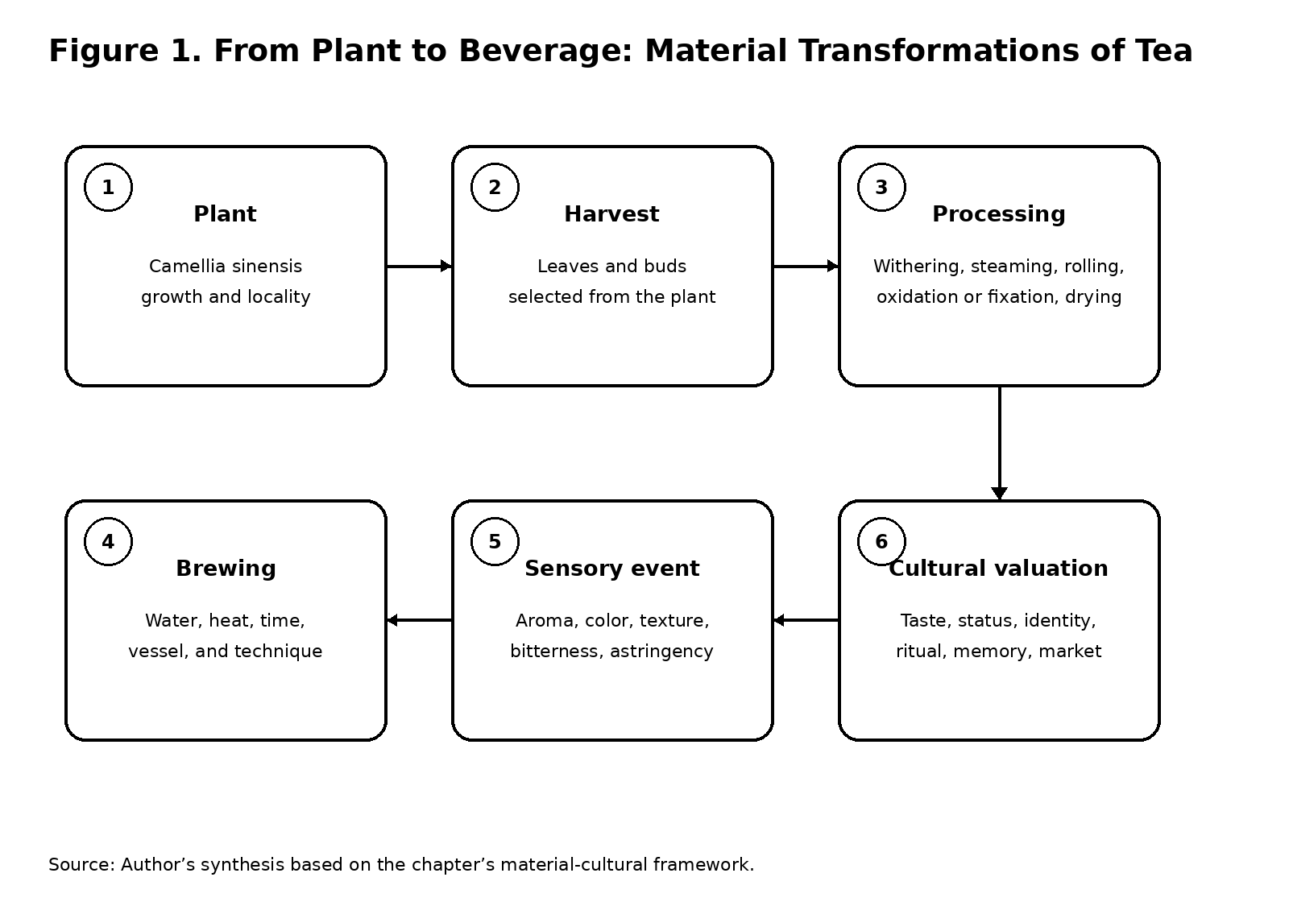

Figure 1. From Plant to Beverage: Material Transformations of Tea. Source: Author’s synthesis.

2.1 Materials, Value, and Cultural Biography
Appadurai’s formulation of the “social life” of things calls attention to the ways objects acquire changing regimes of value as they circulate among different contexts of exchange, display, use, and possession [1]. Kopytoff’s related notion of the cultural biography of things emphasizes that commoditization itself is a cultural process: things become commodities through acts of classification and valuation, and they may move into and out of commodity status [2]. These approaches are especially useful for tea because the leaf moves repeatedly among economic, medicinal, ritual, aesthetic, and domestic registers. Yet tea also presses the analysis in another direction. It is not simply an object whose meaning changes as people use it. It is a living material whose physical properties participate in shaping the practices through which meanings emerge.
Ingold’s distinction between materials and materiality provides a useful refinement here. Rather than treating matter as an inert substrate upon which cultural form is imposed, Ingold emphasizes materials as dynamic processes whose properties emerge through their relations with environments, tools, bodies, and other substances [3]. His later work on making further stresses correspondence between active materials and sentient practitioners [4]. Applied to tea, this perspective shifts attention from “tea” as a stable cultural object toward the transformations through which the leaf becomes drink, fragrance, visual surface, object of connoisseurship, or ritual medium. A tea’s aroma matters not simply because people decide that aroma is culturally important; the volatile qualities of the prepared beverage require particular temperatures, vessels, durations, and sensory practices. Likewise, the color and clarity of an infusion are not purely symbolic attributes. They emerge from processing and brewing and then become criteria of evaluation within historically specific regimes of taste.
The concept of material affordance used in this chapter therefore does not imply that tea possesses intention in a human sense. Rather, it refers to the practical possibilities and constraints presented by the material: what a particular leaf can yield under certain conditions, what a vessel allows a drinker to perceive, what a brewing technique makes repeatable, and what kinds of bodily attention a preparation requires. The affordance of a material becomes culturally consequential when it is stabilized through practice. Repeated handling can turn a sensory distinction into a convention; repeated conventions can become an aesthetic code; and aesthetic codes can become markers of social identity. Tea’s cultural life is thus produced through a reciprocal relation between material properties and learned practices.
This approach also helps avoid two symmetrical errors. The first is technological reductionism, in which tea culture is explained only by processing technologies or botanical properties. The second is cultural idealism, in which material properties disappear behind abstract concepts such as harmony, refinement, spirituality, or authenticity. Neither side is sufficient. The history of tea depends on their interaction. Processing changes the substance; cultural practices determine which changes matter; and the sensory capacities of the resulting material feed back into further practices of cultivation, preparation, description, display, and consumption.
Traditional Chinese tea history offers a particularly clear example. James A. Benn describes tea in premodern China as both a religious and cultural commodity, emphasizing how tea moved among medicinal, monastic, literary, and commercial worlds [5]. His account of Tang tea poetry further demonstrates that poets did not merely borrow tea as a ready-made symbol: they helped construct a vocabulary of qualities—naturalness, refreshment, stimulation, longevity, spiritual clarity—through which tea could be valued and discussed [6]. The Classic of Tea (Chajing), associated with Lu Yu, likewise brought together botanical description, cultivation, processing, utensils, brewing, and places of production in a systematic account. The significance of such texts lies partly in their classification of matter. By naming qualities, distinguishing tools, and prescribing procedures, they make sensory experience portable: a leaf grown in one place can be evaluated through categories that circulate in writing and conversation.
The resulting cultural process can be described as aestheticization, but only if that term is understood materially. Aestheticization is not simply the addition of beauty to an otherwise ordinary commodity. It is the conversion of material differences into culturally consequential distinctions. The smell of one tea becomes “high fragrance”; the color of another becomes evidence of proper processing; the shape of a vessel becomes a sign of historical or regional taste; the timing of a brew becomes part of cultivated competence. What is at stake is therefore not the disappearance of use in favor of art, but the expansion of use into a field in which sensory discrimination itself becomes a form of cultural knowledge.
From this perspective, the history of tea is not a history in which a neutral plant gradually receives symbolic meanings from successive societies. It is a history of repeated material reorganizations. Processing techniques altered taste and aroma; new brewing methods altered what drinkers could perceive; new utensils made some qualities easier to attend to; literary and visual practices taught observers what to notice; and commercial systems attached geographic, social, or moral value to particular forms of tea. The leaf becomes “aesthetic” because a network of practices learns to perceive, describe, compare, preserve, and display its differences.

3. From Leaf to Beverage: Processing, Sensory Experience, and Knowledge

3.1 Processing as Mediation
If tea becomes aesthetically legible through material transformation, processing must be treated as more than a technical prelude to consumption. The history of tea is in part a history of making sensory qualities durable enough to be recognized, transmitted, and valued. In this sense, processing is a form of mediation between plant and person. It is where biological variability becomes a field of human technique without ceasing to be material.
Historical tea cultures repeatedly organized knowledge around the management of this variability. Benn’s study of Chinese tea emphasizes the importance of cultivation and processing in shaping cultural judgments about tea, while Mair and Hoh trace the long history in which tea’s uses changed as production, trade, and preparation practices developed [5,7]. The point is not that processing simply “improves” the plant. Rather, different procedures produce different sensory objects from the same species. A distinction between teas is therefore simultaneously a distinction between material histories.
Brewing extends this transformation. Water temperature, brewing time, quantity of leaf, vessel shape, and the sequence of serving can influence the drink’s aroma, color, texture, bitterness, astringency, and persistence. A beverage is thus an event rather than a stable object. The drinker encounters not only the leaf but the result of a choreography involving water, heat, time, vessel, hand, and mouth. This is precisely where sensory studies and material culture converge. The material world does not simply surround perception; it organizes the conditions under which perception becomes possible.
The distinction matters for interpreting literary representations of tea. A poem that names fragrance, color, or bitterness is not merely providing decorative imagery. It can encode a practical history of preparation. Conversely, a procedural manual can function as an aesthetic text when its classifications of leaf, water, vessel, and technique teach readers how to discriminate. The boundary between technical knowledge and aesthetic knowledge is therefore porous. Tea writing repeatedly turns practical distinctions into cultivated vocabulary.
This is especially visible in the long Chinese tradition of tea literature. Benn notes that Tang poets described tea’s color, aroma, taste, methods of preparation, shapes of teaware, settings of consumption, and aesthetic or medicinal effects [6]. Such poetry does not merely report an already established tea culture; it helps produce standards by which tea may be appreciated. Literary language makes a sensory experience social by giving it a repeatable form. A fragrance can be remembered, compared, and discussed because it has been named. A taste can become a marker of refinement because readers learn to distinguish it from competing sensations.
The relationship between botanical matter and literary mediation can also be framed through Ingold’s emphasis on materials as processual [3]. Tea is particularly resistant to being reduced to a single material state. The plant passes through growth, harvest, processing, storage, infusion, evaporation, and ingestion. At each stage, new properties become available and others disappear. Cultural practice selects among these possibilities. The dried leaf may invite inspection of shape and color; the infused leaf may reveal texture and fragrance; the liquor in the cup may become the object of comparison; the empty vessel may acquire value through provenance or workmanship. Materiality is therefore distributed across a sequence, not concentrated in a final object.
This sequence also complicates the category of “natural.” Tea is often described through associations with purity, mountains, water, freshness, and health. Yet these qualities are historically mediated. The “natural” tea recognized in a poem or commercial advertisement may depend on highly organized cultivation and processing systems. Aesthetic naturalness is therefore frequently an achieved effect: a material condition made legible through techniques of selection, preparation, and description.
This tension becomes especially important in discussions of authenticity. What counts as “authentic” tea often depends on a story about continuity: a particular cultivar, locality, preparation method, utensil, or ritual is represented as carrying an older cultural essence. But the material form of tea is itself historically mutable. Processing techniques change, markets change, consumer expectations change, and national or regional traditions are periodically reformulated. Authenticity therefore appears less as a fixed property than as an evaluative practice that connects present material forms to selected histories. Kopytoff’s concept of cultural biography is useful here because it allows the same material to occupy different categories at different moments [2]. Tea may be medicine in one setting, sacrament in another, luxury good in another, and everyday refreshment in another. These categories do not replace one another in a simple chronological sequence. They coexist and compete. A tea that is sold as a mass-market beverage can simultaneously be marketed as an artisanal specialty; an inexpensive leaf can acquire prestige through provenance; a ritual practice can become a tourist attraction. The “life” of tea is therefore characterized by category shifts rather than a linear movement from function to art.

4. Literary and Visual Cultures of Tea

4.1 Literature as Sensory Mediation
Tea’s aestheticization becomes especially visible when the beverage enters literary and visual forms. One of the central consequences of such representation is that it makes sensory practice available to people who are not physically present at the moment of consumption. A poem, painting, treatise, album, or illustrated manual can transport an experience of tea across space and time. Representation is therefore not external to material culture. It is one of the means by which material distinctions are stabilized and transmitted.
In Tang China, tea poetry emerged as a recognizable literary subject in a period when tea drinking was expanding across religious and secular settings. Benn shows that poets helped establish tea as a medium for friendship, reflection, spiritual cultivation, and ordinary sociability [6]. The literary appearance of tea transformed its status because it attached the beverage to genres, voices, and situations already recognized as culturally meaningful. A cup of tea could now become the occasion for verse, and verse could in turn become a way of teaching readers how to imagine the act of drinking.
This process of literary framing also created a vocabulary of taste. The poet’s attention to color, fragrance, or the movement from alertness to tranquility created a repertoire of sensory associations. Such associations could then be detached from a single act of consumption and reattached to other kinds of cultural judgment. Tea became a model for speaking about clarity, moderation, refinement, and friendship precisely because its sensory experience had been made narratable.
Chinese tea writing was also deeply connected to visual and material culture. Tea utensils, landscapes, calligraphy, and modes of display were not secondary decorations around an otherwise self-sufficient beverage. The material environment of tea drinking helped determine what kind of attention a gathering could sustain. A vessel could foreground color or fragrance; a particular spatial arrangement could slow the sequence of preparation; an inscription could link the act of drinking to a literary tradition. The aesthetic unit was therefore often a constellation of objects and gestures rather than the liquid alone. Figure 2 conceptualizes these reciprocal relations among botanical matter, sensory experience, utensils and space, ritual and body, literature and image, and markets and identity.

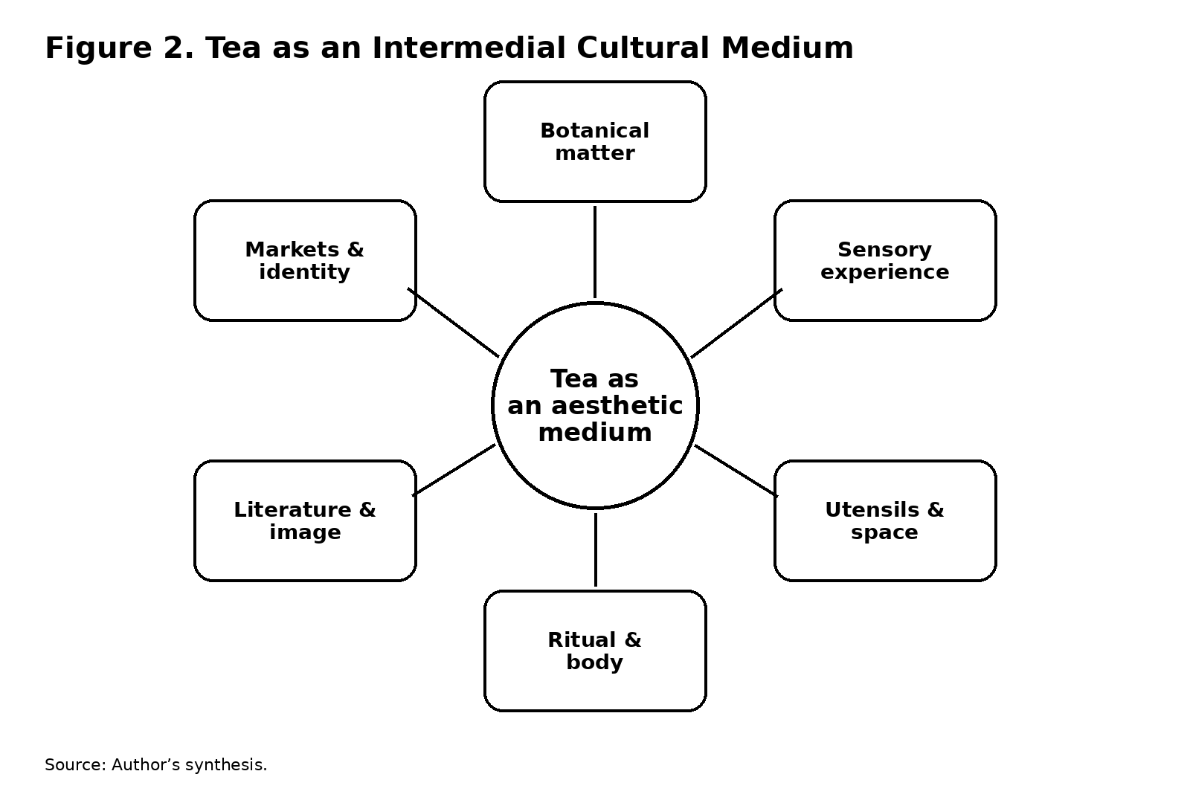

Figure 2. Tea as an Intermedial Cultural Medium. Source: Author’s synthesis.
The same principle appears clearly in the history of Japanese tea. Varley and Kumakura’s Tea in Japan stresses that chanoyu developed through an interaction of architecture, gardens, ceramics, lacquerware, painting, calligraphy, interior design, and ritual [8]. Pitelka’s Japanese Tea Culture: Art, History and Practice further argues against viewing Japanese tea culture as a timeless, purely aesthetic practice, showing instead how tea has been entangled with commerce, politics, historical writing, artistic production, and ideas of Japaneseness [9]. In both cases, material and symbolic orders cannot be separated cleanly.
Kumakura’s more recent account makes the same point through practice. His Japanese Tea Culture: The Heart and Form of Chanoyu examines not only ritual but the tea room, tea utensils, bodily movements, and historical formation of the practice [10]. The question of why an entrance is narrow, why a bowl is passed in a particular manner, or why specific objects occupy specific places is also a question about how bodies learn to inhabit an aesthetic world. Form is not simply visual composition. It is repeated bodily knowledge.
This is where the notion of the “aesthetic medium” becomes more precise. Tea mediates because it brings together material substance and forms of cultural attention. It is a medium not because it communicates a single message but because it organizes relations among body, object, environment, and sign. A tea bowl can be looked at and handled; a fragrance can be inhaled while a poem is recited; a prepared leaf can be compared with a description; the history of a utensil can become part of the social meaning of an encounter. Tea culture is therefore inherently intermedial: botanical matter enters language, image, architecture, ritual, and social performance without becoming fully reducible to any one of them.
The visual arts are especially important because they make the relation between the material and the imagined visible. Paintings and illustrated texts can depict tea production, preparation, drinking spaces, utensils, landscapes, or social scenes. Such images do not simply document practice. They select what counts as noteworthy. The presence of a certain vessel, the arrangement of a room, or the appearance of a landscape can frame tea as a sign of refinement. At the same time, visual representation can direct attention back toward materials: the texture of ceramic, the sheen of lacquer, the color of brewed tea, or the bodily posture of the drinker.
Aestheticization thus involves a feedback loop between practice and representation. People learn how to value tea partly through images and texts, and those values shape subsequent practices of collecting, preparing, and depicting tea. The same object can therefore serve simultaneously as a functional tool, an art object, a historical document, and a social marker. Its multiple identities are not contradictions but evidence of its cultural mobility.

5. Sencha, Literati Culture, and the Social Performance of Taste

5.1 Literati Sociability and Connoisseurship
The history of sencha provides a particularly revealing case because it makes visible a tea culture that cannot be subsumed under the modern popular image of Japanese chanoyu. Michelle Liu Carriger’s recent survey emphasizes that Japanese tea culture has included multiple forms of practice and that sencha and senchadō constitute important parts of this larger history [11]. Treating Japanese tea culture as synonymous with matcha-centered ceremony risks narrowing the field and obscuring the literati networks, commercial exchanges, and everyday practices through which other tea forms acquired significance.
The world associated with sencha in early modern Japan was closely connected to learned sociability. Tea could become part of gatherings organized around poetry, painting, music, calligraphy, antiquarian learning, and conversation. Such gatherings demonstrate why the chapter treats taste as a social performance rather than a private sensation. To “know” tea in a literati setting was to know how to distinguish, discuss, prepare, serve, and situate it within a wider field of cultural references. Connoisseurship transformed sensory discrimination into social competence.
Rai San’yō’s Sanshi Suimeisho offers a compact illustration of this process. The pavilion’s name invokes landscape, and the space becomes a setting in which poetry, painting, sake, and sencha coexist. The important point is not simply that tea appears beside other cultural pursuits. Tea helps structure the occasion itself. The sequence of preparation, the choice of utensils, the sensory character of the beverage, and the social distribution of labor all shape how the gathering unfolds. The drink is therefore part of the architecture of literary sociability.
The manuscripts associated with Rai Kyōhei’s Jūjun kagetsu are especially suggestive because they place tea within an intermedial archive: poetry survives in a material album, itself preserved as a manuscript artifact, while the poems evoke a physical space and a social event. The object of study is consequently neither “tea” nor “literature” in isolation. It is a chain of material mediations through which tea becomes an occasion for writing and writing becomes evidence for reconstructing tea practice.
Yukitada Shimamura’s study of Rai San’yō, sencha, and the material worlds of late early-modern literati culture offers a useful point of reference for this line of inquiry [12]. His attention to the historical relationship between tea practice, literati life, and particular sites such as Sanshi Suimeisho underscores the importance of moving beyond abstract descriptions of “tea culture” toward concrete combinations of objects, spaces, texts, and embodied practice. For the present chapter, the value of such work lies less in providing a comprehensive history of sencha than in demonstrating how a beverage’s material affordances can organize a cultural environment.
The social meaning of taste can be further clarified through Bourdieu’s analysis of distinction [13]. Taste appears natural or personal only because social groups cultivate the competencies that allow certain differences to be perceived as meaningful. Tea culture provides a particularly concrete setting for this process. Distinguishing fragrance, judging water, recognizing a vessel, knowing provenance, or selecting the appropriate utensil can become markers of cultivated status. Yet the analogy with Bourdieu must be handled historically. Japanese literati tea practices were not simply instances of a universal class code. Their distinctions were embedded in specific textual traditions, networks of learning, regional markets, and inherited vocabularies of value.
This is also why connoisseurship should not be understood merely as passive appreciation. Connoisseurs actively produce the objects they claim to judge. By selecting certain leaves, commissioning vessels, preserving utensils, recording gatherings, or writing evaluations, they help constitute a market and a canon. The “good tea” that seems to preexist the act of judgment is partly an outcome of accumulated acts of comparison.
Sencha further complicates any simple relationship between refinement and elite exclusivity. Hellyer’s social and commodity history of Japanese green tea shows that sencha circulated across national and social boundaries and that its meanings were shaped by trans-Pacific trade as well as domestic practices [14]. His account demonstrates that Japanese tea culture cannot be understood solely within a self-contained national frame. Commercial circulation altered taste, availability, and the relationship between everyday consumption and claims about Japanese identity.
This historical mobility reinforces the chapter’s argument that aestheticization is a process rather than a final condition. A tea can move from local product to luxury commodity, from everyday drink to emblem of national culture, or from specialized literati practice to commercial lifestyle product. Each shift changes the field of perception around the leaf. New packaging, brewing equipment, retail spaces, or media representations can make different aspects of tea newly visible.

6. Tea Utensils, Ritual, and Material Mediation

6.1 Objects as Sensory Infrastructures
If tea is an aesthetic medium, its utensils are not peripheral accessories. They mediate the encounter between material substance and embodied perception. The cup, bowl, pot, kettle, tray, scoop, strainer, or storage container helps determine how tea is handled, viewed, smelled, served, and remembered. The history of tea utensils therefore offers a way to track how functional objects become aesthetic objects without ceasing to be functional.
Studies of Japanese tea make this especially clear. Pitelka’s collection includes a study of “Shopping for Pots in Momoyama Japan,” demonstrating that the acquisition of vessels was tied to commerce and connoisseurship rather than detached contemplation [9]. Kumakura likewise treats the tea whisk, bowl, room, and bodily actions as historically contingent components of tea culture [10]. The implication is methodological: to understand the aesthetics of tea, one must study the infrastructures of perception.
A utensil does not merely contain tea. It frames the sensory event. Vessel size affects cooling and aroma; surface and color affect visual perception; material affects heat retention; shape affects the movements required for pouring or drinking. Such factors are technical, but they become aesthetic when users learn to discriminate among them and associate them with particular ideals of taste. The functional and aesthetic dimensions of a utensil are therefore co-produced.
This relation can also be understood through the ritualization of movement. A repeated gesture becomes meaningful not only because it symbolizes something but because repetition changes the body’s relation to the object. The hand learns the weight of the vessel; the eye anticipates the position of the spout; the host’s timing coordinates with the guest’s expectation. Ritual produces a temporal form in which material objects, bodies, and social roles become synchronized.
Kumakura’s account of tea gathering emphasizes how formalized behavior, spatial arrangement, and utensils work together [10]. The tea room is not simply a container for ceremony; its entrances, surfaces, displays, and paths choreograph attention. This makes tea culture comparable to a performance in which objects have roles but are not merely props. The object participates in producing the conditions of the event.
Material mediation is also visible in the history of tea-related political authority. Oshikiri’s study of the shogunate’s “Travelling of the Shogun’s Tea Jar” demonstrates how ritual, material culture, and political authority became intertwined around the acquisition and movement of tea [15]. The tea jar here was both container and political instrument. The material route of tea became a ritualized route through which authority was displayed and reproduced. This case shows that materialization can scale beyond intimate gathering into institutions of state power.
At the same time, tea utensils can destabilize hierarchy. The wabi tradition famously invested ordinary or locally made objects with aesthetic significance, while the history of Japanese tea also involved the valorization of imported goods. The result was a continual negotiation among rarity, provenance, workmanship, use, and interpretation. The aesthetic value of an object did not reside solely in its material composition. It emerged through histories of circulation and acts of framing.
This is another place where Appadurai’s social life of things becomes useful [1]. A vessel can circulate as merchandise, gift, heirloom, ritual object, art object, or museum piece. Its identity changes with context. A tea utensil becomes a particularly vivid example of this process because its functional use can remain active even after it acquires historical or symbolic prestige. The same bowl can be touched, admired, discussed, inherited, photographed, catalogued, or displayed, and each mode of engagement adds another layer to its cultural biography.
The utensil also mediates memory. A named bowl or pot can become associated with a teacher, gathering, region, historical period, or aesthetic lineage. Inscriptions and records intensify this effect by turning material objects into archives. Once the history of a utensil is narrated, later users perceive it differently. The material object becomes a mnemonic device, and its use reproduces the narrative attached to it.
Such processes complicate a simplistic opposition between material object and symbolic meaning. The symbolic history of the object can alter the way its material qualities are perceived, while its material qualities can constrain or redirect its symbolic history. A vessel that retains heat unusually well may encourage a certain brewing style; that brewing style may acquire ceremonial status; the vessel may then become emblematic of that practice. Material mediation is therefore recursive.

7. East Asian Circulations: China, Japan, and Korea

7.1 Regional Circulation and Reclassification
The regional scale of tea history is essential because the cultural forms associated with tea were produced through circulation rather than isolated national development. Tea knowledge, plants, processing techniques, literary texts, utensils, and ritual forms moved across East Asia, where they were selectively adopted, transformed, and reclassified.
In China, the relationship between Buddhism, tea, poetry, and material culture was foundational to the expansion of tea drinking during the Tang period. Benn emphasizes that Buddhist institutions and figures helped popularize tea while poets helped elaborate its cultural meanings [5,6]. The Classic of Tea provided a textual framework capable of connecting botanical knowledge, processing, utensils, brewing, and consumption. Tea thereby became not simply a beverage but an object through which knowledge could be organized.
Japanese tea culture developed through selective appropriation and transformation of Chinese models. Sen Sōshitsu XV’s historical account traces the movement of tea practices from China to Japan and the subsequent formation of distinctly Japanese ways of tea [16]. Varley and Kumakura similarly show that Japanese tea culture emerged through encounters among imported objects, local artistic practices, religious institutions, and political structures [8]. Pitelka’s collection highlights how later historical writing, commerce, artistic production, and notions of Japaneseness further reshaped the field [9]. These histories suggest that cultural “inheritance” is not passive transmission. Imported forms become meaningful through local acts of selection and reinterpretation.
Korea provides another important case because tea culture there developed through its own institutional and political trajectories while remaining connected to Chinese and, later, Japanese influences. Research on Korean tea history emphasizes the long presence of tea in royal, Buddhist, medicinal, literary, and everyday settings [17]. The history of cha-rye also demonstrates that what is presented as “traditional” may be actively constructed and promoted under modern political conditions. Lee and Kwon argue that Korean cha-rye as a nationally promoted tradition was substantially shaped during the Park Chung-hee government, illustrating how tea practice could be reconfigured through modernization and nationalist ideology [17].
This case is especially important for the chapter’s treatment of authenticity. Authenticity is not simply the recovery of an untouched past. It is often produced through selective historical narratives, institutional codification, and material standardization. What counts as traditional tea practice can therefore be the result of relatively recent efforts to stabilize a desirable image of cultural continuity. Tea’s material mutability makes such processes visible because changes in brewing techniques, utensils, terminology, and social setting can be traced against narratives of tradition.
The East Asian comparative frame consequently changes the analytical question. Instead of asking which national culture “owns” tea, the more productive question is how different communities have configured relations among plant, technique, object, body, text, and identity. A Chinese tea treatise, a Japanese tea room, a Korean tea rite, or a modern specialty-tea shop can all be understood as different arrangements for making botanical matter culturally legible.
Such a framework also guards against the tendency to map a linear hierarchy from “material” to “symbolic.” Tea practices in East Asia show the opposite: symbolism often intensifies through material specificity. A local clay pot, a particular water source, a processing method, or a named cultivar can become culturally powerful precisely because its material difference is made perceptible. Cultural meaning is therefore not an abstraction floating above the object. It is anchored in practices of sensory discrimination. Such a relation between material specificity and cultural valuation also appears in Tristan G. Brown’s study of fengshui in Qing China, which shows how landscape and environmental order could become objects of legal, social, and political valuation rather than functioning as a merely passive backdrop [21]. Table 2 compares these configurations across China, Japan, Korea, and the contemporary global market.

Context | Material / practice | Mediating forms | Valuation / identity
China | Tea leaf, processing, water, teaware | Tea treatises, poetry, monastic and literary practice | Knowledge, cultivation, sociability, medicinal and spiritual value
Japan | Sencha, matcha, bowls, rooms, utensils | Chanoyu / senchadō, literati gatherings, visual and material arts | Taste, connoisseurship, lineage, Japaneseness, social distinction
Korea | Tea, vessels, cha-rye, ritual settings | Royal, Buddhist, literary, domestic and modern national forms | Tradition, ritual continuity, cultural identity
Contemporary global market | Specialty leaves, packaging, brewing equipment | Retail, social media, tasting notes, imagery, lifestyle discourse | Authenticity, craft, provenance, wellness, heritage
Table 2. Comparative Material-Cultural Configurations of Tea in East Asia. Source: Author’s synthesis; see especially refs. [5], [8]–[10], [14], [16], and [17].

8. Cultural Consumption, Authenticity, and the Contemporary Aestheticization of Tea

8.1 Authenticity as a Valuation Practice
The aestheticization of tea continues into contemporary consumer culture, where material and symbolic value are increasingly packaged together. Specialty teas are sold not only through flavor profiles but through stories of place, craft, lineage, sustainability, rarity, wellness, and authenticity. Packaging, branding, retail architecture, social media imagery, and tasting rituals turn the leaf into a multi-sensory and narrative commodity.
Kopytoff’s insight that commodities are culturally marked as particular kinds of things is especially relevant here [2]. Contemporary tea markets routinely distinguish between ordinary and specialty products by assigning them different biographies: single-origin teas are attached to place; artisanal teas to craft; heritage cultivars to lineage; ceremonial products to tradition. The commodity is therefore accompanied by an interpretive apparatus that tells consumers what kind of thing it is and why its differences matter.
This process can be read alongside Bourdieu’s account of taste and distinction [13], but contemporary tea culture also illustrates the limits of treating taste as merely a class signal. Digital media have widened access to forms of tea knowledge while simultaneously generating new hierarchies of expertise. Online tasting notes, videos, influencer demonstrations, and specialty retailers can democratize information, yet they can also create new vocabularies of exclusivity. Terms such as “single origin,” “heritage,” “handcrafted,” or “ceremonial grade” may function simultaneously as sensory descriptors and status markers.
The contemporary packaging of tea also demonstrates how visuality reorganizes material perception. Consumers may encounter a tea first through photographs of landscapes, farmers, ceramic ware, leaves, or preparation scenes. The image constructs expectations before the beverage is tasted. A matte package may imply artisanal restraint; a photograph of mist-covered mountains may imply purity; a reference to a historic cultivar may frame the taste as authentic. Consumption thus begins before ingestion. The sensory event is preformatted by visual and textual cues.
This is one reason authenticity deserves to remain in the chapter’s conceptual vocabulary. Authenticity often works through a temporal promise: the product claims to connect the consumer to an earlier, purer, or more culturally legitimate form. Yet the very act of commercializing that promise can transform the practice it invokes. Hellyer’s trans-Pacific history of Japanese green tea offers a useful precedent: tea’s meanings were shaped by international commerce, and market pressures could influence domestic tastes and the symbolic construction of Japanese tea [14]. The contemporary situation extends this dynamic through global digital circulation.
Authenticity is therefore best understood as a relational effect produced through comparison. A tea becomes authentic relative to something that is designated inauthentic, industrial, diluted, foreign, modern, or derivative. Material details become evidence within this contrast. Leaf shape, cultivar name, production site, vessel form, brewing method, and sensory profile can all be recruited as signs of legitimacy.
The politics of authenticity become particularly visible when national and regional identities are attached to tea. Pitelka notes that Japanese tea has participated in the production of ideas about Japaneseness [9]. Lee and Kwon show that Korean tea ritual could be reformulated as national tradition under modern political conditions [17]. These examples suggest that cultural identity is not merely expressed through tea; it is materially assembled through tea practices. The identity claim gains force because it can be tasted, handled, staged, displayed, and repeated.
The same logic applies to contemporary wellness discourse. Tea may be marketed as natural, pure, mindful, detoxifying, or calming. Some of these qualities refer to physiological effects; others belong to cultural narratives about self-discipline and lifestyle. The tea object becomes a medium through which consumers can perform a desired relation to the body, environment, and self. Here aestheticization meets self-fashioning. The leaf is not simply enjoyed; its consumption can become evidence of a certain kind of person.
Yet the contemporary consumer should not be treated as a passive recipient of such meanings. De Certeau’s account of everyday practices reminds us that consumers can appropriate commodities in ways not fully determined by producers [18]. Tea drinkers adapt brewing methods, combine traditions, reinterpret utensils, and create new ritual forms. A commercial product can therefore become the material basis for unexpected practices. The social life of tea continues through these acts of use.
Contemporary tea culture also returns us to the question of material affordance. Digital images can circulate a tea identity globally, but the drink itself still has to be prepared under material conditions. Water, temperature, vessel, time, and leaf quantity continue to matter. The virtual representation may promise authenticity, but the sensory experience can confirm, complicate, or frustrate that promise. In this sense, the material refuses complete abstraction. The leaf retains the capacity to resist the story told about it.

9. Toward a Material-Cultural Theory of Aestheticization

9.1 A Five-Stage Model of Aestheticization
The cases discussed above suggest a general model for understanding how tea becomes aesthetic without assuming that aesthetic value is simply projected onto neutral matter. The process can be described through five related operations: differentiation, mediation, stabilization, socialization, and recontextualization.
First, aestheticization depends on differentiation. A material must display, or be made to display, differences that can be perceived and compared. Flavor, aroma, color, texture, leaf shape, and processing history provide such differences. Cultural practices intensify them by creating categories and vocabularies.
Second, these differences are mediated through tools and bodies. Brewing vessels, water, heat, timing, hand movements, rooms, and serving sequences determine what can be perceived and how. The sensory world is therefore organized by material infrastructures.
Third, repeated acts of comparison stabilize distinctions. A preference becomes a norm; a norm becomes a style; a style becomes a tradition. Literary and visual representations are crucial at this stage because they allow distinctions to circulate beyond individual encounters. The sensory becomes communicable.
Fourth, distinctions become social when they are embedded in institutions and gatherings. Connoisseurship, ritual, education, markets, museums, and family traditions attach social consequences to material differences. Taste can become a sign of competence, belonging, status, or identity.
Fifth, the resulting forms are repeatedly recontextualized. A tea associated with elite practice can become commercialized; a regional method can become nationalized; a commodity can become heritage; a ritual can become lifestyle. Each recontextualization creates a new relationship between material properties and cultural narratives. Figure 3 visualizes the recursive movement among the five stages.

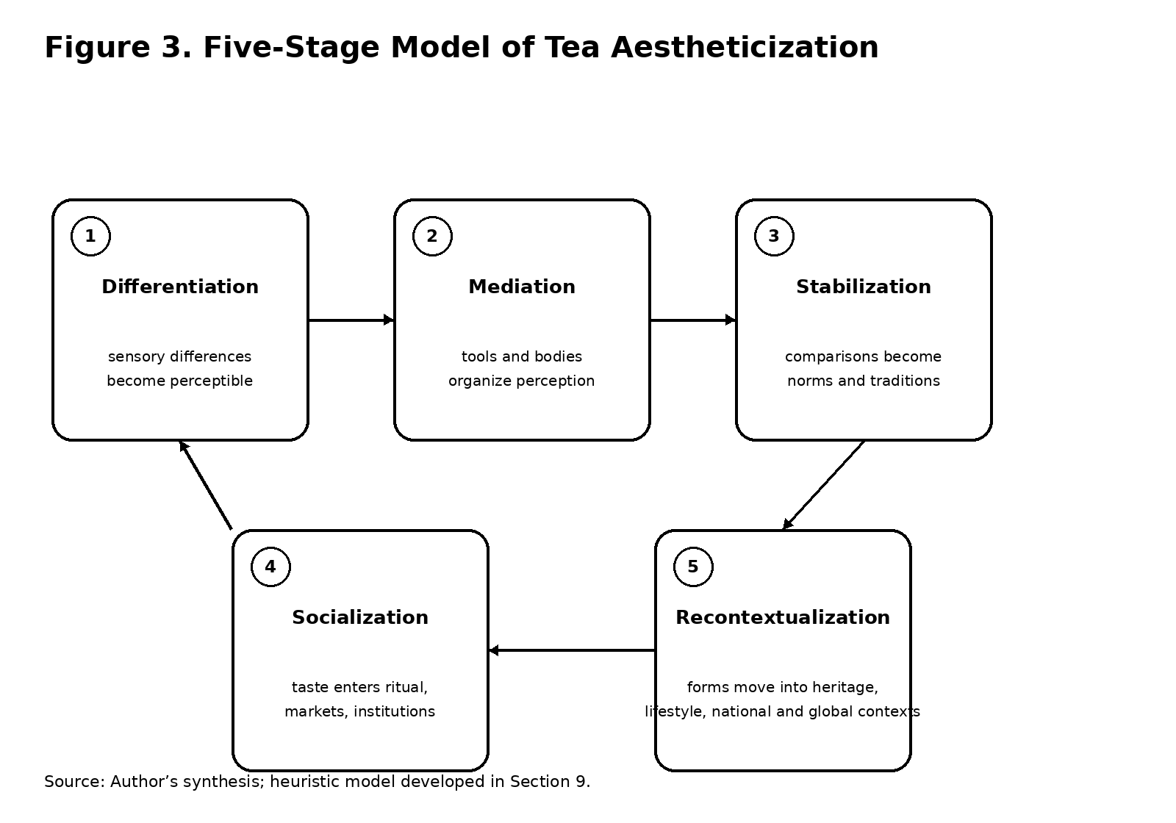

Figure 3. Five-Stage Model of Tea Aestheticization. Source: Author’s synthesis; heuristic model developed in Section 9.
The five-stage model proposed here is a heuristic synthesis of the foregoing cases rather than a taxonomy borrowed from a single source. This model clarifies what is meant here by “aestheticizing the leaf.” The phrase does not refer simply to embellishing tea or representing it as beautiful. It refers to the process by which the biological properties and material transformations of tea become the basis for differentiated modes of attention, evaluation, and social practice. Aestheticization is thus neither purely representational nor purely economic. It is a material-cultural process. Table 1 summarizes the model in operational terms.

Stage | Operation | Material / sensory basis | Cultural effect
1 | Differentiation | Flavor, aroma, color, texture, leaf form, provenance | Differences become perceptible and comparable.
2 | Mediation | Water, heat, vessel, timing, gesture, room | Perception is organized through material infrastructures.
3 | Stabilization | Repeated comparison and description | Preferences become norms, styles, and traditions.
4 | Socialization | Ritual, connoisseurship, education, markets | Taste becomes competence, belonging, status, or identity.
5 | Recontextualization | New media, markets, heritage narratives, lifestyle forms | Existing tea practices acquire new meanings and uses.
Table 1. Five-Stage Model of Tea Aestheticization. Source: Author’s synthesis.
Such a theory also places literature in a different position than a simple “reflection” model would allow. Poems, essays, treatises, diaries, and inscriptions do not merely record tea culture after the fact. They participate in making certain sensory distinctions thinkable and memorable. Conversely, material practices constrain literary language by providing the concrete qualities that writers can perceive, classify, and metaphorize. Text and substance form a reciprocal field.
The same can be said of visual art. A painting of a tea gathering, a manuscript album, a decorated bowl, or a contemporary package does not simply depict a pre-existing cultural meaning. Each object frames attention and selects aspects of tea practice as significant. Visual culture is therefore a technology of valuation.
Ritual occupies a similar position. Ritual does not merely symbolize community or hierarchy; it trains the body in ways of moving, tasting, looking, and waiting. The material specificity of tea gives ritual something to organize around. In turn, ritual increases the cultural legibility of material difference.
Finally, consumption should not be positioned as the endpoint of the process. Consumption is one of the sites where cultural meanings are renewed or revised. Every cup reopens the relation among plant, person, object, and narrative. In this sense, tea has no final cultural form. Its meanings remain dependent on practices of preparation, perception, circulation, and reinterpretation.

10. Conclusion
This chapter has argued that the cultural history of tea is best understood not as the progressive accumulation of symbolic meanings around a stable botanical object, but as an ongoing process of material and sensory mediation. Camellia sinensis becomes culturally consequential through transformation: cultivation turns plant life into agricultural practice; processing turns fresh leaves into differentiated materials; brewing converts those materials into sensory events; utensils organize perception; literary and visual forms make distinctions communicable; ritual socializes them; and markets, institutions, and identity projects recode them for new contexts.
The example of Rai San’yō’s Sanshi Suimeisho condenses this wider history. In the literati pavilion, sencha is simultaneously a plant-derived substance, a beverage, a sensory experience, a technical practice, an object mediated by utensils, an element of sociability, and a prompt for poetry. Its aesthetic value does not arrive after its material properties have been ignored. It emerges precisely because those properties are attended to, differentiated, and incorporated into a larger cultural practice. The tea gathering is therefore a site where botanical matter becomes literary and social form without losing its material specificity.
The broader East Asian comparison reinforces this point. Chinese tea poetry and the Classic of Tea reveal how sensory and technical distinctions entered literary and knowledge systems; Japanese tea history demonstrates how utensils, spaces, ritual movements, and connoisseurship constituted a complex aesthetic environment; Korean tea history shows how practices could be reconfigured through modern projects of tradition and national identity. Across these cases, tea’s meanings are inseparable from the material techniques through which it is cultivated, processed, prepared, handled, tasted, and displayed.
The concept of aestheticization developed here consequently differs from a purely symbolic account of culture. To aestheticize tea is to make material difference socially perceptible and culturally consequential. It is to transform qualities of matter into objects of attention, objects of attention into standards of taste, and standards of taste into practices of distinction, belonging, and identity. The process is recursive: cultural narratives shape how tea is perceived, while material encounters can confirm, alter, or resist those narratives.
This material-cultural perspective also helps explain why tea remains unusually durable as a cultural form. Unlike an image or abstract symbol, tea must be repeatedly enacted. The leaf continues to demand preparation. Water must meet it; vessels must contain it; bodies must drink it. Every new context therefore reopens possibilities for reinterpretation. Tea can remain traditional while changing, intimate while commercial, ordinary while prestigious, and local while globally circulated.
To follow the leaf across these transformations is ultimately to see that aesthetic culture is not produced by minds alone. It is generated through encounters among plants, substances, tools, bodies, texts, images, institutions, and environments. The cultural history of Camellia sinensis is therefore also a history of how humans learn to perceive matter—and how matter, through its affordances and resistances, helps shape the cultural forms through which humans perceive themselves.

Acknowledgments
The author thanks the Council on East Asian Studies at Yale University for making publicly available information about the lecture and archival materials that informed the discussion of Rai San’yō and sencha.

Conflict of Interest
The author declares no conflict of interest.

References
[1] Appadurai A, editor. The Social Life of Things: Commodities in Cultural Perspective. Cambridge: Cambridge University Press; 1986. DOI: 10.1017/CBO9780511819582.
[2] Kopytoff I. The cultural biography of things: commoditization as process. In: Appadurai A, editor. The Social Life of Things: Commodities in Cultural Perspective. Cambridge: Cambridge University Press; 1986. p. 64–92. DOI: 10.1017/CBO9780511819582.004.
[3] Ingold T. Materials against materiality. Archaeological Dialogues. 2007;14(1):1–16. DOI: 10.1017/S1380203807002127.
[4] Ingold T. Making: Anthropology, Archaeology, Art and Architecture. London: Routledge; 2013.
[5] Benn JA. Tea in China: A Religious and Cultural History. Honolulu: University of Hawai’i Press; 2015. DOI: 10.21313/hawaii/9780824839635.001.0001.
[6] Benn JA. Tea poetry in Tang China. In: Tea in China: A Religious and Cultural History. Honolulu: University of Hawai’i Press; 2015. p. 72–95. DOI: 10.21313/hawaii/9780824839635.003.0004.
[7] Mair VH, Hoh E. The True History of Tea. London; New York: Thames & Hudson; 2009.
[8] Varley HP, Kumakura I, editors. Tea in Japan: Essays on the History of Chanoyu. Honolulu: University of Hawai’i Press; 1989. DOI: 10.1515/9780824844394.
[9] Pitelka M, editor. Japanese Tea Culture: Art, History and Practice. London: Routledge; 2013.
[10] Kumakura I. Japanese Tea Culture: The Heart and Form of Chanoyu. Translated by Martha J. McClintock. Tokyo: Japan Publishing Industry Foundation for Culture; 2023. DOI: 10.2307/jj.2840648.
[11] Carriger ML. Tea cultures of Japan. In: Goldstein D, editor-in-chief. Oxford Research Encyclopedia of Food Studies. Oxford: Oxford University Press; 2026. DOI: 10.1093/9780197852538.003.0250.
[12] Shimamura Y. 頼山陽と煎茶: 近世後期の文人の趣味とその精神性に関する試論 [Rai Sanyō to sencha: Kinsei kōki no bunjin no shumi to sono seishinsei ni kansuru shiron]. Tokyo: Kasama Shoin; 2022. ISBN 9784305709585.
[13] Bourdieu P. Distinction: A Social Critique of the Judgement of Taste. Translated by Richard Nice. Cambridge, MA: Harvard University Press; 1984.
[14] Hellyer R. Green with Milk and Sugar: When Japan Filled America’s Tea Cups. New York: Columbia University Press; 2021. DOI: 10.7312/hell19910.
[15] Oshikiri T. The Shogun’s tea jar: ritual, material culture, and political authority in early modern Japan. The Historical Journal. 2016;59(4):927–945. DOI: 10.1017/S0018246X1600008X.
[16] Sen Sōshitsu XV. The Japanese Way of Tea: From Its Origins in China to Sen Rikyu. Translated by V. Dixon Morris. Honolulu: University of Hawai’i Press; 1998. DOI: 10.1515/9780824864804.
[17] Lee HC, Kwon SH. The invention and promotion of cha-rye in Korea. Asian Journal of Social Science. 2022;50(3):171–177. DOI: 10.1016/j.ajss.2022.06.004.
[18] de Certeau M. The Practice of Everyday Life. Volume 1. Translated by Steven Rendall. Berkeley: University of California Press; 1984.
[19] Zhu VJ. The Visual Ethnographer’s Data Other: Secrets Unveiled for a Sociological J. M. Coetzee. Eliva Press; 2026.
[20] Zhu VJ. Sino-Japanese Literature in Perspective: A Short Communication to the World Literature. Edited by Irina Lungu. Chișinău: Eliva Press; 2026.
[21] Brown TG. 風水之理：從法律、環境到近代化，清帝國的地方治理與社會秩序 [Laws of the Land: Fengshui and the State in Qing Dynasty China]. Translated by Chen MQ. Taipei: 畢方文化; 2026. ISBN 9786267816059.
[22] Yale Council on East Asian Studies. Steeped in Art and Nature: On Rai San’yō’s “Sanshi Suimeisho”. Yale University; 2026.

